Strategies of Protected-Area use by an Ecosystem Engineer

Supplementary Material

Anastasia E. Madsen^{1*}, Christin Minge^{2,3*}, T.V. Pushpakumara⁴, U.S. Weerathunga⁴, U.K. Padmalal⁵, Devaka K. Weerakoon⁶, Shermin de Silva^{2,4,7}

¹University of Nebraska-Lincoln, Lincoln NE, USA
²Trunks & Leaves Inc., Newtonville, MA USA
³Friedrich-Schiller University, Institute of Ecology and Evolution, Jena, Germany
⁴EFECT, 215 A 3/7 Park Road, Colombo 5 Sri Lanka
⁵Open University of Sri Lanka, Colombo, Sri Lanka
⁶University of Colombo, Colombo, Sri Lanka
⁷University of British Columbia, Departments of Zoology and Geography, Vancouver, Canada
*Equal contributions
Corresponding author: shermin@elephantresearch.net

Figure S1 – Schematic representation of the Between-Sightings Intervals (BSI). BSI is defined as the number of days passed since the previous sightings of an individual, and was calculated for each individual starting with its first sighting, and ending with its last sighting. A snapshot of 25 days within the study period with 3 hypothetical individuals is represented. The horizontal light gray bands represent the continued duration of the study period (25 days here), the darker gray and black bars represent discrete daily sightings (see legend below), and white bands represent days between sightings (numbered). For each elephant, a mean BSI is calculated from the days passed between sightings, as tabulated to the lower right of each band.

Figure S2 – Musth stages. A) Early-musth is characterized by light temporal secretions and urine dribbling. B) Peak-musth is identified by distinct wet patches on the temples, often with reddish coloration, and constant urine dribbling staining the hind legs. C) Late-musth is identified by reduced temporal secretions and urine dribbling. It is distinguished from early-musth by the presence of dried secretions on the temples and dried urine residue on the sheath of the penis and hind legs.

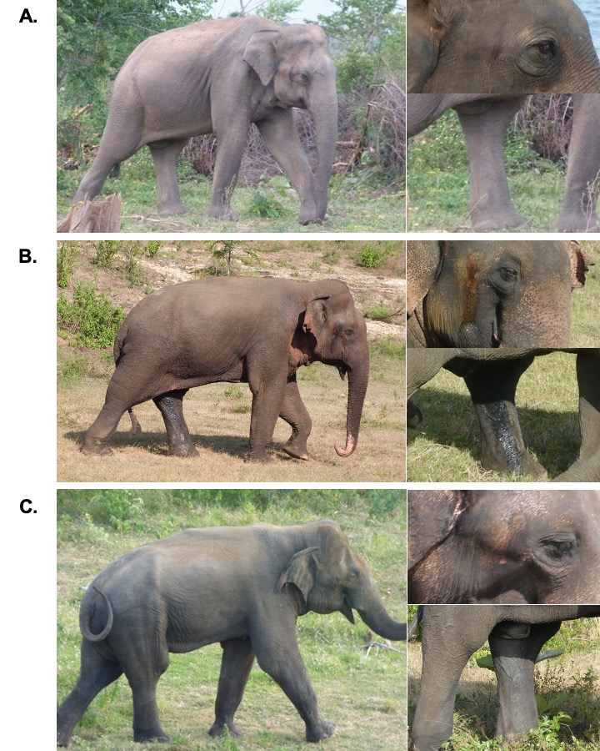

Figure S3 - Cumulative discovery curve for males, N = 379.

Figure S4 - Sightings distributions, N= 216. A) Aggregate across all individuals. B) By age-class.

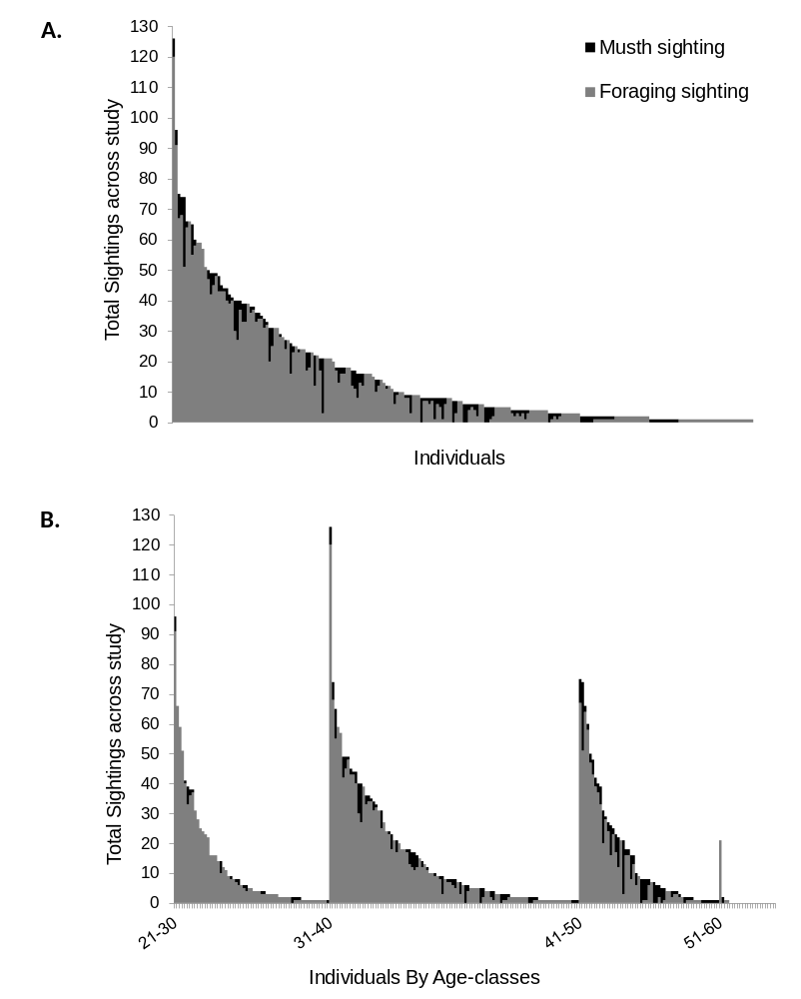

Table S1 – Generalized linear mixed model selection for male between-sightings-interval (n=176 males) Possible covariates were strategy (musth-only, foraging-only, or foraging and musth). Three candidate models and a null model were included for comparison during model selection.
Model | K | AIC | ΔAIC | log Likelihood | Deviance | p-value
*BSI ~ strategy * age class +(1|ID)+(1|Month)+(1|Year) | 13 | 38062 | 0 | -19018 | 38036 | 8.03*10⁻⁵
BSI ~ strategy +(1|ID)+(1|Month)+(1|Year) | 7 | 38073 | 11 | -19029 | 38059 | 0.023
†BSI ~ (1|ID)+(1|Month)+(1|Year) | 5 | 38076 | 14 | -19033 | 38066 | -
BSI ~ age class+(1|ID)+(1|Month)+(1|Year) | 7 | 38079 | 17 | -19032 | 38065 | -
*selected model, †null model

