Archives of Microbiology

Biotransformation of testosterone by the filamentous fungus Penicillium pinophilum

Maryam Mehmannavaz . Bahman Nickavar

Department of Pharmacognosy, School of Pharmacy, Shahid Beheshti University of Medical Sciences, Tehran, Iran

Corresponding author: Bahman Nickavar
Address: Department of Pharmacognosy, School of Pharmacy, Shahid Beheshti University of Medical Sciences, PO Box: 14155-6153, Tehran, Iran
E-mail: bnickavar@sbmu.ac.ir

ORCID ID of the authors
Maryam Mehmannavaz https://orcid.org/0000-0002-0153-3955
Bahman Nickavar https://orcid.org/0000-0003-3921-4981

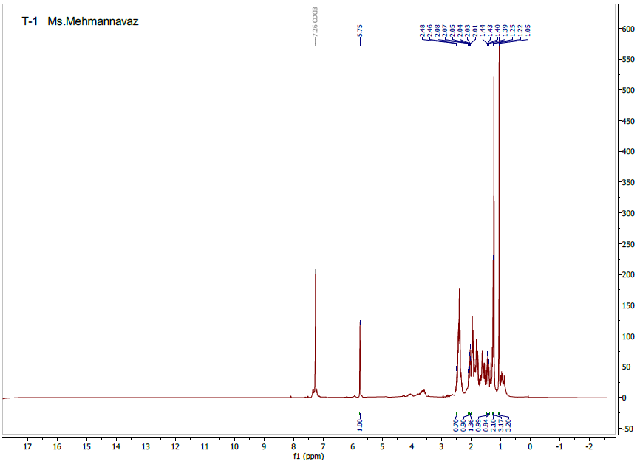
Fig. S1 ¹H NMR spectrum of metabolite II

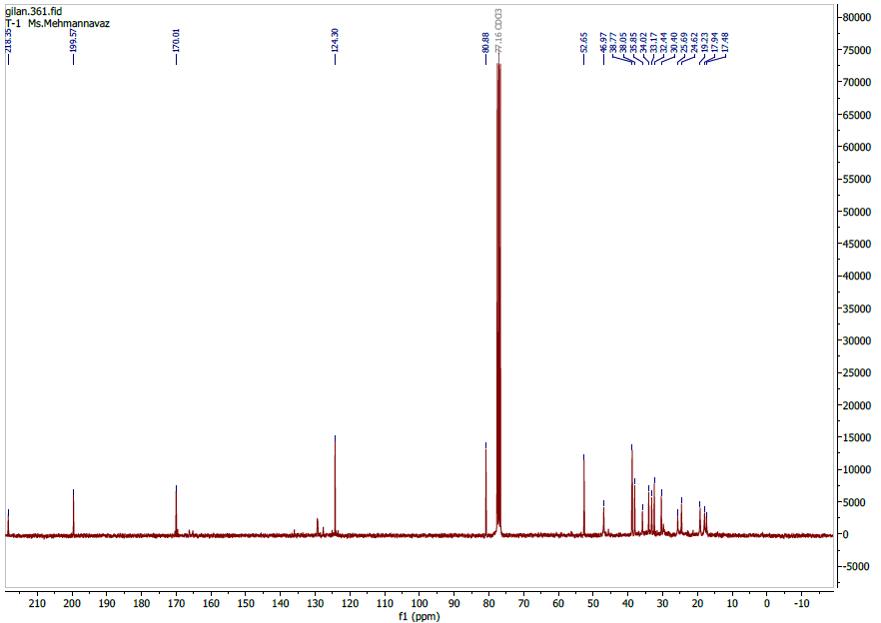
Fig. S2 ¹³C NMR spectrum of metabolite II

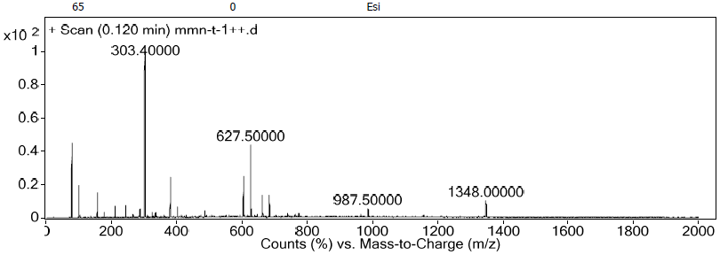
Fig. S3 ESI-MS spectrum of metabolite II

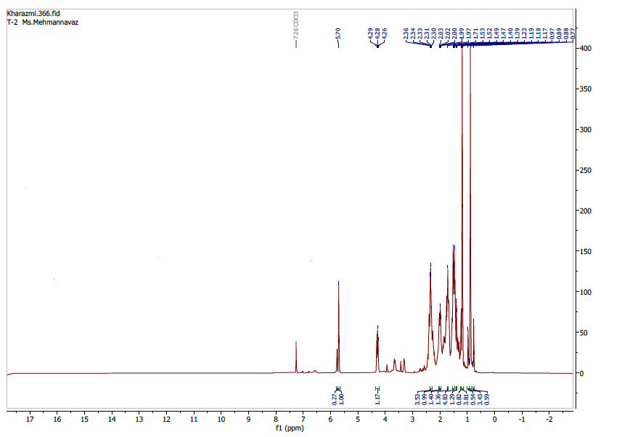
Fig. S4 ¹H NMR spectrum of metabolite III

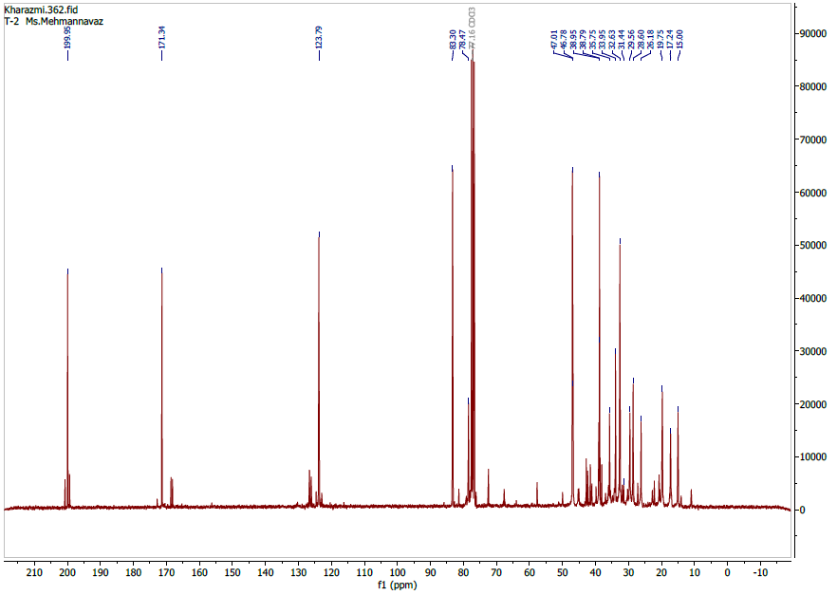
Fig. S5 ¹³C NMR spectrum of metabolite III

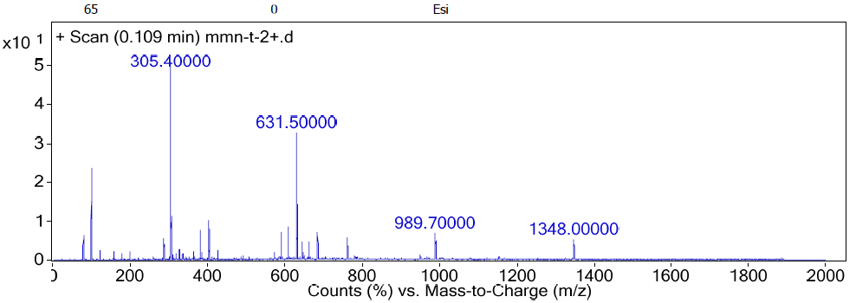
Fig. S6 ESI-MS spectrum of metabolite III

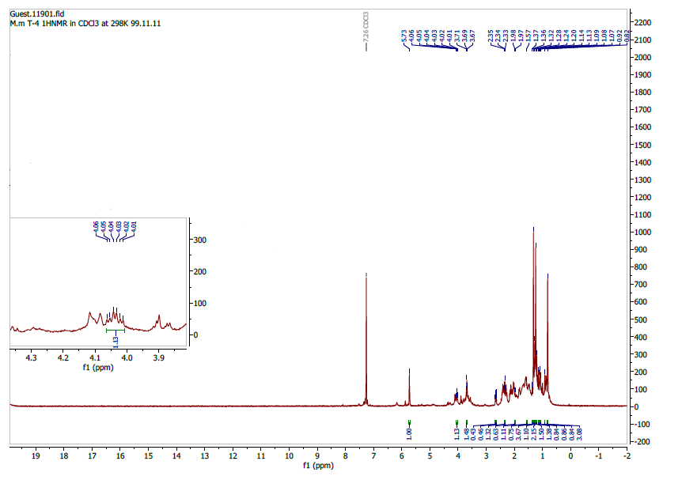
Fig. S7 ¹H NMR spectrum of metabolite IV

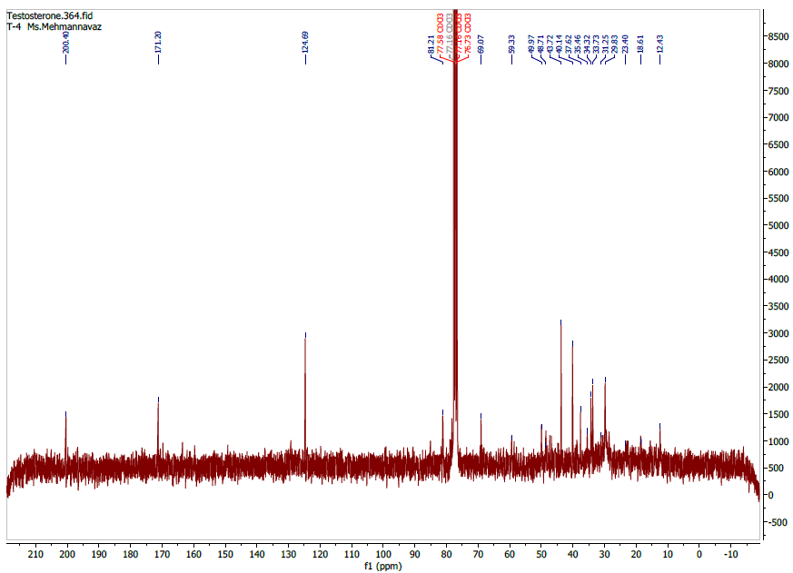
Fig. S8 ¹³C NMR spectrum of metabolite IV

Supplementary Material
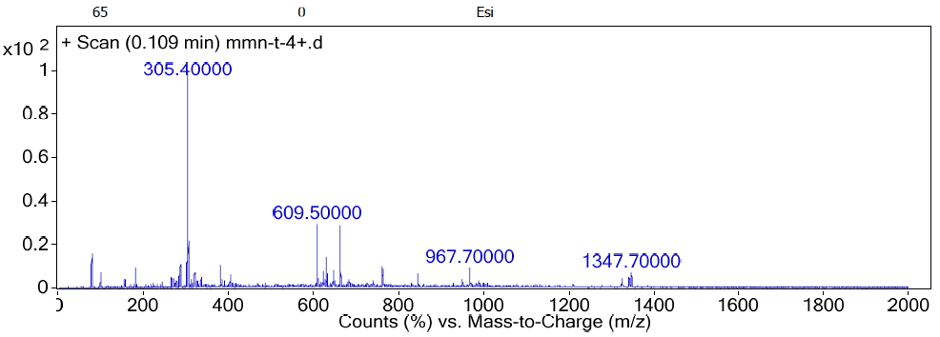
Fig. S9 ESI-MS spectrum of metabolite IV

