Figure S1. The flowchart of our research.
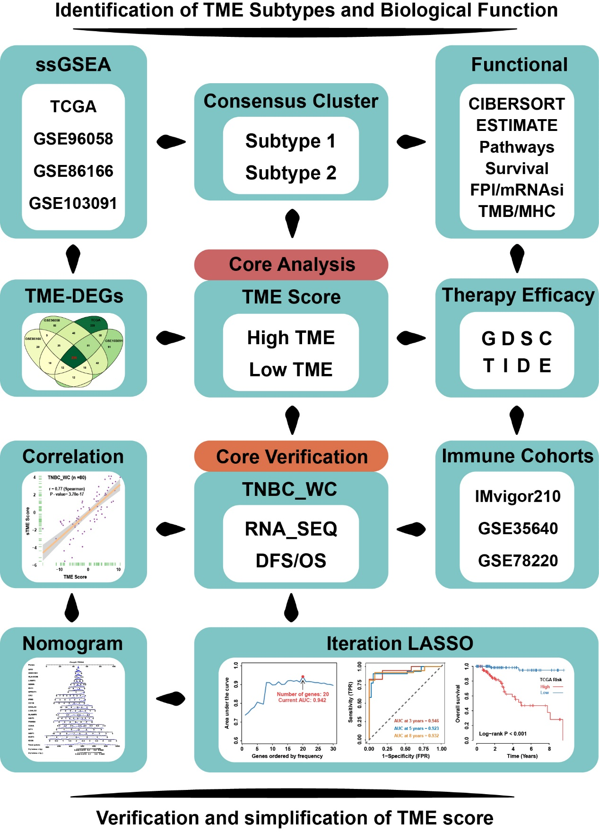

Figure S2. Consensus clustering of immune cell infiltration levels in four TNBC cohorts.
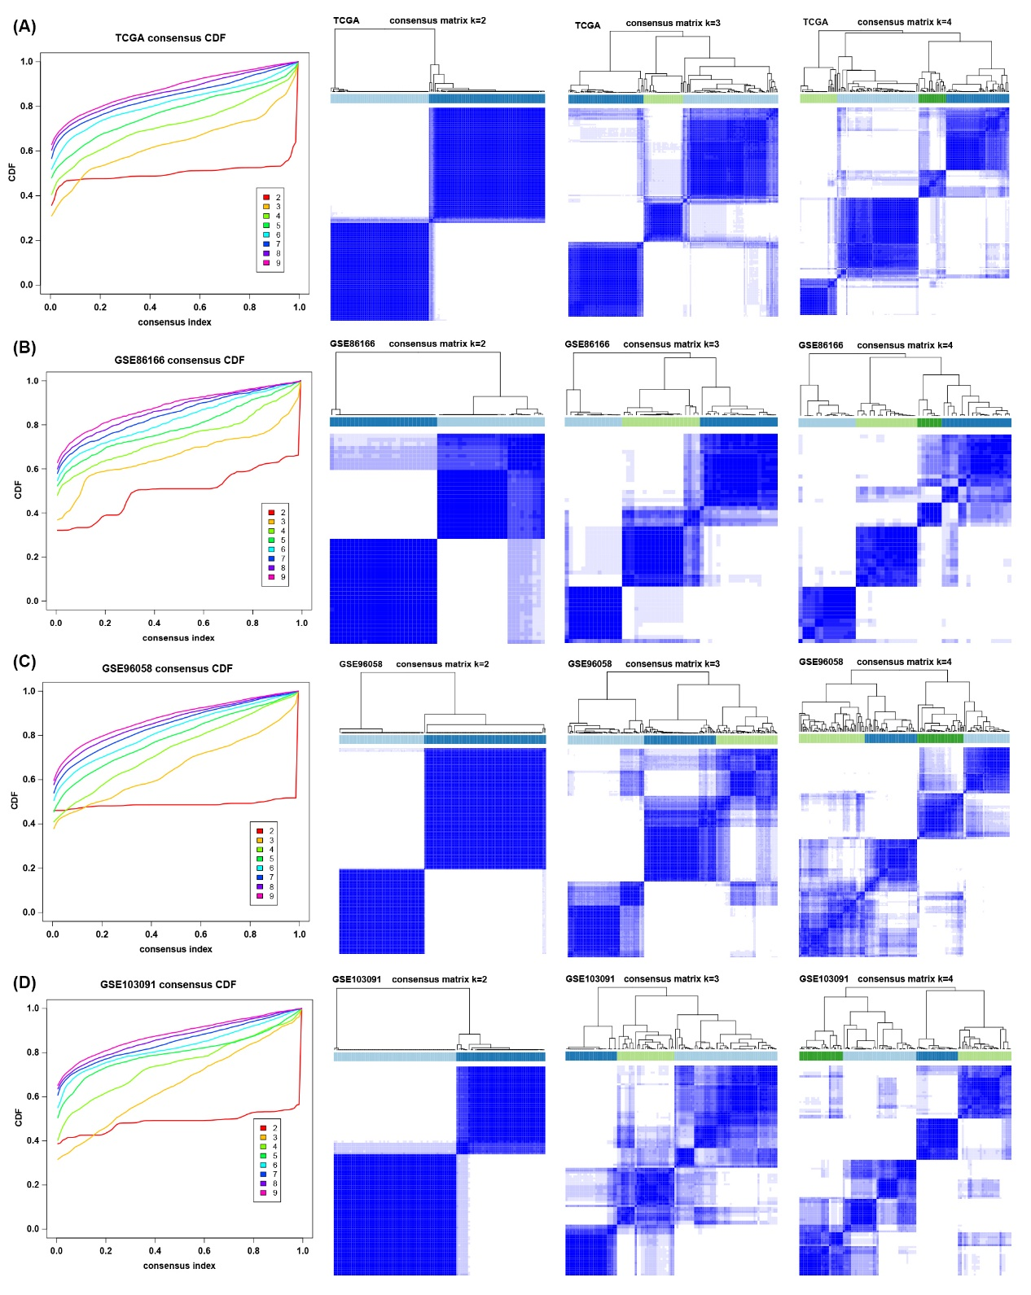
(A-D) Unsupervised clustering of TME in four TNBC cohort and consensus matrices for k = 2 - 4. K = 2 was eventually selected to cluster samples.
Figure S3. Biological function analysis between TME subtypes. 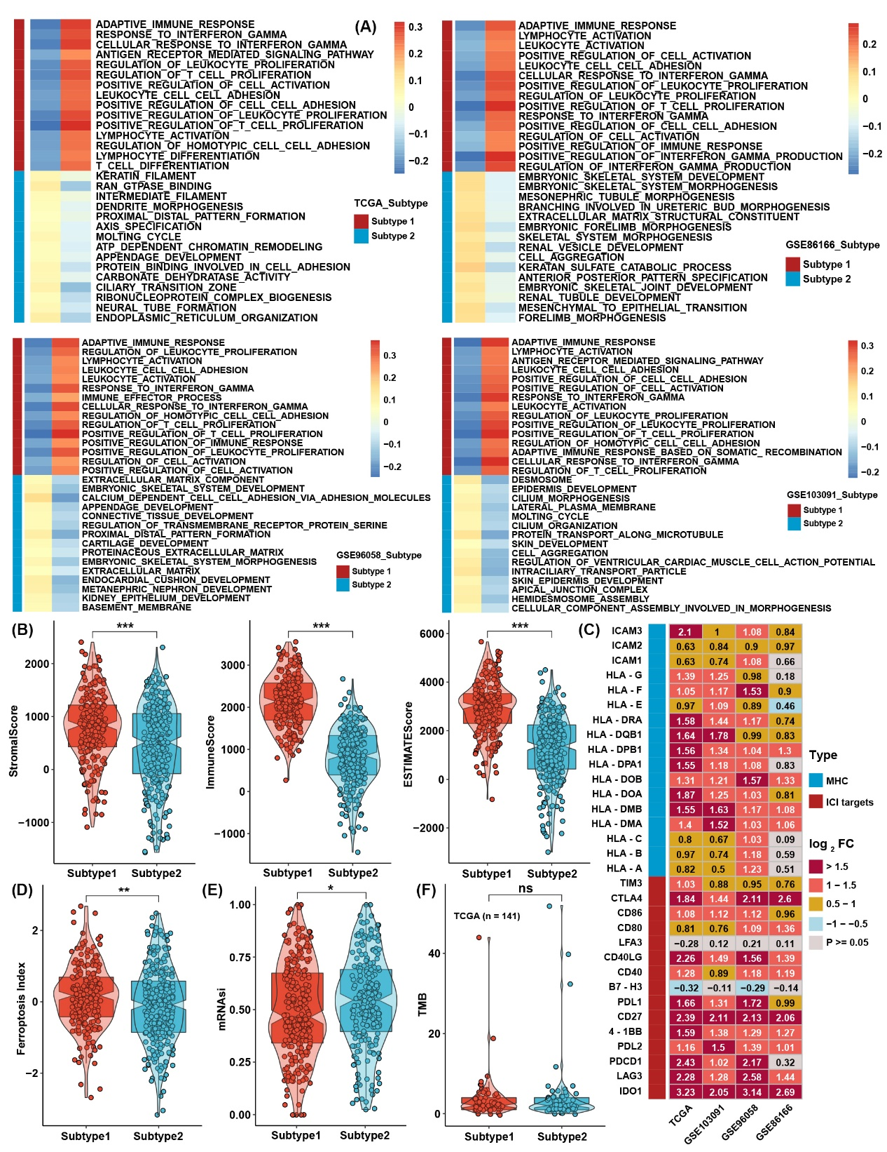
(A) GSEA between two TME subtypes in four TNBC cohorts. (B) The differences in ESTIMATE analysis results between TME subtypes in the whole TNBC cohort. (C) Differential expression analysis of MHC molecules and immune checkpoint inhibitors between TME subtypes in four TNBC cohorts. (D-E) The differences in the results for FPI and mRNAsi between TME subtypes in the whole TNBC cohort. (F) The differences in TMB between TME subtypes in the TCGA cohort. The asterisks represent the statistical p value (*P < 0.05; **P < 0.01; ***P < 0.001).
Figure S4. Generation of TME score and functional verification.
(A) Differences in TME scores between TME subtypes in four TNBC cohorts. (B) Correlation analysis between the GSVA score and TME score in four TNBC cohorts. (C) Correlation analysis between the curative pathway enrichment score and TME score in four TNBC cohorts. (D) Correlation analysis between the TME score and the expression of genes involved in four significant pathways in Figure S4C. (E) Correlation analysis between the TME score and the results of ESTIMATE analysis in four TNBC cohorts. (F-G) The differences in the results for FPI and mRNAsi between TME score groups in the whole TNBC cohort. (H) The differences in TMB between TME score groups in the TCGA cohort. (I) Correlation analysis between the TME score and the expression of 113 ferroptosis-related genes in four TNBC cohorts. (J) The differences in TME scores between different clinical trait groups in the TCGA cohort.
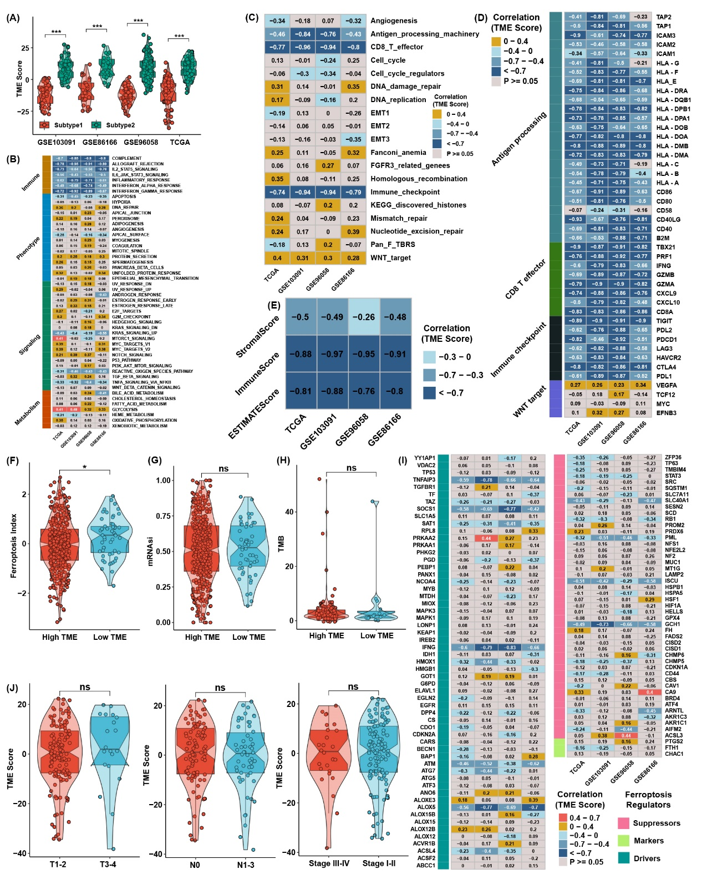
Figure S5. Therapeutic Response Prediction.
(A) Correlation analysis between prediction IC50 values in GDSC and TME score in four TNBC cohorts. (B) Forest plot for the TME score in TCGA pancancer. (C) Survival analysis for the TME score in the IMvigor210 cohort. (D) Correlation analysis between the TME score and the expression of MHC molecules in the IMvigor210 cohort. (E) The difference in TME scores between immunotherapy respondents and nonresponders in GSE78220. (F) Survival analysis for the TME score in the TNBC_WC cohort.
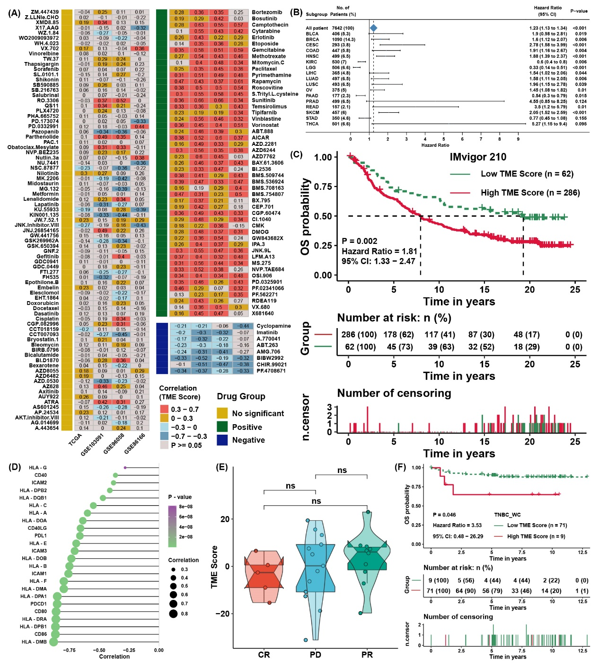

Figure S6. Prognostic signature construction and simplification of the TME score.
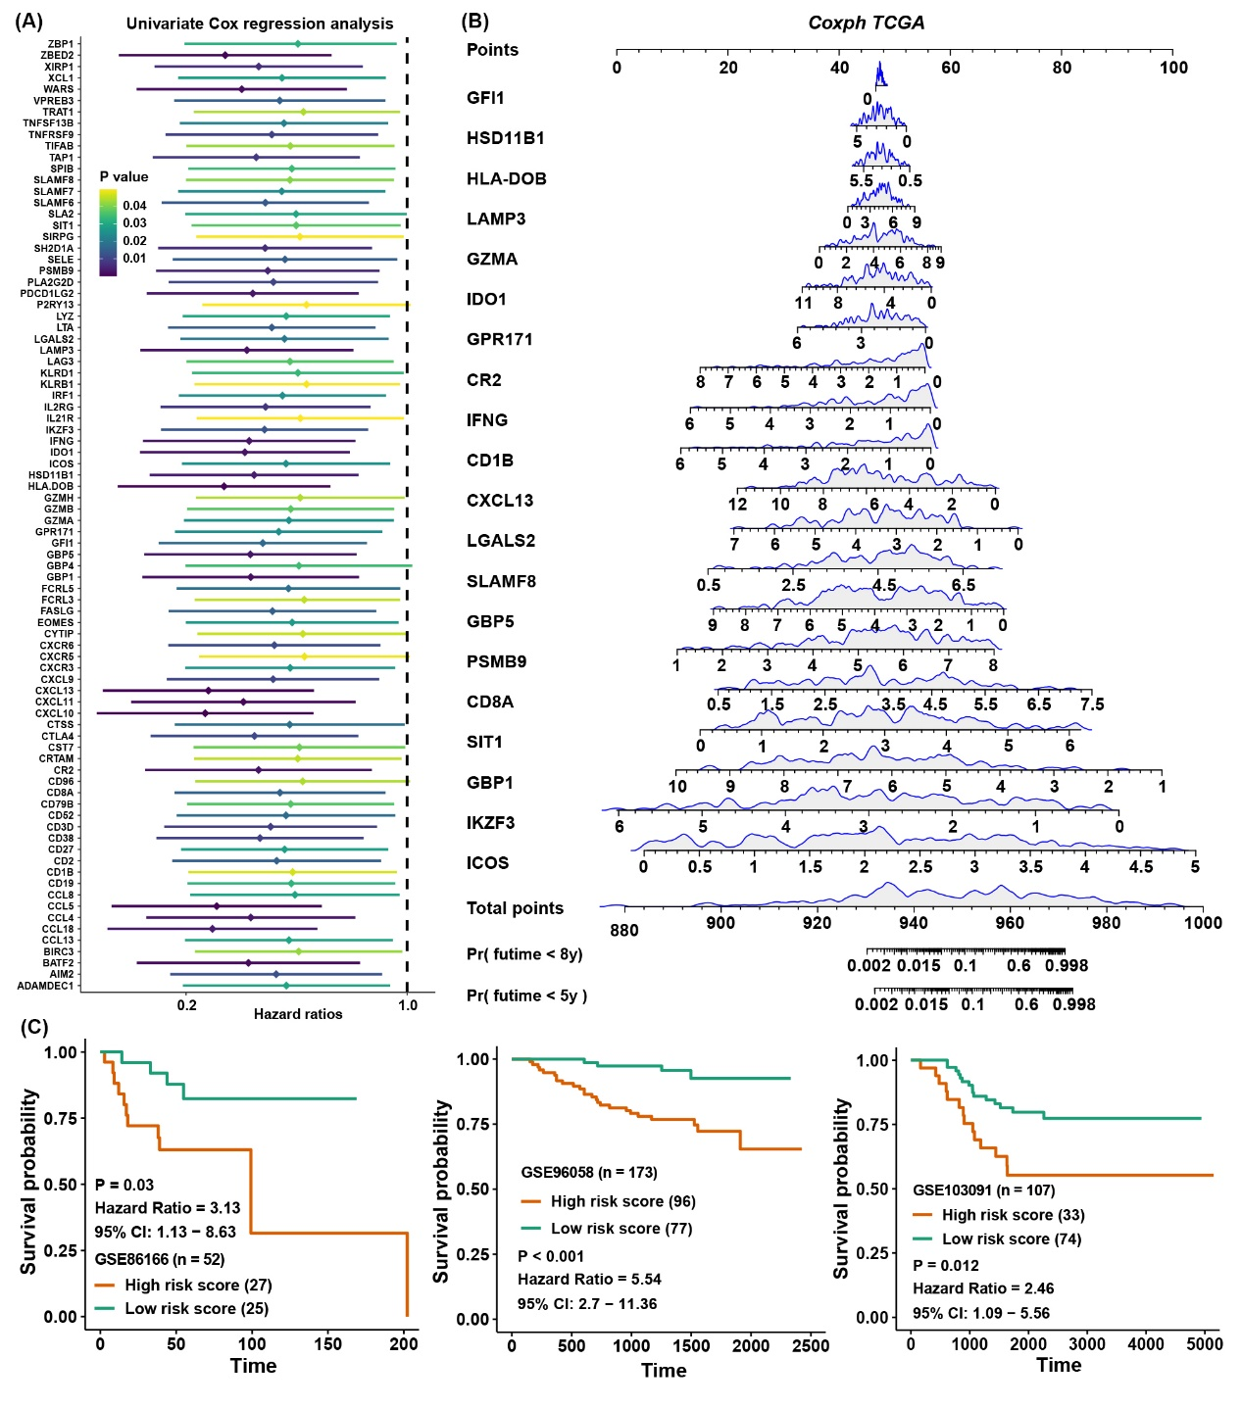
(A) Univariate Cox regression analysis of TME-related DEGs in the TCGA cohort. (B) Nomogram to predict the 5‐y and 8‐y overall survival of TNBC patients. (C) Survival analysis for the risk score in three TNBC cohorts.

