Electronic Supplementary Information (ESI) 1:
¹H NMR ,Mass spectrum, IR spectrum
L¹

L²

L³

L⁴

L⁵

L⁶

L⁷

I

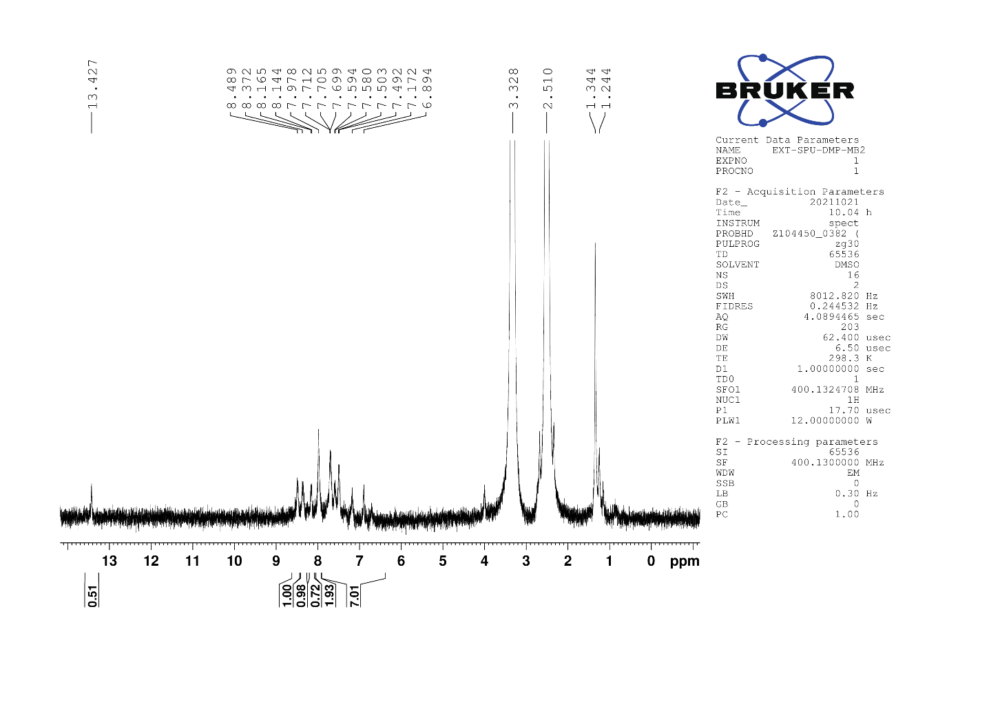
II

III

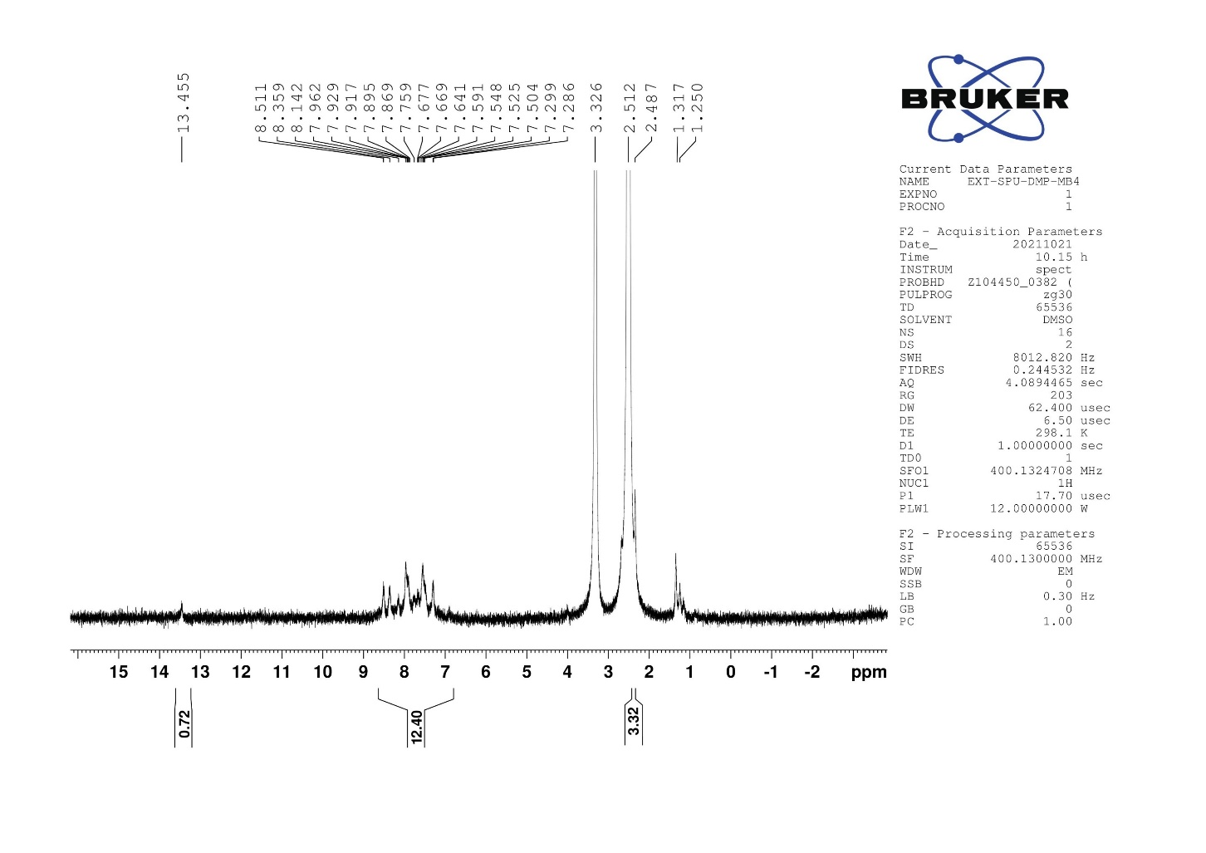
IV

V

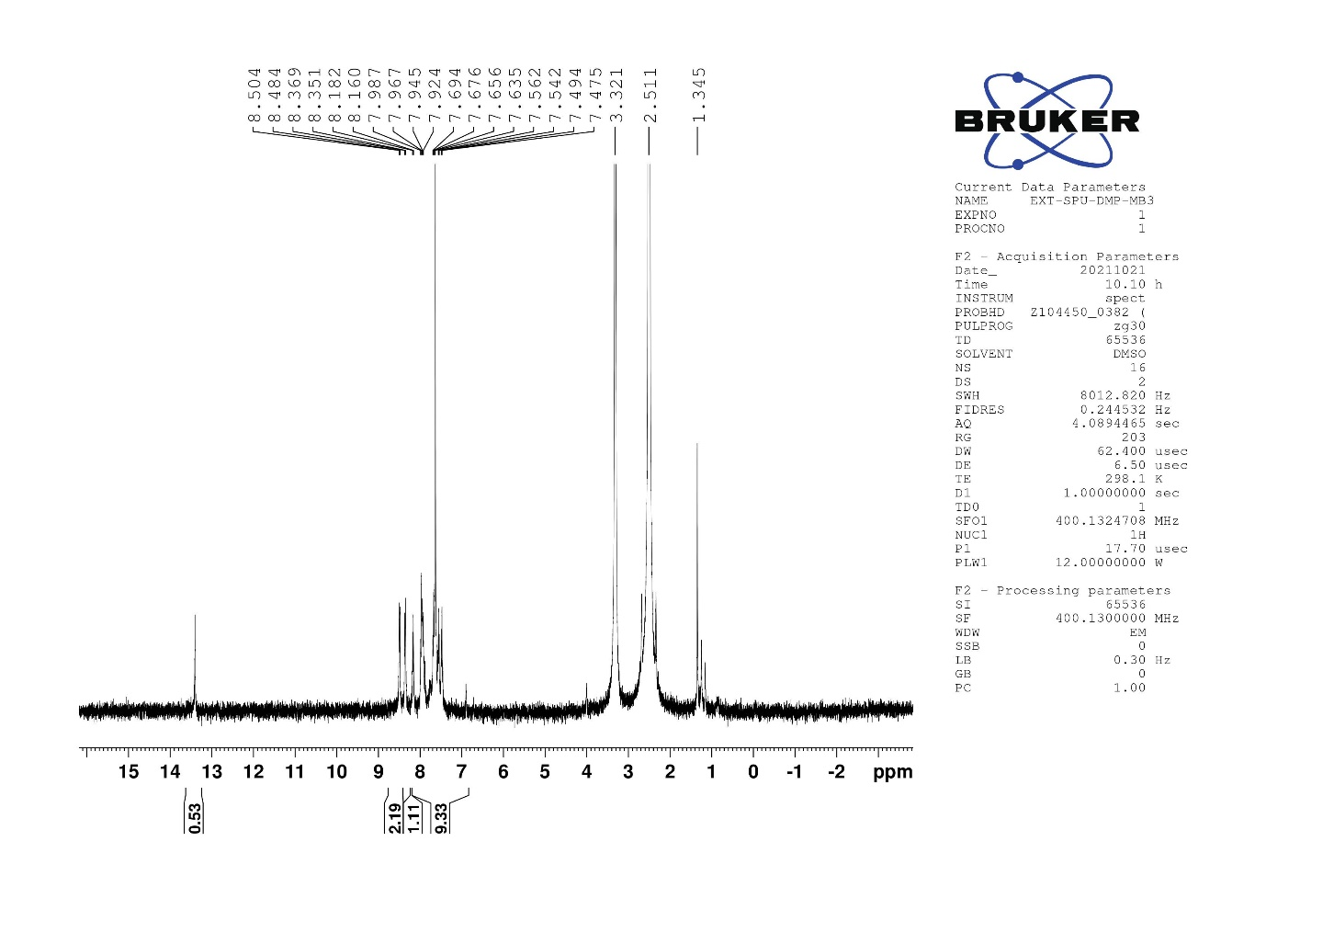
VI

VII
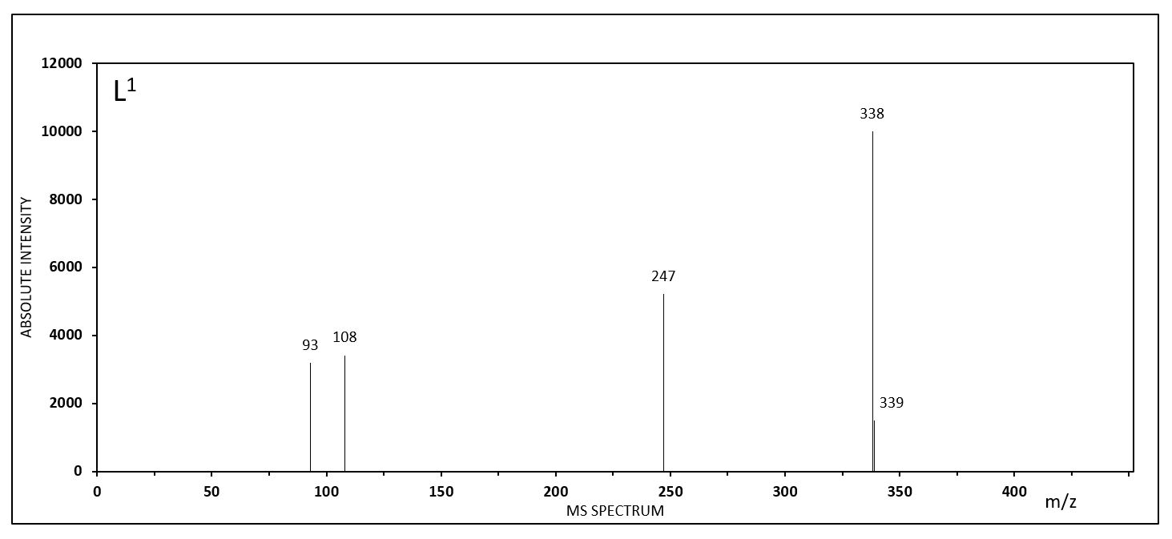

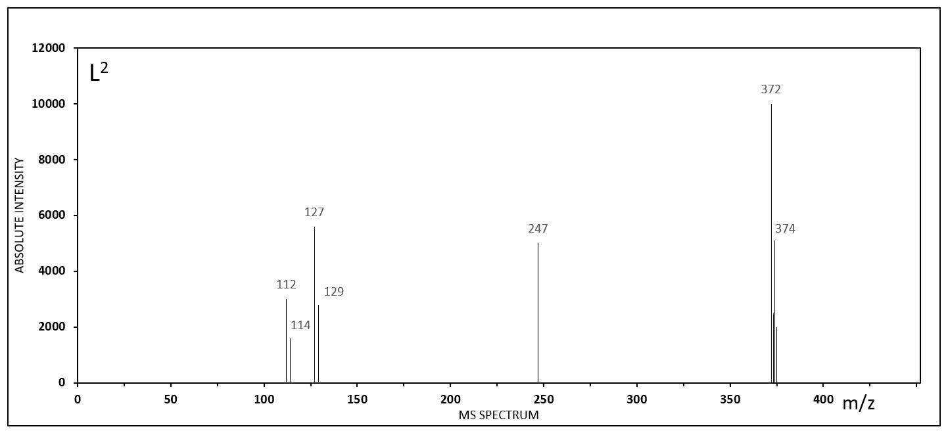

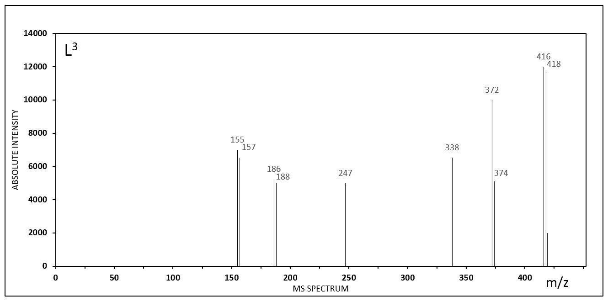

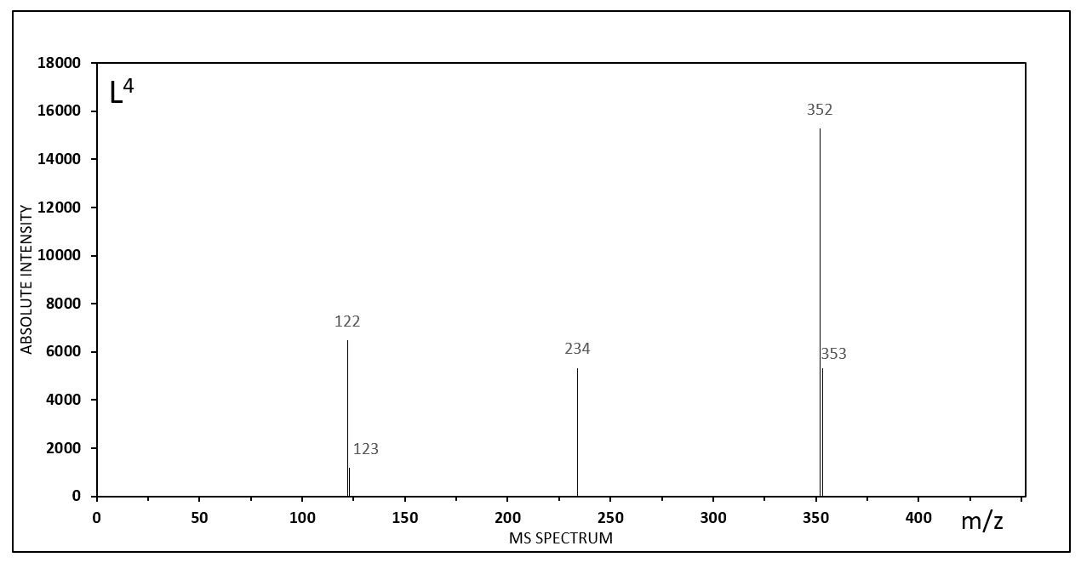

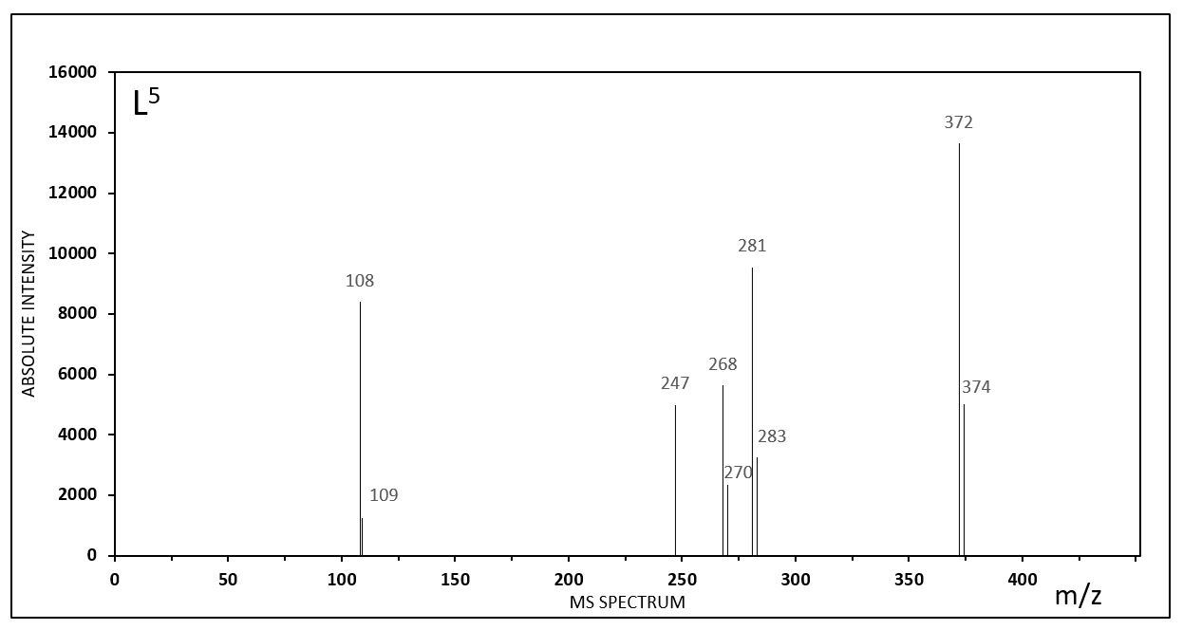

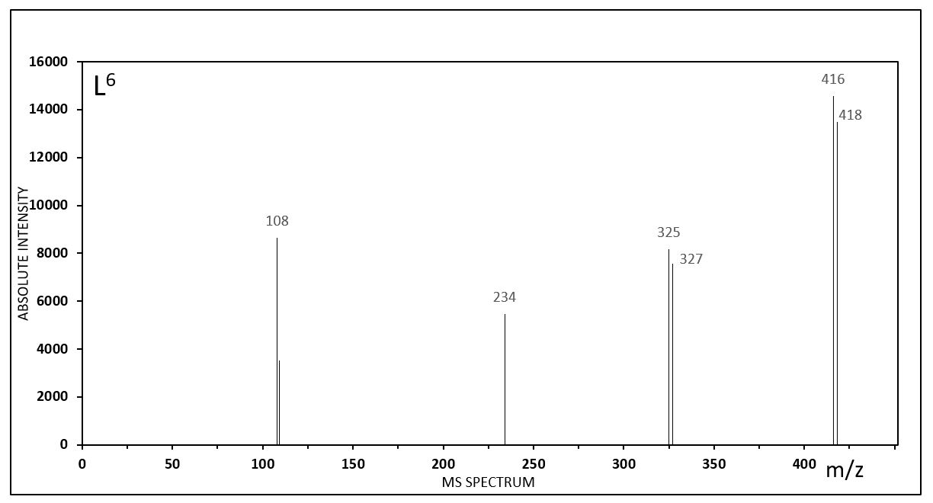

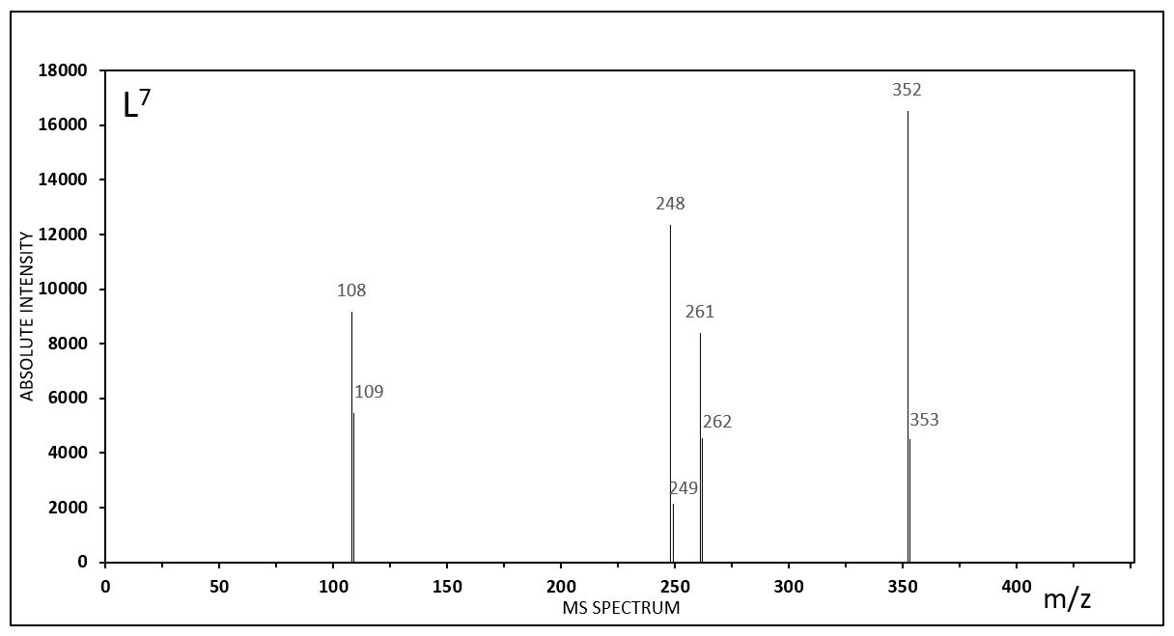

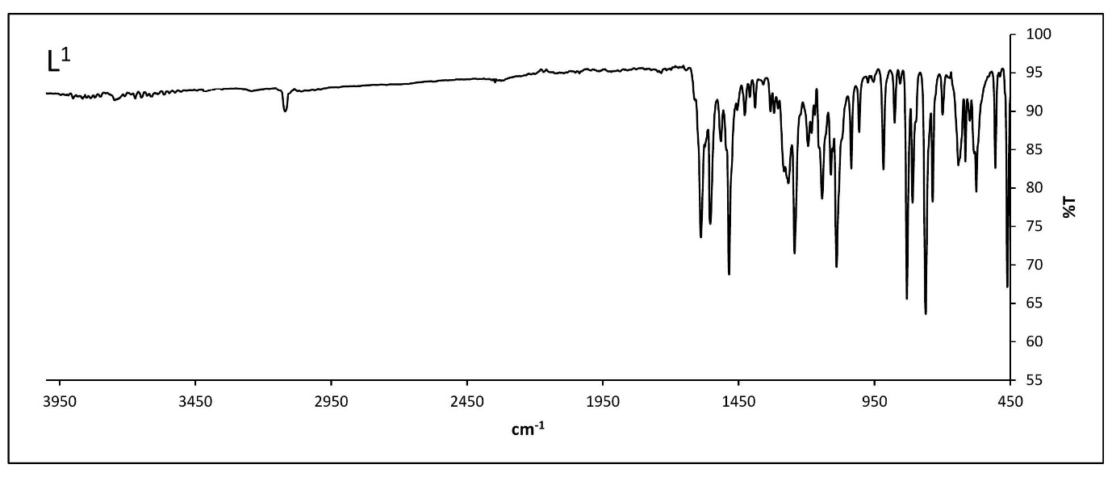
IR Spectra
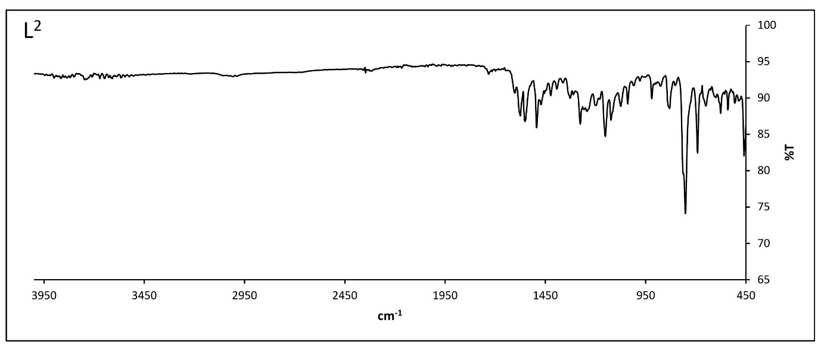
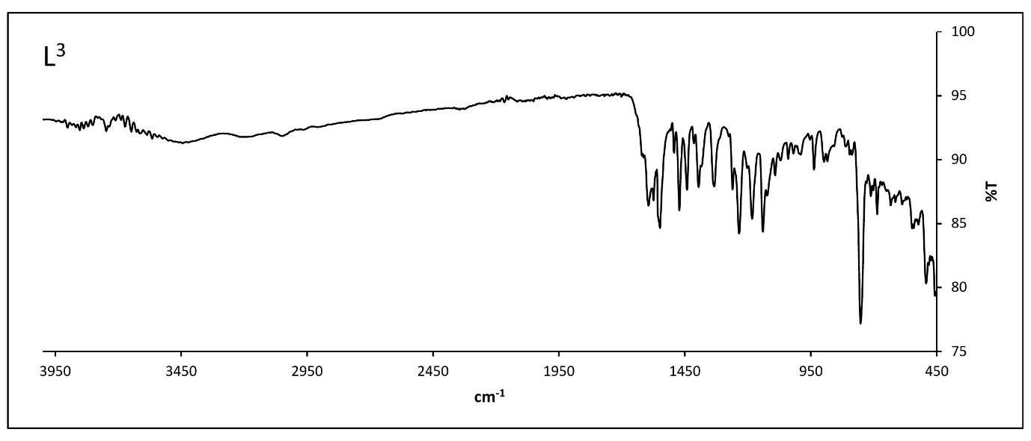

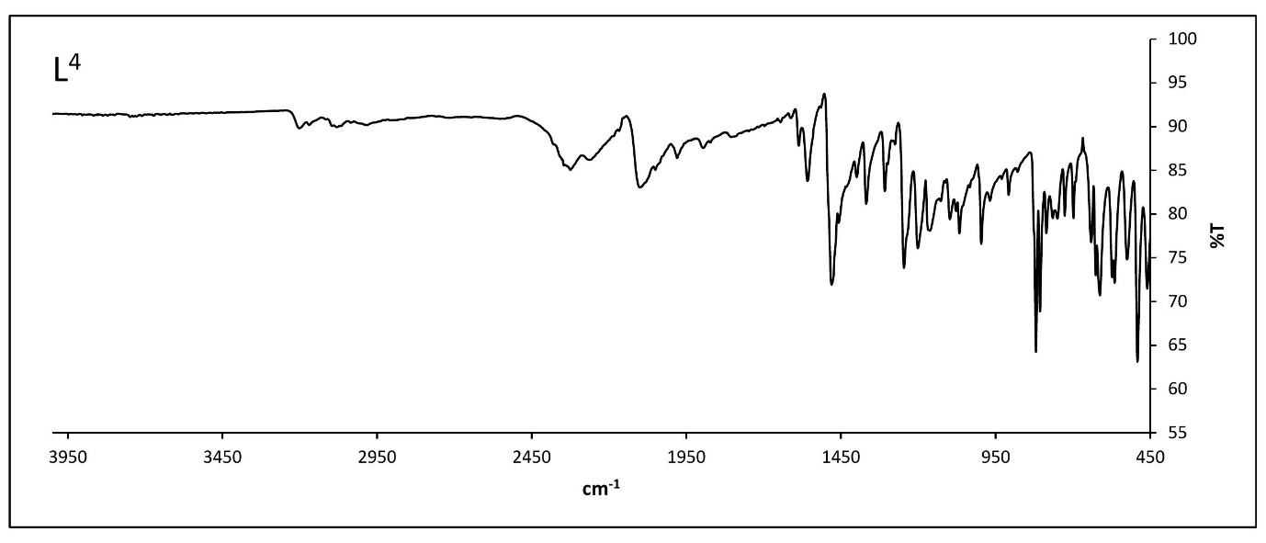

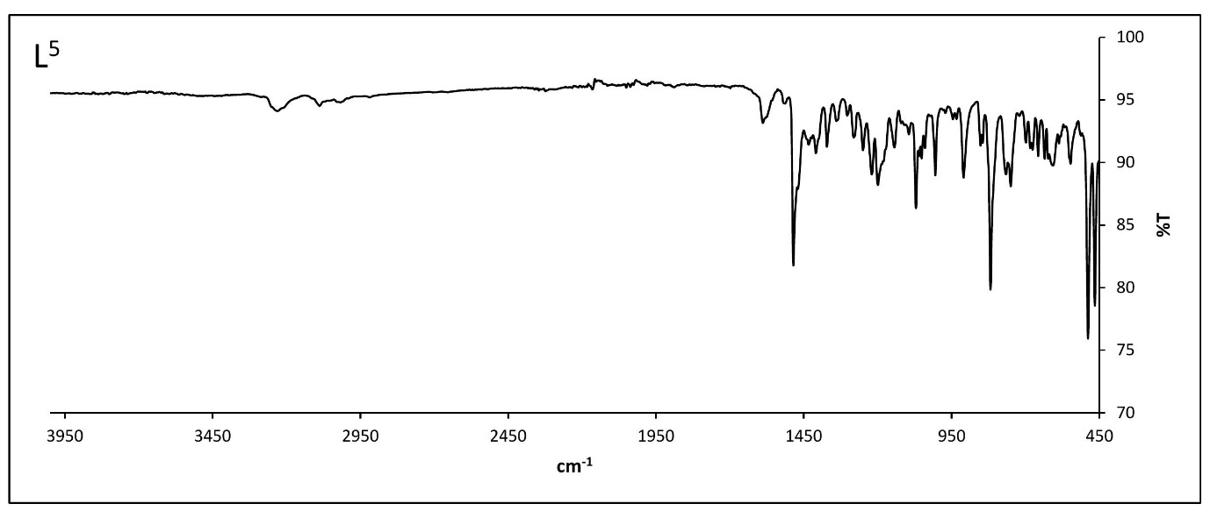
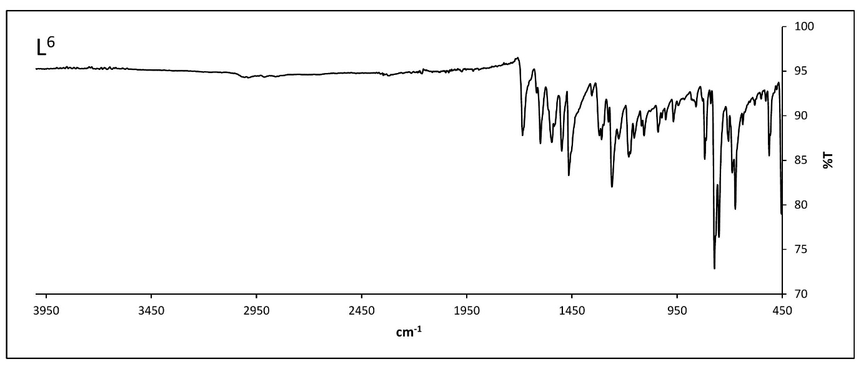
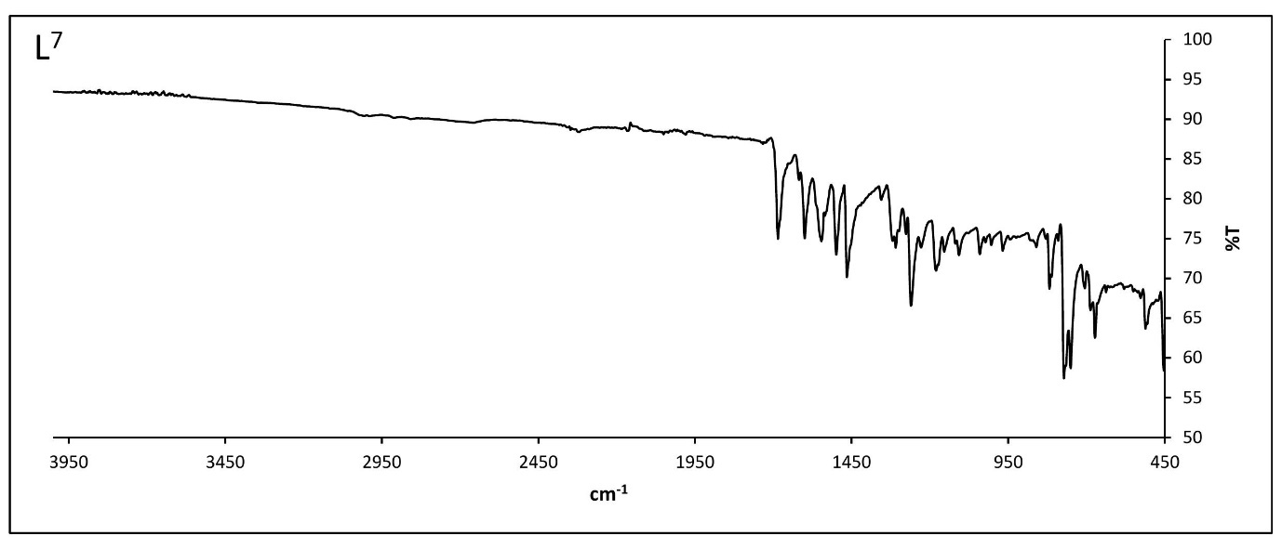

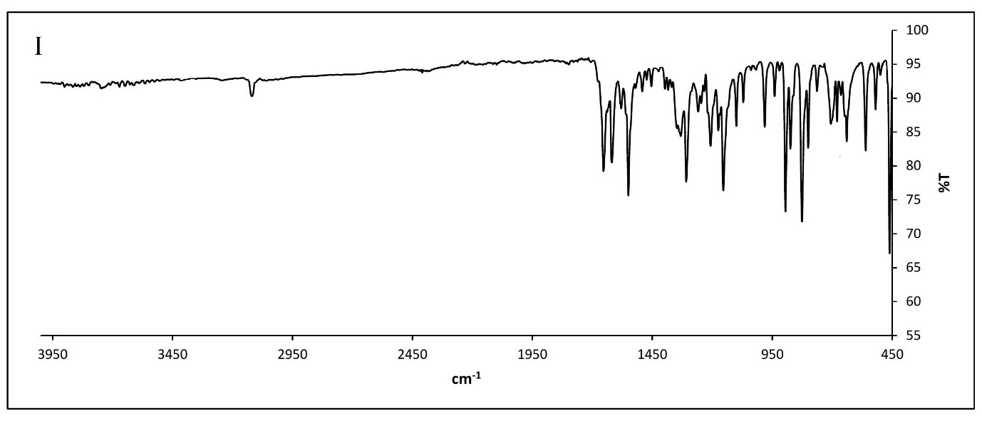
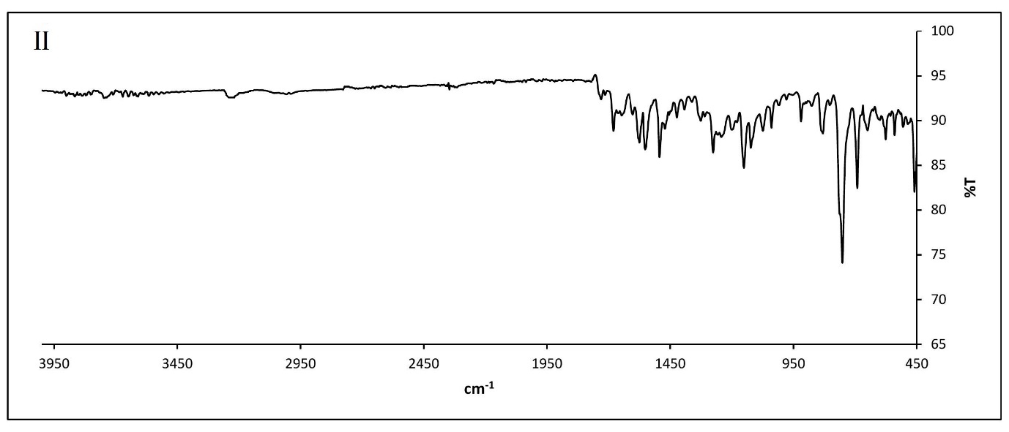

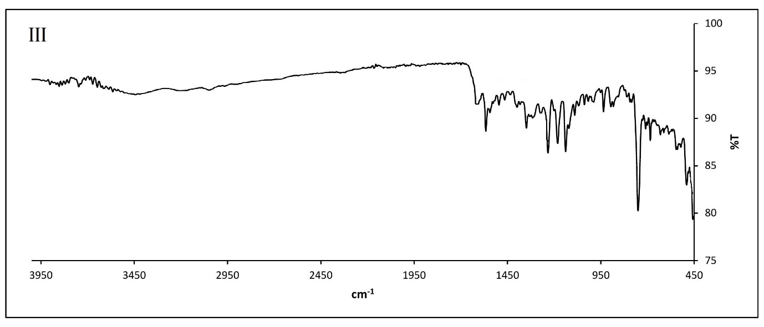

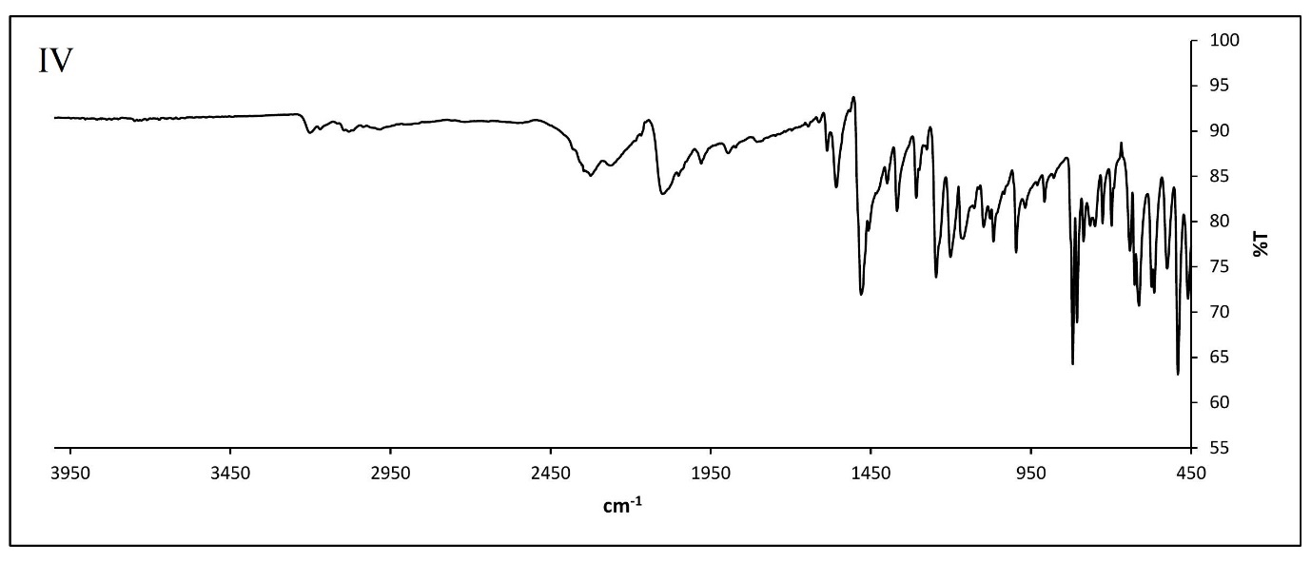
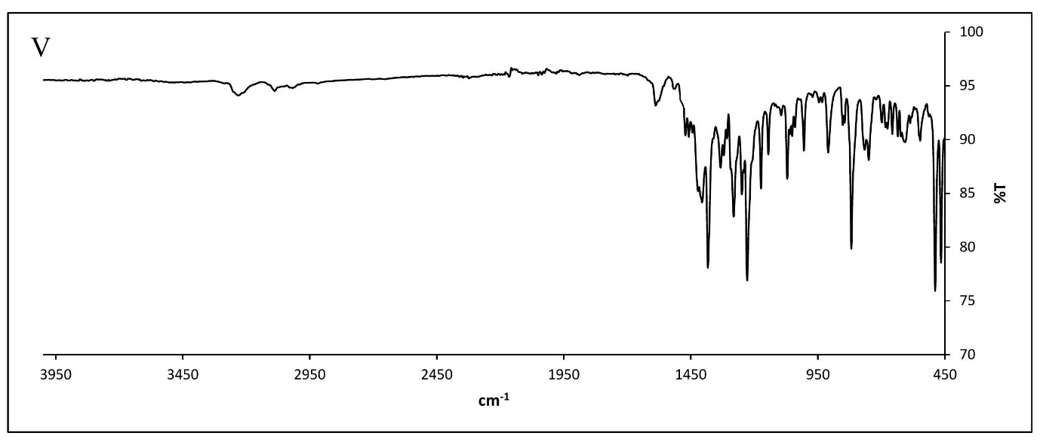

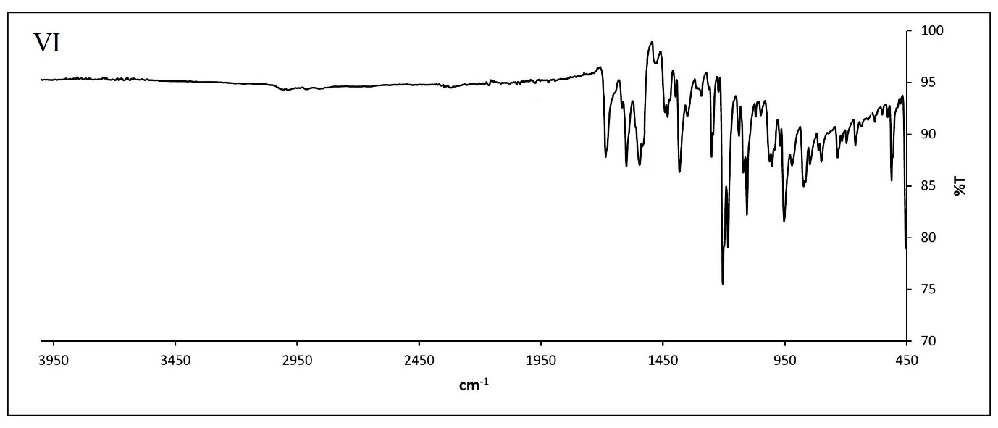

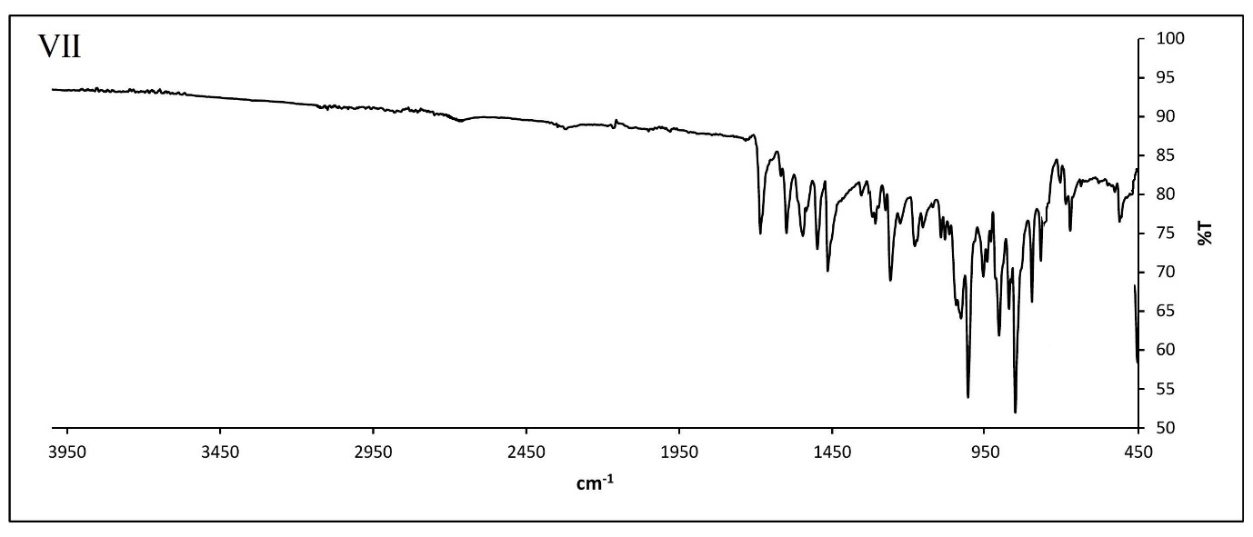

ESI 2: DFT data

(Table of bond length bond angle and mulical charges and images for complex I to VI)
I
Atom number | Bond length (Å) | Atom number | Bond length (Å)
R(1,2) | 1.5305 | R(16,36) | 1.07
R(1,6) | 1.3679 | R(17,18) | 1.5447
R(1,7) | 1.07 | R(17,37) | 1.07
R(2,3) | 1.3699 | R(18,19) | 1.3567
R(2,34) | 1.5121 | R(18,38) | 1.07
R(3,4) | 1.5268 | R(19,39) | 1.07
R(3,11) | 1.5196 | R(20,21) | 1.54
R(4,5) | 1.3644 | R(20,25) | 1.3552
R(4,8) | 1.07 | R(20,32) | 1.47
R(5,6) | 1.5617 | R(21,22) | 1.3552
R(5,9) | 1.07 | R(21,26) | 1.07
R(6,10) | 1.07 | R(22,23) | 1.54
R(11,12) | 1.4716 | R(22,27) | 1.07
R(11,31) | 1.2927 | R(23,24) | 1.3552
R(12,34) | 1.4369 | R(23,28) | 1.07
R(12,35) | 1.2496 | R(24,25) | 1.54
R(13,15) | 1.3764 | R(24,29) | 1.07
R(13,19) | 1.5368 | R(25,30) | 1.07
R(13,35) | 1.4692 | R(31,32) | 1.4
R(14,15) | 1.5648 | R(31,41) | 2.0113
R(14,33) | 1.2584 | R(32,40) | 1
R(14,34) | 1.4665 | R(35,41) | 1.9959
R(15,16) | 1.5385 | R(41,42) | 2.28
R(16,17) | 1.3584 | R(41,43) | 2.28

Atom number | Bond angle (Degree) | Atom number | Bond angle (Degree)
A(2,1,6) | 118.1679 | A(17,18,19) | 120.2125
A(2,1,7) | 120.9179 | A(17,18,38) | 119.8938
A(6,1,7) | 120.9123 | A(19,18,38) | 119.8935
A(1,2,3) | 120.0329 | A(13,19,18) | 119.5111
A(1,2,34) | 127.6247 | A(13,19,39) | 120.2451
A(3,2,34) | 112.3395 | A(18,19,39) | 120.2432
A(2,3,4) | 122.4055 | A(21,20,25) | 120
A(2,3,11) | 107.2356 | A(21,20,32) | 120
A(4,3,11) | 130.3361 | A(25,20,32) | 120
A(3,4,5) | 117.5013 | A(20,21,22) | 120
A(3,4,8) | 121.2516 | A(20,21,26) | 120
A(5,4,8) | 121.2451 | A(22,21,26) | 120
A(4,5,6) | 120.5759 | A(21,22,23) | 120
A(4,5,9) | 119.7112 | A(21,22,27) | 120
A(6,5,9) | 119.7123 | A(23,22,27) | 120
A(1,6,5) | 120.9331 | A(22,23,24) | 120
A(1,6,10) | 119.5326 | A(22,23,28) | 120
A(5,6,10) | 119.5338 | A(24,23,28) | 120
A(3,11,12) | 104.0047 | A(23,24,25) | 120
A(3,11,31) | 138.7005 | A(23,24,29) | 120
A(12,11,31) | 117.2545 | A(25,24,29) | 120
A(11,12,34) | 111.7482 | A(20,25,24) | 120
A(11,12,35) | 118.6237 | A(20,25,30) | 120
A(34,12,35) | 129.6198 | A(24,25,30) | 120
A(15,13,19) | 120.527 | A(11,31,32) | 125.5284
A(15,13,35) | 117.3406 | A(11,31,41) | 108.9274
A(19,13,35) | 122.1143 | A(32,31,41) | 125.5395
A(15,14,33) | 121.9118 | A(20,32,31) | 109.4712
A(15,14,34) | 116.203 | A(20,32,40) | 109.4712
A(33,14,34) | 121.8778 | A(31,32,40) | 109.4712
A(13,15,14) | 119.7322 | A(2,34,12) | 101.5481
A(13,15,16) | 119.4324 | A(2,34,14) | 120.1176
A(14,15,16) | 120.8351 | A(12,34,14) | 109.2853
A(15,16,17) | 119.8222 | A(12,35,13) | 119.4843
A(15,16,36) | 120.0894 | A(12,35,41) | 109.5286
A(17,16,36) | 120.0879 | A(13,35,41) | 130.9717
A(16,17,18) | 120.3819 | A(31,41,35) | 83.6509
A(16,17,37) | 119.8088 | A(31,41,42) | 93.3759
A(18,17,37) | 119.8091 | A(35,41,43) | 93.518
A(17,18,19) | 120.2125 | A(42,41,43) | 89.4256

II
Atom number | Bond length (Å) | Atom number | Bond length (Å)
R(1,2) | 1.5305 | R(16,35) | 1.07
R(1,6) | 1.3679 | R(17,18) | 1.5447
R(1,7) | 1.07 | R(17,36) | 1.07
R(2,3) | 1.3699 | R(18,19) | 1.3567
R(2,33) | 1.5121 | R(18,37) | 1.07
R(3,4) | 1.5268 | R(19,38) | 1.07
R(3,11) | 1.5196 | R(20,21) | 1.54
R(4,5) | 1.3644 | R(20,25) | 1.3552
R(4,8) | 1.07 | R(20,31) | 1.47
R(5,6) | 1.5617 | R(21,22) | 1.3552
R(5,9) | 1.07 | R(21,26) | 1.07
R(6,10) | 1.07 | R(22,23) | 1.54
R(11,12) | 1.4716 | R(22,27) | 1.07
R(11,30) | 1.2927 | R(23,24) | 1.3552
R(12,33) | 1.4369 | R(23,43) | 1.76
R(12,34) | 1.2496 | R(24,25) | 1.54
R(13,15) | 1.3764 | R(24,28) | 1.07
R(13,19) | 1.5368 | R(25,29) | 1.07
R(13,34) | 1.4692 | R(30,31) | 1.4
R(14,15) | 1.5648 | R(30,40) | 2.0113
R(14,32) | 1.2584 | R(31,39) | 1
R(14,33) | 1.4665 | R(34,40) | 1.9959
R(15,16) | 1.5385 | R(40,41) | 2.28
R(16,17) | 1.3584 | R(40,42) | 2.28

Atom number | Bond angle (Degree) | Atom number | Bond angle (Degree)
A(2,1,6) | 118.1679 | A(17,18,19) | 120.2125
A(2,1,7) | 120.9179 | A(17,18,37) | 119.8938
A(6,1,7) | 120.9123 | A(19,18,37) | 119.8935
A(1,2,3) | 120.0329 | A(13,19,18) | 119.5111
A(1,2,33) | 127.6247 | A(13,19,38) | 120.2451
A(3,2,33) | 112.3395 | A(18,19,38) | 120.2432
A(2,3,4) | 122.4055 | A(21,20,25) | 120
A(2,3,11) | 107.2356 | A(21,20,31) | 120
A(4,3,11) | 130.3361 | A(25,20,31) | 120
A(3,4,5) | 117.5013 | A(20,21,22) | 120
A(3,4,8) | 121.2516 | A(20,21,26) | 120
A(5,4,8) | 121.2451 | A(22,21,26) | 120
A(4,5,6) | 120.5759 | A(21,22,23) | 120
A(4,5,9) | 119.7112 | A(21,22,27) | 120
A(6,5,9) | 119.7123 | A(23,22,27) | 120
A(1,6,5) | 120.9331 | A(22,23,24) | 120
A(1,6,10) | 119.5326 | A(22,23,43) | 120
A(5,6,10) | 119.5338 | A(24,23,43) | 120
A(3,11,12) | 104.0047 | A(23,24,25) | 120
A(3,11,30) | 138.7005 | A(23,24,28) | 120
A(12,11,30) | 117.2545 | A(25,24,28) | 120
A(11,12,33) | 111.7482 | A(20,25,24) | 120
A(11,12,34) | 118.6237 | A(20,25,29) | 120
A(33,12,34) | 129.6198 | A(24,25,29) | 120
A(15,13,19) | 120.527 | A(11,30,31) | 125.5284
A(15,13,34) | 117.3406 | A(11,30,40) | 108.9274
A(19,13,34) | 122.1143 | A(31,30,40) | 125.5395
A(15,14,32) | 121.9118 | A(20,31,30) | 109.4712
A(15,14,33) | 116.203 | A(20,31,39) | 109.4712
A(32,14,33) | 121.8778 | A(30,31,39) | 109.4712
A(13,15,14) | 119.7322 | A(2,33,12) | 101.5481
A(13,15,16) | 119.4324 | A(2,33,14) | 120.1176
A(14,15,16) | 120.8351 | A(12,33,14) | 109.2853
A(15,16,17) | 119.8222 | A(12,34,13) | 119.4843
A(15,16,35) | 120.0894 | A(12,34,40) | 109.5286
A(17,16,35) | 120.0879 | A(13,34,40) | 130.9717
A(16,17,18) | 120.3819 | A(30,40,34) | 83.6509
A(16,17,36) | 119.8088 | A(30,40,41) | 93.3759
A(18,17,36) | 119.8091 | A(34,40,42) | 93.518
 |  | A(41,40,42) | 89.4256

III
Atom number | Bond length (Å) | Atom number | Bond length (Å)
R(1,2) | 1.394 | R(16,35) | 1.0859
R(1,6) | 1.4129 | R(17,18) | 1.4136
R(1,7) | 1.0827 | R(17,36) | 1.0861
R(2,3) | 1.4323 | R(18,19) | 1.4002
R(2,33) | 1.4356 | R(18,37) | 1.0867
R(3,4) | 1.407 | R(19,38) | 1.0828
R(3,11) | 1.4625 | R(20,21) | 1.4127
R(4,5) | 1.4091 | R(20,25) | 1.4121
R(4,8) | 1.0827 | R(20,31) | 1.4255
R(5,6) | 1.4097 | R(21,22) | 1.4035
R(5,9) | 1.0862 | R(21,26) | 1.0867
R(6,10) | 1.0866 | R(22,23) | 1.4063
R(11,12) | 1.4466 | R(22,27) | 1.0853
R(11,30) | 1.3369 | R(23,24) | 1.4046
R(12,33) | 1.3836 | R(23,43) | 1.9628
R(12,34) | 1.3264 | R(24,25) | 1.4047
R(13,15) | 1.4367 | R(24,28) | 1.0852
R(13,19) | 1.4099 | R(25,29) | 1.0848
R(13,34) | 1.4239 | R(30,31) | 1.3586
R(14,15) | 1.4767 | R(30,40) | 2.0626
R(14,32) | 1.252 | R(31,39) | 1.0327
R(14,33) | 1.4151 | R(34,40) | 2.1165
R(15,16) | 1.412 | R(40,41) | 2.4159
R(16,17) | 1.3981 | R(40,42) | 2.3903

Atom number | Bond angle (Degree) | Atom number | Bond angle (Degree)
A(2,1,6) | 117.0848 | A(17,18,19) | 121.0932
A(2,1,7) | 120.7357 | A(17,18,37) | 119.9389
A(6,1,7) | 122.1767 | A(19,18,37) | 118.9679
A(1,2,3) | 122.7927 | A(13,19,18) | 120.0096
A(1,2,33) | 128.3488 | A(13,19,38) | 119.1037
A(3,2,33) | 108.8372 | A(18,19,38) | 120.8857
A(2,3,4) | 119.0064 | A(21,20,25) | 119.9506
A(2,3,11) | 106.4218 | A(21,20,31) | 116.9784
A(4,3,11) | 134.4856 | A(25,20,31) | 122.9041
A(3,4,5) | 118.751 | A(20,21,22) | 120.2016
A(3,4,8) | 121.3287 | A(20,21,26) | 119.8041
A(5,4,8) | 119.9169 | A(22,21,26) | 119.9943
A(4,5,6) | 121.0743 | A(21,22,23) | 119.3741
A(4,5,9) | 119.3337 | A(21,22,27) | 119.9434
A(6,5,9) | 119.5919 | A(23,22,27) | 120.6822
A(1,6,5) | 121.2658 | A(22,23,24) | 120.896
A(1,6,10) | 119.126 | A(22,23,43) | 119.5784
A(5,6,10) | 119.6044 | A(24,23,43) | 119.5253
A(3,11,12) | 106.8617 | A(23,24,25) | 119.748
A(3,11,30) | 140.0731 | A(23,24,28) | 120.5305
A(12,11,30) | 113.0135 | A(25,24,28) | 119.7177
A(11,12,33) | 109.3719 | A(20,25,24) | 119.826
A(11,12,34) | 123.7545 | A(20,25,29) | 120.9132
A(33,12,34) | 126.8736 | A(24,25,29) | 119.2421
A(15,13,19) | 119.1429 | A(11,30,31) | 125.3857
A(15,13,34) | 119.6643 | A(11,30,40) | 114.5672
A(19,13,34) | 121.1917 | A(31,30,40) | 120.0454
A(15,14,32) | 126.155 | A(20,31,30) | 126.6517
A(15,14,33) | 112.5014 | A(20,31,39) | 117.9165
A(32,14,33) | 121.343 | A(30,31,39) | 109.8424
A(13,15,14) | 122.5222 | A(2,33,12) | 108.4492
A(13,15,16) | 119.7817 | A(2,33,14) | 129.4007
A(14,15,16) | 117.6957 | A(12,33,14) | 122.13
A(15,16,17) | 120.4953 | A(12,34,13) | 116.2733
A(15,16,35) | 117.9077 | A(12,34,40) | 107.5245
A(17,16,35) | 121.5969 | A(13,34,40) | 136.1741
A(16,17,18) | 119.4756 | A(30,40,34) | 80.8157
A(16,17,36) | 120.2626 | A(30,40,41) | 90.8222
A(18,17,36) | 120.2616 | A(34,40,42) | 101.5675
 |  | A(41,40,42) | 86.8138

IV
Atom number | Bond length (Å) | Atom number | Bond length (Å)
R(1,2) | 1.5305 | R(17,18) | 1.5447
R(1,6) | 1.3679 | R(17,36) | 1.07
R(1,7) | 1.07 | R(18,19) | 1.3567
R(2,3) | 1.3699 | R(18,37) | 1.07
R(2,33) | 1.5121 | R(19,38) | 1.07
R(3,4) | 1.5268 | R(20,21) | 1.54
R(3,11) | 1.5196 | R(20,25) | 1.3552
R(4,5) | 1.3644 | R(20,31) | 1.47
R(4,8) | 1.07 | R(21,22) | 1.3552
R(5,6) | 1.5617 | R(21,26) | 1.07
R(5,9) | 1.07 | R(22,23) | 1.54
R(6,10) | 1.07 | R(22,27) | 1.07
R(11,12) | 1.4716 | R(23,24) | 1.3552
R(11,30) | 1.2927 | R(23,43) | 1.54
R(12,33) | 1.4369 | R(24,25) | 1.54
R(12,34) | 1.2496 | R(24,28) | 1.07
R(13,15) | 1.3764 | R(25,29) | 1.07
R(13,19) | 1.5368 | R(30,31) | 1.4
R(13,34) | 1.4692 | R(30,40) | 2.0113
R(14,15) | 1.5648 | R(31,39) | 1
R(14,32) | 1.2584 | R(34,40) | 1.9959
R(14,33) | 1.4665 | R(40,41) | 2.28
R(15,16) | 1.5385 | R(40,42) | 2.28
R(16,17) | 1.3584 | R(43,44) | 1.07
R(16,35) | 1.07 | R(43,45) | 1.07
R(17,18) | 1.5447 | R(43,46) | 1.07
R(17,36) | 1.07

Atom number | Bond angle (Degree) | Atom number | Bond angle (Degree)
A(2,1,6) | 118.1679 | A(13,19,18) | 119.5111
A(2,1,7) | 120.9179 | A(13,19,38) | 120.2451
A(6,1,7) | 120.9123 | A(18,19,38) | 120.2432
A(1,2,3) | 120.0329 | A(21,20,25) | 120
A(1,2,33) | 127.6247 | A(21,20,31) | 120
A(3,2,33) | 112.3395 | A(25,20,31) | 120
A(2,3,4) | 122.4055 | A(20,21,22) | 120
A(2,3,11) | 107.2356 | A(20,21,26) | 120
A(4,3,11) | 130.3361 | A(22,21,26) | 120
A(3,4,5) | 117.5013 | A(21,22,23) | 120
A(3,4,8) | 121.2516 | A(21,22,27) | 120
A(5,4,8) | 121.2451 | A(23,22,27) | 120
A(4,5,6) | 120.5759 | A(22,23,24) | 120
A(4,5,9) | 119.7112 | A(22,23,43) | 120
A(6,5,9) | 119.7123 | A(24,23,43) | 120
A(1,6,5) | 120.9331 | A(23,24,25) | 120
A(1,6,10) | 119.5326 | A(23,24,28) | 120
A(5,6,10) | 119.5338 | A(25,24,28) | 120
A(3,11,12) | 104.0047 | A(20,25,24) | 120
A(3,11,30) | 138.7005 | A(20,25,29) | 120
A(12,11,30) | 117.2545 | A(24,25,29) | 120
A(11,12,33) | 111.7482 | A(11,30,31) | 125.5284
A(11,12,34) | 118.6237 | A(11,30,40) | 108.9274
A(33,12,34) | 129.6198 | A(31,30,40) | 125.5395
A(15,13,19) | 120.527 | A(20,31,30) | 109.4712
A(15,13,34) | 117.3406 | A(20,31,39) | 109.4712
A(19,13,34) | 122.1143 | A(30,31,39) | 109.4712
A(15,14,32) | 121.9118 | A(2,33,12) | 101.5481
A(15,14,33) | 116.203 | A(2,33,14) | 120.1176
A(32,14,33) | 121.8778 | A(12,33,14) | 109.2853
A(13,15,14) | 119.7322 | A(12,34,13) | 119.4843
A(13,15,16) | 119.4324 | A(12,34,40) | 109.5286
A(14,15,16) | 120.8351 | A(13,34,40) | 130.9717
A(15,16,17) | 119.8222 | A(30,40,34) | 83.6509
A(15,16,35) | 120.0894 | A(30,40,41) | 93.3759
A(17,16,35) | 120.0879 | A(34,40,42) | 93.518
A(16,17,18) | 120.3819 | A(41,40,42) | 89.4256
A(16,17,36) | 119.8088 | A(23,43,44) | 109.4712
A(18,17,36) | 119.8091 | A(23,43,45) | 109.4712
A(17,18,19) | 120.2125 | A(23,43,46) | 109.4712
A(17,18,37) | 119.8938 | A(44,43,45) | 109.4713
A(19,18,37) | 119.8935 | A(44,43,46) | 109.4712
 |  | A(45,43,46) | 109.4712

V
Atom number | Bond length (Å) | Atom number | Bond length (Å)
R(1,2) | 1.3947 | R(15,16) | 1.3978
R(1,6) | 1.4113 | R(15,35) | 1.0859
R(1,7) | 1.0825 | R(16,17) | 1.4137
R(2,3) | 1.432 | R(16,36) | 1.0861
R(2,33) | 1.4321 | R(17,18) | 1.4002
R(3,4) | 1.4066 | R(17,37) | 1.0867
R(3,10) | 1.464 | R(18,38) | 1.0828
R(4,5) | 1.4035 | R(19,20) | 1.4115
R(4,8) | 1.0813 | R(19,24) | 1.4123
R(5,6) | 1.4038 | R(19,31) | 1.43
R(5,43) | 1.8168 | R(20,21) | 1.4047
R(6,9) | 1.0849 | R(20,25) | 1.0869
R(10,11) | 1.4452 | R(21,22) | 1.4094
R(10,30) | 1.3392 | R(21,26) | 1.0866
R(11,33) | 1.3843 | R(22,23) | 1.4086
R(11,34) | 1.3268 | R(22,27) | 1.0864
R(12,14) | 1.437 | R(23,24) | 1.405
R(12,18) | 1.41 | R(23,28) | 1.0866
R(12,34) | 1.4238 | R(24,29) | 1.0857
R(13,14) | 1.4754 | R(30,31) | 1.3524
R(13,32) | 1.2523 | R(30,40) | 2.0644
R(13,33) | 1.4155 | R(31,39) | 1.0331
R(14,15) | 1.4122 | R(34,40) | 2.1158
R(15,16) | 1.3978 | R(40,41) | 2.4157
R(15,35) | 1.0859 | R(40,42) | 2.389

A(2,1,6) | 117.5687 | A(16,17,18) | 121.1283
A(2,1,7) | 120.7835 | A(16,17,37) | 119.9277
A(6,1,7) | 121.6452 | A(18,17,37) | 118.9439
A(1,2,3) | 122.7266 | A(12,18,17) | 120.0393
A(1,2,33) | 128.3781 | A(12,18,38) | 119.1316
A(3,2,33) | 108.8742 | A(17,18,38) | 120.8282
A(2,3,4) | 119.1534 | A(20,19,24) | 120.4883
A(2,3,10) | 106.4165 | A(20,19,31) | 117.2204
A(4,3,10) | 134.3442 | A(24,19,31) | 122.101
A(3,4,5) | 117.6332 | A(19,20,21) | 119.6145
A(3,4,8) | 122.2457 | A(19,20,25) | 119.6376
A(5,4,8) | 120.1182 | A(21,20,25) | 120.7479
A(4,5,6) | 123.0575 | A(20,21,22) | 120.2871
A(4,5,43) | 118.2738 | A(20,21,26) | 119.5506
A(6,5,43) | 118.6684 | A(22,21,26) | 120.1615
A(1,6,5) | 119.8362 | A(21,22,23) | 119.7169
A(1,6,9) | 120.0968 | A(21,22,27) | 120.1658
A(5,6,9) | 120.0635 | A(23,22,27) | 120.1169
A(3,10,11) | 106.7575 | A(22,23,24) | 120.5877
A(3,10,30) | 140.1318 | A(22,23,28) | 120.0376
A(11,10,30) | 113.0505 | A(24,23,28) | 119.3711
A(10,11,33) | 109.4027 | A(19,24,23) | 119.3011
A(10,11,34) | 123.9218 | A(19,24,29) | 120.6002
A(33,11,34) | 126.6755 | A(23,24,29) | 120.0778
A(14,12,18) | 119.0592 | A(10,30,31) | 125.7611
A(14,12,34) | 119.7163 | A(10,30,40) | 114.382
A(18,12,34) | 121.2237 | A(31,30,40) | 119.8569
Atom number | Bond angle (Degree) | Atom number | Bond angle (Degree)
A(14,13,32) | 126.2995 | A(19,31,30) | 126.8771
A(14,13,33) | 112.509 | A(19,31,39) | 118.4651
A(32,13,33) | 121.1911 | A(30,31,39) | 110.1768
A(12,14,13) | 122.4811 | A(2,33,11) | 108.4937
A(12,14,15) | 119.8382 | A(2,33,13) | 129.2399
A(13,14,15) | 117.6805 | A(11,33,13) | 122.2455
A(14,15,16) | 120.495 | A(11,34,12) | 116.3429
A(14,15,35) | 117.9075 | A(11,34,40) | 107.4333
A(16,15,35) | 121.5975 | A(12,34,40) | 136.1932
A(15,16,17) | 119.4387 | A(30,40,34) | 80.9318
A(15,16,36) | 120.2879 | A(30,40,41) | 90.8614
A(17,16,36) | 120.2733 | A(34,40,42) | 101.5575
A(16,17,18) | 121.1283 | A(41,40,42) | 86.676
A(16,17,37) | 119.9277

VI
Atom number | Bond length (Å) | Atom number | Bond length (Å)
R(1,2) | 1.5305 | R(15,35) | 1.07
R(1,6) | 1.3679 | R(16,17) | 1.5447
R(1,7) | 1.07 | R(16,36) | 1.07
R(2,3) | 1.3699 | R(17,18) | 1.3567
R(2,33) | 1.5121 | R(17,37) | 1.07
R(3,4) | 1.5268 | R(18,38) | 1.07
R(3,10) | 1.5196 | R(19,20) | 1.54
R(4,5) | 1.3644 | R(19,24) | 1.3552
R(4,8) | 1.07 | R(19,31) | 1.47
R(5,6) | 1.5617 | R(20,21) | 1.3552
R(5,43) | 1.91 | R(20,25) | 1.07
R(6,9) | 1.07 | R(21,22) | 1.54
R(10,11) | 1.4716 | R(21,26) | 1.07
R(10,30) | 1.2927 | R(22,23) | 1.3552
R(11,33) | 1.4369 | R(22,27) | 1.07
R(11,34) | 1.2496 | R(23,24) | 1.54
R(12,14) | 1.3764 | R(23,28) | 1.07
R(12,18) | 1.5368 | R(24,29) | 1.07
R(12,34) | 1.4692 | R(30,31) | 1.4
R(13,14) | 1.5648 | R(30,40) | 2.0113
R(13,32) | 1.2584 | R(31,39) | 1
R(13,33) | 1.4665 | R(34,40) | 1.9959
R(14,15) | 1.5385 | R(40,41) | 2.28
R(15,16) | 1.3584 | R(40,42) | 2.28

Atom number | Bond angle (Degree) | Atom number | Bond angle (Degree)
A(2,1,6) | 118.1679 | A(16,17,18) | 120.2125
A(2,1,7) | 120.9179 | A(16,17,37) | 119.8938
A(6,1,7) | 120.9123 | A(18,17,37) | 119.8935
A(1,2,3) | 120.0329 | A(12,18,17) | 119.5111
A(1,2,33) | 127.6247 | A(12,18,38) | 120.2451
A(3,2,33) | 112.3395 | A(17,18,38) | 120.2432
A(2,3,4) | 122.4055 | A(20,19,24) | 120
A(2,3,10) | 107.2356 | A(20,19,31) | 120
A(4,3,10) | 130.3361 | A(24,19,31) | 120
A(3,4,5) | 117.5013 | A(19,20,21) | 120
A(3,4,8) | 121.2516 | A(19,20,25) | 120
A(5,4,8) | 121.2451 | A(21,20,25) | 120
A(4,5,6) | 120.5759 | A(20,21,22) | 120
A(4,5,43) | 119.7112 | A(20,21,26) | 120
A(6,5,43) | 119.7123 | A(22,21,26) | 120
A(1,6,5) | 120.9331 | A(21,22,23) | 120
A(1,6,9) | 119.5326 | A(21,22,27) | 120
A(5,6,9) | 119.5338 | A(23,22,27) | 120
A(3,10,11) | 104.0047 | A(22,23,24) | 120
A(3,10,30) | 138.7005 | A(22,23,28) | 120
A(11,10,30) | 117.2545 | A(24,23,28) | 120
A(10,11,33) | 111.7482 | A(19,24,23) | 120
A(10,11,34) | 118.6237 | A(19,24,29) | 120
A(33,11,34) | 129.6198 | A(23,24,29) | 120
A(14,12,18) | 120.527 | A(10,30,31) | 125.5284
A(14,12,34) | 117.3406 | A(10,30,40) | 108.9274
A(18,12,34) | 122.1143 | A(31,30,40) | 125.5395
A(14,13,32) | 121.9118 | A(19,31,30) | 109.4712
A(14,13,33) | 116.203 | A(19,31,39) | 109.4712
A(32,13,33) | 121.8778 | A(30,31,39) | 109.4712
A(12,14,13) | 119.7322 | A(2,33,11) | 101.5481
A(12,14,15) | 119.4324 | A(2,33,13) | 120.1176
A(13,14,15) | 120.8351 | A(11,33,13) | 109.2853
A(14,15,16) | 119.8222 | A(11,34,12) | 119.4843
A(14,15,35) | 120.0894 | A(11,34,40) | 109.5286
A(16,15,35) | 120.0879 | A(12,34,40) | 130.9717
A(15,16,17) | 120.3819 | A(30,40,34) | 83.6509
A(15,16,36) | 119.8088 | A(30,40,41) | 93.3759
A(17,16,36) | 119.8091 | A(34,40,42) | 93.518
A(16,17,18) | 120.2125 | A(41,40,42) | 89.4256
A(16,17,37) | 119.8938
VII
Atom number | Bond length (Å) | Atom number | Bond length (Å)
R(1,2) | 1.3922 | R(16,36) | 1.0862
R(1,6) | 1.4125 | R(17,18) | 1.4
R(1,7) | 1.0827 | R(17,37) | 1.0867
R(2,3) | 1.4309 | R(18,38) | 1.0828
R(2,33) | 1.4359 | R(19,20) | 1.4127
R(3,4) | 1.4051 | R(19,24) | 1.4122
R(3,10) | 1.4636 | R(19,31) | 1.4279
R(4,5) | 1.4148 | R(20,21) | 1.4042
R(4,8) | 1.0835 | R(20,25) | 1.087
R(5,6) | 1.4134 | R(21,22) | 1.4098
R(5,43) | 1.5178 | R(21,26) | 1.0868
R(6,9) | 1.0874 | R(22,23) | 1.4084
R(10,11) | 1.4467 | R(22,27) | 1.0865
R(10,30) | 1.3374 | R(23,24) | 1.4053
R(11,33) | 1.383 | R(23,28) | 1.0868
R(11,34) | 1.3269 | R(24,29) | 1.0852
R(12,14) | 1.4367 | R(30,31) | 1.3566
R(12,18) | 1.4103 | R(30,40) | 2.0643
R(12,34) | 1.4235 | R(31,39) | 1.0324
R(13,14) | 1.4766 | R(34,40) | 2.1155
R(13,32) | 1.2527 | R(40,41) | 2.4168
R(13,33) | 1.4138 | R(40,42) | 2.3913
R(14,15) | 1.4122 | R(43,44) | 1.0954
R(15,16) | 1.3978 | R(43,45) | 1.0968
R(15,35) | 1.0859 | R(43,46) | 1.0992
R(16,17) | 1.4137

Atom number | Bond angle (Degree) | Atom number | Bond angle (Degree)
A(2,1,6) | 117.2248 | A(12,18,17) | 120.0304
A(2,1,7) | 120.7445 | A(12,18,38) | 119.1169
A(6,1,7) | 122.0297 | A(17,18,38) | 120.8514
A(1,2,3) | 122.318 | A(20,19,24) | 120.2929
A(1,2,33) | 128.7275 | A(20,19,31) | 116.9199
A(3,2,33) | 108.9382 | A(24,19,31) | 122.6135
A(2,3,4) | 119.1241 | A(19,20,21) | 119.7279
A(2,3,10) | 106.3614 | A(19,20,25) | 119.5831
A(4,3,10) | 134.4427 | A(21,20,25) | 120.6889
A(3,4,5) | 119.7656 | A(20,21,22) | 120.332
A(3,4,8) | 120.9056 | A(20,21,26) | 119.5103
A(5,4,8) | 119.3276 | A(22,21,26) | 120.1577
A(4,5,6) | 119.285 | A(21,22,23) | 119.5885
A(4,5,43) | 120.0405 | A(21,22,27) | 120.2121
A(6,5,43) | 120.6695 | A(23,22,27) | 120.1977
A(1,6,5) | 122.255 | A(22,23,24) | 120.669
A(1,6,9) | 118.7135 | A(22,23,28) | 120.0594
A(5,6,9) | 119.0277 | A(24,23,28) | 119.2668
A(3,10,11) | 106.8545 | A(19,24,23) | 119.3867
A(3,10,30) | 140.1157 | A(19,24,29) | 120.6466
A(11,10,30) | 112.9762 | A(23,24,29) | 119.9463
A(10,11,33) | 109.391 | A(10,30,31) | 125.5528
A(10,11,34) | 123.8072 | A(10,30,40) | 114.5087
A(33,11,34) | 126.8016 | A(31,30,40) | 119.9369
A(14,12,18) | 119.0996 | A(19,31,30) | 126.8807
A(14,12,34) | 119.6733 | A(19,31,39) | 118.0071
A(18,12,34) | 121.2256 | A(30,31,39) | 109.9493
A(14,13,32) | 126.1527 | A(2,33,11) | 108.3954
A(14,13,33) | 112.5072 | A(2,33,13) | 129.3791
A(32,13,33) | 121.3393 | A(11,33,13) | 122.2063
A(12,14,13) | 122.4888 | A(11,34,12) | 116.2805
A(12,14,15) | 119.7995 | A(11,34,40) | 107.5057
A(13,14,15) | 117.7111 | A(12,34,40) | 136.1821
A(14,15,16) | 120.5103 | A(30,40,34) | 80.8318
A(14,15,35) | 117.8742 | A(30,40,41) | 90.9066
A(16,15,35) | 121.6155 | A(34,40,42) | 101.4926
A(15,16,17) | 119.4518 | A(41,40,42) | 86.7871
A(15,16,36) | 120.2818 | A(5,43,44) | 111.4121
A(17,16,36) | 120.2663 | A(5,43,45) | 111.4001
A(16,17,18) | 121.1061 | A(5,43,46) | 111.0169
A(16,17,37) | 119.9375 | A(44,43,45) | 108.0404
A(18,17,37) | 118.9564 | A(44,43,46) | 107.4998

MULLICAN CHARGES:
I
 | Atom | Charge |  | Atom | Charge
1 | C | 0.022804 | 19 | C | 0.087512
2 | C | 0.137756 | 20 | C | 0.330273
3 | C | 0.240562 | 21 | C | -0.08949
4 | C | -0.0103 | 22 | C | 0.03671
5 | C | 0.012082 | 23 | C | 0.001923
6 | C | 0.028475 | 24 | C | -0.01288
11 | C | 0.10453 | 25 | C | -0.07198
12 | C | 0.173697 | 31 | N | -0.32645
13 | C | 0.203068 | 32 | N | -0.03058
14 | C | 0.039131 | 33 | O | -0.22779
15 | C | 0.124917 | 34 | N | -0.2144
16 | C | -0.03506 | 35 | N | -0.38561
17 | C | 0.020323 | 41 | Pt | 0.160492
18 | C | -0.05592 | 42 | Cl | -0.13977
 |  |  | 43 | Cl | -0.12402

II
 | Atom | Charge |  | Atom | Charge
1 | C | 0.024419 | 20 | C | 0.338865
2 | C | 0.138654 | 21 | C | -0.06209
3 | C | 0.23941 | 22 | C | 0.08773
4 | C | -0.01179 | 23 | C | -0.10703
5 | C | 0.014089 | 24 | C | 0.028708
6 | C | 0.030634 | 25 | C | -0.06213
11 | C | 0.103063 | 30 | N | -0.3281
12 | C | 0.174329 | 31 | N | -0.02755
13 | C | 0.203251 | 32 | O | -0.22655
14 | C | 0.039194 | 33 | N | -0.21382
15 | C | 0.125387 | 34 | N | -0.38547
16 | C | -0.03374 | 40 | Pt | 0.159813
17 | C | 0.021839 | 41 | Cl | -0.13868
18 | C | -0.05451 | 42 | Cl | -0.12091
19 | C | 0.08792 | 43 | Cl | -0.04496

III
 | Atom | Charge |  | Atom | Charge
1 | C | 0.024307 | 20 | C | 0.337036
2 | C | 0.13853 | 21 | C | -0.06504
3 | C | 0.239596 | 22 | C | 0.126525
4 | C | -0.01166 | 23 | C | -0.23296
5 | C | 0.013963 | 24 | C | 0.084596
6 | C | 0.030482 | 25 | C | -0.05903
11 | C | 0.10297 | 30 | N | -0.32846
12 | C | 0.174195 | 31 | N | -0.02755
13 | C | 0.203215 | 32 | O | -0.22662
14 | C | 0.039142 | 33 | N | -0.21387
15 | C | 0.125281 | 34 | N | -0.38545
16 | C | -0.03383 | 40 | Pt | 0.161018
17 | C | 0.021712 | 41 | Cl | -0.13884
18 | C | -0.0546 | 42 | Cl | -0.12116
19 | C | 0.087917 | 43 | Br | -0.01143

IV
1 | C | 0.022176 | 20 | C | 0.319922
2 | C | 0.137619 | 21 | C | -0.0868
3 | C | 0.240837 | 22 | C | -0.06422
4 | C | -0.00982 | 23 | C | 0.430243
5 | C | 0.011114 | 24 | C | -0.23406
6 | C | 0.027751 | 25 | C | -0.07238
11 | C | 0.104969 | 30 | N | -0.32626
12 | C | 0.173044 | 31 | N | -0.03028
13 | C | 0.203018 | 32 | O | -0.22827
14 | C | 0.039222 | 33 | N | -0.21454
15 | C | 0.124852 | 34 | N | -0.38566
16 | C | -0.03561 | 40 | Pt | 0.158788
17 | C | 0.019743 | 41 | Cl | -0.14047
18 | C | -0.05642 | 42 | Cl | -0.12497
19 | C | 0.087396 | 43 | C | -0.09094

V
 | Atom | Charge |  | Atom | Charge
1 | C | 0.043906 | 19 | C | 0.33071
2 | C | 0.138745 | 20 | C | -0.08789
3 | C | 0.239296 | 21 | C | 0.038804
4 | C | 0.049631 | 22 | C | 0.004226
5 | C | -0.13074 | 23 | C | -0.01142
6 | C | 0.081039 | 24 | C | -0.07385
10 | C | 0.104895 | 30 | N | -0.32467
11 | C | 0.177322 | 31 | N | -0.0295
12 | C | 0.203001 | 32 | O | -0.22739
13 | C | 0.039611 | 33 | N | -0.21145
14 | C | 0.125299 | 34 | N | -0.38724
15 | C | -0.03358 | 40 | Pt | 0.163877
16 | C | 0.022022 | 41 | Cl | -0.13575
17 | C | -0.05418 | 42 | Cl | -0.12042
18 | C | 0.088111 | 43 | Cl | -0.02241

VI
 | Atom | Charge |  | Atom | Charge
1 | C | 0.040341 | 19 | C | 0.330764
2 | C | 0.142712 | 20 | C | -0.08807
3 | C | 0.240107 | 21 | C | 0.038456
4 | C | 0.1067 | 22 | C | 0.00386
5 | C | -0.26232 | 23 | C | -0.01146
6 | C | 0.114173 | 24 | C | -0.07373
10 | C | 0.10756 | 30 | N | -0.32462
11 | C | 0.176268 | 31 | N | -0.0297
12 | C | 0.203043 | 32 | O | -0.22744
13 | C | 0.039512 | 33 | N | -0.21203
14 | C | 0.125271 | 34 | N | -0.38663
15 | C | -0.03375 | 40 | Pt | 0.162483
16 | C | 0.021782 | 41 | Cl | -0.1363
17 | C | -0.05446 | 42 | Cl | -0.12077
18 | C | 0.088026 | 43 | Br | 0.020212

VII
 | Atom | Charge |  | Atom | Charge
1 | C | 0.028593 | 19 | C | 0.331244
2 | C | 0.133953 | 20 | C | -0.09031
3 | C | 0.240081 | 21 | C | 0.035991
4 | C | -0.17605 | 22 | C | 0.00117
5 | C | 0.389664 | 23 | C | -0.01484
6 | C | -0.08658 | 24 | C | -0.07009
10 | C | 0.086702 | 30 | N | -0.32718
11 | C | 0.172914 | 31 | N | -0.03071
12 | C | 0.201888 | 32 | O | -0.22913
13 | C | 0.039255 | 33 | N | -0.21141
14 | C | 0.124728 | 34 | N | -0.38665
15 | C | -0.03598 | 40 | Pt | 0.157698
16 | C | 0.019393 | 41 | Cl | -0.14129
17 | C | -0.05685 | 42 | Cl | -0.12515
18 | C | 0.087057 | 43 | C | -0.06811

Optimised Structure of the Metal complexes (I-VII)
I
II
VI
III
IV
V
VII

II
II
HOMO
LUMO
III
IIII
IV
IV
V
V
VII
VII
VI
VI
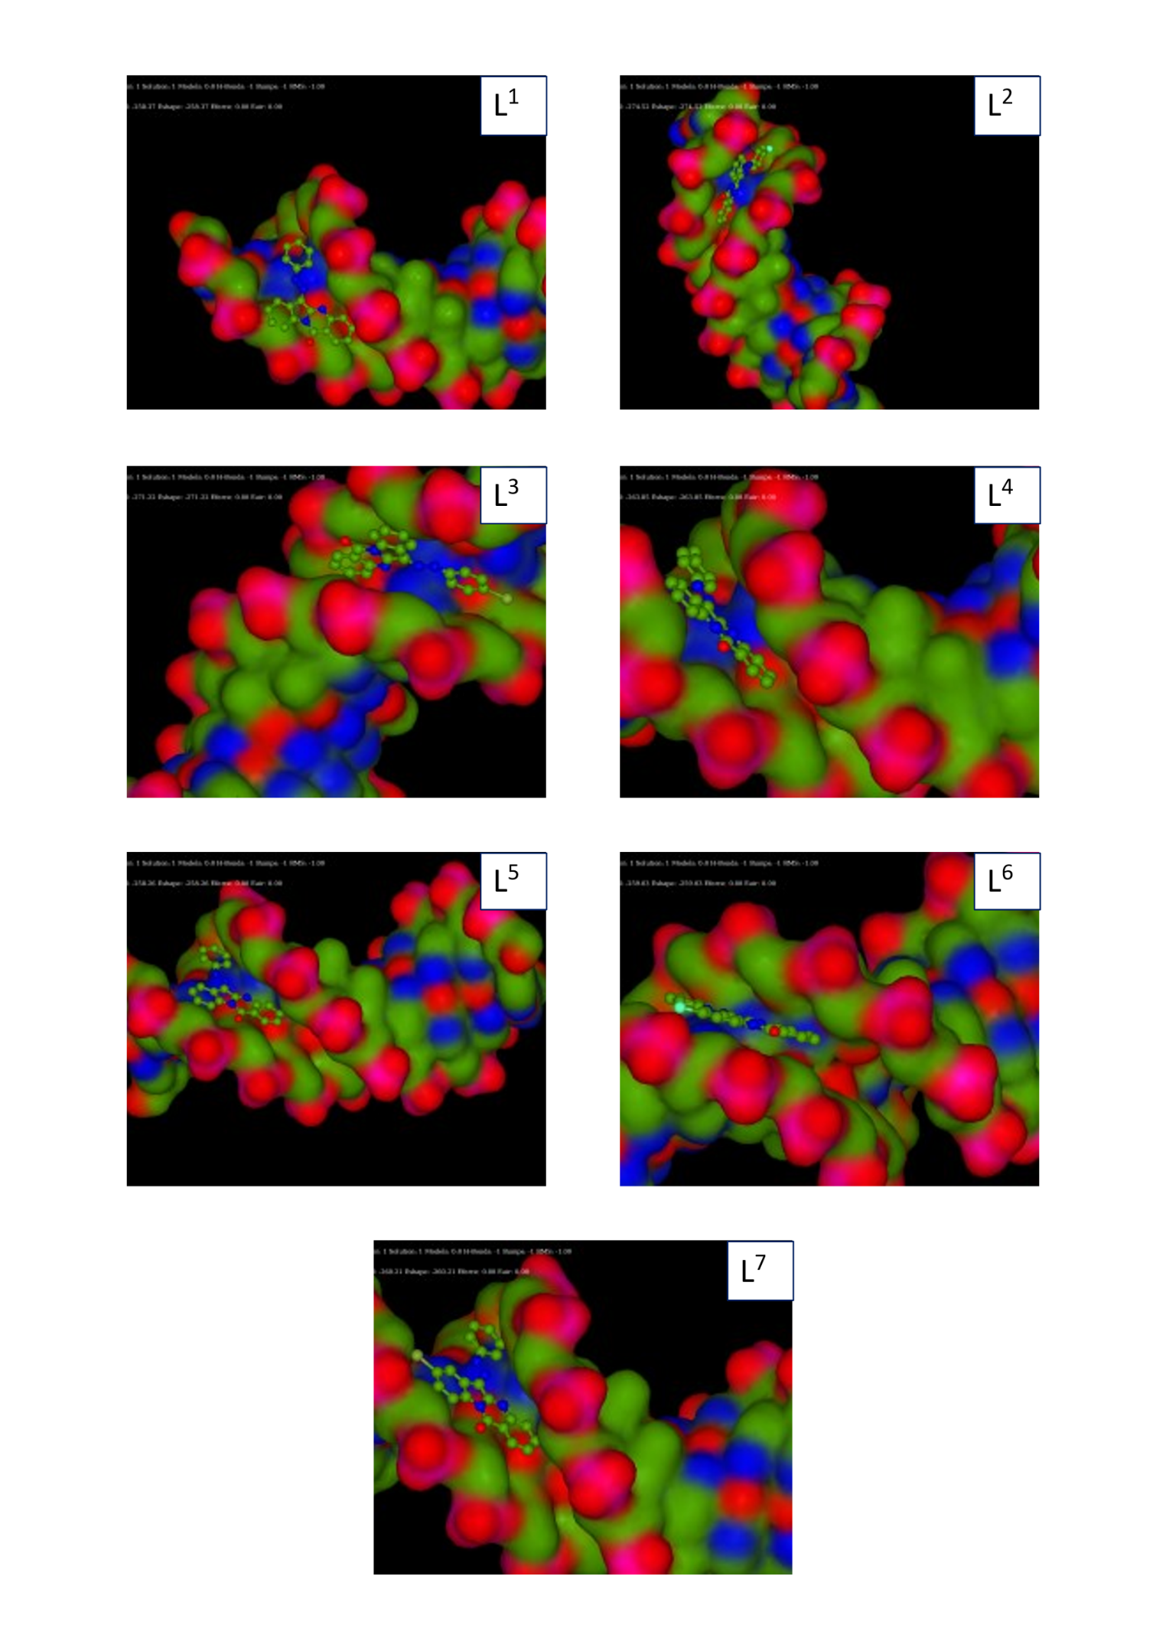
Supplementary data 2: Docking image of the Ligand and complexes

