Supporting Information

Manipulating coordination geometry dependent electron coupling for
high-current-density electrocatalytic water oxidation

Sheng Zhao¹, Feng Hu¹, Lijie Yin¹, Linlin Li¹, Yu-Ming Chang², Han-Yi Chen², and Shengjie Peng¹*

¹College of Materials Science and Technology, Nanjing University of Aeronautics and Astronautics, Nanjing 210016, China.
²Department of Materials Science and Engineering National Tsing Hua University 101, Sec. 2, Kuang-Fu Road, Hsinchu 30013, Taiwan.
*Corresponding author.
Email: pengshengjie@nuaa.edu.cn

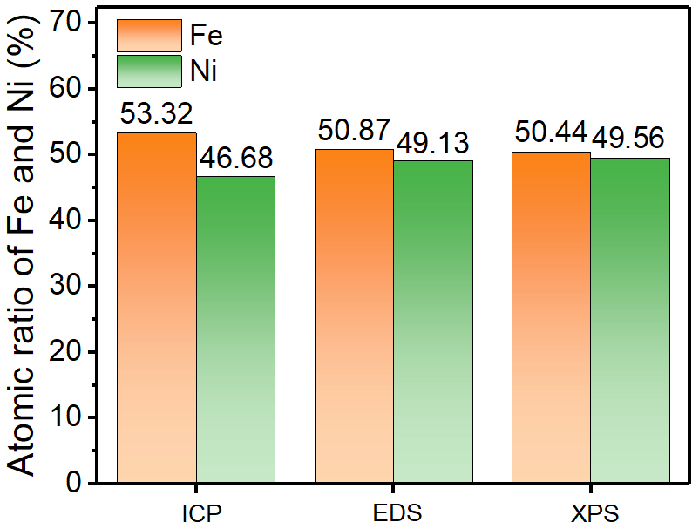
Supplementary Fig. 1 The ratio of Fe and Ni in the sample using 3 mol FeCl₃·6H₂O as the precursor obtained by ICP, EDS, and XPS, respectively. Several methods of content characterization show similar results for the resultant sample.

Supplementary Fig. 2 (a) Low magnified and (b) high magnified SEM images of NiWO₄/NF.

Supplementary Fig. 3 (a) Low magnified and (b) high magnified SEM images of FeWO₄/NF.

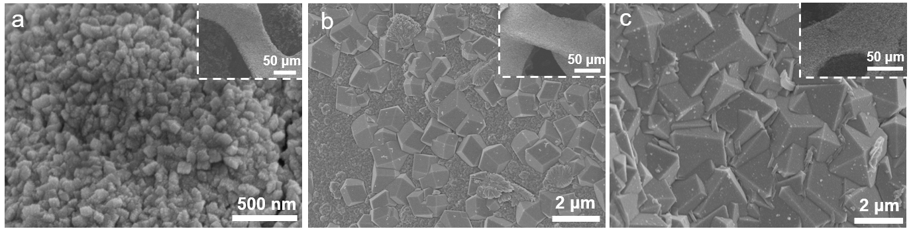
Supplementary Fig. 4 (a-c) SEM images of Fe_{0.67}Ni_{0.33}WO₄/NF, Fe_{0.59}Ni_{0.41}WO₄/NF, and Fe_{0.51}Ni_{0.49}WO₄/NF.

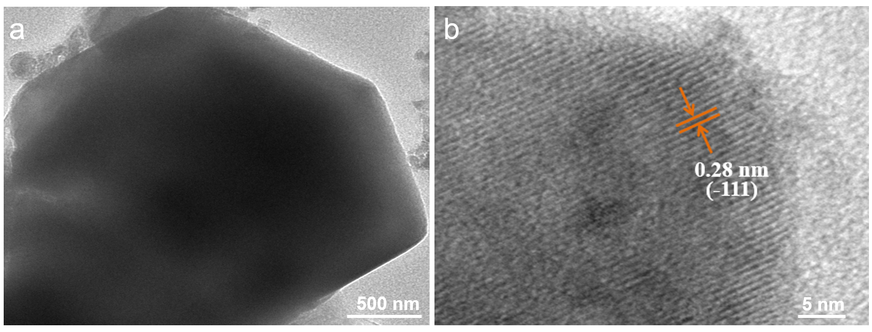
Supplementary Fig. 5 (a) TEM and (b) HRTEM images of Fe_{0.53}Ni_{0.47}WO₄.

Supplementary Fig. 6 (a) XRD patterns of FeWO₄/NF, NiWO₄/NF, and Fe_{0.53}Ni_{0.47}WO₄/NF. (b) The corresponding patterns at the region of 29°−32.5°.
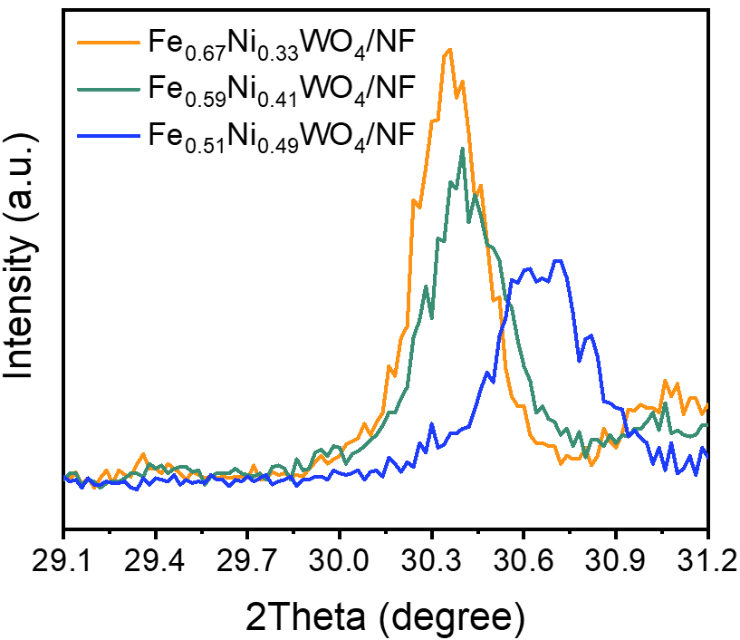
Supplementary Fig. 7 XRD patterns at the region of 29.1°−31.2° of Fe_{0.67}Ni_{0.33}WO₄/NF, Fe_{0.59}Ni_{0.41}WO₄/NF, and Fe_{0.51}Ni_{0.49}WO₄/NF.
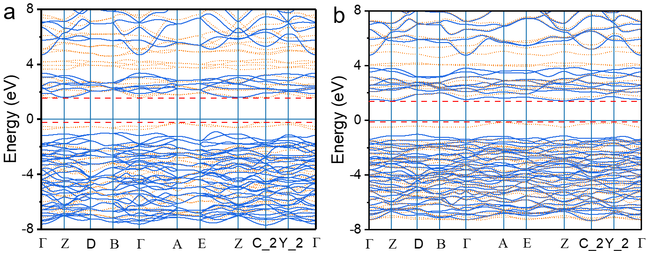
Supplementary Fig. 8 The band structures of (a) FeWO₄ and (b) Fe_{0.53}Ni_{0.47}WO₄. The solid blue line represents the band formed by spintrons up, and the dotted orange line stands for the band formed by spintrons down.
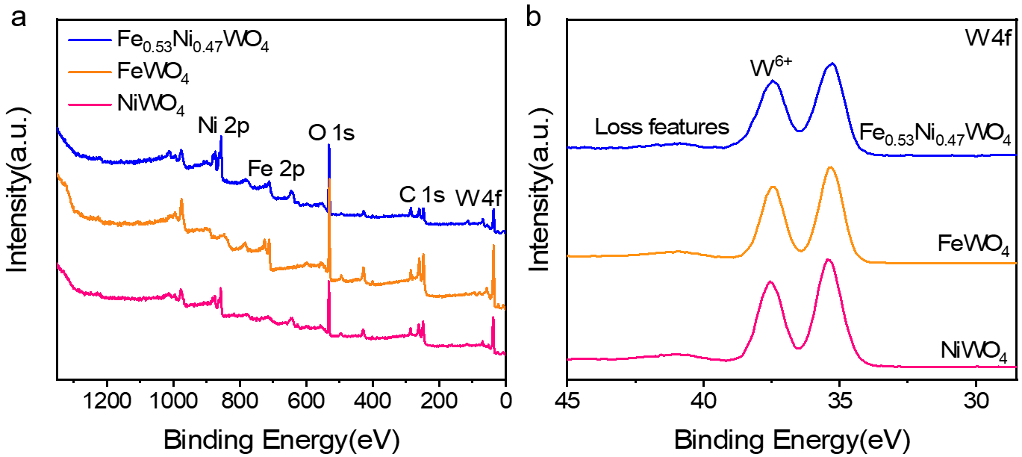
Supplementary Fig. 9 (a) XPS survey spectra of FeWO₄, NiWO₄ and Fe_{0.53}Ni_{0.47}WO₄. (b) The corresponding XPS fine spectra of W 4f. All XPS data were calibrated by the C 1s (28.48 eV). The photoelectron peaks corresponding to Fe, Ni, O, C, W elements can be observed in the XPS survey spectrum of Fe_{0.53}Ni_{0.47}WO₄ prepared using FeCl₃·6H₂O as the precursor. The W 4f region shows the peaks ascribed to W⁶⁺ ¹.

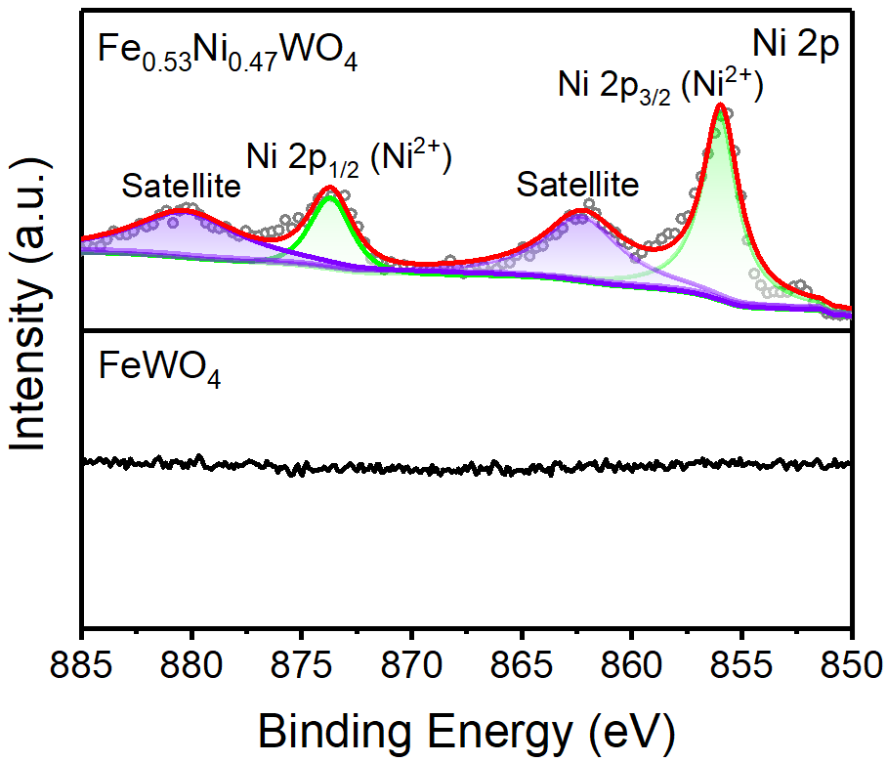
Supplementary Fig. 10 XPS fine spectra of Ni 2p of FeWO₄ and Fe_{0.53}Ni_{0.47}WO₄

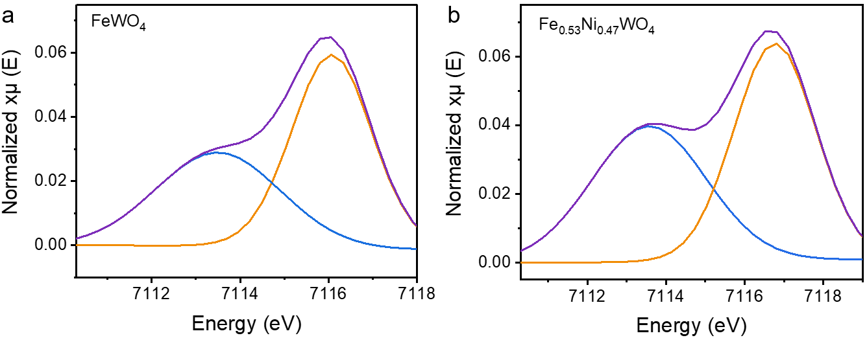
Supplementary Fig. 11 Fe pre-K-edge curves of (a) FeWO₄ and (b) Fe_{0.53}Ni_{0.47}WO₄.

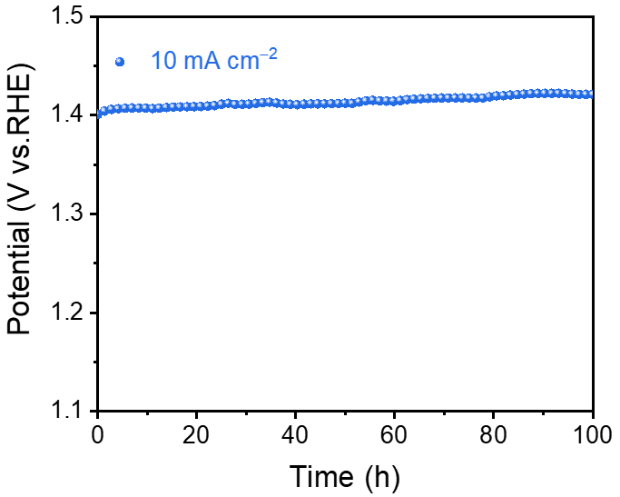
Supplementary Fig. 12 (a) Chronopotentiometry curves of Fe_{0.53}Ni_{0.47}WO₄/NF at 10 mA cm⁻². Potential stabilizes at 1.42 mV (vs. RHE) with less than 2% decay over 100 hours.

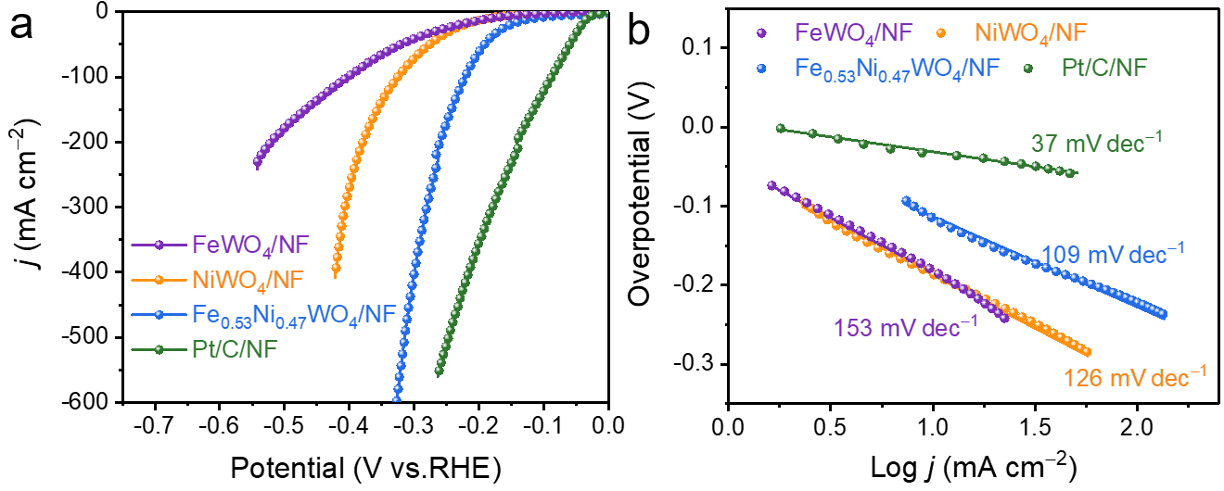
Supplementary Fig. 13 (a) Hydrogen evolution reaction (HER) polarization curves of FeWO₄/NF, NiWO₄/NF, Fe_{0.53}Ni_{0.47}WO₄/NF, and Pt/C/NF. (b) The corresponding Tafel slopes. The FeO₆ octahedral distortion in FeWO₄ caused by Ni substitution also promoted the HER activity. The HER overpotential of Fe_{0.53}Ni_{0.47}WO₄/NF is 66 mV lower than that of FeWO₄/NF, and the Tafel of Fe_{0.53}Ni_{0.47}WO₄/NF is 109 mV dec⁻¹.

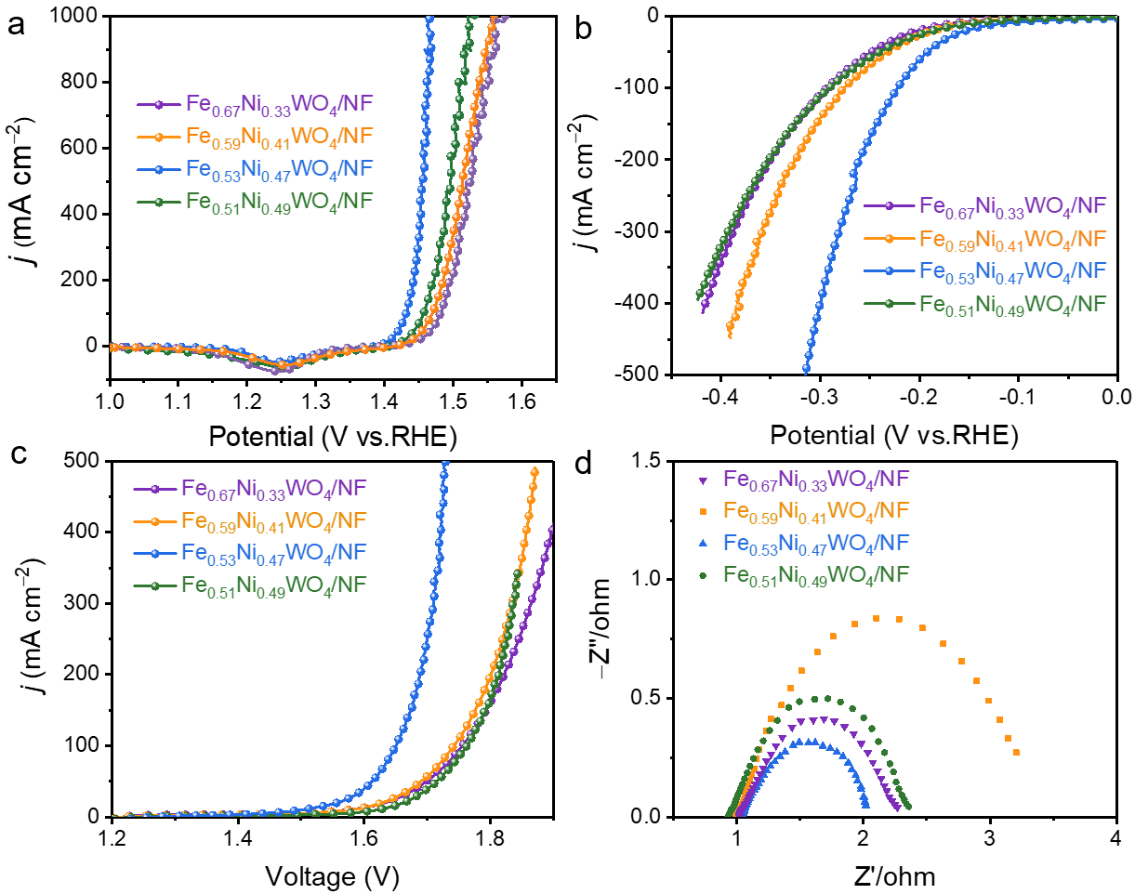
Supplementary Fig. 14 OER (a), HER (b), and water splitting polarization curves (c) of Fe_{0.67}Ni_{0.33}WO₄/NF, Fe_{0.59}Ni_{0.41}WO₄/NF, Fe_{0.53}Ni_{0.47}WO₄/NF, and Fe_{0.51}Ni_{0.49}WO₄/NF. (d) The corresponding EIS Nyquist curves of OER.

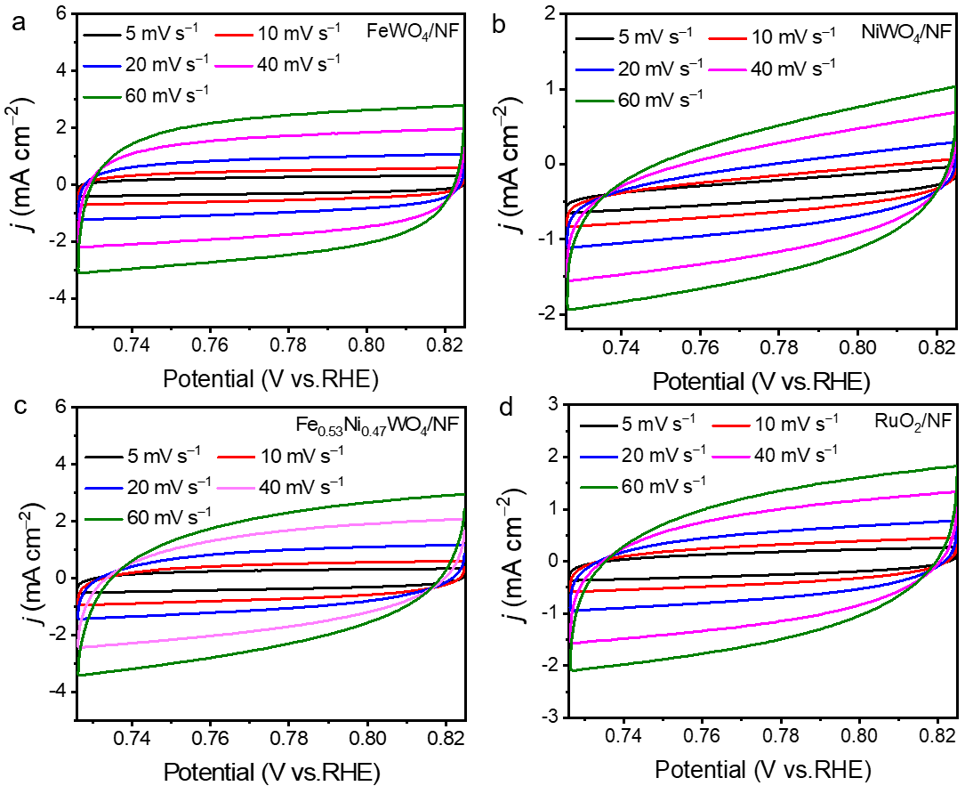
Supplementary Fig. 15 Cyclic voltammograms of (a) FeWO₄/NF, (b) NiWO₄/NF , (c) Fe_{0.53}Ni_{0.47}WO₄/NF, and (d) RuO₂/C/NF at various scan rates (5, 10, 20, 40, 60, and 120 mV s⁻¹) in the potential range of 0.726-0.825 V vs. RHE, which were used to estimate double-layer capacitance (C_{dl}).

3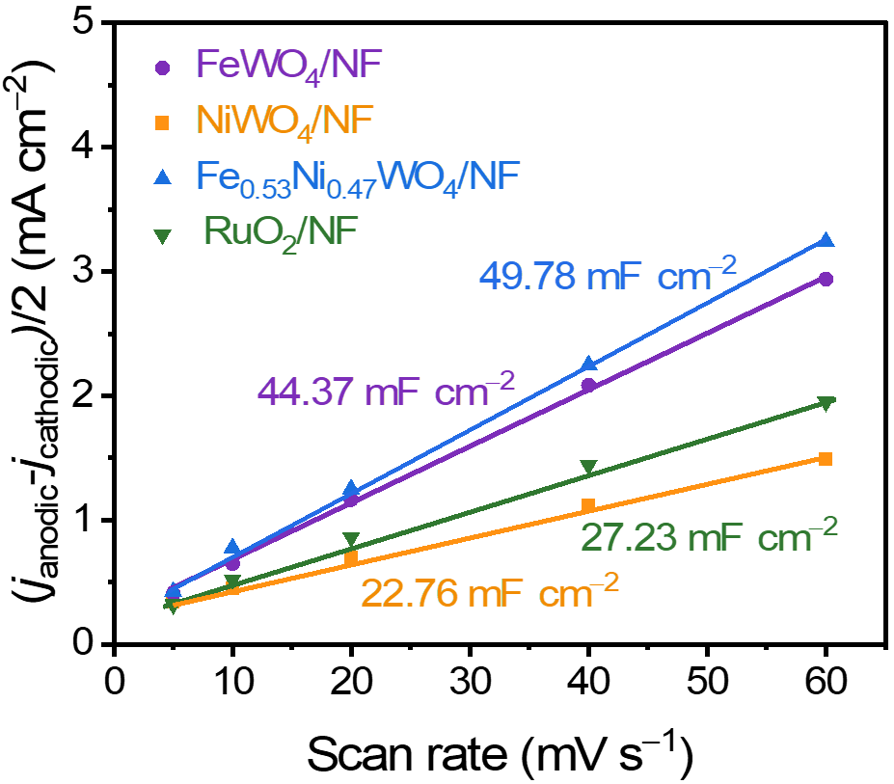
Supplementary Fig. 16 Linear fitting of the current density versus scan rates of FeWO₄/NF, NiWO₄/NF, Fe_{0.53}Ni_{0.47}WO₄/NF, RuO₂/NF and corresponding C_{dl}. Ni substitution slightly increases the apparent active site number of the tungstate.

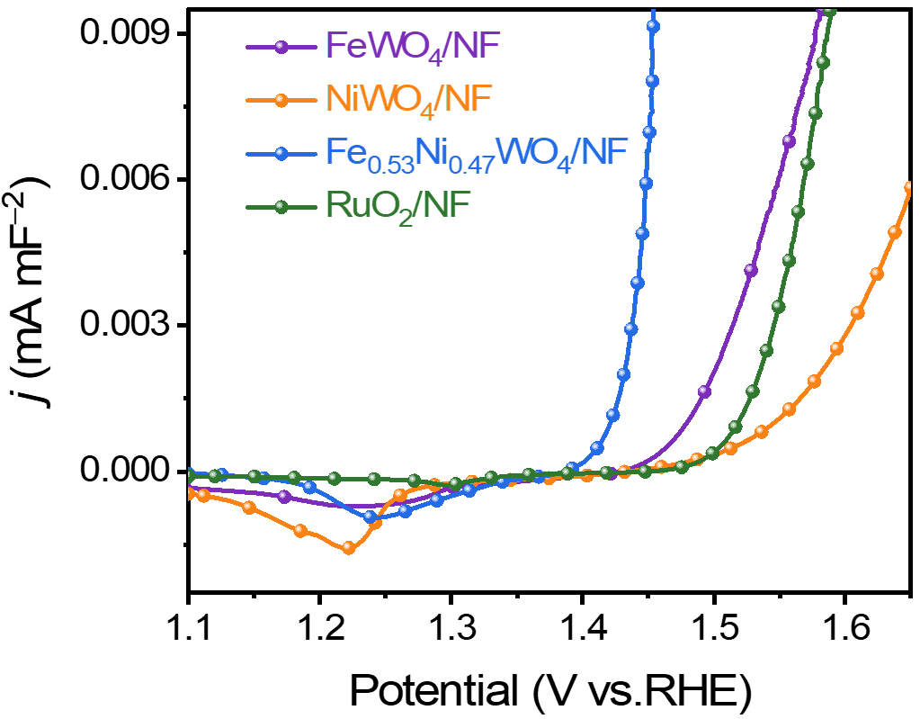
Supplementary Fig. 17 C_{dl} normalized polarization curves of FeWO₄/NF, NiWO₄/NF, Fe_{0.53}Ni_{0.47}WO₄/NF, and RuO₂/NF.

Supplementary Fig. 18 (a) Water splitting polarization curves of FeWO₄/NF ‖ FeWO₄/NF, NiWO₄/NF ‖ NiWO₄/NF, Fe_{0.53}Ni_{0.47}WO₄/NF ‖ Fe_{0.53}Ni_{0.47}WO₄/NF and Pt/C/NF ‖ RuO₂/NF. (b) Chronopotentiometry curves of Fe_{0.53}Ni_{0.47}WO₄/NF ‖ Fe_{0.53}Ni_{0.47}WO₄/NF at 10 mA cm⁻².

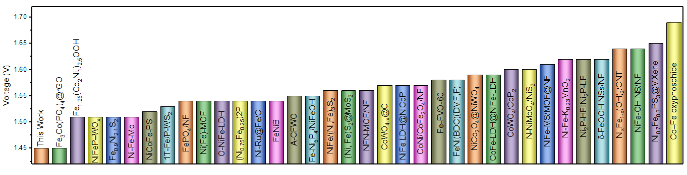
Supplementary Fig. 19 Performance comparison of water splitting of Fe_{0.53}Ni_{0.47}WO₄/NF ‖ pt/C/NF with other works.

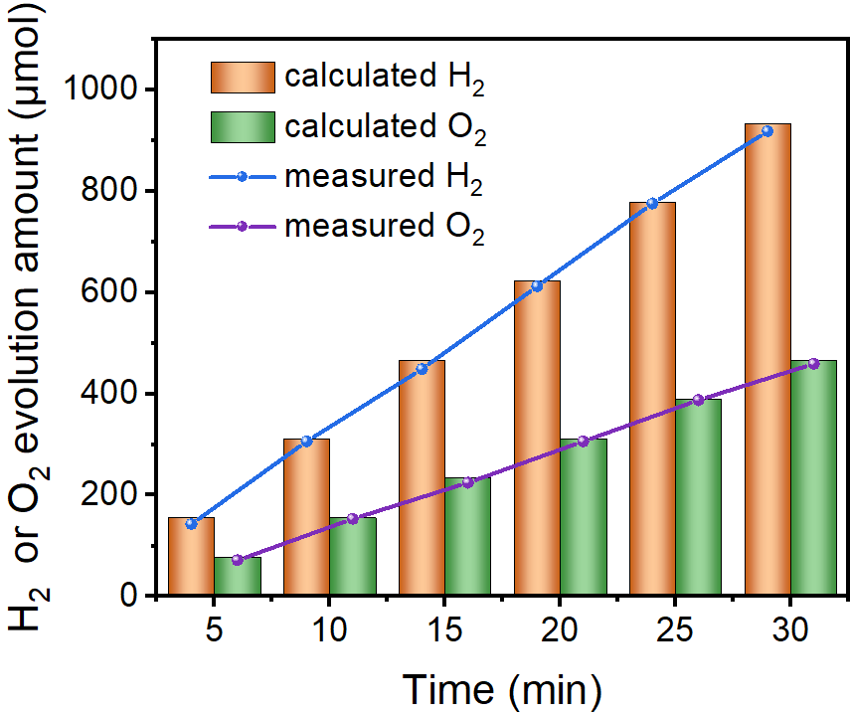
Supplementary Fig. 20 Faraday efficiency of Fe_{0.53}Ni_{0.47}WO₄/NF ‖ Pt/C/NF.

Supplementary Fig. 21 (a) Raman spectra of Fe_{0.53}Ni_{0.47}WO₄/NF before and after OER, (b) XRD patterns of Fe_{0.53}Ni_{0.47}WO₄/NF before and after OER. The peak located at about 887 cm⁻¹, assigning to symmetric stretching vibrations of terminal W=O bonds².

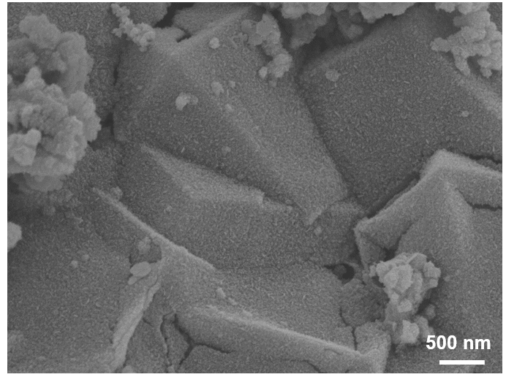
Supplementary Fig. 22 SEM image of Fe_{0.53}Ni_{0.47}WO₄/NF after OER.

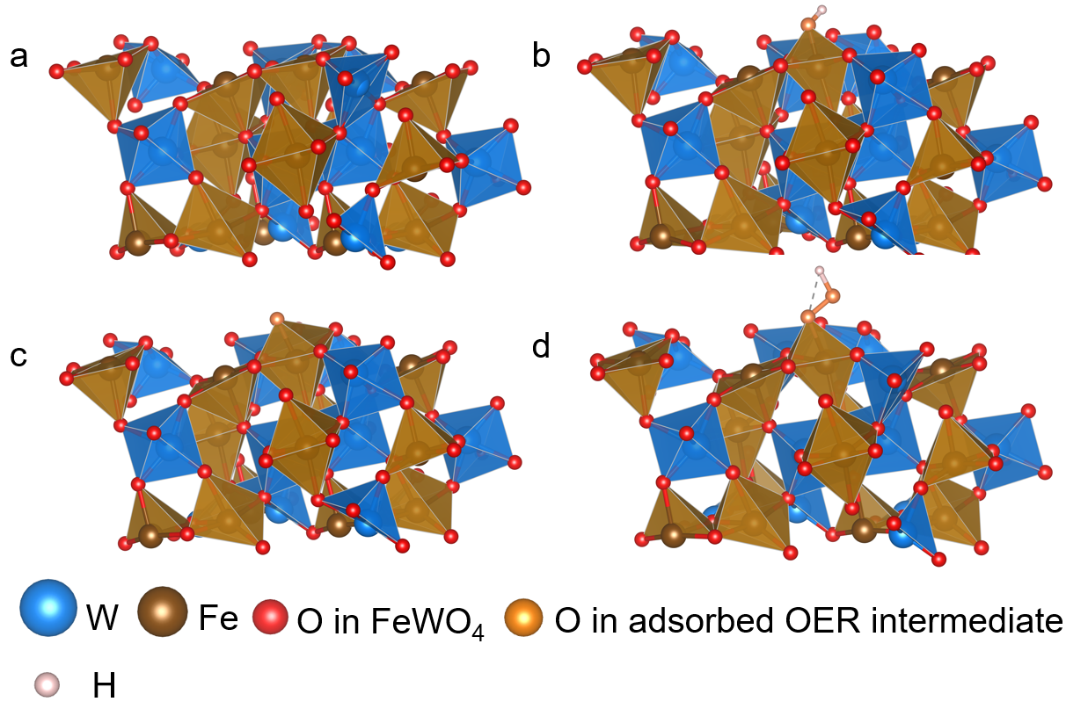
Supplementary Fig. 23 (a) Relaxation structure of FeWO₄. (b-d) Chemisorption models of *OH, *O, and *OOH on Fe site of the FeWO₄.

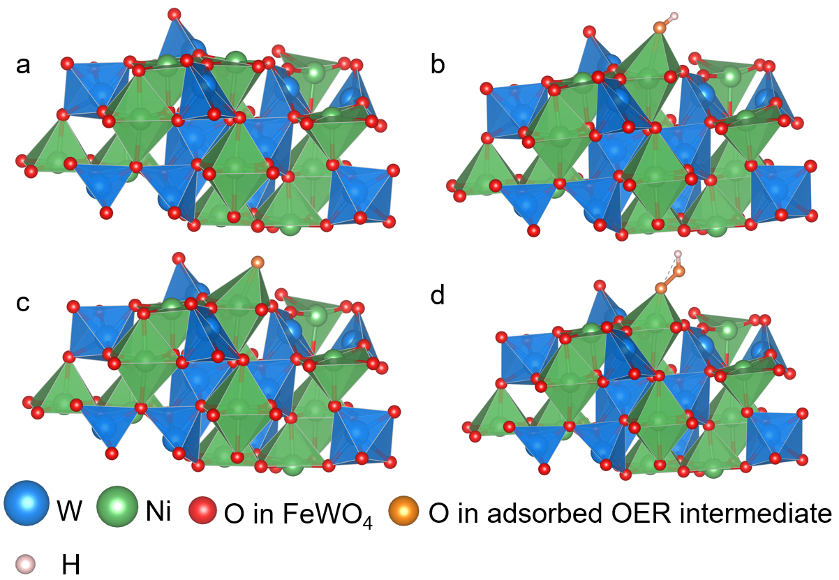
Supplementary Fig. 24 (a) Relaxation structure of NiWO₄. (b-d) Chemisorption models of *OH, *O, and *OOH on Ni site of the NiWO₄.

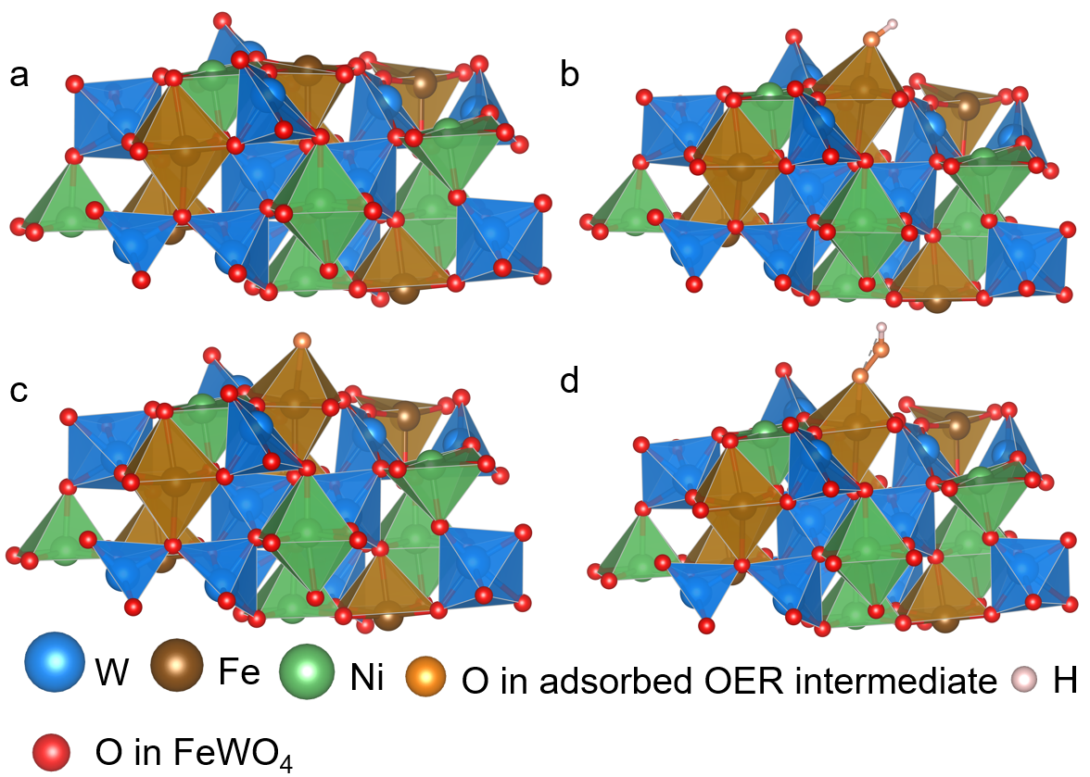
Supplementary Fig. 25 (a) Relaxation structure of Fe_{0.53}Ni_{0.47}WO₄. (b-d) Chemisorption models of *OH, *O, and *OOH on Fe site of the Fe_{0.53}Ni_{0.47}WO₄.

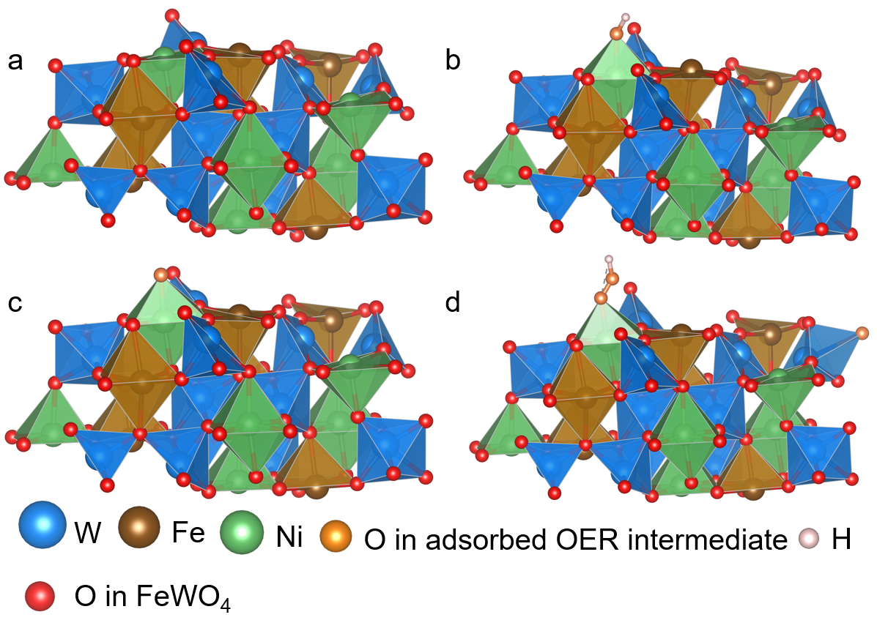
Supplementary Fig. 26 (a) Relaxation structure of Fe_{0.53}Ni_{0.47}WO₄. (b-d) Chemisorption models of *OH, *O, and *OOH on Ni site of the Fe_{0.53}Ni_{0.47}WO₄.

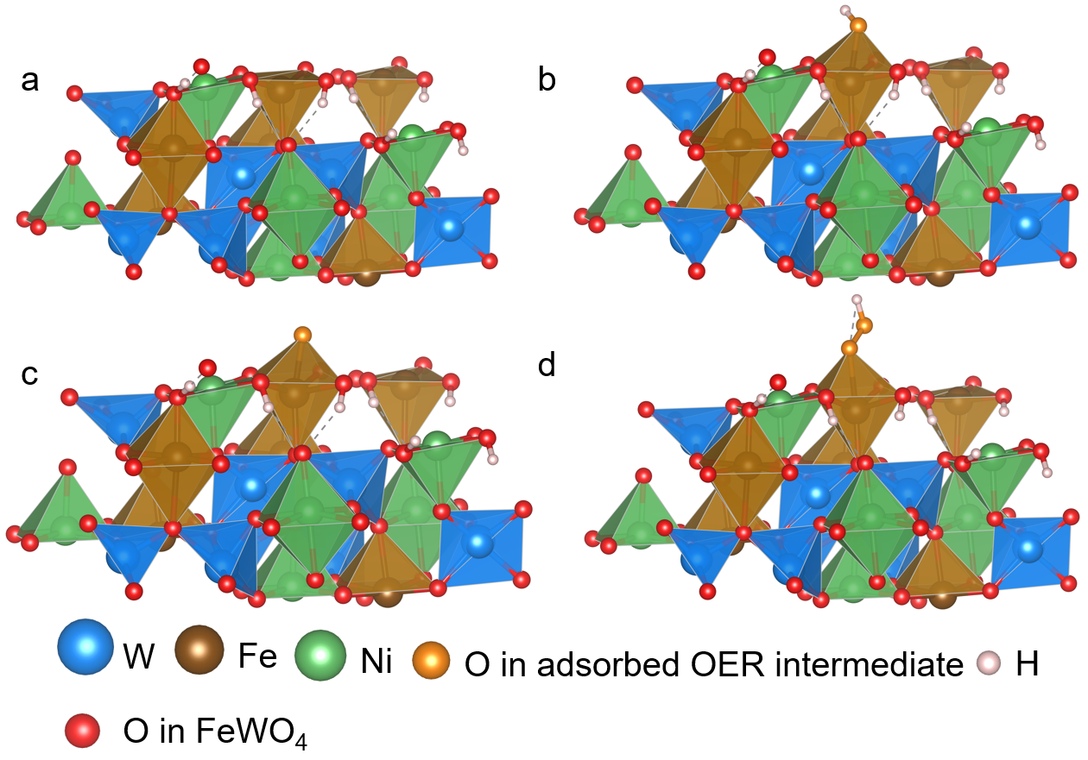
Supplementary Fig. 27 (a) Relaxation structure of surface hydroxylated Fe_{0.53}Ni_{0.47}WO₄. (b-d) Chemisorption models of *OH, *O, and *OOH on Fe site of the surface hydroxylated Fe_{0.53}Ni_{0.47}WO₄.

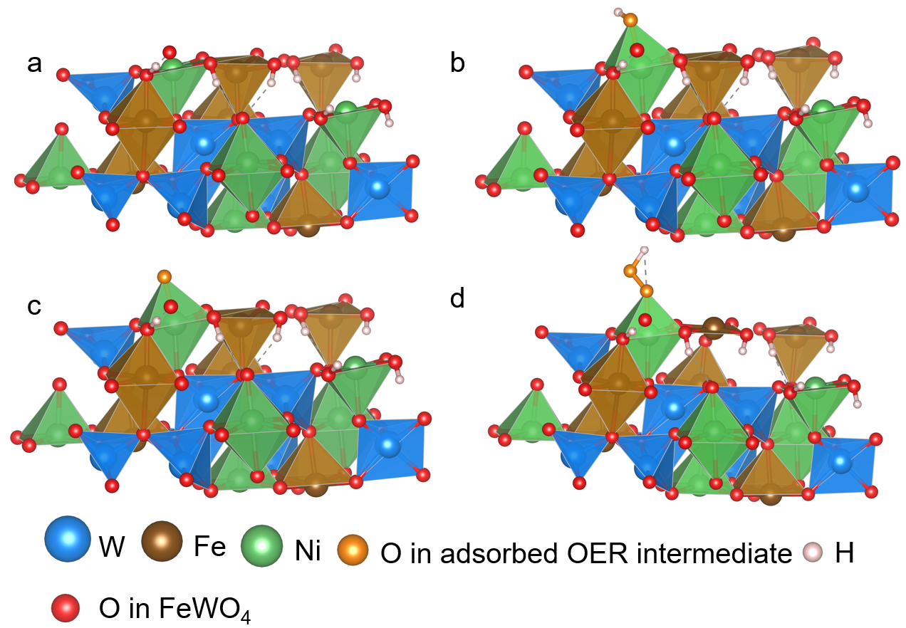
Supplementary Fig. 28 (a) Relaxation structure of surface hydroxylated Fe_{0.53}Ni_{0.47}WO₄. (b-d) Chemisorption models of *OH, *O, and *OOH on Ni site of the surface hydroxylated Fe_{0.53}Ni_{0.47}WO₄.

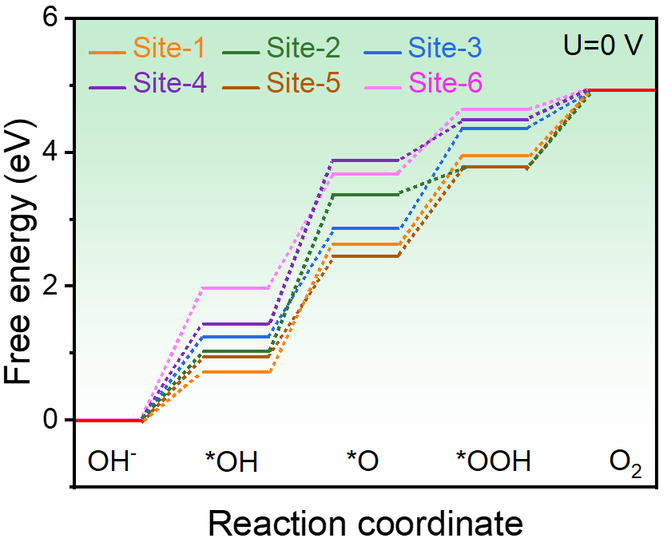
Supplementary Fig. 29 Free Energy profiles of different OER intermediates at 0 V (Site-1~Site-6 represent Fe sites in FeWO₄, Ni sites in NiWO₄, Fe sites in Fe_{0.53}Ni_{0.47}WO₄, Ni sites in Fe_{0.53}Ni_{0.47}WO₄, Fe sites in FeOOH, Ni sites in NiOOH, respectively).

Williamson-Hall plot：
$$\frac{\text{βcosθ}}{\text{λ}}\text{ = }\frac{\text{1}}{\text{S}}\text{ + 4ε}\frac{\text{sinθ}}{\text{λ}}$$
Where β is the full width at half maxima, λ is the wavelength of x-ray, D is crystallite size, and ε is the lattice strain.

Table S1. The atomic ratio of Fe and Ni in Fe_{x}Ni_{1-x}WO₄ obtained by ICP-OES.
Dosage of precursor | Fe | Ni
1 mmol | 0.67 | 0.33
2 mmol | 0.59 | 0.41
3 mmol | 0.53 | 0.47
4 mmol | 0.51 | 0.49

Table S2. Parameters of XRD refinement by Rietveld method.
 | FeWO₄ | Fe_{0.53}Ni_{0.47}WO₄
a (Å) | 4.722 | 4.720
b (Å) | 5.703 | 5.718
c (Å) | 4.966 | 4.979
α (°) | 90.000 | 90.000
β (°) | 89.991 | 90.070
γ (°) | 90.000 | 90.000
Unit-cell volume (Å³) | 133.728 | 134.348
Rwp (%) | 3.540 | 3.440
χ² | 3.110 | 3.460

Table S3. Fe–O bond length and distortion change of FeO₆ octahedral in FeWO₄ and Fe_{0.53}Ni_{0.47}WO₄.
 | FeWO₄ | Fe_{0.53}Ni_{0.47}WO₄
Fe–O (B₁) (Å) | 2.144 | 2.157
Fe–O (B₂) (Å) | 2.154 | 2.204
Fe–O (B₃) (Å) | 2.076 | 2.041
Average (B_{a}) (Å) | 2.125 | 2.134
Distortion Degree | 0.032 | 0.062

Table S4. Performance comparison of this work and recently reported non-noble metal materials for electrocatalytic OER in the alkaline environment.
Catalyst | η₁₀ (mV) | η₁₀₀ (mV) | η₅₀₀ (mV) | η₁₀₀₀ (mV) | Tafel  (mV dec⁻¹) | Reference
Fe_{0.53}Ni_{0.47}WO₄ | 170 | 203 | 223 | 240 | 35 | This work
Ni_{0.8}Fe_{0.2}-AHNA | 210 | 235 | 248 | 258 | 34.7 | Energy Environ. Sci. 2020, 13, 86–95.
Ni₈₃Fe₁₇-ONCAs | 190 | 225 | 255 | 265 | 48 | Adv. Mater. 2021, 33, 2007377.
(Ni,Fe)OOH | 175 | 210 | 259 | 289 | 41.5 | Energy Environ. Sci, 2018, 11, 2858-2864.
SSW-12 h | 220 | 257 | 260 | / | 39 | Adv. Energy Mater. 2020, 10, 1904020.
Co₃O₄/Fe_{0.33}Co_{0.66}P | 185 | 230 | 275 | / | 59.8 | Adv. Mater. 2018, 30, 1803551.
FeP/Ni₂P | 190 | 230 | 290 | 300 | 22.7 | Nat. Commun. 2018, 9, 2551.
NiCe@NiFe | 220 | 254 | 290 | 315 | 59.9 | Appl. Catal. B-Environ. 2020, 260, 118199.
NiFe LDH/NiS | 220 | 386 | 290 | 325 | 60.1 | Adv. Energy Mater. 2021, 2102353.
NiFeMo IOS@NF | 198 | 220 | 293 | / | 36 | Appl. Catal. B-Environ. 2020, 267, 118376.
MFN-MOFs(2:1)/NF | 235 | 240 | 294 | / | 55.4 | Nano Energy 2019, 57, 1–13.
Ni₃N@2M-MoS₂ | 170 | 215 | 300 | 330 | 38.9 | Adv. Mater. 2022, 34, 2108505.
NiFe LDH/MXene/NF | 240 | 270 | 300 | / | 44 | Nano Energy 2019, 63, 103880.
Ni–Fe NP | 200 | 280 | 320 | / | 58 | Nat. Commun. 2019, 10, 5599.
DMsA | 205 | 250 | 330 | / | 34 | Energy Environ. Sci. 2020, 13, 2200–2208.
Co₄N-CeO₂ | 239 | 290 | 350 | / | 37.1 | Adv. Funct. Mater. 2020, 30, 1910596.
(NiCo)₃Se₄ | 270 | 320 | 360 | 329 | 42 | Adv. Mater. 2021, 33, 2103812.
NFN-MOF/NF | 240 | 290 | 360 | / | 58.8 | Adv. Energy Mater. 2018, 8, 1801065.
NiMoO_{x}/NiMoS | 186 | 220 | 370 | 430 | 34 | Nat. Commun. 2020, 11, 5462.
Ni–P–B/paper | 240 | 280 | 375 | 375 | 70.6 | Energy Environ. Sci, 2020, 13, 102-110.
NiVIr-LDH | 210 | 260 | 375 | / | 38 | Nat. Commun. 2019, 10, 3899.
(CrFeCoNi)₉₇O₃ O-HEA | 196 | 300 | 400 | / | 29 | Adv. Mater. 2021, 33, 2101845.
Ni–Mo–B HF | 293 | 290 | 407 | 460 | 79 | Adv. Funct. Mater. 2021, 2107308.
Ni_{0.9}Co_{0.1}(OH)₂ | 250 | 320 | 424 | / | / | Nat. Energy 2019, 4, 786–795
NiFe LDH | 200 | 260 | / | / | 24 | Adv. Mater. 2019, 31, 1903909.
LSC&MoSe₂ | 370 | 480 | / | / | 77 | Nat. Commun. 2019, 10, 1723.
LSC/K-MoSe₂ | 280 | 375 | / | / | 79 | Nat. Commun. 2021, 12, 4606.
Fe₃Co(PO₄)₄@rGO | 220 | 250 | / | / | 57 | Nat. Commun. 2019, 10, 5195.
NiS_{0.5}Se_{0.5} | 257 | 320 | / | / | 61 | Adv. Mater. 2020, 32, 2000231.
w-Ni(OH)2 | 237 | 280 | / | / | 33 | Nat. Commun. 2019, 10, 2149.
FeP-CoP/NC | 230 | 390 | / | / | 73 | Nat. Commun. 2021, 12, 4143.
NiCoFe-NDA/NF | 215 | 270 | / | / | 50.7 | Energy Environ. Sci. 2021, 14, 6546–6553.
Fe-Co₃O₄ | 262 | 305 | / | / | 43 | Adv. Mater. 2020, 32, 2002235.
S|NiNx-PC/EG | 280 | 330 | / | / | 45 | Nat. Commun. 2019, 10 1392.
FeCoNi-HNTAs | 184 | 350 | / | / | 49.9 | Nat. Commun. 2018, 9, 2452.
CoCu-MOF NBs | 260 | 320 | / | / | 63.5 | Angew. Chem. Int. Edit. 2021, 60, 26397–26402.
MOF-Fe/Co | 220 | 300 | / | / | 52 | Angew. Chem. Int. Edit. 2021, 60, 12097–12102.
NiCo_{2x}Fe_{x}O₄ NBs | 274 | 308 | / | / | 42 | Angew. Chem. Int. Edit. 2021, 60, 11841–11846.
NiFc-MOF/NF | 195 | 241 | / | / | 44.1 | Angew. Chem. Int. Edit. 2021, 60, 12770–12774.
Ni(CN)₂/NiSe₂ | 250 | 470 | / | / | 68 | Angew. Chem. Int. Edit. 2021, 60, 23444.
NiCo₂S₄/ZnS | 140 | 210 | / | / | 47 | Angew. Chem. Int. Edit. 2021, 60, 19435.
NiFe-Boride | 167 | 230 | / | / | 25 | Nat. Commun. 2021, 12, 6089.
γ-FeOOH/NF-X | 280 | 310 | / | / | 52 | Adv. Mater. 2021, 33, 2005587.
cMOF/LDH-48 | 195 | 227 | / | / | 34.1 | Adv. Mater. 2021, 33, 2006351.
W-NiS_{0.5}Se_{0.5} | 171 | 239 | / | / | 41 | Adv. Mater. 2022, 2107053.
CoCuFeMoOOH@Cu | 199 | 250 | / | / | 48.8 | Adv. Mater. 2021, 33, 2100745.
CoNiFeCu | 291 | 345 | / | / | 43.9 | Adv. Mater. 2022, 2109108.
NiFeV nanofibers | 181 | 395 | / | / | 62 | Angew. Chem. Int. Edit. 2022, 134, 202115331.
LiCoO_{1.8}Cl_{0.2} | 240 | 278 | / | / | / | Nat. Catal. 2021, 4, 212–222
HG-NiFe | 310 | 350 | / | / | 39 | Sci. Adv. 2018, 4, 7970
CaCoO₃ | 260 | 350 | / | / | 38 | Sci. Adv. 2019, 5, 6262
Co₃Sn₂S₂ | 299 | 370 | / | / | 74 | Sci. Adv. 2019, 5, 9867
Co-TiO₂ | 332 | 396 | / | / | / | Nat. Catal. 2021, 4, 36–45
Br-Ni-MOF(A) | 306 | 480 | / | / | 79.1 | Sci. Adv. 2021, 7, 0919
LBSCOF | 423 | 518 | / | / | 115 | Chem. 2018, 4, 2902–2916
Fe-O₂ cat | 238 | 537 | / | / | 82.7 | Chem. 2018, 4, 1139–1152
Zn_{0.2}Co_{0.8}OOH | 235 | / | / | / | 34.7 | Nat. Energy 2019, 4, 329–338
References
1. F. He, S. Weon, W. Jeon, M. W. Chung, W. Choi, Self-wetting triphase photocatalysis for effective and selective removal of hydrophilic volatile organic compounds in air. Nat. Commun. 12, 6259 (2021).
2. W. Shao, Y. Xia, X. Luo, L. Bai, J. Zhang, G. Sun, C. Xie, X. Zhang, W. Yan, Y. Xie, Structurally distorted wolframite-type Co_{x}Fe_{1-x}WO₄ solid solution for enhanced oxygen evolution reaction. Nano Energy 50, 717−722 (2018).

