SUPPLEMENTARY MATERIAL

Supplementary Table 1. Risk of bias assessment based on ROBINS-I¹⁶
Study，publication year | Bias due to confounding | Bias in selection of  participants | Bias in  measure  ments of  interventions | Bias due to  departures from  intended  interventions | Bias due to  missing  data | Bias in  measure  ments of  outcomes | Bias in  selection of  reported  result | Overall bias
Peng J,2015¹⁹ | N | N | N | N | N | PN | N | Low
Buti M,2015²⁰ | Y | PY | N | N | N | N | N | Serious
Fontaine H,2015²¹ | Y | PY | N | N | N | N | N | Serious
Chen L,2015²² | N | N | N | N | PN | N | N | Low
Hsu YC,2016²³ | N | PN | N | N | N | N | N | Low
Park CH,2016²⁴ | PY | PY | N | N | N | PY | PY | Serious
Jun BG,2016²⁵ | N | PN | PN | PN | N | N | N | Moderate
Lin CC,2016²⁶ | N | N | N | N | PN | PY | PY | Serious
Nagata N,2016²⁷ | N | N | N | PN | N | PY | PN | Serious
Lee HA,2016²⁸ | N | N | PN | N | PN | N | N | Moderate
Siederdissen CH,2016²⁹ | PN | PN | N | N | N | N | PN | Moderate
Siederdissen CH,2016³⁰ | PY | PN | N | N | N | N | PY | Serious
Muche M,2017³¹ | PN | PY | N | N | N | N | PN | Serious
Karakaya F,2017³² | N | N | PN | N | N | N | N | Low
Cao JW,2017³³ | N | N | PN | N | PN | N | N | Moderate
Berg T,2017³⁴ | N | N | PN | PN | N | N | N | Moderate
Jeng WJ,2018³⁵ | PY | N | N | PN | N | N | PN | Serious
Dalekos GN,2018³⁶ | N | N | PN | PN | PN | N | N | Moderate
Papatheodoridis GV,2018³⁷ | N | N | PY | PN | N | N | N | Serious
Rivino L,2018³⁸ | PN | N | PY | PN | PN | N | N | Serious
Chi H,2018³⁹ | PN | N | PN | N | N | PN | N | Moderate
Liu F,2018⁴⁰ | N | PN | N | PN | N | N | N | Moderate
Hsu YC,2018⁴¹ | N | N | PY | PY | N | N | PN | Serious
Kranidioti H,2019⁴² | PY | PY | PN | N | PN | N | N | Serious
Hees SV,2019⁴³ | PY | PN | PN | PN | N | PY | N | Serious
Xie LQ,2019⁴⁴ | PN | N | N | PN | N | PN | N | Moderate
N: no, PN: probably no, PY: probably yes, Y: yes.

SUPPLEMENTARY FIGURE LEGENDS
Supplementary Figure 1. Flow chart of study search and selection
Supplementary Figure 2. Forest plots of overall probabilities of biochemical relapse (BR) after NAs cessation. A: All patients, B: HBeAg-positive patients, C: HBeAg-negative patients. ES means effect size, which refers to estimated probability.
Supplementary Figure 3. The rates of off-NAs biological relapse (BR) during follow-up after NAs cessation. A: All patients, B: HBeAg-positive patients, C: HBeAg-negative patients. Bars are 95% CI. Green lines are trend lines.
Supplementary Figure 4. Publication bias was assessed by Begg’s funnel plots and used Egger’s regression asymmetry test. No evidence of publication bias was found (P > 0.05).

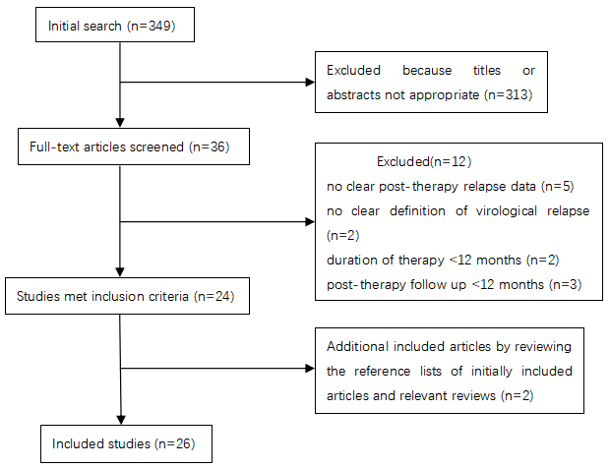
Supplementary Figure 1. Flow chart of study search and selection

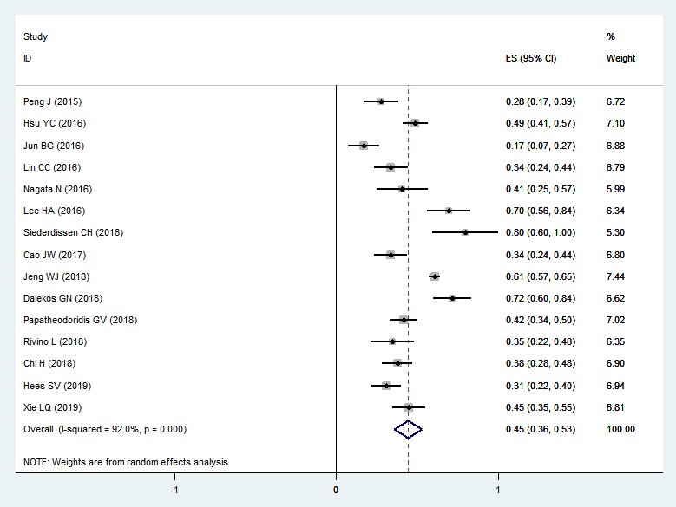
All patients

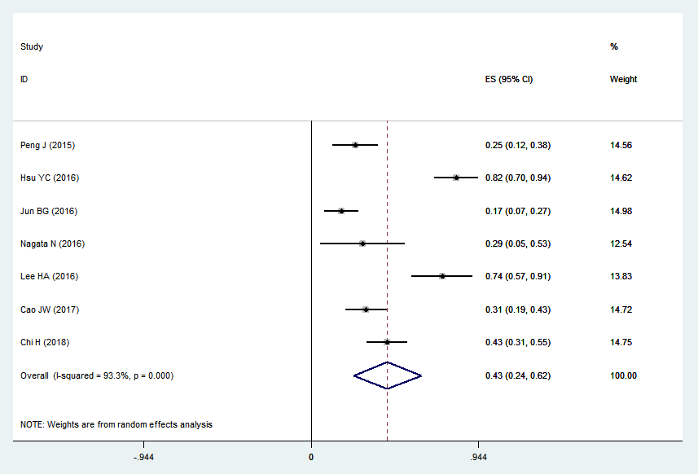
HBeAg-positive patients

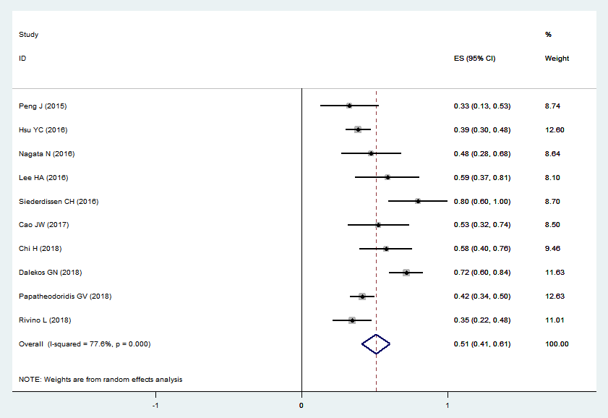
HBeAg-negative patients
Supplementary Figure 2. Forest plots of overall probabilities of biochemical relapse (BR) after NAs cessation. A: All patients, B: HBeAg-positive patients, C: HBeAg-negative patients. ES means effect size, which refers to estimated probability.

Supplementary Figure 3. The rates of off-NAs biological relapse (BR) during follow-up after NAs cessation. A: All patients, B: HBeAg-positive patients, C: HBeAg-negative patients. Bars are 95% CI. Gray lines are trend lines.

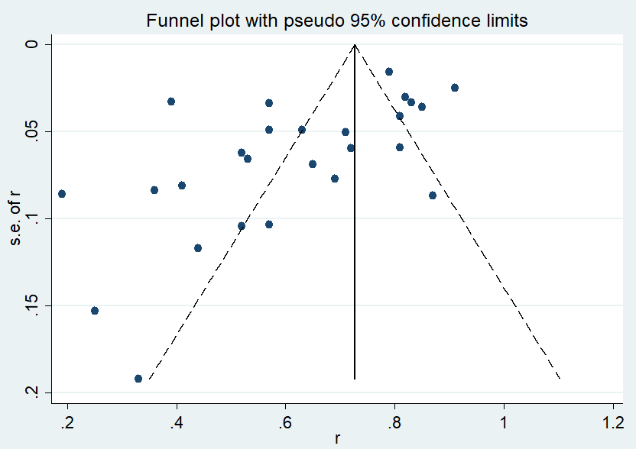
Supplementary Figure 4. Publication bias was assessed by Begg’s funnel plots and used Egger’s regression asymmetry test. No evidence of publication bias was found (P > 0.05).

