Supplementary information to:
Silicon as limiting factor for phosphorus availability in paddy soils
Jörg Schaller ^{1, *}, Bei Wu ², Wulf Amelung ³, Zhengyi Hu ⁴, Eva Lehndorff ⁵, and Martin Obst ⁶

¹ Leibniz Centre for Agricultural Landscape Research (ZALF), Silicon biogeochemistry group, 15374 Müncheberg, Germany
² Institute of Bio- and Geosciences, IBG-3: Agrosphere, Forschungszentrum Jülich GmbH, 52428 Jülich, Germany
³ Institute of Crop Science and Resource Conservation (INRES), Soil Science and Soil Ecology, University of Bonn, Nussallee 13, 53115 Bonn, Germany
⁴ Sino-Danish Center for Education and Research, Sino-Danish College, Resource and Environmental College, University of Chinese Academy of Sciences, Beijing 100049, China.
⁵ Soil Ecology, University of Bayreuth, Dr.-Hans-Frisch-Str. 1-3, Bayreuth 95448, Germany
⁶ Experimental Biogeochemistry, BayCEER, University of Bayreuth, Dr.-Hans-Frisch-Str. 1-3, 95448 Bayreuth, Germany

The supporting information contains two figures (Figs. S1 and S2).

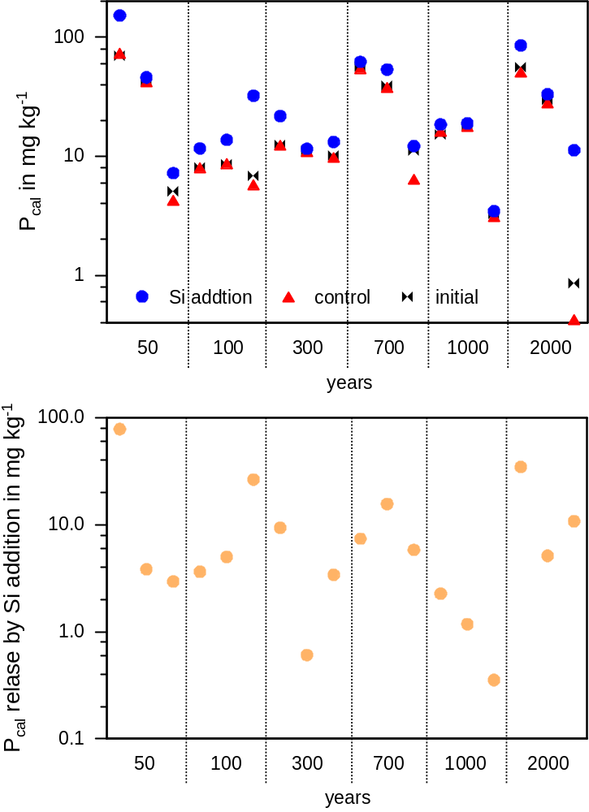
Figure S1 Calcium acetate lactate extractable P (P_{cal}) prior (initial) and after the incubation experiment of the different soil with and without Si addition for two days (upper) for soils with different years under paddy managements and different depth (three samples for each paddy age from right to left each: ~5.7 cm, ~14 cm, and ~21 cm) and the differences between Si-treated and non-treated soil for P_{cal} (lower), shown on a logarithmic scale.
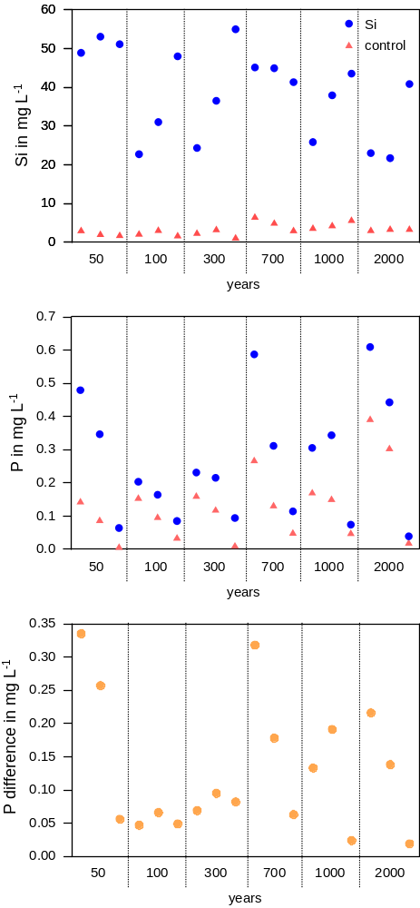
Figure S2 Soluble Si (upper), P (middle) for control and Si addition treatment as well as the differences in P mobilization between Si addition and control treatment (lower) for soils with different years under paddy managements and different depth (three samples for each paddy age from right to left each: ~5.7 cm, ~14 cm, and ~21 cm).

