SUPPLEMENT

Title: Gut microbiota composition can reflect immune responses and identify latent tuberculosis infection in patients with poorly controlled diabetes: A prospective cohort study

Authors: Hung-Ling Huang,^{1,2,3,4}, Yong-Chun Luo,⁵ Po-Liang Lu,^{2,4,6} Cheng-Hsieh Huang,^{7,8,9} Kun-Der Lin,^{2,4,10} Meng-Rui Lee,¹¹ Meng-Hsuan Cheng,^{1,2,4,12} Yao-Tsung Yeh,^{6,9} Cheng-Yuan Kao¹³, Jann-Yuan Wang,^{11,§} Jinn- Moon Yang,^{5,14,15,§} Inn-Wen Chong,^{1,2,4,14, §}

§ Corresponding authors

MATERIALS AND METHODS
Fecal processing and sequencing
- Fecal DNA extraction: Bacterial genomic DNA was extracted from fecal samples using the QIAmp fast DNA Stool Mini Kit (Qiagen, Germany) based on modified instructions. In brief, stool samples were centrifugated at 10,000 rpm for 3 min to remove the storage buffer and lysed with InhibitEX Buffer, proteinase K, RNase A, and ethanol to obtain the processed supernatant. The supernatant was then washed using a QIAamp spin column and eluted with a preheated elution buffer. The concentration was assessed using NanoDrop 2000.
- Sequencing analysis: The sequencing library was constructed based on the standard V3–V4 region of the 16S rRNA gene by using 341F and 805R primers (5-TCGTCGGCAGCGTCAGATGTGTATAAGAGACAGCCTACGGGNGGCWGCAG and 5-GTCTCGTGGGCTCGGAGATGTGTATAAGAGACAGGACTACHVGGGTATCTAATCC, respectively). Polymerase chain reaction (PCR) products were amplified using the KAPA HiFi hotstart readymix (Roche, USA) and purified using AMPure XP magnetic beads (Beckman Coulter, USA). The quality of PCR products was assessed using a Fragment Analyzer (Advanced Analytical, USA), and their quantity was determined using a Qubit 3.0 Fluorometer. The library was then sequenced using MiSeq (Illumina, USA) with paired-end reads (2 × 300 nt) and at least 100,000 reads of every sample.
Feature importance in a random forest model
The feature importance score was computed to measure the degree of association between the classification results and a given feature based on the Gini index [1]. The Gini index i(S) of node S is calculated as follows:
$$i\left(S\right)=1-\sum_{i=1}^{k}{p_{i}^{2}}$$ | (1)
where k is the number of classes, p_{i} is the probability calculated as n_{i}/n, n is the total samples in node S, and n_{i} is number of samples in class i. i(S) decreases when the node S is split to 2 child nodes: the left node (S_{l}) and right node (S_{r}). The decrease in the Gini index of node S, Δi(S), is calculated as follows:
$$∆i\left(S\right)=i\left(S\right)-p_{l}×i\left(S_{l}\right)-p_{r}×i(S_{r})$$ | (2)
where p_{l} and p_{r} are the probability calculated as n_{l}/n and n_{r}/n, respectively. i(S_{l}) and i(S_{r}) are the Gini index of the left child node and right child node split by node S, respectively. For each feature, the average Δi(S) is computed on each tree and normalize to a value between 0 and 1, and the final importance score is the sum of the normalized score divide by the total number of trees.

Reference:
1.Menze BH, Kelm BM, Masuch R, et al. A comparison of random forest and its Gini
importance with standard chemometric methods for the feature selection and
classification of spectral data. BMC Bioinform 2009; 10: 213.

Table S1. Laboratory and cytokine analysis results for the 130 patients with poorly controlled diabetes mellitus
 | All  (n = 130) | Non-LTBI  (n = 87) | LTBI  (n = 43) | P  value
Laboratory data
Leukocyte (x 1000/uL) | 7.2 ± 1.7 | 7.3 ± 1.7 | 7.1 ± 1.8 | 0.557
Hemoglobin (g/dL) | 13.4 ± 2.0 | 13.4 ± 2.0 | 13.6 ± 2.0 | 0.487
Platelet (x 1000/uL) | 241 ± 51 | 244 ± 52 | 235 ± 48 | 0.294
AST (U/L) | 28.4 ± 19.9 | 30.1 ± 22.3 | 27.3 ± 16.9 | 0.216
ALT (U/L) | 26.3 ± 13.7 | 26.9 ± 15.3 | 25.0 ± 10.0 | 0.454
Creatinine (mg/dL) | 1.2 ± 1.1 | 1.2 ± 1.1 | 1.2 ± 0.9 | 0.912
QFT test (IU/mL)
Nil |  | 0.1 ± 0.1 | 0.2 ± 0.5 | 0.305
Mitogen |  | 7.5 ± 1.9 | 7.9 ± 1.6 | 0.120
MTB antigen - Nil |  | 0.1 ± 0.1 | 2.3 ± 2.1 | <0.001
Cytokines (pg/ml)
IL-2 | 4.7 ± 2.2 | 5.7 ± 3.1 | 2.6 ± 1.8 | 0.610
IL-10 | 21.2 ± 5.4 | 25.3 ± 8.1 | 12.9 ± 1 | 0.624
TNF-alpha | 11.9 ± 1.7 | 13.6 ± 2.5 | 8.4 ± 0.8 | 0.038
IL-22 | 33.7 ± 2.2 | 36.7 ± 3.2 | 27.7 ± 0.9 | 0.089
IL-17A | 2.7 ± 0.8 | 3.5 ± 1.2 | 1.1 ± 0.5 | 0.065
IL-17F | 460 ± 153 | 593 ± 227 | 190 ± 21.4 | 0.025
IFN-gamma | 59.0 ± 30.8 | 80.8 ± 45.8 | 14.9 ± 6.4 | 0.482
TGF-beta | 26.1 ± 1.0 | 26.4 ± 1.3 | 25.3 ± 1.5 | 0.647
Abbreviations: AST, aspartate transaminase; ALT, alanine transaminase; IL, interleukin; LTBI, latent tuberculosis infection; MTB, Mycobacterium tuberculosis; QFT, QuantiFERON-TB Gold In-Tube; TNF, tumor necrosis factor.
Data are presented as mean ± standard error of mean
P values were calculated using Student’s t test or the Mann–Whitney U test according to data normality.
Table S2. Relative abundance (%) of the top 10 phyla in both the latent tuberculosis infection (LTBI) group and non-LTBI groups
Top 10 phyla | Non-LTBI | LTBI | P-value*
Bacteroidetes | 47.949 | 51.962 | 0.481
Firmicutes | 44.185 | 40.285 | 0.167
Proteobacteria | 4.282 | 3.282 | 0.051
Actinobacteria | 1.956 | 1.515 | 0.546
Fusobacteria | 1.061 | 2.104 | 0.752
Verrucomicrobia | 0.284 | 0.320 | 0.368
Cyanobacteria | 0.051 | 0.339 | 0.539
Lentisphaerae | 0.067 | 0.061 | 0.361
Synergistetes | 0.038 | 0.059 | 0.327
Tenericutes | 0.058 | 0.036 | 0.174
* According to a Mann–Whitney U test.

Table S3. Relative abundance (%) of the top 10 genera in both latent tuberculosis infection (LTBI) group and non-LTBI group
Top 10 genera | Non-LTBI | LTBI | p-value*
Bacteroides | 29.721 | 37.785 | 0.001
Prevotella_9 | 8.946 | 2.535 | 6.21E-06
Faecalibacterium | 5.398 | 4.776 | 0.806
Alistipes | 2.181 | 3.849 | 0.024
Parabacteroides | 2.697 | 3.142 | 0.315
Blautia | 2.237 | 3.000 | 0.013
Megamonas | 2.550 | 1.956 | 0.093
Lactobacillus | 2.929 | 1.535 | 0.222
Roseburia | 2.105 | 2.222 | 0.994
Phascolarctobacterium | 1.969 | 1.772 | 0.354
* According to a Mann–Whitney U test.

Table S4. Relative abundance (%) of the top 10 genera only in the non-latent tuberculosis infection (non-LTBI) group
Top 10 genera | Non-LTBI | LTBI | P-value*
Rikenellaceae RC9 gut group | 0.022 | 0 | 0.318
Sarcina | 0.022 | 0 | 0.482
Allobaculum | 0.009 | 0 | 0.318
Citrobacter | 0.009 | 0 | 0.155
CHKCI002 | 0.007 | 0 | 0.079
Lachnospiraceae UCG-003 | 0.007 | 0 | 0.318
Acinetobacter | 0.007 | 0 | 0.318
Atopobium | 0.005 | 0 | 0.057
Calothrix PCC-6303 | 0.005 | 0 | 0.482
Pediococcus | 0.005 | 0 | 0.318
* According to a Mann–Whitney U test.

Table S5. Relative abundance (%) of the top 10 genera only in the latent tuberculosis infection (LTBI) group
Top 10 genera | Non-LTBI | LTBI | P-value*
Butyrivibrio | 0 | 0.044 | 0.043
Clostridium sp. CAG:306 | 0 | 0.023 | 0.155
Candidatus Melainabacteria bacterium MEL.A1 | 0 | 0.008 | 0.155
Robinsoniella | 0 | 0.006 | 0.155
UC5-1-2E3 | 0 | 0.004 | 0.155
Methanobrevibacter | 0 | 0.002 | 0.155
Alloscardovia | 0 | 0.002 | 0.155
Paraeggerthella | 0 | 0.002 | 0.155
Clostridium sensu stricto 13 | 0 | 0.002 | 0.155
Murdochiella | 0 | 0.002 | 0.155
* According to a Mann–Whitney U test.

Table S6. Relative abundance (%) of the 26 most differential genera between the latent tuberculosis infection (LTBI) and non-LTBI groups
Genus | Non-LTBI | LTBI | P-value*
Prevotella 9 | 8.946 | 2.535 | 6.21E-06
Bacteroides | 29.721 | 37.785 | 1.31E-03
Actinomyces | 0.043 | 0.004 | 2.27E-03
Eisenbergiella | 0.020 | 0.046 | 3.06E-03
Haemophilus | 0.331 | 0.025 | 3.33E-03
Intestinimonas | 0.072 | 0.054 | 4.02E-03
Muribaculaceae metagenome | 0.315 | 0.038 | 5.47E-03
Rothia | 0.014 | 0.002 | 6.46E-03
Hydrogenoanaerobacterium | 0.002 | 0.008 | 9.28E-03
Candidatus Soleaferrea | 0.020 | 0.015 | 1.14E-02
Uncultured Muribaculaceae | 0 | 0.153 | 1.30E-02
Blautia | 2.237 | 3.000 | 1.33E-02
Streptococcus | 2.614 | 0.956 | 2.10E-02
Ruminococcaceae UCG-013 | 0.036 | 0.040 | 2.21E-02
Alistipes | 2.181 | 3.849 | 2.41E-02
[Eubacterium] xylanophilum group | 0.007 | 0.048 | 2.56E-02
Ruminiclostridium 6 | 0.116 | 0.715 | 3.04E-02
Lachnoclostridium | 1.014 | 1.443 | 3.44E-02
Uncultured Rhodospirillales | 0.025 | 0.293 | 3.80E-02
Anaerotruncus | 0.022 | 0.056 | 4.08E-02
Butyrivibrio | 0 | 0.044 | 4.34E-02
Uncultured Clostridiales Family XIII | 0 | 0.002 | 4.34E-02
Proteus | 0 | 0.002 | 4.34E-02
Flavonifractor | 0.197 | 0.289 | 4.71E-02
Butyricicoccus | 0.246 | 0.312 | 4.97E-02
Acidaminococcus | 0.458 | 0.303 | 4.99E-02
* According to a Mann–Whitney U test.
Table S7. Performance of predictive models that included different numbers of the 26 most differential genera between the latent tuberculosis infection (LTBI) and non-LTBI groups
No. of genera used | AUROC | Accuracy | Sensitivity | Specificity | F1 score*
2 | 0.641 | 0.641 | 0.462 | 0.731 | 0.462
3 | 0.741 | 0.718 | 0.385 | 0.885 | 0.476
4 | 0.820 | 0.821 | 0.615 | 0.923 | 0.696
5 | 0.811 | 0.846 | 0.692 | 0.923 | 0.750
6 | 0.834 | 0.872 | 0.769 | 0.923 | 0.800
7 | 0.891 | 0.795 | 0.538 | 0.923 | 0.636
8 | 0.896 | 0.769 | 0.538 | 0.885 | 0.609
9 | 0.917 | 0.846 | 0.692 | 0.923 | 0.750
10 | 0.926 | 0.846 | 0.692 | 0.923 | 0.750
11 | 0.929 | 0.821 | 0.615 | 0.923 | 0.696
12 | 0.929 | 0.821 | 0.615 | 0.923 | 0.696
13 | 0.926 | 0.821 | 0.615 | 0.923 | 0.696
14 | 0.935 | 0.821 | 0.615 | 0.923 | 0.696
15 | 0.933 | 0.821 | 0.615 | 0.923 | 0.696
16 | 0.923 | 0.795 | 0.538 | 0.923 | 0.636
17 | 0.926 | 0.795 | 0.538 | 0.923 | 0.636
18 | 0.923 | 0.846 | 0.692 | 0.923 | 0.750
19 | 0.843 | 0.744 | 0.462 | 0.885 | 0.545
20 | 0.864 | 0.744 | 0.462 | 0.885 | 0.545
21 | 0.849 | 0.744 | 0.462 | 0.885 | 0.545
22 | 0.837 | 0.744 | 0.462 | 0.885 | 0.545
23 | 0.849 | 0.769 | 0.462 | 0.923 | 0.571
24 | 0.883 | 0.769 | 0.462 | 0.923 | 0.571
25 | 0.845 | 0.795 | 0.615 | 0.885 | 0.667
26 | 0.870 | 0.795 | 0.615 | 0.885 | 0.667
Abbreviation: AUROC, areas under the receiver operating characteristic curve
*The F1 score is the harmonic average of precision and recall, calculated using the formula: $F1=(2×Precision×Recall)/(Precision+Recall)$.
Table S8. Confusion matrix of the classifier involving 6 genera and a test set (39 samples [30%]) for differentiating between latent tuberculosis infection (LTBI) and non-LTBI groups, as determined by a random forest model

Class |  | Actual
 |  | Positive | Negative
Prediction | Positive | 10 | 2
Prediction | Negative | 3 | 24

Table S9. P values for each of the 6 selected genera in linear regression models for predicting the plasma levels of individual cytokines and the proposed model performance
 | IFN-γ | IL-17A | IL-17F | IL-2 | IL-10 | IL-22 | TGF-β | TNF-α
Bacteroides | 0.050 | 0.019 | 0.259 | 0.088 | 0.036 | 0.011 | 0.304 | 0.025
Prevotella_9 | 0.257 | 0.074 | 0.433 | 0.245 | 0.303 | 0.025 | 0.491 | 0.206
Streptococcus | 0.818 | 0.357 | 0.853 | 0.771 | 0.648 | 0.519 | 0.718 | 0.996
Alistipes | 0.156 | 0.244 | 0.242 | 0.324 | 0.193 | 0.119 | 0.158 | 0.297
Actinomyces | 0.400 | 0.365 | 0.478 | 0.384 | 0.495 | 0.344 | 0.616 | 0.469
Blautia | 0.0005 | 0.004 | 0.001 | 0.003 | 0.000 | 0.030 | 0.147 | 0.001
Model performance
R² | 0.134 | 0.122 | 0.110 | 0.105 | 0.150 | 0.108 | 0.040 | 0.129
p value | 0.006 | 0.012 | 0.024 | 0.031 | 0.002 | 0.026 | 0.524 | 0.009
Abbreviation: IFN, interferon; IL, interleukin; TGF, transforming growth factor; TNF, tumor necrosis factor

Figure S1. Rarefaction curve of sequencing data from 130 fecal samples. Samples with fewer than 45,000 sequences were excluded, and the remaining samples were rarefied to 49,423 sequences (range: 32,136 to 121,226) per sample for subsequent ordinations and permutational multivariate ANOVA analysis.
Abbreviations: ASVs, amplicon sequence variants
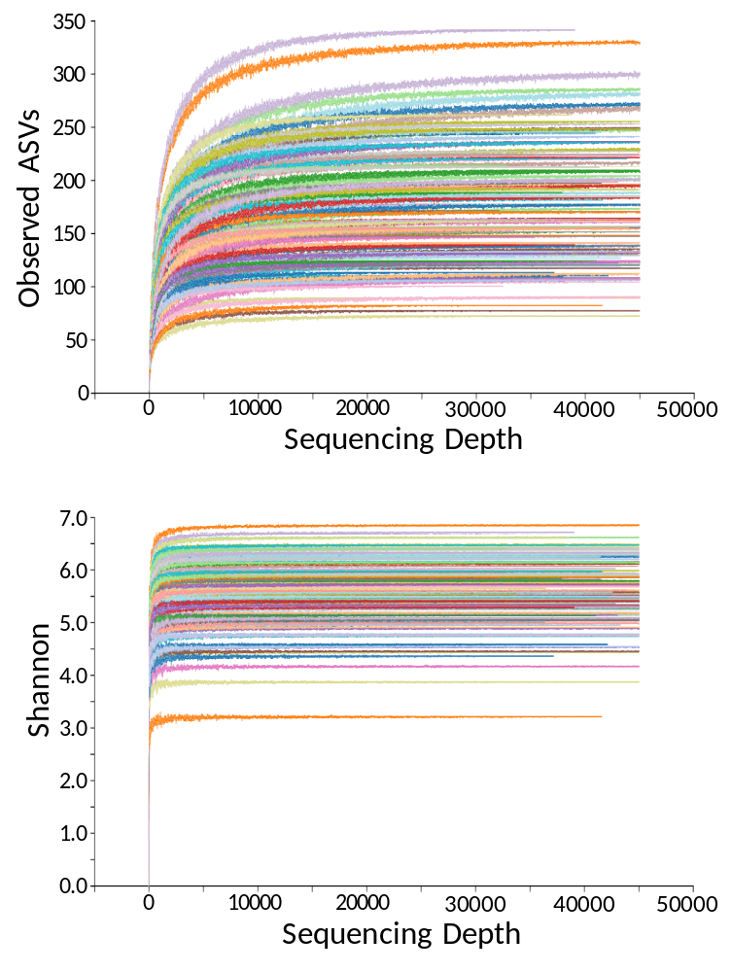
Figure S2. (A) Beta diversity was determined by a principal coordinates analysis plot based on the unweighted UniFrac distance. Each dot represents one sample. (B) Prevotella/Bacteroides (P/B) ratio between the latent tuberculosis infection (LTBI) and non-LTBI groups. *** represents a P value of <0.001 according to a Mann–Whitney U test.
Figure S3. Prediction of gene function of the 6 most differential genera between latent tuberculosis infection (LTBI) and non-LTBI groups using PICRUSt2.
