Supplementary Information
Hydride-ion conductivity and enhanced atmospheric stability of hydride-fluoride SrMgH_{4 – x}F_{x}
Nur Ika Puji Ayu, ª Naoki Matsui, ª Guangzhong Jiang, ª Takashi Hirose, ^{b} Takashi Itoh, ^{b} Takeya Mezaki, ^{c} Yoshitake Toda, ^{c} Kota Suzuki, ^{a,b} Masaaki Hirayama, ^{a,b} Takashi Saito, ^{d,e} Takashi Kamiyama ^{d,e} and Ryoji Kanno *ª

ªResearch Center for All-Solid-State Battery, Institute of Innovation Research, Tokyo Institute of Technology, 4259 Nagatsuta, Midori-ku, Yokohama 226-8502, Japan
^{b}Department of Chemical Science and Engineering, School of Materials and Chemical Technology, Tokyo Institute of Technology, 4259 Nagatsuta, Midori-ku, Yokohama 226-8502, Japan
^{c}AGC Inc., Yokohama Technical Center, 1-1, Suehiro-cho, Tsurumi-ku, Yokohama, Kanagawa 230-0045, Japan
^{d}Neutron Science Division (KENS), Institute of Materials Structure Science, High Energy Accelerator Research Organization (KEK), 203-1 Shirakata, Tokai, Ibaraki 319-1106, Japan.
^{e}Department of Materials Structure Science, School of High Energy Accelerator Science, Graduate University for Advanced Studies, SOKENDAI, 203-1 Shirakata, Tokai, Ibaraki 319-1106, Japan

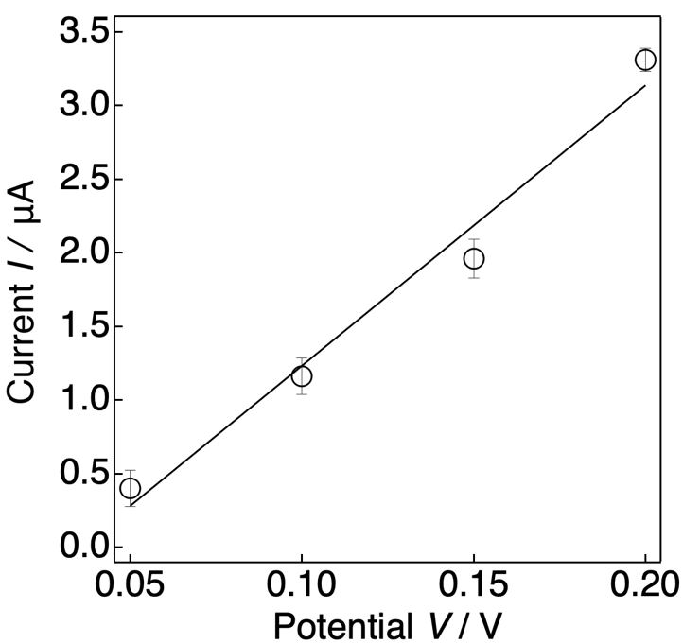
Figure S2. Rietveld refinement pattern of SrMgH₂F₂ based on neutron diffraction (ND) data obtained at 298 K. The red points and black curve indicate the observed and calculated intensities, respectively. The blue line shows the differential curve between the observed and calculated patterns, and the green lines indicate the positions of the Bragg reflections of SrMgH₂F₂.
Figure S1. I–V curve of SrMgH₄ obtained via DC polarization, using Mo as the hydride-ion-blocking electrode. The open circles and black line indicate the measured values and fitting line, respectively.
Table S1. Refined structural parameters of SrMgH₂F₂ based on the Rietveld analysis of the ND pattern collected at 298 K.
Atom | Symbol | Wyckoff  position | g | x | y | z | B_{equ} / Å²
Sr1 | Sr | 4a | 1 | 0 | 0.34383(13) | 0.0553(4) | 0.94(3)
Mg1 | Mg | 4a | 1 | 0.5 | 0.41795(19) | 0.6050(4) | 2.08(8)
F_{eq1} | F | 4a | 1 – g(H_{eq1}) | 0.5 | 0.3160(12) | 0.794(2) | 0.79(14)
H_{eq1} | H | 4a | 0.4746(11) | 0.5 | y(F_{eq1}) | z(F_{eq1}) | B(F_{eq1})
F_{eq2} | F | 4a | 1 – g(H_{eq2}) | 0.5 | 0.5338(10) | 0.4412(15) | 0.65232(7)
H_{eq2} | H | 4a | 0.4754(11) | 0.5 | y(F_{eq2}) | z(F_{eq2}) | B(F_{eq2})
F_{eq3} | F | 4a | 1 – g(H_{eq3}) | 0.5 | 0.3286(15) | 0.332(3) | 1.01441(8)
H_{eq3} | H | 4a | 0.4996(11) | 0.5 | y(F_{eq3}) | z(F_{eq3}) | B(F_{eq3})
F_{ap} | F | 4a | 1 – g(H_{ap}) | 0 | 0.4021(15) | 0.573(5) | 0.69024(6)
H_{ap} | H | 4a | 0.5504(11) | 0 | y(F_{ap}) | z(F_{ap}) | B(F_{ap})
Unit cell: orthorhombic space group Cmc2₁ (36): a = 3.93457(17) Å, b = 14.1970(10) Å, c = 5.6095(4) Å, R_{wp} = 0.62 %, R_{e} = 0.42 %, R_{p} = 0.52 %, R_{B} = 7.42 %, R_{F} = 6.64 %, goodness-of-fit S = R_{wp}/R_{e} = 1.46.

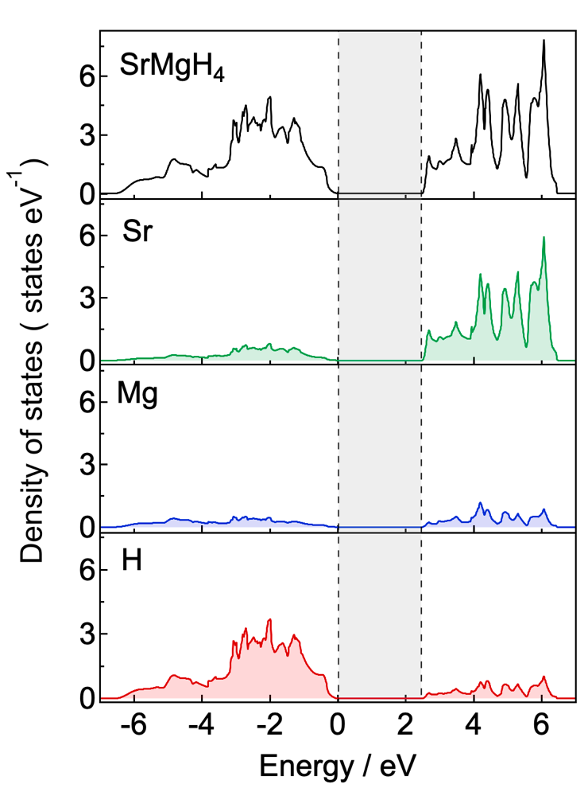
Figure S3. Density of states of SrMgH₄, with the energy measured from the valence band maximum.
Table S2. Relative energies of the hydrogen vacancies at equatorial (H_{eq}) and apical (H_{ap}) sites in SrMgH₄.
Hydrogen vacancy site | Relative energy E / kJ mol^{–1}
H_{eq1} | 0
H_{eq2} | 21.2
H_{eq3} | 13.5
H_{ap} | 39.6

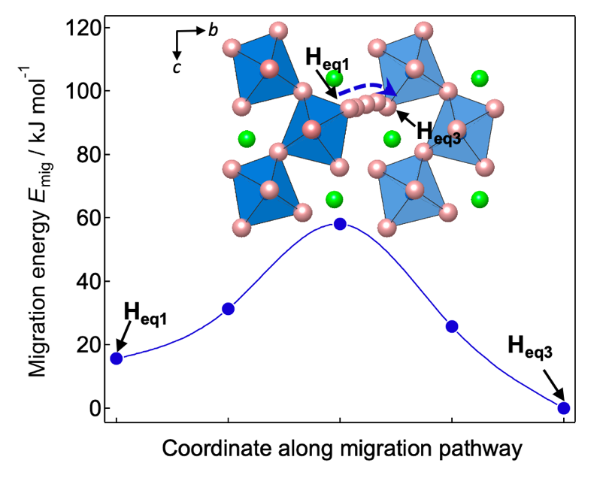
Figure S4. Migration energy of a hydride ion via hydrogen vacancy along the interlayer pathway between the perovskite slabs.

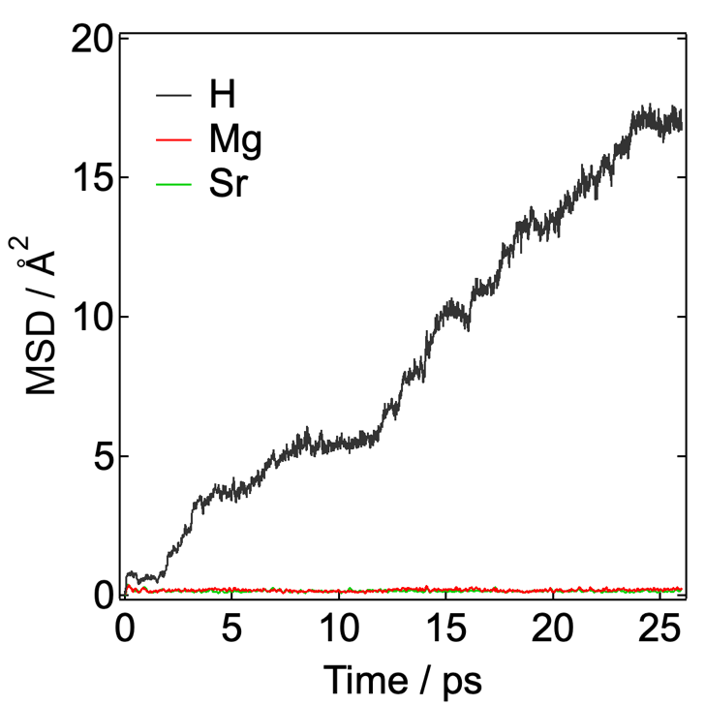
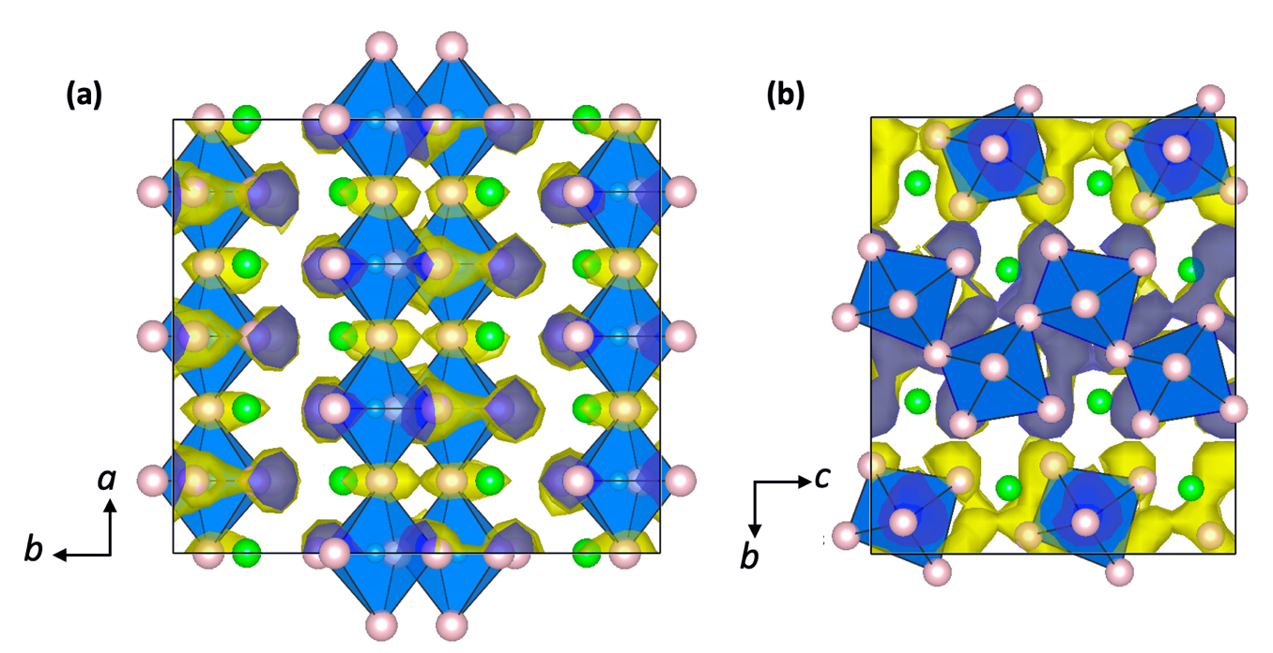
Figure S5. Mean square displacements (MSDs) of the constituent elements of SrMgH₄, according to a density functional theory-molecular dynamics (DFT-MD) simulation of a 2 × 2 × 2 SrMgH₄ supercell at 1000 K, which shows that only H diffuses within the structure.
Figure S6. Probability density analysis of SrMgH₄ obtained via a DFT-MD simulation viewed from the (a) c- and (b) a-axis directions, which reveals the permeation area representing the hydride migration pathway. The green, pink, and blue balls represent Sr, H, and Mg, respectively. The isosurfaces (yellow) of ionic probability density are plotted at iso-levels of 0.001.

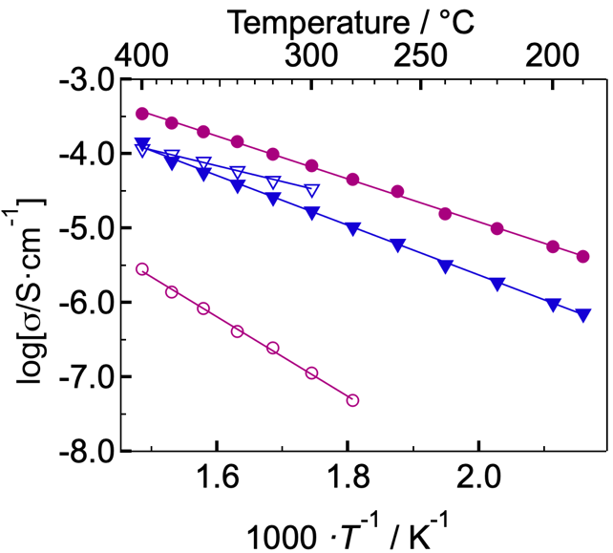
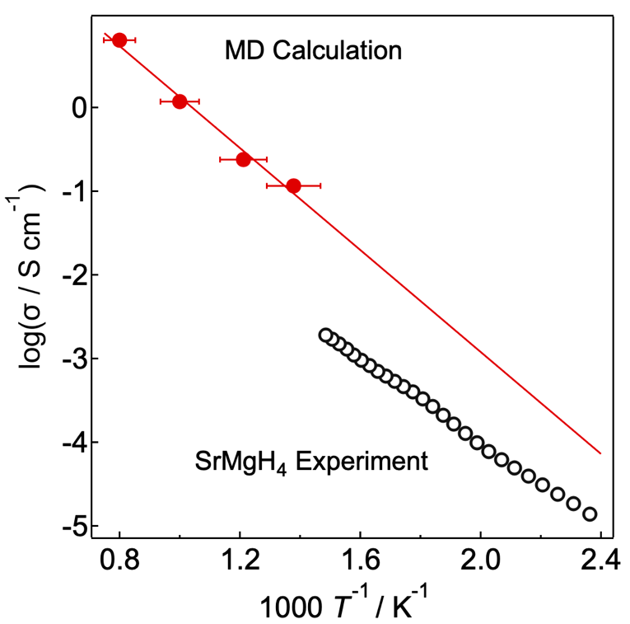
Figure S8. Arrhenius plots of the ionic conductivities of SrMgHF₃ (dark blue) and SrMgH₂F₂ (magenta) measured before (solid markers) and after air exposure (open markers).
Figure S7. Arrhenius plot of the ionic conductivity of SrMgH₄ obtained via an MD simulation (red solid circles) compared to the experimental result (black open circles). The red line represents the extrapolation of the linear fitting of the MD simulation results.

