Table 1. Hydrolytic and oxidative reaction conditions afford distinct cleavage of HEWL.
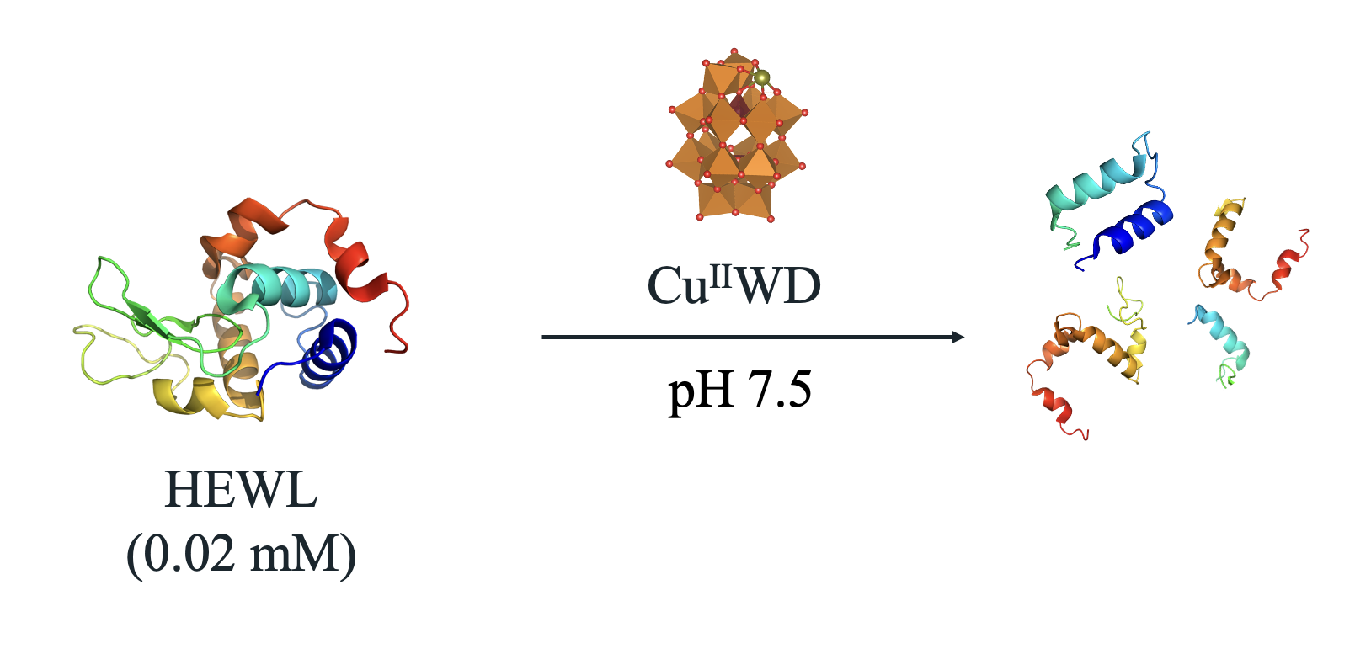
Reaction conditions | Hydrolytic cleavage | Oxidative cleavage
[Cu^{II}WD] (mM) | 2 | 0.05
[Asc] (mM) | - | 1
T (⁰C) | 60 | 37
MW of bands (kDa) | 12.7, 11, 10, 5 | 11.5, 9.1, 7.6

Table 2. Radical scavengers decrease the amount of HEWL cleaved by Cu^{II}WD/Asc.
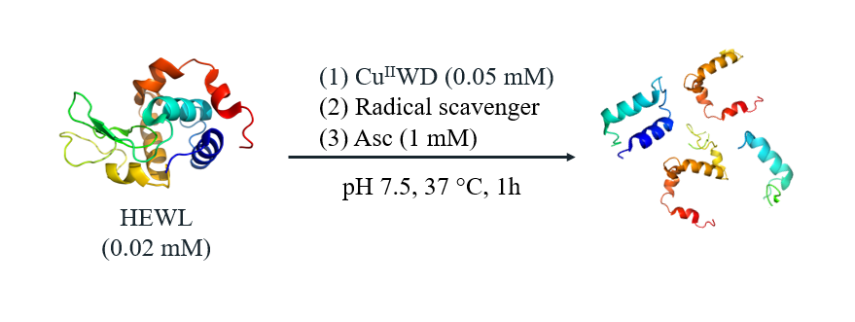
Entry | Radical scavenger | Concentration (mM) | Cleavage (%) | Cleavage inhibition (%)
1 | None | - | 45 | -
2 | Mannitol ª | 1.00 | 24 | 47
3 | Mannitol | 1.00 | 0 | 100
4 | GSH | 0.02 | 45 | -
5 | GSH | 1.00 | 10 | 78
6 | Thiourea | 1.00 | 10 | 78
7 | N₂ ^{b} | - | 0 | 100
ªMannitol was added after Asc. ^{b}The reaction was conducted under N₂ atmosphere.

