All-Inorganic Ligand Featuring an Enzyme-Like Recognition Enables Rapid and Regioselective Protein Cleavage Under Oxidative Conditions

Supporting information

Shorok A. M. Abdelhameed,^{[a]} Francisco de Azambuja,^{[a]} Tamara Vasović, ^{[b]} Tanja Cirkovic Velickovic, ^{[b], [c], [d],[e]}
and Tatjana N. Parac-Vogt* ^{[a]}

^{[a]} KU Leuven, Department of Chemistry, Celestijnenlaan 200F, 3001 Leuven, Belgium
^{[b]} Center of Excellence for Molecular Food Sciences & Department of Biochemistry, University of Belgrade - Faculty of Chemistry, Belgrade, Serbia
^{[c]} Ghent University Global Campus, Yeonsu-gu, Incheon, South Korea
^{[d]} Faculty of Bioscience Engineering, Ghent University, Ghent, Belgium
^{[e]} Serbian Academy of Sciences and Arts, Belgrade, Serbia
Email: tatjana.vogt@kuleuven.be

Table of Contents
1. General Remarks 2
2. Cleavage of HEWL 3
2.1. Oxidative cleavage 3
2.2. Hydrolytic cleavage 7
2.3. ³¹P NMR spectroscopy 8
2.4. Electron paramagnetic resonance (EPR) 9
3. HEWL and Cu^{II}WD interaction studies: 9
3.1. Fluorescence spectroscopy 9
3.2. ¹H NMR spectroscopy 11
3.3. Circular dichroism spectroscopy (CD) 11
4. Mechanistic studies 13
5. Identification of oxidative modifications and cleavage sites by nLC-MS/MS. 16
6. References 22

General Remarks
Unless otherwise noted, reactions were performed without any precautions against air and moisture.
The cleavage reactions were performed in 1 mL aqueous solutions where the final concentrations of hen egg white lysozyme (HEWL), K₈[Cu²⁺(H₂O)(α₂-P₂W₁₇O₆₁)], (Cu^{II}WD), or CuSO₄ and sodium ascorbate (Asc) were 0.02, 0.05 or 2 and 1 mM, respectively. Stock solutions of HEWL (1 mM), Cu^{II}WD or CuSO₄ (10 mM) and Asc (200 mM) were prepared in 10 mM Tris-HCl, pH 7.5, unless otherwise noted. HEWL was purchased from Sigma–Aldrich. Sodium ascorbate was purchased from TCI and CuSO₄ was purchased from Fluka Chemika. All chemicals were used without any further purifications.
SDS-Tricine-PAGE (SDS-PAGE) was performed on a stacking gel of 5% (w/v) polyacrylamide gel in 3.0 M Tris-HCl buffer pH 8.45 and a resolving gel 18% (w/v) polyacrylamide in 3.0 M Tris-HCl buffer pH 8.45. Samples (15 µL) were supplemented with 5 µL sample buffer ( 1M tris-HCl ,pH 6.8 (2.25 mL), glycerol (5 mL), SDS (0.5 g), bromophenol blue (5 mg) and 1M dithiothreitol (2.5 mL) and heated at 95 °C for 5 min, followed by loading 10 µL of the resulting solution on the gel. Unstained low range (3.4 to 100 kDa) protein ladder (PL) was used as a molecular mass standard. An OmniPAGE electrophoretic cell was combined with an EV243 power supply (both produced by Consort, Turnhout, Belgium). Experiments were performed at 200 V for 2.0 h. Proteins in SDS-Tricine-PAGE gels were visualized with silver staining and an image of each gel was taken using a GelDoc EZ Imager (Bio-Rad, Hercules, CA). The percentage of the fragment bands compared to the total amount of protein in each lane was determined using the Bio-Rad Image Lab software Version 3.0.
Hydrogen nuclear magnetic resonance (¹H NMR) spectra, and phosphorus nuclear magnetic resonance (³¹P NMR) spectra were recorded on a Bruker Avance 400 spectrometer (400 and 376 MHz, respectively). Chemical shifts (δ) for hydrogens are reported in parts per million (ppm) downfield from tetramethylsilane propionic acid (TMSP-D₄, 0.5 mM, 0 ppm) and are calibrated using the residual solvent peak in the NMR solvent (D₂O: δ = 4.79 ppm). ³¹P NMR chemical shifts (δ) are reported in ppm upfield from H₃PO₄ 25% (0 ppm).

Data analysis
All NMR spectra were analyzed by using TopSpin 4.0.6. CD and UV-Vis measurements were done using Origin 2018b software. SDS-PAGE gels were analyzed by Bio-Rad Image Lab Software Version 3.0.

Preparation of known compounds
a₂-K₁₀P₂W₁₇O₆₁, (a₂WD) and a₂-K₈P₂W₁₇O₆₁(Cu²⁺.OH₂), (Cu^{II}WD) were prepared according to previous literature report.¹ The compound presented satisfactory analysis coherent with characterization data published previously.

Cleavage of HEWL
  - Oxidative cleavage
Solutions containing HEWL (0.02 mM), Cu^{II}WD or Cu salts (CuCl₂, CuSO₄) (0.05 mM) and Asc or H₂O₂ (1 mM) were prepared in 10.0 mM tris-HCl buffer (pH 7.0). Samples were incubated at 37 °C and aliquots were taken at different time increments and analyzed by SDS-PAGE.

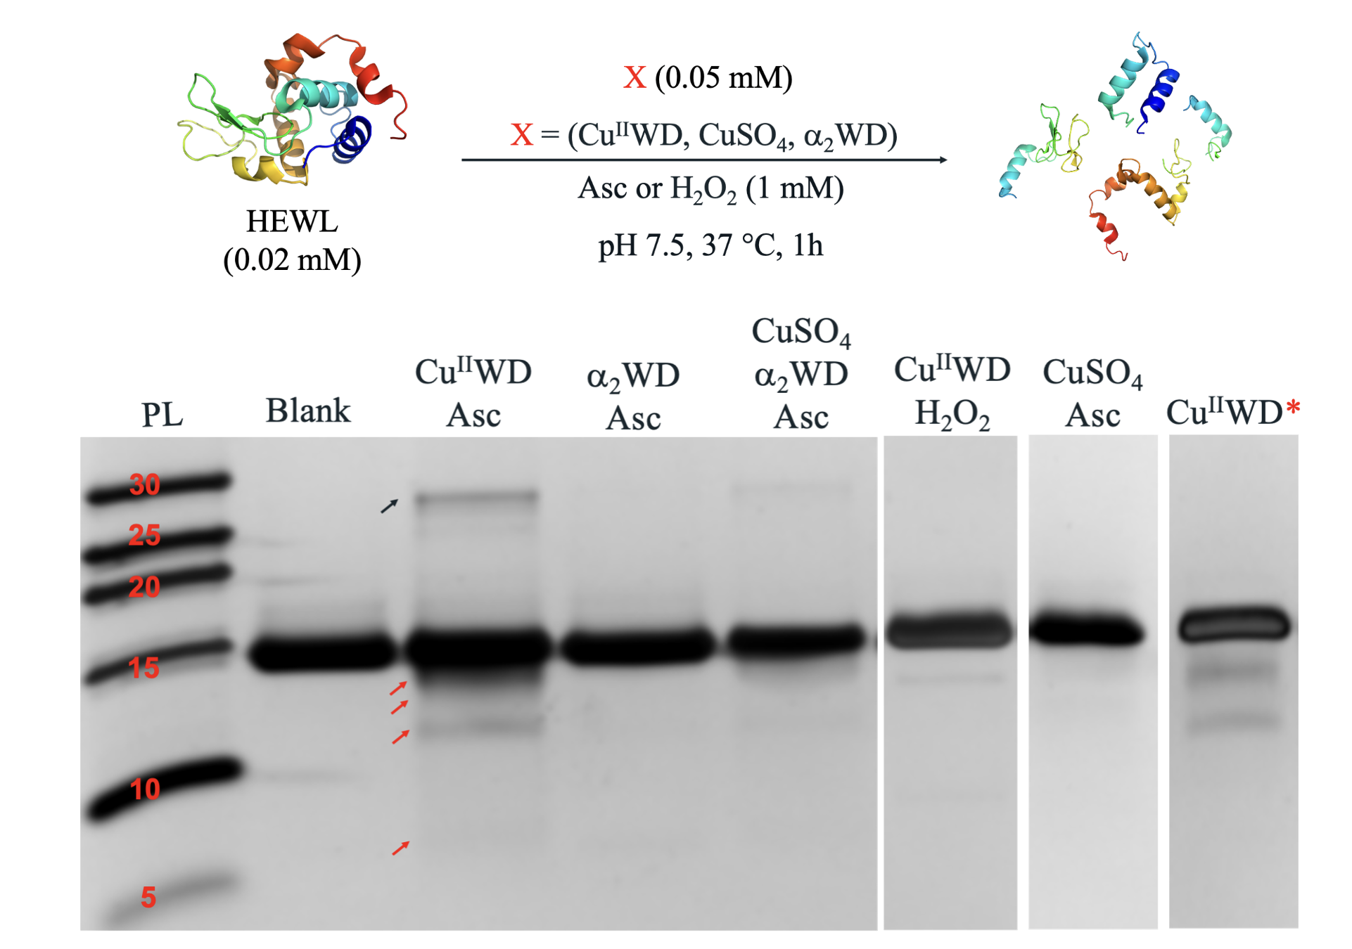
Figure S1. Silver stained SDS-PAGE gel of the cleavage of HEWL (0.02 mM) in presence of Cu^{II}WD, α₂WD or CuSO₄ (0.05 mM/), Asc (1 mM), at pH 7.4 and 37 °C for 1h. Red arrows indicate the produced protein fragments. The black arrow indicates the bands from HEWL dimerization. * Hydrolytic cleavage of HEWL (0.02 mM) in presence of Cu^{II}WD (2 mM) at pH 7.4 and 60°C for 3 days.

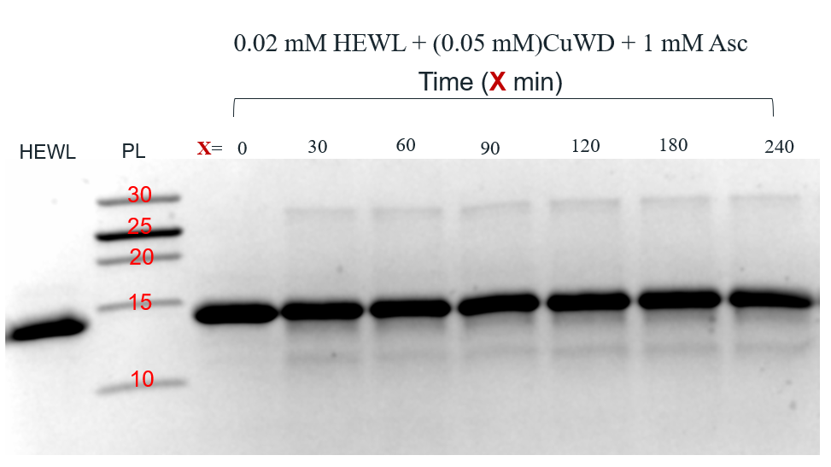
Figure S2. Coomassie stained SDS-PAGE gel of the cleavage of HEWL (0.02 mM) in presence of Cu^{II}WD and Asc at pH 7.4 and 37 °C for 1h.
.
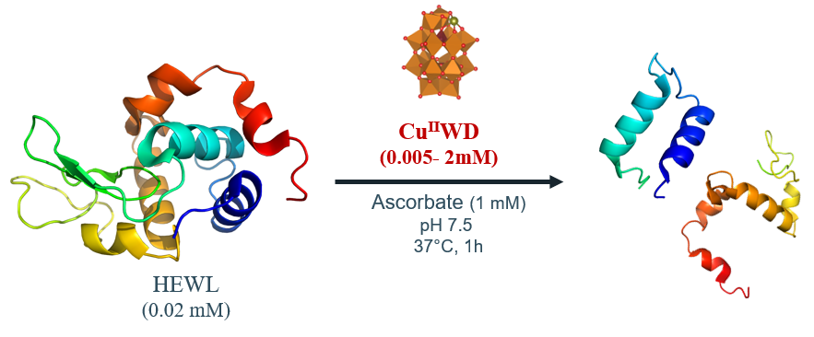
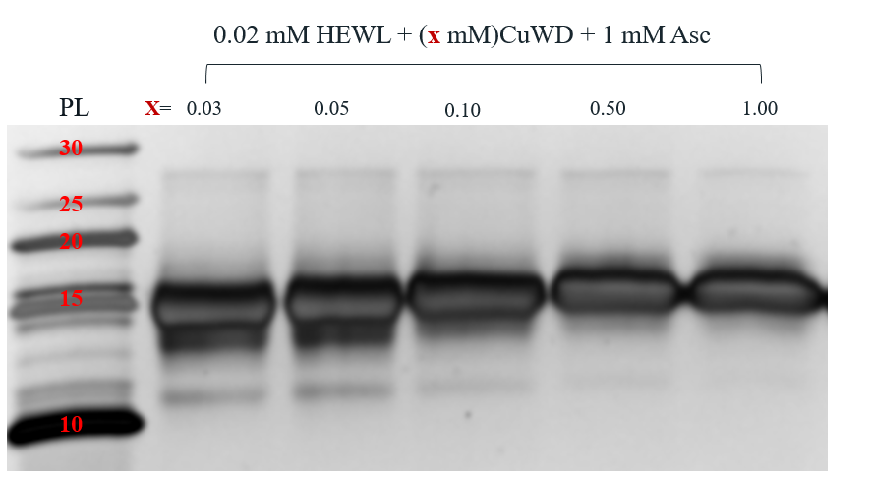
Figure S3. Silver stained SDS-PAGE gels of HEWL (0.02mM) cleavage in presence of Asc (1 mM) and different concentration of Cu^{II}WD (0.005-1.00 mM), at pH 7.4 and 37 °C for 1h.
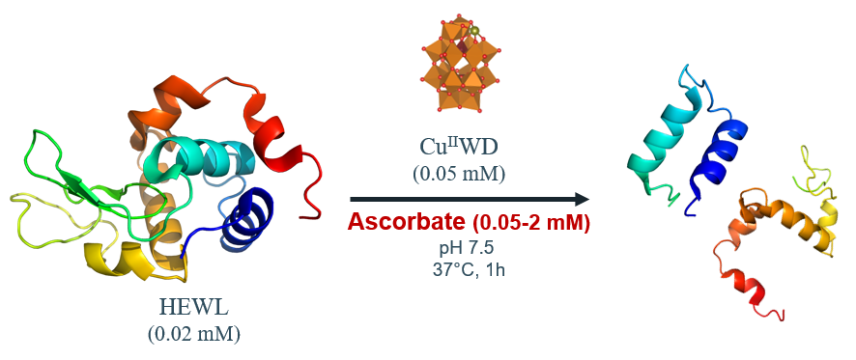
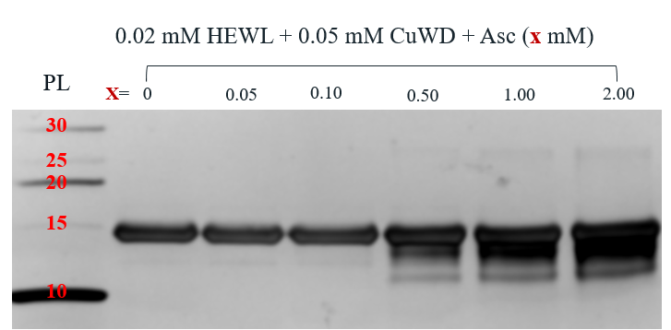
Figure S4. Silver stained SDS-PAGE gel of HEWL (0.02 mM) cleavage in presence of Cu^{II}WD (0.05 mM) and different concentrations of Asc (0.05-2.00 mM), at pH 7.4 and 37 °C for 1h.

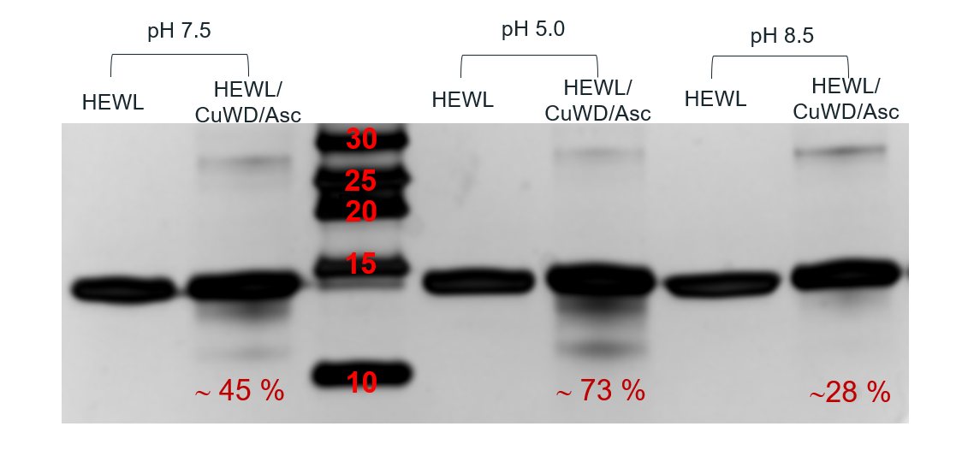
Figure S5. Silver stained SDS-PAGE gel of HEWL (0.02 mM) cleavage in presence of Cu^{II}WD (0.05 mM) and Asc (1mM), at different pH values at 37 °C for 1h. (45, 73 and 28 are the % of HEWL cleaved).

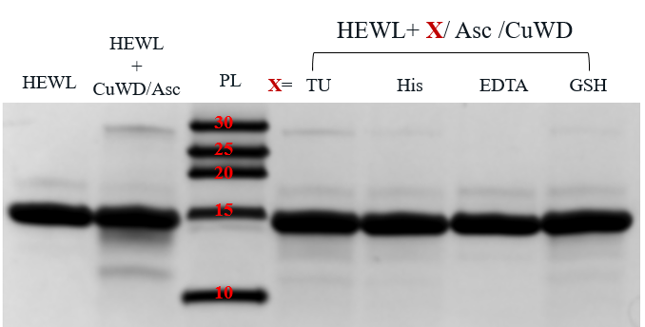
Figure S6. Silver stained SDS-PAGE gel of HEWL (0.02 mM) cleavage in presence of Cu^{II}WD (0.05 mM), Asc (1.00 mM) and inhibitors (1.00 mM), at pH 7.4 and 37 °C for 1h.

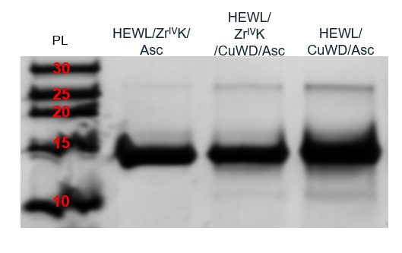
Figure S7. Silver stained SDS-PAGE gel of HEWL (0.02 mM) cleavage in presence of Cu^{II}WD or Zr^{IV}K (0.05 mM), Asc (1.00 mM), at pH 7.4 and 37 °C for 1h.

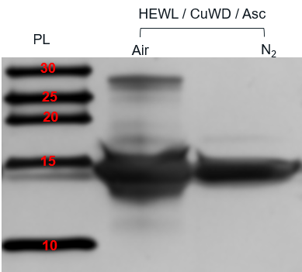
Figure S8. Silver stained SDS-PAGE gel of HEWL (0.02 mM) cleavage in presence of Cu^{II}WD (0.05 mM), Asc (1.00 mM), at pH 7.4 and 37 °C for 1h under air or N₂.
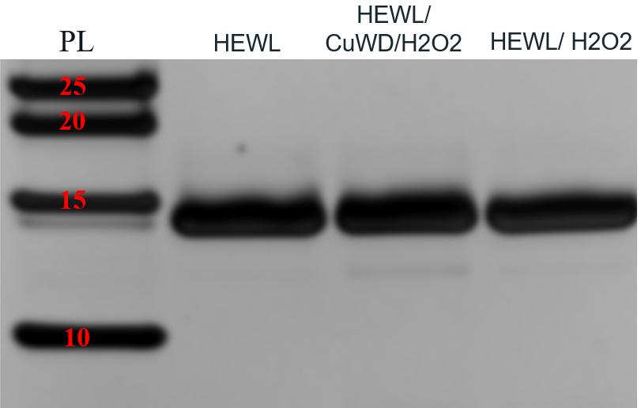
Figure S9. Silver stained SDS-PAGE gel of HEWL (0.02 mM) cleavage in presence of Cu^{II}WD (0.05 mM) and/or H2O2 (1.00 mM), at pH 7.4 and 37 °C for 1h.

  - Hydrolytic cleavage
Solutions containing HEWL (0.02 mM), Cu^{II}WD (2 mM) were prepared in 10.0 mM tris-HCl buffer (pH 7.5). Samples were incubated at 60 °C. Aliquots were taken at different time increments and analyzed by SDS-PAGE. The cleavage of HEWL via Cu^{II}WD, in the absence of Asc, was monitored at pH 7.5, 60 °C for 3 days. Figure S10 shows that in presence of Cu^{II}WD only three bands were produced with (11.5 kDa, 9.1 kDa and 7.6 kDa).

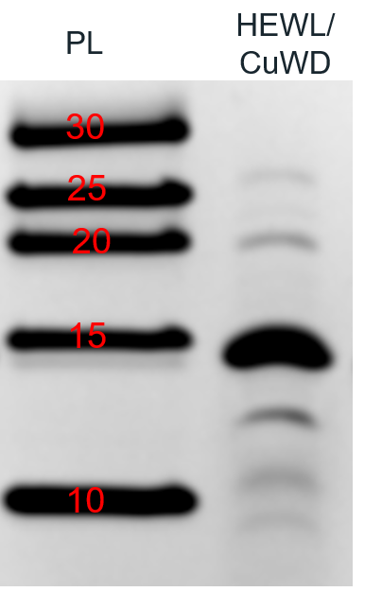
Figure S10. Silver stained SDS-PAGE gel of HEWL (0.02 mM) incubation in absence and presence of Cu^{II}WD at pH 7.5, 60 °C for 3 days. Red arrows indicate the produced protein fragments.
Figure S10, unambiguously, reveals that the bands produced from the cleavage of HEWL via Cu^{II}WD is different from Cu^{II}WD /Asc. This could be attributed to the difference in cleavage pathway since Cu^{II}WD is most plausibly cleave protein through a hydrolytic pathway. Figure S11 shows two proposed pathways of the hydrolytic cleavage of the peptide bond based on literature.² In the first pathway (Figure S11, A) the metal could activate a coordinated hydroxyl or water which eventually will attack the amide carbonyl group. In the second one (Figure S11, B), the metal act as Lewis acid by activating an amide carbonyl towards nucleophilic attack by hydroxyl or water molecule from the solvent. Both mechanisms require at least one free coordination site at the catalyst in order to hydrolyze the peptide bond.
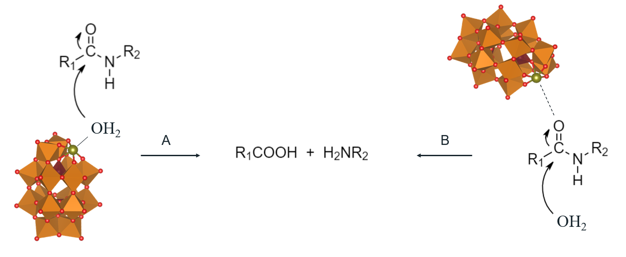
Figure S11. Proposed mechanisms of the hydrolytic cleavage of the peptide bond.

³¹P NMR spectroscopy
A 1.5 mL centrifuge tube was charged with 200 µL of 20 mM Cu^{II}WD stock solution, 20 µL of 1 mM HEWL stock solution, 10 µL of 200 mM Asc and 100 µL D₂O and 780 µL buffer – 10 mM tris-HCl (pH 7.4). The final concentration of Cu^{II}WD was 2.0 mM, and of HEWL was 0.02 mM and 2.0 mM of Asc. The reaction mixture was homogenized using a vortex. Next, 500 μL of the reaction mixture was transferred into an NMR tube. The reaction was incubated for 1 day at 60 ⁰C. Then, the reaction was measured by ³¹P NMR spectroscopy.

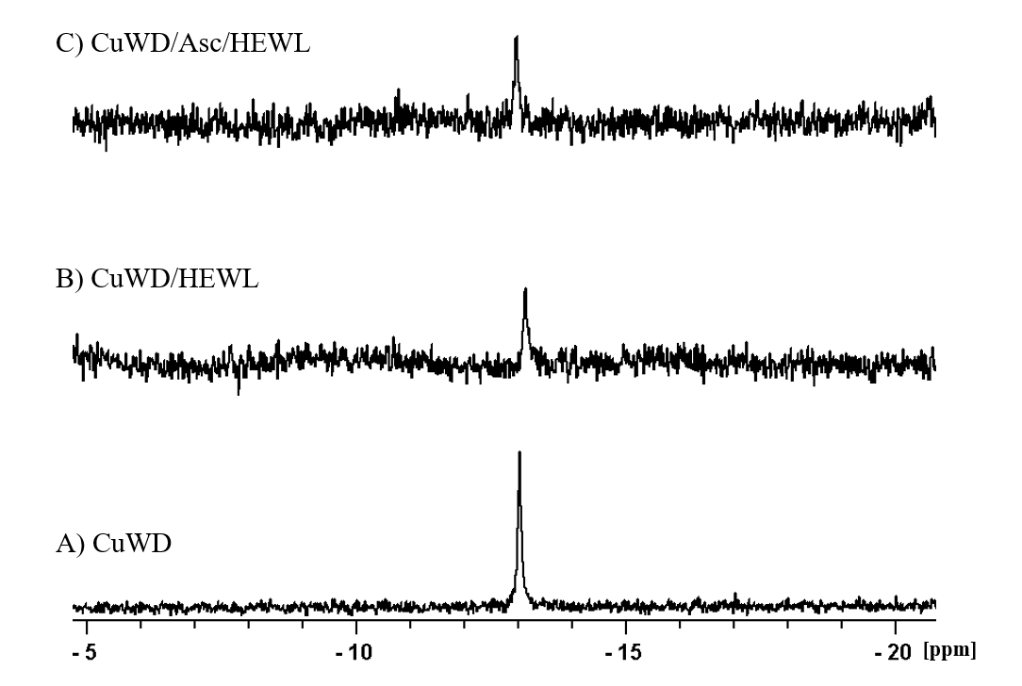
Figure S12. ¹H NMR spectra of (A) 2 mM of Cu^{II}WD; (B) 2 mM Cu^{II}WD in presence of 0.02 mM HEWL; and (C) 2 mM Cu^{II}WD in presence of 0.02 mM HEWL and 2 mM Asc. At pH 7.4 and 60 °C for 1 day.
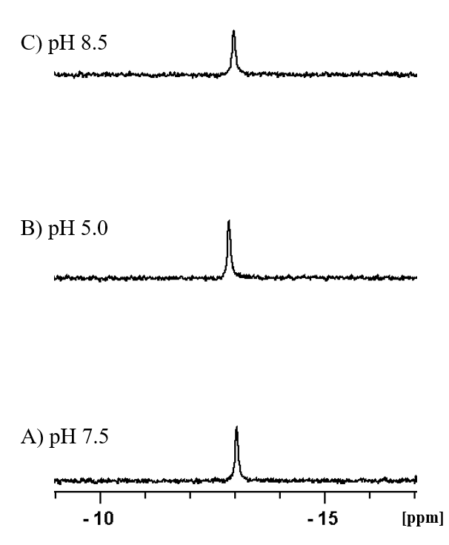
Figure S13. ¹H NMR spectra of 5 mM Cu^{II}WD at different pH values at 60 °C for 1 day.

Electron paramagnetic resonance (EPR)
A 1.5 mL centrifuge tube was charged with 5 µL of 10 mM Cu^{II}WD stock solution, 5 µL of 200 mM Asc stock solution and 20 µL of 1 mM of HEWL stock solution, and enough 10.0 mM tris-HCl (pH 7.5) buffer was added to complete the reaction volume to a total of 1 mL (final concentrations of Cu^{II}WD, Asc and HEWL were 0.05, 1 and 0.02 mM, respectively). The reaction mixture was homogenized using a vortex. Next, 300 µL of the reaction mixture were transferred to an EPR tube. Immediately afterwards, the tube was immersed in liquid N₂. EPR measurements were conducted at 160 K on a X-band Bruker 300E continuous wave spectrometer with a rectangular cavity.

HEWL and Cu^{II}WD interaction studies:
  - Fluorescence spectroscopy
Tryptophan fluorescence quenching studies of HEWL (10.0 µM) solution (10.0 mM tris-HCl buffer, pH 7.4) at room temperature. The emission was monitored from 300 nm to 420 nm. Sample was irradiated with a wavelength of 295 nm to avoid excitation of tyrosine residues, with a maximum at approximately 340 nm. Fluorescence spectra were measured with increasing concentrations of Cu^{II}WD, α₂WD or CuSO₄ (0 to 15.0 µM). Emission fluorescence spectra were recorded on a FS-920P spectrofluorimeter (Edinburgh Instruments, Livingston, UK). Quartz cuvettes with 10.0 mm optical path length were used.

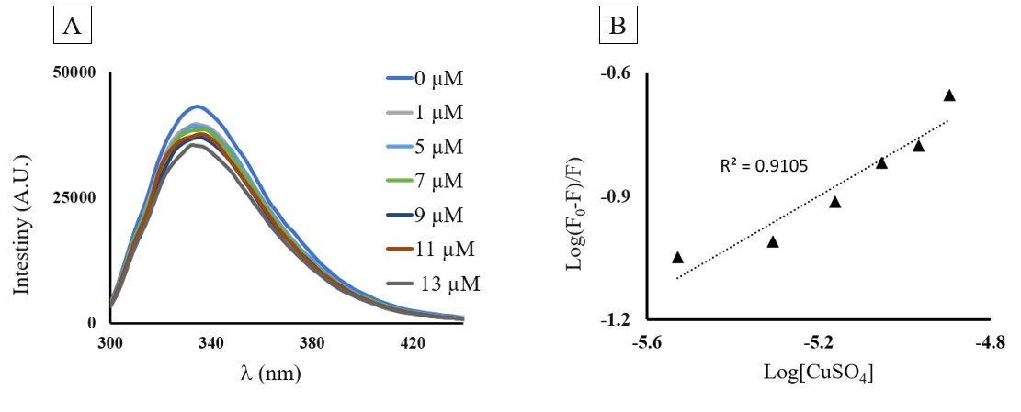
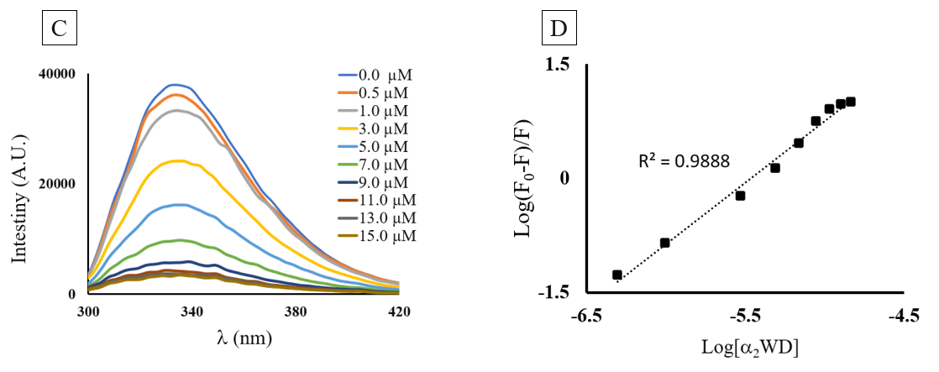
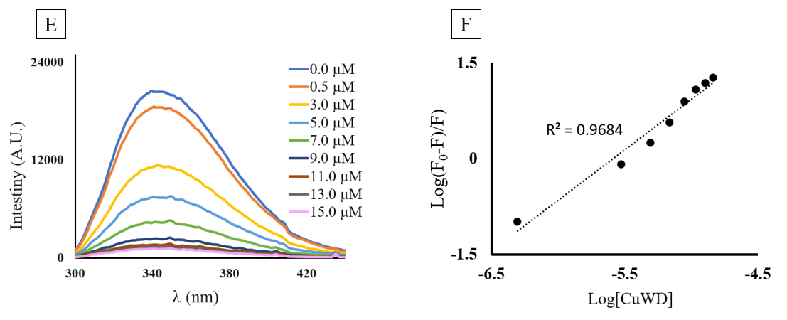

Figure S14. Trp fluorescence quenching spectra of HEWL (10.0 µM) in the presence of: (A) CuSO₄ (0 – 13 µM); (C) α₂WD (0 – 15 µM); (E) Cu^{II}WD (0 – 15 µM) at 25 ºC and pH 7.5, and the corresponding plots of the derived Stern–Volmer plot: (B) CuSO₄; (D) α₂WD; (F) Cu^{II}WD.

  - ¹H NMR spectroscopy
Solutions containing HEWL (1 mM) in the absence or presence of 10% SDS and 0.1 M DTT or in the presence of Cu^{II}WD (0.05 mM) or Cu^{II}WD (0.05 mM) + Asc (0.05 mM) were prepared in 10.0 mM tris-HCl buffer (pH 7.5, 10% D₂O) at room temperature. Figure S15 shows folded HEWL features spread between 6 and 10 ppm, in addition to peaks < 0 ppm. As a control, ¹H NMR spectrum of HEWL in the presence of DTT and SDS was also recorded. DTT and SDS are known to cause effective protein denaturation, which leads to unfolding of the protein. From the data shown in Figure S15, most of the protein remains in its native form upon addition of Cu^{II}WD, Asc or both.

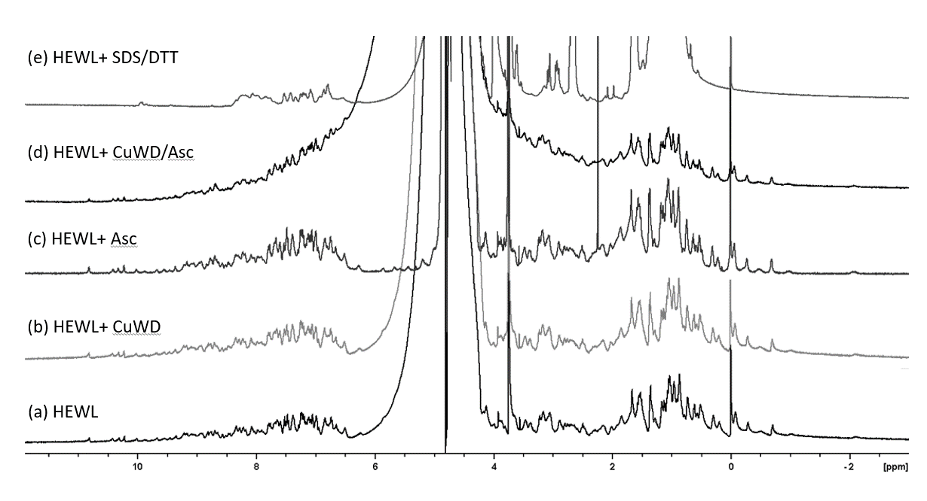
Figure S15. Room temperature ¹H NMR spectra of HEWL solutions: a) HEWL (1 mM); b) Cu^{II}WD (0.05 mM); Asc (1 mM); c) Cu^{II}WD /Asc (0.05 mM/1 mM); and e)10% SDS/DTT (100 mM).

  - Circular dichroism spectroscopy (CD)
Quartz cuvettes with 1.0 mm optical path length were used. The cuvette was loaded with 300 µL of HEWL (0.01 mM) and titrated with Cu^{II}WD in presence and absence of Asc. All Solutions were prepared in 10 mM Tris-HCl buffer pH 7.5 and all measurements were done at 20 ^{ο}C. CD measurements were performed by using a JASCO J-810 spectropolarimeter. Far-UV wavelength scans were recorded from 180 to 300 nm. All the CD spectra were corrected for the background effect by subtracting the spectrum of the respective buffer solution from the spectrum of the protein.
The CD spectrum of HEWL in 10 mM tris-HCl (pH 7.4) at room temperature (Figure S16) shows a large minimum at l = 208 nm and a smaller minimum at l = 222 nm, both characteristic for α-helical structure elements.³ The minimum at l = 215 nm, characteristic of β-sheet elements, is less pronounced because HEWL contains only a minor β-strand region. Figure S16 shows that Cu^{II}WD does not change the overall shape of the HEWL CD spectrum but decrease the intensity of the negative signals at 208 ,215 and 222 nm. Upon addition of Asc (1 mM), a drastic change to HEWL CD spectrum was observed which in agreement with literature.⁴ The minima at l= 215 and l=222 nm was almost lost while the peak at l = 208 nm was less affected. Addition of Cu^{II}WD (0.05 mM) leads to restore minima at l= 215 and l=222 nm but decrease their intensity as well as minimum at l= 208 nm.

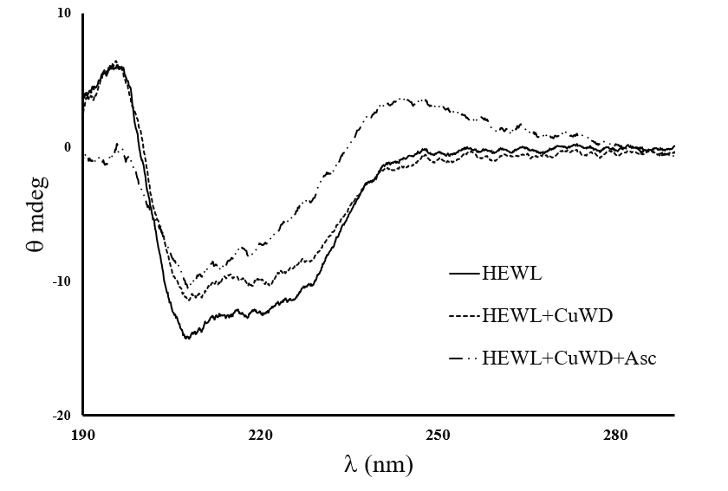
Figure S16. CD spectra evidence changes in HEWL (0.01 mM) secondary structure in the presence of Cu^{II}WD (0.05 mM), Asc (1 mM) or both at 10 mM tris-HCl buffer pH 7.5 and 25 ^{ο}C.

Mechanistic studies
To probe whether the Cu^{II}WD mediated HEWL cleavage in the presence of Asc follows an oxidative pathway, several mechanistic experiments were conducted, based on schemes reported in the literature.^{5,6} In the proposed mechanism, Asc reduces Cu^{II}WD to Cu^{I}WD, which in turn is able to reduce an O₂ molecules from the air, leading to the formation of reactive oxygen species (ROS). The ROS presumably induce a radical formation on residues’ side chains of HEWL prone to oxidation such as tryptophan, tyrosine, histidine and serine are ultimately cleaving protein through an oxidative pathway.^{7,8–10} Therefore, control experiments in the absence of Asc, or in the presence of radical scavengers, were carried. The nature of oxidant was probed in order to investigate the reaction mechanism, as discussed below in detail, and a reaction pathway coherent with the results is presented in Scheme 1.

Nature of reaction. The different HEWL fragmentation pattern observed with and without Asc suggests that distinct cleavage reactions take place, supporting that an oxidative cleavage takes place in the presence of Asc. The hydrolysis of HEWL (0.02 mM) in the presence of only Cu^{II}WD (2 mM) at pH 7.4 and 60 °C was much slower than in the presence of Asc, taking 3 days to produce bands with reasonable intensity in the SDS-PAGE analysis.^{11,12} Together, these result point to Cu^{II}WD most plausibly cleaving the protein through a hydrolytic pathway in the absence of Asc.² In addition, they suggest that reaction undergoes a different pathway in the presence of Asc, most likely an oxidative one.^{13–15,16,17,18}

Radical scavengers. Overall conversion of the protein decreases in the presence of classical radical scavengers or under inert atmosphere, supporting the involvement of radical species in the reaction (Table 2). Addition of mannitol (1 mM), a hydroxyl radical scavenger,¹⁹ shortly after mixing Cu^{II}WD /Asc with HEWL, led to a 47% decrease in the protein cleavage, while mixing mannitol with Cu^{II}WD and HEWL before the addition of Asc completely inhibited the cleavage reaction. Further, the readily oxidizable tripeptide glutathione (GSH)²⁰ had no effect on the reaction when present in low concentration (0.02 mM), but a 78% inhibition was observed when an equimolar amount (1 mM) relative to Asc was used. ¹H NMR spectroscopy, Figure S17, showed the formation of GSSG, the oxidized form of GSH, which evidence the radical scavenging activity of GSH. Thiourea (1 mM) had a similar effect, inhibiting protein cleavage by 78%.²¹
Procedure for GSH oxidation. A 1.5 mL centrifuge tube was charged with 5 µL of 10 mM Cu^{II}WD stock solution, 5 µL of 200 mM Asc stock solution, 5 µL of 200 mM GSH stock solution and 985 µL of D₂O (final concentration of Cu^{II}WD is 0.05 mM, Asc and GSH both were 1.00 mM). The reaction mixture was homogenized using a vortex. Next, 0.50 mM TMSP-d₄ was added as an internal standard for ¹H NMR. Then, 500 μL of the reaction mixture was transferred to an NMR tube.

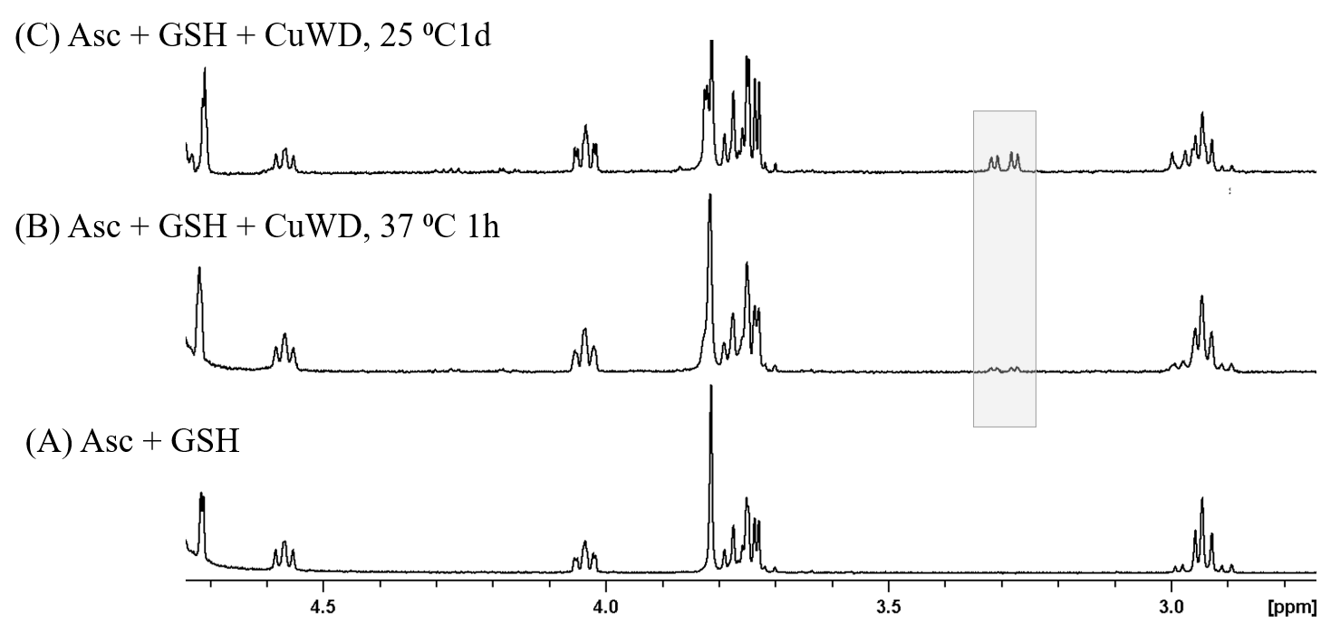
Figure S17. ¹H NMR spectra of 2 mM of Asc and GSH oxidation in absence (A) and presence of Cu^{II}WD (0.05 mM). The grey box marked the most indicative peaks which are related to the oxidized GSH (GSSG)

Role of ascorbate. The in situ formation of an ascorbyl radical was confirmed by electron paramagnetic resonance spectroscopy (EPR). The EPR spectra of Cu^{II}WD solutions with and without HEWL were measured under the same conditions under which cleavage reactions were conducted and showed that an ascorbyl radical (Asc• –) was formed immediately after the addition of Asc in both cases (Figure S18). Accordingly, the formation of dehydroascorbic acid (DA) upon addition of Cu^{II}WD to an Asc solution was also observed by ¹H NMR spectroscopy (Figure S18), confirming the stepwise reduction of Cu^{II}WD by Asc in solution. These results strongly support the role of Asc as the sacrificial reductant in the reaction.

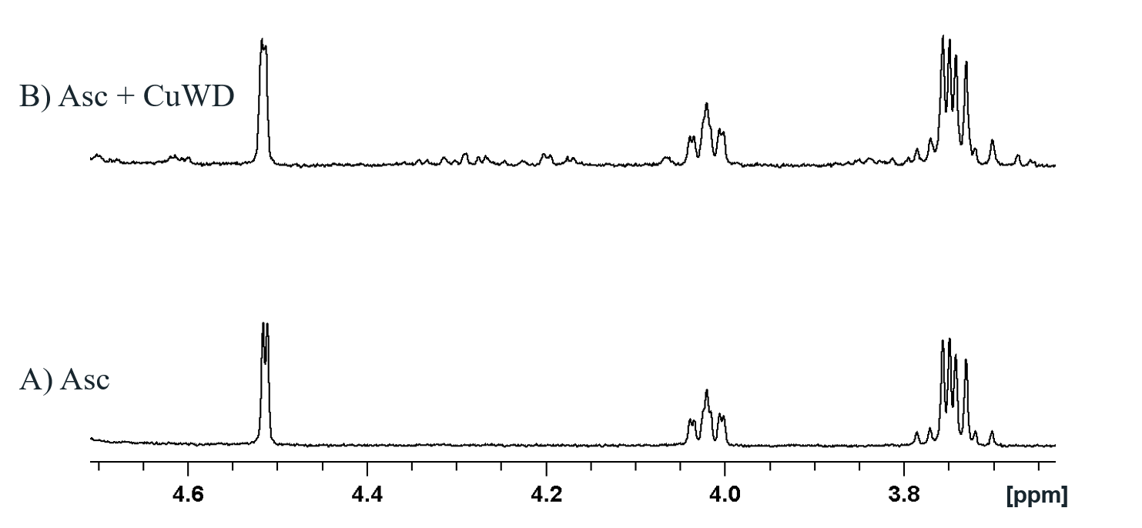
Figure S18. ¹H NMR spectra of Asc (1.00 mM) in the absence (a) and in the presence of Cu^{II}WD (0.05 mM) (b) where the new peaks indicate the oxidation of Asc at 37 ⁰C for 30 min.

Nature of oxidant. No HEWL cleavage was observed when the reaction was conducted under an atmosphere of nitrogen (Figure S8), corroborating the oxidative character of the reaction, and pointing out the crucial role of oxygen in the mechanism. In general, the reduction of oxygen has been proposed to afford reactive oxygen species like O₂•–, O₂²⁻ or HO•, which can be protonated in solution to generate peroxides that could further react. However, no cleavage was detected when HEWL was treated with Cu^{II}WD /H₂O₂ (0.05 mM/1 mM) instead of the usual Cu^{II}WD/Asc combination (Figures S1 and S9), strongly suggesting that any H₂O₂ eventually formed in solution is not responsible for the cleavage observed. This contradicts common mechanistic proposals stating H₂O₂ as an intermediate in similar reactions,²² though the reactivity of Cu^{II} complexes towards H₂O₂ largely depends on the redox potential of the complex, which may vary widely due to the ligands in the coordination sphere of Cu^{II}, and/or the reaction conditions.^{23,24,25} Together, these results suggest a mild oxidant species formed through the reaction of Cu^{I}WD and O₂ might be enabling HEWL oxidative cleavage.^{26,27} Importantly, this would also account for the fact that the reaction is not inhibited Asc’s known radical scavenger ability,²⁸ as the oxidant would be produced in low concentration at the vicinity of the protein, unaffected by an excess of Asc.
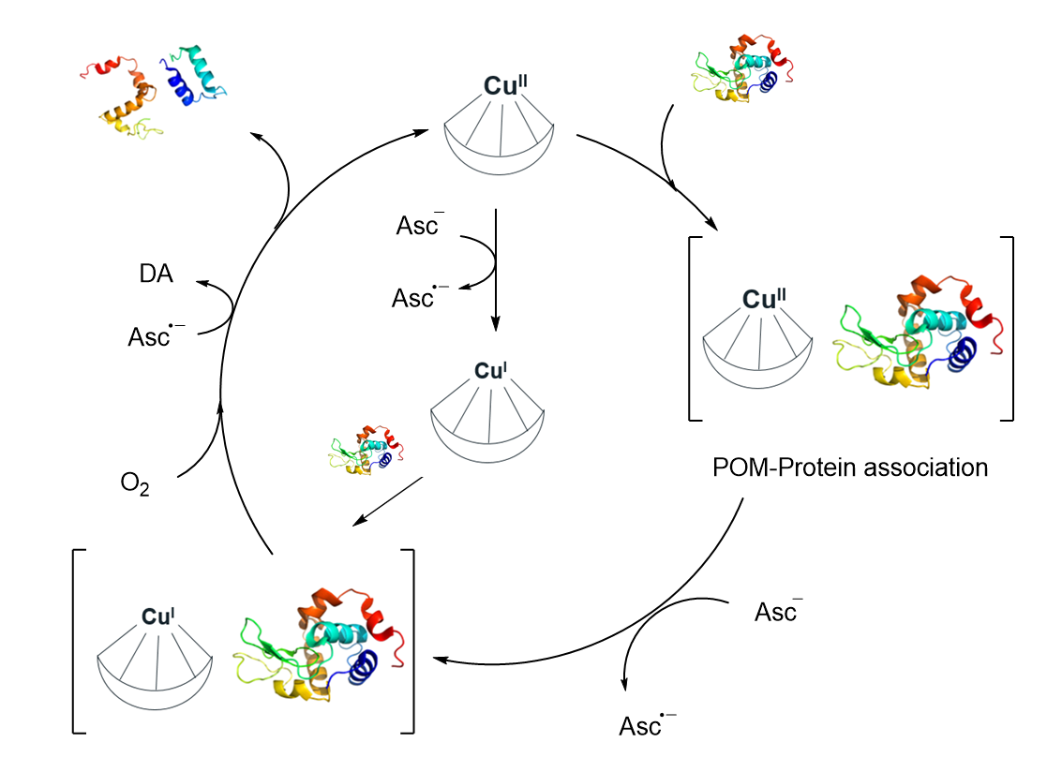
Figure S19. The proposed mechanism of the reaction of Cu^{II}WD with Asc

Identification of oxidative modifications and cleavage sites by nLC-MS/MS.
After SDS-PAGE and Coomassie Brilliant Blue (CBB) staining and scanning (Figure S20), gel bands were excised, and in-gel digested with trypsin using the method described by Shevchenko et al.²⁹ The proteins were digested with proteomics-grade porcine trypsin at a ratio of 1:30. Peptides from in-gel digestions, were chromatographically separated using an UltiMate™ 3000 RSLC nano-liquid chromatographic system (nLC) (Thermo Fisher Scientific, Bremen, Germany), equipped with a 2-column set up: i) a trap column C18, 50 mm, and ii) an analytical column PepMap (C18, 15 cm × 75 μm, 3 μm particles, and 100 Å pore size). The mobile phases were (A) water (MS-grade) with 0.1% formic acid and (B) acetonitrile (MS-grade) with 0.1% formic acid. The gradient program was as follows: 0–0.5 min 95% A, 0.5–10 min 95-66% A, 10–15 min -66-0% A, 15–20 min 0% A, 20–23 min 5% A, with flow rate of 0.25 μL/min. This nLC system was coupled with an Orbitrap Exploris 240 high resolution mass spectrometer equipped with heated electrospray ionization source (Thermo Fisher Scientific, Bremen, Germany). Spray was generated with an integrated column emitter, with tip voltage set at 2.2 kV, capillary voltage at 6 V and capillary temperature at 275 °C. A high-resolution full Fourier-Transform Mass Spectrometry (FTMS) profile spectrum and MS/MS spectra of top 50 ions (scan range 200–3000 m/z, resolving power 60 000, 1 microscan) was acquired using Xcalibur (4.4) software (Thermo Fisher Scientific) with the precursor mass tolerance of 10 ppm. The experiments were done in duplicate. Identification of protein and post-translational modifications (PTMs) was performed using the PEAKS Studio X Pro software program (Bioinformatics Solutions Inc., Waterloo, ON, Canada). Signature MS/MS spectra were searched using PEAKS DB and PEAKS PTM algorithms against a database consisting of a UniProtKB (tremble and reviewed) subfamily Gallus Gallus (taxon identifier 9031, 30 501, downloaded on August 17, 2021 from http://www.uniprot.org/) and cRAP (the common Repository of Adventitious Proteins) database (downloaded on August 17, 2021 from http://www.thegpm.org/crap/). Oxidation (Met) and deamidation (Gln, Asn) were considered as variables, with carbamidomethylation (Cys) set as fixed in the PEAKS DB algorithm. In the PEAKS PTM algorithm, an PTM search was undertaken using a list of 313 PTM items. Up to two missed trypsin cleavages with non-specific cleavages at both ends of a peptide were allowed. Mass tolerances were set to ±10 ppm for parent ions and ± 0.02 Da for fragment ions. Protein filters were as follows: protein −10 lgP ≥ 20, proteins unique peptides ≥ 1, and “A” Score for confident PTMs identification of at least 50. Peptide filters were as follows: false discovery rate for peptide-spectrum matches < 0.5%; therefore, the resulting false discovery rate of the peptide sequence was lower than 1% (for more details check Smiljanic et al, 2019)³⁰.
When identifying peptides with the PEAKS Studio X pro software package, all trypsin-derived peptides were taken into account, together with peptides generated by hydrolysis catalyzed by an enzyme of unknown specificity, to obtain all semi-tryptic and non-tryptic peptides. All semi-tryptic or non-tryptic peptides were extracted and overlapped with the peptides found in the control (Table S1) in order to find peptides generated only by the action of Cu^{II}WD/Asc. The sample preparation steps involved in peptide mapping are also sources of non-enzymatic PTMs. Alkaline pH, used during all steps of sample preparation, induces deamidation and disulfide bond scrambling and oxidation of methionine.
Sample treatment before analysis is necessary and can limit the information obtained. Because of the high tendency of oxidation at Cys residues during processing, reduction and alkylation is carried out. This therefore results in loss of most information about oxidant-mediated changes at Cys residues. Several studies have shown that reduction and alkylation can also decrease the levels of other modifications (e.g. 3-chloro-Tyr). Sequencing without alkylation and reduction can decrease sequence coverage.³¹

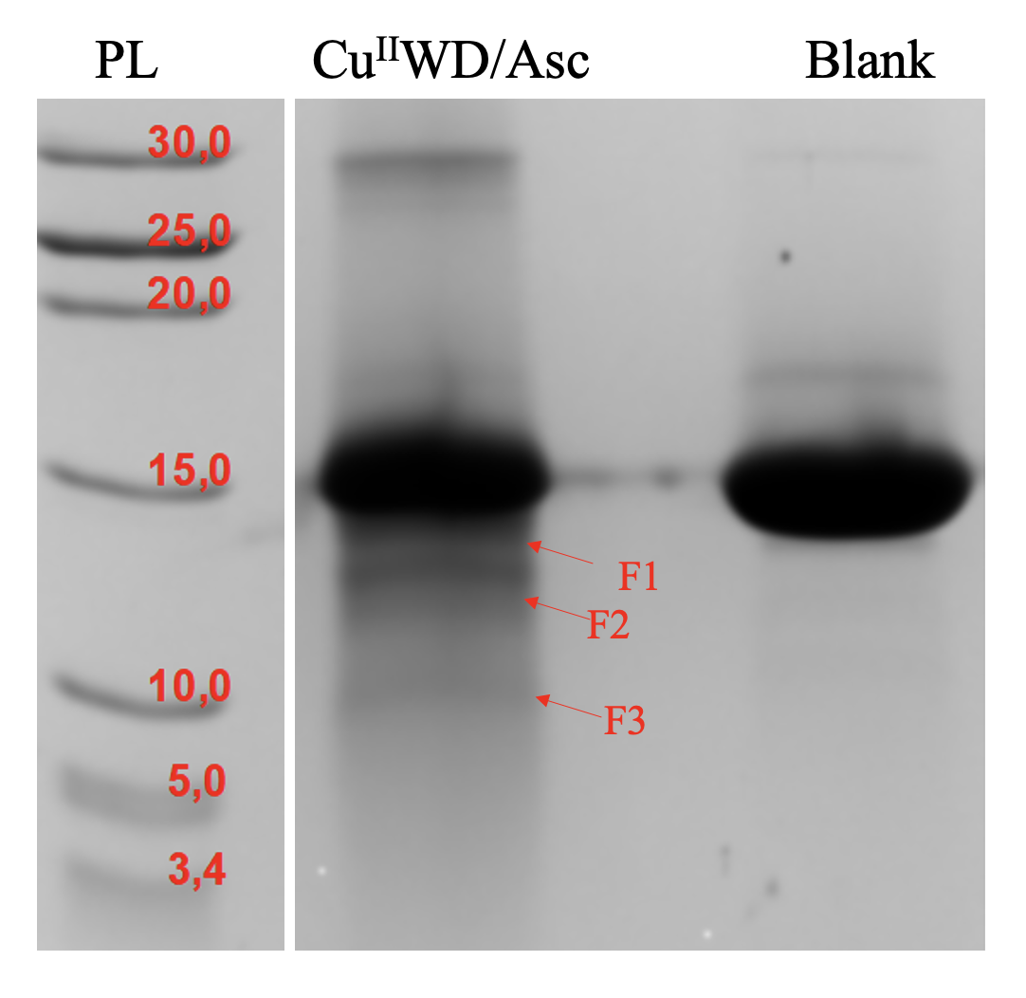
Figure S20. CBB SDS-PAGE gel of HEWL (0.04 mM) cleavage in presence of Cu^{II}WD (0.1 mM), Asc (4 mM). F1, 2 and 3 are the oxidative cleaved fragments

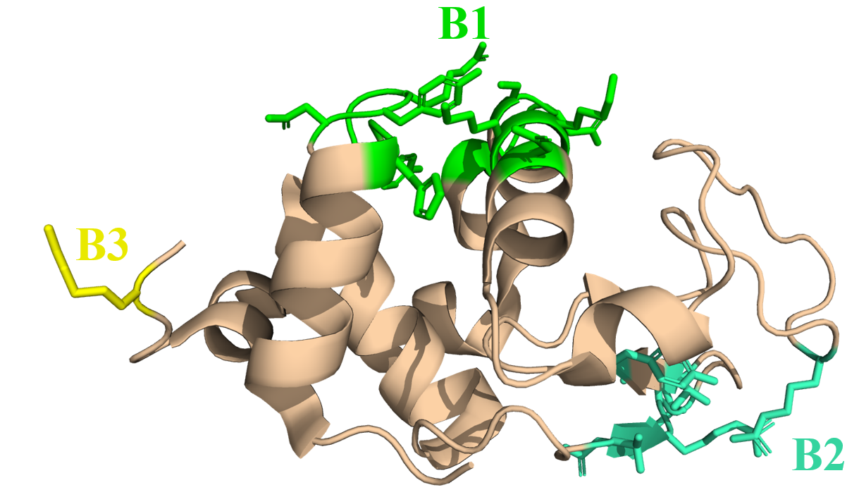

Figure S21. Cartoon representation of HEWL showing the three different binding sites: B1-[green] (His15, Gly16, Asn19, Tyr20, Arg21, Asn93, Lys96, and Lys97); B2-[greencyan] (Asn44, Arg45, Asn46, Thr47); B3-[yellow] (Arg128).
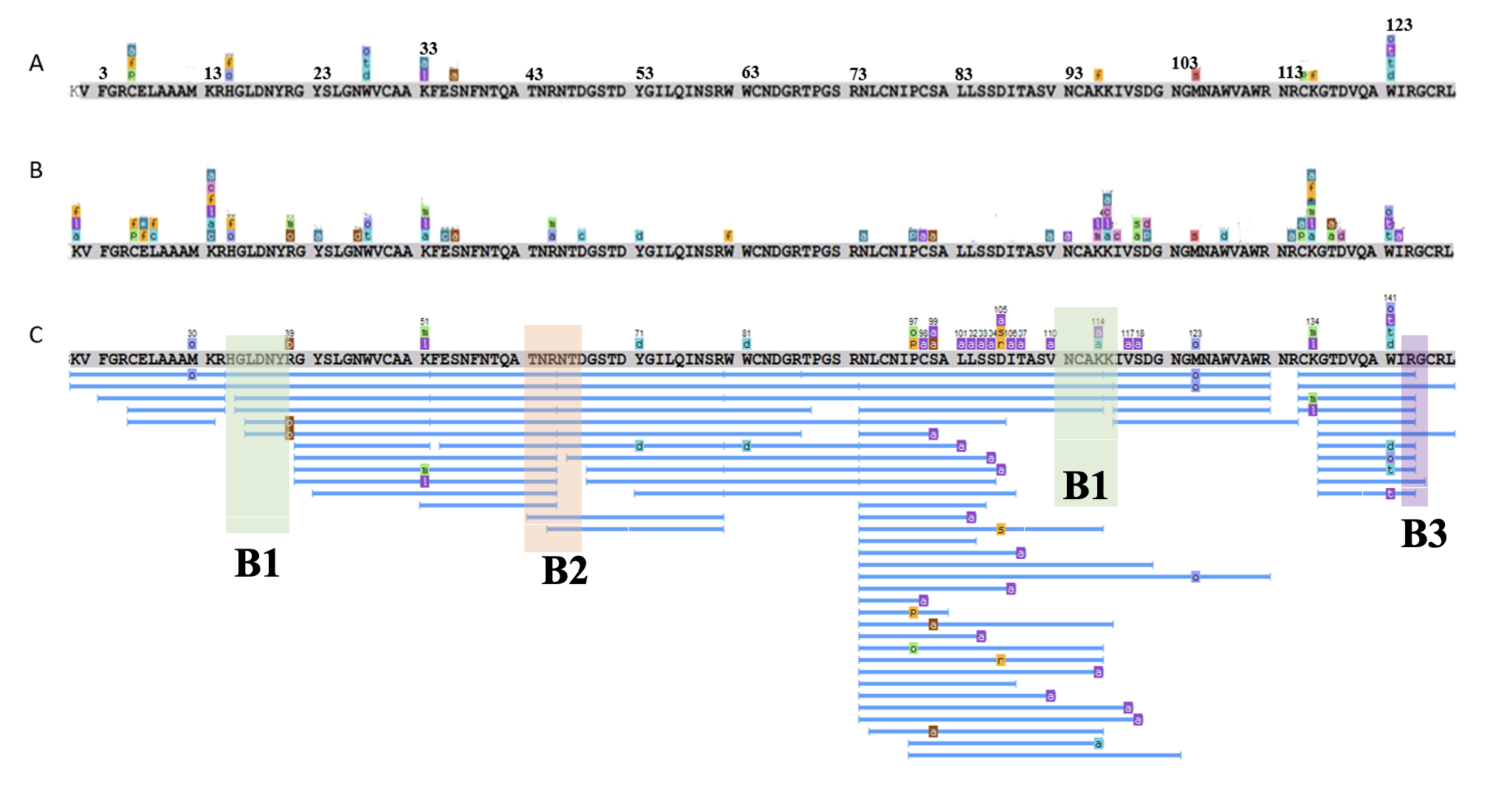
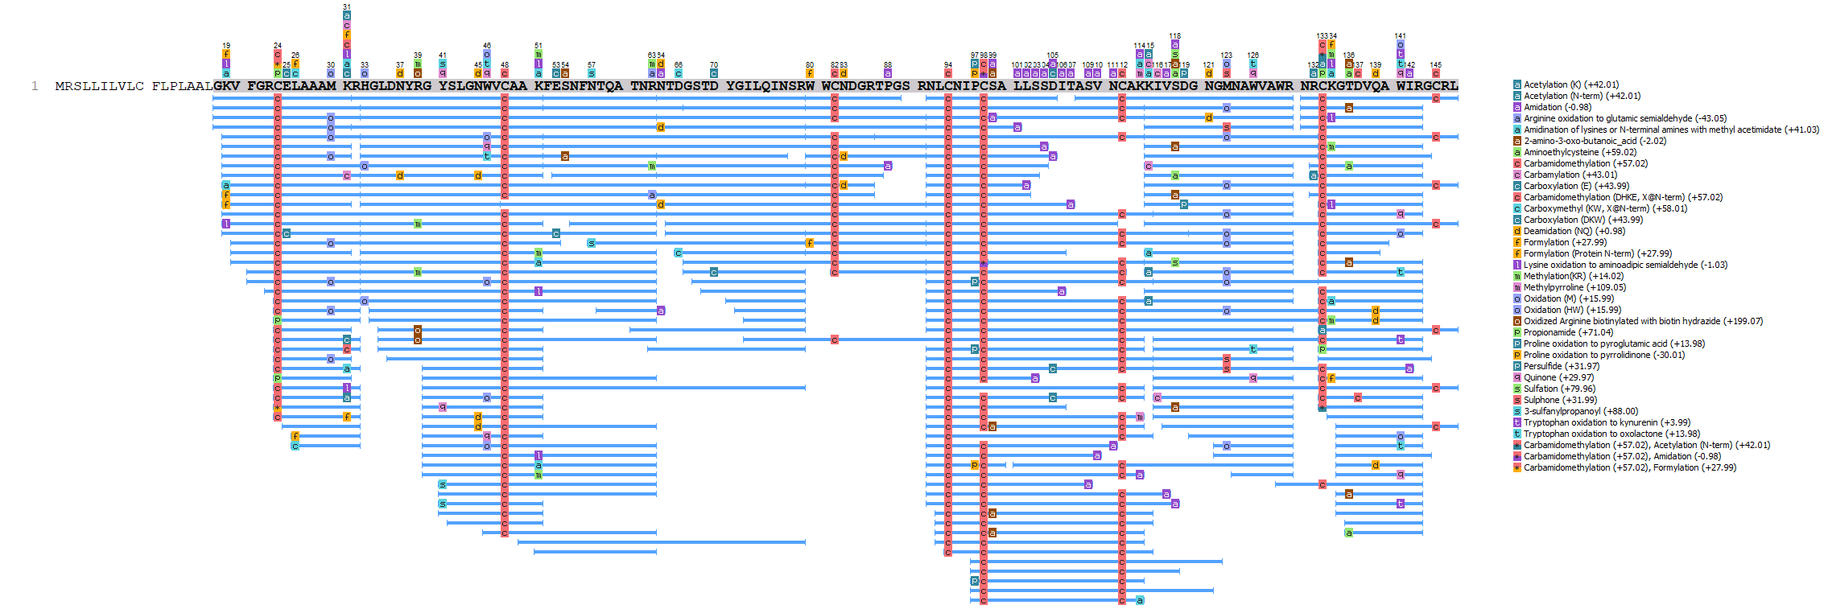
Figure S22. HEWL amino acid sequence with different modification; (A) Untreated HEWL,(B) Treated intact HEWL, (C) Coverage of HEWL sequence by Cu^{II}WD/Asc generated peptides and the different Cu^{II}WD binding sites are highlighted: Green (B1: His15, Gly16, Asn19, Tyr20, Arg21, Asn93, Lys96, and Lys97); Orange (B2: Asn44, Arg45, Asn46, Thr47); Purple (B3: Arg128).
Table S1. All peptides found only in Cu^{II}WD/Asc treated samples (F1, F2, F3). Colors corresponding to regions around binding sites: green-B1, orange- B2, purple- B3.
Entry | Peptide | Start | End | PTM | Sample
1 | V.FGRC(+57.02)ELAAAM(+15.99)KR.H | 3 | 14 | Carbamidomethylation; Oxidation (M) | F1
2 | V.FGRC(+57.02)ELAAAMKR.H | 3 | 14 | Carbamidomethylation | F1
3 | V.FGRC(+57.02)ELAAAMKR.H | 3 | 14 | Carbamidomethylation | F3
4 | G.RC(+57.02)ELAAAMKR.H | 5 | 14 | Carbamidomethylation | F1, F3
5 | R.C(+71.04)ELAAAMKR.H | 6 | 14 | Propionamide | F1
6 | R.C(+57.02)ELAAAMKR.H | 6 | 14 | Carbamidomethylation | F1, F2, F3
7 | R.C(+57.02)ELAAAMK(+57.02)R.H | 6 | 14 | Carbamidomethylation; Carbamidomethylation (DHKE X@N-term) | F1
8 | E.L(+27.99)AAAMKR.H | 8 | 14 | Formylation | F1
9 | E.L(+58.01)AAAMKR.H | 8 | 14 | Carboxymethyl (KW X@N-term) | F1
10 | H.GLDNYRGYSLGNWVC(+57.02)AAK.F | 16 | 33 | Carbamidomethylation | F1, F2, F3
11 | H.GLDNYRGYSLGNWVC(+57.02)AAK.F | 16 | 33 | Carbamidomethylation | F1
12 | G.LDNYRGYSLGNWVC(+57.02)AAKFESNFNTQATNR.N | 17 | 45 | Carbamidomethylation | F1, F2,
13 | G.LDNYRGYSLGNWVC(+57.02)AAK.F | 17 | 33 | Carbamidomethylation | F1
14 | G.LDNYRGYSLGNWVC(+57.02)AAK.F | 17 | 33 | Carbamidomethylation | F1
15 | G.LDNYRGYSLGNWVC(+57.02)AAK.F | 17 | 33 | Carbamidomethylation | F1, F2,
16 | G.Y(+79.97)SLGNWVC(+57.02)AAKFESNFNTQATNR.N | 23 | 45 | Carbamidomethylation | F1, F2
17 | G.Y(+88.00)SLGNWVC(+57.02)AAKFESNFNTQATNR.N | 23 | 45 | 3-sulfanylpropanoyl; Carbamidomethylation | F1
18 | G.Y(+88.00)SLGNWVC(+57.02)AAK.F | 23 | 33 | 3-sulfanylpropanoyl; Carbamidomethylation | F2
19 | Y.SLGNWVC(+57.02)AAK.F | 24 | 33 | Carbamidomethylation | F2
20 | N.WVC(+57.02)AAKFESNFNTQATNR.N | 28 | 45 | Carbamidomethylation | F2, F3
21 | N.WVC(+57.02)AAKFESNFNTQATNR.N | 28 | 45 | Carbamidomethylation | F2
22 | V.CAAKFESNFNTQATNR.N | 30 | 45 |  | F2
23 | A.K(+97.02)FESNFNTQATNR.N | 33 | 45 | Maleimide | F2
24 | A.K(+119.04)FESNFNTQATNR.N | 33 | 45 | Pyridylacetyl | F2
25 | F.ESNFNTQATNR.N | 35 | 45 |  | F2, F3
26 | F.N(+88.00)TQATNRNTDGSTDYGILQINSR.W | 39 | 61 | 3-sulfanylpropanoyl | F2
27 | N.TQATNRN(-.98).T | 40 | 46 | Amidation | F2
28 | A.TNRNTDGSTDYGILQINSR.W | 43 | 61 |  | F2
29 | R.NTDGSTDYGILQIN.S | 46 | 59 |  | F2, F3
30 | N.TDGSTDYGILQINSR.W | 47 | 61 |  | F2
31 | N.TDGSTDYGILQINSRWWC(+57.02)NDGRTPGSR.N | 47 | 73 | Carbamidomethylation | F2
32 | N.T(+57.02)DGSTDYGILQINSR.W | 47 | 61 | Carbamidomethylation | F2
33 | T.D(+58.01)GSTDYGILQINSR.W | 48 | 61 | Carboxymethyl (KW X@N-term) | F2
34 | D.GSTD(+57.02)YGILQINSR.W | 49 | 61 | Carbamidomethylation | F2, F3
35 | D.GSTD(+43.99)YGILQINSR.W | 49 | 61 | Carboxylation (DKW) | F2
36 | R.WWC(+57.02)NDGRTP(-.98).G | 62 | 70 | Carbamidomethylation; Amidation | F2
37 | R.WWC(+57.02)NDGRTPG.S | 62 | 71 | Carbamidomethylation | F2
38 | R.NLC(+57.02)NIPC(+57.02)SALLSSDITASVNC(+57.02)AKKIV(-.98).S | 74 | 99 | Carbamidomethylation; Amidation | F2
39 | R.NLC(+57.02)NIPC(+57.02)SALLS(-.98).S | 74 | 85 | Carbamidomethylation; Amidation | F2, F3
40 | R.NLC(+57.02)NIPC(+57.02)S(-.98).A | 74 | 81 | Carbamidomethylation; Amidation | F2
41 | R.NLC(+57.02)NIPC(+57.02)(-.98).S | 74 | 80 | Carbamidomethylation; Amidation | F2
42 | R.NLC(+57.02)NIPC(+57.02)SALLSSDITASV(-.98).N | 74 | 92 | Carbamidomethylation; Amidation | F2
43 | R.NLC(+57.02)NIPC(+57.02)SALLSS(-.98).D | 74 | 86 | Carbamidomethylation; Amidation | F2
44 | R.NLC(+57.02)NIPC(+57.02)SALL(-.98).S | 74 | 84 | Carbamidomethylation; Amidation | F2, F3
45 | R.NLC(+57.02)NIPC(+57.02)SALLSSDI(-.98).T | 74 | 88 | Carbamidomethylation; Amidation | F2
46 | R.NLC(+57.02)NIPC(+57.02)SALLSSD(-.98).I | 74 | 87 | Carbamidomethylation; Amidation | F2
47 | R.NLC(+57.02)NIPC(+57.02)SALLSSDI.T | 74 | 88 | Carbamidomethylation | F2
48 | R.NLC(+57.02)NIPC(+57.02)SALLSS.D | 74 | 86 | Carbamidomethylation | F2
49 | R.NLC(+57.02)NIPC(+57.02)SALLSSDI.T | 74 | 88 | Carbamidomethylation | F2, F3
50 | R.NLC(+57.02)NIPC(+57.02)SALL.S | 74 | 84 | Carbamidomethylation | F2, F3
51 | R.NLC(+57.02)NIPC(+57.02)SAL(-.98).L | 74 | 83 | Carbamidomethylation; Amidation | F2
52 | R.NLC(+57.02)NIPC(+57.02)SALLSSDITASVNC(+57.02)AKKIVS(-.98).D | 74 | 100 | Carbamidomethylation; Amidation | F2
53 | R.NLC(+57.02)NIP(-30.01)C(+57.02)SA.L | 74 | 82 | Carbamidomethylation; Proline oxidation to pyrrolidinone | F2, F3
54 | R.NLC(+57.02)N(+.98)IPC(+57.02)SALLSSDITASVNC(+57.02)AKKIVSD.G | 74 | 101 | Carbamidomethylation, Deamidation | F2
55 | R.NLC(+57.02)NIPC(+57.02)SALLS.S | 74 | 85 | Carbamidomethylation | F2
56 | R.NLC(+57.02)NIPC(+57.02)SALLSSDIT(-.98).A | 74 | 89 | Carbamidomethylation; Amidation | F2
57 | R.NLC(+57.02)NIPC(+57.02)SALLSSDITASVNC(+57.02)AKK(+57.02).I | 74 | 97 | Carbamidomethylation | F2
58 | R.NLC(+57.02)NIPC(+57.02)SALLSSDITAS(-.98).V | 74 | 91 | Carbamidomethylation; Amidation | F2
59 | R.NLC(+57.02)NIPC(+57.02)S(-18.01)ALL.S | 74 | 84 | Carbamidomethylation; Dehydration | F2
60 | N.LC(+57.02)NIPC(+57.02)SALLSSD(+57.02)ITASVNC(+57.02)AK.K | 75 | 96 | Carbamidomethylation | F2
61 | N.LC(+57.02)NIPC(+57.02)SALLSSDITASVNC(+57.02)AK.K | 75 | 96 | Carbamidomethylation | F2
62 | N.LC(+57.02)NIPC(+57.02)S(+126.10)ALLSSDITASVNC(+57.02)AK.K | 75 | 96 | Carbamidomethylation | F2
63 | N.LC(+57.02)NIPC(+57.02)S(+136.00)ALLSSDITASVNC(+57.02)AKK.I | 75 | 97 | Carbamidomethylation | F2
64 | N.LC(+57.02)NIPC(+57.02)SALLS(+154.00)SDITASVNC(+57.02)AK.K | 75 | 96 | Carbamidomethylation | F2
65 | N.LC(+57.02)NIPC(+57.02)S(+121.04)ALLSSDITASVNC(+57.02)AK.K | 75 | 96 | Carbamidomethylation | F2
66 | N.LC(+57.02)NIPC(+57.02)S(+79.97)ALLSSD(+57.02)ITASVNC(+57.02)AK.K | 75 | 96 | Carbamidomethylation | F2
67 | N.LC(+57.02)NIPC(+57.02)S(+59.02)ALLSSDITASVNC(+57.02)AKK.I | 75 | 97 | Carbamidomethylation | F2
68 | L.C(+57.02)NIPC(+57.02)S(+380.15)ALLSSDITASVNC(+57.02)AKK.I | 76 | 97 | Carbamidomethylation | F2
69 | I.P(+13.98)C(+57.02)SALLSSDITASVNC(+57.02)AK.K | 79 | 96 | Proline oxidation to pyroglutamic acid; Carbamidomethylation | F2
70 | I.PC(+57.02)SALLSSDITASVNC(+57.02)AKK(+31.99)IVSDGN.G | 79 | 103 | Carbamidomethylation | F2
71 | I.PC(+57.02)SALLSSDITASVNC(+57.02)AKK(+14.02)IVS(+79.97).D | 79 | 100 | Carbamidomethylation | F2
72 | I.PC(+57.02)SALLSSDITASVNC(+57.02)AK(+41.03).K | 79 | 96 | Carbamidomethylation; Amidination of lysines or N-terminal amines with methyl acetimidate | F2
73 | I.PC(+57.02)SALLSSDITAS(-20.03)VNC(+57.02)AKKIVSDGNG.M | 79 | 104 | Carbamidomethylation | F2
74 | I.PC(+57.02)SALLSSDITASVNC(+57.02)AK(+27.99)KIVSDGN.G | 79 | 103 | Carbamidomethylation | F2
75 | I.PC(+57.02)SALLSSDITASVNC(+57.02)AKKIVS.D | 79 | 100 | Carbamidomethylation | F2
76 | C.SALLSSD(+61.92)ITASVNC(+57.02)AK.K | 81 | 96 | Replacement of proton by copper; Carbamidomethylation | F2
77 | T.ASVNC(+57.02)AKK(-1.03)IVSDGNGMNAWVAWR.N | 90 | 112 | Carbamidomethylation | F2
78 | I.VSDGNGMNAWVAWR.N | 99 | 112 |  | F2
79 | A.WRNRC(+57.02)K(+145.02)GTDVQAWIR.G | 111 | 125 | Carbamidomethylation; 3-(carbamidomethylthio)propanoyl | F2
80 | N.R(+42.01)C(+57.02)KGTDVQAWIR.G | 114 | 125 | Acetylation (N-term); Carbamidomethylation; | F1
81 | N.RC(+57.02)K(+117.02)GTDVQAWIR.G | 114 | 125 | Carbamidomethylation; N-Homocysteine thiolactone | F1
82 | N.RC(+57.02)KGT(+59.02)DVQAWIR.G | 114 | 125 | Carbamidomethylation; Aminoethylcysteine | F1
83 | R.C(+57.02)KGTDVQAWIRG.C | 115 | 126 | Carbamidomethylation | F1, F3
84 | R.C(+57.02)KGTDVQ(-18.01).A | 115 | 121 | Carbamidomethylation,dehydratation | F3
85 | G.T(+59.02)DVQAWIR.G | 118 | 125 | Aminoethylcysteine | F1

References
1. Lyon DK, Miller WK, Novet T, et al. Highly oxidation resistant inorganic-porphyrin analog polyoxometalate oxidation catalysts. 1. The synthesis and characterization of aqueous-soluble potassium salts of .alpha.2-P2W17O61(Mn+.cntdot.OH2)(n-10) and organic solvent soluble tetra-n-butylammoniu. J Am Chem Soc. 1991;113(19):7209-7221. doi:10.1021/ja00019a018
2. Grant K, Kassai M. Major Advances in the Hydrolysis of Peptides and Proteins by Metal Ions and Complexes. Current Organic Chemistry. 2006;10(9):1035-1049. doi:10.2174/138527206777435535
3. Tanaka F, Forster LS, Pal PK, Rupley JA. The Circular Dichroism of Lysozyme. Vol 250.; 1975.
4. Li D, Ji B, Jin J. Spectrophotometric studies on the binding of Vitamin C to lysozyme and bovine liver catalase. Journal of Luminescence. 2008;128:1399-1406. doi:10.1016/j.jlumin.2008.01.010
5. Zhou P, Zhang J, Zhang Y, et al. Generation of hydrogen peroxide and hydroxyl radical resulting from oxygen-dependent oxidation of l-ascorbic acid via copper redox-catalyzed reactions. RSC Advances. 2016;6(45):38541-38547. doi:10.1039/c6ra02843h
6. FİLİZ İMER, ALDEMİR E, KILIÇ H, SONMEZOĞLU İ, APAK R. The Protective Effect of Amino Acids on the Copper(II)−Catalyzed Autoxidation of Ascorbic Acid. International Journal of Food Properties. 2008;16(6):46-53. doi:10.1080/10942912.2010.487630
7. Törnvall U. Pinpointing oxidative modifications in proteins - Recent advances in analytical methods. Analytical Methods. 2010;2(11):1638-1650. doi:10.1039/c0ay00375a
8. Ok Kang J, Chan PC, Kesner L. Peroxidation of lysozyme treated with Cu(II) and hydrogen peroxide. Inorganica Chimica Acta. 1985;107(4):253-258. doi:10.1016/S0020-1693(00)82297-5
9. Permentier HP, Bruins AP. Electrochemical oxidation and cleavage of proteins with on-line mass spectrometric detection: Development of an instrumental alternative to enzymatic protein digestion. J Am Soc Mass Spectrom. 2004;15(12):1707-1716. doi:10.1016/j.jasms.2004.09.003
10. Marques EF, Medeiros MHG, Di Mascio P. Lysozyme oxidation by singlet molecular oxygen: Peptide characterization using [18O]-labeling oxygen and nLC-MS/MS. Journal of Mass Spectrometry. 2017;52(11):739-751. doi:10.1002/jms.3983
11. Stroobants K, Moelants E, Ly HGT, Proost P, Bartik K, Parac-Vogt TN. Polyoxometalates as a novel class of artificial proteases: Selective hydrolysis of lysozyme under physiological pH and temperature promoted by a cerium(IV) Keggin-type polyoxometalate. Chemistry - A European Journal. 2013;19(8):2848-2858. doi:10.1002/chem.201203020
12. Vandebroek L, De Zitter E, Ly HGT, et al. Protein-Assisted Formation and Stabilization of Catalytically Active Polyoxometalate Species. Chemistry - A European Journal. 2018;24(40):10099-10108. doi:10.1002/chem.201802052
13. Sereikaite J, Jachno J, Santockyte R, Chmielevski P, Bumelis VA, Dienys G. Protein scission by metal ion-ascorbate system. Protein Journal. 2006;25(6):369-378. doi:10.1007/s10930-006-9014-7
14. Uehara H, Luo S, Aryal B, Levine RL, Rao VA. Distinct oxidative cleavage and modification of bovine [Cu– Zn]-SOD by an ascorbic acid/Cu(II) system: Identification of novel copper binding site on SOD molecule. Free Radical Biology and Medicine. 2016;94:161-173. doi:10.1016/j.freeradbiomed.2016.01.020
15. Alqarni MH, Muharram MM, Alshahrani SM, Labrou NE. Copper-induced oxidative cleavage of glutathione transferase F1-1 from Zea mays. International Journal of Biological Macromolecules. 2019;128:493-498. doi:10.1016/J.IJBIOMAC.2019.01.128
16. Bridgewater JD, Vachet RW. Metal-catalyzed oxidation reactions and mass spectrometry: The roles of ascorbate and different oxidizing agents in determining Cu–protein-binding sites. Analytical Biochemistry. 2005;341(1):122-130. doi:10.1016/j.ab.2005.02.034
17. Guilloreau L, Combalbert S, Sournia-Saquet A, Mazarguil H, Faller P. Redox Chemistry of Copper–Amyloid-β: The Generation of Hydroxyl Radical in the Presence of Ascorbate is Linked to Redox-Potentials and Aggregation State. ChemBioChem. 2007;8(11):1317-1325. doi:10.1002/cbic.200700111
18. Singh RK, Oort B v., Möllers B, et al. Detection and characterization of a novel copper-dependent intermediate in a lytic polysaccharide monooxygenase. chemEurJ. 2020;26:454-463. doi:10.1101/610865
19. Tadolini B, Cabrini L. The influence of pH on OH scavenger inhibition of damage to deoxyribose by Fenton reaction. Molecular and Cellular Biochemistry. 1990;94(2):97-104. doi:10.1007/BF00214116
20. Galano A, Alvarez-Idaboy JR. Glutathione: Mechanism and kinetics of its non-enzymatic defense action against free radicals. RSC Advances. 2011;1(9):1763-1771. doi:10.1039/c1ra00474c
21. Whiteman M, Halliwell B. Thiourea and dimethylthiourea inhibit peroxynitrite-dependent damage: Nonspecificity as hydroxyl radical scavengers. Free Radical Biology and Medicine. 1997;22(7):1309-1312. doi:10.1016/S0891-5849(96)00545-X
22. Zhou P, Zhang J, Zhang Y, et al. Generation of hydrogen peroxide and hydroxyl radical resulting from oxygen-dependent oxidation of l-ascorbic acid via copper redox-catalyzed reactions. RSC Advances. 2016;6(45):38541-38547. doi:10.1039/c6ra02843h
23. Methenitis C, Skounas S, Pneumatikakis G, Morcellet M. Kinetic studies and mechanism of hydrogen peroxide catalytic decomposition by cu(II) Complexes with polyelectrolytes derived from l-alanine and glycylglycine. Bioinorganic Chemistry and Applications. 2010;2010(Ii). doi:10.1155/2010/643120
24. Perez-Benito JF. Reaction pathways in the decomposition of hydrogen peroxide catalyzed by copper(II). Journal of Inorganic Biochemistry. 2004;98:430-438. doi:10.1016/j.jinorgbio.2003.10.025
25. Koppenol WH. Chapter 1 Chemistry of iron and copper in radical reactions. New Comprehensive Biochemistry. 1994;28(C):3-24. doi:10.1016/S0167-7306(08)60437-8
26. Kim B, Jeong D, Ohta T, Cho J. Nucleophilic reactivity of a copper(II)-hydroperoxo complex. Communications Chemistry. 2019;2(1):1-6. doi:10.1038/s42004-019-0187-3
27. Su XF, Guan W, Yan LK, Su ZM. Tricopper-polyoxometalate catalysts for water oxidation: Redox-inertness of copper center. Journal of Catalysis. 2020;381:402-407. doi:10.1016/j.jcat.2019.11.025
28. Cheignon C, Collin F, Faller P, Hureau C. Is ascorbate Dr Jekyll or Mr Hyde in the Cu(Aβ) mediated oxidative stress linked to Alzheimer’s disease? Dalton Transactions. 2016;45(32):12627-12631. doi:10.1039/c6dt01979j
29. Shevchenko A, Tomas H, Havli J, Olsen J v, Mann M. In-gel digestion for mass spectrometric characterization of proteins and proteomes. Nature Protocols. 2006;1(6):2856-2860. doi:10.1038/nprot.2006.468
30. Smiljanic K, Prodic I, Apostolovic D, et al. In-depth quantitative profiling of post-translational modifications of Timothy grass pollen allergome in relation to environmental oxidative stress. Environment International. 2019;126:644-658. doi:10.1016/j.envint.2019.03.001
31. Hawkins CL, Davies MJ. Detection, identification, and quantification of oxidative protein modifications. Journal of Biological Chemistry. 2019;294(51):19683-19708. doi:10.1074/jbc.REV119.006217

