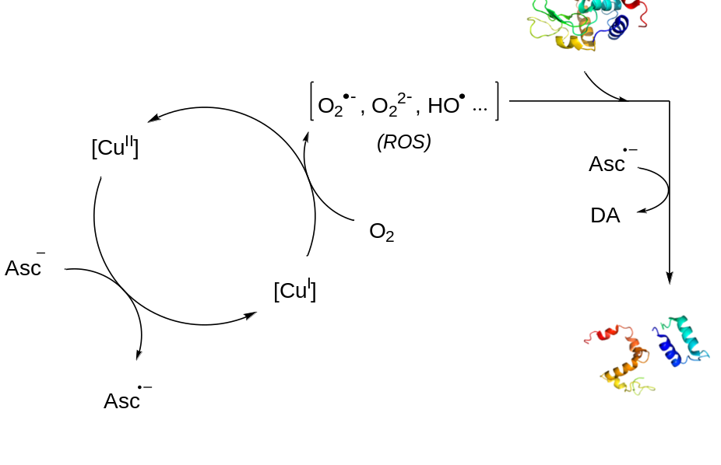
Scheme 1. Proposed mechanism of the reaction of Cu^{II} with Asc. DA = dehydroascorbic acid.

