Supplementary Materials for

The Microphysics of the Warm-rain and Ice Crystal Processes of Precipitation in Simulated Continental Convective Storms

Ashok Kumar Gupta^{a,b}, Vaughan T. J. Phillipsª, Deepak Wamanª, Sachin Patadeª, Akash Deshmukhª, Arti Jadavª, and Aaron Bansemer^{c}

ª Department of Physical Geography and Ecosystem Science, University of Lund, Lund, Sweden
^{b} Department of Earth and Environmental Sciences, Vanderbilt University, Nashville, Tennessee
^{c} National Center for Atmospheric Research, Boulder, Colorado

Correspondence to: ashok.k.gupta@vanderbilt.edu

This PDF file includes:
Materials and Methods (related to warm-rain and ice crystal processes)
Figs. S1 to S21
Supplementary texts
Table S1 (highlighting cloud radiative effects)

Materials and methods
Description of cases and experimental setup
STEPS: cold-based convective storm
Major downburst events during the STEPS campaign were reported on 19 June 2000^{27,46}. This event on 19 June forms the first case study, where convective clouds with a cloud base near 0ºC (~4-5 km altitude above MSL, with the terrain height at ~1.3 km above MSL) were observed over the Kansas–Colorado border⁴⁶.

Three-dimensional simulations are performed for a convective line spanning a horizontal area of 80 km by 80 km wide, with the convective core moving along a track through Goodland. We simulated the STEPS case for two and half hours (2345 UTC 19 June–0215 UTC 20 June 2000), with a time step of 10 seconds. The horizontal grid spacing is 1 km, and the vertical resolution is 0.5 km. In the model, the x-axis points in the direction of 70º north with the convective line parallel to the y-axis. Initialization of convection in AC was achieved using eight cold, dry air bubbles (each separated horizontally by 10 km and put 10 km apart) with maximum perturbations of moisture and temperature of 2 kg⁻¹ and 3K. Many smaller warmer bubbles with random horizontal radii were introduced, which were superimposed on the cold bubbles. Phillips et al.^{27,38} describe more about the STEPS model set up and validation (therein Figs. 1, 2 and 3 in Phillips et al.²⁷).

MC3E: slightly warm-based convective storm
The MC3E field campaign took place during April-June 2011 in Northern Oklahoma and surrounding regions for the study of convective life cycle and precipitation processes (Jensen et al., 2016). An extensive warm-season mesoscale convective system (MCS) was observed during 10-13 May 2011 with the use of ground-based (e.g., RADAR) and aircraft-based instruments (e.g., 2D cloud imaging probe, high-volume precipitation spectrometer). The MCS during this period was ~150 km wide, extending from Eastern Colorado to Western Texas. The availability of low-level moisture along with the high CAPE (> 2000 J/kg) on 11 May (~16-22 UTC) helped in developing a MCS. This storm on 11 May 2011 brought intense convective precipitation augmented by widespread rain from stratiform clouds⁵¹.

The comprehensive observation of the MCS event is simulated for the domain covering an area of 80 km x 80 km with a horizontal grid spacing of 2 km and a vertical resolution of about 0.5 km. The moisture perturbations are applied in the lowest 2 km during initialization. The time step was 10 sec. The boundary conditions were doubly periodic in the horizontal plane. The large scale advective forcings of heat and moisture were applied from MC3E observations. We use hourly data for the large scale forcing and surface fluxes of heat and moisture interpolated to the model levels to maintain convection in the MC3E simulation. The duration of the simulation was 72 hours (10 May–13 May 2011). The simulation of the convective event during 10-13 May 2011 was initialized from the observed sounding of temperature, humidity, and wind⁴⁷.

The thermodynamic structure of the sounding and the aerosol conditions contrasted between both STEPS and MC3E cases, such that the dryness of lower troposphere in STEPS created a cold cloud base. This would be expected to favor the ice-crystal process. The normalized CCN concentration (supersaturation of 1%) was observed to be about 1000-2000 cm⁻³ at 1-3 km MSL in STEPS, and 2000-2500 cm⁻³ in MC3E near the ground. The warm-rain process is controlled by average cloud droplet size and is promoted by the cloud base implied by the sounding being ~17ºC in MC3E, but the more numerous CCN solute aerosol slightly counteract this by reducing the tendency towards larger cloud droplets, relative to STEPS (cloud base of ~1ºC).

Overview of Aerosol-Cloud (AC) model
Aerosol-cloud (AC) used in this study is based on the hybrid bin/bulk (two-moment) microphysics scheme, together with interactive radiation and semi prognostic aerosol schemes. Hydrometeor species represented are water vapor, cloud droplets, cloud ice crystals, graupel/hail and snow and aerosol species are sulfate, sea salt, black carbon, mineral dust, primary biological particles, soluble organics and non- biological insoluble organics^{16,38,39,41,42,43,44}. This model can predict the droplet initiation from aerosol conditions both at cloud base and in-cloud. Both primary ice initiation, through heterogeneous nucleation by IN activity of solid aerosols or by spontaneous homogeneous freezing (colder than about -36ºC) and secondary ice initiation (via collisions, breakups, and fragmentations of different hydrometeor species) are represented in the convective storm^{27,44, 52}.

Numerous advanced modifications within cloud and aerosol microphysical process (as described in Phillips et al.14,16,18, 27, 37, 38, 41,42,43,44,52) are implemented.

In our AC model with hybrid bin/bulk microphysics treatments, many microphysical processes are represented related to initiation of ice particles and growth of precipitation with dependencies on aerosol chemistry^{18,27,37,38,39,40,41,42,43,44}.

The ice crystal and collision-coalescences processes are treated in detail. Phillips et al.³⁷ described the relative roles of nucleation processes (homogenous vs heterogenous processes) in the genesis of cloud particles in the cloud ensemble.

Various field observations, such as KWAJEX, CEPEX, TOGA COARE, STEPS, and MC3E have been used to validate AC during model development. For instance, the sticking efficiency scheme of Phillips et al.⁴³ revealed the coagulation of ice-ice collisions based on the energy conservation principle. In recent years, emphasis has been on innovation of new schemes for secondary ice productions^{16,44,45}. Phillips et al.⁴⁴ discussed that the physical formulation of the colliding ice particles in a convective storm (observed for STEPS case) based on the energy conservation approach. In this formulation, the colliding ice particles can belong to any microphysical species, such as crystals, snow, graupel, hail, or freezing drops. Phillips et al.²⁷ showed that the breakup of all ice-ice collisions contributed to enhancing the overall ice concentrations between 0ºC to -30ºC and increasing ice-precipitation via ice-crystals processes (as observed in the convective storm with cloud base ~0ºC). AC enables the investigation of the cloud properties and precipitation processes (cold and warm-rain process) and aerosol effects on the both cold and warm-rain process.

Passive tagging tracers techniques for identifying the components from warm-rain and ice crystal processes
For identifying the processes controlling precipitation, rain and graupel are tagged and tracked during the entire 3D simulation for their source types (originated by warm-rain process or ice-crystal process) using four equations below for mass mixing ratios. The tagged rain and graupel behave passively as a tracer and do not alter their prognostic variable of the model. The contributions of warm and cold precipitation components to the total surface precipitation are evaluated.

The knowledge of the particle (or drop) size distributions (PSDs) is a prerequisite for determining the precipitation production and their types^{27,53}. PSDs can be well-represented by the gamma distributions for convective and stratiform rain in tropical regions^{54,55}. Information of PSDs in AC is characterized based on both gamma and exponential distributions using the temperature-dependent intercept (N_{o}), slope ($Λ$), and dispersion or shape ($μ$) parameters for different mass- and size- dependent hydrometeor species^{16,27,37,38,44,54,56} (e.g., cloud liquid, ice, graupel/hail, snow).

The gamma distribution has the advantage of better characterizing graupel/hail size distributions where there are few small particles^{55,57,58,59,60}. The general gamma distribution PSDs model for cloud ice and cloud water ($x=w, i$) and precipitation estimation is described as:
$$n\left(D_{x}\right)=n_{o,x}D_{x}^{μ_{x}}\exp\left(-{\text{Λ}}_{\text{x}}D_{x}\right)$$
where $n_{o,x}$ ($m^{-3}{mm}^{-1}$) is the intercept parameter and $Λ_{x}\left({mm}^{-1}\right)$ is the slope parameter, $D_{x}$ is the spherical diameter (m), and $μ_{x}$ is the shape factor. The intercept values $n_{o,x}$ for $x=g \left(graupel\right), s\left(snow\right), r(rain)$ are incorporated based on the double moment approach and the field observations^{37,53,54,61,62}.The continuity equation covering both mass and particle mixing ratios for prognostic variables (e.g., vapor, cloud liquid, and cloud ice) are described in Phillips et al.⁴⁰, representing some of the source terms depicted in Fig. 1. Rain size distributions are influenced by whether they originate from the ice crystal process and warm-rain process (e.g., collision–coalescence).

Warm-rain process tendencies
In nature, conversion of cloud liquid to rain occurs by coalescence and depends on the mean droplet size implied by the predicted droplet number and on the dispersion of droplets size distribution^{63,64,65,66,67}. According to Kogan et al.⁶⁷, the new parametrized autoconversion suitable for deep convection, is given as:
$$A_{u}\left(\left.{q_{r};q}_{w}\right|q_{w}\right)={\left(\frac{{dq}_{r}}{dt}\right)}_{autoconversion}=7.98×{10}^{10}×{q_{w}}^{4.22}×{N_{w}}^{-3.01}$$

Here, $\frac{{dq}_{r}}{dt}\left({kg kg}^{-1}s^{-1}\right)$is the conversion tendencies for the cloud liquid mixing ratio; $q_{w}{(kg kg}^{-1})$ is the cloud liquid mixing ratio; $N_{w}\left({ cm}^{-3}\right)$ is the cloud drop concentration. Terminology of $A_{u}\left(\left.{q_{r};q}_{w}\right|q_{w}\right)$and other related terms are described in table 1 below.

Components from the warm-rain process (denoted by subscript “warm”) and ice crystal process (denoted by subscript “cold”) of precipitation production are evaluated using passive tagging tracers for rain and graupel.

In a slightly warm-based cloud, the conversion of cloud water to rain and melting of graupel can contribute to the warm-rain process of precipitation^{13,26,28,29}. Identification of the warm-rain components of graupel and rain prognostic variables are tracked as follows:

$${\left(\frac{∂q_{r_warm}}{∂t}\right)}_{mic}=$$
${{A_{u}\left(\left.{q_{r};q}_{w}\right|q_{w}\right)+{Υ_{g_warm}M}_{e}\left(q_{r};q_{g}\right)+ Υ}_{r_warm}A}_{c}\left(\left.{q_{r};q}_{w}\right|q_{r}\right)-{{Υ_{g_warm}A}_{c}\left(\left.{q_{g};q}_{r}\right|q_{g}\right)}_{q_{g}>q_{r}}-{{Υ_{r_warm}A}_{c}\left(\left.{q_{g};q}_{r}\right|q_{g}\right)}_{q_{r}>q_{g}}-\sum_{x=s,i}{{Υ_{r_warm}A}_{c}\left(\left.{q_{g};q}_{x}\right|q_{r}\right)-\sum_{x=g,s}{{Υ_{r_warm}A}_{c}{\left(\left.{q_{w};q}_{r}\right|q_{x}\right)}_{Splash}} }$…………… (1)

$${\left(\frac{∂q_{g_warm}}{∂t}\right)}_{mic}=$$
${Υ_{g_warm}A}_{c}\left(\left.{q_{g};q}_{w}\right|q_{g}\right)+{Υ_{r_warm}A}_{c}\left(\left.{q_{g};q}_{r}\right|q_{i}\right)+{Υ_{r_warm}A}_{c}\left(\left.{q_{g};q}_{r}\right|q_{s}\right)+{{{{Υ_{g_warm}A}_{c}\left(\left.{q_{g};q}_{i}\right|q_{g}\right)+Υ}_{g_warm}A}_{c}\left(\left.{q_{g};q}_{r}\right|q_{g}\right)}_{q_{g}>q_{r}}+{{Υ_{r_warm}A}_{c}\left(\left.{q_{g};q}_{r}\right|q_{g}\right)}_{q_{r}>q_{g}}-{Υ_{g_warm}M}_{e}\left(q_{r};q_{g}\right)-Υ_{g_warm}HM\left(\left.{q_{i};q}_{w}\right|q_{g}\right)-\sum_{x=g,h}{Υ_{g_warm}N\left(\left.{q_{i};q}_{x}\right|q_{x}\right)}-\sum_{x=g,s,i}{{Υ_{g_warm}N}_{RF1}\left(\left.{q_{i};q}_{r}\right|q_{x}\right)-\sum_{x=g,i}{{Υ_{g_warm}N}_{RF1}\left(\left.{q_{i};q}_{w}\right|q_{x}\right)-{Υ_{g_warm}N}_{RF2}\left(\left.{q_{i};q}_{r}\right|q_{g}\right) } }$ …………... (2)
The positive signs in Eqs. (1) and (2) represent the source terms, whereas the negative signs indicate the sink terms. Table 1 describes the above symbols used for different microphysical conversion terms. AC using passive tagging tracer techniques, enabling to estimate the precipitation types. The$Υ_{r_warm}$ and $Υ_{g_warm}$ are defined as:
$${Υ_{r_warm}= q}_{r_warm}/q_{r}$$
$${Υ_{g_warm}= q}_{g_warm}/q_{g}$$
Here, $Υ_{g_warm}$ is the warm fraction of graupel component and $Υ_{r_warm}$ is the warm fraction of rain component.

The details of these microphysical conversion terms can be found below in Table 1, and some of these terms are also described in Phillips et al.14,16,18, 27, 37, 38, 41,42,43,44,5214,16,18, 27, 37, 38, 41,42,43,44,52.

Ice crystal process tendencies
The ice crystal process drives precipitation production if the cloud base is not too warm, depending on the aerosol conditions. The various microphysical processes associated with the growth of ice crystals to snow (through aggregation and vapor growth) and to graupel ("cold graupel") by riming contribute to the production of "cold" precipitation. For instance, the melting associated with snow and cold graupel which originate from ice crystals (Fig. 1) contributes to cold rain production^{38,67}. These processes are also highlighted in Fig. 1.

Similar to the rain and graupel diagnostic variables in the warm-rain process, we have characterized tendencies equations related to the cold components of mass mixing ratio. These are:
$${\left(\frac{∂q_{r_cold}}{∂t}\right)}_{mic}=$$
${Υ_{r_cold}A}_{c}\left(\left.{q_{r};q}_{w}\right|q_{r}\right){{+Υ}_{g_cold}M}_{e}\left(q_{r};q_{g}\right){+M}_{e}\left(q_{r};q_{s}\right){+ A}_{c}\left(\left.{q_{r};q}_{w}\right|q_{s,i}\right)-A_{c}\left(\left.{q_{s};q}_{r}\right|q_{s}\right)-{{Υ_{g_cold}A}_{c}\left(\left.{q_{g};q}_{r}\right|q_{g}\right)}_{q_{g}>q_{r}}-{{Υ_{r_cold}A}_{c}\left(\left.{q_{g};q}_{r}\right|q_{g}\right)}_{q_{r}>q_{g}}-\sum_{x=s,i}{{Υ_{r_cold}A}_{c}\left(\left.{q_{g};q}_{r}\right|q_{x}\right)-\sum_{x=g,s}{{Υ_{r_cold}A}_{c}{\left(\left.{q_{w};q}_{r}\right|q_{x}\right)}_{Splash}}}$……………. (3)

$${\left(\frac{∂q_{g_cold}}{∂t}\right)}_{mic}=$$
$A_{u}\left(\left.{q_{g};q}_{s}\right|q_{s}\right)+Ac\left(\left.{q_{g};q}_{w}\right|q_{i}\right)+Ac\left(\left.{q_{g};q}_{s}\right|q_{g}\right)+{Υ_{g_cold}A}_{c}\left(\left.{q_{g};q}_{w}\right|q_{g}\right)+{Υ_{r_cold}A}_{c}\left(\left.{q_{g};q}_{r}\right|q_{i}\right)+{{{{Υ_{g_cold}A}_{c}\left(\left.{q_{g};q}_{i}\right|q_{g}\right)+Υ}_{g_cold}A}_{c}\left(\left.{q_{g};q}_{r}\right|q_{g}\right)}_{q_{g}>q_{r}}+{{Υ_{r_cold}A}_{c}\left(\left.{q_{g};q}_{r}\right|q_{g}\right)}_{q_{r}>q_{g}}-{Υ_{g_{cold}}M}_{e}\left(q_{r};q_{g}\right)-Ac\left(\left.{q_{s};q}_{g}\right|q_{s}\right)-Υ_{g_{cold}}HM\left(\left.{q_{i};q}_{w}\right|q_{g}\right)-\sum_{x=g,h}{Υ_{g_{cold}}N\left(\left.{q_{i};q}_{x}\right|q_{x}\right)}-\sum_{x=g,s,i}{{Υ_{g_{cold}}N}_{RF1}\left(\left.{q_{i};q}_{x}\right|q_{r}\right)-\sum_{x=g,i}{{Υ_{g_{cold}}N}_{RF1}\left(\left.{q_{i};q}_{w}\right|q_{x}\right)-{Υ_{g_{cold}}N}_{RF2}\left(\left.{q_{i};q}_{r}\right|q_{g}\right) }}$………….... (4)

Similar to equations (1) and (2), the positive signs in equations (3) and (4) represent the source terms, whereas the negative signs indicate the sink terms. The$Υ_{r_cold}$ and $Υ_{g_cold}$ are defined as:
$${Υ_{r_cold}= q}_{r_cold}/q_{r}$$
$${Υ_{g_cold}= q}_{g_cold}/q_{g}$$
Here, $Υ_{g_cold}$ is the cold fraction of graupel component and $Υ_{r_cold}$ is the cold fraction of rain component. The equations relating to number mixing ratios associated with cold components of rain and graupel described are described below.

Similarly, we can also write the tendencies equations related number mixing ratios (in kg⁻¹s⁻¹) of rain and graupel.

Table 1. The symbols used for denoting tendencies equations related to the warm and cold components of mass mixing ratios of rain and graupel are defined in the same fashion as in Phillips et al.³⁷ (therein Table 1). In parentheses, the first symbol represents the final genesis of the species and the symbol after the semicolon indicates the initial interacting species. Tendencies for microphysical hydrometeor species of mass mixing ratios are in kg kg⁻¹s⁻¹. $HM$represents Hallett and Mossop process of rime-splintering, $N_{RF1}$ indicates riming-freezing (RM) of first mode, $N_{RF2}$ indicates the RM of second mode, and “Me” indicates the melting.
Symbols | Interpretations
$${ A}_{c}\left(\left.{q_{r};q}_{w}\right|q_{r}\right)$$ | Accretion of cloud liquid by rain (associated with both warm-rain & ice crystal processes)
$$A_{u}\left(\left.{q_{r};q}_{w}\right|q_{w}\right)$$ | Autoconversion of cloud liquid to rain
$$A_{u}\left(\left.{q_{g};q}_{s}\right|q_{s}\right)$$ | Conversion of snow to graupel
$${A_{c}\left(\left.{q_{g};q}_{r}\right|q_{g}\right)}_{m_{g}>m_{r}}$$ | Accretion of rain by graupel when the graupel mass is bigger than rain mass.
$${A_{c}\left(\left.{q_{g};q}_{r}\right|q_{g}\right)}_{m_{r}>m_{g}}$$ | Accretion of rain by graupel when the rain mass is bigger than graupel mass.
$$A_{c}\left(\left.{q_{g};q}_{w}\right|q_{g}\right)$$ | Riming of cloud liquid by graupel or cloud ice
$$A_{c}\left(\left.{q_{g};q}_{w}\right|q_{i}\right)$$ | Riming of cloud liquid by cloud ice, forming graupel
$$A_{c}\left(\left.{q_{g};q}_{s}\right|q_{g}\right)$$ | Accretion of snow by graupel
$$A_{c}\left(\left.{q_{g};q}_{r}\right|q_{i}\right)$$ | Accretion of cloud ice by rain, forming graupel
$$A_{c}\left(\left.{q_{g/s};q}_{s/i}\right|q_{r}\right)$$ | Accretion of rain by snow or ice, forming graupel or snow
$$A_{c}\left(\left.{q_{g};q}_{i}\right|q_{g}\right)$$ | Accretion of cloud ice by graupel
$$A_{c}\left(\left.{q_{w};q}_{r}\right|q_{g}\right)$$ | Accretion of graupel by rain, forming cloud water via splashing
$$A_{c}\left(\left.{q_{w};q}_{r}\right|q_{s}\right)$$ | Accretion of snow by rain, forming cloud water via splashing
$$A_{c}\left(\left.{q_{g/s};q}_{r}\right|q_{s}\right)$$ | Accretion of rain by snow (forming graupel or snow)
$$A_{c}\left(\left.{q_{r};q}_{w}\right|q_{s}\right)$$ | Riming of cloud liquid by snow contributing to cold-rain (ice-crystal process)
$$A_{c}\left(\left.{q_{r};q}_{w}\right|q_{i}\right)$$ | Riming of cloud liquid by cloud ice, contributing to cold-rain (ice-crystal process)
$$HM\left(\left.{q_{i};q}_{w}\right|q_{g}\right)$$ | Rime splintering of graupel producing cloud-ice particles
$$N\left(\left.{q_{i};q}_{g,h}\right|q_{g,h}\right)$$ | Ice fragments from graupel-graupel/hail-hail collisions
$$N_{RF1}\left(\left.{q_{i};q}_{r}\right|q_{i/s/g}\right)$$ | Accretion of rain by ice/snow/graupel, forming ice particles via riming-freezing process of first mode¹⁶
$$N_{RF1}\left(\left.{q_{i};q}_{w}\right|q_{g,i}\right)$$ | Accretion of cloud liquid by ice/graupel, forming ice particles via riming-freezing process of first mode¹⁶
$$N_{RF2}\left(\left.{q_{i};q}_{r}\right|q_{g}\right)$$ | Accretion of rain by graupel, forming ice particles via riming-freezing process of second mode¹⁶
$$M_{e}\left(q_{r};q_{s}\right)$$ | Melting of snow to form cold rain (associated with ice-crystal process)
$$M_{e}\left(q_{r};q_{g}\right)$$ | Melting of snow to form warm rain (associated with warm-rain process) or cold rain (associated with ice-crystal process)

Techniques adopted for conducting low CB and no-SIP sensitivity simulations
As stated above, the low CB simulation is conducted by lowering cloud base without altering the in-cloud ascent statistics. This constancy of in-cloud ascent was achieved by increasing both the relative humidity in the lower troposphere (from 22% to 59% for STPES and from 48% to 99% for MC3E at the surface) and the environmental temperature at all in-cloud levels (by up to ~18 K for STEPS and ~11K for MC3E), compared to the initial sounding used to start the simulation. For the humidity, this increment in vapor mass was proportional to a height-dependent factor which was unity below 3 km MSL and zero above 4 km MSL, being linearly interpolated in between. For the temperature, the increment was proportional to another height-dependent factor that was proportional to a quadratic function of height, being zero at both cloud base and the maximum cloud top level and unity mid-way in between⁶⁹. The convective available potential energy (CAPE) of the initial environment was increased from 710 J/kg to about 6000 J/kg for the STEPS and from 3581 J/kg to about 12000 J/kg for the MC3E. Such a high increase in CAPE is expected for the invariance of ascent statistics because the lower the cloud base the weaker the efficiency of conversion of CAPE to updraft kinetic energy^{69,70}.

For no-SIP sensitivity simulations, the four secondary ice formation mechanisms were prohibited. These include breakup in ice–ice collisions (mechanical breakup^{27,44}), rime splintering⁶, fragmentation of freezing rain/drizzle by Modes 1 and 2 (raindrop freezing fragmentation¹⁶), and sublimation breakup⁴⁵.

Figures S1 to S18
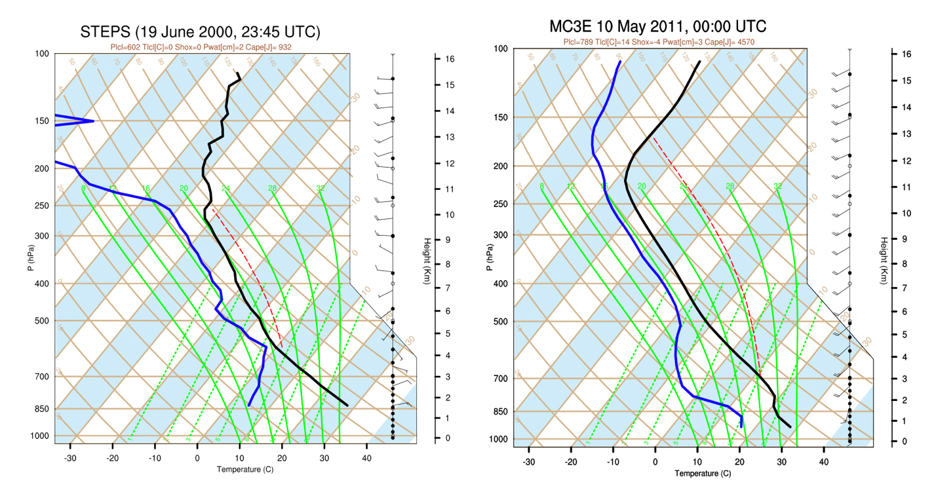
Figure S1: The skew-T plot for STEPS case on 19 June 200 at 23:45 UTC (left panel) and for MC3E case on 10 May 2011 at 00:00 UTC (right panel). The solid black line represents air temperature. The solid blue line indicates the dew point temperature. A dotted red line represents moist adiabat.

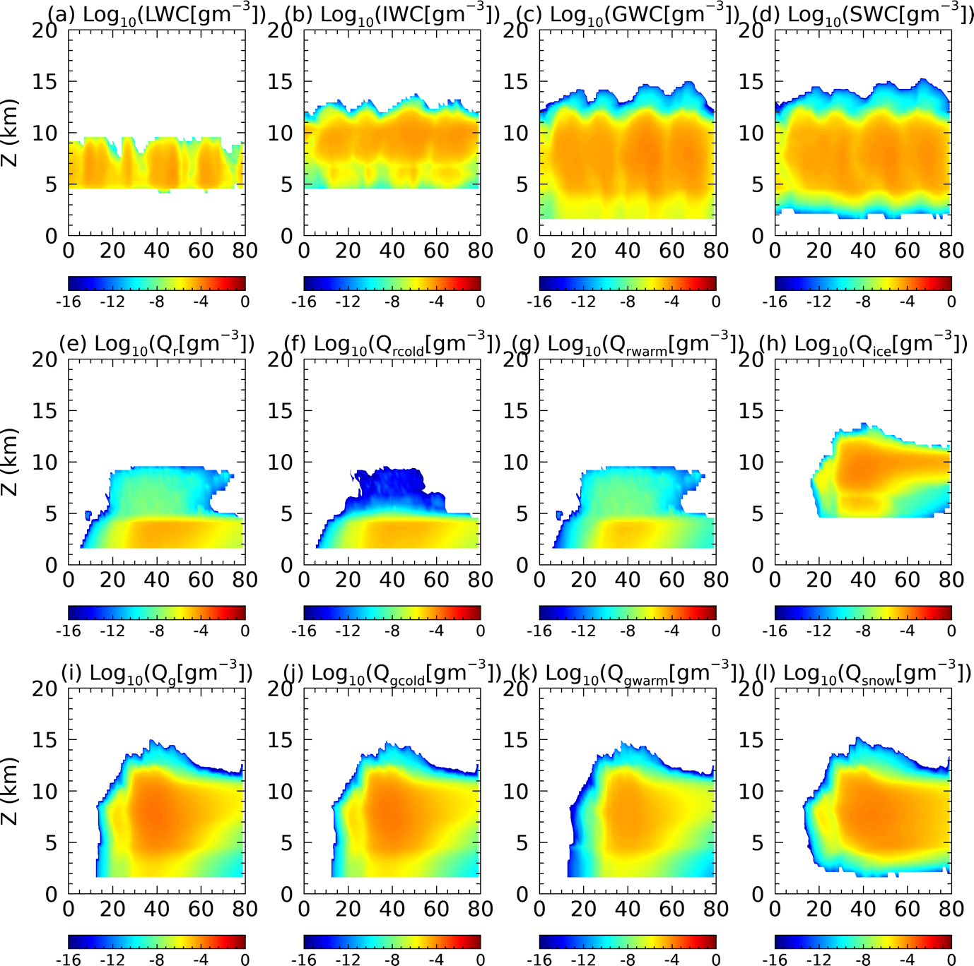
Figure S2: Zonal mean of the conditional average of various quantities (in regions with either clouds or precipitation) over time and height: (a-d) contents of cloud liquid (LWC), cloud ice (IWC), graupel (GWC) and snow (SWC); (e) rain mass mixing ratio ($Q_{g}$) and their (f) warm ($Q_{gwarm}$) and (g) cold ($Q_{gcold}$) components; (h) ice mass mixing ratio ${(Q}_{ice})$; (i) graupel mass mixing ratio ${(Q}_{g})$ and their (j) warm ($Q_{gwarm}$) and (k) cold ${(Q}_{gcold})$ components and (l) snow mass mixing ratio ($Q_{snow}$). This is for cold-based convective storms in the control run of the STEPS case during 2345 UTC 19 Jun–0215 UTC 20 Jun 2000 (except without the first hour of simulation). All variables related to mixing ratios and paths are at logarithm scale with base 10.

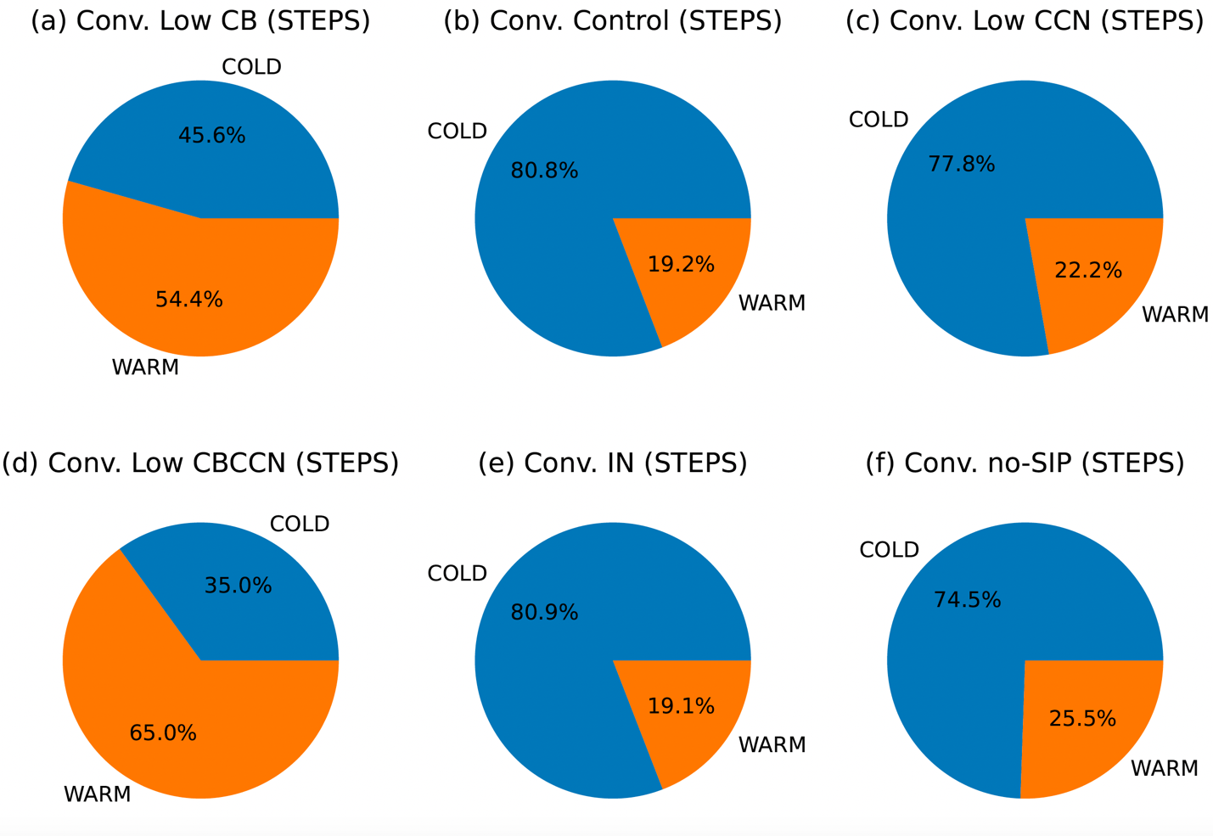
Figure S3: Same as Figure 9 but for precipitation over convective region.
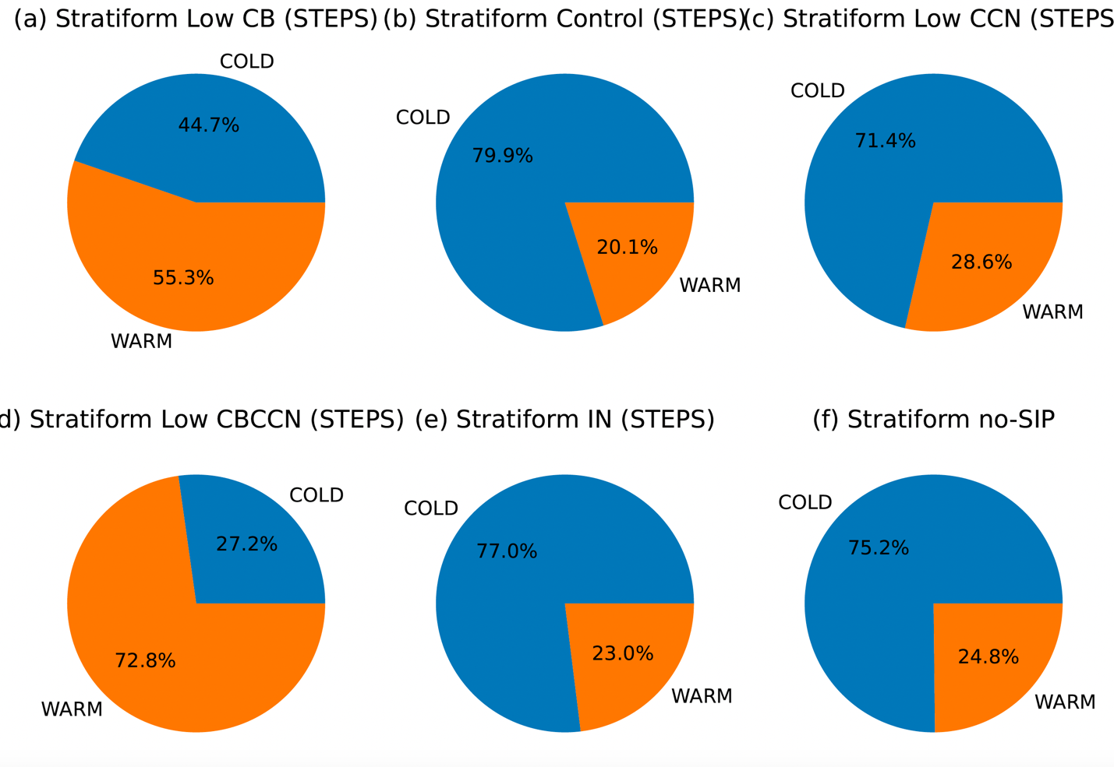
Figure S4: Same as Figure S3 but for precipitation over stratiform region.
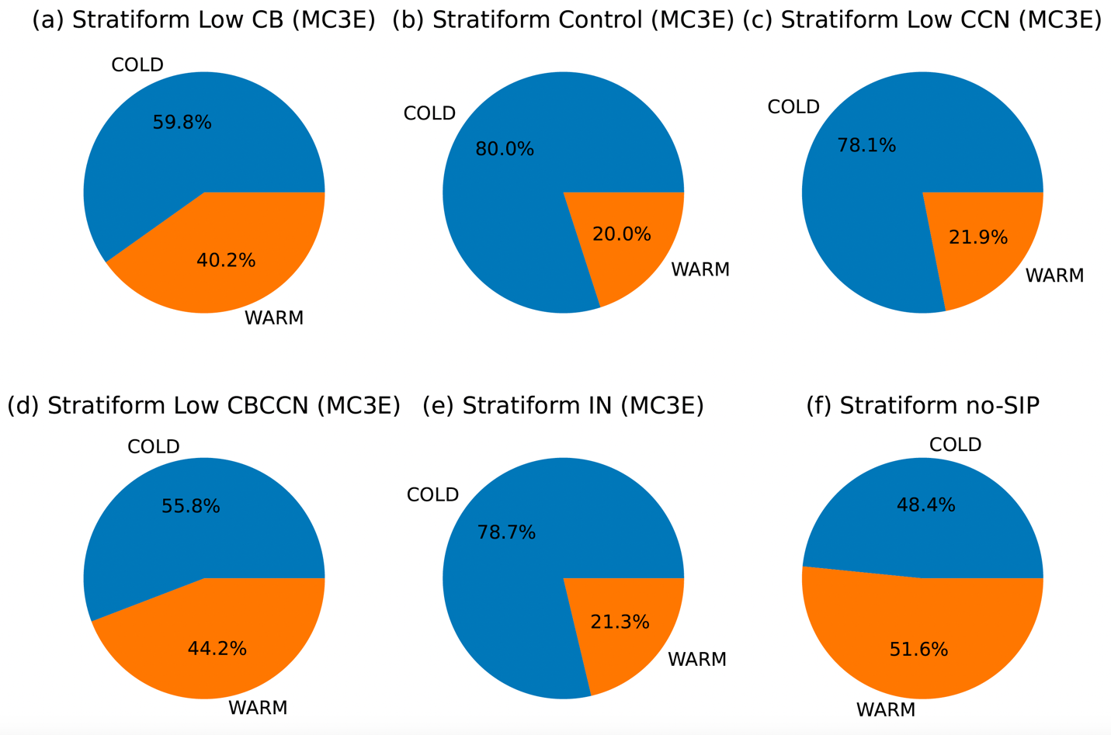
Figure S5: Same as Figure S4 but for MC3E case.

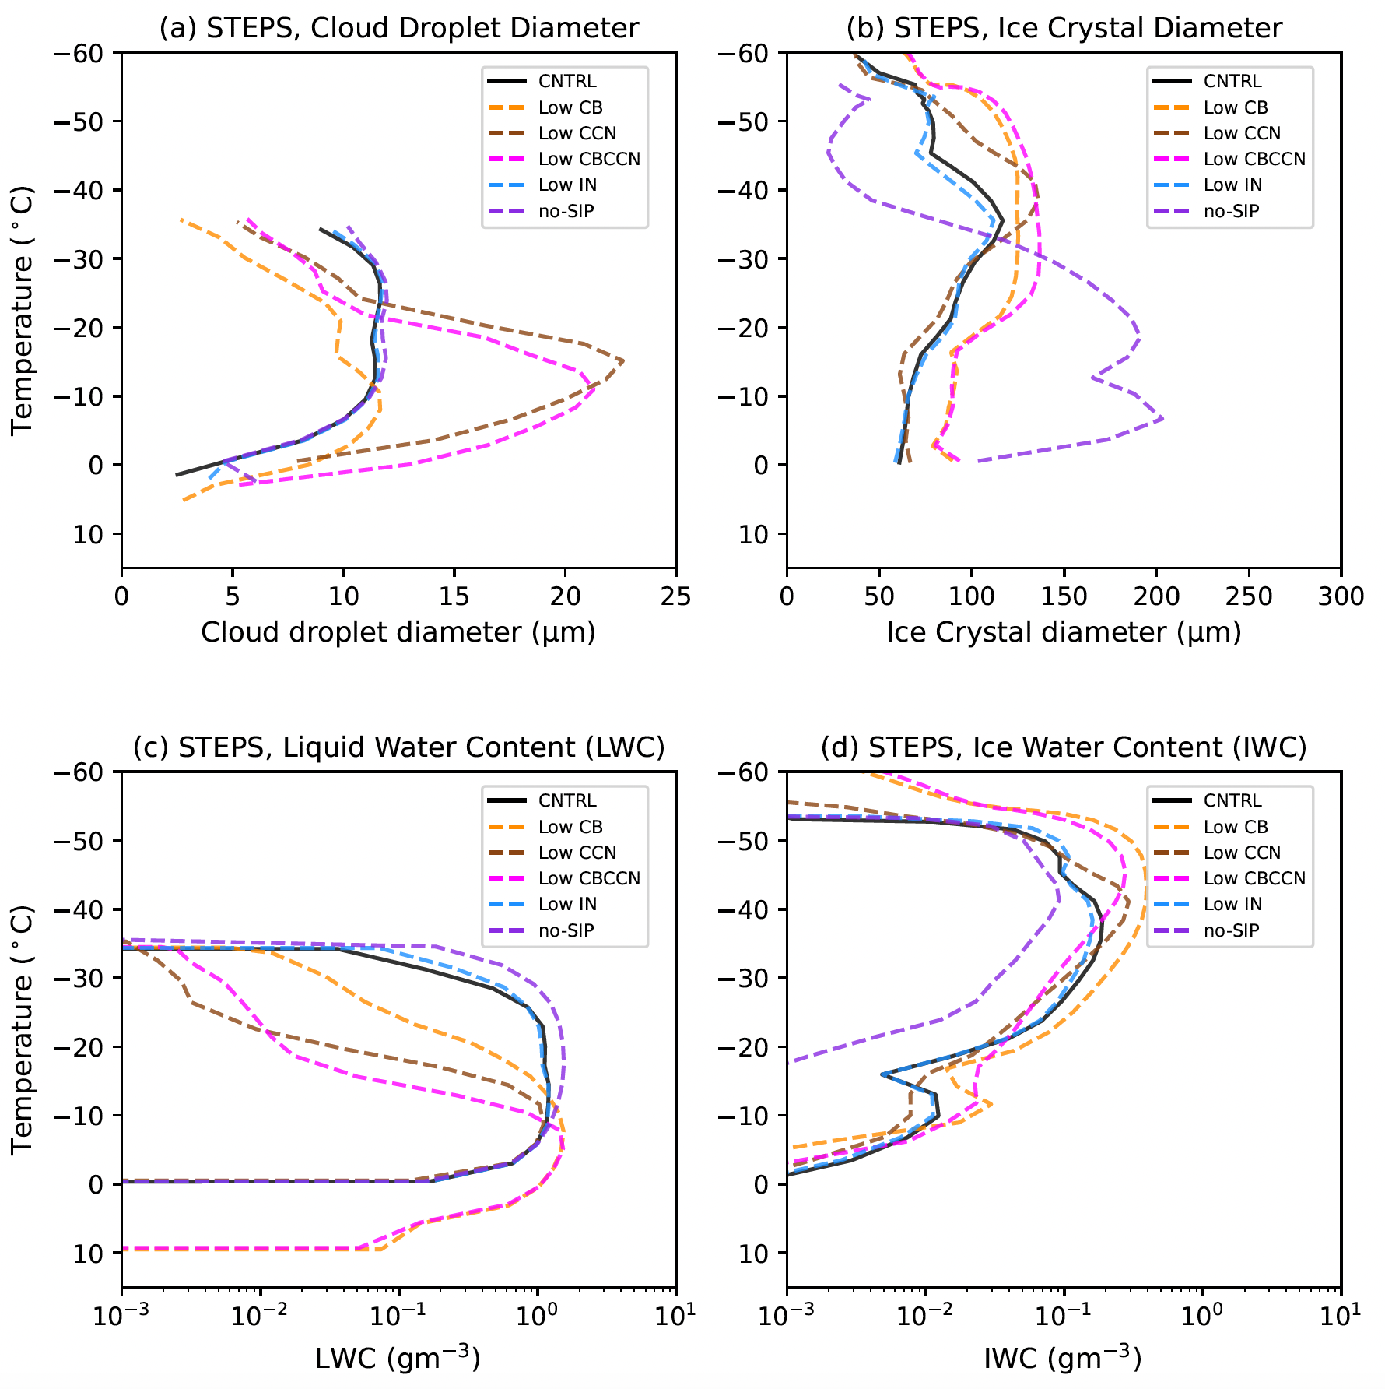
Figure S6. (a) Sensitivity of conditionally averaged mean cloud droplets diameter under lowered cloud base (CB), lowered cloud condensation nuclei (CCN), both lowered CB and CCN (low CBCCN), lowered ice nuclei (IN) and under no secondary ice productions (no-SIP) for the STEPS case from 23:45 UTC on 19 June to 02:15 UTC on 20 June 2000 (except without first hour of simulation). (b) Similar to Figure S6(a), bur for mean ice crystal diameter in microns ($μm$). (c) Similar to Figure S6(a), bur for mean liquid water content (LWC). (d) Similar to Figure S6(a), but for mean ice water content (IWC).

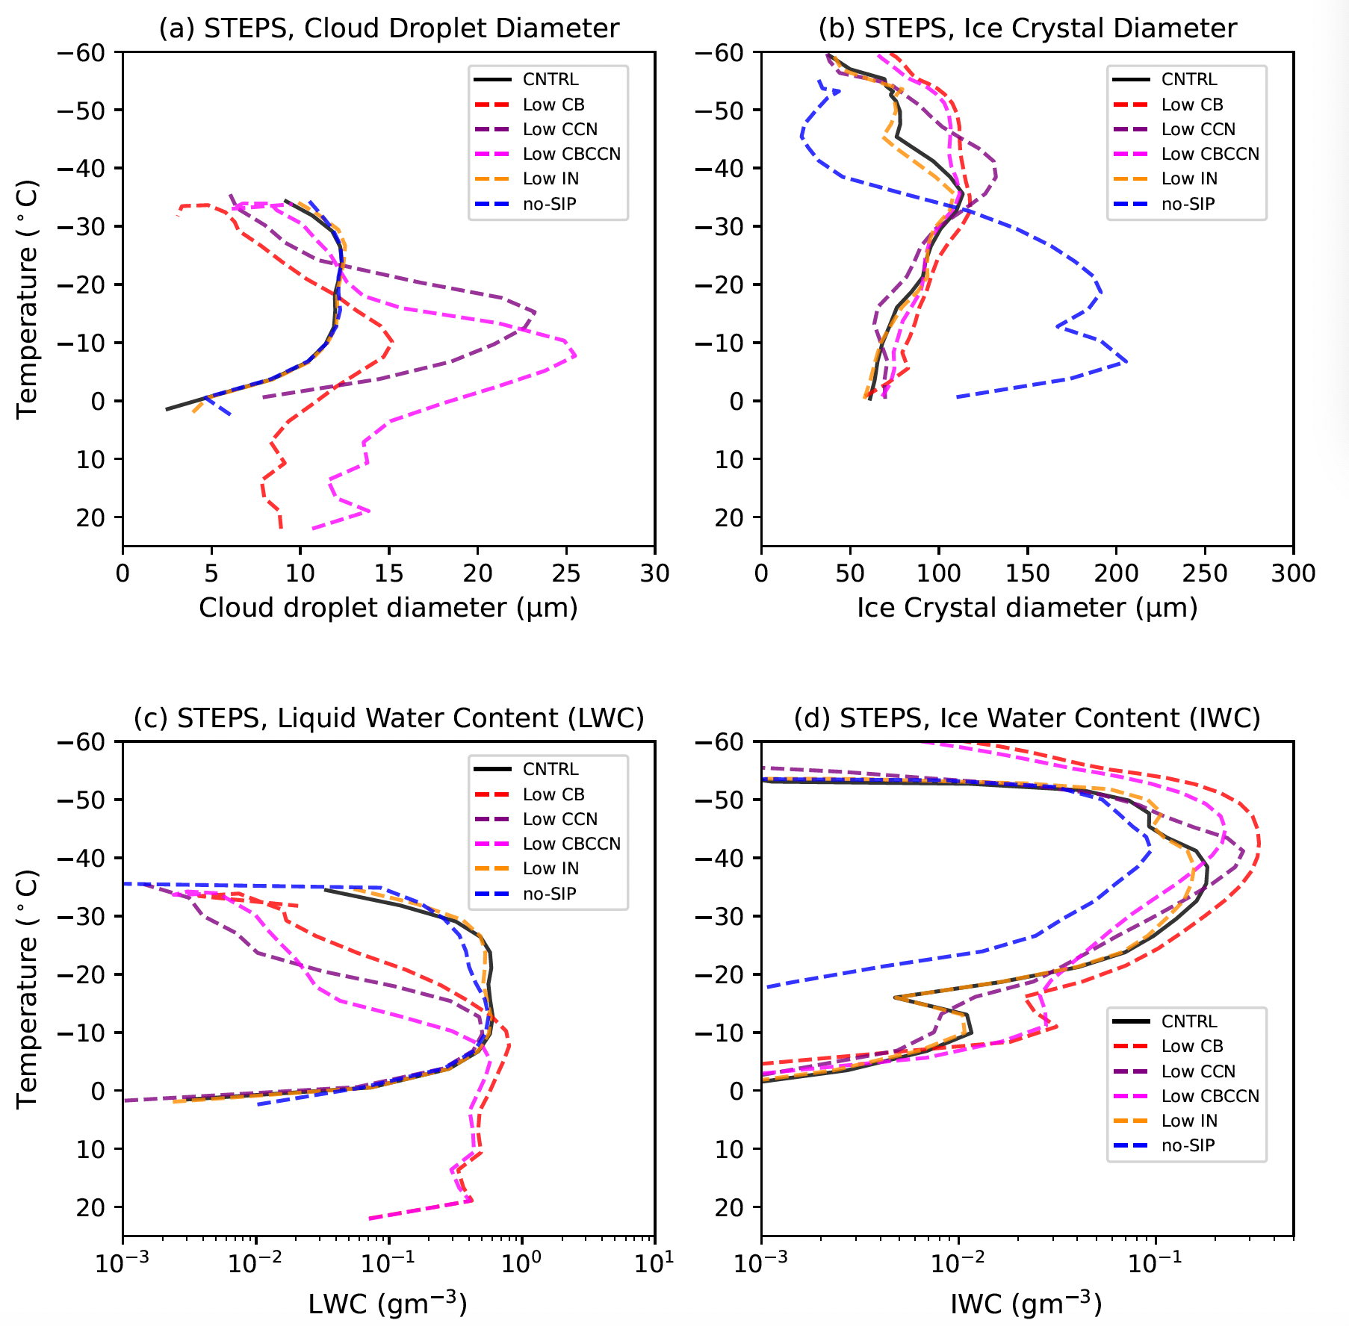
Figure S7. Same as Figure S6 but for entire 2 hours and 30 mins simulations during STEPS.
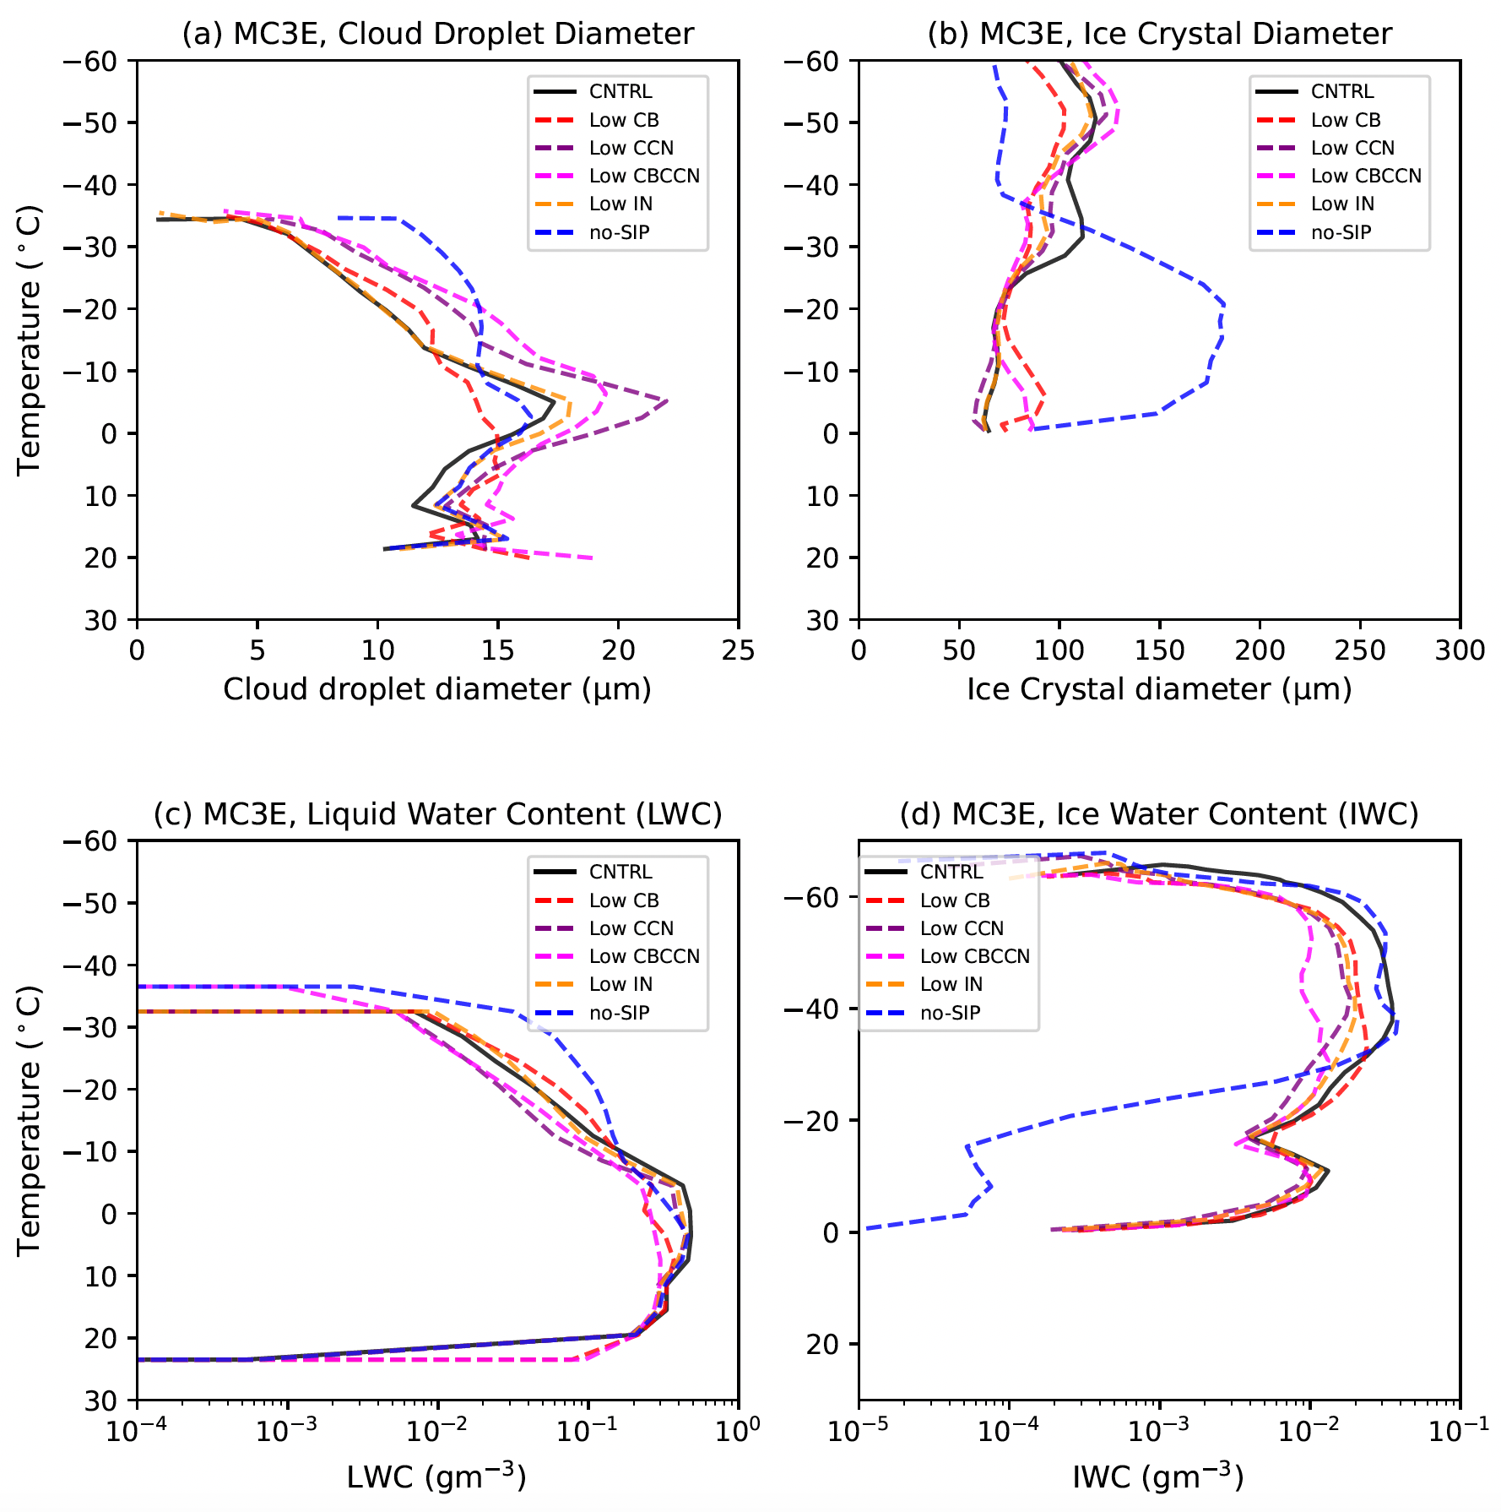
Figure S8: Similar to Figure S6 but for MC3E case on 11 May 2011 (0000 UTC-2300 UTC).

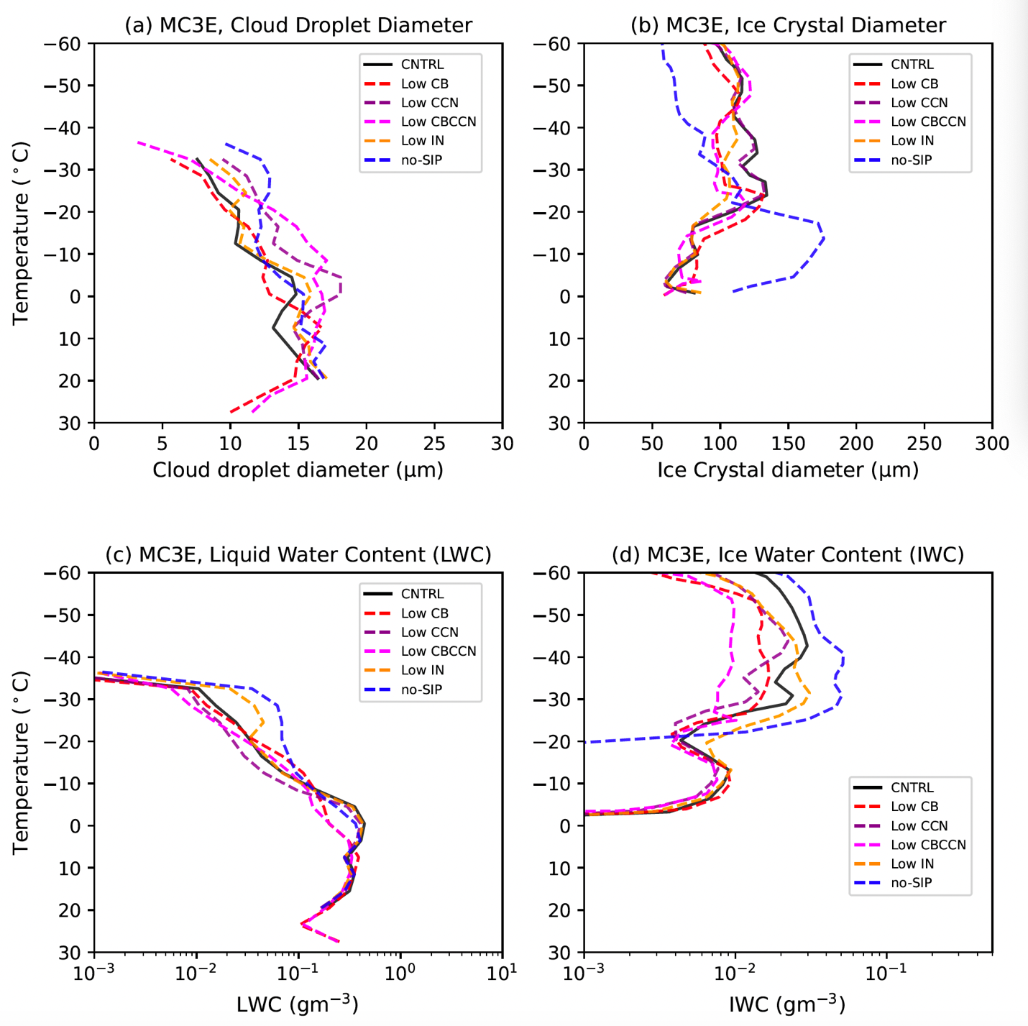
Figure S9: Similar to Figure S8, but for entire MC3E simulation during 72 hours of simulations (10-13 May 2011).

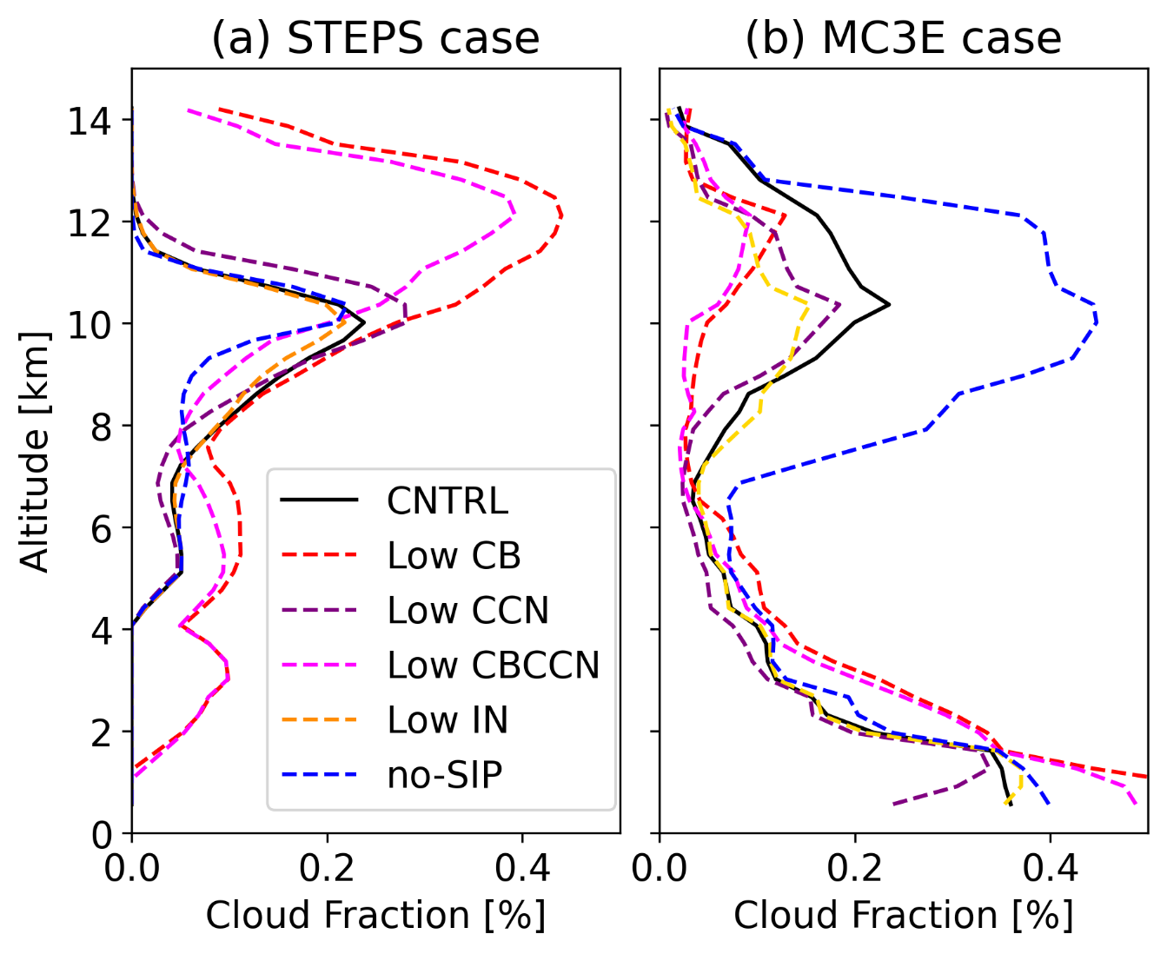
Figure S10. (a) Sensitivity of mean cloud fraction under lowered cloud base (CB), lowered cloud condensation nuclei (CCN), both lowered CB and CCN (low CBCCN), lowered ice nuclei (IN) and no secondary ice productions (no-SIP) for the STEPS case from 23:45 UTC on 19 June to 02:15 UTC on 20 June 2000. (b) Similar to (a), but for MC3E case on 11 May 2011 (0000 UTC-2300 UTC).

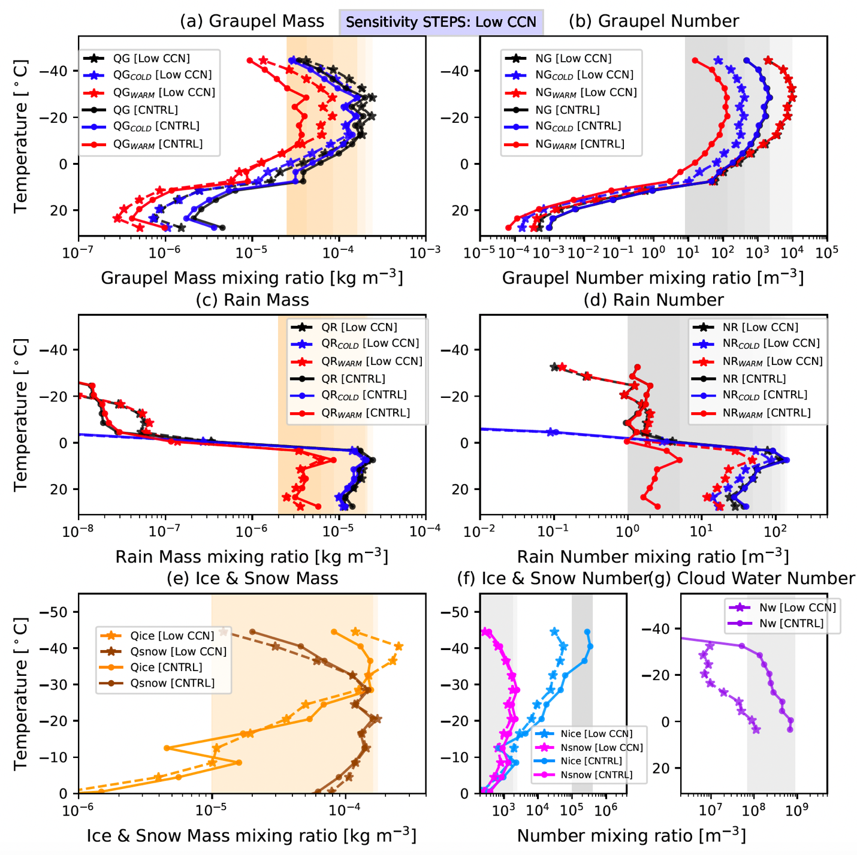
Figure S11: Same as Figure 7, but for sensitivity of different hydrometeor profiles when CCN aerosol conditions is lowered (Low CCN).

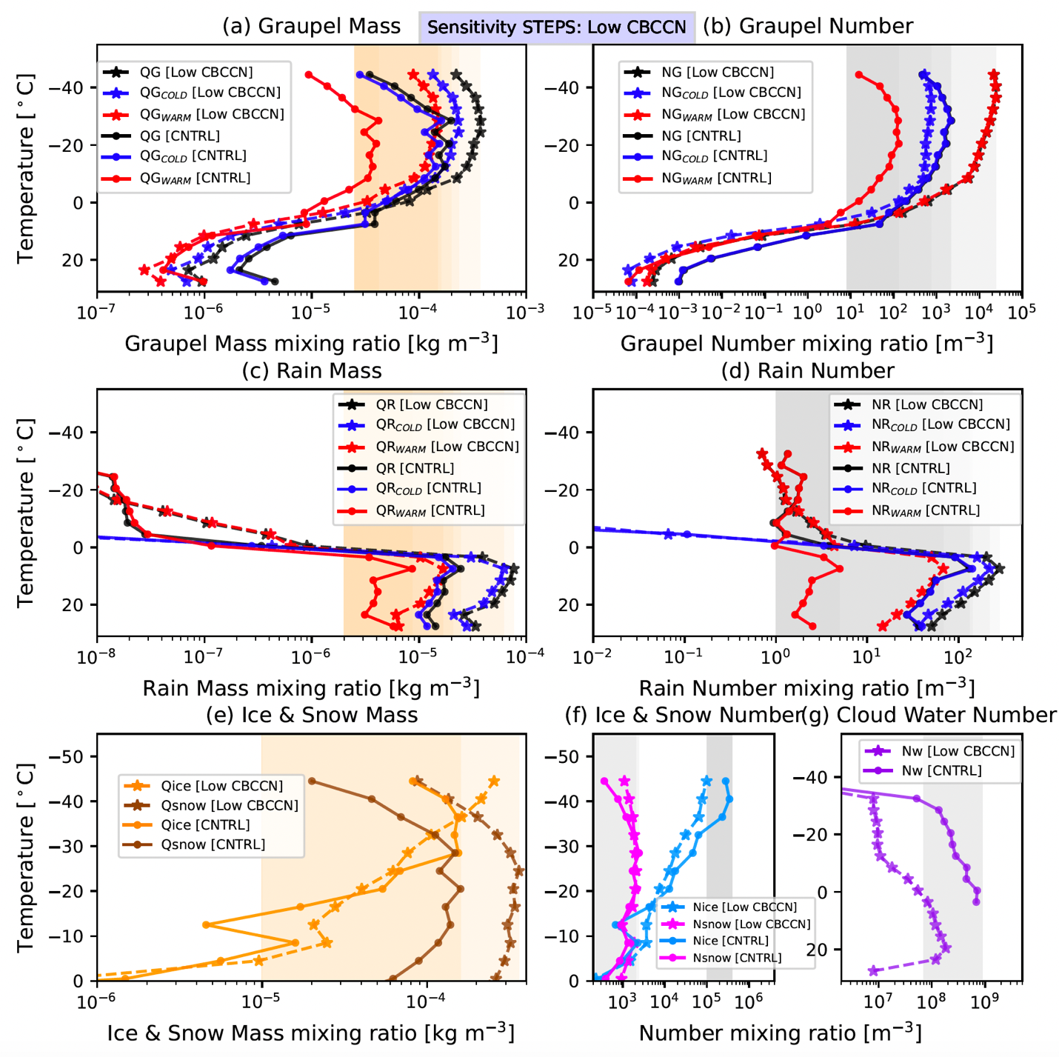
Figure S12: Same as Figure 7 but for sensitivity of different hydrometeor profiles when both cloud base and CCN aerosol conditions are lowered together (Low CBCCN).

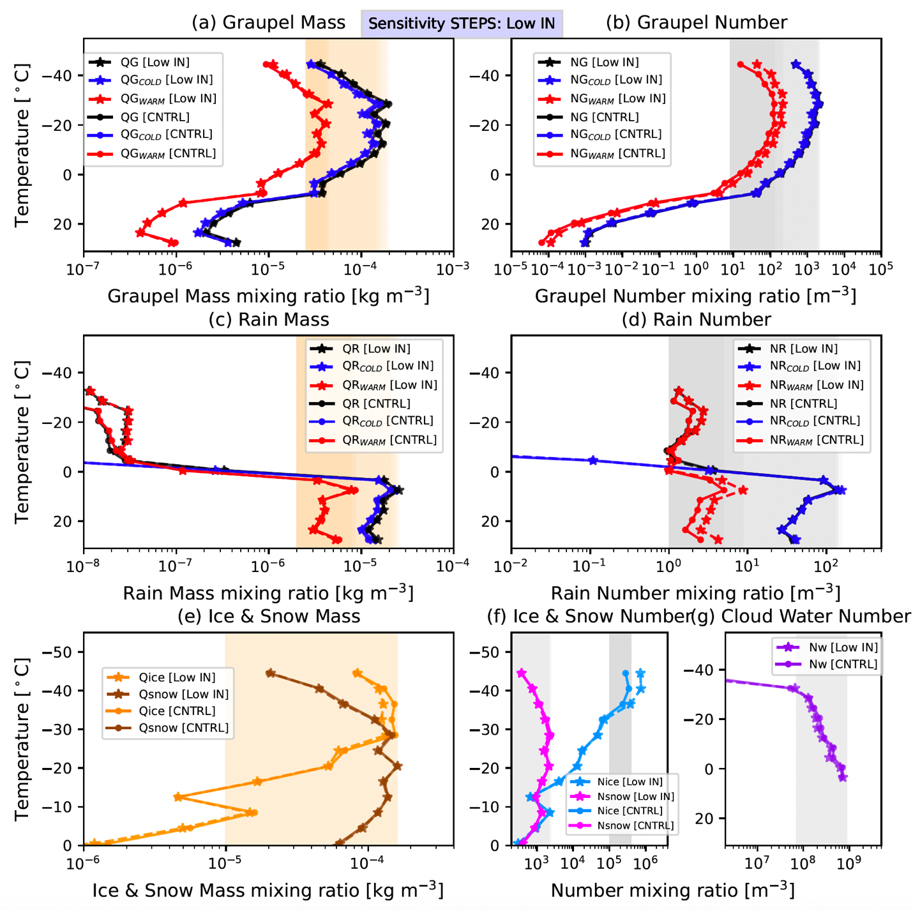
Figure S13: Same as Figure 7, but for sensitivity of different hydrometeor profiles when IN aerosol conditions is lowered (Low IN).

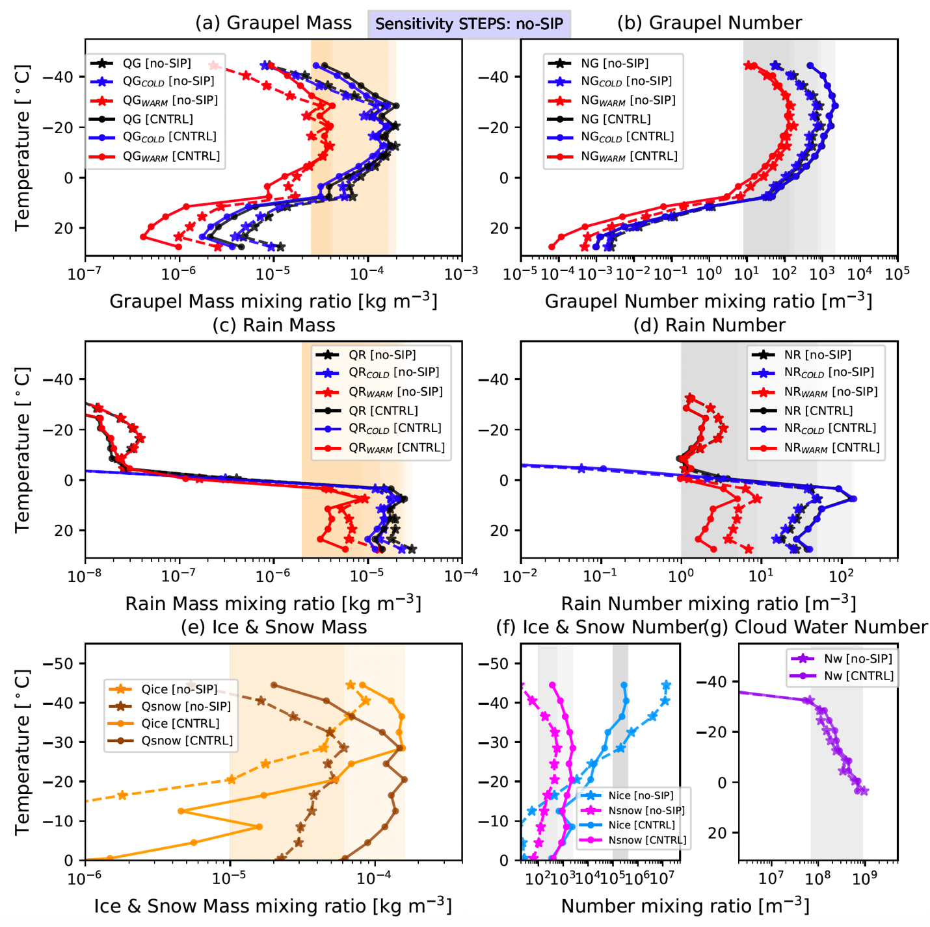
Figure S14: Same as Figure 7 but for sensitivity of different hydrometeor profiles when SIP is switched off (no-SIP).

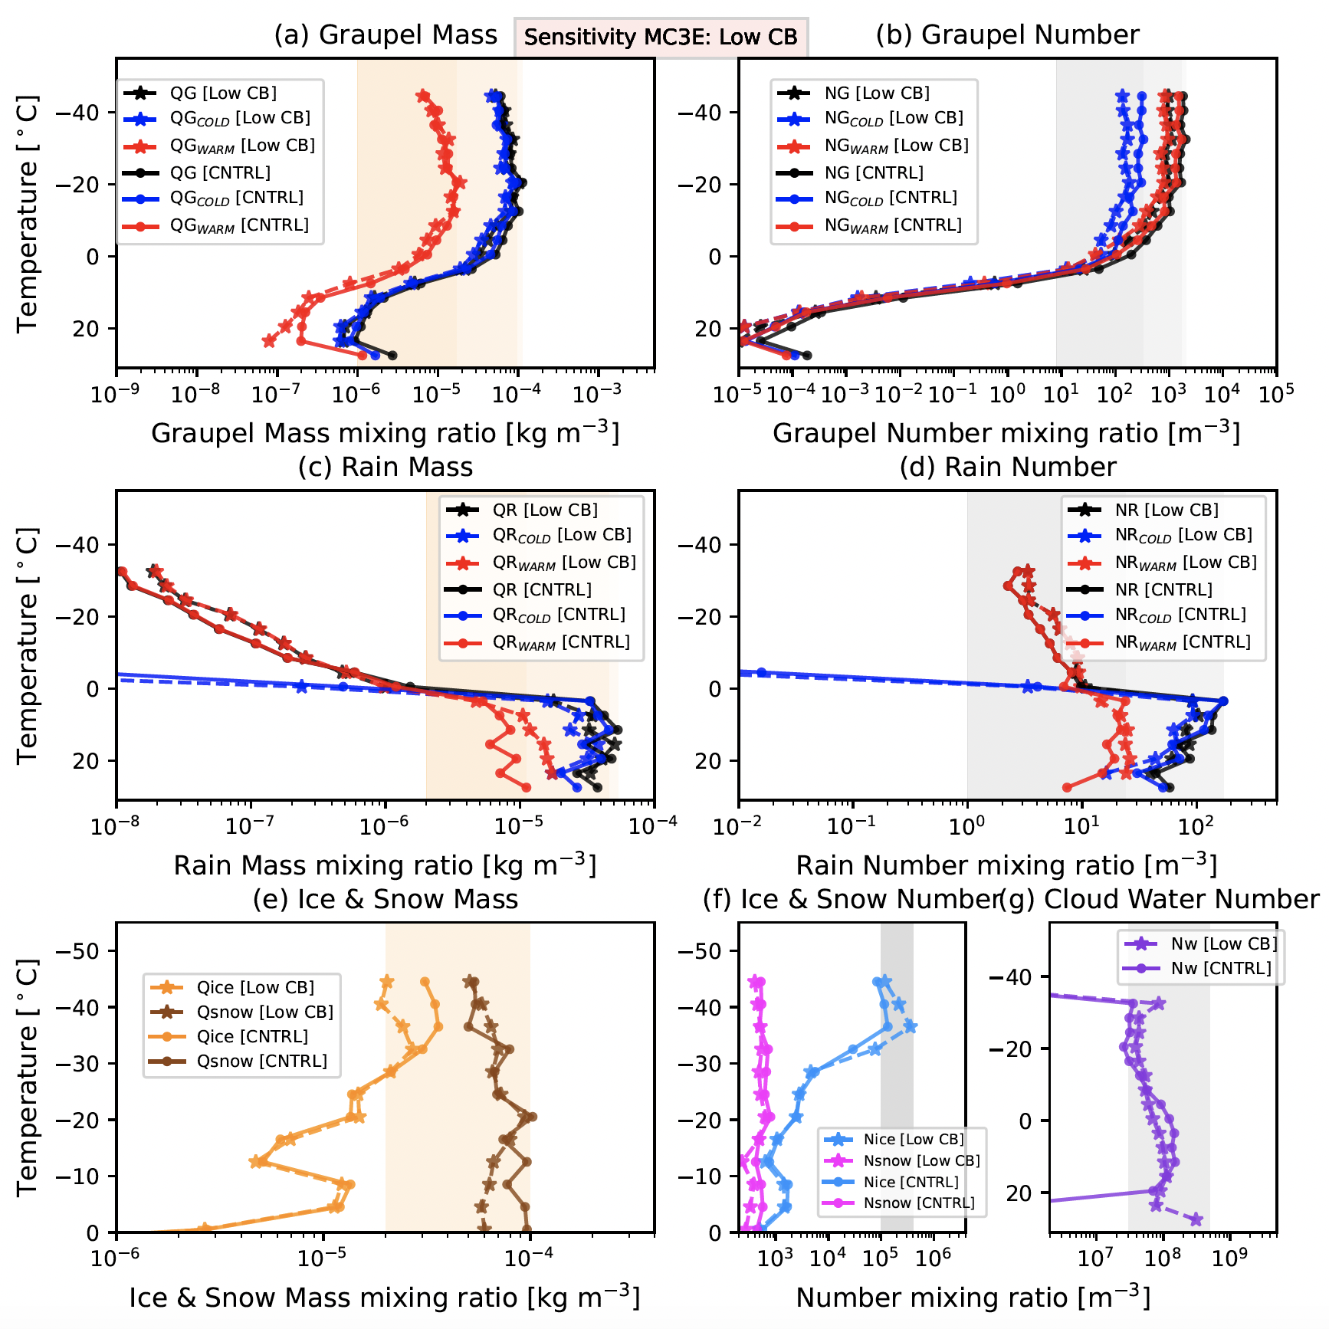
Figure S15: Same as Figure 5 but for low CB sensitivity simulation of MC3E case during 0000–2300 UTC on 11 May 2011.

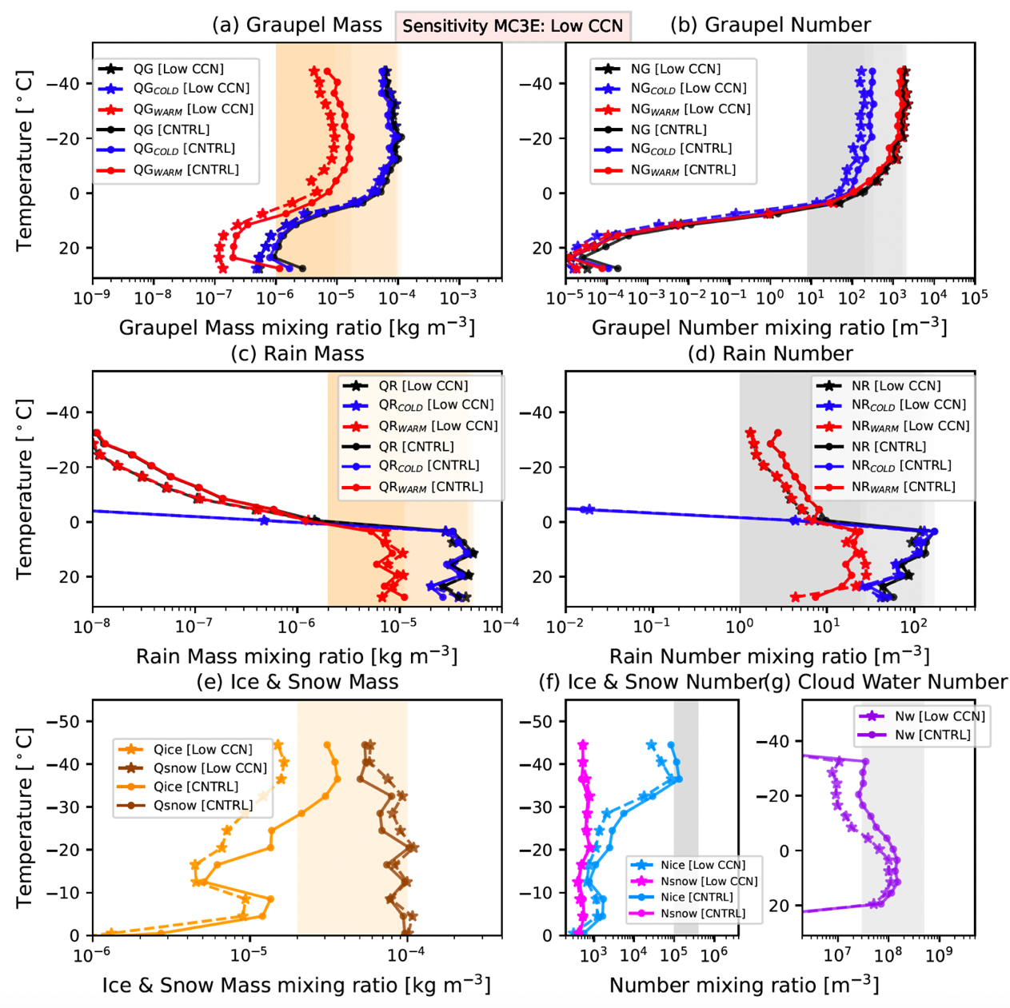
Figure S16: Same as Figure 7 but for low CCN sensitivity simulation of MC3E during 0000–2300 UTC on 11 May 2011.

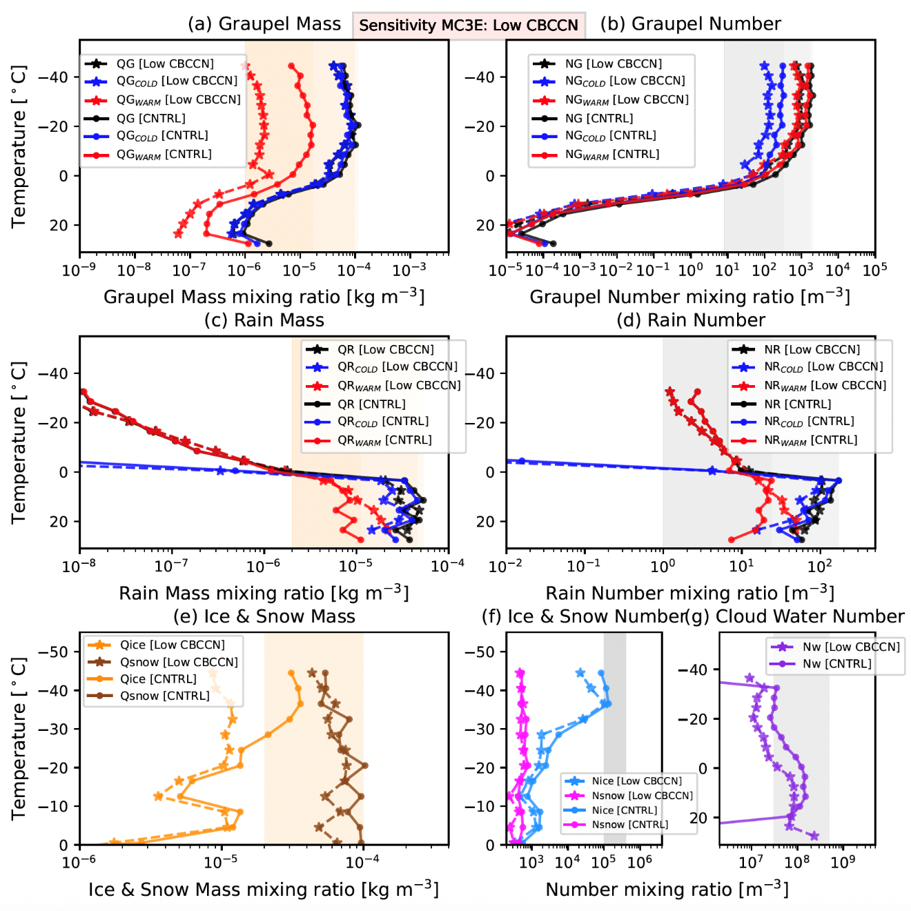
Figure S17: Same as Figure 7 but for low CBCCN sensitivity simulation of MC3E during 0000–2300 UTC on 11 May 2011.
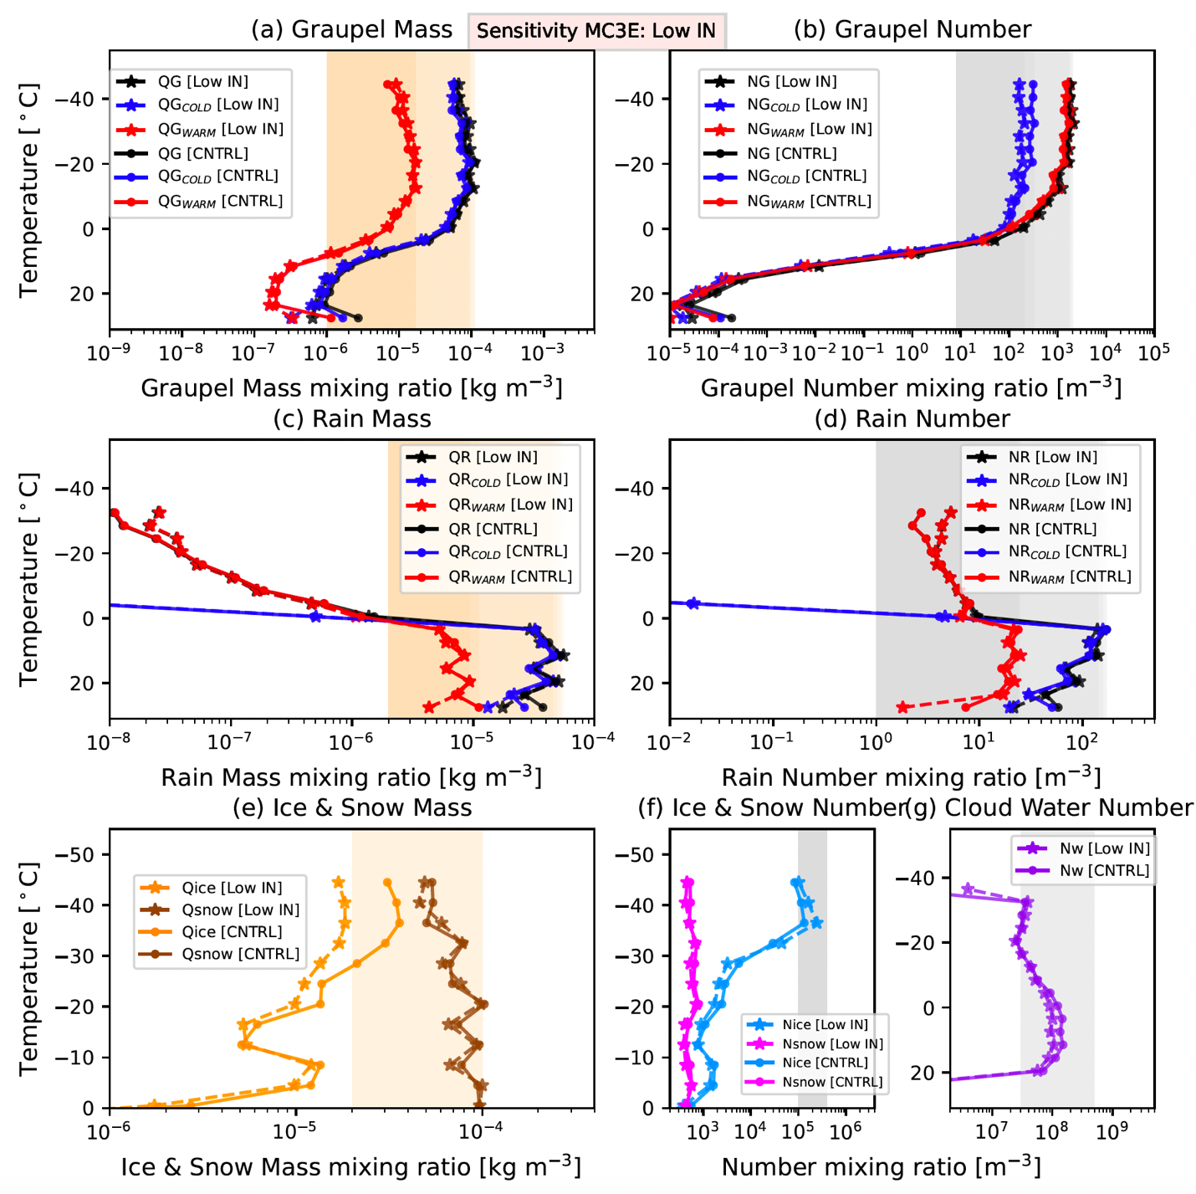
Figure S18: Same as Figure 7 but for low IN sensitivity simulation of MC3E during 0000–2300 UTC on 11 May 2011.
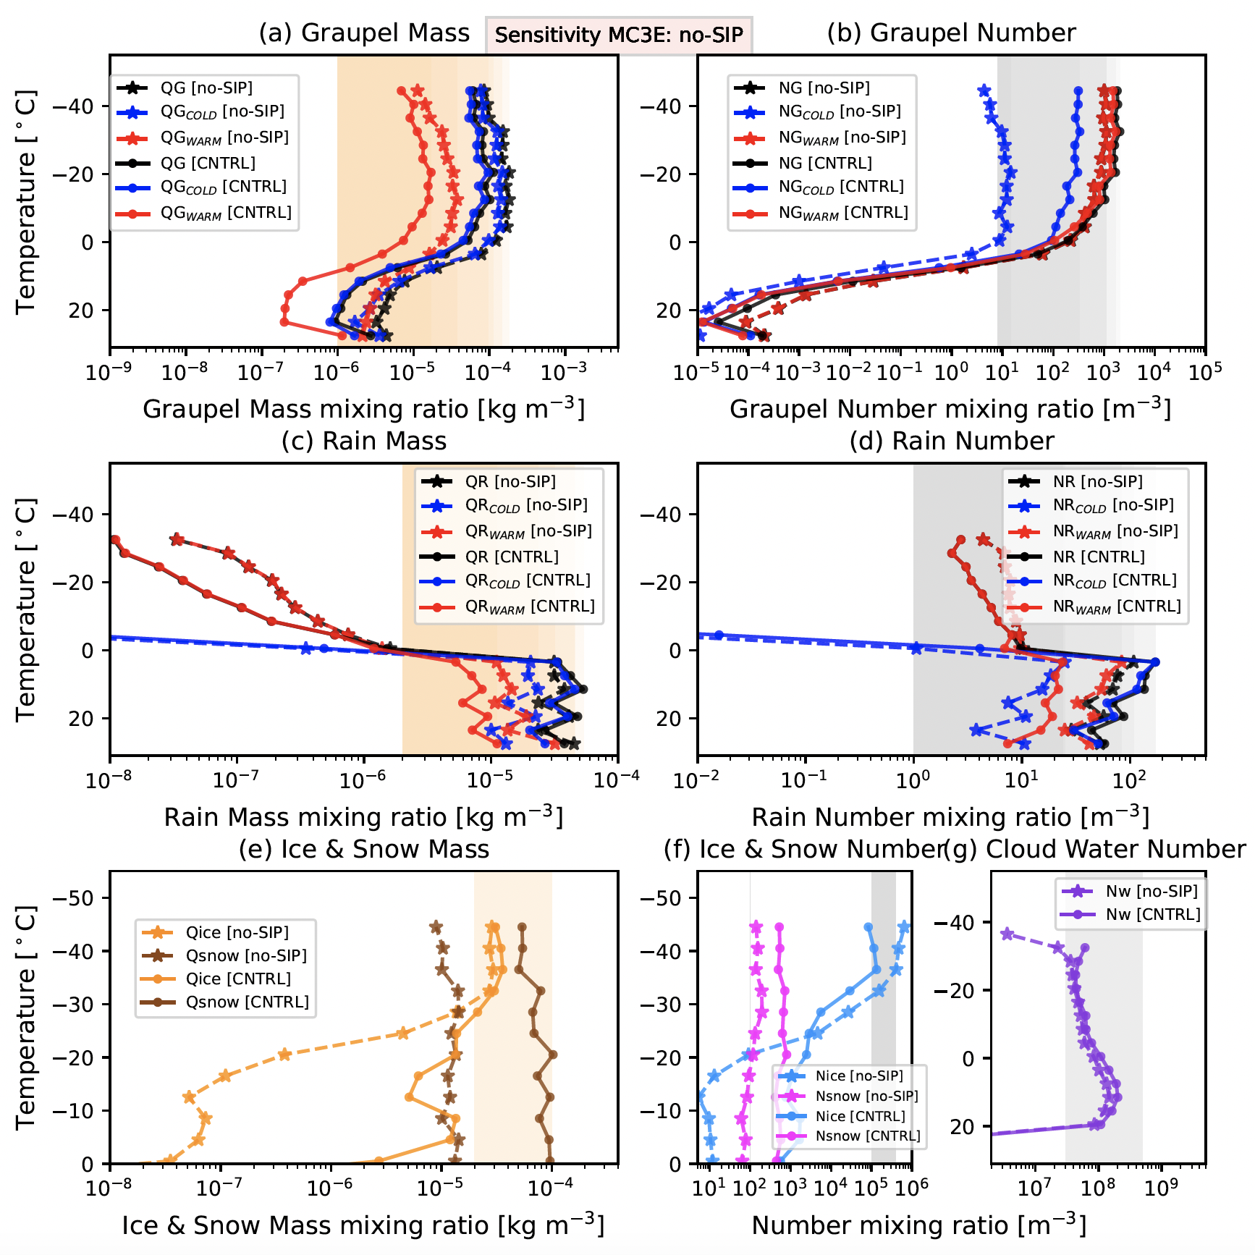
Figure S19: Same as Figure 7 but for no-SIP sensitivity simulation of MC3E during 0000–2300 UTC on 11 May 2011.

Schematics summarizing major findings:
STEPS simulations (Control vs. low CB/CCN):
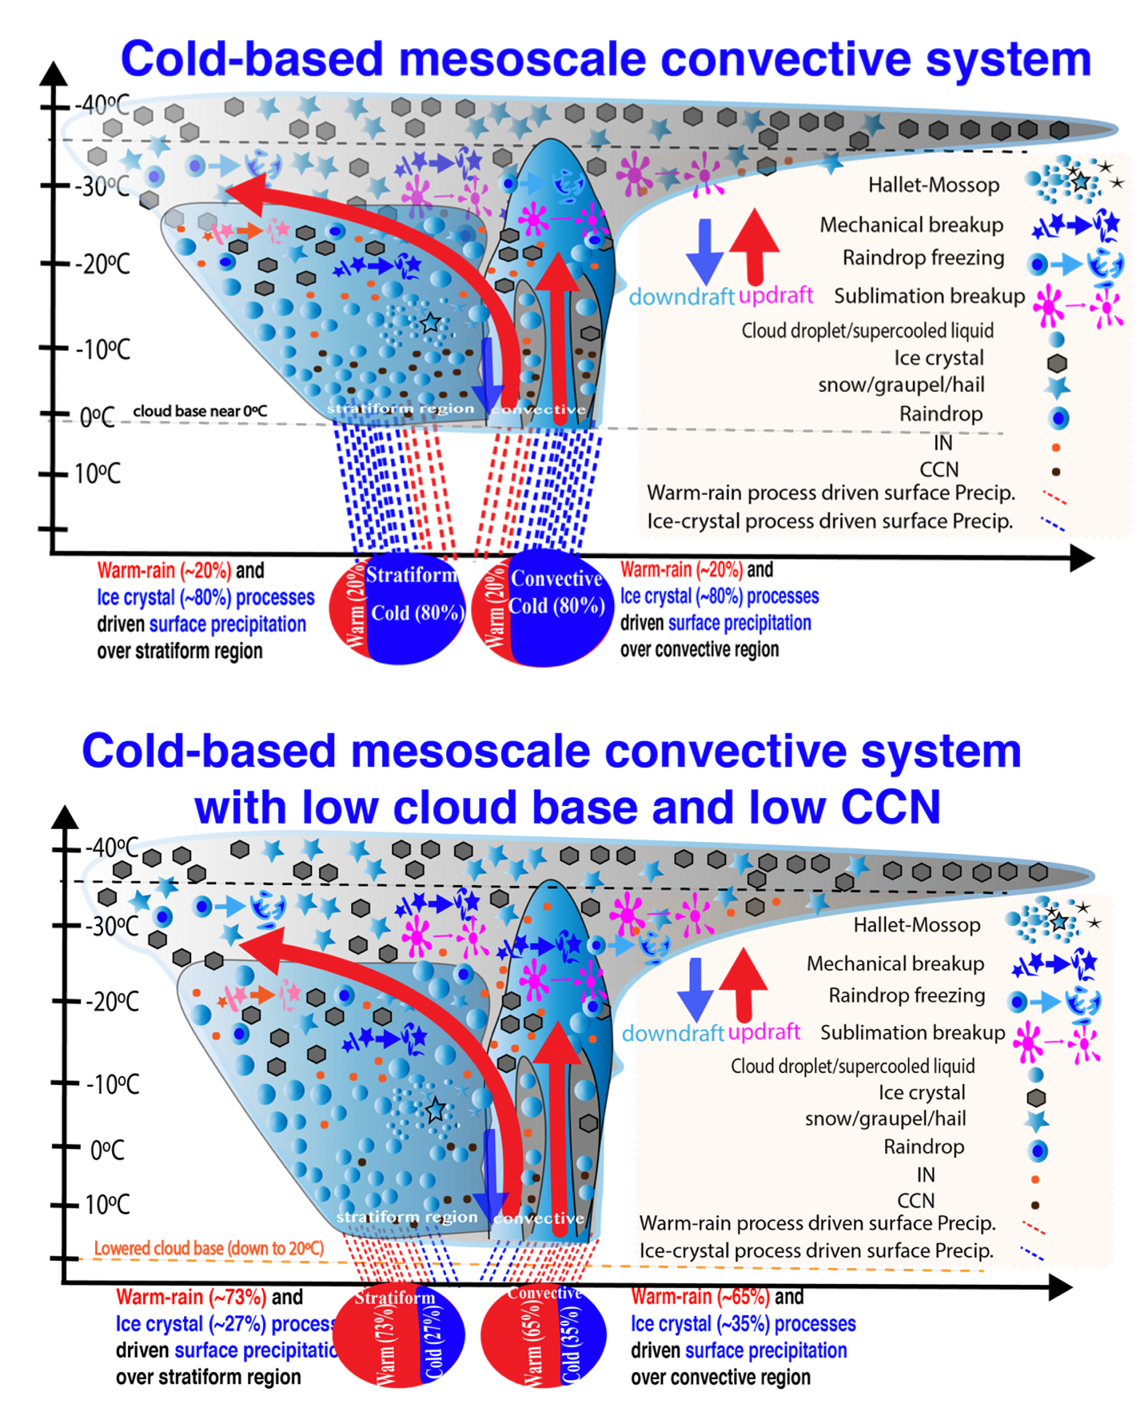
Figure S20. Upper panel: the schematic describing the control simulation of cold-based mesoscale system as in STEPS case (cloud base at ~0ºC). Two pie charts at the bottom are shown for warm-rain and ice-crystal processes driven surface precipitation over stratiform and convective regions. In the control run, ice crystal process primarily contributes to the ground precipitation over both these regions.
Bottom panel: Same as upper panel but for low CBCCN sensitivity simulation of STEPS. In this sensitivity simulation, majority of the ground precipitation has now been switched to the warm-rain process.

MC3E simulations (control vs. low CB/CCN)
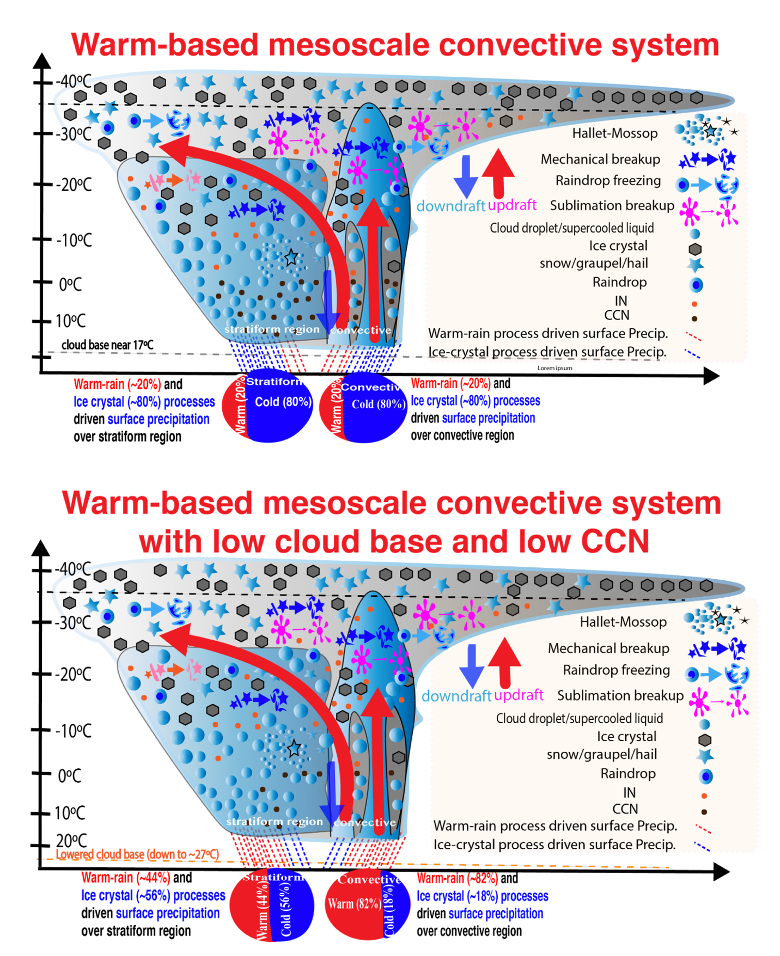
Figure. S21. Same as Fig. S19. but for a warm-based mesoscale convective system.
Table S1:
Comparison of SW, LW and Total (SW + LW) flux predicted under control simulation and all five sensitivity tests for STEPS (a) and MC3E (b). The outgoing flux is treated with the negative sign, whereas incoming with the positive sign.
