Supporting Information for

Role of weak magnetic field for enhanced oxidation of orange G by magnetic Fenton
Zhenyu Shi^{1,2}, Ruijia Zhang³, Jing Zhang^{1*}

- College of Environment & Ecology, Chongqing University, Chongqing 400045, P. R. China
- Environment Monitoring Center of Jiangsu Province, Nanjing 210036, PR China
- Xuzhou Municipal Engineering Design Institute Co., Ltd., Xuzhou 221000, P. R. China
*Corresponding author address:
Jing Zhang
College of Environment & Ecology, Chongqing University, Chongqing 400045, P. R. China
E-mail: zhangjing2018@cqu.edu.cn

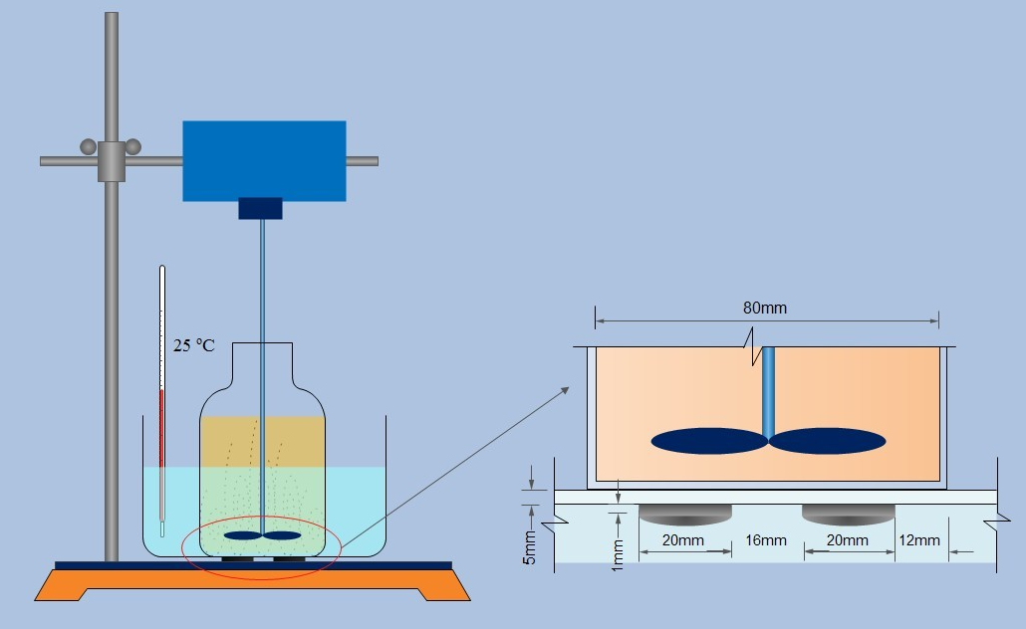

Fig. S1 Diagram of the experimental setup.

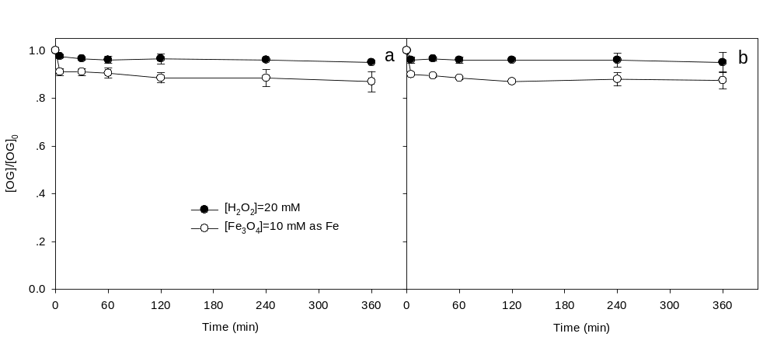

Fig. S2 Removal of OG by H₂O₂ or Fe₃O₄ alone without WMF (a) and with WMF (b), Reaction conditions: [OG]=0.1 mM, pH=3.0, T=25 ºC.
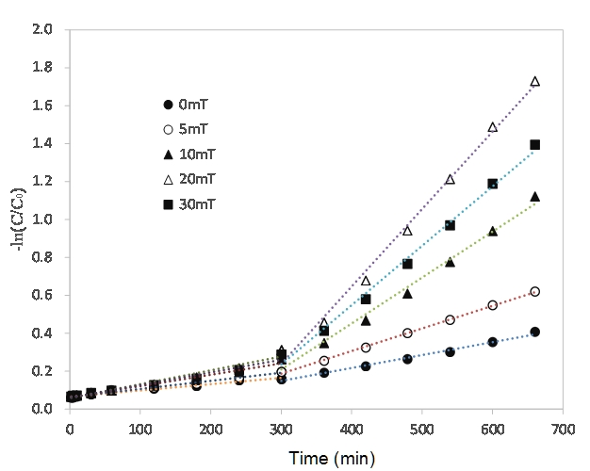
Fig. S3 The first-order kinetic fitting of OG degradation by Fe₃O₄/H₂O₂ as a function of MF intensity. Reaction conditions: [OG]=0.1 mM, [H₂O₂]=20 mM, [Fe₃O₄]=1 mM as Fe, pH=3.0, T=25 ºC.
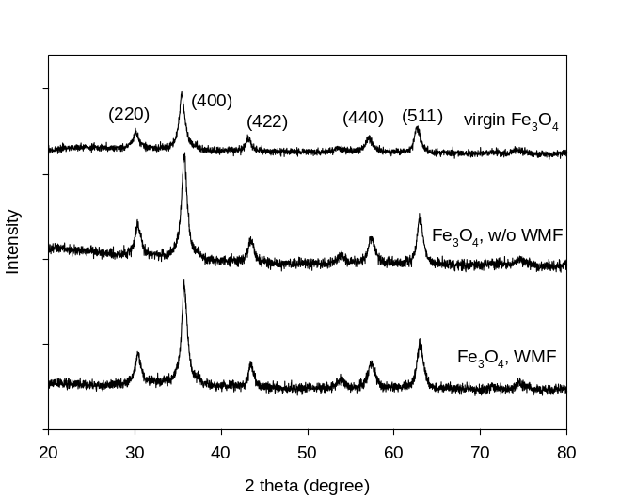

Fig. S4 XRD patterns for virgin Fe₃O₄, spent Fe₃O₄ used in heterogeneous Fenton with and without WMF.

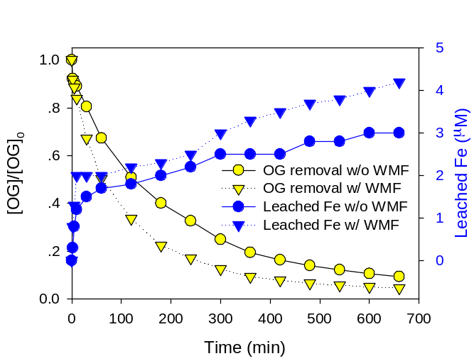
Fig. S5 Degradation of OG in homogeneous Fe(II)/H₂O₂ process with and without WMF. The dosage of Fe(II) was set according the maximum dissolved Fe ions at the end of reactions. Reaction conditions: [OG]=0.1 mM, [H₂O₂] =20 mM, pH=3.0, T=25 ºC.

Table S1 XPS analysis for Fe₃O₄
Samples | XPS
Samples | Fe^{II} peak position |  | Fe^{III} peak position |  | Satellite peak position |  | surface  Fe^{II}/Fe^{III}  molar ratio
Samples | 2p_{1/2} | 2p_{3/2} | 2p_{1/2} | 2p_{3/2} | 2p_{1/2} | 2p_{3/2} | surface  Fe^{II}/Fe^{III}  molar ratio
Virgin Fe₃O₄ | 723.9 | 710.7 | 725.4 | 712.4 | 718.8 | 715.5 | 1.00
Spent Fe₃O₄ without WMF | 723.9 | 710.7 | 725.4 | 712.4 | 718.8 | 715.5 | 0.76
Spent Fe₃O₄ with WMF | 723.9 | 710.7 | 725.4 | 712.4 | 718.8 | 715.5 | 0.22

