New austalide derivative from the marine-derived Aspergillus sp. and evaluation of its biological activity

Mohamed S. Elnaggar^{a,b,#}, Ahmed M. Elissawy^{a,b,#,*}, Fadia S. Youssefª and Abdel Nasser B. Singab^{a,b,*}

ª Department of Pharmacognosy, Faculty of Pharmacy, Ain Shams University, Abbassia, 11566, Cairo, Egypt
^{b} Center for Drug Discovery Research and Development, Faculty of Pharmacy, Ain Shams University, Cairo 11566, Egypt
# Contributed equally
* Correspondence
Ahmed M. Elissawy, Ph.D.; E-mail: aelissawy@pharma.asu.edu.eg, Tel: +2 01147937711
Abdel Nasser B. Singab, Ph.D.; E-mail: dean@pharma.asu.edu.eg, Tel: +201005036231

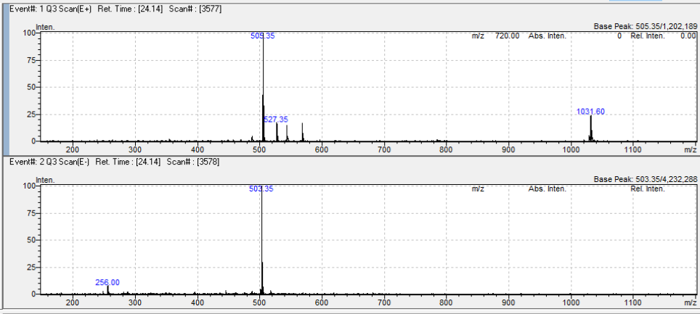
S1. +ve/-ve ESIMS of compound 1

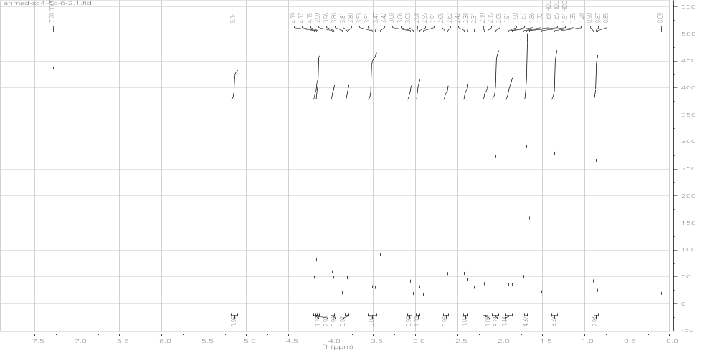S2. ¹ H NMR spectrum of compound 1

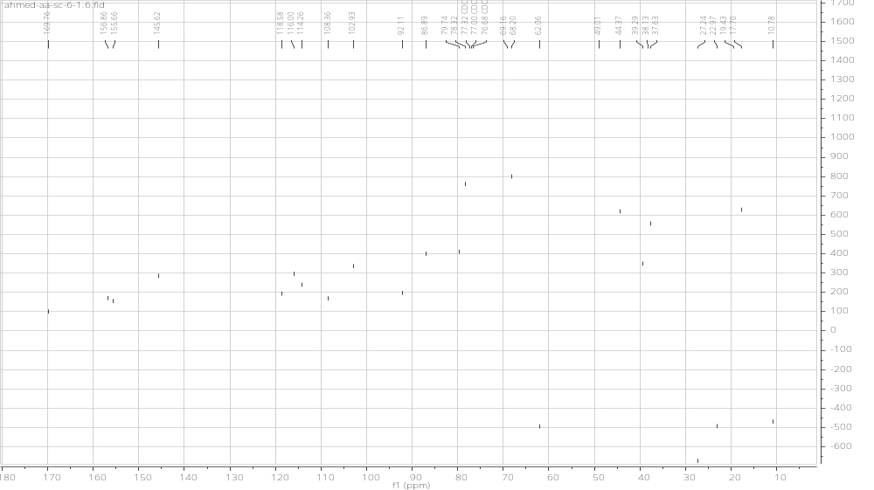
S3. APT NMR spectrum of compound 1

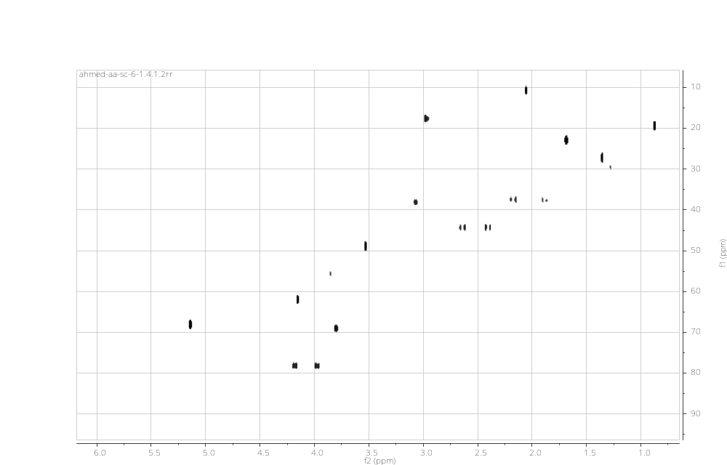 S4. HSQC spectrum of compound 1
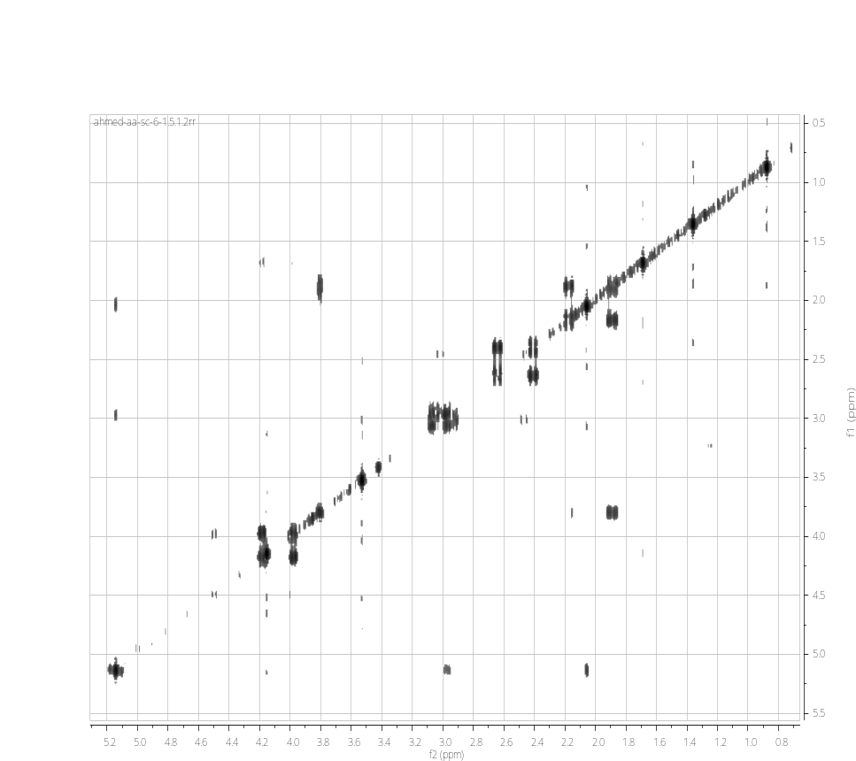
S5. COSY spectrum of compound 1
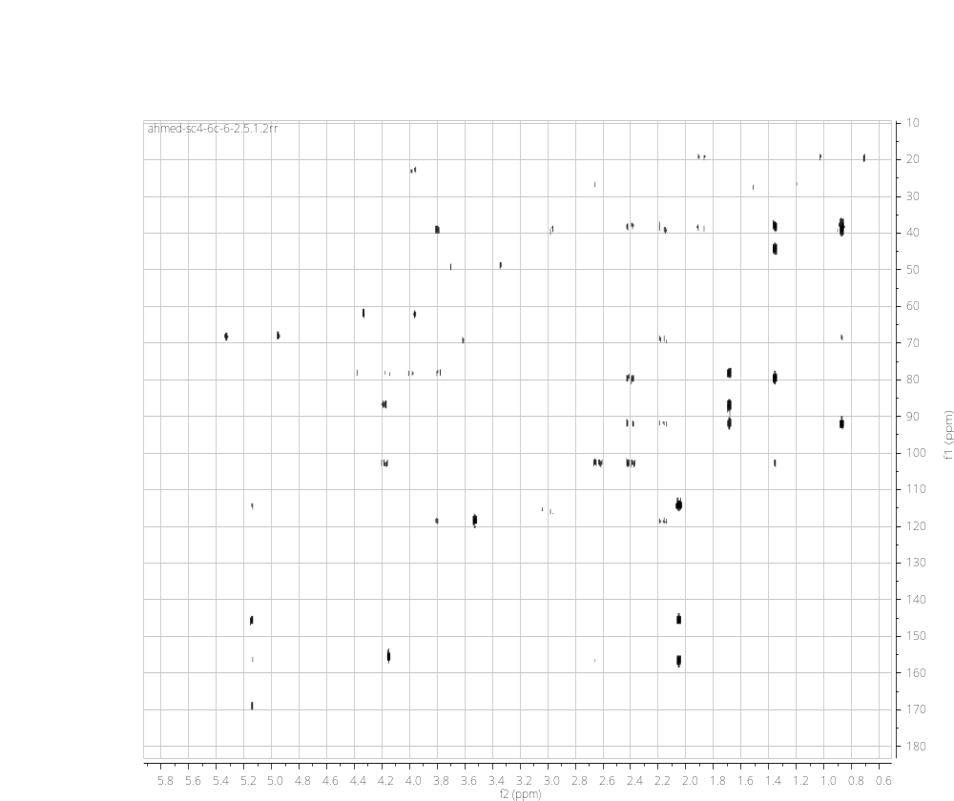 S6. HMBC spectrum of compound 1
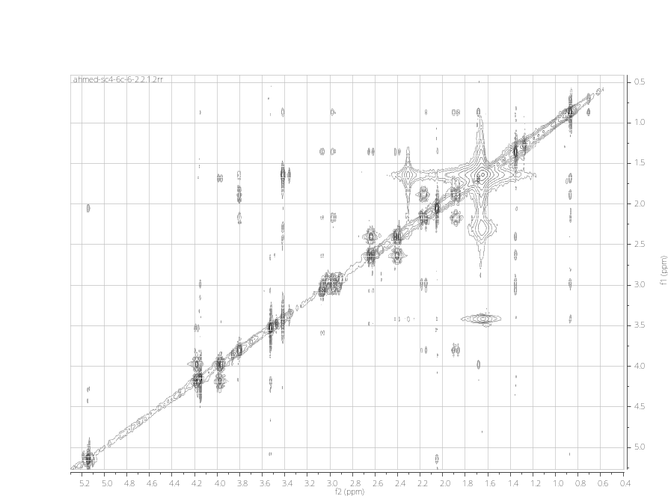
S7.NOESY NMR spectrum of compound 1

