Supplementary Table 1. A summary of socio-demographics, baseline depressive symptom severity, and number of contact logs of 313 participants with a longer observation period (94 weeks), with comparisons across the three study sites.
Characteristics | Total | KCL | CIBER | VUMC | P value
Number of participants, n | 313 | 206 | 91 | 16
Baseline PHQ8 score (median [IQR]) | 11.00  [7.00, 16.00] | 8.00  [5.25, 13.00] | 15.00  [10.00, 18.00] | 9.00  [7.00, 10.00] | <.001
Number of contact logs (median [IQR]) | 9.00  [6.00, 14.00] | 12.00  [8.00, 16.00] | 5.00  [3.00, 8.00] | 3.50  [2.75, 5.25] | <.001
Age (median [IQR]) | 51.00  [37.00, 59.00] | 47.00  [32.00, 58.00] | 54.00  [47.50, 60.00] | 39.50  [33.50, 52.25] | <.001
Female, n (%) | 235  (75.1) | 155  (75.2) | 67  (73.6) | 13  (81.3) | .81
Marital status |  |  |  |  | .06
Single/separated/divorced/widowed | 155  (49.5) | 109  (52.9) | 36  (39.6) | 10  (62.5)
Married/cohabiting/LTR | 158  (50.5) | 97  (47.1) | 55  (60.4) | 6  (37.5)
Has children, n (%) | 173  (55.3) | 97  (47.1) | 70  (76.9) | 6  (37.5) | <.001
Years in education (median [IQR]) | 15.00  [12.00, 18.00] | 17.00  [14.00, 19.00] | 11.00  [9.00, 14.00] | 17.00  [15.00, 21.50] | <.001
Annual income, n (%) |  |  |  |  | .003
<15,000 (£/€) | 86  (27.5) | 53  (25.7) | 32  (35.2) | 1  (6.3)
15,000-55,000 (£/€) | 181  (57.8) | 116  (56.3) | 53  (58.2) | 12  (75.0)
>55000 (£/€) | 44  (14.1) | 36  (17.5) | 6  (6.6) | 2  (12.5)
Accommodation, n (%) |  |  |  |  | .04
Own outright/with mortgage | 177  (56.6) | 105  (51.0) | 63  (69.2) | 9  (56.3)
Renting | 110  (35.1) | 82  (39.8) | 21  (23.1) | 7  (43.8)
Living rent-free | 23  (7.4) | 18  (8.7) | 5  (5.5) | 0  (0)

Supplement Table 2. Summary participants’ socio-demographics, PHQ-8 score, and study app usage behaviors across three distinct engagement subgroups of Phone-Active data for the first 43 weeks of the RADAR-MDD study.
Characteristics | C1 | C2 | C3 | P value
Number of participants, n | 231 | 179 | 204
Age (median [IQR]) | 53.00  [34.00, 61.50] | 45.00  [31.00, 55.50] | 48.00  [32.00, 57.25] | .003
Male, n (%) | 52 (22.5) | 42 (23.5) | 55 (27.0) | .53
Number of surveys (median [IQR]) | 20.00  [18.00, 21.00] | 13.00  [11.00, 15.00] | 4.00  [1.00, 6.00] | <.001
Number of contact logs (median [IQR]) | 3.00  [2.00, 5.00] | 5.00  [3.00, 7.00] | 5.00  [2.00, 9.00] | <.001
Baseline PHQ8 score (median [IQR]) | 9.00  [6.00, 15.00] | 10.00  [8.00, 15.00] | 13.00  [7.00, 17.00] | .003
PHQ8 response time (minutes) (median [IQR]) | 73.68  [31.31, 215.77] | 148.08  [54.05, 322.27] | 302.36  [122.30, 527.10] | <.001
PHQ8 completion time (seconds) (median [IQR]) | 50.29  [37.92, 68.96] | 49.42  [40.01, 66.95] | 61.56  [46.12, 83.00] | <.001
RSES response time (minutes) (median [IQR]) | 67.94  [24.11, 198.42] | 134.96  [44.55, 304.56] | 274.09  [108.18, 518.50] | <.001
RSES completion time (seconds) (median [IQR]) | 54.54  [43.78, 72.39] | 55.75  [43.99, 74.28] | 69.24  [50.34, 100.52] | <.001
Site, n (%) |  |  |  | <.001
CIBER | 47(20.3) | 48 (26.8) | 51 (25.0)
KCL | 119 (51.5) | 102 (57.0) | 129 (63.2)
VUMC | 65 (28.1) | 29 (16.2) | 24 (11.8)
Married Status, n (%) |  |  |  | .24
Single/separated/divorced/widowed | 114 (49.4) | 97 (54.2) | 117 (57.4)
Married/cohabiting/LTR | 117 (50.6) | 82 (45.8) | 87 (42.6)
Years in education (median [IQR]) | 16.00  [12.00, 19.00] | 16.00  [13.00, 19.00] | 15.00  [12.00, 19.00] | .90
Has children, n (%) |  |  |  | .78
Yes | 116 (50.2) | 88 (49.2) | 100 (49.0)
No | 114 (49.4) | 91 (50.8) | 104 (51.0)
Annual income, n (%) |  |  |  | .73
<15,000 (£/€) | 48 (20.8) | 48 (26.8) | 56 (27.5)
15,000-55,000 (£/€) | 135 (58.4) | 102 (57.0) | 111 (54.4)
more than 55000 (£/€) | 40 (17.3) | 25 (14.0) | 33 (16.2)
Accommodation, n (%) |  |  |  | .47
Own outright/with mortgage | 131 (56.7) | 90 (50.3) | 102 (50.0)
Renting | 82 (35.5) | 73 (40.8) | 81 (39.7)
Living rent-free | 13 (5.6) | 15 (8.4) | 18 (8.8)

Supplement Table 3. Summary participants’ socio-demographics, PHQ-8 score, and study app usage behaviors across three distinct engagement subgroups of Phone-Passive data for the first 43 weeks of the RADAR-MDD study.
Characteristics | C1 | C2 | C3 | P value
Number of participants, n | 259 | 148 | 207
Age (median [IQR]) | 52.00  [36.50, 61.00] | 46.50  [30.75, 56.25] | 46.00  [30.50, 57.50] | .01
Male, n (%) | 66 (25.5) | 36 (24.3) | 47 (22.7) | .79
Days with phone passive data (median [IQR]) | 283.00  [257.00, 298.00] | 167.00  [142.25, 205.25] | 32.00  [4.00, 67.50] | <.001
Number of contact logs (median [IQR]) | 5.00  [2.00, 7.00] | 4.00  [2.00, 7.00] | 4.00  [2.00, 7.00] | .30
Baseline PHQ8 score (median [IQR]) | 9.00  [6.00, 15.00] | 10.00  [7.00, 14.00] | 12.00  [8.00, 17.00] | .001
PHQ8 response time (minutes) (median [IQR]) | 121.70  [45.13, 327.68] | 99.76  [40.89, 289.39] | 150.94  [52.23, 340.70] | .21
PHQ8 completion time (seconds) (median [IQR]) | 53.63  [41.84, 72.91] | 48.08  [36.46, 66.11] | 55.29  [39.75, 74.47] | .01
RSES response time (minutes) (median [IQR]) | 116.13  [36.36, 347.98] | 81.50  [31.10, 254.39] | 160.42  [39.65, 321.28] | .14
RSES completion time (seconds) (median [IQR]) | 61.08  [47.33, 83.46] | 51.87  [41.31, 70.32] | 63.55  [46.68, 82.90] | .001
Site, n (%) |  |  |  | <.001
CIBER | 60 (23.2) | 24 (16.2) | 62 (30.0)
KCL | 165 (63.7) | 82 (55.4) | 103 (49.8)
VUMC | 34 (13.1) | 42 (28.4) | 42 (20.3)
Married Status, n (%) |  |  |  | .26
Single/separated/divorced/widowed | 131 (50.6) | 77 (52.0) | 120 (58.0)
Married/cohabiting/LTR | 128 (49.4) | 71 (48.0) | 87 (42.0)
Years in education (median [IQR]) | 15.00  [12.00, 18.00] | 17.00  [14.00, 20.00] | 16.00  [12.00, 19.00] | .005
Has children, n (%) |  |  |  | .15
Yes | 142 (54.8) | 66 (44.6) | 96 (46.4)
No | 116 (44.8) | 82 (55.4) | 111 (53.6)
Annual income, n (%) |  |  |  | .80
<15,000 (£/€) | 65 (25.1) | 31 (20.9) | 56 (27.1)
15,000-55,000 (£/€) | 151 (58.3) | 83 (56.1) | 114 (55.1)
more than 55000 (£/€) | 37 (14.3) | 29 (19.6) | 32 (15.5)
Accommodation, n (%) |  |  |  | .08
Own outright/with mortgage | 150 (57.9) | 71 (48.0) | 102 (49.3)
Renting | 90 (34.7) | 67 (45.3) | 79 (38.2)
Living rent-free | 17 (6.6) | 7 (4.7) | 22 (10.6)

Supplement Table 4. Summary participants’ socio-demographics, PHQ-8 score, and study app usage behaviors across three distinct engagement subgroups of Fitbit-Passive data for the first 43 weeks of the RADAR-MDD study.
Characteristics | C1 | C2 | C3 | P value
Number of participants, n | 407 | 99 | 108
Age (median [IQR]) | 48.00  [32.00, 58.50] | 45.00  [31.50, 54.00] | 51.50  [36.00, 61.00] | .06
Male, n (%) | 99 (24.3) | 26 (26.3) | 24 (22.2) | .79
Days with Fitbit passive data (median [IQR]) | 294.00  [274.00, 301.00] | 156.00  [132.00, 190.00] | 18.00  [0.00, 67.00] | <.001
Number of contact logs (median [IQR]) | 4.00  [2.00, 7.00] | 5.00  [3.00, 8.00] | 4.00  [2.00, 6.50] | .09
Baseline PHQ8 score (median [IQR]) | 9.00  [6.00, 15.00] | 11.00  [7.00, 16.00] | 13.00  [9.00, 17.50] | <.001
PHQ8 response time (minutes) (median [IQR]) | 113.51  [38.68, 288.84] | 170.78  [53.70, 470.75] | 161.81  [65.91, 410.24] | .007
PHQ8 completion time (seconds) (median [IQR]) | 50.28  [39.19, 66.99] | 52.80  [37.71, 81.08] | 64.20  [50.71, 84.31] | <.001
RSES response time (minutes) (median [IQR]) | 97.68  [29.95, 288.16] | 143.47  [56.43, 423.82] | 177.56  [65.53, 381.02] | .009
RSES completion time (seconds) (median [IQR]) | 56.40  [44.29, 73.28] | 60.74  [44.95, 87.61] | 69.43  [53.61, 96.26] | <.001
Site, n (%) |  |  |  | <.001
CIBER | 77 (18.9) | 29 (29.3) | 40 (37.0)
KCL | 237 (58.2) | 54 (54.5) | 59 (54.6)
VUMC | 93 (22.9) | 16 (16.2) | 9 (8.3)
Married Status, n (%) |  |  |  | .06
Single/separated/divorced/widowed | 204 (50.1) | 61 (61.6) | 63 (58.3)
Married/cohabiting/LTR | 203 (49.9) | 38 (38.4) | 45 (41.7)
Years in education (median [IQR]) | 16.00  [13.00, 19.00] | 15.00  [13.00, 20.00] | 14.50  [11.00, 18.00] | .004
Has children, n (%) |  |  |  | .03
Yes | 191 (46.9) | 48 (48.5) | 65 (60.2)
No | 216 (53.1) | 51 (51.5) | 42 (38.9)
Annual income, n (%) |  |  |  | .08
<15,000 (£/€) | 90 (22.1) | 35 (35.4) | 27 (25.0)
15,000-55,000 (£/€) | 232 (57.0) | 53 (53.5) | 63 (58.3)
more than 55000 (£/€) | 75 (18.4) | 8 (8.1) | 15 (13.9)
Accommodation, n (%) |  |  |  | .30
Own outright/with mortgage | 215 (52.8) | 44 (44.4) | 64 (59.3)
Renting | 157 (38.6) | 46 (46.5) | 33 (30.6)
Living rent-free | 30 (7.4) | 8 (8.1) | 8 (7.4)

Supplement Table 5. Summary participants’ socio-demographics, PHQ-8 score, and study app usage behaviors across four distinct engagement subgroups of Phone-Active data for the first 94 weeks of the RADAR-MDD study.
Characteristics | C1 | C2 | C3 | C4 | P value
Number of participants, n | 82 | 63 | 59 | 109
Age (median [IQR]) | 56.00  [46.25, 63.00] | 49.00  [32.50, 59.00] | 48.00  [30.00, 57.50] | 47.00  [35.00, 54.00] | <.001
Male, n (%) | 24 (29.3) | 15 (23.8) | 13 (22.0) | 26 (23.9) | .75
Number of surveys (median [IQR]) | 41.00  [37.25, 44.00] | 25.00  [22.00, 30.00] | 18.00  [14.50, 24.00] | 5.00  [1.00, 8.00] | <.001
Number of contact logs (median [IQR]) | 7.00  [5.00, 10.00] | 11.00  [7.00, 17.00] | 9.00  [5.00, 13.50] | 10.00  [5.00, 14.00] | .002
Baseline PHQ8 score (median [IQR]) | 9.00  [5.75, 13.00] | 10.00  [7.00, 14.00] | 13.00  [8.50, 17.50] | 13.00  [7.00, 17.00] | .005
PHQ8 response time (minutes)  (median [IQR]) | 84.20  [31.44, 204.10] | 114.91  [71.77, 275.07] | 158.96  [48.80, 338.91] | 185.82  [71.58, 469.91] | .01
PHQ8 completion time (seconds)  (median [IQR]) | 50.78  [37.80, 66.44] | 47.26  [38.60, 57.76] | 49.67  [39.45, 64.32] | 55.58  [41.74, 81.56] | .04
RSES response time (minutes)  (median [IQR]) | 62.88  [25.62, 195.36] | 104.12  [41.94, 359.53] | 176.02  [40.42, 351.18] | 194.83  [53.30, 457.22] | .008
RSES completion time (seconds)  (median [IQR]) | 52.23  [42.13, 71.35] | 52.09  [44.01, 67.51] | 54.67  [42.18, 69.99] | 66.35  [49.14, 98.78] | <.001
Site, n (%) |  |  |  |  | .001
CIBER | 27 (32.9) | 14 (22.2) | 19 (32.2) | 31 (28.4)
KCL | 45 (54.9) | 49 (77.8) | 35 (59.3) | 77 (70.6)
VUMC | 10 (12.2) | 0 (0.0) | 5 (8.5) | 1 (0.9)
Married Status, n (%) |  |  |  |  | .43
Single/separated/divorced/widowed | 35 (42.7) | 33 (52.4) | 28 (47.5) | 59 (54.1)
Married/cohabiting/LTR | 47 (57.3) | 30 (47.6) | 31 (52.5) | 50 (45.9)
Years in education (median [IQR]) | 15.50  [12.00, 18.00] | 16.00  [12.00, 19.00] | 15.00  [12.00, 18.00] | 15.00  [12.00, 19.00] | .87
Has children, n (%) |  |  |  |  | .47
Yes | 49 (59.8) | 38 (60.3) | 31 (52.5) | 55 (50.5)
No | 32 (39.0) | 25 (39.7) | 28 (47.5) | 54 (49.5)
Annual income, n (%) |  |  |  |  | .84
<15,000 (£/€) | 20 (24.4) | 18 (28.6) | 18 (30.5) | 30 (27.5)
15,000-55,000 (£/€) | 50 (61.0) | 38 (60.3) | 34 (57.6) | 59 (54.1)
more than 55000 (£/€) | 12 (14.6) | 7 (11.1) | 6 (10.2) | 19 (17.4)
Accommodation, n (%) |  |  |  |  | .08
Own outright/with mortgage | 58 (70.7) | 33 (52.4) | 31 (52.5) | 55 (50.5)
Renting | 20 (24.4) | 28 (44.4) | 22 (37.3) | 40 (36.7)
Living rent-free | 3 (3.7) | 2 (3.2) | 5 (8.5) | 13 (11.9)

Supplement Table 6. Summary participants’ socio-demographics, PHQ-8 score, and study app usage behaviors across four distinct engagement subgroups of Phone-Passive data for the first 94 weeks of the RADAR-MDD study.
Characteristics | C1 | C2 | C3 | C4 | P value
Number of participants, n | 122 | 53 | 61 | 77
Age (median [IQR]) | 54.00  [41.00, 62.75] | 46.00  [35.00, 53.00] | 48.00  [37.00, 55.00] | 50.00  [36.00, 59.00] | .009
Male, n (%) | 33 (27.0) | 9 (17.0) | 16 (26.2) | 20 (26.0) | .54
Days with phone passive data  (median [IQR]) | 607.00  [538.25, 639.00] | 417.00  [362.00, 465.00] | 230.00  [179.00, 286.00] | 31.00  [3.00, 86.00] | <.001
Number of contact logs (median [IQR]) | 10.50  [7.00, 17.00] | 9.00  [6.00, 14.00] | 10.00  [6.00, 15.00] | 6.00  [3.00, 10.00] | <.001
Baseline PHQ8 score (median [IQR]) | 8.50  [5.25, 14.00] | 11.00  [6.00, 17.00] | 10.50  [7.25, 15.75] | 13.00  [9.00, 17.00] | .02
PHQ8 response time (minutes)  (median [IQR]) | 107.42  [40.78, 320.76] | 123.17  [35.15, 246.15] | 107.89  [37.38, 329.76] | 174.82  [63.87, 261.17] | .81
PHQ8 completion time (seconds)  (median [IQR]) | 51.78  [41.09, 66.86] | 47.00  [37.99, 61.73] | 46.49  [37.06, 61.44] | 55.58  [41.17, 75.53] | .16
RSES response time (minutes)  (median [IQR]) | 105.32  [33.88, 336.49] | 104.53  [21.69, 290.55] | 83.92  [33.37, 280.32] | 178.30  [64.61, 336.32] | .55
RSES completion time (seconds)  (median [IQR]) | 57.42  [45.97, 74.53] | 53.36  [43.56, 68.84] | 50.79  [41.02, 72.28] | 64.11  [48.09, 97.14] | .06
Site, n (%) |  |  |  |  | .007
CIBER | 26 (21.3) | 15 (28.3) | 17 (27.9) | 33 (42.9)
KCL | 92 (75.4) | 35 (66.0) | 37 (60.7) | 42 (54.5)
VUMC | 4 (3.3) | 3 (5.7) | 7 (11.5) | 2 (2.6)
Married Status, n (%) |  |  |  |  | .85
Single/separated/divorced/widowed | 60 (49.2) | 24 (45.3) | 30 (49.2) | 41 (53.2)
Married/cohabiting/LTR | 62 (50.8) | 29 (54.7) | 31 (50.8) | 36 (46.8)
Years in education (median [IQR]) | 14.50  [12.00, 18.00] | 17.00  [13.00, 18.00] | 16.00  [13.00, 19.00] | 15.00  [12.00, 19.00] | .55
Has children, n (%) |  |  |  |  | .85
Yes | 69 (56.6) | 26 (49.1) | 35 (57.4) | 43 (55.8)
No | 52 (42.6) | 27 (50.9) | 26 (42.6) | 34 (44.2)
Annual income, n (%) |  |  |  |  | .15
<15,000 (£/€) | 32 (26.2) | 14 (26.4) | 15 (24.6) | 25 (32.5)
15,000-55,000 (£/€) | 69 (56.6) | 29 (54.7) | 39 (63.9) | 44 (57.1)
more than 55000 (£/€) | 21 (17.2) | 8 (15.1) | 7 (11.5) | 8 (10.4)
Accommodation type, n (%) |  |  |  |  | .82
Own outright/with mortgage | 71 (58.2) | 32 (60.4) | 33 (54.1) | 41 (53.2)
Renting | 41 (33.6) | 18 (34.0) | 23 (37.7) | 28 (36.4)
Living rent-free | 10 (8.2) | 3 (5.7) | 4 (6.6) | 6 (7.8)

Supplement Table 7. Summary participants’ socio-demographics, PHQ-8 score, and study app usage behaviors across four distinct engagement subgroups of Fitbit-Passive data for the first 94 weeks of the RADAR-MDD study.
Characteristics | C1 | C2 | C3 | C4 | P value
Number of participants, n | 153 | 58 | 52 | 50
Age (median [IQR]) | 53.00  [40.00, 60.00] | 45.00  [32.00, 54.75] | 43.00  [30.50, 53.00] | 54.50  [40.75, 63.00] | <.001
Male, n (%) | 38 (24.8) | 18 (31.0) | 10 (19.2) | 12 (24.0) | .56
Days with Fitbit passive data  (median [IQR]) | 634.00  [586.00, 655.00] | 426.50  [358.25, 480.00] | 218.00  [162.75, 264.00] | 61.50  [2.50, 100.50] | <.001
Number of contact logs (median [IQR]) | 10.00  [7.00, 16.00] | 8.00  [5.00, 14.00] | 9.00  [5.75, 12.25] | 6.00  [3.00, 9.75] | <.001
Baseline PHQ8 score (median [IQR]) | 9.00  [7.00, 13.75] | 12.00  [6.00, 18.00] | 13.00  [7.00, 17.00] | 13.00  [8.75, 17.00] | .11
PHQ8 response time (minutes)  (median [IQR]) | 106.57  [38.25, 252.87] | 166.12  [59.78, 305.03] | 198.13  [39.73, 378.89] | 160.82  [63.15, 259.01] | .56
PHQ8 completion time (seconds)  (median [IQR]) | 47.46  [39.41, 58.66] | 48.08  [39.29, 63.49] | 57.93  [41.96, 77.13] | 67.27  [48.78, 92.50] | .001
RSES response time (minutes)  (median [IQR]) | 100.70  [27.77, 234.81] | 143.48  [38.42, 316.74] | 180.24  [18.92, 425.51] | 149.08  [50.24, 331.34] | .56
RSES completion time (seconds)  (median [IQR]) | 52.44  [43.61, 66.07] | 53.18  [42.18, 73.52] | 67.99  [48.09, 94.11] | 71.15  [54.14, 106.58] | .001
Site, n (%) |  |  |  |  | .11
CIBER | 35 (22.9) | 15 (25.9) | 20 (38.5) | 21 (42.0)
KCL | 109 (71.2) | 39 (67.2) | 30 (57.7) | 28 (56.0)
VUMC | 9 (5.9) | 4 (6.9) | 2 (3.8) | 1 (2.0)
Married Status, n (%) |  |  |  |  | .39
Single/separated/divorced/widowed | 70 (45.8) | 34 (58.6) | 27 (51.9) | 24 (48.0)
Married/cohabiting/LTR | 83(54.2) | 24 (41.4) | 25 (48.1) | 26 (52.0)
Years in education (median [IQR]) | 16.00  [12.00, 19.00] | 15.00  [13.00, 18.00] | 15.00  [12.00, 20.00] | 14.00  [11.00, 17.00] | .19
Has children, n (%) |  |  |  |  | .17
Yes | 84 (54.9) | 27 (46.6) | 26 (50.0) | 36 (72.0)
No | 68 (44.4) | 31 (53.4) | 26 (50.0) | 14 (28.0)
Annual income, n (%) |  |  |  |  | .32
<15,000 (£/€) | 37 (24.2) | 17 (29.3) | 17 (32.7) | 15 (30.0)
15,000-55,000 (£/€) | 87 (56.9) | 34 (58.6) | 31 (59.6) | 29 (58.0)
more than 55000 (£/€) | 29 (19.0) | 6 (10.3) | 4 (7.7) | 5 (10.0)
Accommodation, n (%) |  |  |  |  | .08
Own outright/with mortgage | 94 (61.4) | 26 (44.8) | 23 (44.2) | 34 (68.0)
Renting | 50 (32.7) | 23 (39.7) | 24 (46.2) | 13 (26.0)
Living rent-free | 8 (5.2) | 8 (13.8) | 5 (9.6) | 2 (4.0)
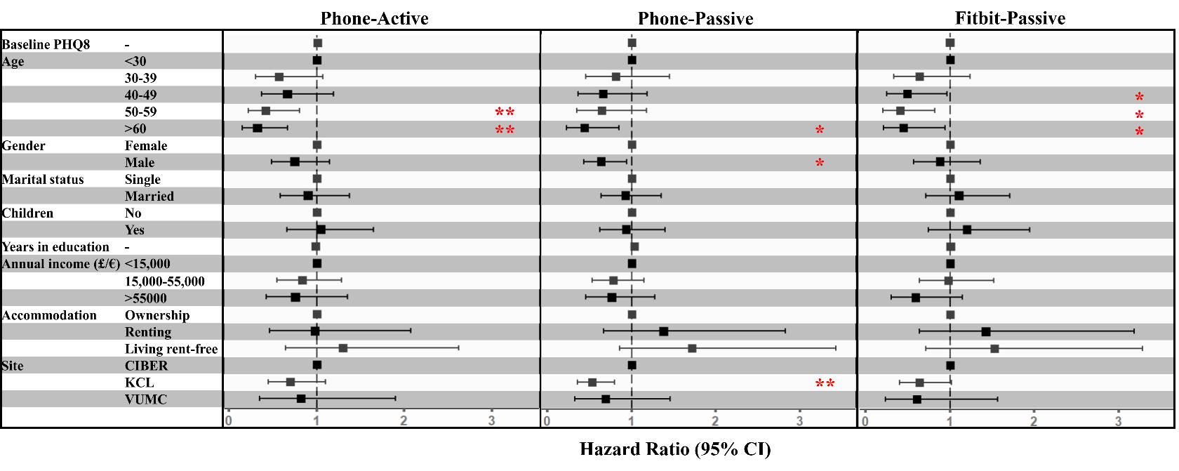
Supplement Figure 1. The hazard ratio plots of Cox Proportional-Hazards models for assessing the impact of multiple variables of interest on the participant retention time in the study of the secondary cohort (94-week observation period) for the Phone-Active, Phone-Passive, and Fitbit-Passive data streams, respectively. Significance levels: p < .05 *, p < .01 **, and p < .001 ***.

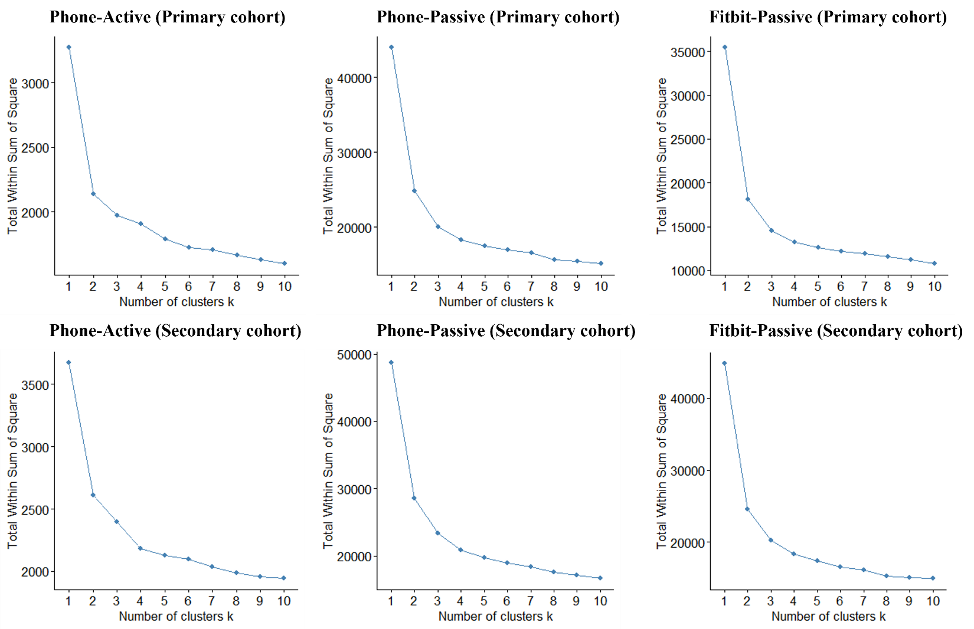
Supplement Figure 2. Comparison of within-cluster variations across data streams using different cluster sizes (N=1-10) for K-means clustering. The optimal numbers of clusters for primary (43-week observation period) and secondary (94-week observation period) cohorts are 3 and 4, respectively.

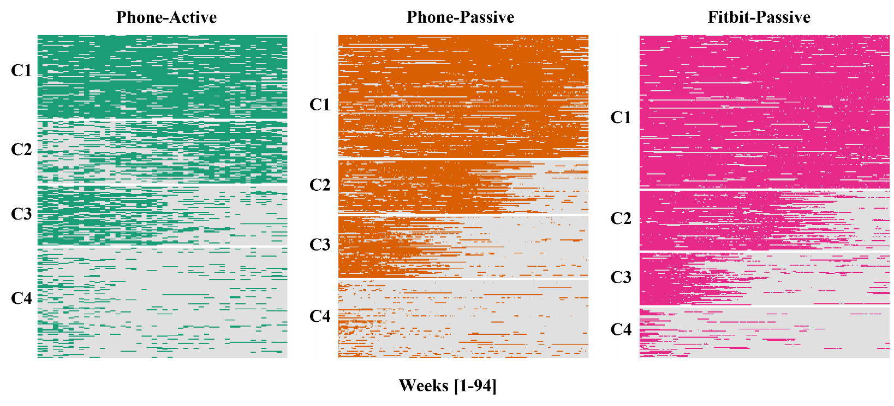
Supplement Figure 3. Heatmaps of participant longitudinal engagement patterns for the three data streams in the longer observation period (94 weeks), clustered using K-means clustering. In each heatmap, each row represents a data-availability vector of one participant (described in Methods), and subgroups were arranged from the most engaged cluster to the least engaged cluster (C1-C4).

