Chromatin accessibility landscape and active transcription factors in primary human invasive lobular and ductal breast carcinomas

Supplementary Figures

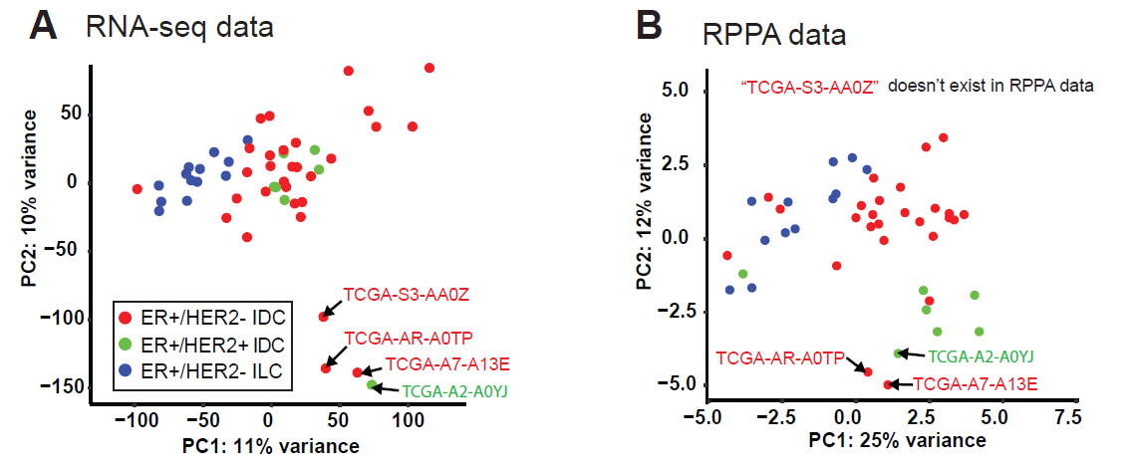

Supplement Figure 1. PCA of gene and protein expression data. (A) ER+ tumor clustering by TCGA RNA-seq data (16,418 genes after removing low read count genes) or (B) by Reverse Phase Protein Array (RPPA) data (132 proteins).

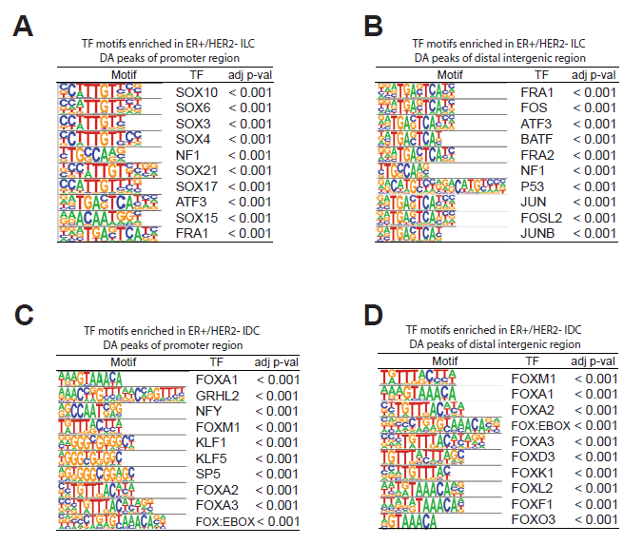

Supplement Figure 2. Enrichment of TF-binding motifs in promoter or distal intergenic regions for ILCs and IDCs. (A-B) Enrichment of TF-binding motifs per the promoter region (491 peaks) or distal intergenic region (2,488 peaks) enriched in ILCs. (C-D) Enrichment of TF-binding motifs per the promoter region (1,075 peaks) or distal intergenic region (2,729 peaks) enriched in IDCs. The top 10 most enriched motifs were selected and displayed.

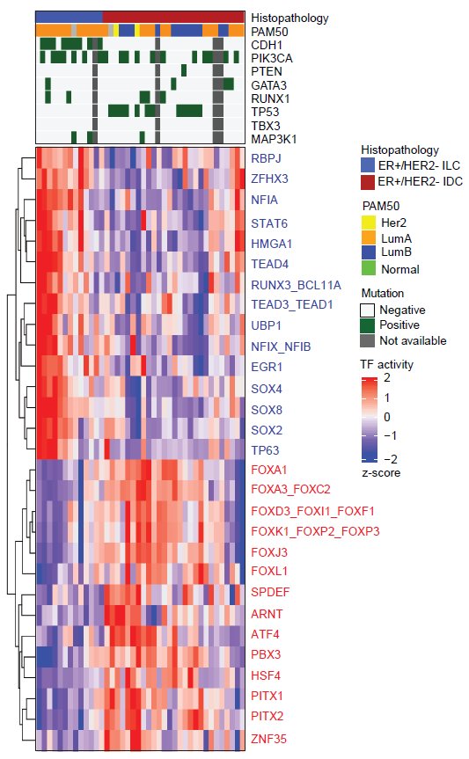

Supplementary Figure 3. Heatmap for TF activities. TFs significantly associated with ILCs (15 TFs in blue) and IDCs (14 TFs in red) (an absolute mean TF activity difference > 0.035 and the FDR-corrected p-value = 0.05).

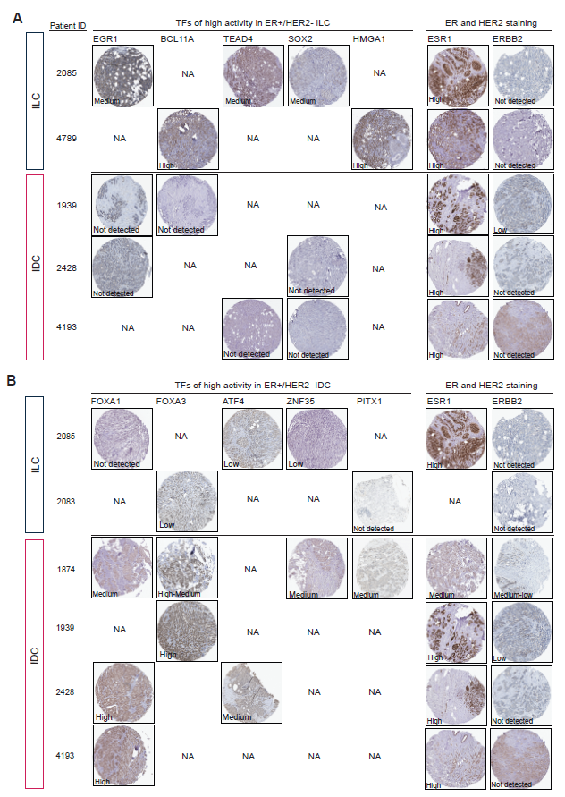

Supplement Figure 4. Immunohistochemical staining for TF protein expression and corresponding ER and HER2 staining. (A) EGR1, BCL11A, TEAD4, SOX2, and HMGA1, of which high activities in ILCs, have the protein expression high or medium in ILCs, but not detected in IDCs. (B) FOXA1, FOX3, ATF4, ZNF35, PITX1, of which high activities in IDCs, have the protein expression high or medium in IDCs, but not detected or low in ILCs. NA, tumor samples of staining images are not available.

Supplementary Table

Supplementary Table 1. List of ER+ ILC or ER+ IDC specific TF genes and essentiality scores derived from siMEM analysis.
The p-value/FDR derived for each TF according to published screens (GSE73526) using siMEM.

 | Gene | siMEM score difference | p-value | FDR
TFs of high activity in ILCs | RUNX3 | -0.694 | < 1x10⁻¹⁶ | 0.002
TFs of high activity in ILCs | SOX4 | -0.264 | 0.002 | 0.013
TFs of high activity in ILCs | TEAD3 | -0.244 | 0.015 | 0.054
TFs of high activity in ILCs | UBP1 | -0.392 | 0.015 | 0.054
TFs of high activity in ILCs | NFIA | -0.237 | 0.055 | 0.151
 | BCL11A | -0.173 | 0.065 | 0.151
 | TEAD1 | 0.239 | 0.094 | 0.189
 | STAT6 | -0.138 | 0.141 | 0.246
 | ZFHX3 | 0.196 | 0.209 | 0.348
 | RBPJ | 0.195 | 0.286 | 0.445
 | NFIB | -0.070 | 0.343 | 0.480
 | NFIX | 0.195 | 0.388 | 0.494
 | HMGA1 | -0.081 | 0.550 | 0.642
 | EGR1 | 0.038 | 0.803 | 0.865
 | TEAD4 | -0.024 | 0.899 | 0.899
TFs of high activity in IDCs | FOXA1 | -0.567 | < 1x10⁻¹⁶ | < 1x10⁻¹⁶
TFs of high activity in IDCs | SPDEF | -0.480 | 0.001 | 0.008
TFs of high activity in IDCs | PBX3 | 0.255 | 0.010 | 0.052
TFs of high activity in IDCs | HSF4 | 0.183 | 0.051 | 0.192
 | FOXJ3 | 0.099 | 0.106 | 0.317
 | FOXP3 | 0.098 | 0.137 | 0.343
 | FOXF1 | 0.127 | 0.181 | 0.388
 | FOXC2 | -0.095 | 0.263 | 0.494
 | PITX1 | -0.048 | 0.323 | 0.538
 | PITX2 | 0.037 | 0.538 | 0.808
 | ATF4 | 0.004 | 0.968 | 0.993
 | FOXI1 | -0.018 | 0.815 | 0.993
 | FOXL1 | 0.004 | 0.962 | 0.993
 | ZNF35 | 0.000 | 0.993 | 0.993
 | FOXD3 | 0.027 | 0.778 | 0.993

o Yellow highlight: FDR < 0.2
o Blue text: Essential genes in ER+ ILC cell lines
o Red text: Essential genes in ER+ IDC cell lines

