Table 2: Introduction of the α-β unsaturated carbonyl motive by allylic oxidation (Eyong et al. 2015) of lupane derivatives

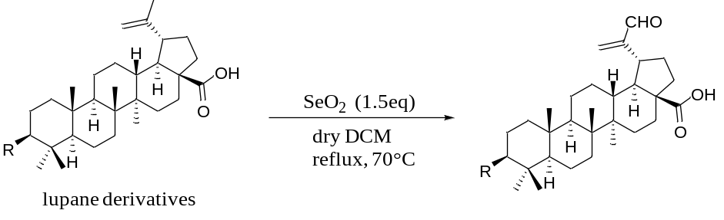
Substrate | Product(s) | Isolated Yield | Time (min)
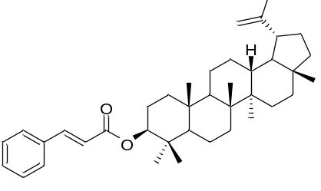  4 | 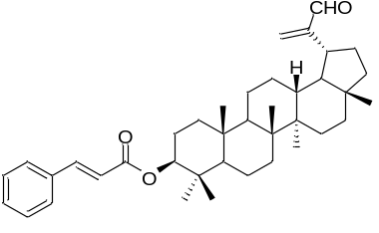  19 | 30% | 30
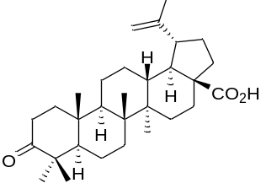  8 | 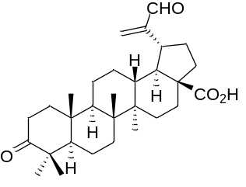  14 | 30% | 30
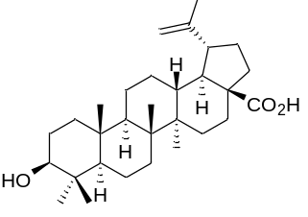  10 | 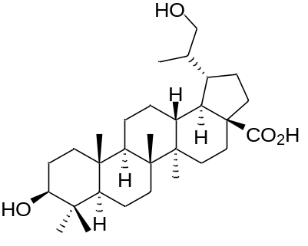  17 | 25% | 10
 | 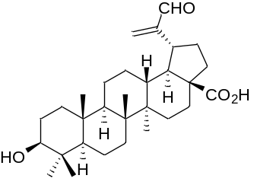  18 | 40%
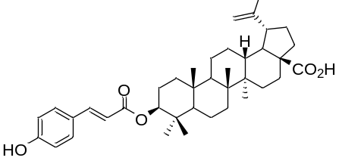  11 | 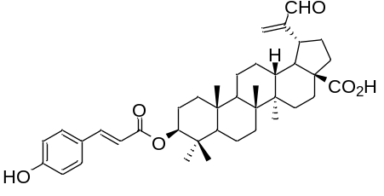  16 | 30% | 30
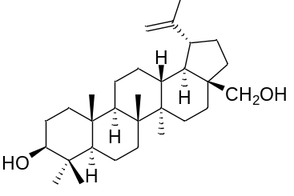  12 | 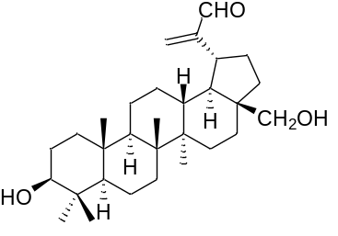  15 | 30% | 60

Table 3: ¹H and ¹³C NMR spectral data of the synthesized compounds
N° | δc (DEPT) |  | δ_{H} (m, J in Hz) | δc (DEPT) | δ_{H} (m, J in Hz) | δc (DEPT) | δ_{H} (m, J in Hz) | δc (DEPT) | δ_{H} (m, J in Hz) | δc (DEPT) |  | δ_{H} (m, J in Hz) | δc (DEPT) | δ_{H} (m, J in Hz)
14 |  |  |  | 15 |  | 16 |  | 17 |  | 18 |  |  | 19
1  2 |  | 39.6(CH₂)  34.1(CH₂) | 0.99(m) ;1.67(br d, J= 12.9Hz)  1.85(m) | 38.8(CH₂)  27.4(CH₂) | 0.92(m) ;1.57(br d, J= 12.0Hz)  1.47(m);1.72(dd, 10 and 12Hz) | 38.2(CH₂)  34.2(CH₂) | 0.99(m) ;1.67(brd, J= 12.8Hz)  1.85(m) | 38.2(CH₂)  34.2(CH₂) | 1.09(m) ;1.71(br d, J= 13.0Hz)  1.88(m) | 38.2(CH₂)  34.2(CH₂) | 0.99(m) ;1.67(br d, J= 12.9Hz)  1.85(m) |  | 38.2(CH₂) | 0.99(m);1.67(br d, J= 12.9Hz)  1.85(m)
3 |  | 218.1(C) | - | 77.22(CH) | 2.97 (dd, 5 and 10Hz) | 81.0(CH) | 4.43 (m) | 78.8(CH) | 4.63 (dd) | 77.3(CH) | 3,24 (m) |  | 78.8(CH) | 4.63 (dd)
4 |  | 47.3(C) | - | 38.3(C) | - | 38.3(C) | - | 38.3(C) | - | 38.9(C) | - |  | 38.3(C) | -
5 |  | 54.9(CH) | 0.82(m) | 55.3(CH) | 0.72(m) | 55.4(CH) | 0.82(m) | 55.4(CH) | 0.82(m) | 55.4(CH) | 0.82(m) |  | 55.4(CH) | 0.82(m)
6 |  | 19.6(CH₂) | 1.56(m); 1.38(m) | 18.3(CH₂) | 1.55(m); 1.33(m) | 18.1(CH₂) | 1.56(m); 1.38(m) | 18.1(CH₂) | 1.56(m); 1.38(m) | 18.4(CH₂) | 1.56(m); 1.38(m) |  | 18.1(CH₂) | 1.56(m);1.38(m)
7 |  | 33.6(CH₂) | 1.45(m); 1.38(m) | 34.3(CH₂) | 1.44(m); 1.38(m) | 34.2(CH₂) | 1.45(m); 1.38(m) | 34.2(CH₂) | 1.45(m); 1.38(m) | 34.4(CH₂) | 1.45(m); 1.38(m) |  | 34.2(CH₂) | 1.45(m);1.38(m)
8 |  | 40.7(C) | - | 41.0(C) | - | 40.6(C) | - | 40.6(C) | - | 40.6(C) | - |  | 40.6(C) | -
9 |  | 49.9(CH) | 1.38(m) | 50.1(CH) | 1.38(m) | 50.37(CH) | 1.38(m) | 50.37(CH) | 1.38(m) | 50.3(CH) | 1.38(m) |  | 50.37(CH) | 1.38(m)
10 |  | 37.0(C) | - | 37.4(C) | - | 37.0(C) | - | 37.0(C) | - | 37.2(C) | - |  | 37.0(C) | -
11 |  | 21.4(CH₂) | 1.43(m); 1.21(m) | 20.9(CH₂) | 1.42(m); 1.22(m) | 20.8(CH₂) | 1.43(m); 1.21(m) | 20.8(CH₂) | 1.43(m); 1.21(m) | 20.9(CH₂) | 1.43(m); 1.21(m) |  | 20.8(CH₂) | 1.43(m);1.21(m)
12 |  | 25.5(CH₂) | 1.21(m); 1.94(m) | 25.6(CH₂) | 1.23(m); 1.91(m) | 25.4(CH₂) | 1.21(m); 1.94(m) | 25.4(CH₂) | 1.21(m); 1.94(m) | 25.4(CH₂) | 1.21(m); 1.94(m) |  | 25.4(CH₂) | 1.21(m);1.94(m)
13 |  | 38.5(CH) | 2.58(m) | 37.0(CH) | 2.74(m) | 37.9(CH) | 2.74(m) | 37.9(CH) | 2.74(m) | 37.9(CH) | 2.74(m) |  | 37.9(CH) | 2.74(m)
14 |  | 42.5(C) | - | 42.8(C) | - | 42.3(C) | - | 42.3(C) | - | 42.4(C) | - |  | 42.3(C) | -
15 |  | 30.5(CH₂) | 1.26(m); 1.88(m) | 27.1(CH₂) | 1.26(m); 1.88(m) | 30.5(CH₂) | 1.26(m); 1.88(m) | 30.5(CH₂) | 1.26(m); 1.88(m) | 30.5(CH₂) | 1.26(m); 1.88(m) |  | 30.5(CH₂) | 1.26(m);1.88(m)
16 |  | 32.1(CH₂) | 1.55(m); 2.63(m) | 29.3(CH₂) | 1.55(m); 2.63(m) | 32.2(CH₂) | 1.55(m); 2.63(m) | 32.2(CH₂) | 1.55(m); 2.63(m) | 32.2(CH₂) | 1.55(m); 2.63(m) |  | 32.2(CH₂) | 1.55(m);2.63(m)
17 |  | 56.3(C) | - | 47.8(C) | - | 56.2(C) | - | 56.2(C) | - | 56.0(C) | - |  | 56.2(C) | -
18 |  | 49.2(CH) | 1.77(t, J=11.5Hz) | 47.8(CH) | 1.77(m) | 46.9(CH) | 1.77(t, J=11.5Hz) | 46.9(CH) | 1.70(m) | 46.9(CH) | 1.77(t, J=11.5Hz) |  | 46.9(CH) | 1.77(t, J= 11.5Hz)
19 |  | 46.8(CH) | 2.74(m) | 48.(CH) | 2.65 (m) | 49.1(CH) | 3.52(m) | 49.1(CH) | 3.52(m) | 49.1(CH) | 3.52(m) |  | 49.1(CH) | 3.52(m)
20 |  | 147.3(C) | - | 148.3(C) | - | 150.6(C) | - | 41.1(CH) |  | 147.3(C) | - |  | 150.9(C) | -
21 |  | 29.7(CH₂) | 1.53(m); 2.24(m) | 29.8(CH₂) | 1.53(m); 2.24(m) | 29.5(CH₂) | 1.53(m); 2.24(m) | 29.5(CH₂) | 1.53(m); 2.24(m) | 29.6(CH₃) | 1.53(m); 2.24(m) |  | 29.5(CH₂) | 1.53(m);2.24(m)
22 |  | 37.0(CH₂) | 1.57(m); 2.25(m) | 34.0(CH₂) | 1.56(m); 2.15(m) | 37.0(CH₂) | 1.57(m); 2.25(m) | 37.0(CH₂) | 1.57(m); 2.25(m) | 36.6(CH₃) | 1.57(m); 2.25(m) |  | 37.0(CH₂) | 1.57(m);2.25(m)
23  24  25  26  27  28  29  30  1’  2’  3’  1’’  2’’  3’’  4’’  5’’  6’’ |  | 26.6(CH₃)  21.0(CH₃)  16.0(CH₃)  15.8(CH₃)  14.6(CH₃)  180.9(C)  105.8(CH₂)  198.2(C) | 1.27 (s)  1.09 (s)  0.95 (s)  1.01 (s)  0.99 (s)  -  6.30 and 5.94 (br s)  9.50 (s) | 28.0(CH₃)  15.3(CH₃)  16.1(CH₃)  16.1(CH₃)  14.7(CH₃)  58.23(CH₃)  105.8(CH₂)  196.0(C) | 0.88 (s)  0.66 (s)  0.76 (s)  0.91 (s)  0.98 (s)  3.53 and 3.09 (d, 10 Hz)  6.42 and 6.08 (br s)  9.51 (s) | 27.8(CH₃)  15.7(CH₃)  15.9(CH₃)  16.4(CH₃)  14.5(CH₃)  179.0(C)  109.3(CH₂)  198.0(CH)  167.8(C)  115.0(CH)  144.6(CH)  125.96(C)  129.8(CH)  115.7(CH)  159.3(C)  115.7(CH)  129.8(CH) | 0.98 (s)  0.94 (s)  0.90 (s)  0.88 (s)  0.87 (s)  -  6.47and 6.10(br s)  9.53 (s)  -  6.15 (d, J= 15 Hz)  7.48 (d, J= 15 Hz)  -  6.72 (d, J= 5 Hz)  7.31 (d, J= 5Hz)  -  7.31 (d, J= 5 Hz)  6.72 (d, J= 5 Hz) | 28.0(CH₃)  16.2(CH₃)  16.7(CH₃)  17.8(CH₃)  15.9 (CH3)  179.0(C)  15.1(CH₃) | 0.96(s)  1.05(s)  0.91(s)  0.89(s)  0.85(s)  -  0.94(s) | 27.6(CH₃)  16.1(CH₃)  16.2(CH₃)  16.4(CH₃)  14.8(CH₃)  177.6(C)  105.8(CH₂)  196.0(C) | 0.86 (s)  0.66 (s)  0.76 (s)  0.87 (s)  0.91 (s)  -  6.47 and 6.10 (s)  9.50 (s) |  | 28.0(CH₃)  16.2(CH₃)  16.7(CH₃)  17.8(CH₃)  15.9 (CH₃)  14.4 (CH₃)  110.1(CH₂)  195.3(CH)  166.8(C)  119.1(CH)  144.5(CH)  134.8(C)  129.1(CH)  128.2(CH)  130.3(CH)  128.2(CH)  129.1(CH) | 0.96(s)  1.05(s)  0.91(s)  0.89(s)  0.85(s)  0.94(s)  6.32-5.95 (br s)  9.54 (s)  -  6.46 (d, J= 15 Hz)  7.68 (d, J= 15 Hz)  -  7.55 (m)  7.40 (m)  7.54 (m)  7.40 (m)  7.55 (m)

