SUPPORTING INFORMATION
Glyceraldehyde-3-phosphate dehydrogenase (PfGAPDH) : Design, Isolation, Synthesis and preliminary anti-malarial activity against Plasmodium falciparum 3D7 strains.

Pierre Yemback¹., Kenneth O. Eyong¹., Noella M. Efange²., Michael H. K. Kamdem³., Derek T. Ndinteh³., Patricia O. Odumosu⁴., Gabriel N. Folefoc¹., Lawrence Ayong²., Thomas Werner⁵

¹Department of Organic Chemistry, Faculty of Science, The University of Yaounde 1, Cameroon) BP 812 Yaounde Cameroon
² Malaria Research Unit, Centre Pasteur du Cameroun, B.P. 1274 Yaounde, Cameroon)
³Drug Discovery and Smart Molecules Research Laboratory, Department of Chemical Sciences, University of Johannesburg, P.O. Box 17011, Doornfontein, Johannesburg 2028, South Africa)
⁴Pharmaceutical Chemistry Department, Faculty of Pharmaceutical Sciences, University of Jos, P. M. B. 2084, Jos, Nigeria
⁵Department of Chemistry, Organic Chemistry, Paderborn University, Warburger Strasse 100, D-33098 Paderborn, Germany

✉ Eyong K. Oben
eyongkk@yahoo.com

Key words: PfGAPDH, molecular docking, antimalarial drugs, lupane derivatives, Baillonella toxisperma.

General experimental procedures
Melting points were performed on a Büchi SMP-20 melting point apparatus. The NMR spectra in chloroform-d and methanol-d₄ were obtained using Brucker BioSpin GmbH instruments, operating at 400 MHz for ¹H NMR and 100 MHz for ¹³C NMR. Chemical shifts are given in δ (ppm) using tetramethylsilane (TMS) as internal standard. EI-MS was obtained with JEOL JMS-600H mass spectrometer. The extraction of the plant material was done using a digital ultrasonic cleaner LMUC series of mark LABMAN (serial number L1328). Flash chromatography was performed on SCHOTT Buchner (Duran, West Germany) with a porosity of 4. Analytical thin-layer chromatography (TLC) was performed on precoated silica gel plates (Merck 60F₂₅₄; 20x20, 0.25 mm). Column chromatography was performed on silica gel (70-230 mesh; Merck). Chromatograms were visualized by spraying with a solution of 10 % H₂SO₄, iodine vapor or under ultraviolet light of wavelengths 254 and 366 nm.

Olean-12-en-3β-hexadecanoate (3)
¹H-NMR of Compound 3
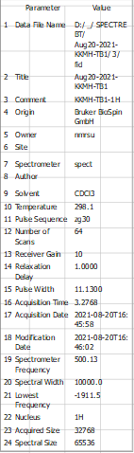
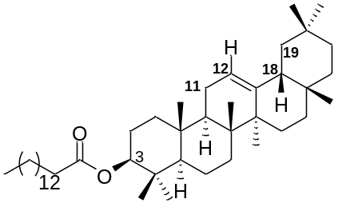
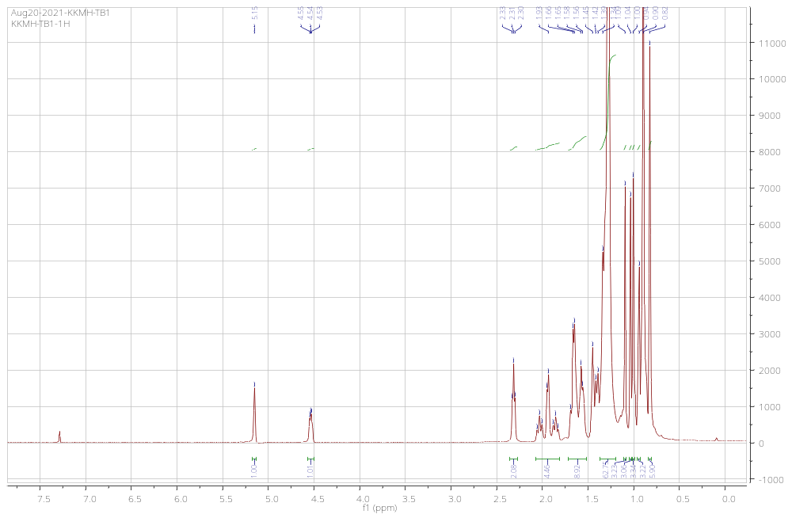
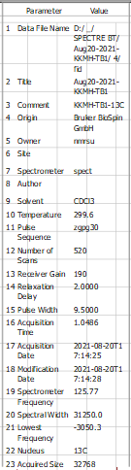
¹³C NMR spectra
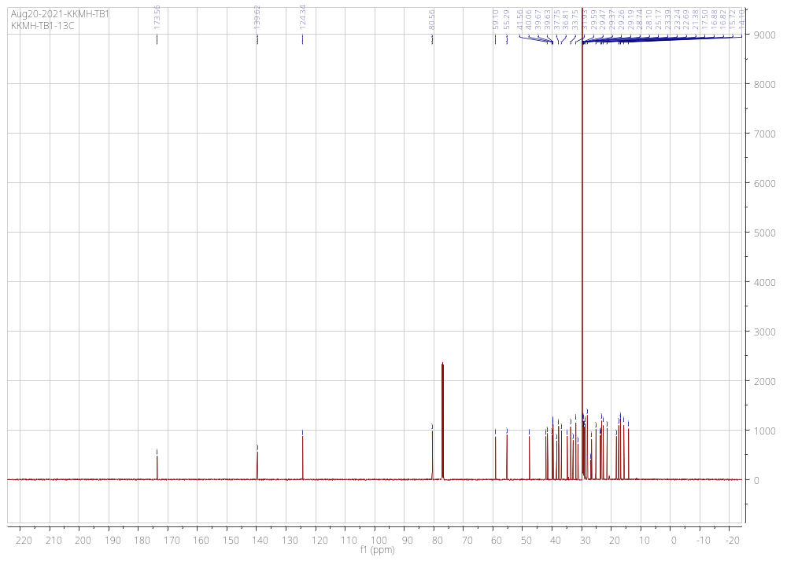
3-β-trans cinnamoyloxylup-20(29)-ene (4)
¹H-NMR of Compound 4
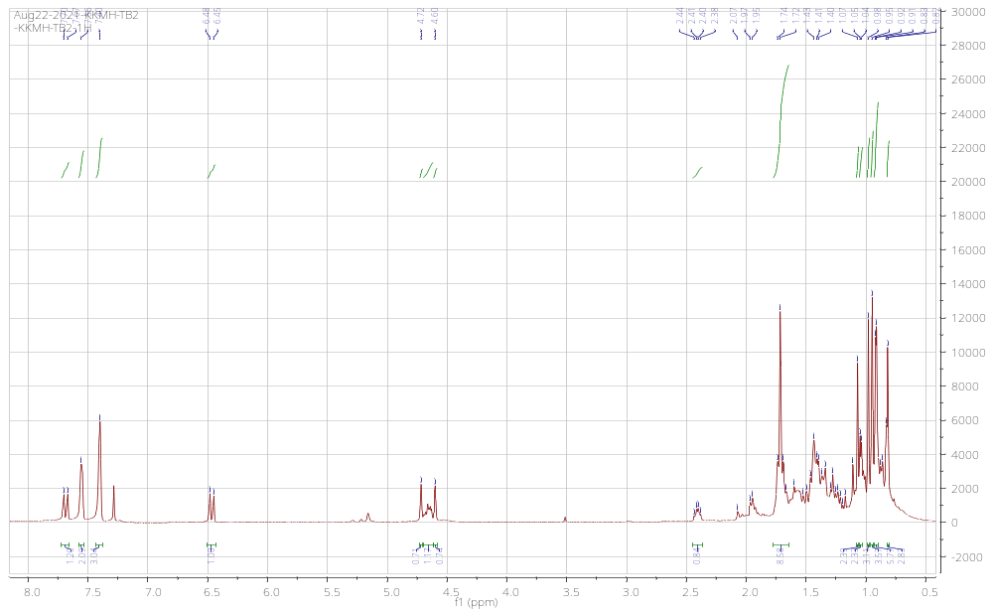
¹³C NMR spectra
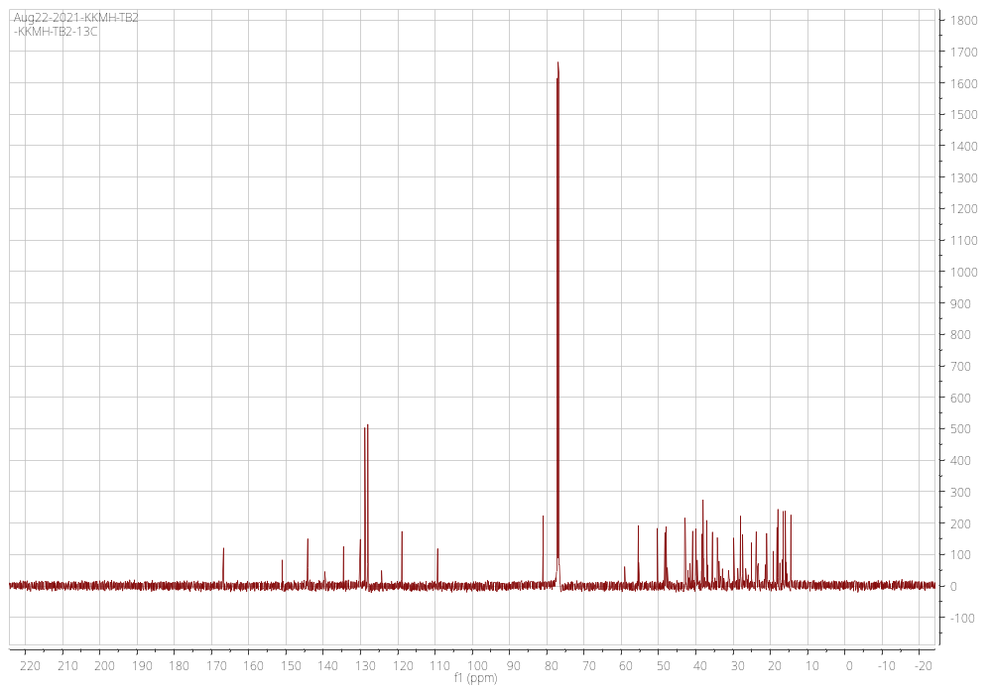
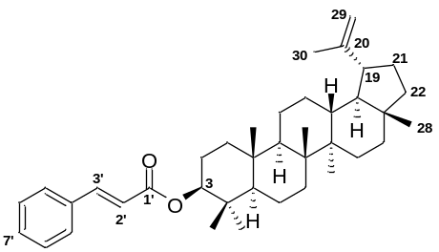

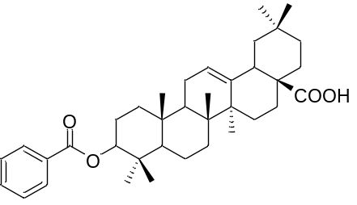
Oleanolic acid benzoate (5)
¹H-NMR of Compound 5
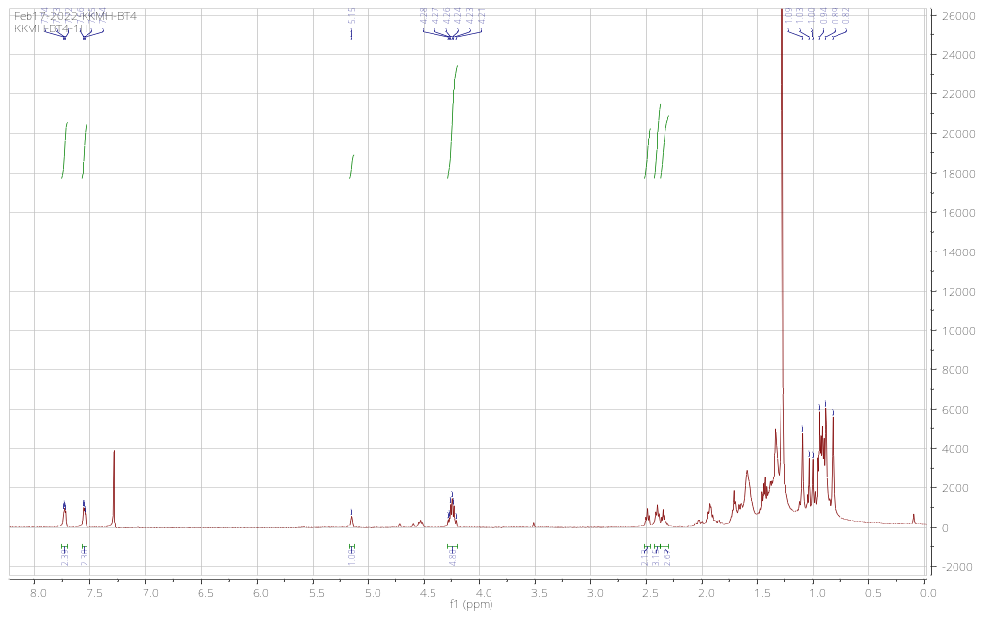
¹³C NMR spectra
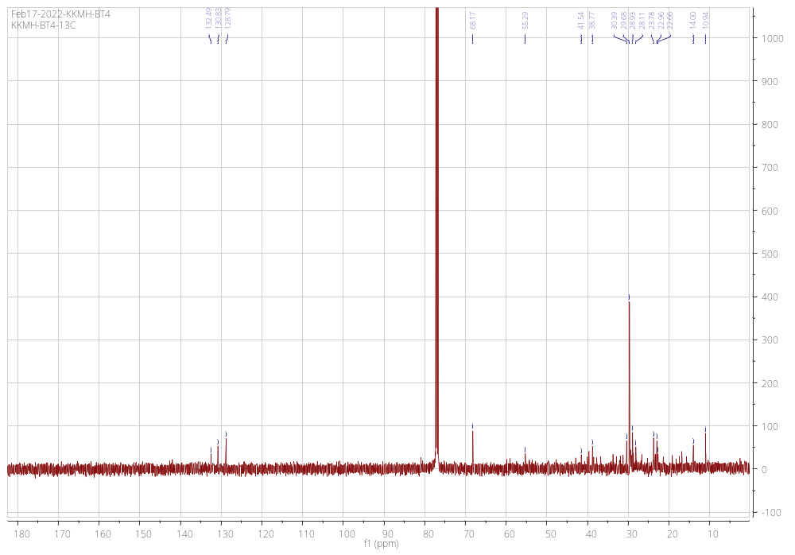
3β -amyrin (6)
¹H-NMR of Compound 6
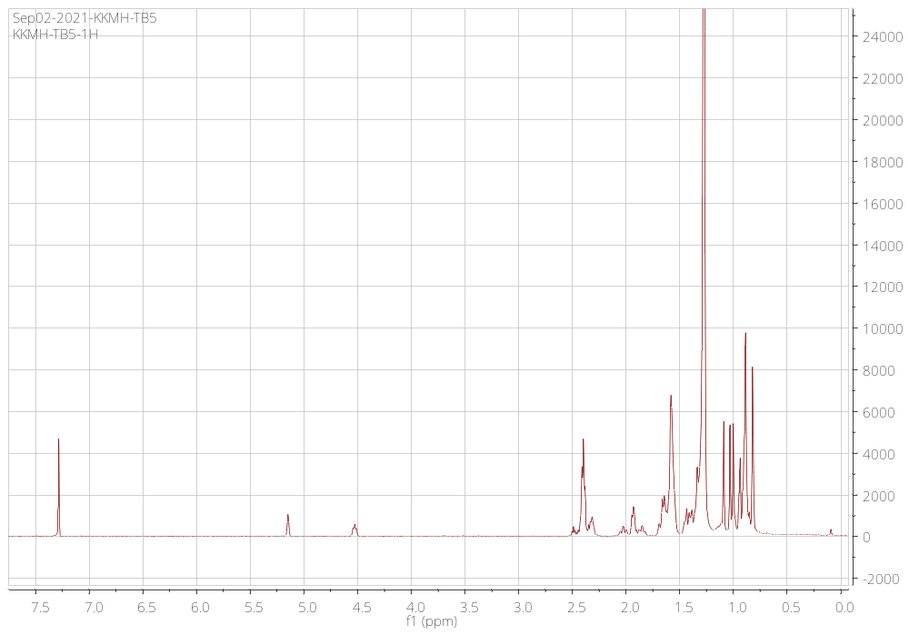
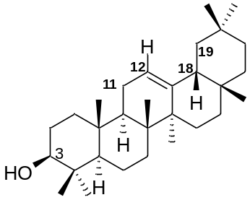
¹³C NMR spectra
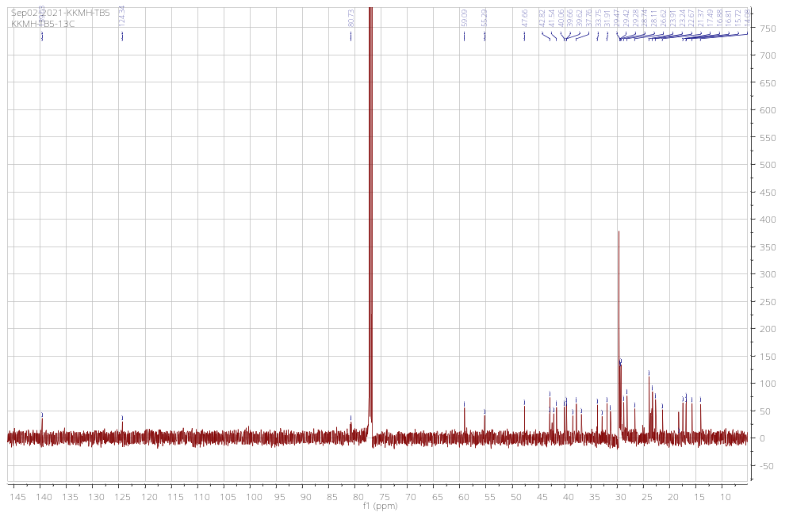
taraxerol (7)
¹H-NMR of Compound 7
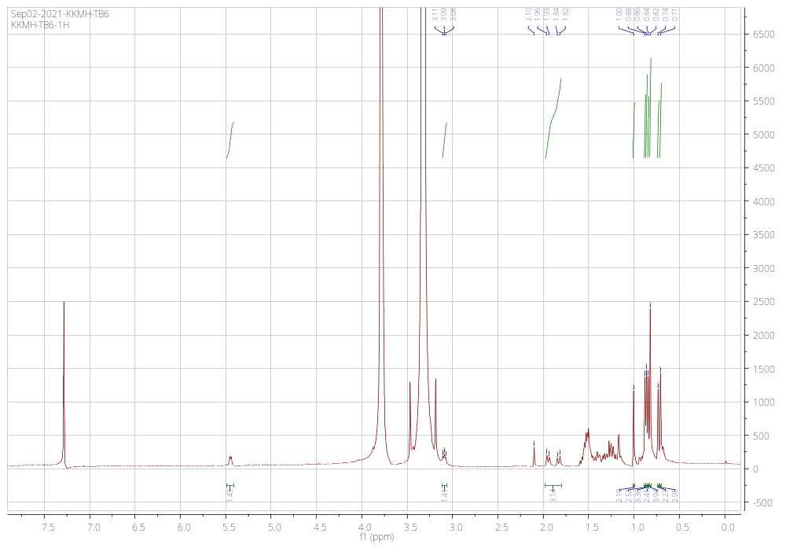
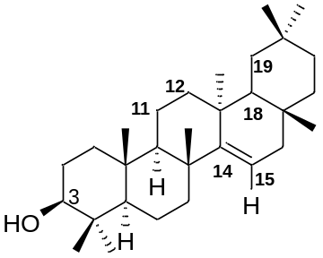
¹³C NMR spectra
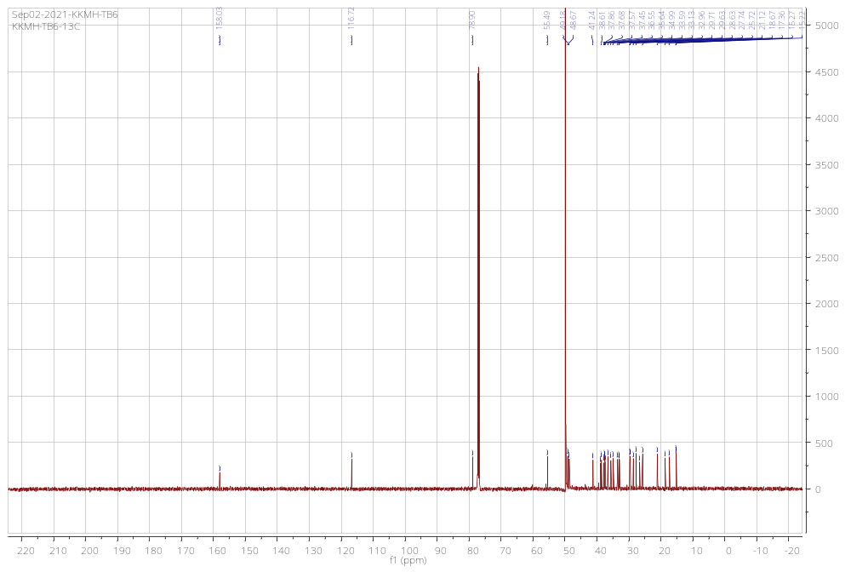
betulonic acid (8)
¹H-NMR of Compound 8
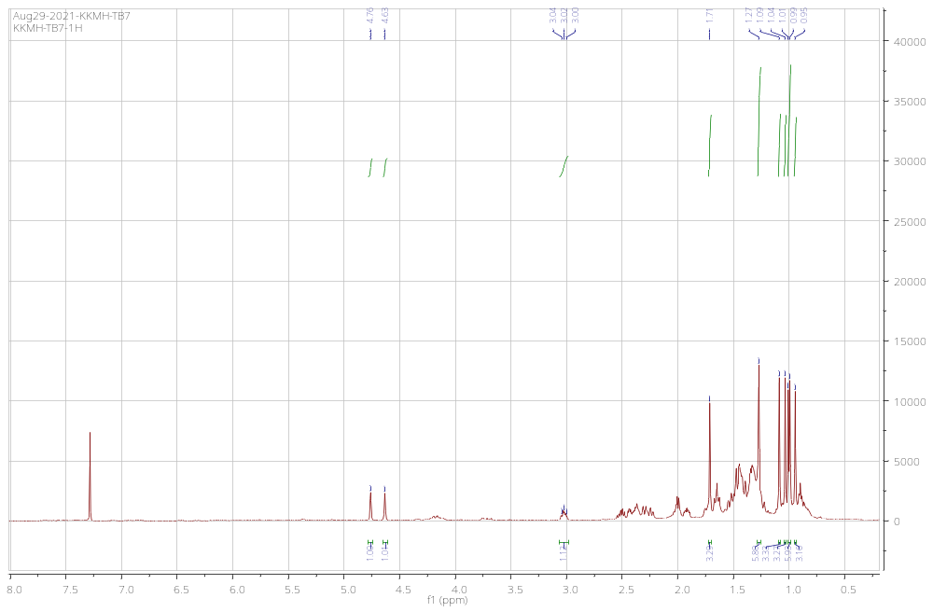
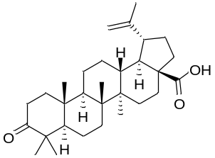
¹³C NMR spectra
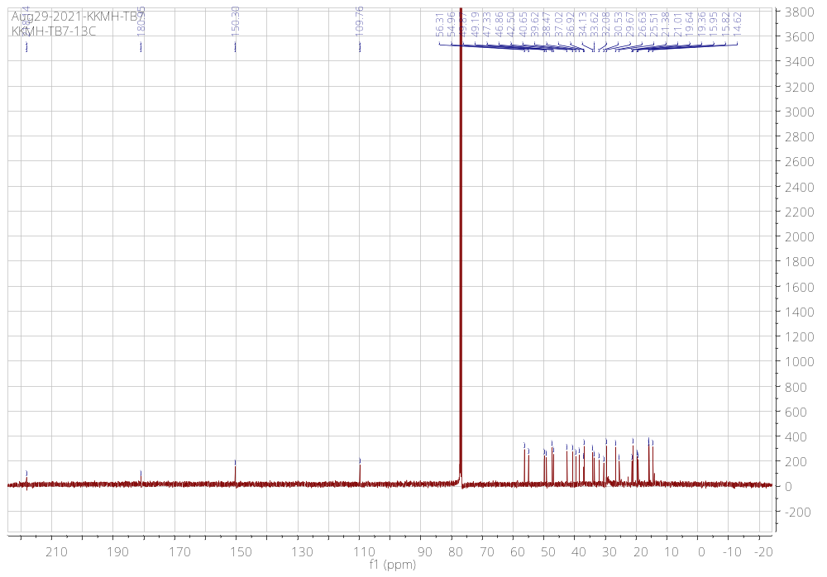
β-sitosterol (9)
¹H-NMR of Compound 9
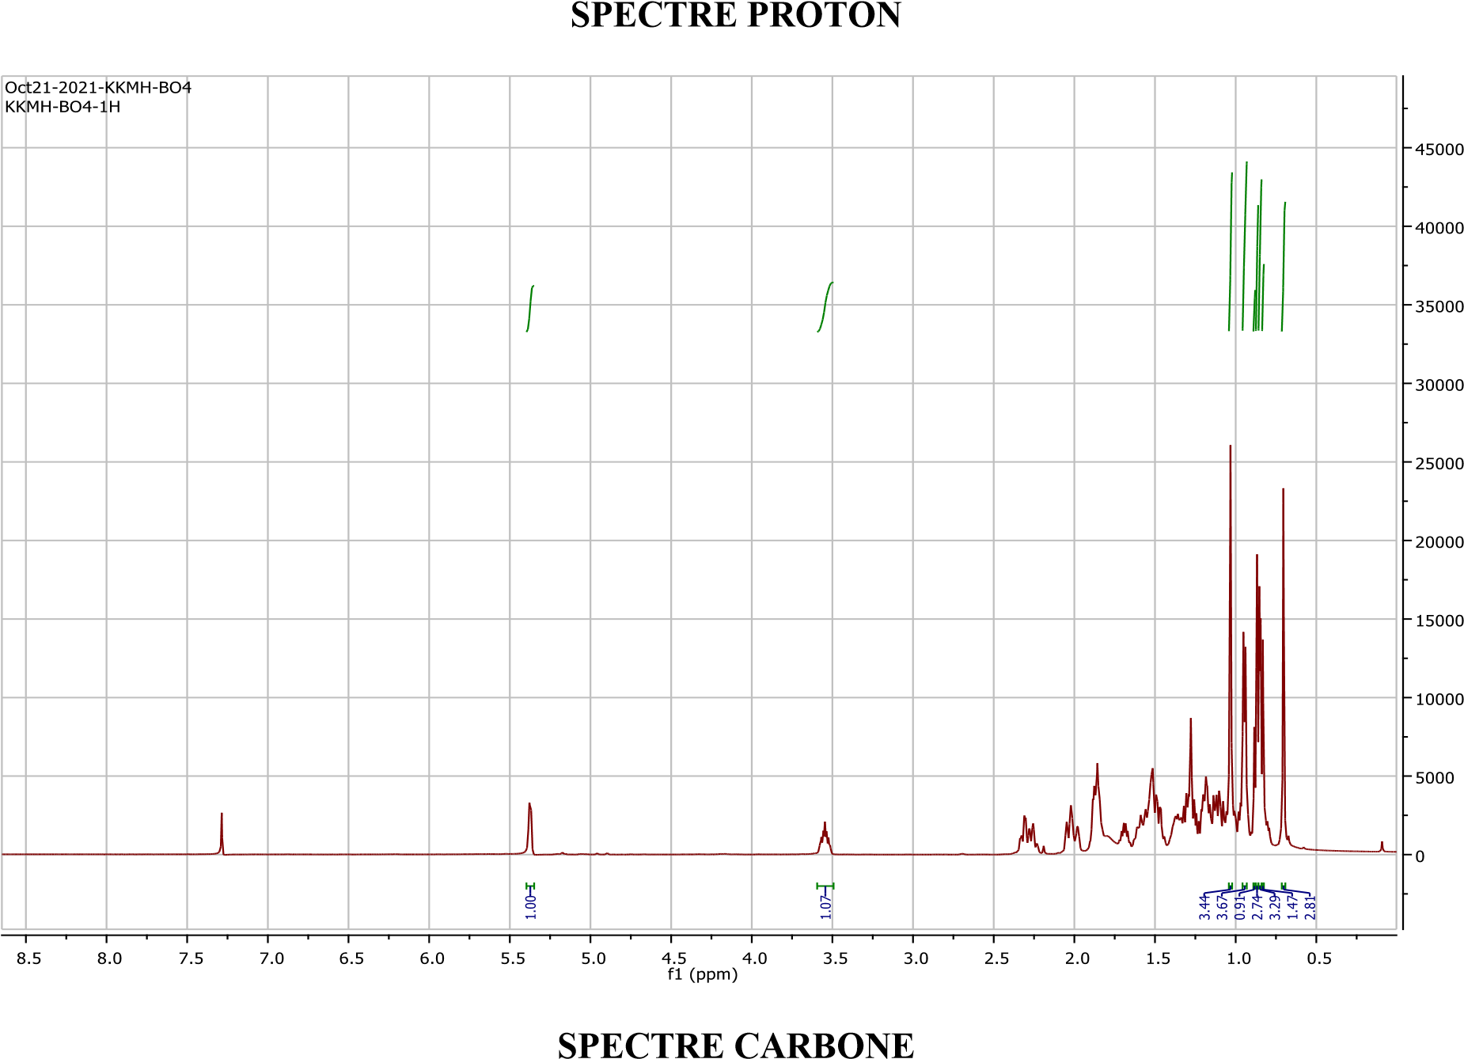
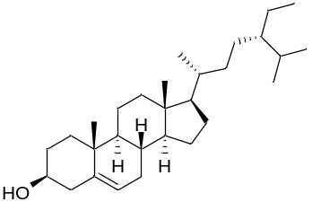
¹³C NMR spectra
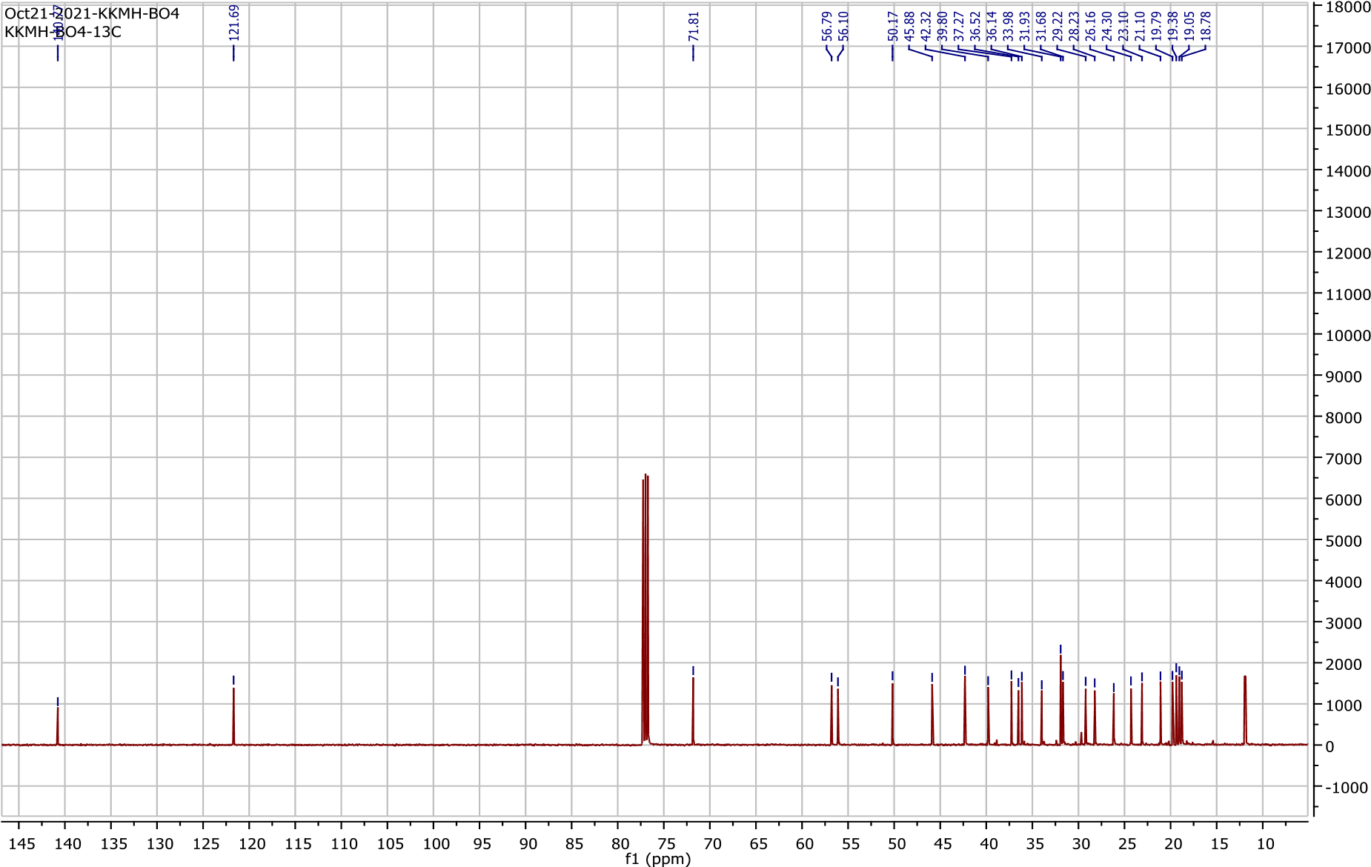
betulinic acid (10)
¹H-NMR of Compound 10
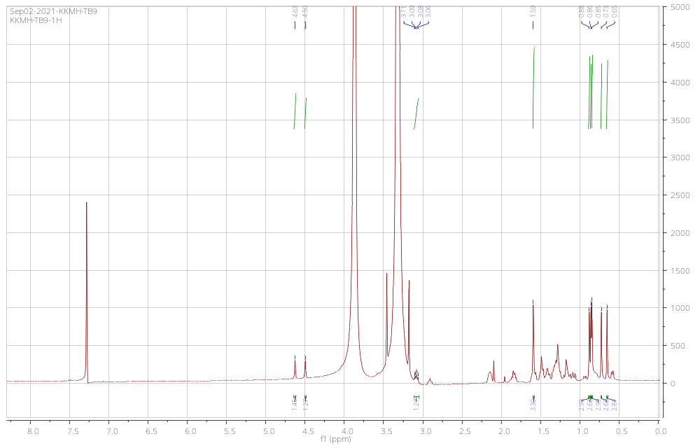
¹³C NMR spectra
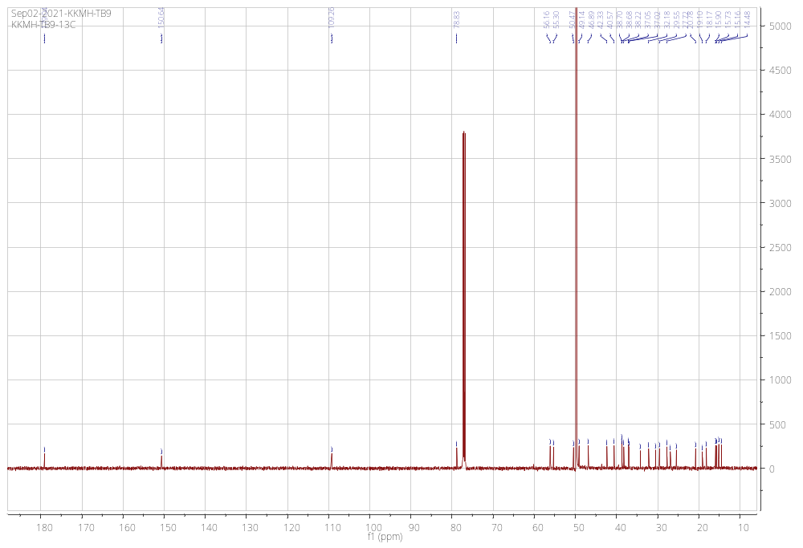
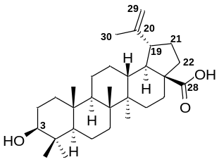
3β-(trans-p-Coumaroyl)oxylup-20(29)-en-28-oïc acid (11)
¹H-NMR of Compound 11
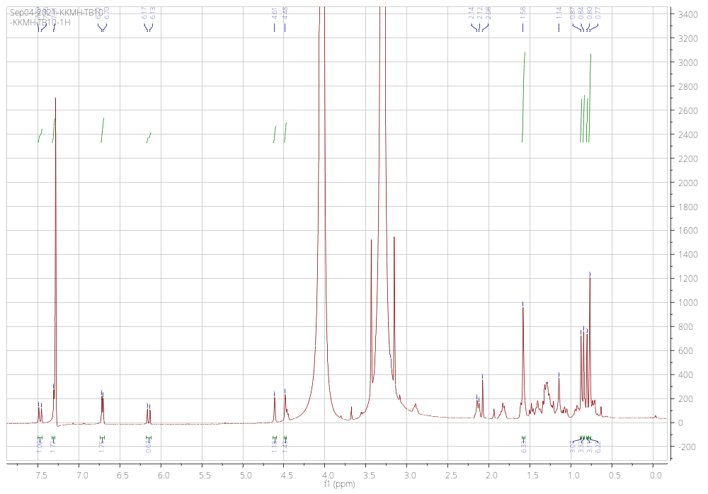
¹³C NMR spectra
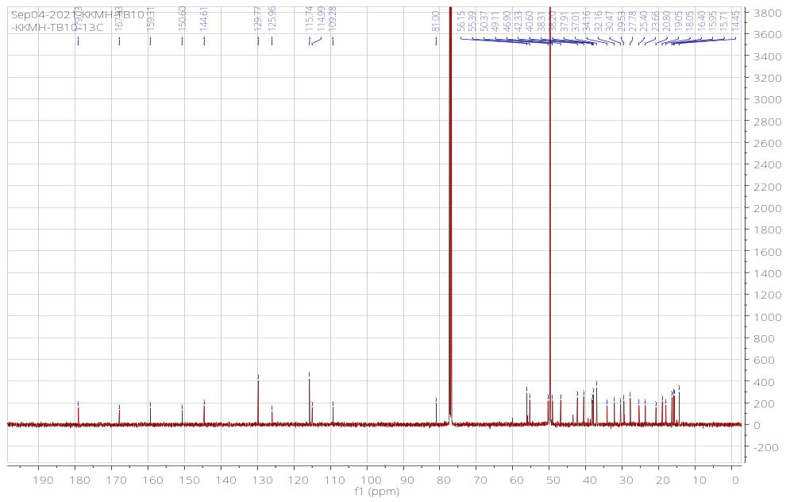
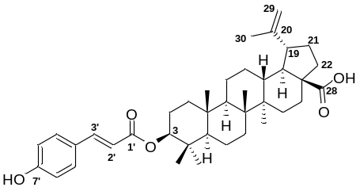

Betulin (12)
Mass spectra of Compound 12
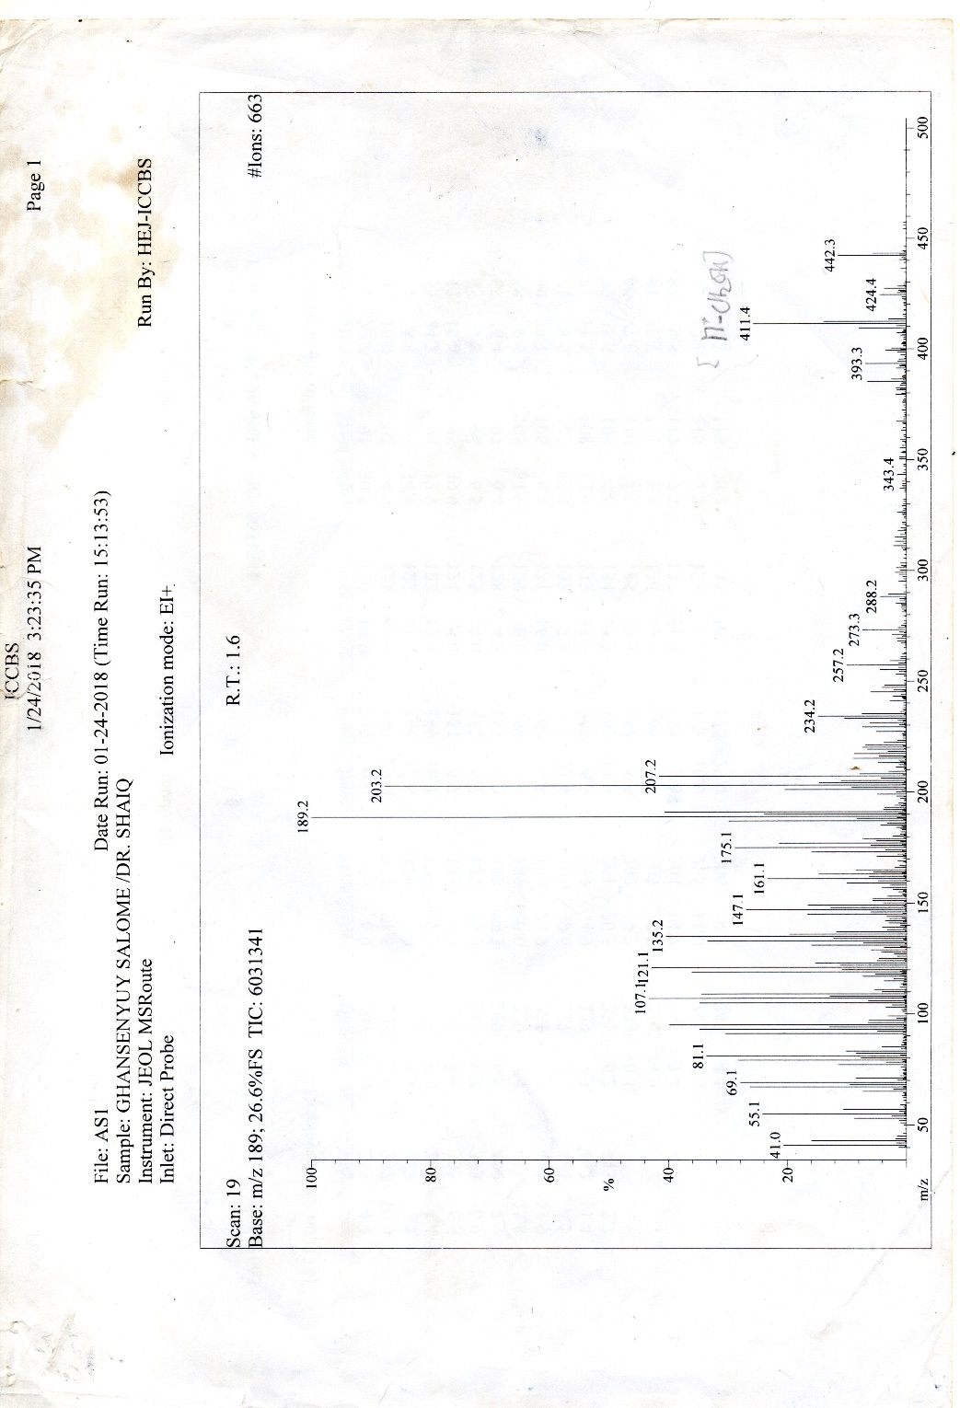
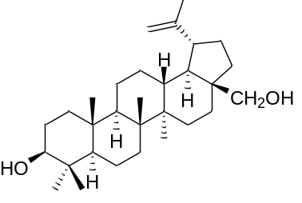
¹H-NMR of Compound 12
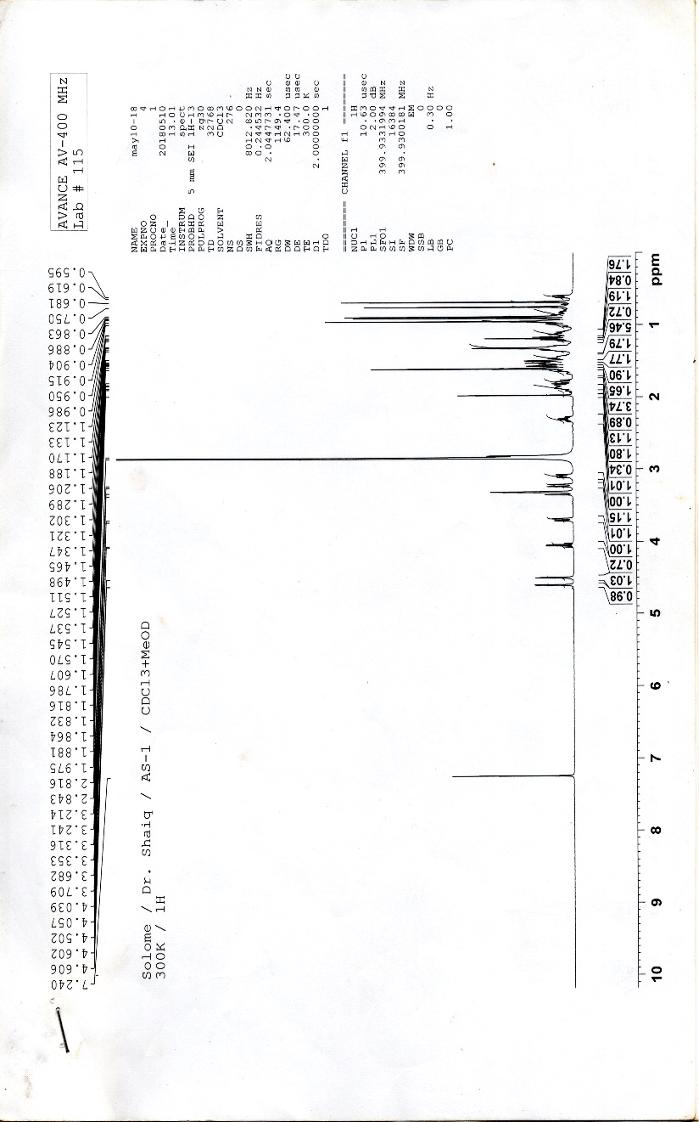
Betulonic acid acryl aldehyde (14)
¹H-NMR of Compound 14
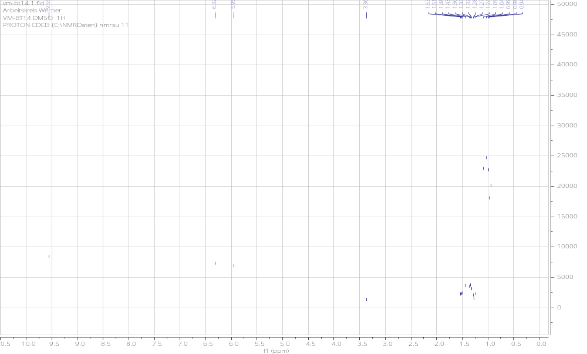
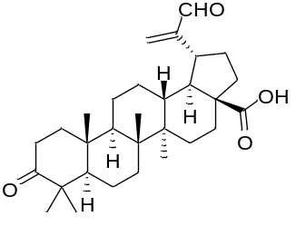
¹³C NMR spectra
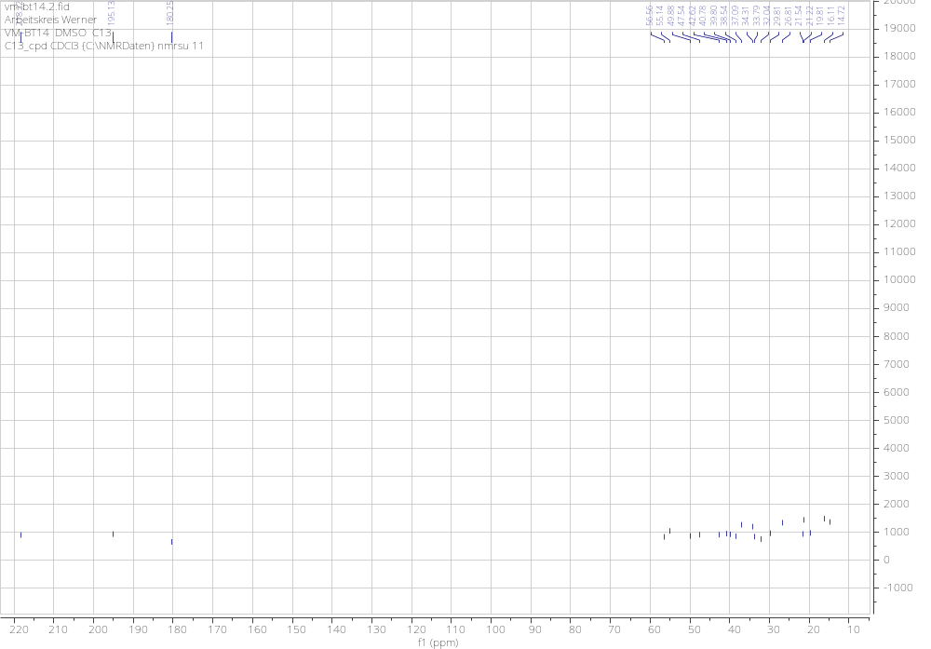

Betulin acryl aldehyde (15)
¹H-NMR of Compound 15
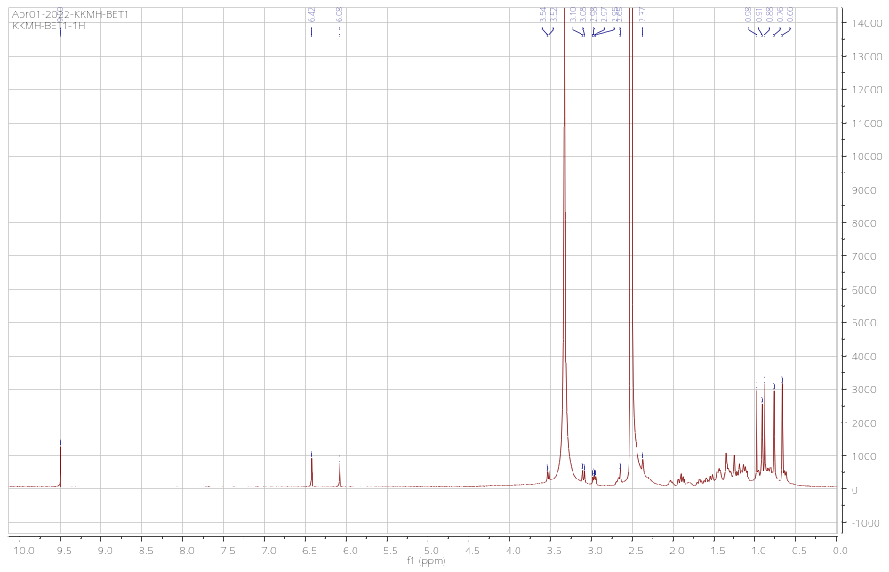
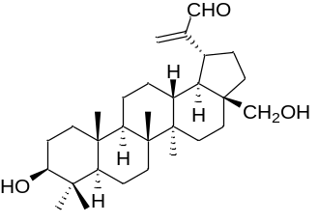
¹³C NMR spectra
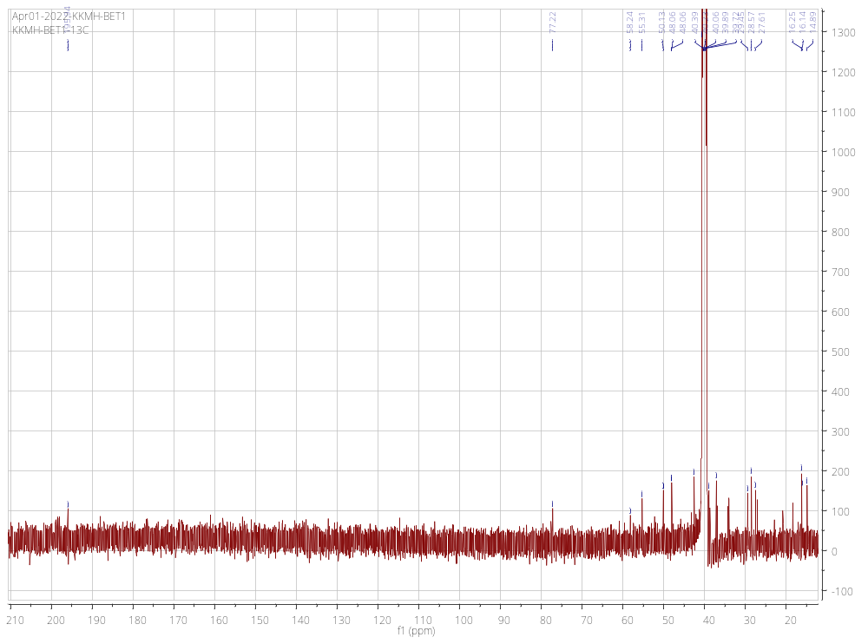

30-hydroxy betulinic acid 17:
¹H-NMR of Compound 17
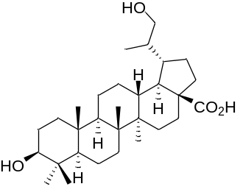
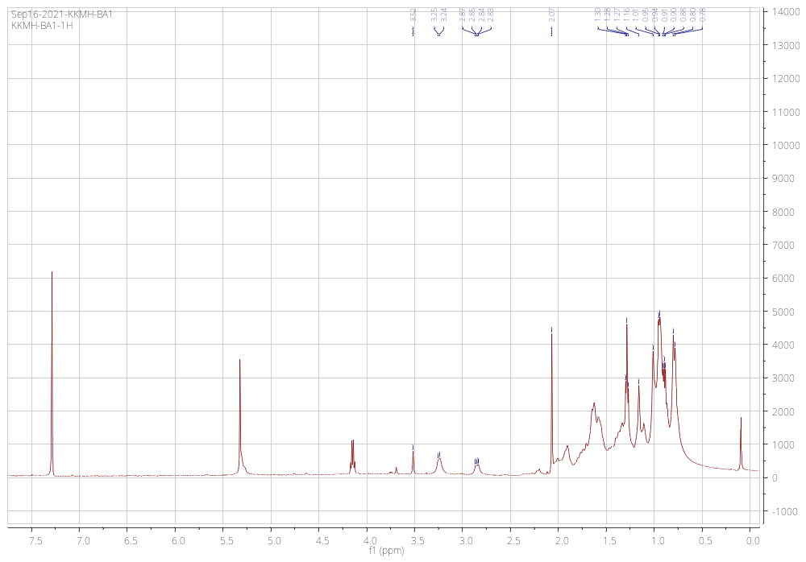

betulinic acid acrylaldehyde 18:
¹H-NMR of Compound 18
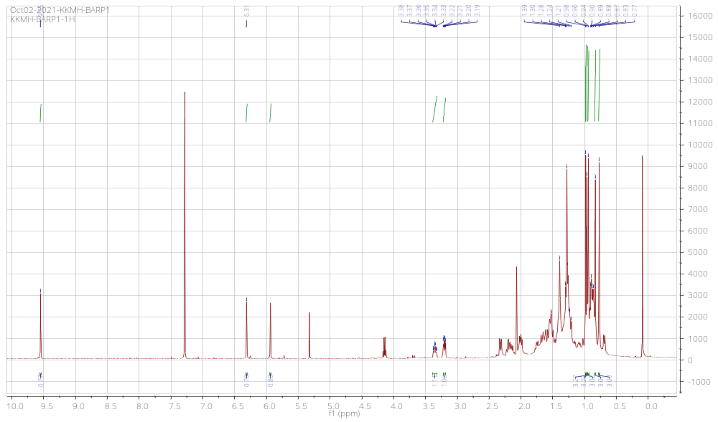
¹³C NMR spectra
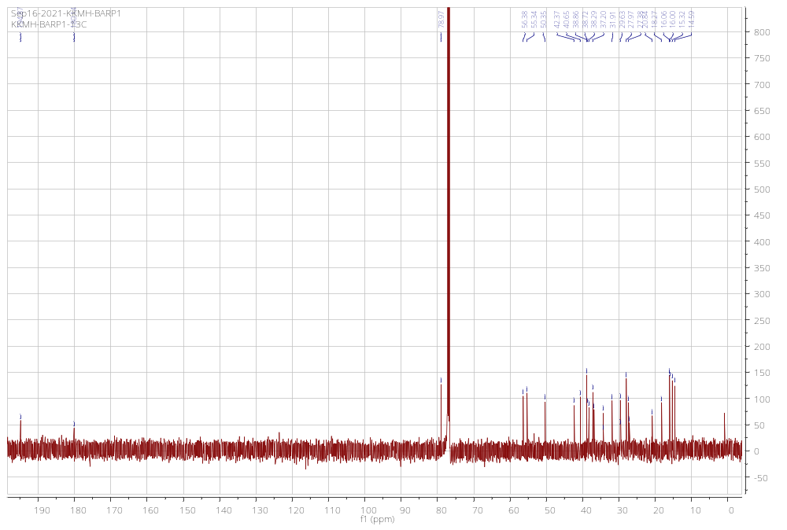
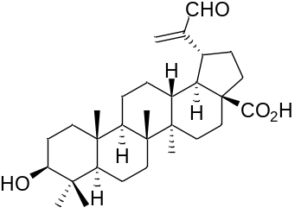
3-β-trans cinnamoyloxylup-20(29)-ene acryl aldehyde 19:
¹H-NMR of Compound 19
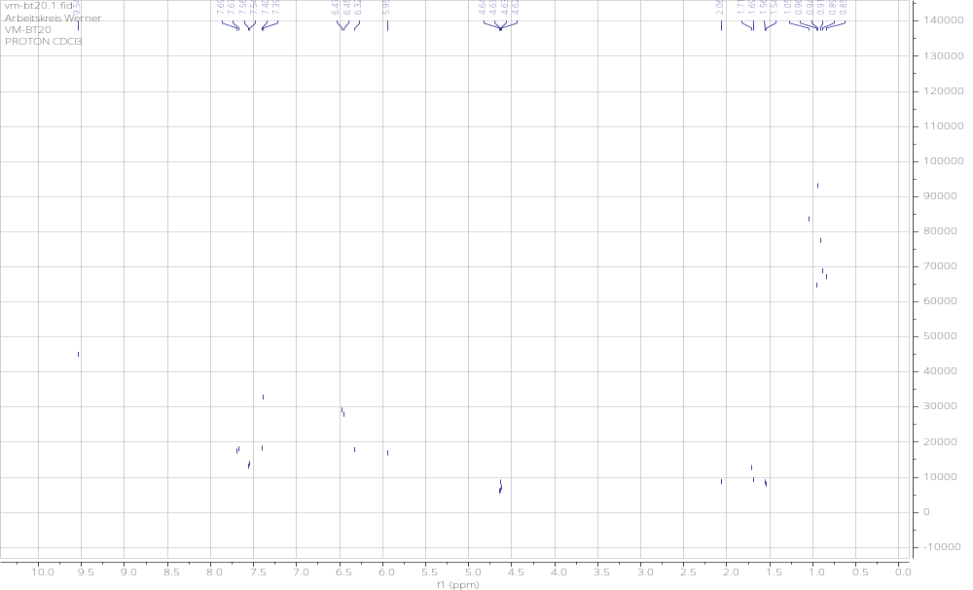
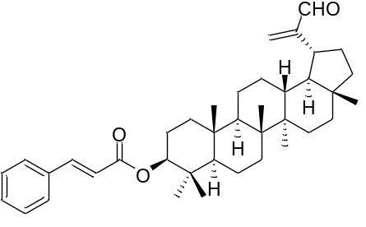
¹³C NMR spectra
