Is small airway dysfunction an abnormality independently associated with aging? A cross-sectional analysis from the ECOPD cohort.

Cuiqiong Dai¹*; Fan Wu¹ ²*; Zihui Wang¹*; Jieqi Peng¹*; Huajing Yang¹; Youlan Zheng¹; Lifei Lu¹; Ningning Zhao¹; Zhishan Deng¹; Shan Xiao¹; Xiang Wen¹; Jianwu Xu¹; Kunning Zhou¹; Xiaohui Wu¹; Yumin Zhou^{1#}; Pixin Ran^{1#}

Supplemental materials
Statistical analyses
Data regarding characteristics are expressed as mean ± standard deviation. We made univariate comparisons between the two groups with respect to characteristics by using Student’s t test for continuous variables with normal distribution or Mann-Whitney U test for continuous variables with skewness distribution, and the χ² test or Fisher exact test for categorical variables respectively. The linear-by-linear association test was conducted for the prevalence of SAD and the polynomial linear trend test for SAD markers across various age stratification. We applied multivariate binary logistic regression models to assess the association of age with SAD risk. Multiple linear regression models were carried out to determine the impact of age on the extent of SAD in SAD subjects. We conducted all the above analyses in total subjects and then repeated in the subjects with the stratification of airflow limitation. Finally, to intuitively compare the contributions of age to a variety of SAD markers, we extracted parameters from CT, IOS, and spirometry according to the largest or the second-largest absolute estimates of their multiple linear regression models among the 6 stratified subgroups, and then visualized these parameters in a vertical bar. Covariates adjusted in all the regression models were sex, BMI, smoking status, smoking index, educational level, asthma, tuberculosis, chronic bronchitis, annual household income, smokers living at home, parental history of respiratory diseases, occupational exposure > 6 months, indoor exposure to biomass for cooking or heating. There was no imputation in our study for nomissing data on the main variables of interest. All the data analyses were performed on IBM SPSS Version 25.0. Two-sided p values less than 0.05 were considered statistically significant.

Supplemental tables
e-Table 1. Prevalence of SAD defined by CT, IOS, and spirometry over age in subjects with and without airflow limitation.
variables | Subgroups stratified by airflow limitation and definitonal methods |  | Age stratification(yrs) |  |  |  | P for trend
variables |  |  | <= 49 | 50-59 | 60-69 | >= 70 | P for trend
Prevalence (%) of SAD | subjects without airflow limitation | SAD defined by CT | 0.70 (1/139) | 4.9 (21/426) | 9.2 (35/381) | 29.6 (24/81) | <0.001
Prevalence (%) of SAD | subjects without airflow limitation | SAD defined by IOS | 20.1 (28/139) | 15.7 (67/426) | 23.9 (91/381) | 25.9 (21/81) | 0.025
Prevalence (%) of SAD | subjects without airflow limitation | SAD defined byspirometry | 36.0 (50/139) | 46.2 (197/426) | 61.2 (233/381) | 76.5 (62/81) | <0.001
Prevalence (%) of SAD | subjects with airflow limitation | SAD defined by CT | 16.7 (3/18) | 37.3 (62/166) | 59.3 (267/450) | 68.7 (136/198) | <0.001
Prevalence (%) of SAD | subjects with airflow limitation | SAD defined by IOS | 55.6 (10/18) | 35.5 (59/166) | 48.9 (220/450) | 54.0 (107/198) | 0.004
Prevalence (%) of SAD | subjects with airflow limitation | SAD defined by spirometry | 100 (18/18) | 99.4(165/166) | 99.8(449/450) | 100(198/198) | 0.333
Note: P for trend was calculated by linear-by-linear association test. SAD defined by CT was LAA₋₈₅₆ > 20%. SAD defined by IOS was R5-R20 > 0.07. SAD defined by spirometry was post bronchodilator MMEF %predicted, FEF₅₀ %predicted or FEF₇₅ %predicted (any two of the three) < 65%. SAD = small airway dysfunction, CT = computed tomography, IOS = impulse oscillometry, yrs = years, % = percent.

e-Table 2. Multivariate binary logistic regression analysis of age and SAD risk in subjects with and without airflow limitation.
variables | Subgroups | definitional methods for SAD | OR (95%CI) | P value
Age (per 10 yrs increase) | Subjects without airflow limitation | SAD defined by CT | 2.78 (1.91-4.03) | <0.001
Age (per 10 yrs increase) | Subjects without airflow limitation | SAD defined by spirometry | 1.47 (1.17-1.85) | <0.001
Age (per 10 yrs increase) | Subjects without airflow limitation | SAD defined by IOS | 1.79 (1.49-2.14) | <0.001
Age (per 10 yrs increase) | Subjects with airflow limitation | SAD defined by CT | 1.73 (1.35-2.23) | <0.001
Age (per 10 yrs increase) | Subjects with airflow limitation | SAD defined by IOS | 1.53 (1.22-1.93) | <0.001
Age (per 10 yrs increase) | Subjects with airflow limitation | SAD defined by spirometry | 37.4(0.02-81696.6) | 0.356
Note: CT-defined SAD was defined as LAA₋₈₅₆>20%. IOS-defined SAD was defined as R5-R20>0.07. Spirometry-defined SAD was defined as post bronchodilator MMEF %predicted, FEF50 %predicted or FEF75 %predicted (any two of the three) < 65%. All these models were all adjusted for sex, BMI, smoking status, smoking index, educational level, asthma, tuberculosis, chronic bronchitis, annual household income, smokers living at home, parental history of respiratory disease, occupation exposure > 6 months, indoor exposure to biomass for cooking or heating. All the variables of age in these models indicate per 10 years increase.
Abbreviations: SAD = small airway dysfunction, CT = computed tomography, IOS = impulse oscillometry, OR = odds ratio, CI = confidence interval

e-Table 3. Multi-adjusted contributions of age to the extent of SAD among CT-defined SAD subjects from subjects without airflow limitation (n = 81).
Outcomes for SAD markers | Unstandardized β | Standardized β | 95%CI | P value
CT
LAA₋₉₅₀, % | 1.15 | 0.21 | -0.25, 2.55 | 0.105
LAA₋₈₅₆, % | 6.21 | 0.21 | 4.32, 8.10 | <0.001
RV, L | -0.25 | -0.22 | -0.52, 0.02 | 0.074
TLC, L | -0.15 | -0.12 | -0.43, 0.13 | 0.280
IOS
R5, Ka/L/s | 0.02 | 0.16 | -0.00, 0.04 | 0.113
R20, Ka/L/s | 0.01 | 0.08 | -0.01, 0.02 | 0.383
R5-R20, Ka/L/s | 0.01 | 0.18 | -0.00, 0.02 | 0.155
X5, Ka/L/s | -0.02 | -0.33 | -0.03, -0.00 | 0.011
AX, Ka/L | 0.15 | 0.35 | 0.05, 0.25 | 0.005
Fres, Hz | 1.41 | 0.32 | 0.29, 2.53 | 0.015
postbronchodilator
MMEF, %predicted | -5.65 | -0.25 | -11.45, 0.14 | 0.056
FEF₅₀, %predicted | -8.59 | -0.37 | -14.47, -2.70 | 0.005
FEF₇₅, %predicted | -1.94 | -0.06 | -10.39, 6.51 | 0.648
All the models were adjusted for sex, BMI, smoking status, smoking index, educational level, asthma, tuberculosis, chronic bronchitis, annual household income, smokers living at home, parental history of respiratory disease, occupation exposure > 6 months, indoor exposure to biomass for cooking or heating.All the variables of age in these models mean per 10 years unit increase.
Abbreviations: CI =confidence interval; β = estimate; definitions of other abbreviations see Table 1.

e-Table 4. Multi-adjusted contributions of age to the extent of SAD among CT-defined SAD subjects from subjects with airflow limitation (n = 468).
Outcomes for SAD markers | Unstandardized β | Standardized β | 95%CI | P value
CT
LAA₋₉₅₀, % | 0.68 | 0.05 | -0.51,1.88 | 0.263
LAA₋₈₅₆, % | 3.42 | 0.13 | 0.96,5.89 | 0.007
RV, L | -0.05 | -0.03 | -0.19,0.10 | 0.519
TLC, L | -0.32 | -0.19 | -0.47,-0.17 | <0.001
IOS
R5, Ka/L/s | 0.02 | 0.07 | -0.01,0.03 | 0.136
R20, Ka/L/s | -0.00 | -0.04 | -0.01,0.01 | 0.395
R5-R20, Ka/L/s | 0.02 | 0.12 | 0.00,0.03 | 0.015
X5, Ka/L/s | -0.02 | -0.12 | -0.04,-0.00 | 0.016
AX, Ka/L | 0.29 | 0.14 | 0.09,0.49 | 0.004
Fres, Hz | 1.64 | 0.16 | 0.62,2.67 | 0.002
postbronchodilator
MMEF, %predicted | -2.08 | -0.12 | -3.78,-0.39 | 0.016
FEF₅₀, %predicted | -2.86 | -0.15 | -4.76,-0.96 | 0.003
FEF₇₅, %predicted | 0.19 | 0.01 | -1.37,1.75 | 0.813
Note: All the models were adjusted for sex, BMI, smoking status, smoking index, educational level, asthma, tuberculosis, chronic bronchitis, annual household income, smokers living at home, parental history of respiratory disease, occupation exposure > 6 months, indoor exposure to biomass for cooking or heating.All the variables of age in these models mean per 10 years unit increase.
Abbreviations: CI =confidence interval; β = estimate; definitions of other abbreviations see Table 1.

e-Table 5. Multi-adjusted contributions of age to the extent of SAD among IOS-defined SAD subjects from subjects without airflow limitation (n = 207).
Outcomes for SAD markers | Unstandardized β | Standardized β | 95%CI | P value
CT
LAA₋₉₅₀, % | 0.12 | 0.13 | -0.00,0.25 | 0.056
LAA₋₈₅₆, % | 3.08 | 0.38 | 1.97,4.19 | <0.001
RV, L | 0.09 | 0.15 | 0.01,0.18 | 0.022
TLC, L | -0.12 | -0.10 | -0.25,0.01 | 0.074
IOS
R5, Ka/L/s | 0.00 | -0.00 | -0.01,0.01 | 0.982
R20, Ka/L/s | -0.00 | -0.04 | -0.01,0.01 | 0.605
R5-R20, Ka/L/s | 0.00 | 0.06 | -0.01,0.01 | 0.406
X5, Ka/L/s | -0.01 | -0.20 | -0.02,-0.00 | 0.006
AX, Ka/L | 0.08 | 0.17 | 0.01,0.15 | 0.022
Fres, Hz | 0.48 | 0.15 | 0.00,0.97 | 0.050
postbronchodilator
MMEF, %predicted | -2.82 | -0.12 | -6.13,0.50 | 0.095
FEF₅₀, %predicted | -3.08 | -0.12 | -6.65,0.49 | 0.090
FEF₇₅, %predicted | -1.39 | -0.05 | -5.88,3.11 | 0.543
Note: All these models were all adjusted for sex, BMI, smoking status, smoking index, educational level, asthma, tuberculosis, chronic bronchitis, annual household income, smokers living at home, parental history of respiratory disease, occupation exposure > 6 months, indoor exposure to biomass for cooking or heating. All the variables of age in these models indicate per 10 years increase. Abbreviations: CI =confidence interval; β = estimate; definitions of other abbreviations see Table 1.

e-Table 6. Multi-adjusted contributions of age to the extent of SAD among IOS-defined SAD subjects from subjects with airflow limitation (n = 396).
Outcomes for SAD markers | Unstandardized β | Standardized β | 95%CI | P value
CT
LAA₋₉₅₀, % | 0.50 | 0.04 | -0.63,1.63 | 0.385
LAA₋₈₅₆, % | 6.21 | 0.21 | 4.32,8.10 | <0.001
RV, L | 0.02 | 0.02 | -0.12,0.17 | 0.758
TLC, L | -0.32 | -0.20 | -0.47,-0.16 | <0.001
IOS
R5, Ka/L/s | -0.00 | -0.02 | -0.02,0.01 | 0.668
R20, Ka/L/s | -0.01 | -0.05 | -0.01,0.00 | 0.287
R5-R20, Ka/L/s | 0.00 | 0.01 | -0.01,0.01 | 0.843
X5, Ka/L/s | -0.01 | -0.09 | 0.12,0.00 | 0.117
AX, Ka/L | 0.09 | 0.05 | -0.10,0.28 | 0.334
Fres, Hz | 0.27 | 0.04 | -0.43,0.98 | 0.442
postbronchodilator
MMEF, %predicted | -2.24 | -0.08 | -3.59,-0.89 | 0.001
FEF₅₀, %predicted | -2.56 | -0.15 | -4.18,-0.95 | 0.002
FEF₇₅, %predicted | -0.57 | -0.05 | -1.79,0.64 | 0.354
Note: All these models were all adjusted for sex, BMI, smoking status, smoking index, educational level, asthma, tuberculosis, chronic bronchitis, annual household income, smokers living at home, parental history of respiratory disease, occupation exposure > 6 months, indoor exposure to biomass for cooking or heating. All the variables of age in these models indicate per 10 years increase. Abbreviations: CI =confidence interval; β = estimate; definitions of other abbreviations see Table 1.

e-Table 7. Multi-adjusted contributions of age to the extent of SAD among spirometry-defined SAD subjects from subjects without airflow limitation (n = 542).
Outcomes for SAD markers | Unstandardized β | Standardized β | 95%CI | P value
CT
LAA₋₉₅₀, % | 0.36 | 0.19 | 0.21,0.52 | <0.001
LAA₋₈₅₆, % | 3.34 | 0.24 | 2.16,4.53 | <0.001
RV, L | 0.08 | 0.09 | 0.01,0.14 | 0.021
TLC, L | -0.13 | -0.10 | -0.21,-0.05 | 0.003
IOS
R5, Ka/L/s | 0.01 | 0.04 | -0.00,0.01 | 0.263
R20, Ka/L/s | 0.00 | 0.00 | -0.01,0.01 | 0.962
R5-R20, Ka/L/s | 0.01 | 0.09 | 0.00,0.01 | 0.043
X5, Ka/L/s | -0.01 | -0.14 | -0.01,-0.00 | 0.002
AX, Ka/L | 0.07 | 0.14 | 0.03,0.11 | 0.001
Fres, Hz | 0.75 | 0.15 | 0.34,1.17 | <0.001
postbronchodilator
MMEF, %predicted | -2.14 | -0.17 | -3.25,-1.03 | <0.001
FEF₅₀, %predicted | -2.69 | -0.17 | -4.08,-1.29 | <0.001
FEF₇₅, %predicted | -0.35 | -0.02 | -1.64,0.94 | 0.592
Note: All these models were all adjusted for sex, BMI, smoking status, smoking index, educational level, asthma, tuberculosis, chronic bronchitis, annual household income, smokers living at home, parental history of respiratory disease, occupation exposure > 6 months, indoor exposure to biomass for cooking or heating. All the variables of age in these models indicate per 10 years increase. Abbreviations: CI =confidence interval; β = estimate; definitions of other abbreviations see Table 1.

e-Table 8. Multi-adjusted contributions of age to the extent of SAD among spirometry-defined SAD subjects from subjects with airflow limitation (n = 830).
Outcomes for SAD markers | Unstandardized β | Standardized β | 95%CI | P value
CT
LAA₋₉₅₀, % | 1.03 | 0.10 | 0.36,1.70 | 0.003
LAA₋₈₅₆, % | 6.51 | 0.22 | 4.57,8.45 | <0.001
RV, L | 0.09 | 0.06 | -0.01,0.18 | 0.088
TLC, L | -0.31 | -0.20 | -0.41,-0.20 | <0.001
IOS
R5, Ka/L/s | 0.01 | 0.06 | -0.00,0.02 | 0.112
R20, Ka/L/s | -0.01 | -0.05 | -0.01,0.00 | 0.120
R5-R20, Ka/L/s | 0.02 | 0.12 | 0.01,0.02 | 0.001
X5, Ka/L/s | -0.02 | -0.14 | -0.03,-0.01 | <0.001
AX, Ka/L | 0.21 | 0.13 | 0.09,0.33 | 0.001
Fres, Hz | 1.59 | 0.17 | 0.92,2.25 | <0.001
postbronchodilator
MMEF, %predicted | -3.04 | -0.18 | -4.23,-1.84 | <0.001
FEF₅₀, %predicted | -4.20 | -0.20 | -5.62,-2.78 | <0.001
FEF₇₅, %predicted | -0.65 | -0.05 | -1.68,0.39 | 0.218
Note: All these models were all adjusted for sex, BMI, smoking status, smoking index, educational level, asthma, tuberculosis, chronic bronchitis, annual household income, smokers living at home, parental history of respiratory disease, occupation exposure > 6 months, indoor exposure to biomass for cooking or heating. All the variables of age in these models indicate per 10 years increase. Abbreviations: CI =confidence interval; β = estimate; definitions of other abbreviations see Table 1.

Supplemental figures
e-Figure 1. Flow diagram for stratification of 1859 subjects by airflow limitation and definitional methods.
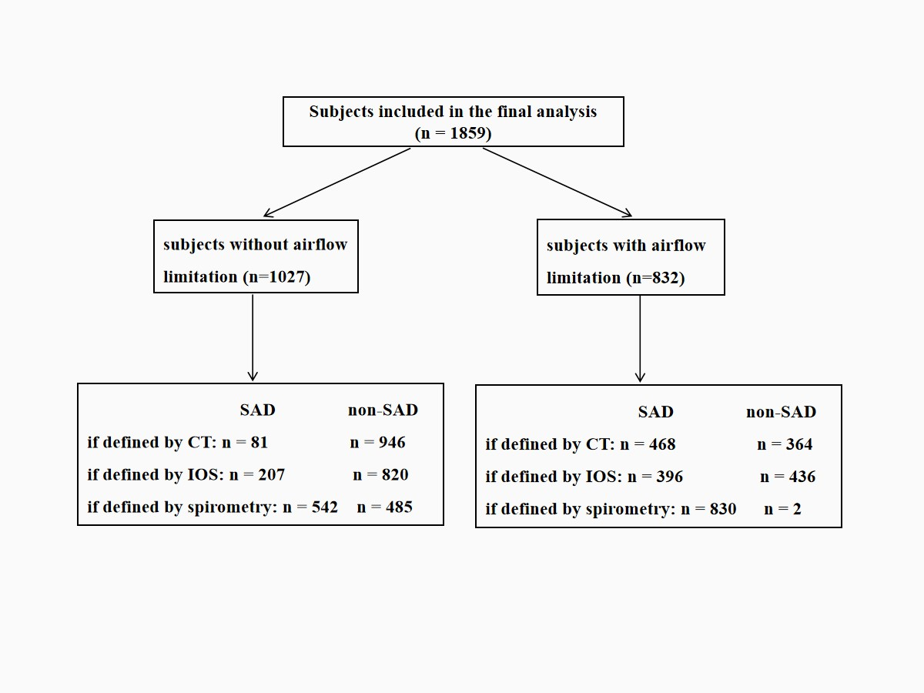
Note: SAD = small airway dysfunction, CT = computed tomography, IOS = impulse oscillometry

e-Figure 2. Distribution of small airway abnormality indicated by markers from CT, IOS and spirometry over age stratification in subjects with and without airflow limitation.
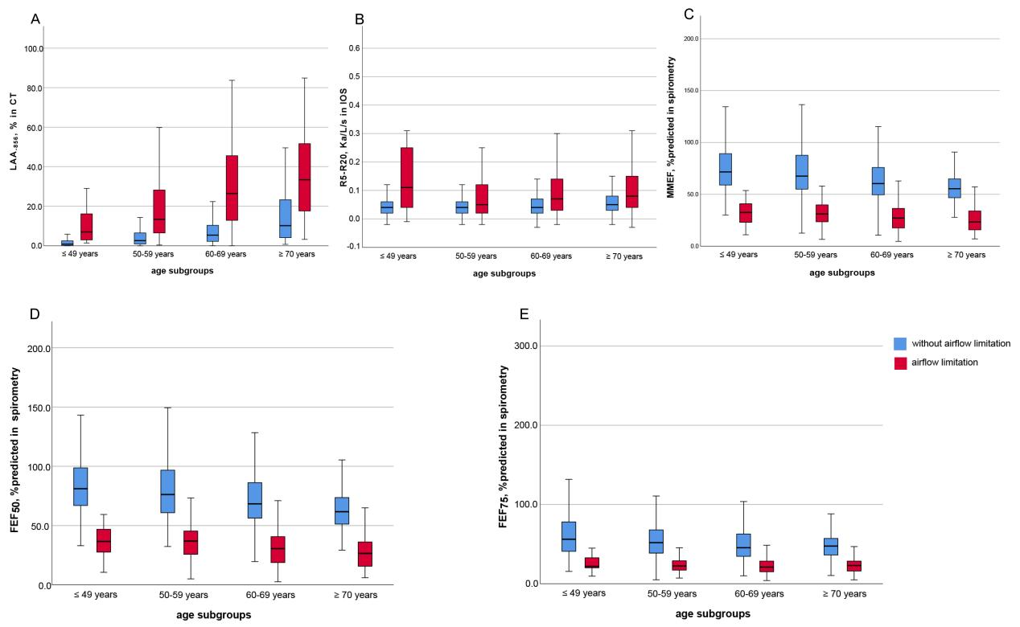
Note: Abbreviations: LAA-₈₅₆ = low-attenuation area of the lung with attenuation values below -856 Hounsfield units on full-expiration CT; R5-R20 = the difference from resistance at 5 Hz to resistance at 20 Hz; MMEF, %predicted = maximal mid-expiratory flow of percent predicted; FEF₅₀, %predicted and FEF₇₅, %predicted = forced expiratory flow at 50 and 75 of forced vital capacity of percent predicted.

