Calcineurin signaling promotes Takotsubo cardiomyopathy
SUPPLEMENTAL FIGURES
Bastian Bruns, Marilena Antoniou, Irena Baier, Meryem Sevinchan, Marie-Christine Moog, Maximilian Joos, Christoph Dieterich, Hilal Khan, Heather Wilson, Dana K. Dawson, Norbert Frey, Jobst-Hendrik Schultz, Johannes Backs

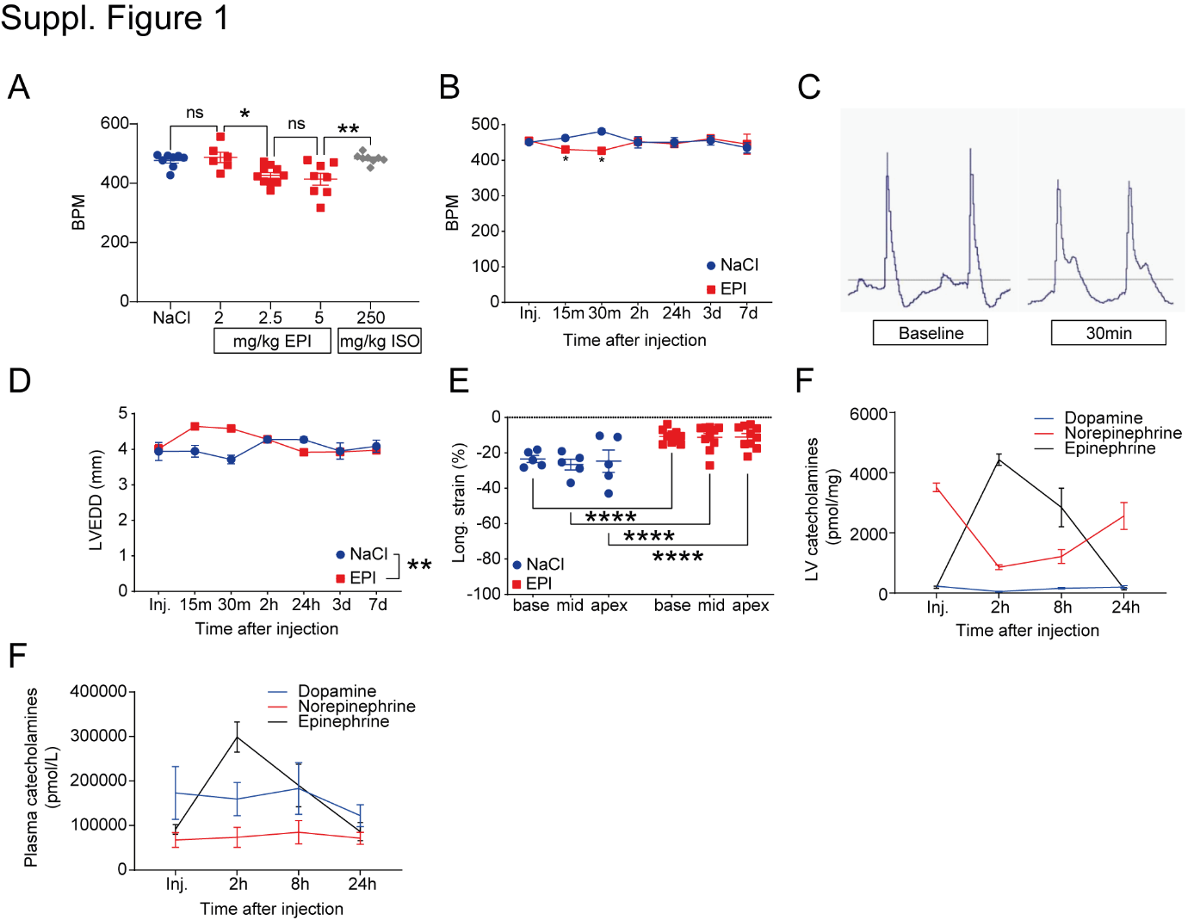

Supplemental Figure 1: Epinephrine-induced reversible acute heart failure in mice. Heart rate (beats per minute (BPM)) 30min. upon NaCl 0.9% (NaCl), ascending doses of epinephrine (EPI) (2, 2.5, and 5mg/kg), or isoprenaline (ISO) (250mg/kg) from mice undergoing isoflurane narcosis (A) and time course of heart rate after 2.5mg/kg EPI or NaCl (B). Representative ECG images before (Baseline) and 30 minutes (30min.) after EPI (C). Left ventricular enddiastolic diameter (LVEDD) kinetics after 2.5mg/kg EPI (D). Impaired basal (base), midventricular (mid), and apical (apex) longitudinal strain upon EPI vs. NaCl in male mice at 30min. (E). Left ventricular tissue (LV) catecholamine (dopamine, norepinephrine, epinephrine) kinetics in male mice after EPI (F). Plasma catecholamine kinetics in male mice upon EPI (F). Data as mean ±SEM. *p<0.05, **p<0.01 and ****p<0.0001, ANOVA or paired T-test, n=3-10/group.

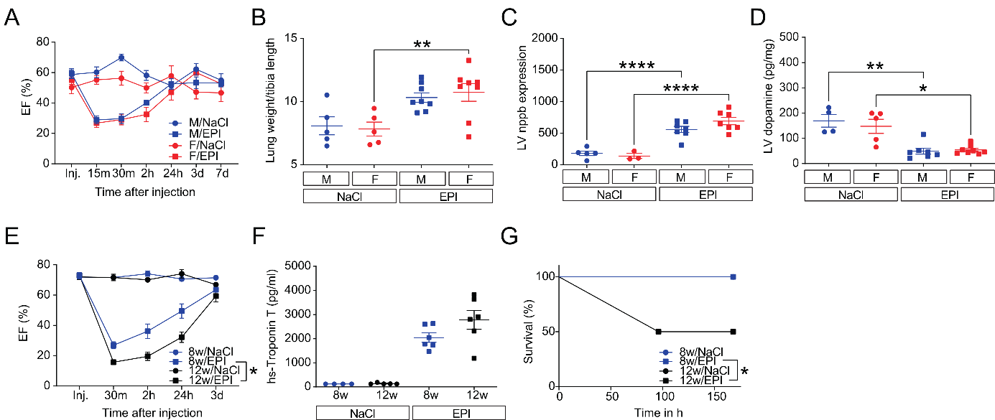
Supplemental Figure 2: Gender- and age discrepancies in epinephrine-induced heart failure. Left ventricular ejection fraction (EF%) kinetics over 7d from male (M) and female mice (F), after NaCl 0.9% (NaCl) or epinephrine (EPI) injection (Inj.) under isoflurane narcosis (A). Lung weight per tibia length (B) and LV nppb/gapdh mRNA expression 2h after NaCl or EPI treatment in M vs. F mice (C). Gender comparison of LV dopamine at 2h (D). EF kinetics (E), hs-Troponin T (F), and Kaplan-Maier analysis (G) of M mice at 8- (8w) or 12 weeks of age (12w) with NaCl, or EPI. Data as mean ±SEM. *p<0.05, **p<0.01, ***p<0.001 and ****p<0.0001, ANOVA / paired T-Test and Log-rank test were appropriate, n=3-8/group.

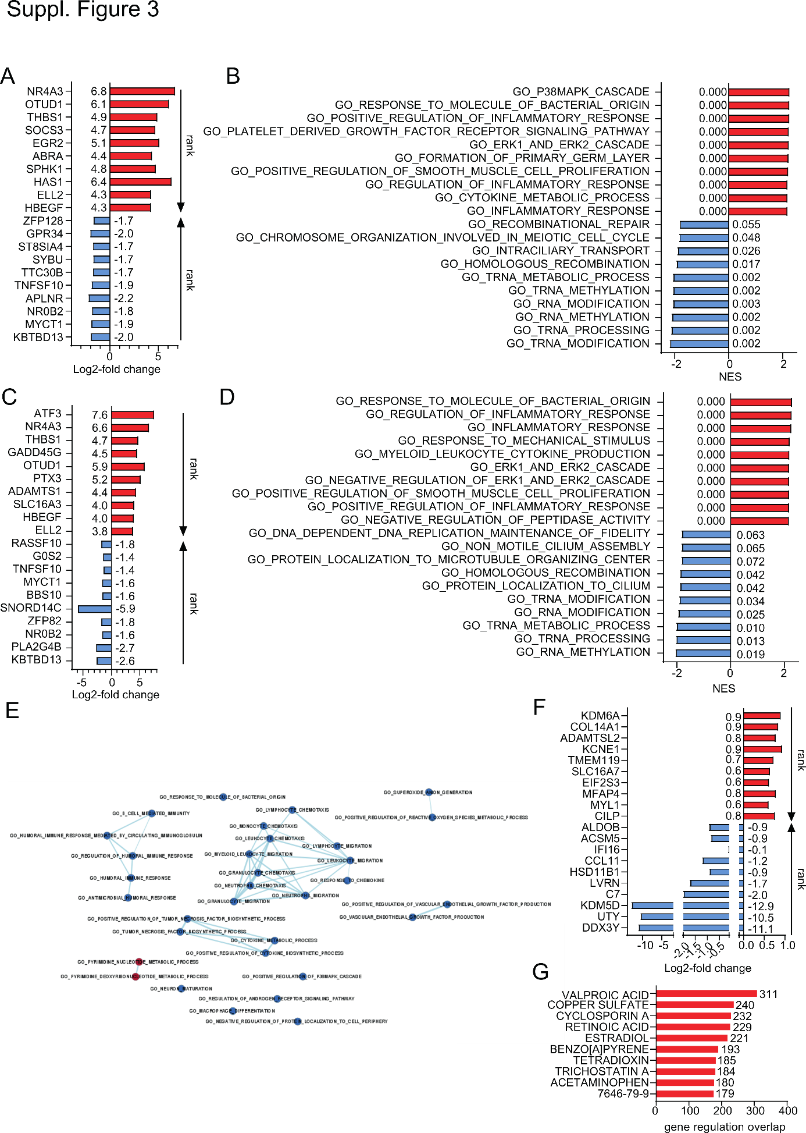
Supplemental Figure 3: Epinephrine-induced heart failure promotes pro-inflammatory myocardial gene expression networks. Gene set enrichment analysis (GSEA) from RNA-sequencing was conducted in NaCl- vs. epinephrine (EPI)-treated male (A, B) and female (C, D) as well as in EPI-treated female vs. male mice from left ventricular tissue (LV) (E, F). Log₂-fold change of top ranked up- (red) and downregulated (blue) genes of NaCl vs. EPI-treated males (A) and females (C), as well as of EPI-treated females vs. males (F) 2h after insult. Normalized enrichment score (NES) and – next to bars – false discovery rate (FDR) of top up- (red) and downregulated (blue) enriched gene set ontology (GO) biological pathways of NaCl vs. EPI-treated male (B) and female mice (D) 2h after insult. Intersection network of GSEA enrichment map depicting significant positive (red), and negative (blue) enriched GO biological pathways of female vs. male mice after EPI (E). Each node depicts one GO biological pathway gene set with connecting line thickness accounting for the number of common genes per pathway. Top ten drug targets with significant myocardial gene expression overlap of NaCl vs epinephrine (EPI)-treated male mice from the Tanlab drug signature database (common regulated genes) (G). N=3-7/group, Mann-Whitney test (2-sided) p=0.0003 (G).

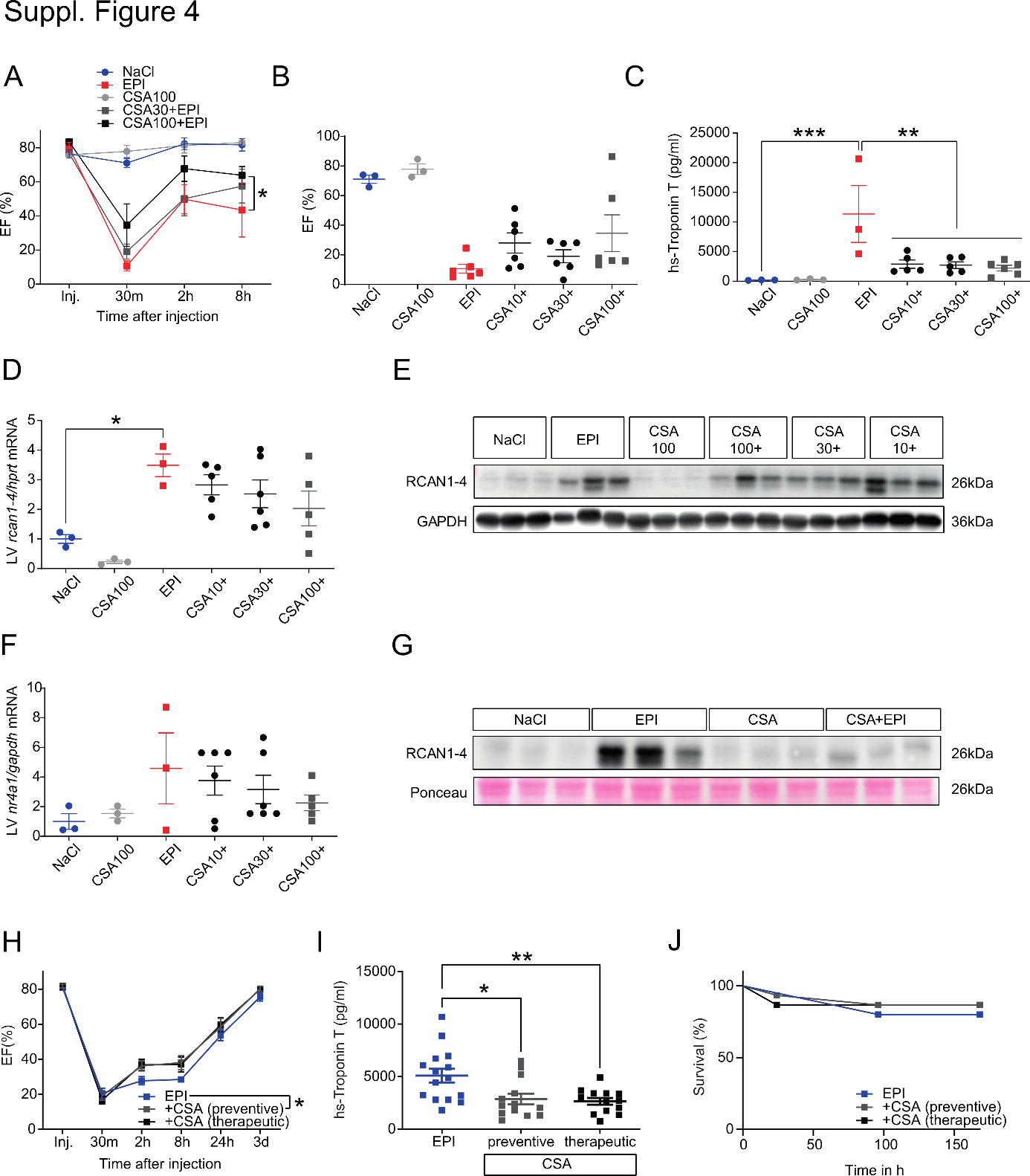
Supplemental Figure 4: Calcineurin inhibition improves heart failure and myocardial damage. Ejection fraction (EF) kinetics (A) and EF at 30min. (B) after epinephrine (EPI) or NaCl0.9% (NaCl) in male mice pretreated with a single dose of 10- (CSA10+), 30- (CSA30+), or 100mg (CSA100+)/kg body weight CSA 30min before (A, B). Plasma high-sensitive Troponin T (hs-Troponin T) at 24h (C). Left ventricular tissue (LV) regulator of calcineurin 1-4 (RCAN1-4) mRNA expression (D) as well as immunoblotting (IB) at 8h (E). LV nuclear receptor subfamily 4 group a member 1 (nr4a1) mRNA expression 8h after EPI, NaCl, and CSA as indicated (F). LV RCAN1-4 IB after pretreatment with 10mg/kg CSA 30min. before NaCl or EPI from a separate experiment (G). EF kinetics (H), hs-Troponin T (I), and Kaplan-Maier analysis (J) of male mice with 10mg/kg CSA 2h before (preventive) or 30min. after EPI (therapeutic) and subsequent CSA application twice per day. Data as mean ±SEM. *p<0.05, **p<0.01, ***p<0.001, ****p<0.0001 by ANOVA, paired T-Test, or Log-rank test were appropriate, n=3-17/group as indicated.

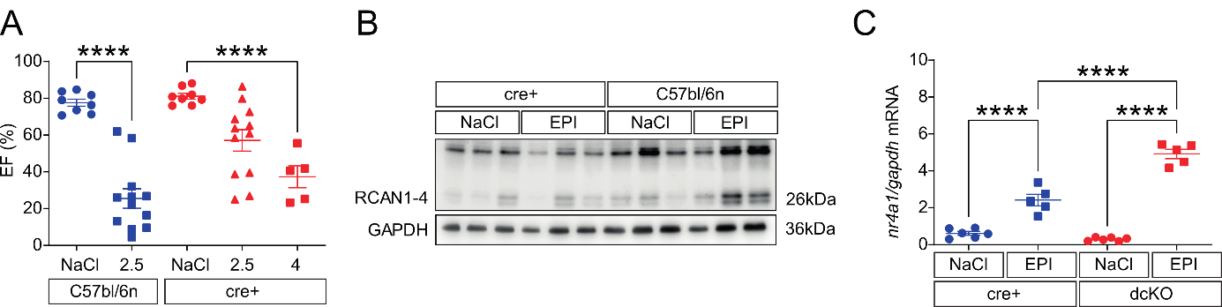
Supplemental Figure 5: Epinephrine-induced heart failure in the CaMKIIγδ KO mice line. Left ventricular ejection fraction (EF) 30min. after injection of NaCl0.9% (NaCl), 2.5mg/kg epinephrine (2.5), or 4mg/kg (4) in commercially available male mice (C57/bl6n) or wildtype littermates (cre+) from an inducible cardiomyocyte-specific calcium/calmodulin-dependent kinase II γδ double knockout mouse line with a bl/6n background reveals line-specific resilience of cardiac function (A), mirrored by impaired left ventricular tissue (LV) regulator of calcineurin 1-4 (RCAN1-4) upregulation upon 2.5mg/kg epinephrine (EPI) in immunoblotting (B). Upregulation of LV mRNA of the nuclear receptor subfamily 4 group A member 1 (nr4a1) in wildtype littermates (cre+) and knockout mice (dcKO) upon NaCl or EPI (C). Data as mean ±SEM. ****p<0.0001 by ANOVA, n=3-12/group as indicated.

