1– Pyrogallic acid 2– Coumaric acid 3– Protocatechuic acid
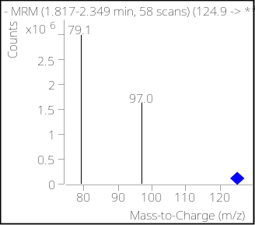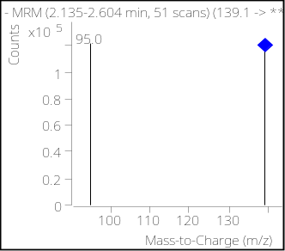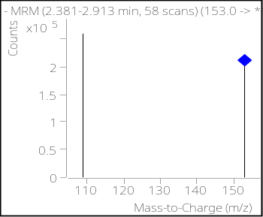
153.0
109.1
139.1
4– Chlorogenic acid 5– 4-Hydroxy benzoic acid 6– Caffeic acid
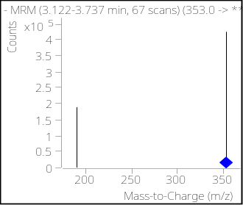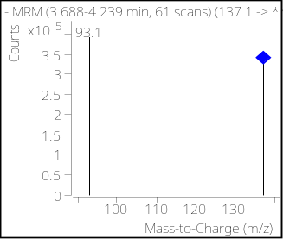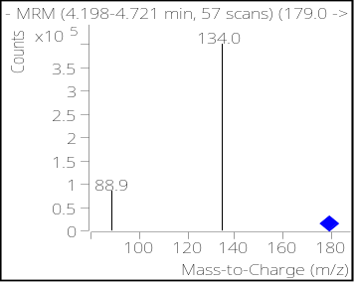
190.8
137.1
352.9
7– Syringic acid 8– Vanillin 9– Ferulic acid
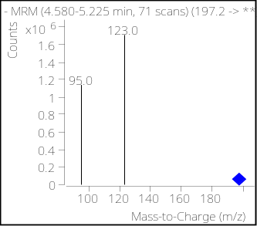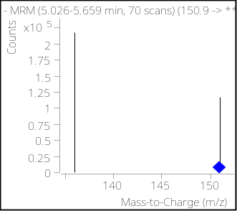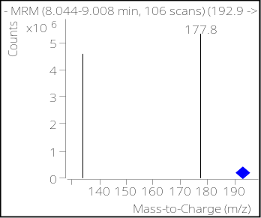
151.0
136.1
134.0
10– Benzoic acid 11– Salicylic acid 12– Cinnamic acid
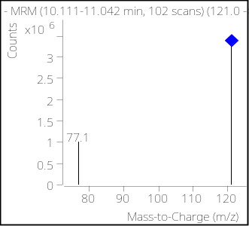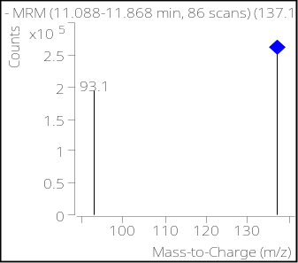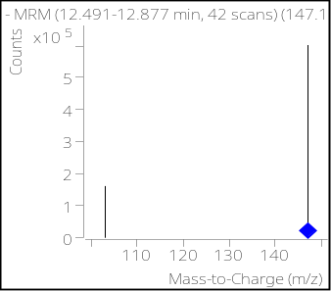
147.0
103.0
137.1
121.0

Figure. S1 HPLC-(ESI)QQQ-MS MS spectra of chromatographic peaks obtained from phenolic acids standards. Those blue diamonds represent pseudo molecular ions of the precursor ions.

A

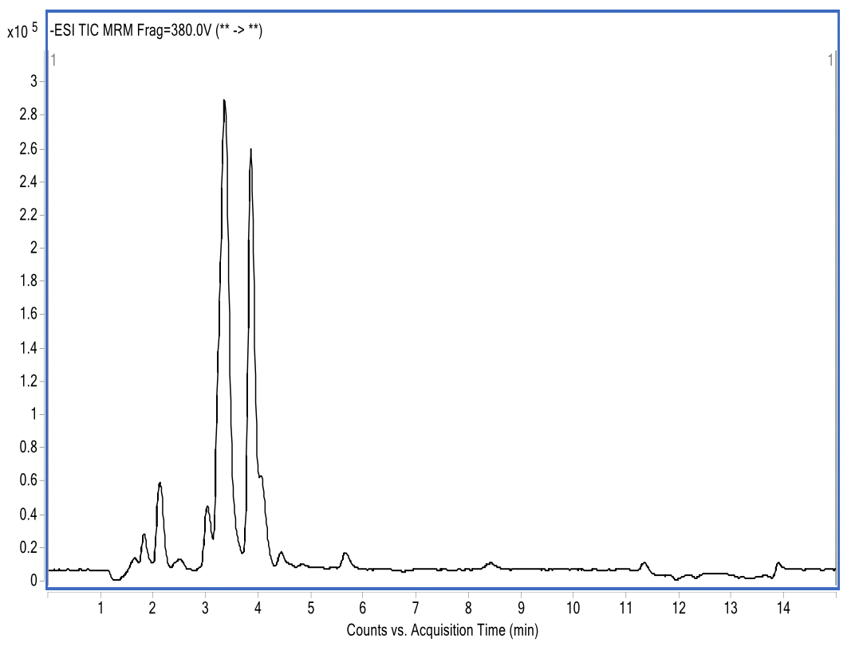
B

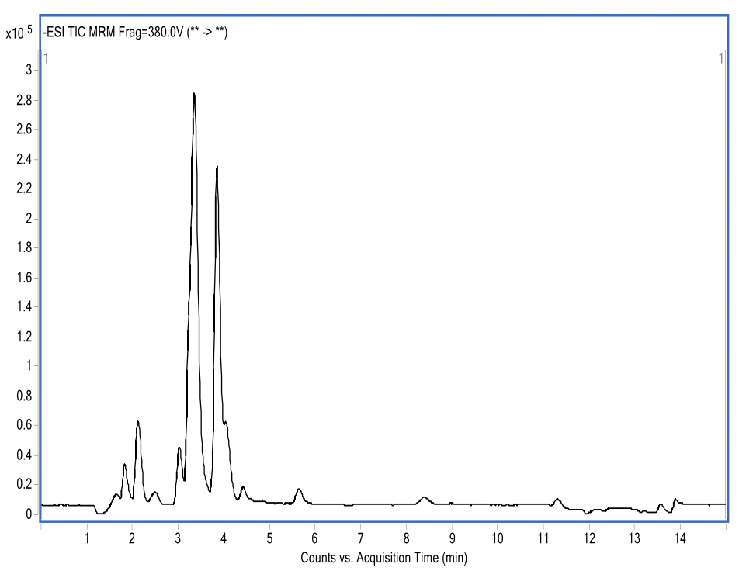
C

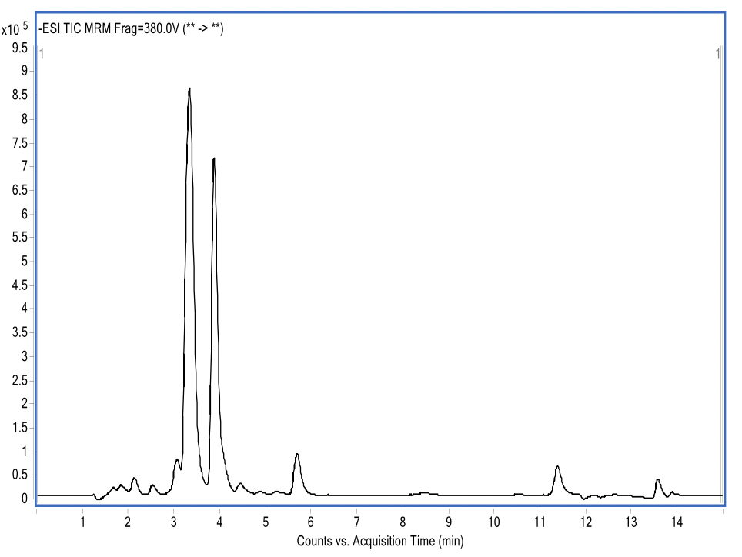

D
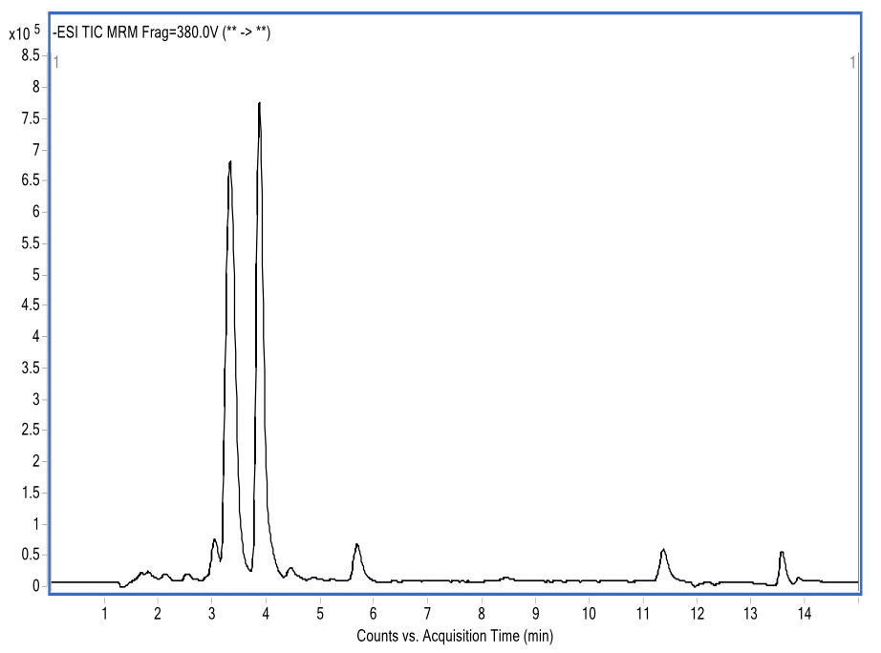

Figure. S2 Ion chromatograms of cadmium-contaminated K. obovata’ leaves under different concentration of Zn treatment. (A) control treatment; (B) 80 mg·kg⁻¹ Zn treatment; (C) 300 mg·kg⁻¹ Zn treatment; (D) 400 mg·kg⁻¹ Zn treatment

