S1: Different primer sequences used for quantitative-Real time PCR and cDNA cloning

Gene | Primer
IFS1-qRT | F | AGAATTCCGTCCCGAGAGGTT
IFS1-qRT | R | TGCCATTCCTGAAGTAGCCAA
IFS2-qRT | F | AATGTGCCCTGGAGTCAATCTG
IFS2-qRT | R | GGCGTCACCACCCTTCAATAT
Actin 2/7-qRT | F | ACTTGCCCATCAGGAAGCTC
Actin 2/7-qRT | R | TGTTCACCACCTCTGCCAAG
IFS1 | F | CACCATGTTGCTGGAACTTGCACTTGGT
IFS1 | R | TTAAGAAAGGAGTTTAGATGCAACGCC
IFS2 | F | CACCATGTTGCTTGAACTTGCACTTGGT
IFS2 | R | TTAAGAAAGGAGTTTAGATGCAACGCC

S2: Multiple alignment of IFS1 and IFS2 CDS (93% identity)

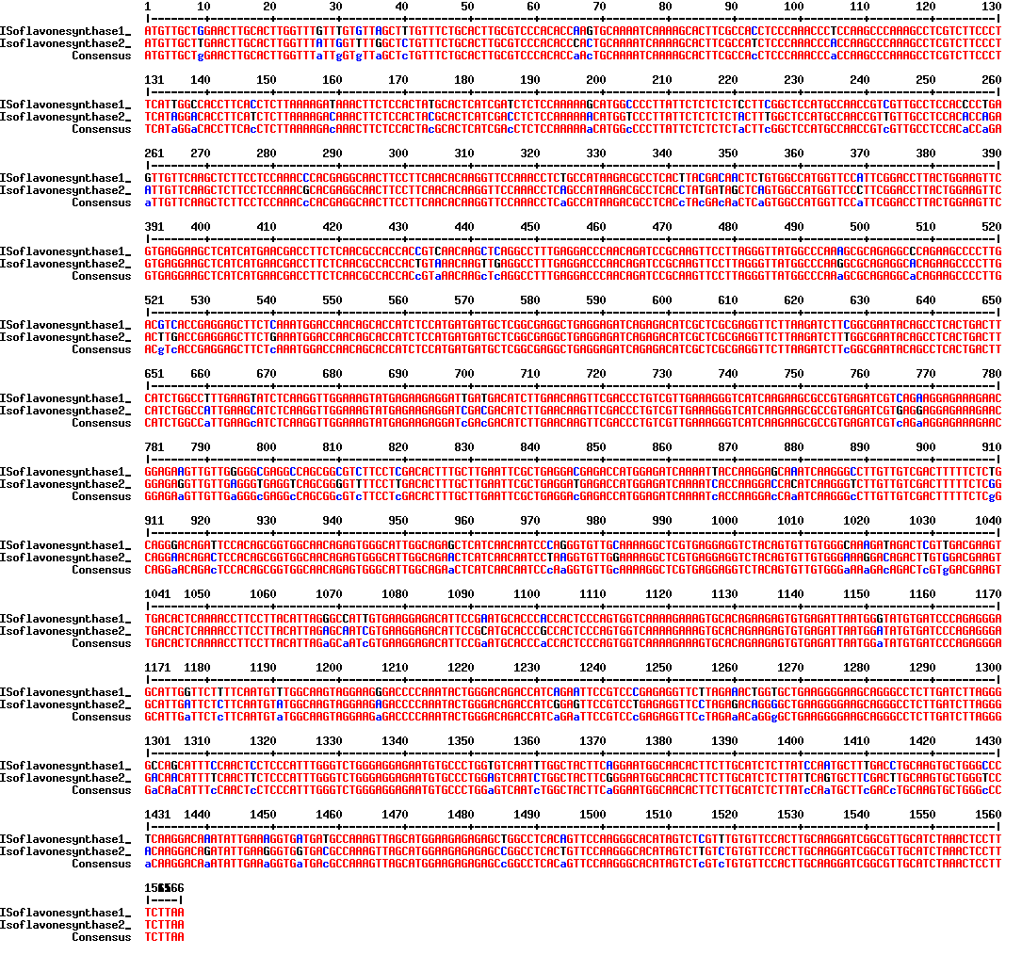

S3: Multiple alignment of IFS1 and IFS2 proteins (97.12% identity)

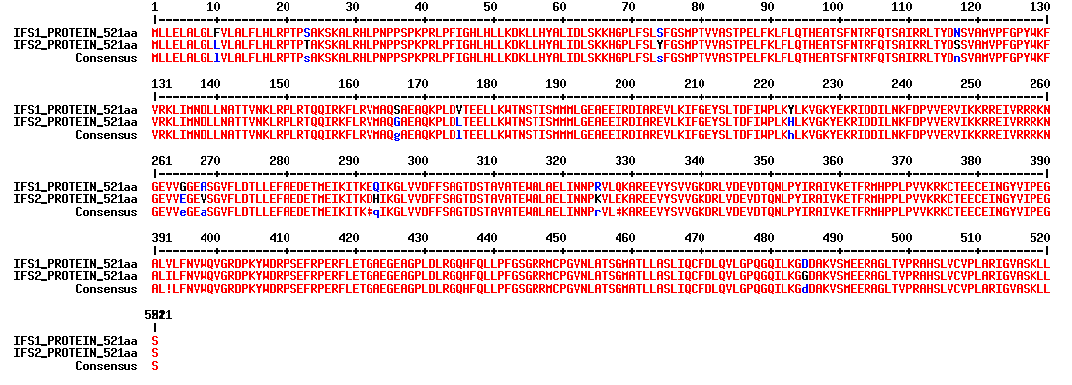

S4: STRING Scores for IFS1 and IFS2 sequences

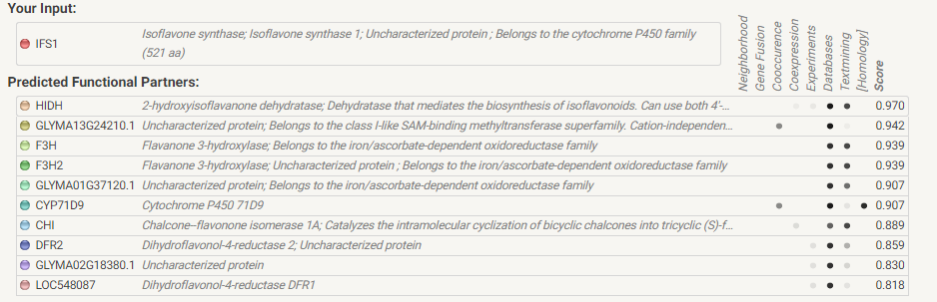

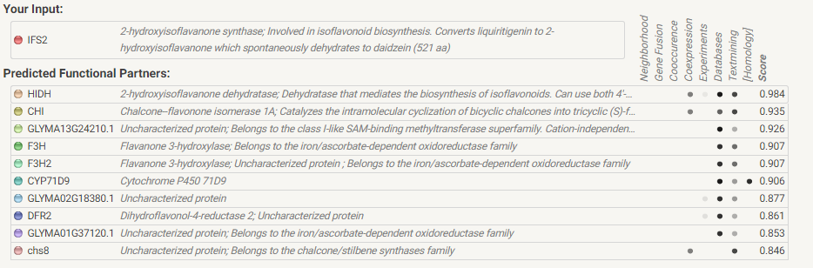
IFS1

IFS2

