Graphical Abstract
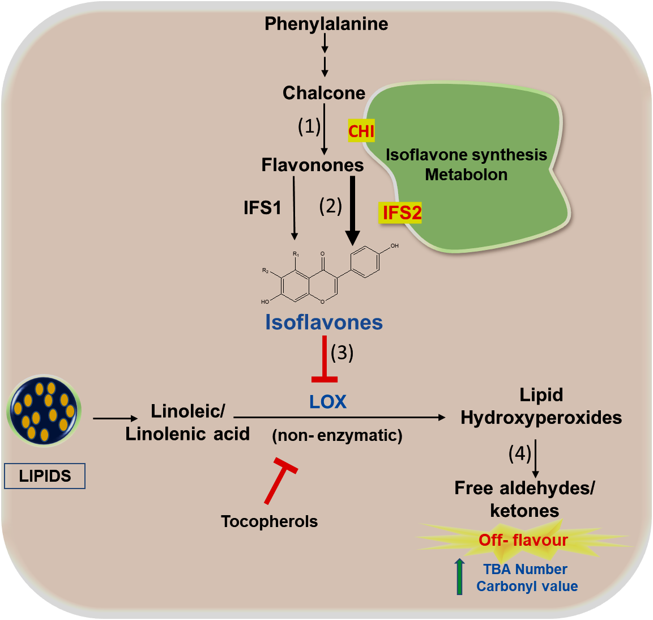
Isoflavone synthesis involves chalcone isomerase (CHI;1), which provides precursors, and isoflavone synthase (IFS1 & IFS2), which is a crucial step. The IFS2 isozyme interacts strongly with CHI, whereas IFS1 does not, resulting in substrate channelling through IFS2. These isoflavones inhibit fatty acid oxidation by lipoxygenase (3), decreasing the levels of free aldehydes and ketones (4) and reducing off-flavour.

