Supplemantary Information for: Direct Determination of the Topological Thermal Conductance via Local Power Measurement
Ron Aharon Melcer¹, Sofia Konyzheva^{1,2}, Moty Heiblum1, and Vladimir Umansky¹.
- Braun Center for Submicron Research, Department of Condensed Matter Physics, Weizmann Institute of Science, Rehovot 761001, Israel
- Laboratory of Quantum Materials (QMAT), Institute of Materials (IMX), École polytechnique fédérale de Lausanne, 1015 Lausanne, Switzerland

Reproducibility
We measured four samples fabricated from three different GaAs MBE grown heterostructures. The chip design of all is similar to the one shown in Fig. 1c. We tested two variations: (i) The length of edge propagation from source to power-meter changed from $20μm$ to $10μm$; (ii) The number of 2DEG regions connected to PM was changed from three to two. In addition, we made several measurements in a higher base temperature $T_{0}$. The results are consistent in all measured devices and geometries. We summarized all the measured results in Table S1.

Shot noise
In addition to measuring the power carried by the fluctuations associated with the ‘double-step’ distribution, we also measured the low-frequency fluctuations, i.e shot noise. We sourced current $I$ from $S_{I}$ and partitioned the edge mode in a quantum point contact (QPC) located at the center of ‘gate-down’ (GD). By closing ‘gate-arm’ (GA) we can measure the shot noise in the amplifier contact (see Fig. 4a). Assuming independent tunneling events of quasiparticles with charge $e^{*}$, the shot noise is given by,
 | $$S_{shot}=2e^{⋆}It\left(1-t\right)\left(\coth\left(\frac{e^{⋆}V}{2k_{b}T}\right)-\frac{2k_{b}T}{e^{⋆}V}\right) ,$$ | (S1)
with $t$ the transmission probability, $k_{b}$ Boltzmann constant, $T$ the temperature and $V=I/G$ the mode’s voltage ($G$ is the edge mode’s conductance). Fitting the measured noise to formula S1 allows the extraction of the quasiparticle charge $e^{⋆}$[S1, S2] and the temperature [S3]. For integer filling edge modes with $G=G_{0}=\frac{e^{2}}{h}$ ($e$the electron’s charge and $h$ plank’s constant), one expects $e^{⋆}=e$. As shown in Fig. S1a, all the measurements of the noise in the outer edge mode are consistent with Eq. S1.
Gain calibration was done via shot noise in the outer edge mode of filling factor 2. Once the gain is fixed, we fitted the charge and the temperature. In all measured transmissions of the outer mode, we find $e^{⋆}=e$ and $T\sim 20mK$(which is consistent with the measured cryostat temperature of $15mK$). See exact fitting coefficients in the caption of Fig. S1a.
The results for the shot noise of the partitioned inner edge mode are plotted in Fig. S1b. Here, we find a smaller noise than expected. By fitting the noise to Eq. S1 we find $e^{⋆}/e=0.65±0.01$ ($e^{⋆}/e=0.55±0.02)$ and $T=7.0±0.5mK$ ($T=17±2mK$) for QPC transmission of $t=0.47$ ($t=0.38$). These results remain unexplained.

Measurement protocol – multi-terminal thermal conductance:
To better clarify our measurement technique, we show in this section a ‘step by step’ analysis of the raw data. As an example, we consider the data for $ν=2$ shown in Fig. 2.

Noise acquisition:
We heat the Source (S) by sourcing currents $I$ and $–I$ from $S_{1}$ and $S_{2}$, respectively (see Fig. 1c). The strength of the low-frequency current fluctuations is measured in two separate contacts $A_{S}$ and $A_{PM}$, located downstream from S and the power-meter (PM), respectively. We repeat this measurement for three different voltages on ‘gate-down’ (GD), corresponding to two, one, and zero fully transmitted edge modes (from S to PM). The raw data is plotted in Fig. S2a.

Extracting temperatures:
The elevated temperature of S is associated with Johnson-Nyquist (J-N) noise. The low-frequency power spectral density of the current fluctuations flowing to $A_{S}$is given by
 | $$S_{S→A_{S}}^{JN}=2k_{b}αG_{S→A_{S}}^{⋆}\left(T_{S}-T_{0}\right).$$ | (S2)
where $k_{b}$ is the Boltzmann constant, $T_{S}$ ($T_{0}$) is the source’s temperature (base temperature), and $α$ is a pre-factor that accounts for a smaller noise in particle-hole conjugated states with un-equilibrated edge modes [S4] (for $ν=2$, $α=1$). $G_{{S→A}_{S}}^{⋆}$ is the effective conductance related to the device geometry. It is given by
 | $$G_{S→A_{S}}^{⋆}=\frac{G_{S→A_{S}}\left(G_{S→PM}+G_{S→G}\right) }{G_{S→A_{S}}+G_{S→PM}+G_{S→G}}.$$ | (S3)
with $G_{S→A_{S}}$ the conductance from S to $A_{s}$, $G_{S→PM}$ the conductance from S to the PM, and $G_{S→G}$ is the conductance from S to the ground (G). For $ν=2,$we have$G_{S→A_{S}}^{⋆}=\frac{4}{3}G_{0}$ ($G_{0}=\frac{e^{2}}{h},$ with $e$the electron’s charge and $h$ plank’s constant) [S5].
The noise measured at $A_{PM}$ has two uncorrelated contributions. The first is the result of the elevated temperature of the PM. The power spectral density of the J-N noise is given by.
 | $S_{PM→A_{PM}}^{JN}=2k_{b}αG_{PM→A_{PM}}^{⋆}\left(T_{PM}-T_{0}\right)$, | (S4)
with,
 | $$G_{PM→A_{PM}}^{⋆}=\frac{G_{PM→A_{PM}}G_{PM→G}}{G_{PM→G}+G_{PM→A_{PM}}}.$$ | (S5)
For $ν=2$, when the PM is connected to three arms $G_{PM→A_{PM}}^{⋆}=\frac{4}{3}G_{0}$.
The second contribution to the noise measured in $A_{PM}$ is due to low-frequency J-N current noise flowing from S to PM.
 | $S_{S→PM}^{JN}=2k_{b}αG_{S→ PM}^{⋆}\left(T_{S}-T_{0}\right)$, | (S6)
with,
 | $$G_{S→ PM}^{⋆}=\frac{G_{S→PM}(G_{S→G}+G_{S→A_{S}})}{G_{S→PM}+G_{S→G}+G_{S→A_{S}}}.$$ | (S7)
$G_{S→ PM}^{⋆}$ depends on the number of conducting modes transmitted (through GD) from S to PM. Hence, ${G_{S→ PM}^{⋆}}/{G_{0}}=\frac{4}{3},\frac{5}{6},0$ for two, one and zero fully transmitted channels, respectively. These current fluctuations are equally divided in the PM between all the outgoing edge modes. We find that the total noise arriving to $A_{PM}$ is given by,
 | $S_{A_{PM}}=2k_{b}α\left(G_{PM→A_{PM}}^{⋆}\left(T_{PM}-T_{0}\right)+{\left(\frac{G_{PM→A_{PM} }}{G_{PM→G}+G_{PM→A_{PM} }}\right)}^{2}G_{S→ PM}^{⋆}\left(T_{S}-T_{0}\right)\right)$. | (S8)
Simultaneously measuring the noise in $A_{S}$ and $A_{PM}$ allows us to extract $T_{S}$ and $T_{PM}$ using Eq. S2 and S8. We plot $T_{PM}$ as a function of $T_{S}$ in Fig. S2b.

Calibrating the PM:
We are interested in the power arriving at PM rather than its temperature. We accomplish this by performing a separate calibration measurement where we heat the PM directly with a known power (S remains unheated). We open both GD and GU and inject DC currents $I_{cal}$ & $-I_{cal}$ from $S_{1}^{cal}$ and $S_{2}^{cal}$, respectively. This leads to power dissipation $P=\frac{I_{cal}^{2}}{G_{2T}}$ ($G_{2T}$ is the state’s two-terminal conductance). We measure the noise in $A_{PM}$ (Fig S2c), which, in this case, is proportional only to the PM’s temperature according to Eq. S4 (Fig. S2d). Using the calibration process, we can plot the impinging power on the PM as a function of the source’s temperature (Fig. S1e).

Measurement protocol – the power of ‘double step’ distributions
In this chapter, we show a systematic analysis of the raw data of the power measurement of the ‘double-step distribution’ (DSD). As an example, we consider the outer edge mode of $ν=2$, shown in Fig. 4e.

Shot noise measurement
The first step is to measure the shot noise $S_{shot}$, i.e, the low-frequency spectral density of the fluctuations associated with the DSD. The DSD is generated by sourcing current $2I$ from the current source $S_{I}$ (in $ν=2$ a current $I$ will flow in each of the edge modes). The edge mode is partitioned in a QPC located at the ‘gate-down’ (GD) center. By closing the ‘gate-arm’ (GA), we ‘deactivate’ the power-meter (PM), not allowing it to add any low-frequency fluctuations on top of the shot noise (Fig. 4a of the main text). Important to note that the PM does heat up due to the impinging power. Nonetheless, since it is floating, its elevated temperature will not be associated with added current fluctuations in the outgoing edge modes (due to ‘current conservation’ of the arriving current fluctuations). We plot $S_{shot}$ vs. $I$ in Fig. S3a. The analysis of the noise is discussed in the dedicated section above.

Thermal noise measurement
By opening GA we allow J-N noise to emanate from the PM and arrive at the amplifier contact (Fig. 4b). The noise in this configuration is plotted against $I$in Fig. S3b. The spectral density of the J-N noise is given by equations S4, S5 (notice that here there are only two arms),
 | $$S_{PM→A_{PM}}^{JN}=2k_{b}G_{0}\left(T_{PM}-T_{0}\right) ,$$ | (S9)
The total noise arriving at $A_{PM}$ consists of the J-N noise and the shot noise that is divided at the PM contact (the fluctuations are uncorrelated),
 | $$S=S_{PM→A_{PM}}^{JN}+\frac{1}{4}S_{shot} .$$ | (S10)
Using Eq. S9 & Eq. S10 with the known $S_{shot}$ we extract $T_{PM}$. $T_{PM}$ is plotted against $I^{2}$ in Fig. S3c.

Calibrating the PM
By opening GD, we can source DC current $I_{cal}$ from $S_{I}$ to the PM (Fig. 4c). The excess current leads to dissipation of power $P=\frac{1}{8G_{0}}I_{cal}^{2}$ in the PM, with J-N noise flowing to the amplifier contact (Eq. S9 & Fig. S2d). We plot the dissipated power vs. $T_{PM}$ in Fig. S2e, which defines the calibration process.

Subtracting the DC power
By combining the DSD noise measurement with the calibration measurement, we plot the dissipated power of the DSD vs. $I^{2}$ (colored markers in Fig. S2f). This power has two contributions, the power carried by the fluctuations $P_{AC}$ and the dissipated part of the power carried by the DC current. Generally, an edge mode carrying a DC current $I$ does not dissipate the full excess power $P_{DC}^{in}=\frac{I^{2}}{{2G}_{0}}$ in a floating contact. From the impinging power, one has to subtract the power that is carried by the outgoing DC currents $P_{DC}^{out}=\frac{N}{2}V_{PM}^{2}G_{0}$, where $N$ is the number of integer modes leaving the contact (in our sample $N=4$ since the PM connected to two arms at $ν=2$). The contact’s potential $V_{PM}$ is determined by the sum of the impinging currents in all the incoming modes,
 | $$V_{PM}=\sum_{i}{\frac{I_{i}}{NG_{0}}} ,$$ | (S11)
with $I_{i}$ the current in the $i$’th incoming mode. The dissipated power $P_{DC}^{dis}=P_{DC}^{in}-P_{DC}^{out}$ could be written in terms of the incoming currents as
 | $$P_{DC}^{dis}=\frac{1}{2G_{0}}\left(\sum_{i}{I_{i}^{2}}-{\frac{1}{N}\left(\sum_{i}{I_{i}}\right)}^{2}\right) .$$ | (S12)
When we partition the outer mode in our experiment, it is the only biased mode impinging at the PM. It carries DC current $tI$ ($t$ the QPC transmission probability), giving $P_{DC}^{dis}={\frac{3}{8G_{0}}\left(tI\right)}^{2}$ (dashed lines in Fig. S2f). When the inner edge mode is partitioned, it carries current $tI$, with an un-partitioned outer mode with current $I$; thus, the total dissipated power is $P_{DC}^{dis}=\frac{I^{2}}{8G_{0}}\left(3+3t^{2}-2t\right)$. $P_{AC}$ is extracted by subtracting the dissipated DC power from the measured power $P_{AC}=P-P_{DC}^{dis}$ (Fig. S2g).

Power measurement is independent of gain calibration
As an aside, we wish to point out that the protocol described above allows the extraction of the power without the need to calibrate the amplification gain or the base temperature. The reason is that the measured temperature of the PM is only used as an intermediate result to compare the impinging powers of the DSD and the calibration measurement. Thus, it is sufficient to measure the increase of temperature $ΔT=T_{PM}-T_{0}$ up to a multiplying constant, which eliminates the need to calibrate the gain. In the shown data, the amplification gain and $T_{0}$ were extracted from the shot noise measurements of the outer edge mode, described in the designated section above.

Thermal Hall conductance
In this section, we wish to further discuss the physics of heat transport along the edge modes and the necessary conditions required for extracting $κ_{xy}$ from our power measurements. In order to do so, we consider the heat balance equations of the power-meter (PM) for the two geometries involved in the experiment. We will discuss a general quantum Hall effect (QHE) state with $n_{d}$ downstream modes and $n_{u}$ upstream modes.
First, we consider the configuration in which ‘gate-down’ (GD) is closed and ‘gate-up’ (GU) is open (Fig. 3a). The total excess power impinging upon the PM is,
 | $$P_{d}=\frac{κ_{0}}{2}\left(n_{d}\left(T_{d}^{2}\left(l_{d}\right)-T_{0}^{2}\right)+n_{u}\left(T_{u}^{2}\left(l_{u}^{'}\right)-T_{0}^{2}\right)\right) ,$$ | (S13)
where $κ_{0}=\frac{π^{2}k_{b}^{2}}{3h}$ is the thermal conductance quantum; $T_{d}\left(l_{d}\right)$ is the temperature of the downstream modes emanating from the source (S) after propagating the distance $l_{d}$ to the PM; $T_{u}\left({l^{'}}_{u}\right)$ is the temperature of the upstream modes emanating from the ground (G) after propagating the distance $l_{u}^{'}$ to the PM. We take the ground’s temperature to be $T_{0}$. In Eq. S13 we have already included the assumption that there is no other thermal conduction mechanism from S to PM besides the QHE edge modes (we verify this assumption by performing a measurement where both GD and GU are open).
A second assumption we wish to implement is that no heat is lost from the edge to the environment along the propagation length from S to PM. This is a reasonable assumption as the length from S to PM is $20μm$ or less in all the measured samples. Recent experiments suggest that both upstream and downstream modes are capable of carrying heat for such distances without significant dissipation [S4, S6]. This assumption implies that a heated mode can only lose its power to a counter-propagating mode on the same edge (via thermal equilibration). It allows us to rewrite the impinging power as
 | $$P_{d}=\frac{κ_{0}}{2}n_{d}\left(T_{S}^{2}-T_{0}^{2}\right)-P_{d→u}\left(T_{S},T_{PM},l_{d}\right)+P_{d→u}\left(T_{PM},T_{0},{l^{'}}_{u}\right) ,$$ | (S14)
where $T_{S}$ is the source’s temperature, and the function$P_{d→u}\left(T_{1},T_{2},l\right)$ describes the total power backscattered from the hot downstream modes emanating from contact with temperature $T_{1}$ to the upstream modes emanating from contact with temperature $T_{2}$ along the propagation length $l$.
There are two mechanisms contributing to this process of edge equilibration. The first is the backscattering of plasmon modes at the edge-mode contact interface [S4, S7]. This term is length independent and proportional to the difference in temperatures squared, $P_{d→u}^{1}\left(T_{1},T_{2},l\right)∝T_{1}^{2}-T_{2}^{2}$. The exact coefficient depends on an exact theory of the edge modes. For example, for $ν=\frac{2}{3}$ in the strong interaction fixed point [S4] $P_{d→u}^{1}\left(T_{1},T_{2},l\right)=\frac{1}{2}\frac{κ_{0}}{2}(T_{1}^{2}-T_{2}^{2})$.
The second mechanism is inelastic scattering along the edge [S8], causing heat to flow from the hot modes to the cold ones. The details of this interaction are unknown, and the equilibration's efficiency can depend on microscopic details of the edge. It is convenient to describe the equilibration process via Newton’s law of cooling [S9, S10], which introduces a thermal equilibration length $l_{eq}$ and implies,
 | $$P_{d→u}^{2}\left(T_{1},T_{2},l\right)=f_{d→u}\left(\frac{l}{l_{eq}}\right)\frac{κ_{0}}{2}\left(T_{1}^{2}-T_{2}^{2}\right) ,$$ | (S15)
with $f_{d→u}$ describing the equilibration process along the edge. For $ν=\frac{2}{3}$, $f_{d→u}(x)=\frac{x}{1+x}$, and for a general P-H conjugated states with $n_{u}≠n_{d}$
 | $$f_{d→u}\left(x\right)=\frac{n_{d}n_{u}\left(\exp\left(\frac{x}{n}\right)-\exp\left(-\frac{x}{n}\right)\right)}{n_{d}\exp\left(\frac{x}{n}\right)-n_{u}\exp\left(-\frac{x}{n}\right)},$$ | (S16)
with $n=\frac{n_{d}n_{u}}{n_{d}-n_{u}}$. In Eq. S16 we assumed that the efficiency of equilibration is identical between all the modes along the edge. Two interesting limits are $f_{d→u}\left(x=0\right)=0$ and $f_{d→u}\left(x→∞\right)=\min{(n_{d},n_{u}})$. Moreover, $f_{d→u}$ is invariant under $n_{d}↔n_{u}$.
Even though Eq. 3 of the main text holds for a more general class of inter-mode interaction; we will adopt Newton’s law of cooling mechanism in the remaining of this chapter. The main reason (other than its simplicity) is the experimental fact that in the temperature regime we measured, this model appears to describe our results well (as is evident by the linear dependence of the power with $T_{S}^{2}$). Describing the inter-edge interaction in this formalism allows writing the total backscattered power as,
 | $$P_{d→u}\left(T_{1},T_{2},l\right)=\frac{κ_{0}}{2}g_{d→u}\left(\frac{l}{l_{eq}}\right)\left(T_{1}^{2}-T_{2}^{2}\right) ,$$ | (S17)
where the function $g_{d→u}$ includes both equilibration mechanisms. Under these definitions, the excess power impinging upon the PM is given by,
 | $$P_{d}=\frac{κ_{0}}{2}\left(\left(n_{d}-g_{d→u}\left(\frac{l_{d}}{l_{eq}}\right)\right)\left(T_{S}^{2}-T_{0}^{2}\right)+g_{d→u}\left(\frac{l_{u}^{'}}{l_{eq}}\right)\left(T_{PM}^{2}-T_{0}^{2}\right)\right).$$ | (S18)
The situation where GD is open and GU closed is very similar. Under the same assumptions, we can write the excess power arriving at the PM as,
 | $$P_{u}=\frac{κ_{0}}{2}\left(\left(n_{u}-g_{u→d}\left(\frac{l_{u}}{l_{eq}}\right)\right)\left(T_{S}^{2}-T_{0}^{2}\right)+g_{u→d}\left(\frac{l_{d}^{'}}{l_{eq}}\right)\left(T_{PM}^{2}-T_{0}^{2}\right)\right) ,$$ | (S19)
where $l_{u}$ is the distance the upstream edge modes propagates from S to PM, and $l_{d}^{'}$ is the distance that the downstream mode propagates from PM to G.
In our devices, $l_{u}=l_{d}$, and $l_{u}^{'}=l_{d}^{'}$. In addition, the inter-mode interaction is invariant under $n_{d}↔n_{u}$ implying $g_{d→u}=g_{u→d}$. As a result, the subtraction of the impinging power in the two geometries is independent of the equilibration length and yields the topological thermal Hall conductance,
 | $$P_{d}-P_{u}=\left(n_{d}-n_{u}\right)\frac{κ_{0}}{2}\left(T_{S}^{2}-T_{0}^{2}\right).$$ | (S20)

Power carried by ‘double-step’ distributions
We derive Eq. 4 in the main text and discuss the conditions we expect it to hold. The most straightforward way to derive the power carried by the fluctuations is to integrate over the entire range of the spectral density (over frequency). When an integer mode carrying current $I$ is partitioned in a quantum point contact (QPC) with probability $t$, the spectral density of the outgoing fluctuations is given by [S11],
 | $$S\left(f\right)=G_{0}t\left(1-t\right)\left[\left(hf+eV\right)\coth\left(\frac{hf+eV}{2k_{b}T}\right)+\left(hf - eV\right)\coth{ \left(\frac{hf - eV}{2k_{b}T}\right)}- 2hf\coth{ \left(\frac{hf}{2k_{b}T}\right)}\right] .$$ | (S21)
The spectrum of the fluctuations is plotted in Fig. S3. Performing the integral over Eq. S21 indeed yields Eq. 3 of the main text
 | $$P_{AC}=\frac{1}{2G_{0}}\int_{0}^{∞}{df}S\left(f\right)=\frac{G_{0}}{2}V^{2}t\left(1-t\right).$$ | (S22)
A different approach is to calculate directly the energy current carried by the out-of-equilibrium distribution. The energy current (identical to power in 1D) carried by an electronic chiral edge mode with a distribution $f(ϵ)$ is given by,
 | $$P=\frac{1}{h}\int_{0}^{∞}{dϵ}ϵf\left(ϵ\right) .$$ | (S23)
We consider the double step distribution given by the statistical sum of a hot (biased) edge mode with probability $t$ and a cold (unbiased) edge mode with probability $1-t$. The distribution of the cold edge could be described by a Fermi-Dirac distribution with temperature $T$ and chemical potential $μ_{0}$ - $f_{0}\left(ϵ\right)=f_{FD}(ϵ;μ_{0},T)$. Similarly, the distribution of the hot edge is given by $f_{V}\left(ϵ\right)=f_{FD}(ϵ;μ_{0}+eV,T)$, and we assume a linear response $μ_{0}≫eV,T$. The total excess power is thus
 | $$P=\frac{1}{h}\int_{0}^{∞}{dϵ} ϵ\left(tf_{h}\left(ϵ\right)+\left(1-t\right)f_{c}\left(ϵ\right)-f_{c}\left(ϵ\right)\right)=\frac{1}{2}tG_{0}V^{2}.$$ | (S24)
And one can derive the power carried by the fluctuations by subtracting the power carried by the DC current $P_{AC}=P-\frac{1}{2G_{0}}{\left(tI\right)}^{2}$.
The two calculations above rely on the independent tunneling of electrons across the QPC, forming the double-step distribution, thus generating shot noise with tunneling charge $e$. However, redistribution of the edge modes [S6] and the melting of double-step distributions [S12] has been observed, as well suppressing shot noise. Nonetheless, Eq. 3 in the main text is valid as long as energy and current are conserved. To see it, let us consider energy conservation in the QPC, implying that the incoming power must be equal to the outgoing power (transmitted and reflected),
 | $P_{DC}^{in}=P_{DC}^{t}+P_{AC}^{t}+P_{DC}^{r}+P_{AC}^{r} ,$ | (S25)

where $P_{DC}^{in}=\frac{1}{2G_{0}}I^{2}$ is the incoming power to the QPC, $P_{DC}^{t}=\frac{1}{2G_{0}}{\left(tI\right)}^{2}$ is the DC power carried by the transmitted mode, $P_{DC}^{r}=\frac{1}{2G_{0}}{\left(\left(1-t\right)I\right)}^{2}$ is the DC power carried by the reflected mode, and $P_{AC}^{t}$ ($P_{AC}^{r}$) is the power carried by the fluctuations in the transmitted (reflected) mode. Current conservation in all frequencies implies that the transmitted and reflected noises are anti-correlated (the total outgoing AC current must be zero), and in particular,
 | $$P_{AC}^{t}=P_{AC}^{r}=\frac{1}{2}\left(P_{DC}^{in}-P_{DC}^{t}-P_{DC}^{r}\right)=\frac{1}{2G_{0}}t\left(1-t\right)I^{2}.$$ | (S26)
The observation of smaller power in the inner edge mode of $ν=2$ implies the violation of either energy conservation (due to energy leak to reconstructed neutral modes [S13]), or current conservation (perhaps of the high-frequency fluctuations).

Amplifier calibration
When the sample is in equilibrium (no electrical or thermal bias), the spectral density of the voltage noise has two contributions,
 | $S_{V}=A^{2}\left(S_{base}+S_{JN}\right)$, | (S27)
where $S_{base}$ is the amplifier noise, $A$ is the gain, and $S_{JN}=4k_{b}TR$ is the equilibrium Johnson Nyquist noise [S14, S15]. By linear fitting $S_{V}$ with the cryostat’s temperature $T$ (at temperatures larger than $30mK$) we extract both $A$ and $S_{base}$ (Fig. S5). The amplifier’s base noise is used to calculate the electron’s temperature when the cryostat reaches its lowest temperature (usually at temperatures below $T\sim 20mK$ the temperature of the electronic bath decouples from that of the cryostat duo to the week electron-phonon interaction). Using Eq. S27 we find $T_{0}=\left(\frac{S_{V}}{A^{2}}-S_{base}\right)/4k_{b}R$.

Device | Chip design | $$ν$$ | $T_{0}$ (mK) | Channel  configuration | $$κ/κ_{0}$$
Device 1  Density:  $1.1×{10}^{11}cm^{-2}$  Mobility:  $$4.0×{10}^{6}cm^{2}V^{-1}s^{-1}$$ | 3 arms  Distance $20μm$ | 2 | $$11$$ | DS 2 | $$1.91±0.04$$
 |  |  |  | DS 1 | $$0.97±0.03$$
 |  |  |  | 0 | $$-0.01±0.03$$
 |  |  |  | US 2 | $$0.01±0.04$$
 | 3 arms  Distance $20μm$ | $$\frac{2}{3}$$ | 17 | DS | $$0.41±0.06$$
 |  |  |  | US | $0.34±0.04$
 |  |  |  | 0 | $0.01±0.03$
Device 2  Density:  $1.4×{10}^{11}cm^{-2}$  Mobility:  $$4.3×{10}^{6}cm^{2}V^{-1}s^{-1}$$ | 2 arms  Distance $20μm$ | 2 | 11 | DS 2 | $1.95±0.03$
 |  |  |  | DS 1 | $$0.97±0.03$$
 |  |  |  | 0 | $$0.00±0.01$$
 | 2 arms  Distance $20μm$ | $$3$$ | 10 | DS 3 | $$2.69±0.07$$
 |  |  |  | DS 2 | $$1.80±0.04$$
 |  |  |  | DS 1 | $$0.84±0.03$$
 | 2 arms  Distance $20μm$ | $$\frac{2}{3}$$ | 13 | DS 1 | $$0.33±0.02$$
 |  |  |  | US 1 | $$0.36±0.03$$
 |  |  |  | 0 | $$0.02±0.02$$
 | 2 arms  Distance $20μm$ | $$\frac{2}{3}$$ | 34 | DS 1 | $$0.37±0.04$$
 |  |  |  | US 1 | $$0.36±0.04$$
 |  |  |  | 0 | $$0.02±0.02$$
 | 3 arms  Distance $10μm$ | 1 | $$30$$ | DS 1 | $$1.07±0.04$$
 | 3 arms  Distance $10μm$ | 1 | $$71$$ | DS 1 | $$1.14±0.28$$
 | 3 arms  Distance $10μm$ | $$\frac{2}{3}$$ | 13 | DS 1 | $$0.42±0.03$$
 |  |  |  | US 1 | $$0.39±0.04$$
 |  |  |  | 0 | $$0.03±0.02$$
 | 3 arms  Distance $10μm$ | $$\frac{2}{3}$$ | 30 | DS 1 | $$0.41±0.09$$
 |  |  |  | US 1 | $$0.32±0.11$$
 | 3 arms  Distance $10μm$ | $$\frac{2}{3}$$ | 51 | DS 1 | $$0.52±0.13$$
 |  |  |  | US 1 | $$0.4±0.15$$
Device 3  Density:  $3.2×{10}^{11}cm^{-2}$  Mobility:  $$1.1×{10}^{7}cm^{2}V^{-1}s^{-1}$$ | 3 arms  Distance $10μm$ | 2 | 16 | DS 2 | $$2.09±0.08$$
 |  |  |  | DS 1 | $$1.08±0.05$$
 |  |  |  | 0 | $$0.12±0.09$$
 | 3 arms  Distance $10μm$ | $$\frac{4}{3}$$ | 12 | DS 2 | $$1.98±0.06$$
 |  |  |  | DS 1 | $$0.97±0.05$$
 |  |  |  | 0 | $$0.14±0.03$$

Table S1. Reproducibility of the results. Thermal conductance is measured in all devices and geometries. The channels’ configuration corresponding to the channels that conduct the heat from the source to the PM; DS – downstream, US – upstream, 0 – no modes. The number (0,1,…) refers to the number of innermost modes.

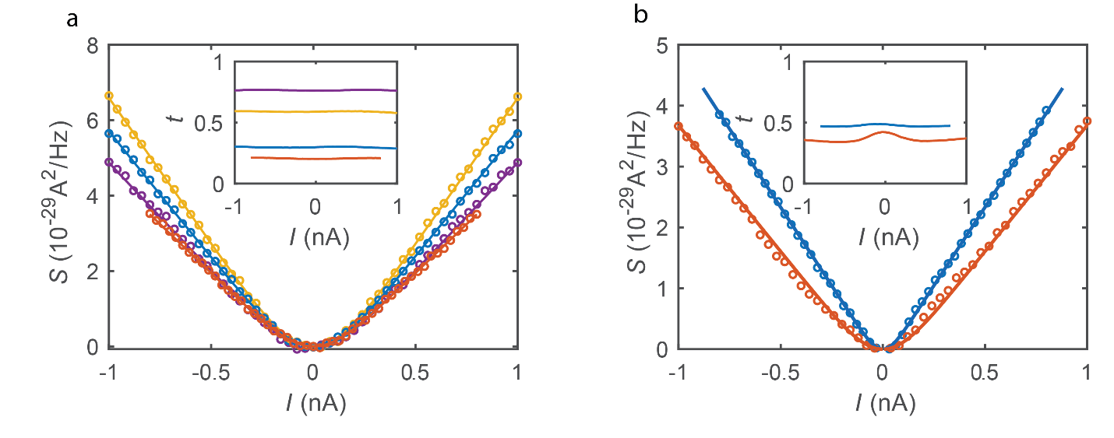
Figure S1. Shot noise. Low frequency shot noise as a function of the partitioned current $I$. The different colored markers correspond to different transmissions $t$ of the QPC. The differential transmission is plotted in the inset. The straight lines are fits to the data according to Eq. S1 (a) Outer edge mode. We find for $t=0.76$ (purple) $e^{⋆}/e=1$ (by calibration) $T=22±3mK$; for $t=0.59$ (yellow) $e^{⋆}/e=0.99±0.01$, $T=22±2mK$; for $t=0.3$ (blue) $e^{⋆}/e=1.01±0.01$, $T=22±2mK$; for $t=0.21$ (orange) $e^{⋆}/e=1.01±0.01$, $T=19±2mK$. (b) Inner edge mode. We find for $t=0.47$ (blue), ${e^{⋆}}/e=0.65±0.01$, $T=7.0±0.5$; for $t=0.38$ (orange), ${e^{⋆}}/e=0.55±0.02$, $T=17±2mK$.
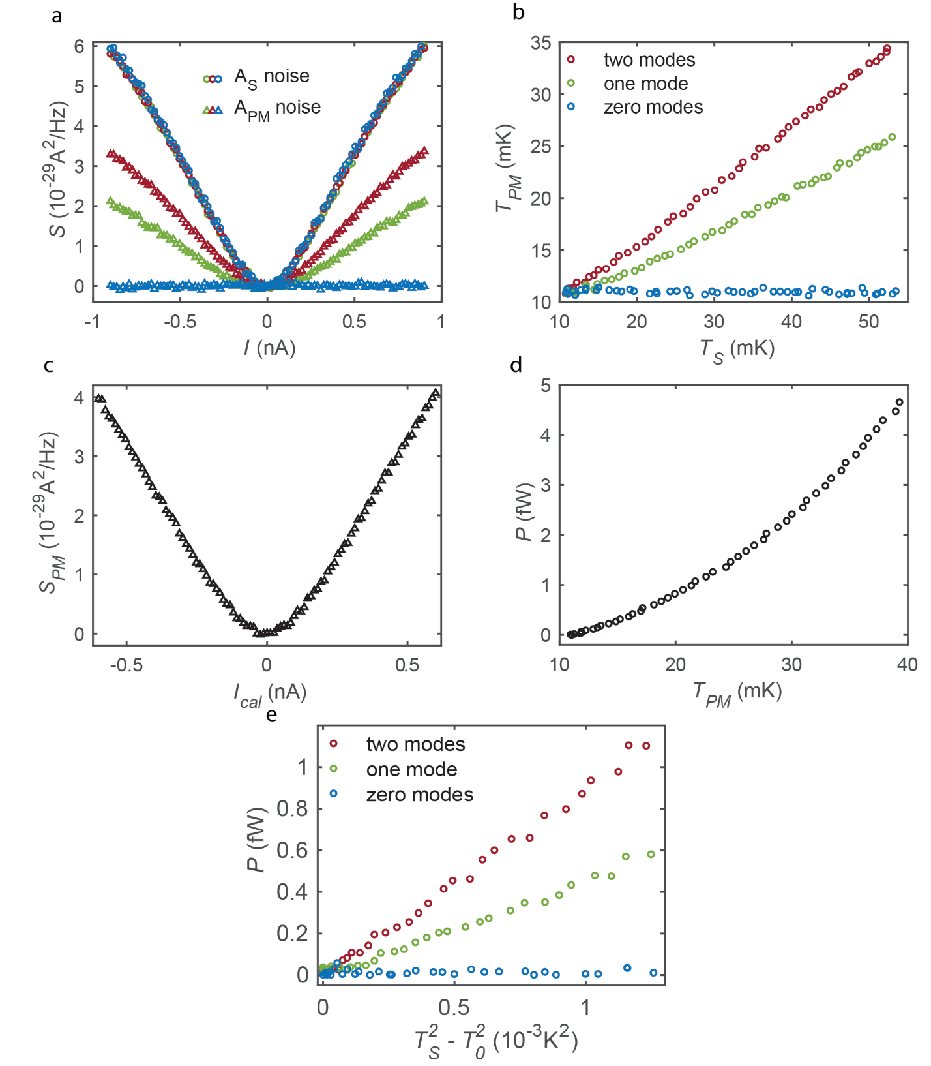

Figure S2. Measurement protocol for thermal conductance. (a) Measured raw data. Noise picked up at $A_{S}$ (circles) and $A_{PM}$ (triangles) as a function of the current $I$ sourced from $S_{1}$ (while current $–I$ is simultaneously sourced from $S_{2}$). The different marker colors correspond to the number of modes transmitted across GD from S to PM; red – two modes; green – one mode; blue – zero modes. As expected, the noise at $A_{S}$ is independent of the number of transmitted modes. (b) PM’s temperature as a function of the source’s temperature for the three different GD configurations. (c) Raw data for the calibration process. Noise measured at $A_{PM}$ as a function of the current $I_{cal}$ sourced from $S_{1}^{cal}$ (while current $–I_{cal}$ is simultaneously sourced from $S_{2}^{cal}$). (d) Calibration of the PM. The impinging power $P=\frac{I_{cal}^{2}}{G_{2T}}$ as a function of the PM’s temperature extracted from the noise. (e) Combining the thermal measurement shown in b with the calibration measurement shown in d, we can plot the impinging power on the PM as a function of the source’s temperature (squared).
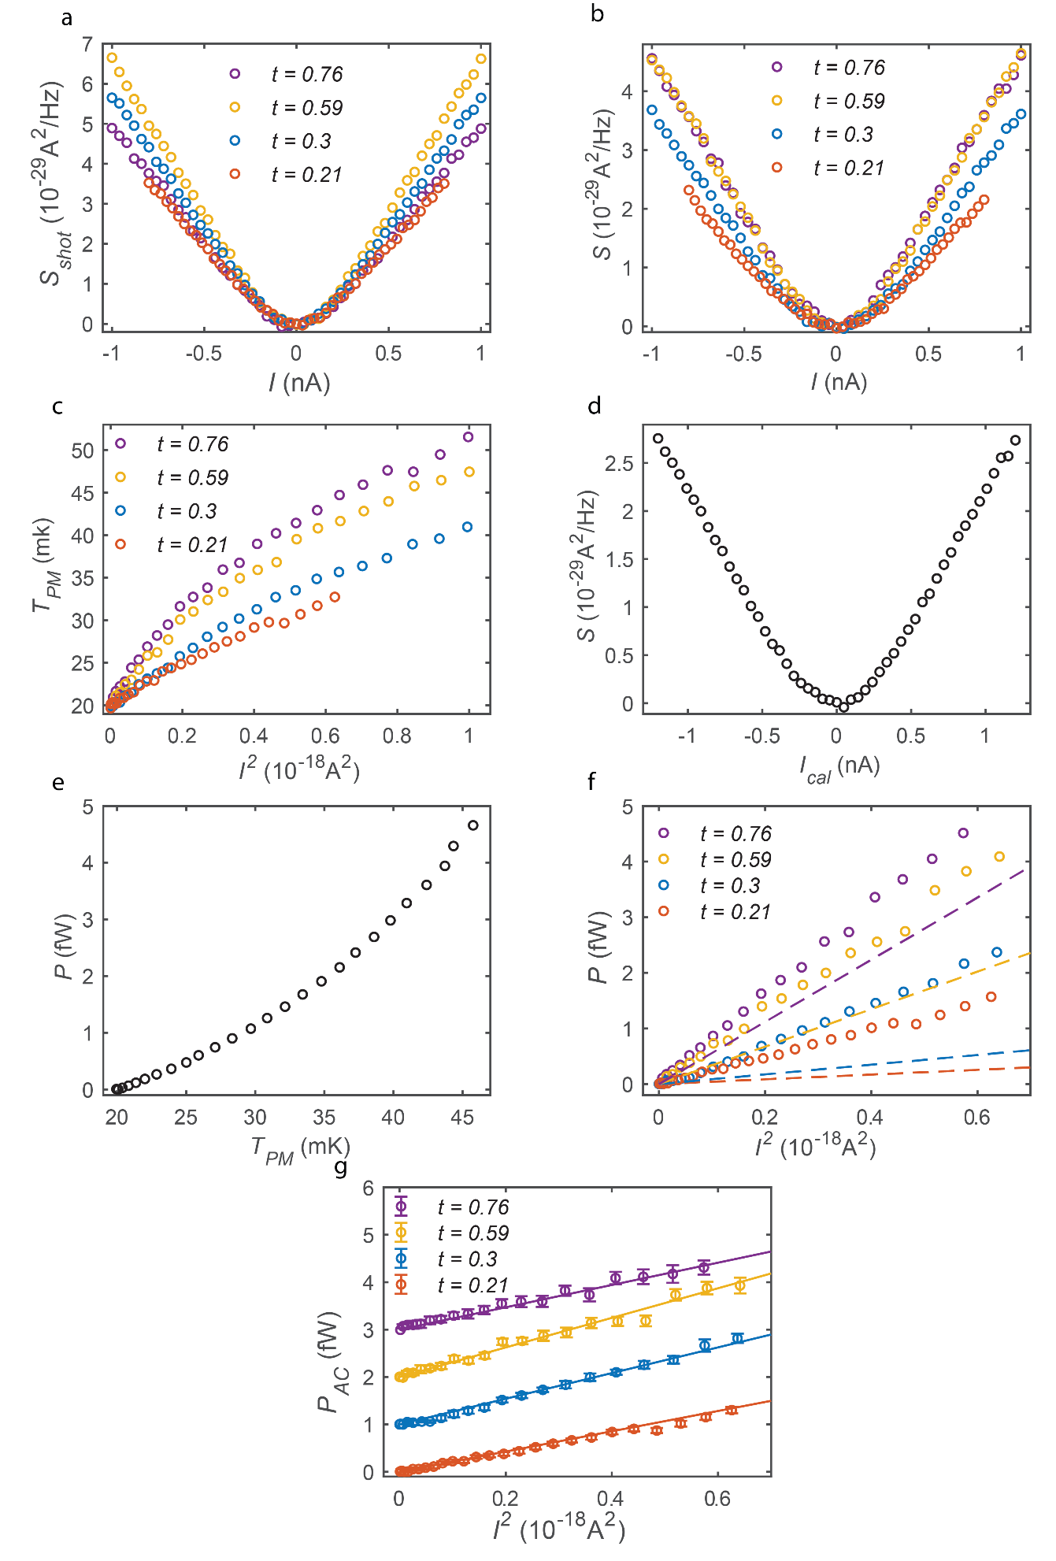
Figure S3. Measurement protocol for double step distributions. (a) Shot noise measurement. Noise measured at $A_{PM}$ as a function of the current injected in the outer edge mode. GA is closed. (b) Raw data. Noise measured at $A_{PM}$ as a function of the current injected in the outer edge mode when GA is open. This noise has two contributions – shot noise generated at the QPC and J-N noise generated at the PM. (c) By subtracting the shot noise contribution, we can extract the PM’s temperature from the noise according to Eq. S9. (d) Raw data for the calibration process. Noise measured at $A_{PM}$ as a function of the current $I_{cal}$ sourced from $S_{I}$. Both GD and GA are fully open. (e) Calibration of the PM. The dissipated power $P=\frac{1}{8G_{0}}I_{cal}^{2}$ as a function of the PM’s temperature extracted from the noise. (f) Total power dissipating at the PM as a function of the current injected to the outer edge mode squared, derived by combining the main measurement (plotted in c) with the calibration (plotted in e). The total power consists of two contributions – the dissipated DC power (plotted as dashed lines) and the power carried by the fluctuations $P_{AC}$. (g) $P_{AC}$, extracted by subtracting the dissipated DC power from the total power, vs $I^{2}$. The data is shifted by $1 (fW)$ for consecutive transmissions for clarity. The straight lines correspond to the theoretically predicted power $P=\frac{1}{2G_{0}}t\left(1-t\right)I^{2}$ (without any fitting parameters). Here we restored the error bars, marking the statistical scattering of the data.

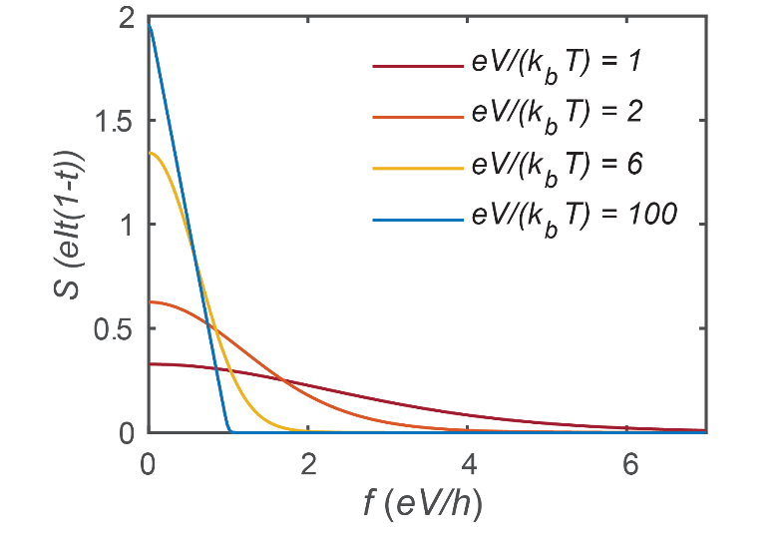
Figure S4. Noise spectrum. The spectral density of the noise associated with ‘double-step distributions’ (in units of $eIt(1-t)$) vs. frequency (in units of $eV/h$) for different temperatures. The power is the area under the graph, and is equal for all the temperatures. The shot noise is the low frequency limit of the curves.

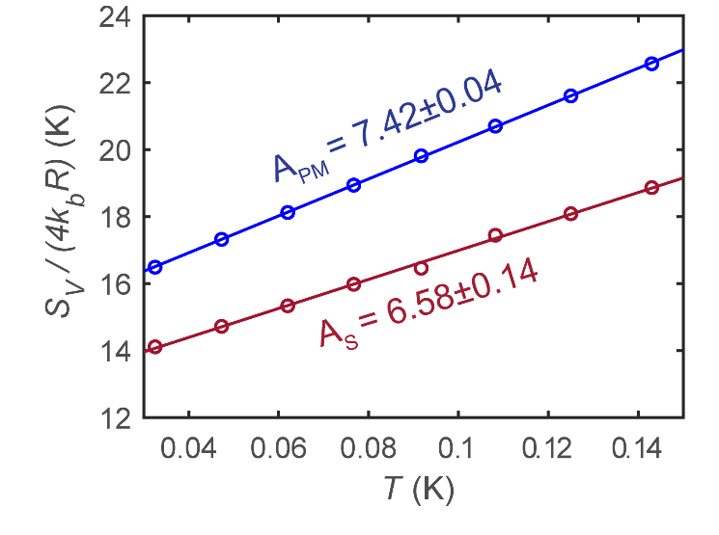
Figure S5. Amplifier calibration. Low-frequency spectral density of the voltage fluctuations measured at the two amplifiers (normalized by $4k_{b}R$ ) in equilibrium. The background voltage fluctuations linearly increase with the cryostat’s temperature. The slope of the linear fit is the gain squared of the amplifier.

References

S1. dePicciotto, R., et al., Direct observation of a fractional charge. Nature, 1997. 389(6647): p. 162-164.
S2. Saminadayar, L., et al., Observation of the e/3 fractionally charged Laughlin quasiparticle. Physical Review Letters, 1997. 79(13): p. 2526-2529.
S3. Spietz, L., et al., Primary Electronic Thermometry Using the Shot Noise of a Tunnel Junction. Science, 2003. 300(5627): p. 1929-1932.
S4. Melcer, R.A., et al., Absent thermal equilibration on fractional quantum Hall edges over macroscopic scale. Nature Communications, 2022. 13(1): p. 376.
S5. Jezouin, S., et al., Quantum Limit of Heat Flow Across a Single Electronic Channel. Science, 2013. 342(6158): p. 601-604.
S6. Rosenblatt, A., et al., Energy Relaxation in Edge Modes in the Quantum Hall Effect. Physical Review Letters, 2020. 125(25): p. 256803.
S7. Protopopov, I.V., Y. Gefen, and A.D. Mirlin, Transport in a disordered ν=2∕3 fractional quantum Hall junction. Annals of Physics, 2017. 385: p. 287-327.
S8. Kane, C.L. and M.P.A. Fisher, Quantized thermal transport in the fractional quantum Hall effect. Physical Review B, 1997. 55(23): p. 15832-15837.
S9. Banerjee, M., et al., Observed quantization of anyonic heat flow. Nature, 2017. 545(7652): p. 75-79.
S10. Aharon-Steinberg, A., Y. Oreg, and A. Stern, Phenomenological theory of heat transport in the fractional quantum Hall effect. Physical Review B, 2019. 99(4): p. 6.
S11. Blanter, Y.M. and M. Buttiker, Shot noise in mesoscopic conductors. Physics Reports, 2000. 336(1-2): p. 1-166.
S12. le Sueur, H., et al., Energy relaxation in the integer quantum Hall regime. Phys Rev Lett, 2010. 105(5): p. 056803.
S13. Bhattacharyya, R., et al., Melting of interference in the fractional quantum Hall effect: Appearance of neutral modes. Physical Review Letters, 2019. 122(24): p. 246801.
S14. Johnson, J.B., Thermal Agitation of Electricity in Conductors. Physical Review, 1928. 32(1): p. 97-109.
S15. Nyquist, H., Thermal Agitation of Electric Charge in Conductors. Physical Review, 1928. 32(1): p. 110-113.

