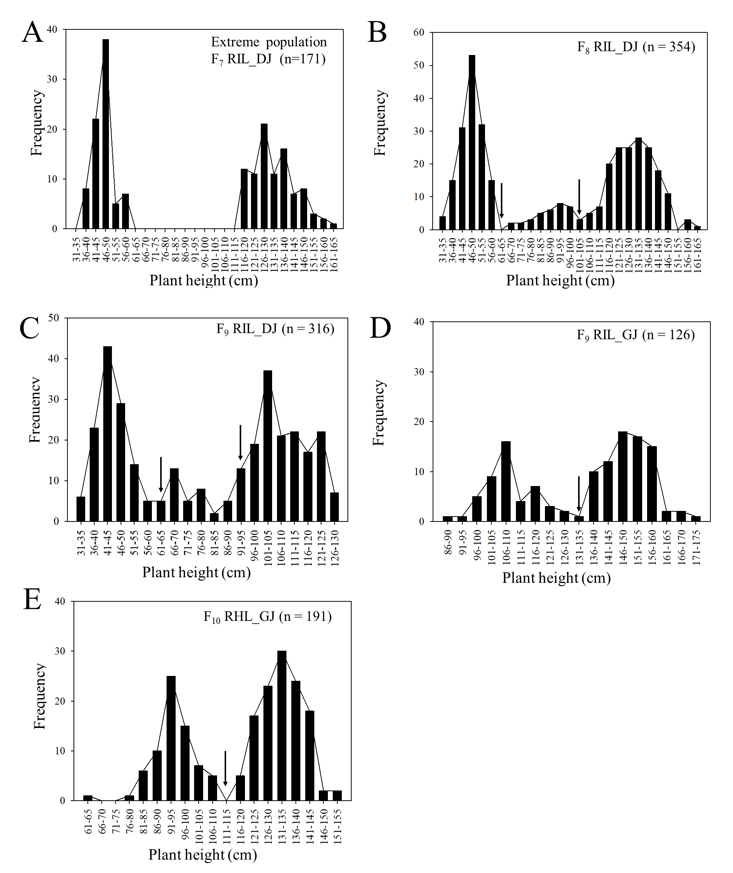
SFig. 1 Frequency distribution of plant height in different populations. A: frequency distribution of plant height in an extreme population with 171 F₇ RIL_DJ; B: frequency distribution of plant height in 354 F₈ RIL_DJ; C: frequency distribution of plant height in 316 F₉ RIL_DJ; D: frequency distribution of plant heights in 126 F₉ RIL_GJ; E: frequency distribution of plant heights in 191 F₁₀ RHL_GJ.

