Supporting Information
Figure S1:
It shows the full-color reconstructed images of individual quantum dots while they are wet. As compared to Figure 1, all images show a uniform distribution of quantum dots.
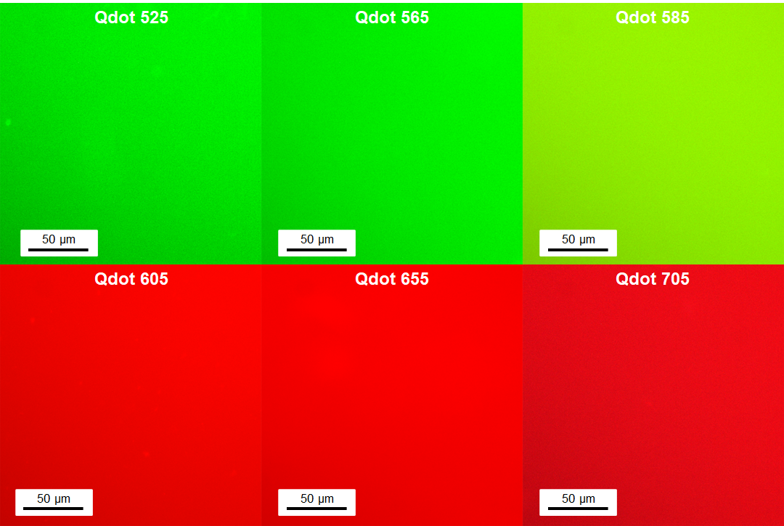
Figure S1. Reconstructed full-color images of individual quantum dots in the wet condition.

Figure S2:
It shows that we have observed a spectral shift of about 5 nm of the wet and dry samples of all our quantum dot samples.
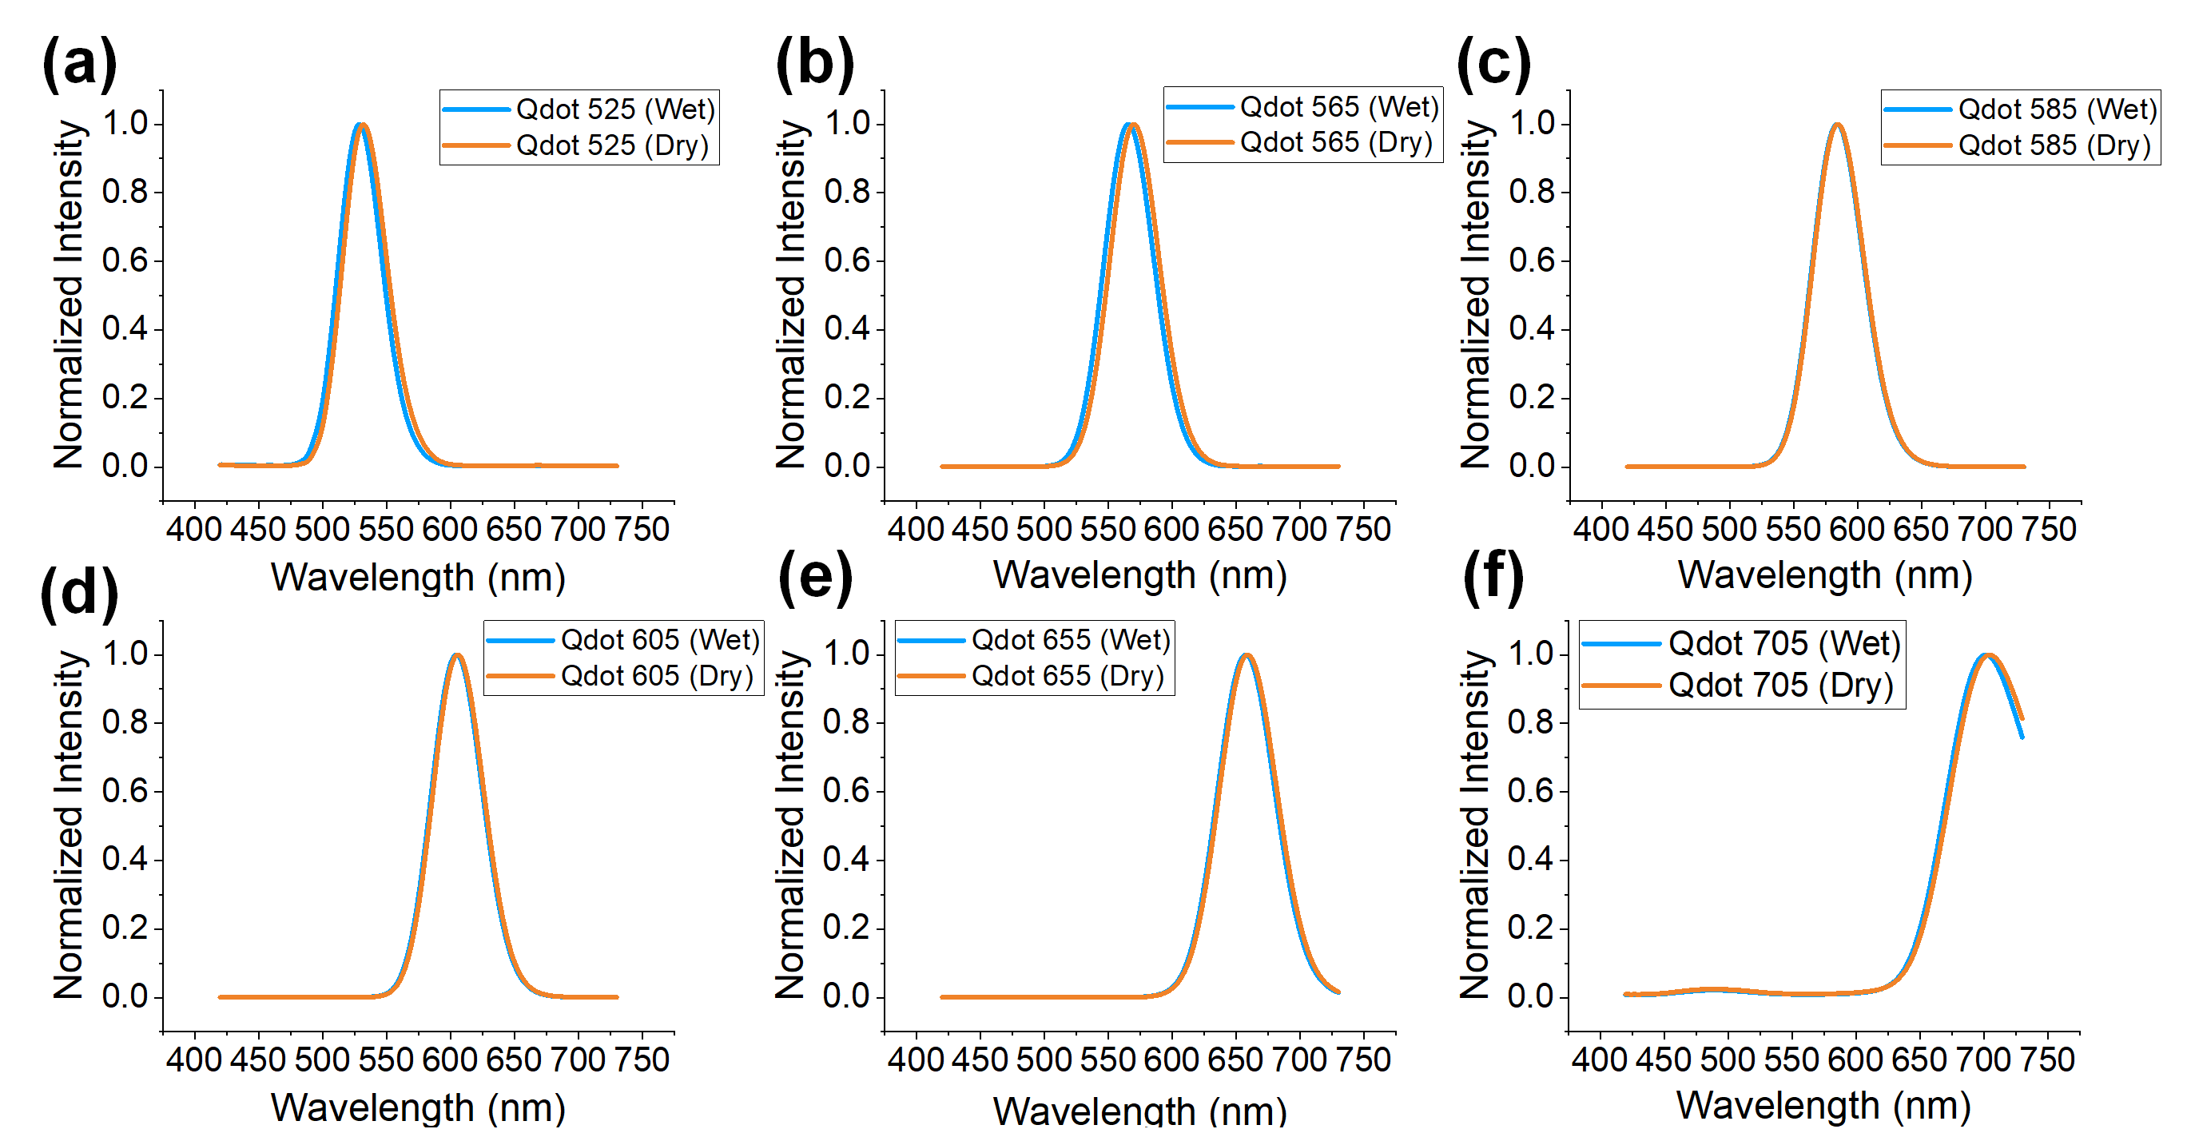
Figure S2. Spectral profiles of all quantum dots in wet and dry conditions.

Figure S3:
The spectral information of the individual quantum dots can be used to predict the spectrum of a homogeneous mixture, and the results are shown in Figure S3. The predicted spectrum of the mixture (“Calculated”) agreed with the measured (“Experimental”) spectrum reasonably well. Discrepancies may be attributed to factors such as the aggregation of quantum dots, and inter-quantum dot energy transfer, which could result in a loss of intensity and spectral shift of the quantum dots.
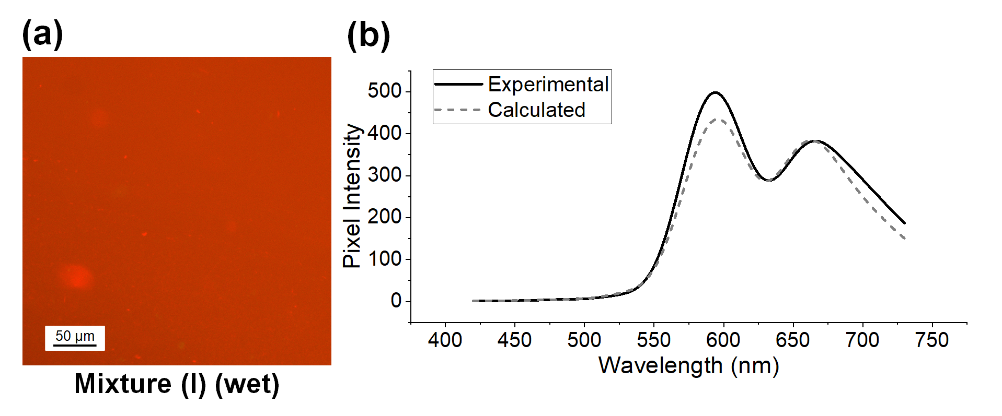
Figure S3. Hyperspectral imaging results of mixture (I). (a) Reconstructed full-color image of the mixture. (b) Calculated and experimentally measured the average spectrum of the mixture within the white area in (a).

