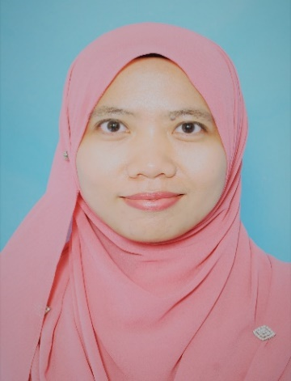
Nurzafirah obtained her PhD in Health Science from International Islamic University Malaysia. She currently works at the Borneo Marine Research Institute, Universiti Malaysia Sabah, Malaysia. She does research in multi-discipline area with core research in biomedical science, biotechnology and marine science. She has won several accolades in local and international research competition. She has supervised 13 postgraduate and over 50 undergraduate students. She has also published more than 40 research articles in reputable journals/books and being reviewer to local and international journals and publisher. She enjoys research a lot and found it challenging and rewarding at the same time. Her current interests are on the microplastics, food microbiology, glycosaminoglycans and collagen, fatty acids composition, as well lactic acid bacteria isolated from marine animals. She is also actively involved in marine conservation and passionate in effort to build a sustainable future.

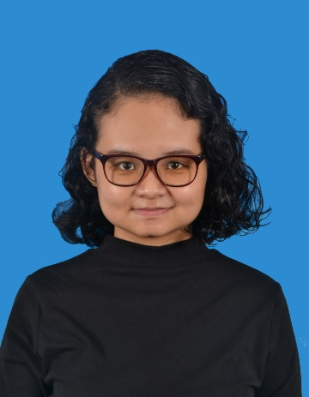
Sarah Syazwani Shukhairi graduated from Management and Science University with Diploma in Medical Laboratory Technology and Bachelor of Biomedical Science (Honours). She has been awarded as President’s List and Dean’s List Award recipient multiple times during her studies. She just finishes her internship at Forest Research Institute Malaysia. She is multilingual and fluent in English, Malay and Mandarin. Currently, she’s pursuing her Master degree in Marine Biotechnology at Borneo Marine Research Institute, Universiti Malaysia Sabah, Malaysia and actively involved with marine conservation projects.

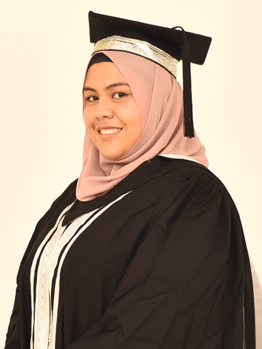
Miftahul Jannah Muhammad Husin graduated from Management and Science University with Diploma in Medical Laboratory Technolagy and Bachelor of Biomedical Science (Honours). She was awarded an academic award by MSU's President during both of her convocation in diploma and bachelor due to her excellence in academics. She was a vice president in a Biovarsity Club where she managed to plan events and projects. Currently, she is working as a Medical Laboratory Technologist at the UKM Specialist Children's Hospital. She is also working in a specialized laboratory of bone marrow and flow cytometer. She has published one research article and one review article.

Jemimah Shalom a/p B Peragas graduated from University Malaysia Terengganu with Bachelor's Degree in Science (Marine Science). She was awarded a notable Vice Chancellor Award at her recent convocation due to her excellence in academic and co-curricular activities. She was a committee in a Police Undergraduate Voluntary Corps (KOR Suksis) where she was responsible for handling various programme and ensure the safety and protocol of the event. She is multilingual and fluent in English, Malay and Tamil. Currently she is actively involved with marine conservation and doing several sustainable and conservation projects local and international. She has published 1 research article and one review article.

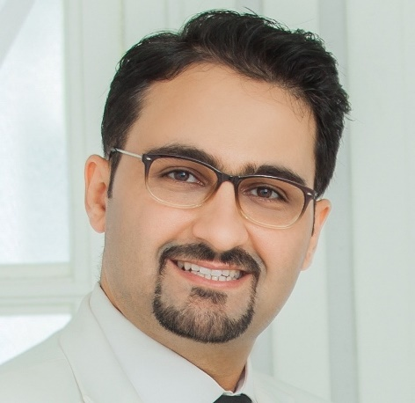
Dr Saud is a postdoctoral and PhD graduate in Mechanical/Biomaterials Engineering from the University Teknologi Malaysia and his research focuses on the design and development of novel biomaterials and their related applications. Currently, he is working as a program coordinator at the Management and Science University, Shah Alam, Malaysia. Dr. Saud is a registered professional engineer in a number of engineering associations and societies and has more than 10 years of experience in material engineering, manufacturing and design. He is the author of more than 110 research articles published in well-known and highly impacted journals. He has also been awarded with a number of gold and bronze medals in many innovations and innovative national and international engineering and technology exhibitions. He is also an editor and reviewer in several well-known journals and publishers.

Muhamad Shirwan Abdullah Sani obtained his PhD in Halal Products Science from Universiti Putra Malaysia. He was appointed as a registered chemist of Department of Chemistry, Ministry of Science, Technology and Innovation between 2006-2013. He had served as an expert witness for environmental enforcement cases and involved in method development of oil spill analysis during his employment tenure in the department. He is actively involved as Department of Islamic Development Malaysia (JAKIM) and Human Resource Development Fund (HRDF)-certified trainer for halal assurance system, and an auditor and consultant for halal-related activities in Japan, South Korean and Taiwan. He has been engaging as a trainer for halal laboratory testing in COMSATS University Islamabad, Lahore Campus, Pakistan. Presently, he serves as a registered chemist of Malaysian Institute of Chemistry (L/1643/5200/07) and Head of Laboratories for International Institute for Halal Research and Training (INHART), International Islamic University Malaysia (IIUM). His research focuses on the method development for halal authentication and plant antimicrobials as food preservatives.

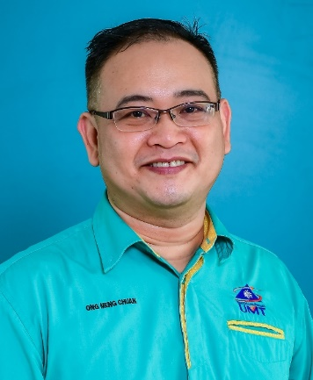
Dr. Ong Meng Chuan is an Associate Professor at the Faculty of Science and Marine Environment, Universiti Malaysia Terengganu. He holds a doctoral degree in Marine Pollution specifically in metals pollution from the University of South Brittany, France. His research focuses on the metal content in sediment samples which can act as geo–marker for pollution studies. Apart from the sediment samples, his research also included biota samples of fishes, crustaceans, bivalves, molluscs and plants such as seaweed and seagrass. From these biota samples, the suitability of using these organisms as bioindicator can be identified which best reflect the environmental quality. Hence, risk assessment towards human health by consuming these organisms can be estimated. He is currently actively gathering all the Malaysian marine aquatic environment data to be stored in the GIS database. With this database, these data can easily refer by other researchers for their studies.

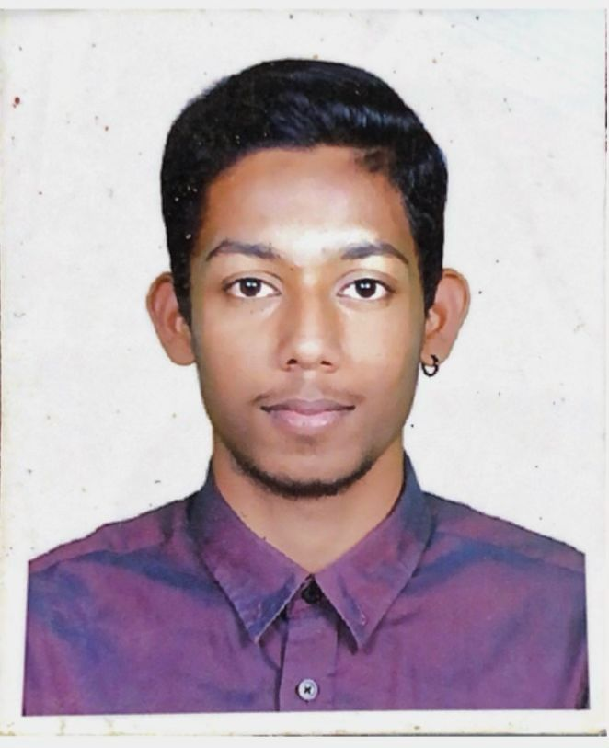
Naveen Kumar Naidu graduated from Management and Science University in Medical Laboratory Technology and is currently doing his Internship in Bachelors of Biomedical Science (Honours). He has been awarded multiple times for achieving Dean’s List awards. He was the Vice President of the BioVarsity Club where he managed to plan events and supervise projects that were held. Currently he is doing is internship at BP Healthcare in Medan Tuanku, KL. He is also currently working under the Vaccination program for kids as well as being a frontliner for Covid Screening.

