Supplementary materials for
Gene expression management in a stony coral, Acropora tenuis, depends upon identities of algal symbionts and developmental stages

Yuki Yoshioka ^{1, 2}, Hiroshi Yamashita ³, Go Suzuki ³ and Chuya Shinzato ^{1*}
¹ Atmosphere and Ocean Research Institute, The University of Tokyo, Kashiwa, Chiba, Japan
² Graduate School of Frontier Sciences, The University of Tokyo, Kashiwa, Chiba, Japan
³ Fisheries Technology Institute, Japan Fisheries Research and Education Agency, Ishigaki, Okinawa, Japan
*Corresponding authors: Chuya Shinzato (c.shinzato@aori.u-tokyo.ac.jp)

Contents:
Supplementary Tables S1–S8.
Supplementary Figures S1–S6.

Supplementary Table S1. Uptake efficiency and algal cell densities of Durusdinium in Acropora tenuis planula larvae, 3 days post-inoculation.
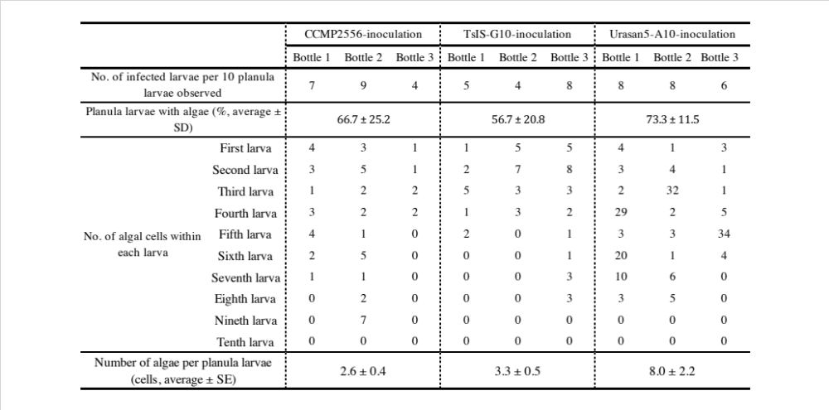

Supplementary Table S2. Summary of RNA-seq data of planula larvae 3 days post-inoculation with Durusdinium and with no symbiont exposure.
SRA accession | Samples | Number of clean reads | Total base of clean read | Mapping rate (%)
DRR345063 | CCMP2556-inoculation 1 | 5,513,028 | 275,134,045 | 73.7
DRR345064 | CCMP2556-inoculation 2 | 7,099,738 | 354,328,821 | 71.1
DRR345065 | CCMP2556-inoculation 3 | 7,991,748 | 398,835,372 | 73.7
DRR345066 | TsIS-G10-inoculation 1 | 6,690,312 | 333,884,382 | 74.3
DRR345067 | TsIS-G10-inoculation 2 | 8,562,524 | 427,300,446 | 73.5
DRR345068 | TsIS-G10-inoculation 3 | 6,206,530 | 309,714,010 | 73.8
DRR345069 | Urasan5-A10-inoculation 1 | 6,395,206 | 319,149,661 | 73.8
DRR345070 | Urasan5-A10-inoculation 2 | 7,254,923 | 362,053,548 | 73.9
DRR345071 | Urasan5-A10-inoculation 3 | 6,817,244 | 340,216,666 | 73.5
DRR345072 | Apo-symbiotic 1 | 9,608,871 | 479,533,801 | 71.2
DRR345073 | Apo-symbiotic 2 | 7,776,748 | 388,100,515 | 72.6
DRR345074 | Apo-symbiotic 3 | 6,574,594 | 328,115,307 | 73.4

Supplementary Table S3. List of differentially expressed genes in primary polyps inoculated with Durusdinium trenchii.
Attached separately (SupTableS5.xlsx) due to file size.

Supplementary Table S4. List of differentially expressed genes detected in planula larvae inoculated with Symbiodinium.
Attached separately (SupTableS3.xlsx) due to file size.

Supplementary Table S5. Summary of RNA-seq data of primary polyps 10 and 20 days post-inoculation with Durusdinium trenchii and with no symbiont exposure.
*Original RNA-seq data was produced by Yuyama et al. (2018).
SRA accession | Sample description | No. of raw-reads | No. of reads after quality trim | Mapping rate (%)
DRR119956 | apo-symbiotic polyps at 10 dpi | 34,156,878 | 33,862,121 | 67.8
DRR119957 | apo-symbiotic polyps at 10 dpi | 36,291,353 | 35,938,029 | 69.1
DRR119958 | apo-symbiotic polyps at 20 dpi | 36,190,136 | 35,826,131 | 68.5
DRR119959 | apo-symbiotic polyps at 20 dpi | 36,022,487 | 35,678,132 | 68.0
DRR119964 | CCMP2556-inoculated polyps at 10 dpi | 35,808,273 | 35,483,153 | 62.8
DRR119965 | CCMP2556- inoculated polyps at 10 dpi | 35,177,042 | 34,830,711 | 63.0
DRR119966 | CCMP2556- inoculated polyps at 20 dpi | 36,004,384 | 35,603,765 | 50.2
DRR119967 | CCMP2556- inoculated polyps at 20 dpi | 32,023,583 | 31,702,519 | 51.1

Supplementary Table S6. List of differentially expressed genes commonly detected from Durusdinium trenchii and Symbiodinium microadriaticum inoculation and specifically detected from inoculations with each symbiont.
Attached separately (SupTableS6.xlsx) due to file size.

Supplementary Table S7. List of SLC-like differentially expressed genes.
Attached separately (SupTableS7.xlsx) due to file size.

Supplementary Table S8. Results of enrichment analyses for differentially expressed genes.
Attached separately (SupTableS8.xlsx) due to file size.

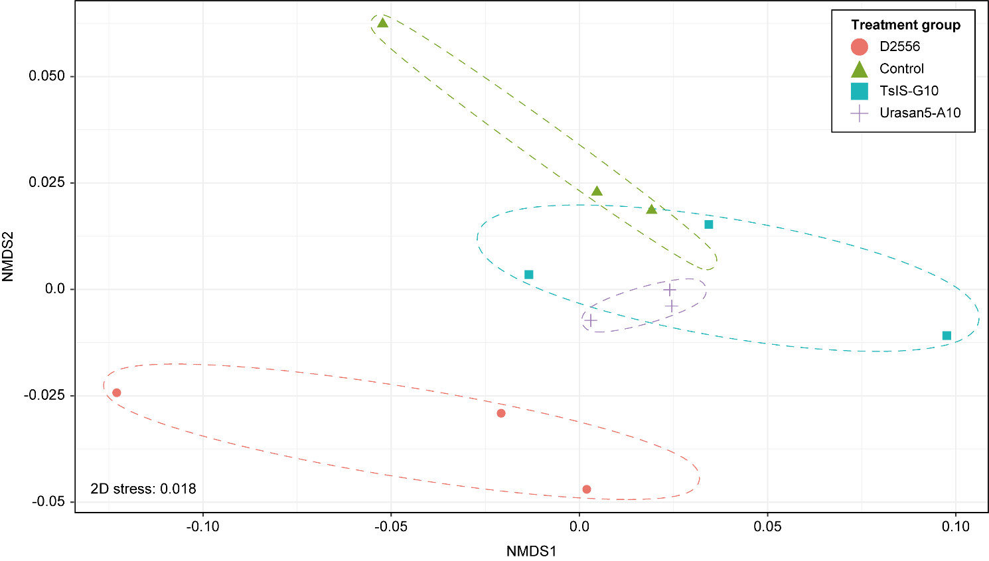
Supplementary Figure S1. Non-metric multidimensional scaling of RNA-seq samples based on expression of Acropora tenuis genes.
Gene expression levels among all samples were normalized using the trimmed mean of M values method, and were then converted to CPM. A total of 7,697 genes for which expression levels (TMM-normalized CPM) were larger than 10 in all samples were used with the “metaMDS” of the vegan package (Oksanen et al. 2007). 2D stress was 0.134. Ellipses (dotted line) are drawn around each time point using “geom_mark_ellipse” of the ggplot package (Wickham 2009).

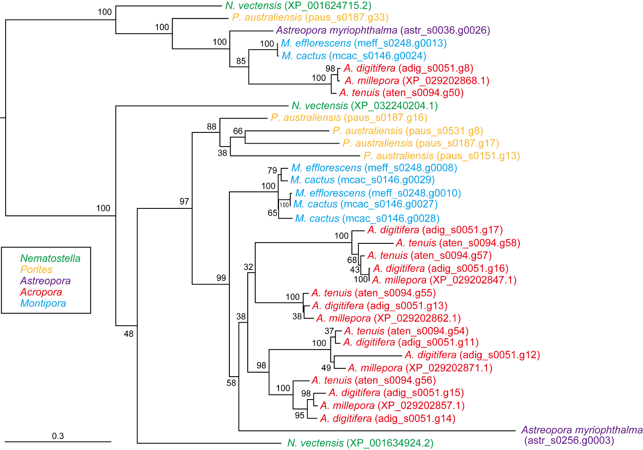
Supplementary Figure S2. Molecular phylogenetic analysis of sugar transporters having sugar (and other) transporter domains.
482 gap-trimmed, aligned amino acids were used for phylogenetic tree reconstruction (CPREV model). Genes from Nematostella, Porites, Astreopora, Montipora, Acropora are colored in green, yellow, purple, red, and light blue, respectively. The bar indicates expected substitutions per site in aligned regions.
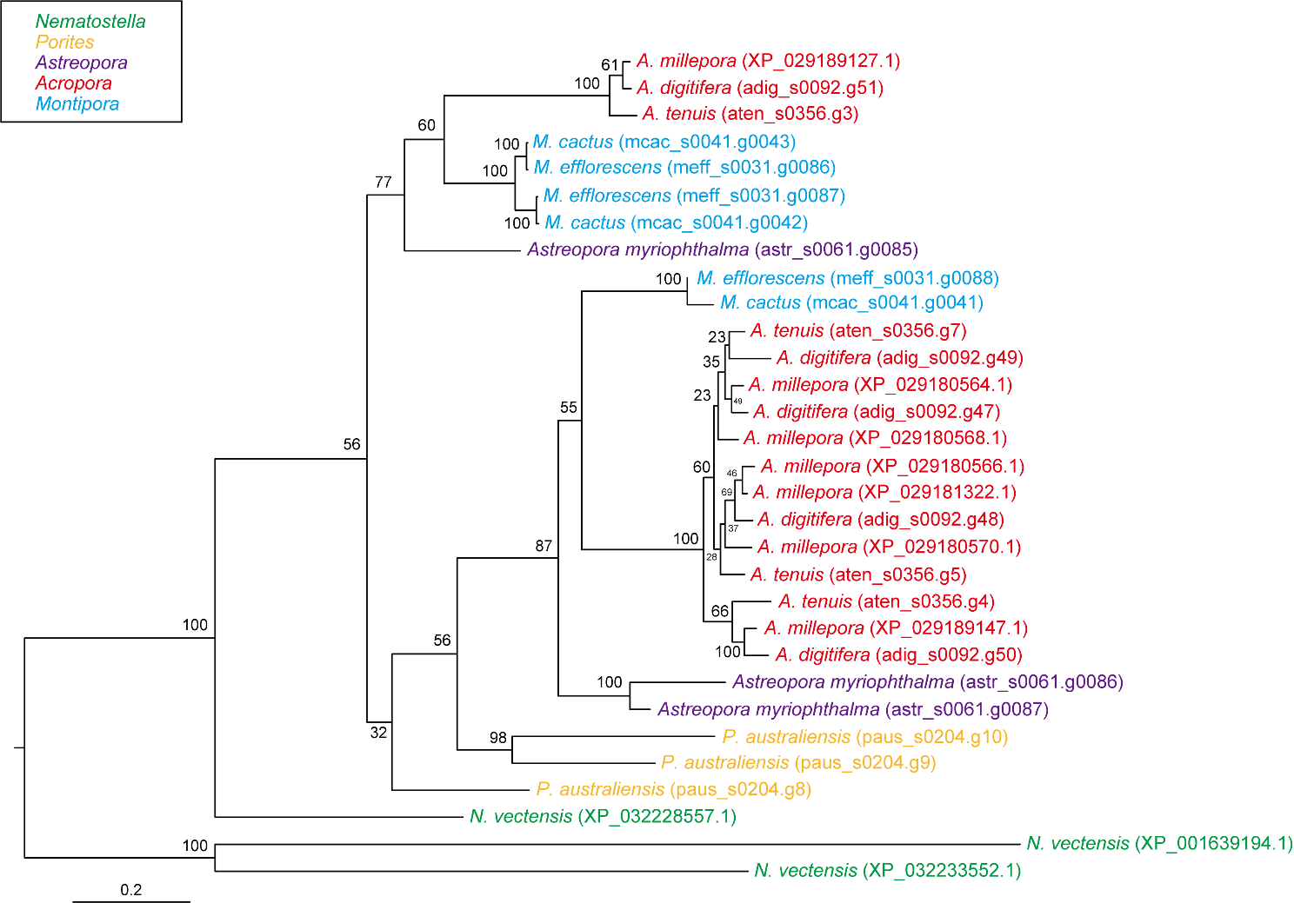
Supplementary Figure S3. Molecular phylogenetic analysis of amino acid transporters having POT family domains.
517 gap-trimmed, aligned amino acids were used for phylogenetic tree reconstruction (JTT model). Genes from Nematostella, Porites, Astreopora, Montipora, Acropora are colored in green, yellow, purple, red, and light blue, respectively. The bar indicates expected substitutions per site in aligned regions.
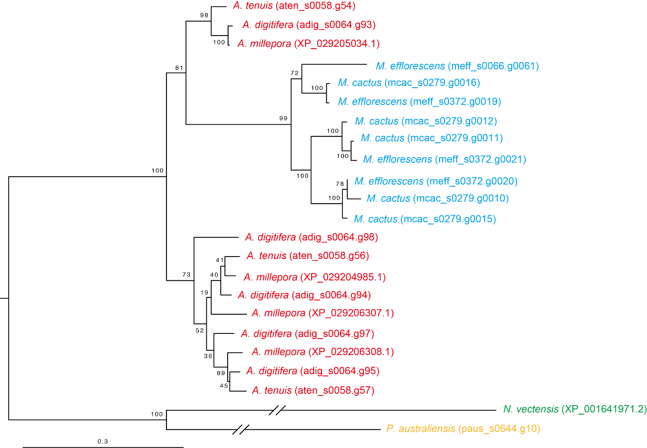
Supplementary Figure S4. Molecular phylogenetic analysis of amino acid transporters having transmembrane amino acid transporter domains.
375 gap-trimmed, aligned amino acids were used for phylogenetic tree reconstruction (JTT model). Genes from Nematostella, Porites, Astreopora, Montipora, Acropora are colored in green, yellow, purple, red, and light blue, respectively. The bar indicates expected substitutions per site in aligned regions.
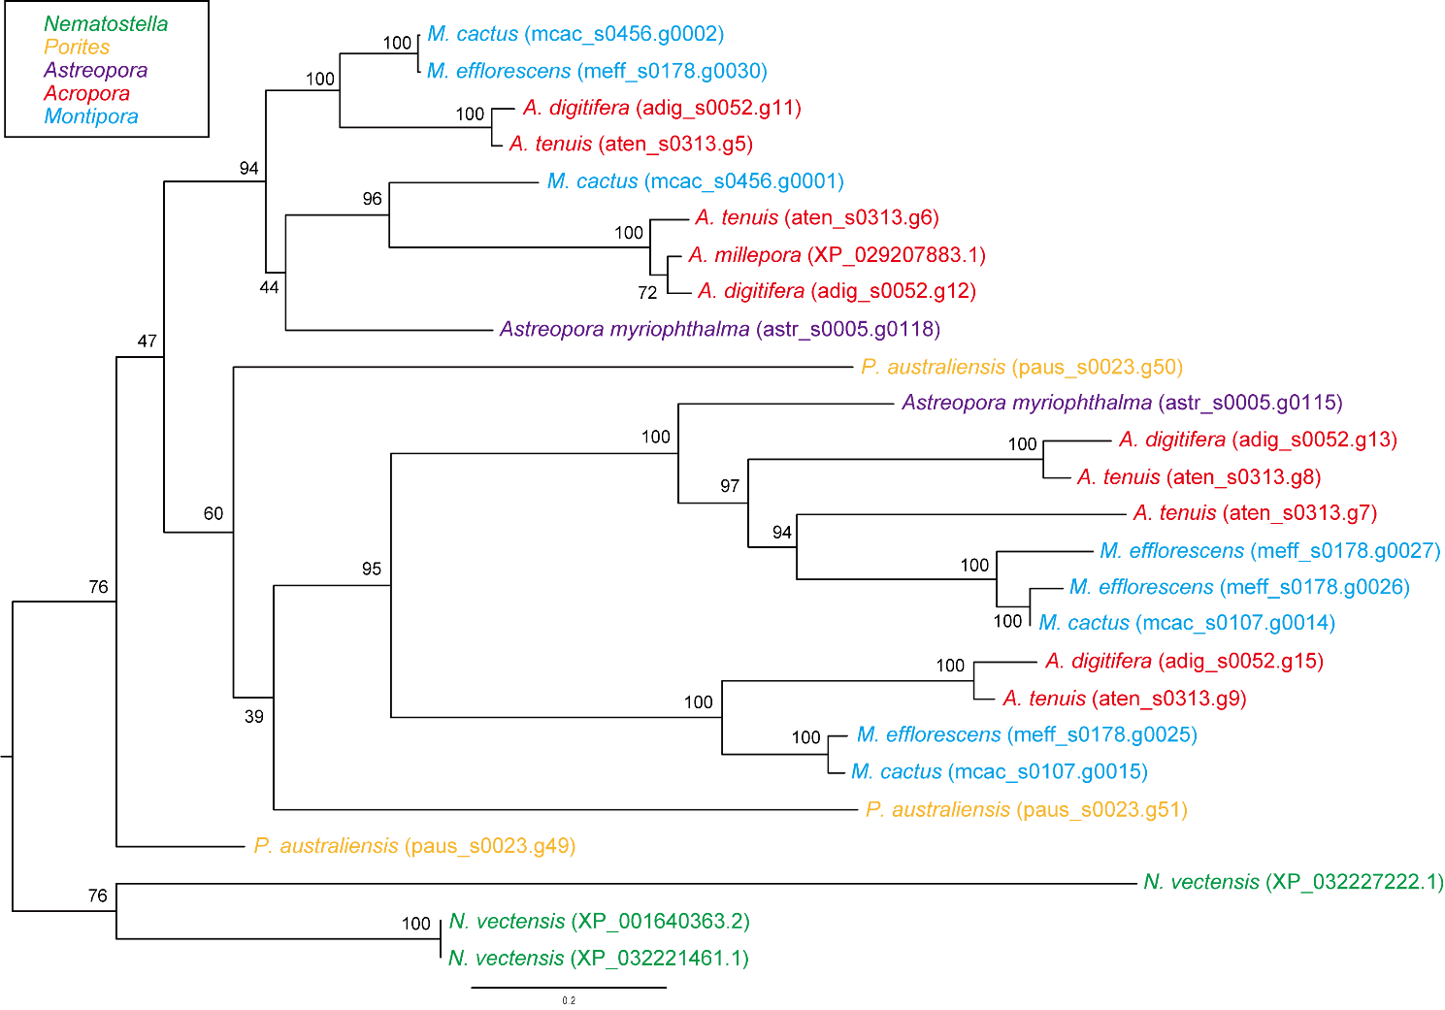
Supplementary Figure S5. Molecular phylogenetic analysis of ion transporters having sodium/calcium exchanger protein domains.
473 gap-trimmed, aligned amino acids were used for phylogenetic tree reconstruction (JTT model). Genes from Nematostella, Porites, Astreopora, Montipora, Acropora are colored in green, yellow, purple, red, and light blue, respectively. The bar indicates expected substitutions per site in aligned regions.
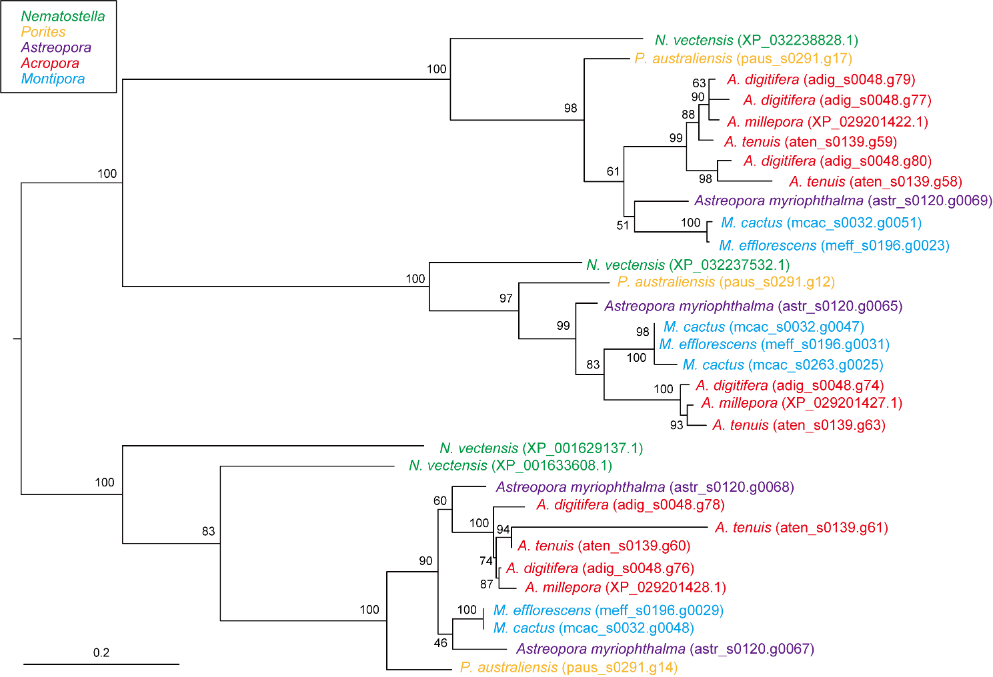
Supplementary Figure S6. Molecular phylogenetic analysis of amino acid transporters having amino acid permease domains.
437 gap-trimmed, aligned amino acids were used for phylogenetic tree reconstruction (JTT model). Genes from Nematostella, Porites, Astreopora, Montipora, Acropora are colored in green, yellow, purple, red, and light blue, respectively. The bar indicates expected substitutions per site in aligned regions.
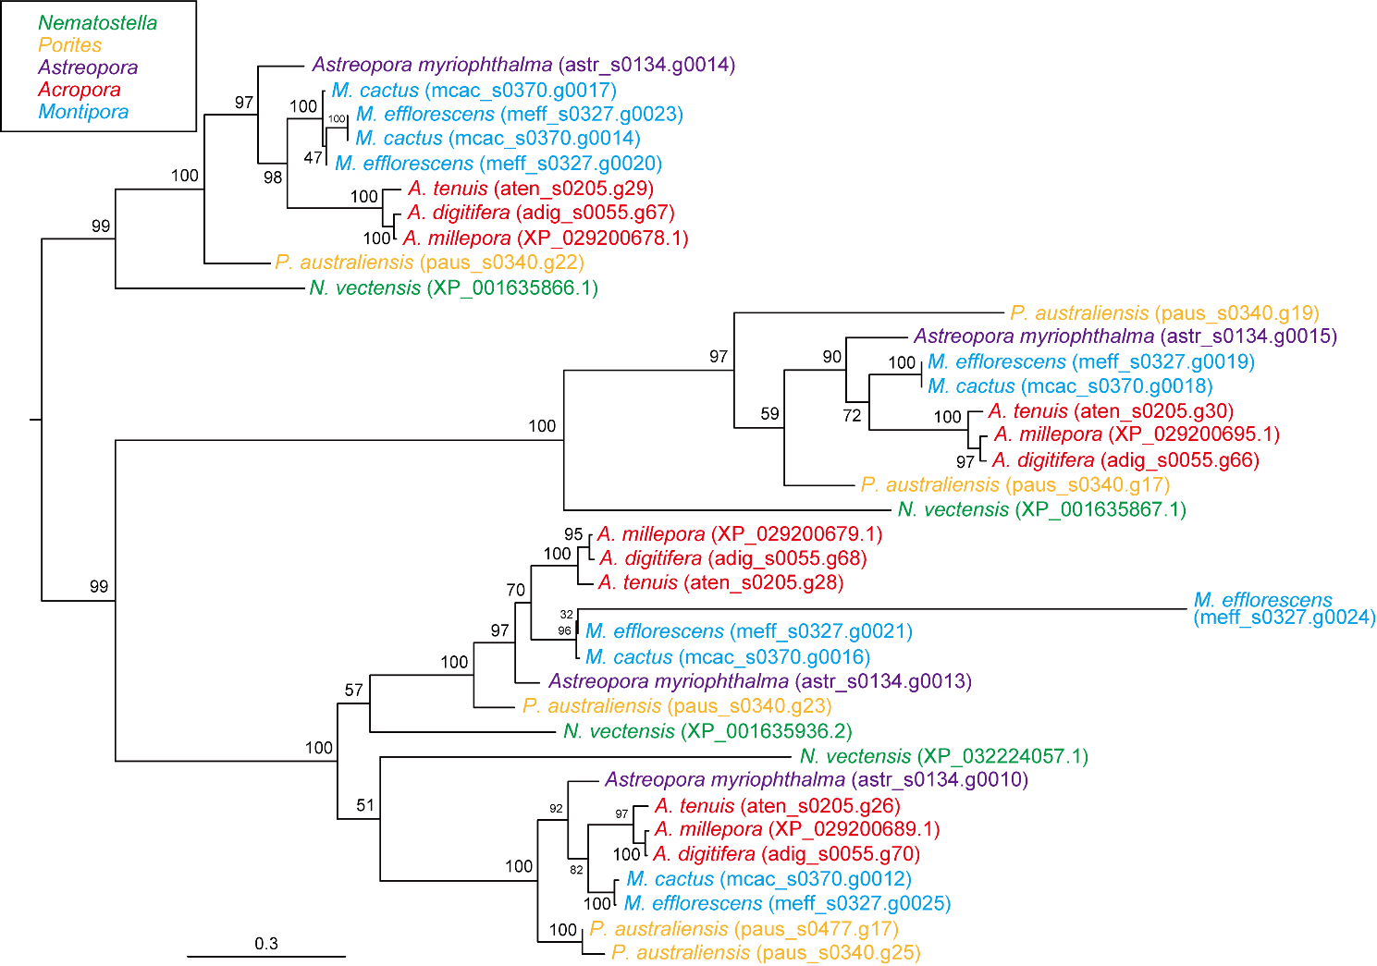
Supplementary Figure S7. Molecular phylogenetic analysis of amino acid transporters having transmembrane amino acid transporter protein domains.
554 gap-trimmed, aligned amino acids were used for phylogenetic tree reconstruction (JTT model). Genes from Nematostella, Porites, Astreopora, Montipora, Acropora are colored in green, yellow, purple, red, and light blue, respectively. The bar indicates expected substitutions per site in aligned regions.
References
Oksanen J., R. Kindt, P. Legendre, B. O’Hara, M. H. H. Stevens, M. J. Oksanen, and M. Suggests. 2007. The vegan package. Community ecology package 10:719.
Wickham H. 2009. Elegant graphics for data analysis. Media 35:10.1007.
Yuyama I., M. Ishikawa, M. Nozawa, M. Yoshida, and K. Ikeo. 2018. Transcriptomic changes with increasing algal symbiont reveal the detailed process underlying establishment of coral-algal symbiosis. Sci Rep 8:16802.

