Electronic Supplementary Material(for online publication only)
Table S1. The element percentage of precipitates on the surface of the Ti mesh cathode and precipitates between the sediment and overlying water tested by the EDS spectrum
Element | Precipitates between sediment and overlying water（%） | Precipitate on the surface of the Ti mesh cathode（%）
C | 23.05 | 29.08
O | 54.19 | 53.76
Mg | 12.75 | 15.61
Al | 0.34 | 0.70
Si | 1.40 | 0.50
Ca | 8.27 | 0.34
Total | 100.00 | 100.00
Table S2. Statistics representing community diversity indices of bacteria
Treatment  groups |  | Seq_  num | OTU_  num | Shannon_  index | ACE_  index | Chao1_  index | Simpson
Control |  | 28202 | 6143 | 7.29 | 25190.64 | 15978.73 | 3.8e-03
Electrolysis |  | 54269 | 5474 | 5.40 | 25997.18 | 15765.53 | 0.06

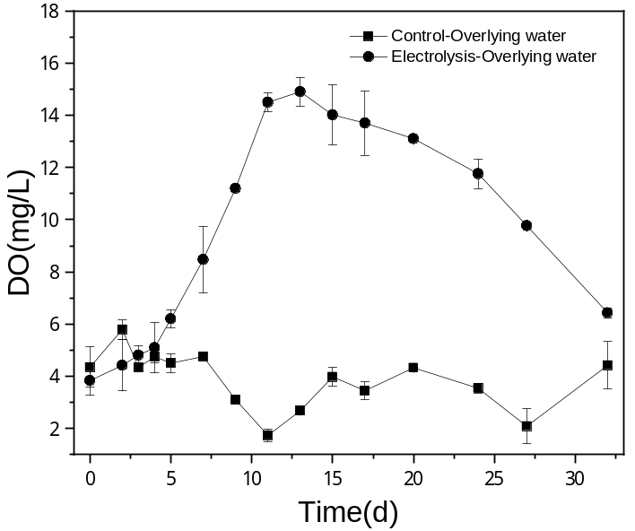
Fig. S1. The concentration of DO in the overlying water of the electrolysis group with one Mg-Al alloy anode paired with a Ti mesh cathode and a RuO₂-IrO₂/Ti anode paired with a Ti mesh cathode in eutrophic sediment
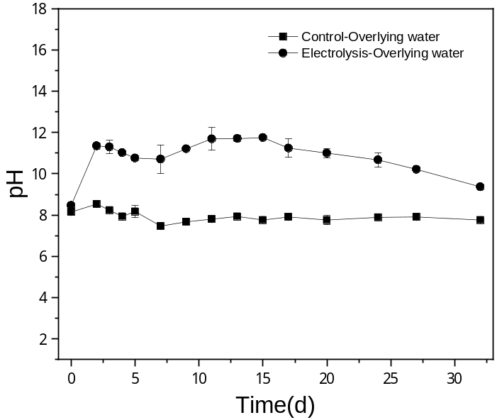
Fig. S2. The pH value in overlying water of electrolysis group with one Mg-Al alloy anode paired with a Ti mesh cathode and a RuO₂-IrO₂/Ti anode paired with a Ti mesh cathode in eutrophic sediment
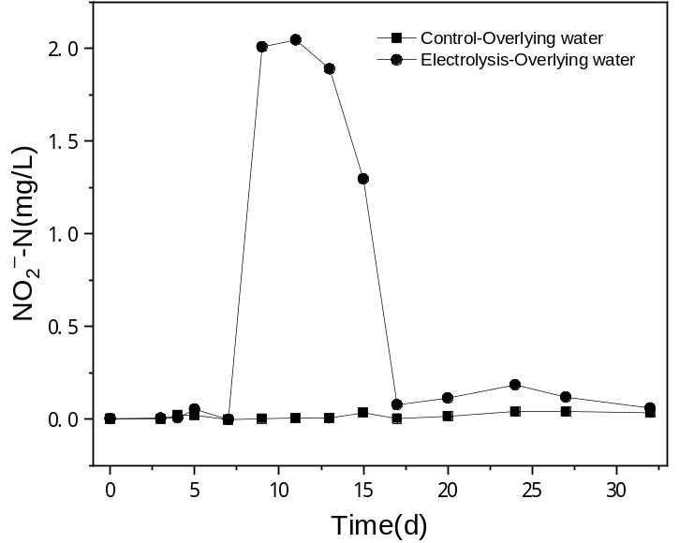
Fig. S3. The concentration of NO₂–-N in the overlying water of electrolysis group with one Mg-Al alloy anode paired with a Ti mesh cathode and a RuO₂-IrO₂/Ti anode paired with a Ti mesh cathode in eutrophic sediment
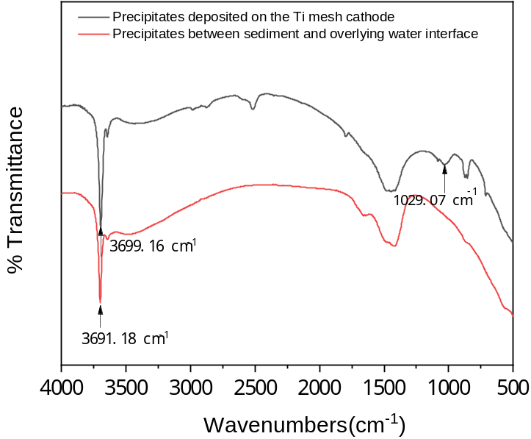
Fig. S4. FTIR spectra of precipitates deposited on the surface of a Ti mesh cathode and the precipitates between sediment and overlying water

