The VIDEO trial: A Feasibility RCT of Vitrectomy Plus Standard Care Intravitreal Ranibizumab or Aflibercept Injections versus Standard Care Intravitreal Ranibizumab or Aflibercept injections Alone In Patients With Centre Involving Diabetic Macular Edema

Patient info sheet V2.0 7.9.18 IRAS Number 220073

Chief Investigator Mr D A H Laidlaw MD FRCOphth
St Thomas’ Hospital Lambeth Palace Road London SE1 7EH

Tel: 0207 188 4320
alistair.laidlaw@gstt.nhs.uk

We would like to invite you to take part in a research study. Before you decide to participate its important for you to understand why the research is being done and what it will involve for you. Please take the time to read the following information carefully. Ask us if there is anything that is not clear or if you would like more information and feel free to talk to others about the study if you would like. Take as much time as you want to decide whether or not you wish to take part.

What is the purpose of the study?
Diabetic Macular Oedema (DMO) is swelling at the back of the eye in Diabetic patients. This swelling damages the retina and affects patients’ vision.

The current NHS standard treatment for DMO is a course of injections of Lucentis (Ranibizumab) or Aflibercept (Eylea) into the eye up to every month.
These medications (Ranibizumab and Aflibercept) are collectively known as Anti-VEGF injections. The average number of injections required by patients with DMO is around 8 in the first year with some people requiring as many as 13 in the first year of treatment. The aim of treatment is to reduce the swelling of the retina and thereby improve the vision.

We know that performing an operation called a vitrectomy in patients with DMO can also reduce the swelling of the retina.

We want to investigate whether performing vitrectomy surgery earlier, and in combination with Anti-VEGF injections, improves vision in the long-term and or reduces the number of injections per year needed by patients with DMO.

We do not know whether performing a vitrectomy along with standard injections is better than performing standard injections alone. That is why a randomised controlled trial is required.

This Pilot study will help us plan a larger study that we hope to do in the future to compare early vitrectomy surgery with the standard treatment of Anti-VEGF injections. It would take a bigger study to provide proof. We need to complete this smaller study first in order to plan the bigger definitive study.

Data collected from the study will be used by one of our trainee Ophthalmologists, Dr Matthew Maguire, for his research doctorate.

What is a vitrectomy?
The centre of the eye is filled with a jelly-like substance called Vitreous. Vitrectomy is an operation that uses specialised instruments to remove this vitreous.
The removal of vitreous does not cause any permanent harm. The vitreous is replaced by natural fluid produced inside the eye. In some cases, the surgeon may leave a special gas bubble inside the eye which disappears on its own after a few weeks.
Often a thin layer of scar tissue can grow on the surface of the retina where it adheres to the vitreous. This may affect the vision. If present, we will remove this membrane at the same time as removing the vitreous.

The operation takes approximately 40 minutes (about twice as long as a cataract operation) and can be performed using a local anaesthetic injection with the patient remaining comfortable and awake during the procedure. It is very important for the patient to stay still, as the operation involves very delicate manoeuvres.

This operation is performed routinely for many eye conditions including patients with diabetic retinopathy. It is done as a day case so you go home the same day. There should be minimal impact on daily activity.
Often the eye is slightly red after the procedure and may be slightly irritable for a few days.

Why have I been invited to take part?

You have been invited to take part because you have significant DMO which is affecting your vision.

Do I have to take part?

No, it is up to you to decide whether you want to take part or not, participation is entirely voluntary. If you decide to take part you will be given this information sheet to keep and will be asked to sign a consent form. You are free to withdraw at any time, without giving a reason. Withdrawing from the study, or deciding not to take part, would not affect the standard of care you receive.

What will happen if I decide to take part?

Whether you decide to take part on the trial or not, all patients will receive the current standard treatment of monthly injections of a medicine called Ranibizumab (Lucentis) or Aflibercept (Eylea) depending on your department’s choice.

Initial treatment of Ranibizumab starts with 3 injections, one month apart over a period of 8 weeks.
Initial treatment with Aflibercept starts with 5 injections one month apart over consecutive months.

The average number of injections is between 7 and 9 in the first year and some people require as many as 13 in the first year of treatment.

If after 12 weeks you still have significant DMO (swelling greater than 350 microns when measured on OCT scan) you will be asked again if you wish to take part in the study and will be asked to sign a consent form.

You will be asked to complete a questionnaire and we will perform a series of tests. These are routine tests with no recognised additional risk to you that are performed on a regular basis for patients with DMO.

What are these tests?

Visual acuity and Contrast sensitivity: Reading letters off a chart to measure your vision – much like an eye test at the opticians.

Slit lamp examination: The eye is examined by the eye doctor using a microscope and a light source, again, much like during an eye test at the opticians.

Optical Coherence Tomography and photography: A camera type device takes a scan the eye. The device does not touch the eye, there is a small flash of light from the camera.

Multifocal ERG: A small adhesive strip is placed on the skin below your eye, and you are asked to look into a small handheld device for 2 minutes. This device measures how the retina at the back of the eye is working.

There are no reported risks to any of these procedures. The visual acuity measurement, slit lamp examination and Optical Coherence Tomography scan would be performed whether or not you are in the trial.

We will also ask you to complete a short questionnaire at the beginning and end of the study. This questionnaire asks questions about how your eyesight affects daily activities.

What happens next?

You will then be allocated at random to 1 of 2 groups. There is an equal chance of being assigned to each group.
This process is called ‘Randomisation’. This ensures that both groups are as equally matched as possible, and patients are allocated to each group by chance. A computer will perform the randomisation and we will write to you after the clinic to inform which group you will be allocated to and whether you will receive an operation or just injections.

Group 1 will receive the current standard treatment of injections as often as is required.
Group 2 will undergo a Vitrectomy as well as the standard care of injections as often as is required.

There are well defined criteria for the number and timing of injections for patients with DMO, depending on the response to the previous injections. The same criteria will be used on everyone in the study.

The Vitrectomy will be performed within 1 month, and you will be asked to come back for a post-operative check within 2 weeks. Thereafter you will be reviewed on a regular basis for assessment for injections, just like the group that hasn’t had an operation.

After 12 months the 2 groups will be compared to see if there is a difference between them.

Example of treatment course

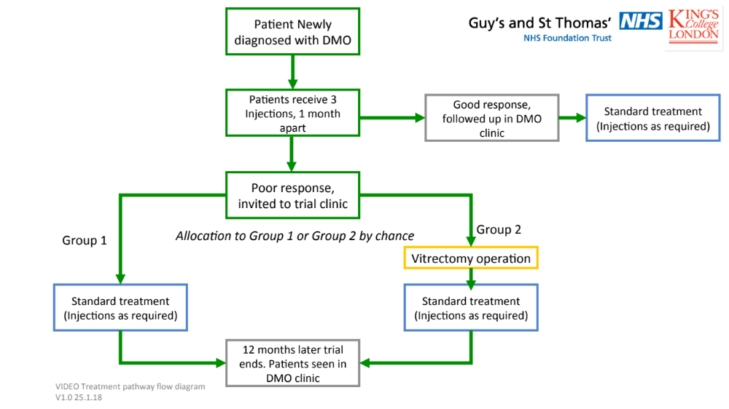

What are the possible disadvantages and risks of taking part?

We are doing this study because we do not know whether Vitrectomy in conjunction with standard care is better or not than the standard care alone in patients such as you.

Vitrectomy

There is evidence that Vitrectomy is beneficial in treating DMO, its benefit when used earlier and in conjunction with injections has not however been proven. The potential benefit is that patients who have a vitrectomy either need fewer injections or end up with better vision than those who have injections alone. This research aims to investigate the role of Vitrectomy more conclusively.

It could however be that Vitrectomy and injections are associated with worse results than injections alone. We do not believe this to be the case but it could be so. This is why a randomised trial is required.

Your vision may be a little blurred for a week or two after the Vitrectomy. It is unusual for there to be any deterioration of vision after that. A small number of patients (about 1 in 30) undergoing a vitrectomy may need a gas bubble in their eye to act as a splint if a hole or tear is found in the retina. This is absorbed by the body typically over two to three weeks. The vision in like looking through water until the gas absorbs.

Vitrectomy can speed up the onset of cataract, which is a very treatable cause of worsening vision. In previous studies very few patients with DMO undergoing vitrectomy developed a cataract that needed surgery. If you develop a cataract that affects your vision after having the vitrectomy we will offer to treat it for you.

A rise in the eye pressure may occur after a vitrectomy. This is usually treatable with drops and usually resolves. There is about a 1:100 chance of needing long term eye pressure treatment.

Retinal detachments is a rare complication of surgery occurring in approximately 1 in 100 cases. This can usually be repaired with a single extra operation.

The serious complication risk is about 1 in 1000 cases, where the eye becomes totally blind due to a bleed during surgery or an infection after surgery. Whilst this is a very real risk the risk from an extra injection is not dissimilar.

Injections

On average patients require between 7 and 9 injections of Anti-VEGF in their first year, however it can be as high as 13.

Intravitreal injections also carry a risk of cataract development and infection. There is a risk of 1:3000 of the eye becoming totally blind from infection after an injection.

There are also risks of bleeding, and retinal tears which may require further treatment or surgery.

Sometimes the eye is red and slightly irritable after the injection.

What are the possible benefits of taking part?

Most studies show that Vitrectomy gives sustained improvement in the amount of DMO, which may be associated with an improvement in vision.

It may be that the group undergoing Vitrectomy require fewer injections than the group having injections alone and this is a potential benefit.

The group undergoing vitrectomy may also have better vision than the other group at the end of the study, which is another potential benefit.

This is what the study hopes to find out.

Your participation will help us understand the value of Vitrectomy for patients with DMO, and the information will be invaluable in helping future management of patients with the same condition.

What treatment would I receive if I do not take part?
If you decide not to take part you will have the option to receive the current standard NHS treatment of clinical assessments, intravitreal injections and surgery as necessary.

What does Vitrectomy involve?

The procedure is commonly performed for lots of different eye conditions. You will be asked to come for a morning or afternoon appointment where the Nurses will ask you some questions and get you changed for the operation.
A local anaesthetic injection is used to numb the eye and keep you comfortable, a sterile drape is then placed loosely over your face to keep everything sterile. The operation takes about 40 minutes, (twice as long as a cataract operation), and carries a similar risk profile. You will need to lie flat for this time.
During the operation you may be aware of some bright lights, the surgeon may talk to you to explain things if you wish.
After the procedure we will give you some drops to take and you return home the same morning or afternoon. There will a plastic shield over your eye that you can remove the following day.
We will see you again in clinic 2 weeks later to check everything is ok.

What do injections involve?

Patients may need to come back every one to three months for repeat injections for several years. The average number of injections is 7-9 in the first year.
The procedure is performed in the treatment room in clinic and you will need to lie flat for approximately 5-10 minutes.
A Nurse will ask you some questions and get you ready for the procedure which involves some eye drops.
The skin around the eye is cleaned and then a small clamp is used to keep the eye open. Additional drops are given to clean the eye and then the medication is injected into the back of the eye.
Sometimes further drops are given to take home.
The eye is sometimes red and irritable after the procedure and you go home the same day. A follow up appointment will be arranged as necessary.

What if there is a problem?
If you have a concern about any aspect of this study, you should ask to speak to the researchers who will do their best to answer your questions.
If you have a concern about any aspect of this study, you should ask to speak to the researchers who will do their best to answer your questions [Matthew Maguire, Matthew.Maguire@gstt.nhs.uk, 020 7188 4885 or 07833 048476]. If you remain unhappy and wish to complain formally, you can do this through the Guy’s and St Thomas’ Patients Advice and Liaison Service (PALS) on 020 7188 8801, pals@gstt.nhs.uk. The PALS team are based in the main entrance on the ground floor at St Thomas’ Hospital and on the ground floor at Guy’s Hospital in the Tower Wing.
In the event that something does go wrong and you are harmed during the research you may have grounds for legal action for compensation against Guy’s and St Thomas’ NHS Foundation Trust and/or King’s College London but you may have to pay your legal costs. The normal National Health Service complaints mechanisms will still be available to you (if appropriate)
If you have a complaint, you should talk to your research doctor who will do their best to answer your questions. If you remain unhappy, you can make a formal complaint through the NHS complaints procedure. Details can be obtained through the Guy’s and St Thomas’ Patient Advisory Liaison Service (PALS) on 0207 1887188, address: PALS, KIC, Ground floor, north wing, St Thomas’ Hospital, Westminster Bridge Road, London, SE1 7EH . This study is insured by Guy’s & St Thomas’ NHS Foundation Trust under the Clinical Negligence Scheme for trials.

What will happen if I don't want to carry on with the study?
You can withdraw at any time and your surgery and follow up will occur as if you were not part of the study.

How will my information be kept confidential?
Your involvement in the study and the information about you that we collect, including your eye test results, will be kept strictly confidential in accordance with the Data Protection Act. Most of it will be derived from your hospital records. Only trained investigators who are required to maintain confidentiality will have access to your information.

What will happen to the results of this study?
When the study is finished we hope to report our findings at research meetings and in scientific journals. No one will be able to identify you from the findings we report as your results will be combined with the results from all of the other patients in the study. We aim to use the results to help in the design of a bigger more conclusive study so we can get a definitive answer in the best way to manage DMO

Who is organising and funding this study?
Mr Laidlaw is organising the study in conjunction with Guys and St. Thomas’s Trust and Kings College London
Funding is provided through Fight for sight

Who has reviewed this study?
The study has been discussed with a panel of leading experts in retinal disease from hospitals across the UK, including the Professor of Ophthalmology at St Thomas’ Hospital.
All research in the NHS is looked at by an independent group of people, called a Research Ethics Committee, to protect your interests. This study has been reviewed and given favourable opinion by London-Brent Research Ethics Committee.

What to expect during the consent process
You will be able to discuss any aspects of the study that you wish with the researchers. You will be asked to sign a consent form that records that you agree to take part in the study.

Involvement of General Practitioner / other healthcare practitioner

Your GP will be informed that you have agreed to take part in this study but they do not have to do anything extra for the study.

Commercial exploitation
There are no plans to commercially exploit the results of this study.

Contact Details

If you have any questions about the study please do not hesitate to contact the lead investigator, Mr Alistair Laidlaw, Consultant Ophthalmic Surgeon.

Address: Department of Ophthalmology, Guy's and St Thomas' NHS Foundation Trust, St Thomas’ Hospital, Westminster Bridge Road, London SE1 7EH.

Tel: 020 7188 4885 or 07833 048476 (mobile)

Email: eyeresearch@gstt.nhs.uk

Supplementary Patient Information Sheet on the use of data
Guy’s and St Thomas’ NHS Foundation Trust is the sponsor for this study based in the United Kingdom. We will be using information from you and/or your medical records in order to undertake this study and will act as the data controller for this study. This means that we are responsible for looking after your information and using it properly. Guy’s and St Thomas’ NHS Foundation Trust will keep identifiable information about you until the end of the study and analysis period.
Your rights to access, change or move your information are limited, as we need to manage your information in specific ways in order for the research to be reliable and accurate. If you withdraw from the study, we will keep the information about you that we have already obtained. To safeguard your rights, we will use the minimum personally-identifiable information possible.
You can find out more about how we use your information https://www.guysandstthomas.nhs.uk/research/patients/about.aspx
Guy’s and St Thomas’ NHS Foundation Trust will collect information from you and/or your medical records for this research study in accordance with our instructions.
Guy’s and St Thomas’ NHS Foundation Trust will use your name, NHS number and contact details to contact you about the research study, and make sure that relevant information about the study is recorded for your care, and to oversee the quality of the study. Individuals from Guy’s and St Thomas’ NHS Foundation Trust and regulatory organisations may look at your medical and research records to check the accuracy of the research study. The only people in Guy’s and St Thomas’ NHS Foundation Trust who will have access to information that identifies you will be people who need to contact you to request additional data or audit the data collection process. The people who analyse the information will not be able to identify you and will not be able to find out your name or contact details.

Thank you for reading this information sheet
and for considering taking part in our study.

