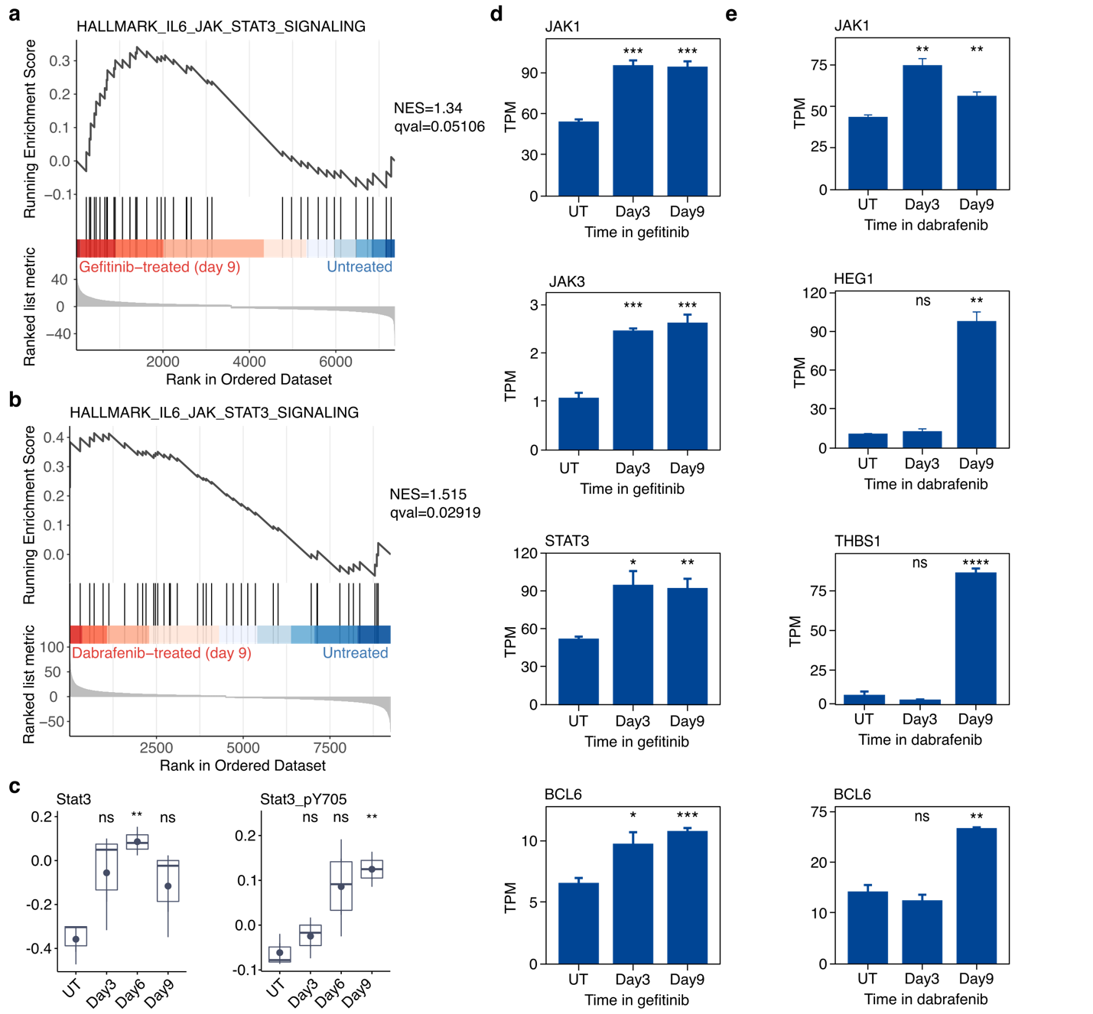

Figure S1. Targeted therapy induces activation of the STAT3 signaling pathway in drug-tolerant cells. a GSEA NES scores indicate the Hallmark gene set “IL6/JAK/STST3 Signaling” is significantly enriched in PC9 cells treated with gefitinib for 9 days, relative to untreated PC9 cells. b GSEA NES scores indicate the Hallmark gene set “IL6/JAK/STST3 Signaling” is significantly enriched in SKMEL28 cells treated with dabrafenib for 9 days, relative to untreated SKMEL28 cells. c RPPA quantification of proteins and phospho-proteins associated with STAT3 signaling, including STAT3, and phospho-STAT3 (Y705), from PC9 cells in gefitinib for 0, 3, 6, or 9 days. d,e Normalized transcript abundance levels of several genes associated with IGF signaling including JAK1, JAK3, STAT3, and BCL6 in PC9 cells in gefitinib (d) or SKMEL28 cells in dabrafenib (e) for 0 (UT), 3, or 9 days. d,e Data are represented as the mean + SEM (n = 3). Two-tailed Student’s t test were used for comparisons between two groups (untreated vs time point) for statistical analyses. *P < 0.05, **P < 0.01, ***P < 0.001, ****P < 0.0001, ns = P > 0.05.

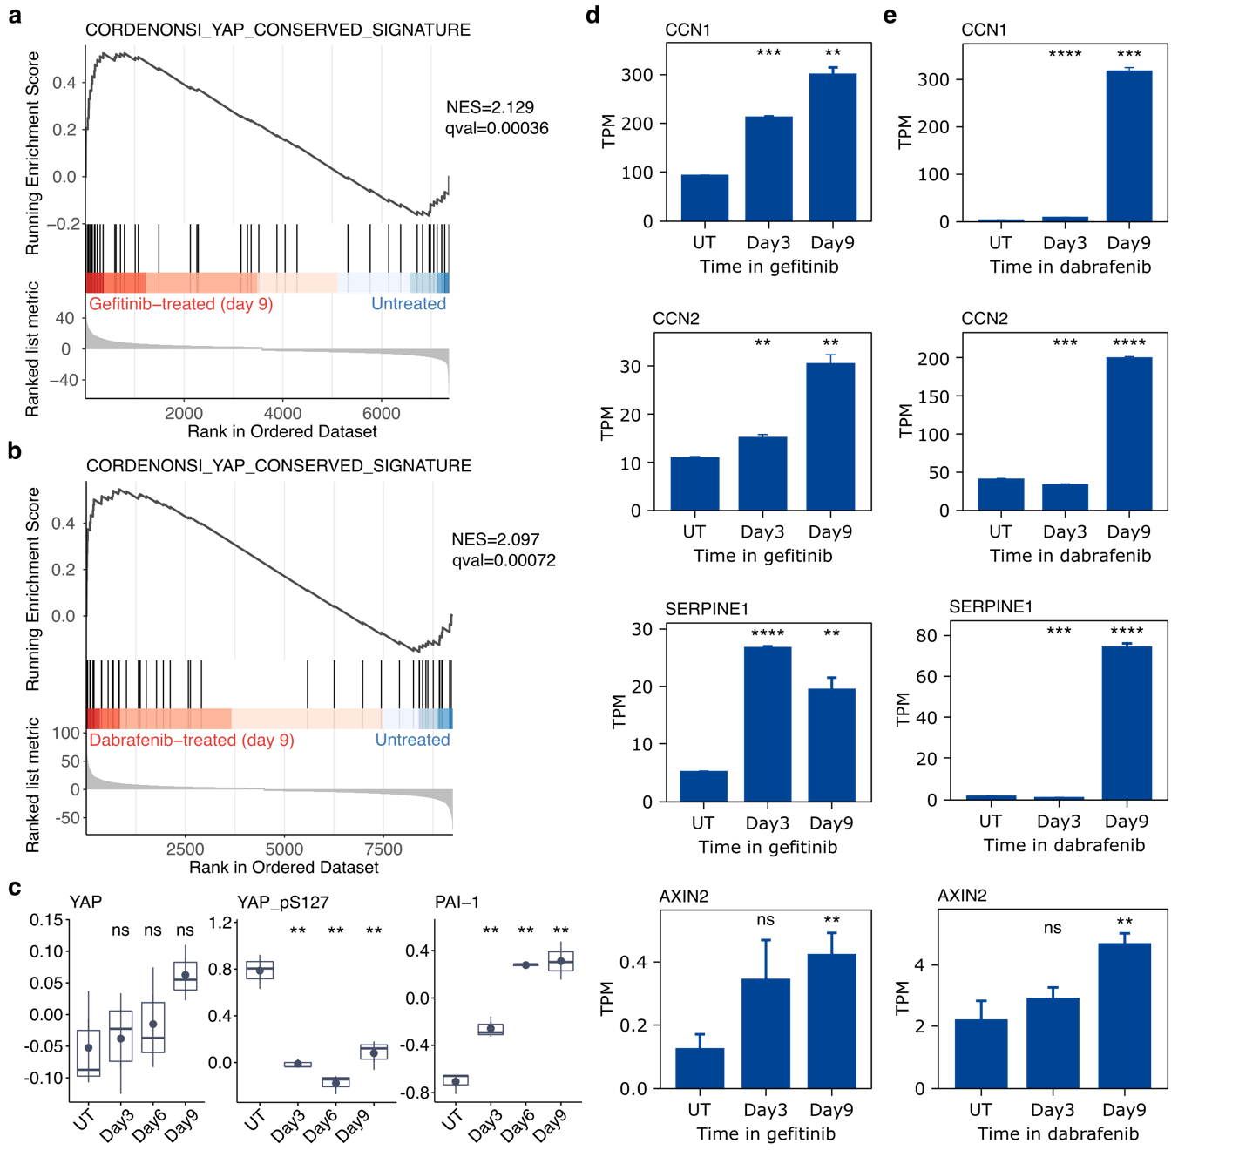

Figure S2. Targeted therapy induces activation of the YAP pathway in drug-tolerant cells. a GSEA NES scores indicate the gene set “YAP Conserved Signature” is significantly enriched in PC9 cells treated with gefitinib for 9 days, relative to untreated PC9 cells. b GSEA NES scores indicate the gene set “YAP Conserved Signature” is significantly enriched in SKMEL28 cells treated with dabrafenib for 9 days, relative to untreated SKMEL28 cells. c RPPA quantification of proteins and phospho-proteins associated with YAP signaling, including YAP, phospho-YAP (S127), and PAI1, from PC9 cells in gefitinib for 0, 3, 6, or 9 days. d,e Normalized transcript abundance levels of several genes associated with YAP signaling including CCN1, CCN2, SERPINE1, and AXIN2 in PC9 cells in gefitinib (d) or SKMEL28 cells in dabrafenib (e) for 0 (UT), 3, or 9 days. d,e Data are represented as the mean + SEM (n = 3). Two-tailed Student’s t test were used for comparisons between two groups (untreated vs time point) for statistical analyses. *P < 0.05, **P < 0.01, ***P < 0.001, ****P < 0.0001, ns = P > 0.05.

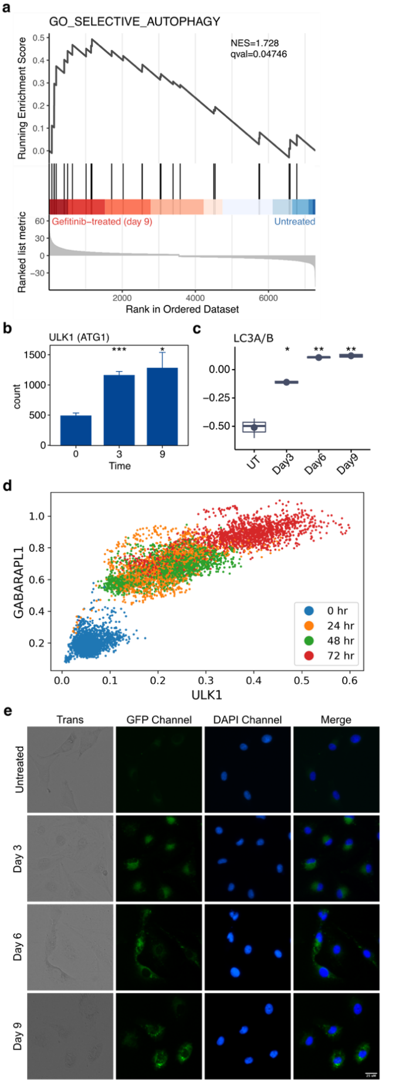
Figure S3. Increased autophagic flux accompanies the emergence of drug tolerance. a GSEA plot reveals the GO gene set “Selective Autophagy” is significantly enriched in PC9 cells treated with gefitinib for 9 days, relative to untreated PC9 cells. b Normalized transcript abundance of ULK1 in PC9 cells treated with gefitinib for 0, 3, or 9 days. c RPPA quantification LC3A/B, from PC9 cells in gefitinib for 0, 3, 6, or 9 days. d Gene-gene relationship of ULK1 and GABARAPL1 from MAGIC imputation analysis performed on scRNA-seq of PC9 cells in gefitinib for 0, 24, 48, or 72 hours. e Autophagy flux in PC9 cells in gefitinib for 0, 3, 6, or 9 days, visualized via CYTO-ID staining. b Data are represented as the mean + SEM (n = 3). Two-tailed Student’s t test were used for comparisons between two groups (untreated vs time point) for statistical analyses. *P < 0.05, **P < 0.01, ***P < 0.001, ****P < 0.0001, ns = P > 0.05.

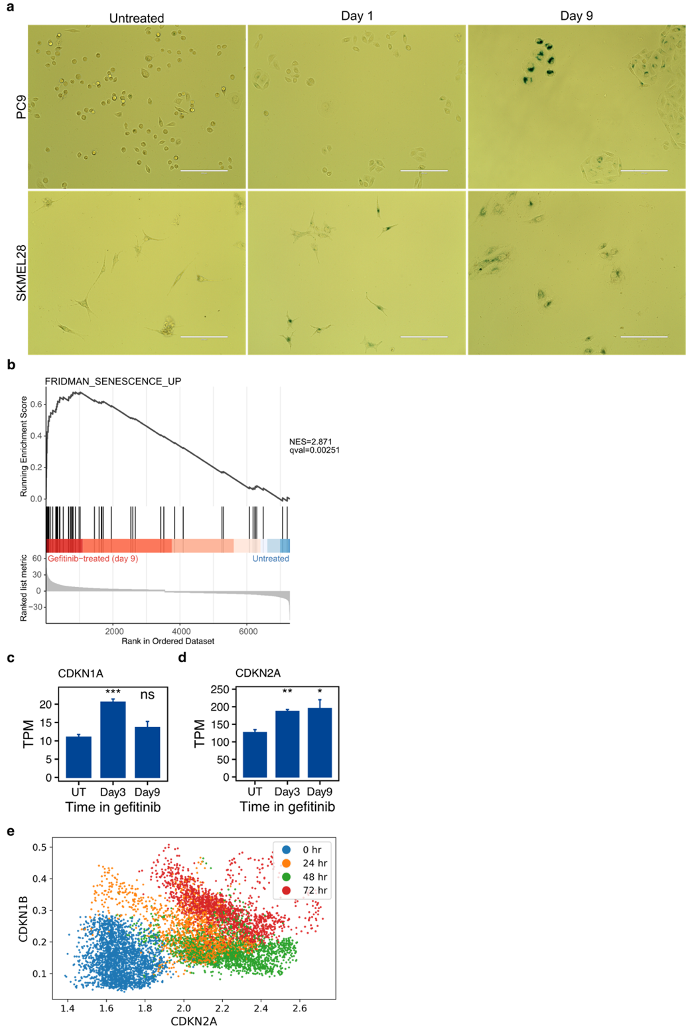

Figure S4. Features of cellular senescence accompany the emergence of drug tolerance. a Brightfield images of PC9 cells (top) and SKMEL28 cells (bottom) cultured in targeted therapy for the indicated time and subsequently for stained SA-β-gal activity. The scale bar in each image corresponds to 200 μm. b GSEA plot showing the relative enrichment of the “Fridman Senescence Up” gene set in gefitinib-treated PC9 cells. c,d Normalized transcript abundance of CDKN1A (c) and CDKN2A (d) in PC9 cells treated with gefitinib for 0, 3, or 9 days. e Gene-gene relationship of CDKN2A and CDKN1B from MAGIC imputation analysis performed on scRNA-seq of PC9 cells in gefitinib for 0, 24, 48, or 72 hours. c,d Data are represented as the mean + SEM (n = 3). Two-tailed Student’s t test were used for comparisons between two groups (untreated vs time point) for statistical analyses. *P < 0.05, **P < 0.01, ***P < 0.001, ****P < 0.0001, ns = P > 0.05.

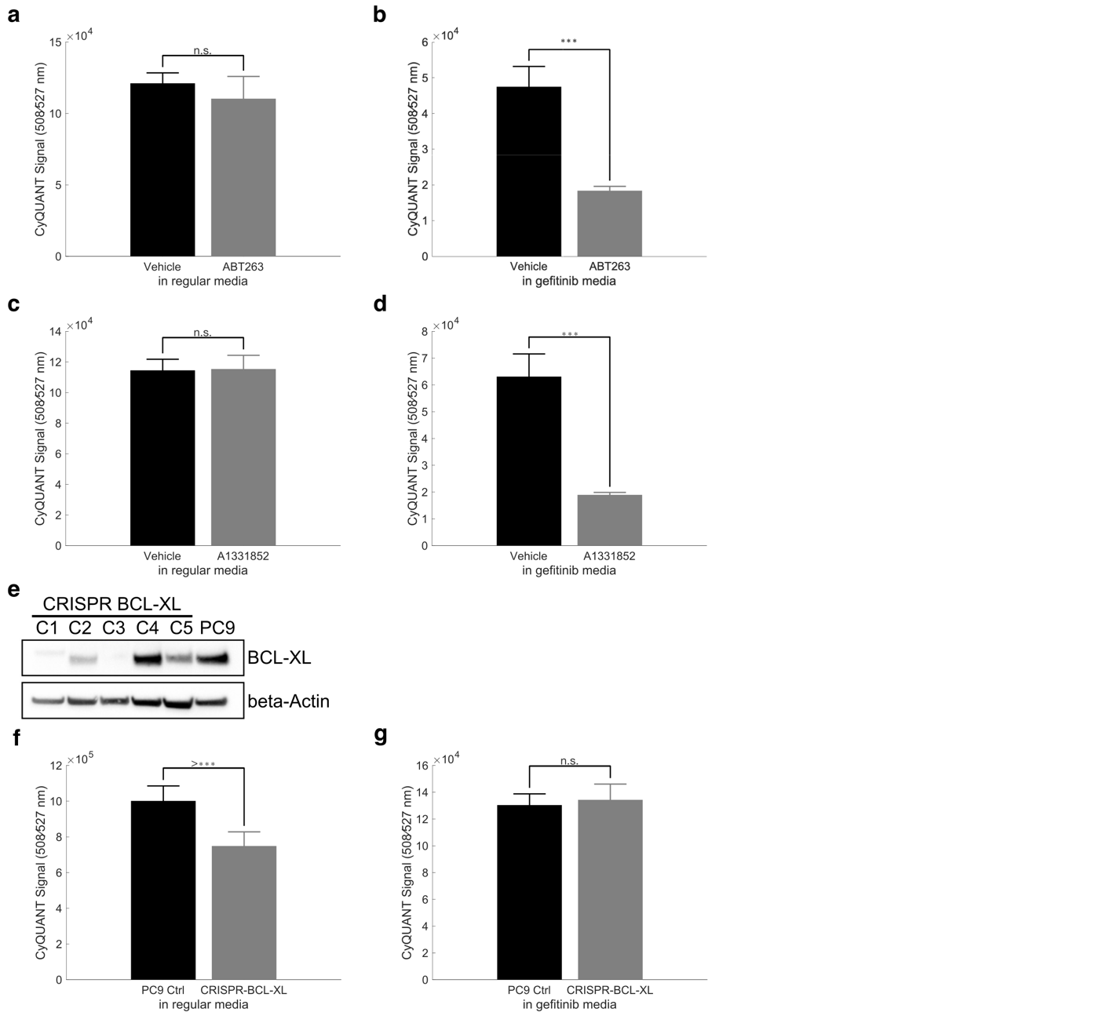

Figure S5. Pharmacologic, but not genetic disruption of senescence-associated factors results in increased gefitinib killing. a Quantification of PC9 cells in normal media or gefitinib media treated with vehicle (DMSO) or Navitoclax (ABT-263. b Quantification of PC9 cells in normal media or gefitinib media treated with DMSO or A1331852. a,b Data are represented as the mean + SD (n = 3). Two-tailed Student’s t test were used for comparisons between two groups for statistical analyses. *P < 0.05, **P < 0.01, ***P < 0.001, ****P < 0.0001, ns = P > 0.05. c Western blot analysis of BCL-XL protein from parental PC9 cells or clonal populations (C1-C5) of CRISPR-BCL-XL PC9 cells, with beta-actin serving as a loading control. d Quantification of parental PC9 cells and CRISPR-BCL-XL PC9 cells (Clone 3) in normal media and gefitinib media. Data are represented as the mean + SD (n = 8). Two-tailed Student’s t test were used for comparisons between two groups for statistical analyses. *P < 0.05, **P < 0.01, ***P < 0.001, ****P < 0.0001, ns = P > 0.05.

