Incompatible insect technique mass rearing infrastructure cost calculator for the control of Culex quinquefasciatus in Hawaiʻi

Adam E. Vorsino¹*, Zhiyong Xi²

¹Strategic Habitat Conservation Program, Ecological Services, Pacific Islands Fish and Wildlife Office, U.S. Fish and Wildlife Service, 300 Ala Moana Blvd Ste. 3-122, Honolulu, Hawaiʻi 96850

²Department of Microbiology and Molecular Genetics, Michigan State University, 314 Giltner Hall, 293 Farm Lane, East Lansing, Michigan 48824

*Corresponding author: Adam_Vorsino@fws.gov

AEV: Adam_Vorsino@fws.gov
ZX: xizy@msu.edu

Supplemental Materials Section 2: Quotes used to derive facility per meter cost estimate
The following quotes were derived from the Federal GSA advantage website. Each of the three quotes were converted from square foot to meters squared, and the median of all three was used to estimate the cost of an 800m² modular facility. An 800m² facility is assumed to be large enough for rearing approx. 1.5 million IIT/SIT male Culicid. It has been recommended that at minimum the facility size should be optimized to rear at least 500k - 1 million IIT/SIT male Culicid (Dr. Zhiyong Xi, pers. comm) as cost savings are insignificant (and may be detrimental to the process) below that level. The maximum recommended size of a facility necessary to rear at least 500k - 1 million IIT/SIT male Culicid is 300-500m² (Dr. Zhiyong Xi, pers. comm).
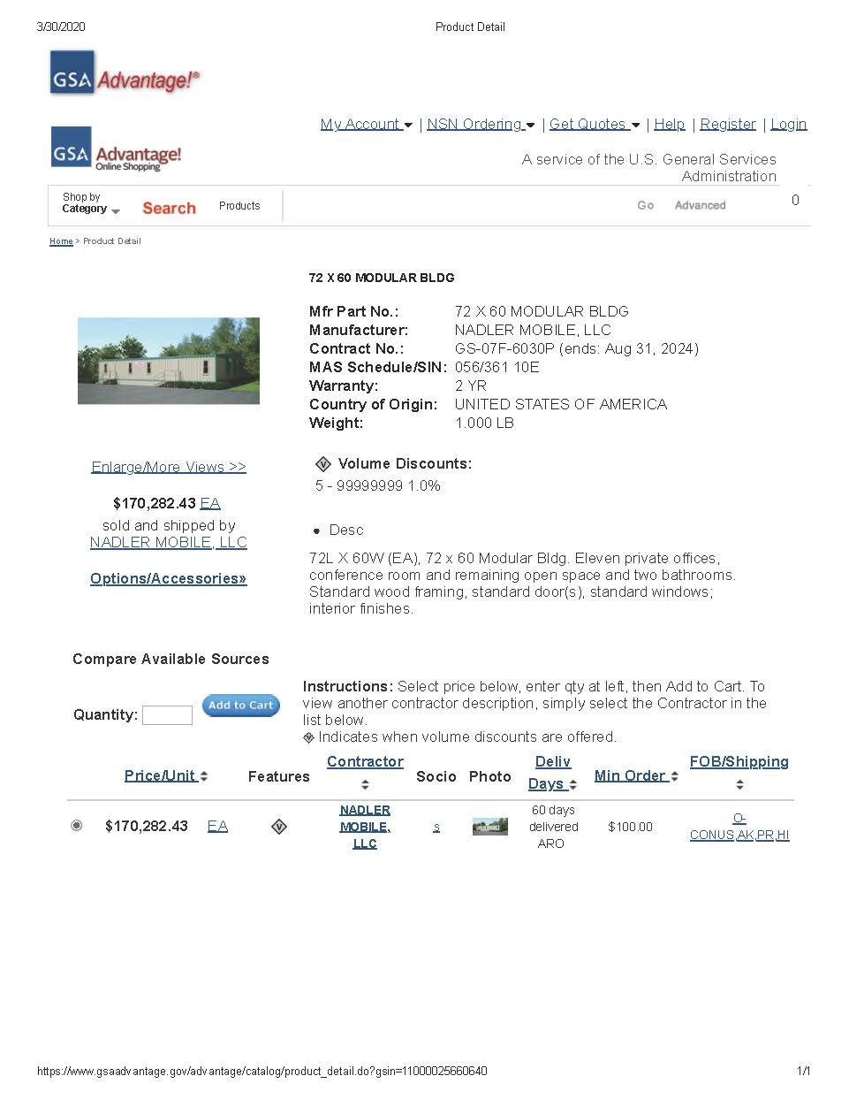
Figure 1: Modular office quote 1.
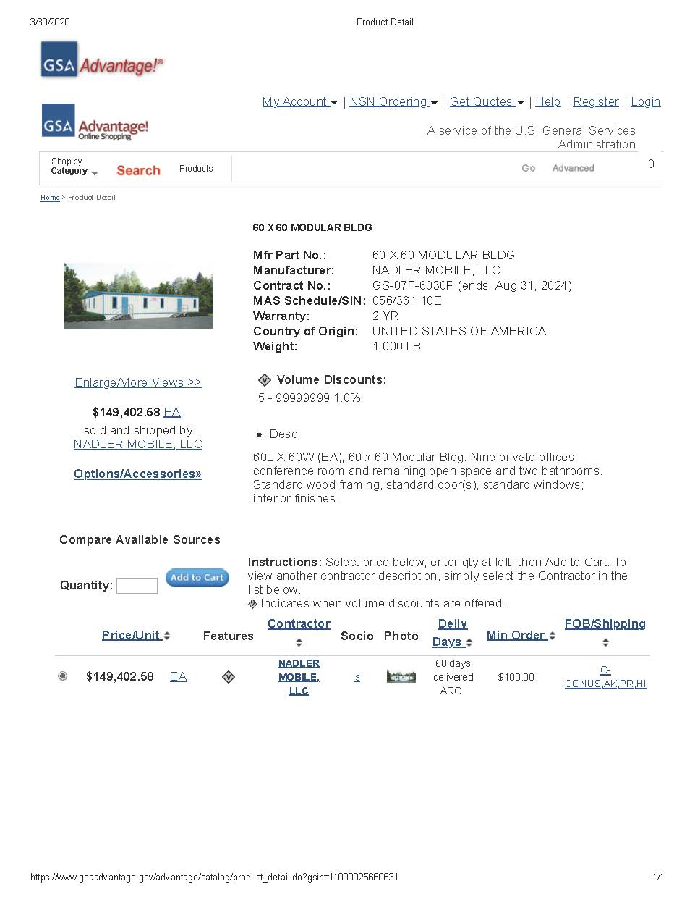
Figure 2: Modular office quote 2.
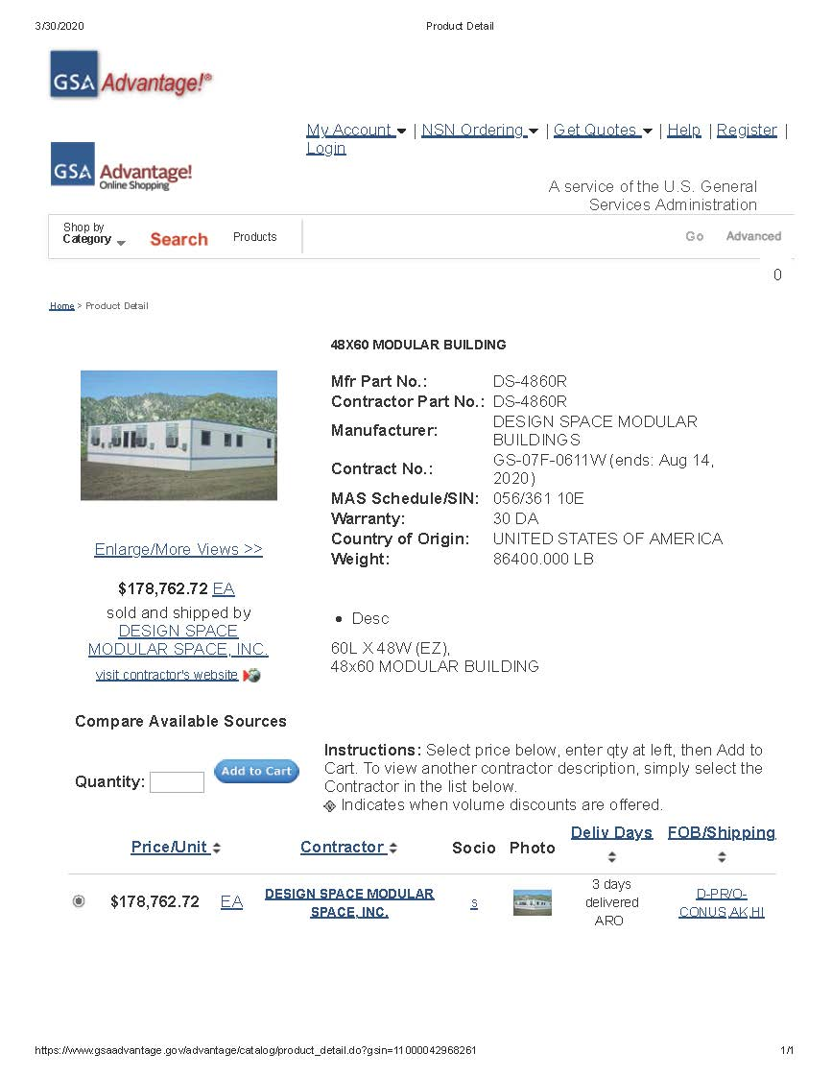
Figure 3: Modular office quote 3.

