Supplementary Data

Advancing small-animal perfusion models: Normothermic dual-vessel ex vivo rat liver machine perfusion based on a clinical setup

Authors
Felix Strobl¹, MD; Julian Michelotto¹; Vanessa Muth¹; Simon Moosburner^{1,2}, MD; Kristina Knaub¹; Maximilian Zimmer¹; Johann Pratschke¹; MD, Igor M. Sauer¹, MD; Nathanael Raschzok, MD*^{1,2}; Joseph M.G.V. Gassner^{1,2}, MD

 | E0|G- | E250|G- | E1000|G- | E2000|G- | E0|G+ | E250|G+ | E1000|G+ | E2000|G+ | Steen Solution | p-Value
Animal weight [g] | 306 ± 18.5 | 288 ± 10.4 | 308 ± 10.6 | 297 ± 4.0 | 332 ± 8.2 | 300 ± 20.3 | 289 ± 15.3 | 302 ± 18.0 | 305 ± 17.3 | 0.5134
Liver weight [g] | 13.8 ± 0.5 | 13.0 ± 0.3 | 13.6 ± 0.5 | 12.5 ± 0.3 | 13.5 ± 0.6 | 12.2 ± 0.8 | 12.0 ± 0.9 | 12.6 ± 0.9 | 12.5 ± 0.7 | 0.3775
Cold Ischemia [min] | 77.3 ± 4.6 | 77.3 ± 3.3 | 66.5 ± 4.6 | 72.8 ± 5.4 | 66.0 ± 2.5 | 71.3 ± 1.8 | 68.0 ± 1.6 | 64.8 ± 3.3 | 72.3 ± 1.0 | 0.1179
ALT [U/l]  T0  T3  T6 | 48.0 ± 8.1  221.8 ± 27.4  1258 ± 357.2 | 40.0 ± 2.9  162.3 ± 32.0  588.3 ± 195.9 | 22.5 ± 6.9  119.8 ± 35.5  787.5 ± 163.8 | 31.8 ± 9.9  79.5 ± 15.8  175.5 ± 48.6 | 42.3 ± 3.2  110.0 ± 21.8  577.5 ± 141.9 | 26.3 ± 4.1  102.8 ± 12.1  399.5± 103.6 | 28.0 ± 4.8  75.0 ± 8.3  245.5 ± 25.8 | 28.0 ± 4.8  78.5 ± 16.8  265.5 ± 32.7 | 16.3 ± 3.1  38.0 ± 4.3  127 ± 15.4 | 0.026  0.008  0.002
AST [U/l]  T0  T3  T6 | 95.0 ± 18.1  501.0 ± 29.3  2607.0 ± 572.3 | 96.3 ± 12.7  473.8 ± 64.9  1582.3 ± 269.9 | 54.8 ± 9.6  362.5 ± 52.9  2088.5 ± 177.8 | 65.6 ± 18.2  237.8 ± 27.9  937.3 ± 239.8 | 97.0 ± 8.6  297.5 ± 35.7  1549.0 ± 247.5 | 60.0 ± 7.2  231.5± 10.6  953.3 ± 130.7 | 72.8 ± 13.0  204.0 ± 16.2  962.8 ± 118.9 | 58.0 ± 11.2  190.8 ± 36.0  875.5 ± 118.1 | 38.3 ± 6.3  113.3± 15.3  435.8 ± 61.1 | 0.027  <0.001  0.002
LDH [U/l]  T0  T3  T6 | 812.8 ± 202.1  5164.8 ± 337.6  19601.8 ± 3130.1 | 1023.3 ± 164.1  5279.3 ± 587.1  15965.3 ± 2432.0 | 445.0 ± 77.3  3883.8 ± 592.7  19632.8 ± 2380.8 | 529.5 ± 148.2  2707.0 ± 353.6  9652.8 ± 3045.1 | 928.3 ± 127.9  3926.6 ± 411.5  13233.0 ± 2596.4 | 593.0 ± 43.6  3394.3 ± 215.4  9778.0 ± 1298.2 | 728.3 ± 100.6  3302.3 ± 328.6  8953.5 ± 836.6 | 518.5 ± 83.6  2774.8 ± 317.3  8976.3 ± 1158.1 | 335.8 ± 39.4  1306.0 ± 168.9  4368.0 ± 492.5 | 0.020  0.002  0.003
Lactate [mmol/l]  T0  T3  T6 | 3.11 ± 0.16  3.97 ± 0.54  3.16 ± 0.58 | 3.86 ± 0.45  4.91 ± 0.24  4.27 ± 0.79 | 3.61 ± 0.26  4.39 ± 0.50  3.25 ± 0.45 | 3.41 ± 0.11  3.96 ± 0.47  3.55 ± 0.61 | 3.08 ± 7.0  4.00 ± 1.9  2.94 ± 1.4 | 3.03 ± 0.22  2.44 ± 0.43  1.86 ± 0.42 | 3.52 ± 0.43  3.97 ± 0.54  3.16 ± 0.58 | 3.47 ± 0.38  3.44 ± 0.51  2.28 ± 0.52 | 3.80 ± 0.16  4.88 ± 0.87  3.77 ± 0.60 | 0.4  0.065  0.13
Lactate total [mg]  T0  T6 | 250.3 ± 54.6  748.0 ± 196.0 | 342.4 ± 52.8  1463.0 ± 304.8 | 247.5 ± 24.1  903.4 ± 141.3 | 292.9 ± 37.3  1097.3 ± 337.2 | 166.4 ± 34.2  640.8 ± 67.5 | 339.6 ± 52.7  1091.8 ± 209.0 | 246.1 ± 19.4  587.1 ± 73.9 | 240.6 ± 18.3  607.8 ± 127.2 | 28.6 ± 52.3  853.9 ± 170.9 | 0.2  0.095
Glucose [mmol/l]  T0  T3  T6 | 13.9 ± 0.6  8.9 ± 1.0  6.0 ± 0.7 | 15.9 ± 0.4  11.6 ± 0.4  7.9 ± 0.3 | 15.2 ± 1.1  11.4 ± 1.0  8.7 ± 1.2 | 16.6 ± 1.1  10.4 ± 1.7  7.8 ± 0.6 | 18.4 ± 1.2  10.5 ± 0.3  7.7 ± 0.2 | 15.0 ± 1.6  7.4 ± 0.4  5.5 ± 0.2 | 13.8 ± 1.6  8.9 ± 1.0  6.0 ± 0.7 | 15.8 ± 1.4  9.3 ± 1.7  6.8 ± 0.6 | 14.6 ± 0.5  10.4 ± 0.4  7.8 ± 0.7 | 0.2  0.073  0.046
Urea [mg/dl]  T0  T3  T6 | 14 ± 0.6  18 ± 2.3  19 ± 1.8 | 15 ± 1.3  14 ± 0.9  15 ± 0.9 | 14 ± 2.3  16 ± 1.6  19 ± 0.6 | 14 ± 0.5  12 ± 0.6  15 ± 0.8 | 17 ± 0.4  26 ± 2.3  31 ± 0.9 | 11 ± 1.5  24 ± 1.1  26 ± 3.0 | 15 ± 1.4  24 ± 1.4  28 ± 2.1 | 15 ± 0.5  30 ± 0.6  31 ± 0.8 | 11 ± 1.1  24 ± 1.4  25 ± 1.2 | 0.1  0.001  <0.001
Bile production [mg/g liverweight]  T1  T2  T3  T4  T5  T6 | 50.2 ± 2.9  75.0 ± 12.3  47.4 ± 11.2  25.2 ± 7.7  11.4 ± 4.2  6.6 ± 2.1 | 57.6 ± 12.6  70.4 ± 6.9  57.5 ± 7.6  37.6 ± 9.2  30.4 ± 12.5  22.3 ± 11.9 | 68.6 ± 5.8  94.3 ± 5.7  67.5 ± 3.8  38.7 ± 3.2  29.3 ± 3.5  27.9 ± 3.6 | 81.8 ± 9.6  101.1 ± 3.4  85.1 ± 5.6  65.5 ± 7.7  60.5 ± 5.3  54.4 ± 4.7 | 52.5 ± 4.0  76.7± 2.3  61.4 ± 1.0  51.6 ± 2.4  47.8 ± 2.7  42.6 ± 4.0 | 55.4 ± 10.7  88.0 ± 8.4  68.0 ± 4.9  52.8 ± 6.0  38.4 ± 9.1  23.6 ± 8.9 | 67.2 ± 9.0  90.5 ± 4.9  78.2 ± 7.4  65.5 ± 5.8  52.6 ± 9.2  40.7 ± 12.5 | 72.2 ± 10.0  93.9 ± 5.8  72.7 ± 4.0  68.0 ± 4.9  65.7 ± 7.0  56.0 ± 5.8 | 49.9 ± 5.9  70.1 ± 5.0  68.0 ± 5.3  53.2 ± 5.9  52.8 ± 4.3  49.6 ± 3.9 | 0.13  0.022  0.044  0.005  0.008  0.008
HOUR [ml/min/g]  T0  T3  T6 | 0.04 ± 0.003  0.04 ± 0.003  0.03 ± 0.002 | 0.05 ± 0.003  0.05 ± 0.003  0.03 ± 0.004 | 0.04 ± 0.002  0.04 ± 0.003  0.02 ± 0.002 | 0.06 ± 0.005  0.04 ± 0.005  0.04 ± 0.006 | 0.05 ± 0.007  0.04 ± 0.002  0.03 ± 0.004 | 0.05 ± 0.007  0.05 ± 0.004  0.03 ± 0.004 | 0.05 ± 0.001  0.04 ± 0.002  0.03 ± 0.002 | 0.05 ± 0.007  0.04 ± 0.005  0.03 ± 0.004 | 0.06  0.05  0.04 ± 0.005 | 0.2  0.3  0.018
Hepatic arterial pressure [mmHg]  T1  T2  T3  T4  T5  T6 | 114.3 ± 37.8  125.9 ± 41.7  131.5 ± 39.1  150.6 ± 35.1  154.8 ± 35.4  158.8 ± 35.9 | 64.8 ± 2.8  51.6 ± 2.8  52.9 ± 2.2  64.1 ± 8.3  83.3 ± 22.5  132.0 ± 21.1 | 44.3 ± 2.7  41.8 ± 3.5  41.1 ± 3.4  42.9 ± 4.0  43.9 ± 5.0  46.8 ± 6.3 | 57.0 ± 1.5  52.1 ± 2.4  51.2 ± 2.5  52.4 ± 2.9  56.0 ± 5.2  74.8 ± 19.3 | 137.5 ± 18.4  127,8 ± 23.4  114.2 ± 27.6  121.7 ± 27.3  137.3 ± 32.8  146.6 ± 30.8 | 73.7 ± 12.8  95.9 ± 18.8  131.8 ± 34.4  161.3± 31.2  150.6± 27.5  173.0± 23.7 | 67.1 ± 10.3  61.4 ± 9.1  64.4 ± 8.8  74.8 ± 9.7  101.5 ± 23.3  139.8 ± 20.1 | 75.6 ± 15.5  72.6 ± 18.7  71.6 ± 16.8  69.0 ± 13.4  66.1 ± 10.2  67.3 ± 8.9 | 48.1 ± 4.5  48.6 ± 4.7  50.3 ± 4.3  53.3 ± 3.7  57.2 ± 4.9  75.1 ± 18.9 | 0.025  0.029  0.011  0.007  0.005  0.007
Portal venous pressure [mmHg]  T1  T2  T3  T4  T5  T6 | 7.2 ± 0.4  7.6 ± 0.5  7.9 ± 0.4  9.1 ± 1.0  8.9 ± 1.2  8.7 ± 1.2 | 6.7 ± 0.5  7.1 ± 1.1  6.5 ± 0.5  7.5 ± 0.9  6.6 ± 0.7  6.1 ± 0.5 | 5.5 ± 0.3  5.2 ± 0.2  5.0 ± 0.3  6.7 ± 0.7  6.7 ± 0.6  6.1 ± 0.5 | 5.6 ± 0.9  5.7 ± 0.9  5.6 ± 0.9  6.0 ± 1.1  5.7 ± 1.0  5.6 ± 1.0 | 6.3 ± 0.5  6.3 ± 0.5  6.3 ± 0.3  6.6 ± 0.3  6.5 ± 0.3  6.2 ± 0.3 | 5.1 ± 0.2  4.6 ± 0.2  5.0 ± 0.4  5.1 ± 0.3  4.8 ± 0.5  5.0 ± 0.6 | 5.7 ± 0.2  5.1 ± 0.2  5.4 ± 0.4  5.3 ± 0.3  5.1 ± 0.3  5.0 ± 0.3 | 8.0 ± 2.6  7.8 ± 2.7  7.9 ± 2.7  7.6 ± 2.5  7.5 ± 2.6  7.6 ± 2.5 | 3.1 ± 0.1  3.2 ± 0.2  3.3 ± 0.4  3.6 ± 0.5  3.6 ± 0.3  3.4 ± 0.3 | 0.020  0.015  0.014  0.020  0.029  0.034
pH-value  T0  T3  T6 | 7.56 ± 0.04  7.44 ± 0.04  7.60 ± 0.03 | 7.36 ± 0.05  7.27 ± 0.02  7.39 ± 0.01 | 7.46 ± 0.05  7.31 ± 0.03  7.42 ± 0.05 | 7.29 ± 0.05  7.44 ± 0.04  7.39 ± 0.04 | 7.50 ± 0.04  7.37 ± 0.04  7.41 ± 0.04 | 7.43 ± 0.02  7.37 ± 0.04  7.45 ± 0.04 | 7.48 ± 0.03  7.41 ± 0.02  7.52 ± 0.03 | 7.53 ± 0.05  7.44 ± 0.04  7.45 ± 0.02 | 7.63 ± 0.03  7.39 ± 0.05  7.50 ± 0.05 | 0.003  0.066  0.035
Hematocrit [%]  T0  T3  T6 | 14.1 ± 1.3  13.9 ± 0.9  10.9 ± 1.7 | 15.9 ± 1.4  16.9 ± 1.5  14.6 ± 2.3 | 13.5 ± 0.9  12.3 ± 0.9  10.0 ± 0.5 | 14.3 ± 0.8  13.6 ± 0.7  13.5 ± 0.7 | 13.7 ± 0.6  12.9 ± 0.6  12.5 ± 0.3 | 14.2 ± 1.1  13.9 ± 0.7  12.6 ± 1.2 | 14.6 ± 0.4  13.6 ± 0.8  12.8 ± 0.5 | 14.9 ± 0.1  13.6 ± 0.1  13.5 ± 0.7 | 14.1 ± 0.8  12.7 ± 1.7  11.7 ± 1.4 | 0.7  0.3  0.2
Sodium [mmol/l]  T0  T3  T6 | 141 ± 0.6  139 ± 1.6  139 ± 0.6 | 141 ± 1.8  137 ± 1.0  137 ± 2.1 | 138 ± 1.1  138 ± 1.3  140 ± 0.6 | 138 ± 0.4  138 ± 0.5  137 ± 1.0 | 139 ± 1.3  138 ± 1.1  137 ± 0.8 | 139 ± 2.1  137 ± 0.5  137 ± 0.3 | 140 ± 1.7  138 ± 1.3  138 ± 1.1 | 142 ± 1.5  139 ± 0.9  137 ± 1.3 | 140 ± 0.6  140 ± 0.5  138 ± 1.3 | 0.4  0.5  0.4
Potassium [mmol/l]  T0  T3  T6 | 5.2 ± 0.22  3.9 ± 0.09  4.4 ± 0.13 | 4.6 ± 0.48  3.7 ± 0.11  4.2 ± 0.07 | 5.4 ± 0.20  3.6 ± 0.10  4.3 ± 0.15 | 5.6 ± 0.19  3.9 ± 0.34  3.9 ± 0.29 | 4.3 ± 0.35  4.0 ± 0.01  4.1 ± 0.01 | 5.8 ± 0.53  3.7 ± 0.17  4.2± 0.17 | 4.9 ± 0.12  3.4 ± 0.07  3.9 ± 0.12 | 5.4 ± 0.19  3.6 ± 0.33  3.6 ± 0.08 | 5.5 ± 0.19  3.3 ± 0.09  3.6 ± 0.21 | 0.055  0.044  0.030
Calcium_{ion} [mmol/l]  T0  T3  T6 | 1.17 ± 0.01  1.17 ± 0.03  1.12 ± 0.02 | 1.16 ± 0.03  1.15 ± 0.03  1.14 ± 0.03 | 1.16 ± 0.07  1.12 ± 0.02  1.14 ± 0.03 | 1.13 ± 0.05  1.21 ± 0.02  1.15 ± 0.01 | 1.14 ± 0.02  1.12 ± 0.02  1.12 ± 0.01 | 1.11 ± 0.01  1.13 ± 0.01  1.12 ± 0.01 | 1.16 ± 0.01  1.19 ± 0.03  1.17 ± 0.04 | 1.13 ± 0.05  1.21 ± 0.02  1.15 ± 0.01 | 0.99 ± 0.06  1.20 ± 0.02  1.15 ± 0.02 | 0.089  0.2  0.3
Chloride [mmol/l]  T0  T3  T6 | 111 ± 1.8  107 ± 1.1  108 ± 0.6 | 109 ± 1.1  107 ± 0.6  106 ± 0.9 | 115 ± 1.8  108 ± 1.3  107 ± 0.5 | 112 ± 0.9  107 ± 0.4  108 ± 1.3 | 109 ± 0.6  104 ± 0.5  105 ± 0.4 | 111 ± 2.0  109 ± 2.0  109 ± 1.2 | 111 ± 1.1  109 ± 0.6  108 ± 0.5 | 112 ± 0.9  107 ± 0.4  108 ± 1.0 | 110 ± 1.3  106 ± 0.9  110 ± 1.2 | 0.14  0.073  0.050
8-Isoprostane [pg/µg protein] | 0.236 ± 0.025 | 0.226 ± 0.016 | 0.265 ± 0.011 | 0.141 ± 0.019 | 0.160 ± 0.028 | 0.347 ± 0.024 | 0.297 ± 0.022 | 0.152 ± 0.022 | 0.123 ± 0.013 | <0.0001
Interleukin 1β [pg/µg protein] | 0.729 ± 0.101 |  |  | 1.099 ± 0.124 | 1.006 ± 0.187 |  |  | 1.435 ± 0.142 | 0.933 ± 0.044 | 0.0163
Interleukin 6 [pg/µg protein] | 4.683 ± 0.540 |  |  | 4.030 ± 0.434 | 3.855 ± 0.413 |  |  | 3.184 ± 0.659 | 2.906 ± 0.711 | 0.2710
Interleukin 10 [pg/µg protein] | 0.674 ± 0.074 |  |  | 0.538 ± 0.048 | 0.745 ± 0.032 |  |  | 0.578 ± 0.055 | 0.604 ± 0.088 | 0.0789
TNFα [pg/µg protein] | 0.016 ± 0.002 |  |  | 0.016 ± 0.003 | 0.013 ± 0.003 |  |  | 0.012 ± 0.003 | 0.010 ± 0.002 | 0.5867
Supplementary Table 1 – All groups were performed at n = 4. All data is presented as Mean ± SEM. Statistical analysis was performed using Kruskal-Wallis test.

 | DMEM + Plasma  (E2000|G+) | Steen Solution | p-Value
ALT [U/l]  T0  T3  T6 | 28.0 ± 4.8  78.5 ± 16.8  265.5 ± 32.7 | 16.3 ± 3.1  38.0 ± 4.3  127 ± 15.4 | 0.1297  0.0586  0.0086
AST [U/l]  T0  T3  T6 | 58.0 ± 11.2  190.8 ± 36.0  875.5 ± 118.1 | 38.3 ± 6.3  113.3± 15.3  435.8 ± 61.1 | 0.1744  0.0947  0.0158
LDH [U/l]  T0  T3  T6 | 518.5 ± 83.6  2774.8 ± 317.3  8976.3 ± 1158.1 | 335.8 ± 39.4  1306.0 ± 168.9  4368.0 ± 492.5 | 0.0954  0.0064  0.0106
Bile production [mg/g liverweight]  T1  T2  T3  T4  T5  T6 | 72.2 ± 10.0  93.9 ± 5.8  72.7 ± 4.0  68.0 ± 4.9  65.7 ± 7.0  56.0 ± 5.8 | 49.9 ± 5.9  70.1 ± 5.0  68.0 ± 5.3  53.2 ± 5.9  52.8 ± 4.3  49.6 ± 3.9 | 0.1033  0.0208  0.5116  0.1051  0.1665  0.3982
Hepatic arterial pressure [mmHg]  T1  T2  T3  T4  T5  T6 | 75.6 ± 15.5  72.6 ± 18.7  71.6 ± 16.8  69.0 ± 13.4  66.1 ± 10.2  67.3 ± 8.9 | 48.1 ± 4.5  48.6 ± 4.7  50.3 ± 4.3  53.3 ± 3.7  57.2 ± 4.9  75.1 ± 18.9 | 0.1384  0.2591  0.2670  0.3008  0.4646  0.7229
Portal venous pressure [mmHg]  T1  T2  T3  T4  T5  T6 | 8.0 ± 2.6  7.8 ± 2.7  7.9 ± 2.7  7.6 ± 2.5  7.5 ± 2.6  7.6 ± 2.5 | 3.1 ± 0.1  3.2 ± 0.2  3.3 ± 0.4  3.6 ± 0.5  3.6 ± 0.3  3.4 ± 0.3 | 0.1093  0.1455  0.1437  0.1701  0.1789  0.1493
pH-value  T0  T3  T6 | 7.53 ± 0.05  7.44 ± 0.04  7.45 ± 0.02 | 7.63 ± 0.03  7.39 ± 0.05  7.50 ± 0.05 | 0.1179  0.5141  0.3686
8-Isoprostane [pg/µg protein] | 0.152 ± 0.022 | 0.123 ± 0.013 | 0.2895
IL-1β [pg/µg protein] | 1.435 ± 0.142 | 0.933 ± 0.044 | 0.0148
IL-6 [pg/µg protein] | 3.184 ± 0.659 | 2.906 ± 0.711 | 0.7834
IL-10 [pg/µg protein] | 0.578 ± 0.055 | 0.604 ± 0.088 | 0.8131
TNFα [pg/µg protein] | 0.012 ± 0.003 | 0.010 ± 0.002 | 0.6536
Supplementary Table 2 – All groups were performed at n = 4. All data is presented as Mean ± SEM. Statistical analysis was performed using multiple t-tests.

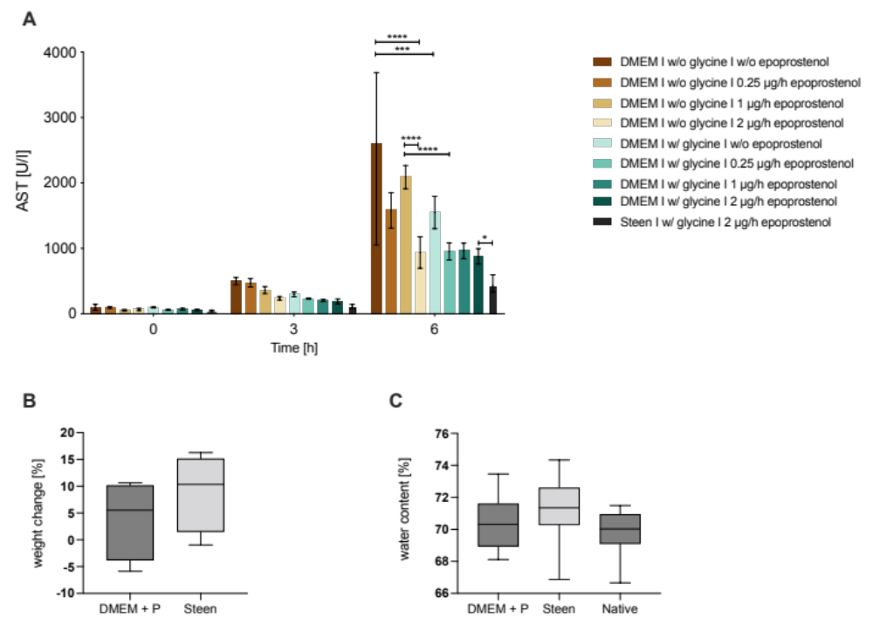
Supplementary Figure 1 – (A) Aspartate-transaminase release into perfusate over perfusion duration. (B) Weight change of livers from pre- to post-perfusion using different basic media (DMEM and fresh frozen rat plasma vs. Steen™ Solution. (C) Water content of livers post-perfusion, calculated through dry to wet weight ratio, native group consists of non-perfused explanted livers. All groups were performed at n = 4. Data presented as mean ± range. P-values are represented by * (<0.05), ** (<0.01), *** (<0.001), **** (<0.0001)
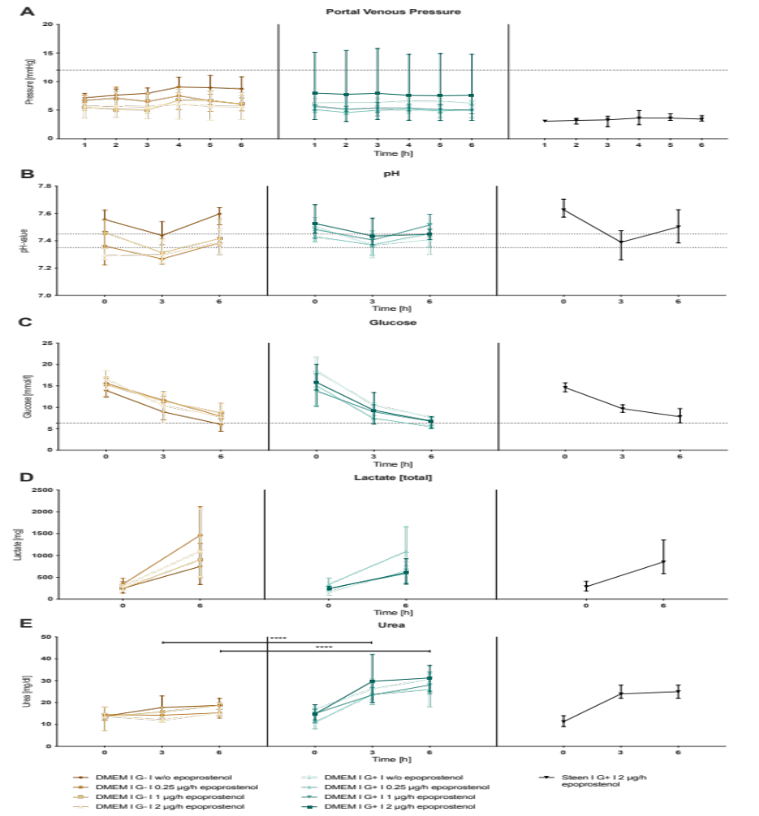
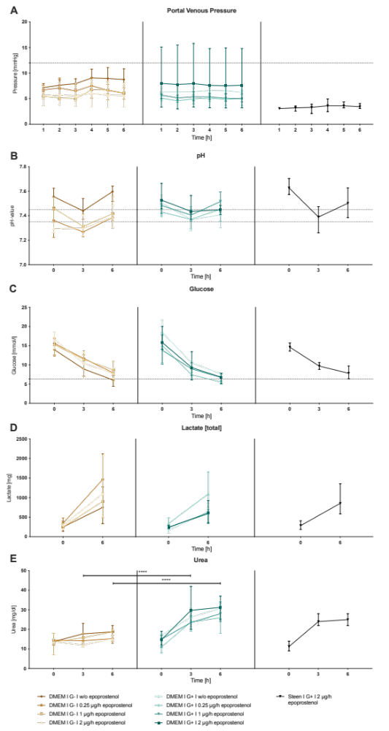
Supplementary Figure 2 – (A) Portal venous pressure over perfusion duration. (B) pH in perfusate over perfusion duration. (C) Glucose content in perfusate over perfusion duration. (D) Total lactate content in perfusate and dialysate over perfusion duration. (E) Urea content in perfusate over perfusion duration. All groups were performed at n = 4.
Dotted lines represent reference range, Data presented as mean ± range, p-values are represented by * (<0.05), ** (<0.01), *** (<0.001), **** (<0.0001)

