Supplementary Material
Root distribution and traits in a young alley-cropping system: impacts on soil carbon storage, nutrient dynamics and microbial activity
Plant and Soil

Siegwart Lorène¹ ORCID ID 0000-0002-8784-581X
Jourdan Christophe^{1,2} ORCID ID 0000-0001-9857-3269
Piton Gabin¹ ORCID ID 0000-0002-6036-5787
Sugihara Soh³ ORCID ID 0000-0002-5874-8957
Van den Meersche Karel^{1,2} ORCID ID 0000-0002-0866-7657
Bertrand Isabelle¹* ORCID ID 0000-0002-2233-631X

1 - UMR Eco&Sols, Univ Montpellier, CIRAD, INRAE, IRD, InstitutAgro Montpellier, Montpellier, France
2- CIRAD, UMR Eco&Sols, F-34398 Montpellier, France
3- Institute of Agriculture, Tokyo University of Agriculture and Technology, 3-5-8 Saiwai-cho, Fuchu-shi, Tokyo 183-8509, Japan

*Corresponding author: isabelle.bertrand@inrae.fr

Supplementary Table 1 Effect of soil depth, location and their interaction on the root biomass, functional traits, elemental composition, C-fractions and some quality indexes. Data are F- and p-values (n=3).
 | Soil depth |  | Location |  | Interaction
 | F-value | p-value | F-value | p-value | F-value | p-value
Biomass
Root biomass density | 19.64 | 4.92 × 10⁻⁵ | 3.95 | 4.02 × 10⁻² | 3.38 | 3.48 × 10⁻²
C stocks in living roots | 17.14 | 1.05 × 10⁻⁴ | 3.40 | 5.89 × 10⁻² | 3.40 | 3.40 × 10⁻²
Functional traits
Diameter | 2.01 | 0.19 | 10.26 | 6.13 × 10⁻³ | 0.87 | 0.45
Specific root length | 1.04 | 0.34 | 1.56 | 0.26 | 0.23 | 0.80
Coefficient A | 1.03 | 0.32 | 0.29 | 0.75 | 0.91 | 0.42
Elemental composition
C content | 3.46 | 0.06 | 1.05 | 0.37 | 0.44 | 0.78
N content | 2.02 | 0.17 | 0.11 | 0.90 | 0.54 | 0.71
P content | 5.49 | 1.53 × 10⁻² | 1.55 | 0.24 | 0.88 | 0.50
C:N | 1.17 | 0.34 | 0.15 | 0.86 | 0.47 | 0.76
C:P | 4.16 | 3.51 × 10⁻² | 0.82 | 0.46 | 0.62 | 0.66
N:P | 4.01 | 3.87 × 10⁻² | 0.78 | 0.48 | 0.19 | 0.94
C-fractions
Lignin content | 0.29 | 0.75 | 1.71 | 0.21 | 0.33 | 0.85
Cellulose content | 0.63 | 0.54 | 0.38 | 0.69 | 0.73 | 0.58
Hemicellulose content | 3.52 | 5.40 × 10⁻² | 10.56 | 1.19 × 10⁻³ | 3.19 | 4.19 × 10⁻²
Soluble compounds content | 3.45 | 0.06 | 3.08 | 0.07 | 1.64 | 0.21
Quality index
Lignin:N | 0.20 | 0.82 | 1.45 | 0.26 | 0.18 | 0.95
Ligno-cellulosic index | 0.59 | 0.57 | 2.12 | 0.15 | 0.35 | 0.84
Soluble:cell walls | 2.13 | 0.15 | 2.03 | 0.16 | 1.80 | 0.18

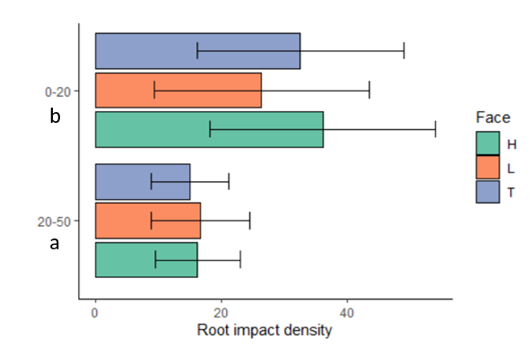
Supplementary Fig. 1 The root impact density on each cube face for each soil layer (0-20 and 20-50 cm).

Supplementary Table 2 Linear regressions between the root length density and the mean root impact density for each location.
 | R² | Regression coefficient
UVS | 87.2 % | 4.24
Crop-1m | 79.2 % | 2.80
Crop-4m | 79.3 % | 2.63

Supplementary Table 3 Effect of soil depth (0-20, 20-50 and 50-100 cm) and location (Crop-1 m and Crop-4 m) on root anatomy (n=3). Data are p-values.
 | Soil depth | Location | Interaction
Root total area | 0.55 | 0.62 | 0.87
Stele area | 3.46 × 10⁻² | 0.34 | 0.55
Stele area :total root area ratio | 0.66 | 0.81 | 0.74
Endoderm width | 0.18 | 0.94 | 0.92
Average area of the metaxylem vessels | 0.91 | 0.89 | 0.99
Number of metaxylem vessels | 0.41 | 0.51 | 0.77
Ratio number of metaxylem vessels :stele area | 0.77 | 0.86 | 0.78
Total area occupied by metaxylem vessels | 0.11 | 0.20 | 0.14
Total area occupied by metaxylem vessels :stele area ratio | 0.21 | 1.03 × 10⁻² | 1.18 × 10⁻²

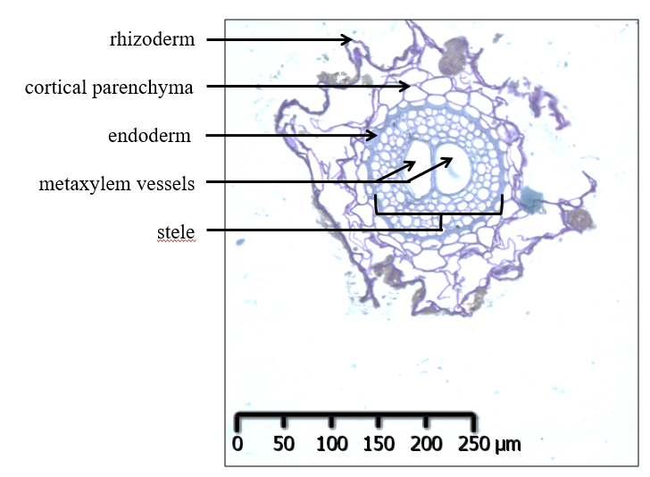
Supplementary Fig. 2 Transverse section of a wheat root and definition of the anatomical traits.
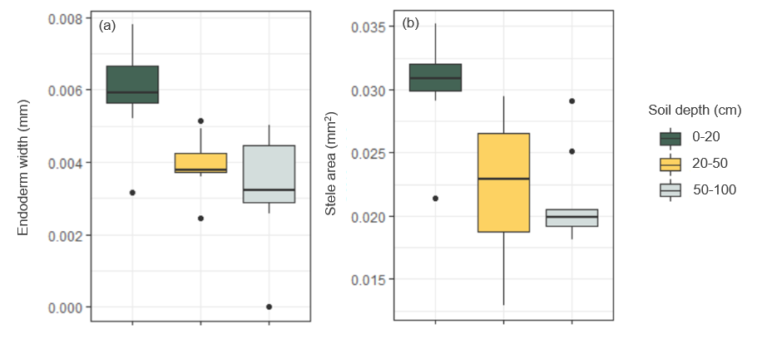
Supplementary Fig. 3 Anatomical traits of wheat roots (endoderm width (a) and stele area (b) according to soil depth (0-20. 20-50 and 50-100 cm). Data are mean values, and error bars represent the standard deviations (n=6). Lowercase letters indicate significant differences between the modalities when they were significant (p-value < 0.05).

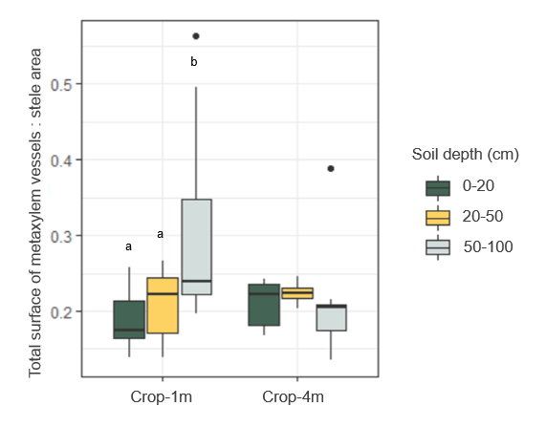
Supplementary Fig. 4 Ratio of the total area of metaxylem vessels: stele area of durum wheat roots according to soil depth (0-20. 20-50 and 50-100 cm) and to location (Crop-1 m and Crop-4 m). Data are mean values, and error bars represent the standard deviation (n=3). For each location, lowercase letters indicate significant differences between the modalities when they were significant (p-value < 0.05).

Supplementary Table 4 Effect of soil depth, location and their interaction on the soil physical, chemical and microbiological properties. Data are F- and p-values (n=3).
 | Soil depth |  | Location |  | Interaction
 | F-value | p-value | F-value | p-value | F-value | p-value
Physical properties
Bulk density | 455.60 | 7.88 × 10⁻¹⁵ | 0.00 | 1.00 | 0.00 | 1.00
Bulk density on fine particles | 217.22 | 2.53 × 10⁻¹² | 0.00 | 1.00 | 0.00 | 1.00
Stones volumetric proportion | 7.31 | 5.57 × 10⁻³ | 0.00 | 1.00 | 0.00 | 1.00
Clay content | 38.15 | 8.16 × 10⁻⁷ | 0.19 | 0.83 | 0.03 | 1.00
Silt content | 13.59 | 3.55 × 10⁻⁴ | 0.58 | 0.57 | 0.28 | 0.89
Sand content | 35.67 | 1.27 × 10⁻⁶ | 0.08 | 0.93 | 0.02 | 1.00
Moisture | 0.05 | 0.95 | 0.57 | 0.58 | 0.59 | 0.67
Chemical properties
Organic C content | 52.79 | 8.99 × 10⁻⁸ | 0.36 | 0.71 | 0.13 | 0.97
Organic C stocks | 41.54 | 4.63 × 10⁻⁷ | 0.40 | 0.67 | 0.25 | 0.91
Total N content | 23.62 | 1.68 × 10⁻⁵ | 0.61 | 0.55 | 0.25 | 0.91
Total P content | 18.76 | 6.39 × 10⁻⁵ | 0.22 | 0.80 | 0.40 | 0.81
Soil C:N | 31.99 | 2.57 × 10⁻⁶ | 0.79 | 0.47 | 0.02 | 1.00
Soil N:P | 1.09 | 0.36 | 0.72 | 0.50 | 0.27 | 0.89
Soil C:P | 13.83 | 3.25 × 10⁻⁴ | 0.15 | 0.86 | 0.29 | 0.88
Dissolved organic C content | 13.30 | 3.95 × 10⁻⁴ | 1.33 | 0.29 | 0.49 | 0.75
Mineral N content | 19.88 | 4.59 × 10⁻⁵ | 5.93 | 1.18 × 10⁻² | 0.67 | 0.62
Olsen P content | 23.66 | 1.66 × 10⁻⁵ | 0.11 | 0.90 | 0.70 | 0.60
CEC | 42.97 | 3.68 × 10⁻⁷ | 0.42 | 0.66 | 0.03 | 1.00
pH | 5.23 | 1.79 × 10⁻² | 0.53 | 0.60 | 0.15 | 0.96
Biological properties
MBC | 12.99 | 4.46 × 10⁻⁴ | 0.52 | 0.60 | 0.40 | 0.81
MBN | 3.60 | 5.10 × 10⁻² | 0.55 | 0.59 | 1.40 | 0.28
MBC:N | 0.37 | 0.70 | 0.76 | 0.49 | 1.28 | 0.32
16S | 26.63 | 8.10 × 10⁻⁶ | 0.65 | 0.53 | 0.15 | 0.96
18S | 45.45 | 2.52 × 10⁻⁷ | 2.96 | 0.08 | 1.16 | 0.36
16S:18S | 9.38 | 2.02 × 10⁻³ | 3.27 | 0.06 | 0.98 | 0.45
C-enzymatic activity | 65.79 | 1.91 × 10⁻⁸ | 0.76 | 0.48 | 0.45 | 0.77
N-enzymatic activity | 6.54 | 8.40 × 10⁻³ | 0.65 | 0.53 | 0.58 | 0.68
P-enzymatic activity | 26.57 | 8.22 × 10⁻⁶ | 0.15 | 0.87 | 0.61 | 0.66
C-enzymatic specific activity | 43.85 | 3.21 × 10⁻⁷ | 0.08 | 0.92 | 0.38 | 0.82
N-enzymatic specific activity | 0.55 | 0.59 | 0.55 | 0.59 | 0.19 | 0.94
P-enzymatic specific activity | 0.33 | 0.72 | 0.05 | 0.95 | 0.16 | 0.96
Length | 35.50 | 1.31 × 10⁻⁶ | 0.01 | 0.99 | 0.63 | 0.65
Angle | 2.24 | 0.14 | 0.68 | 0.52 | 0.20 | 0.94

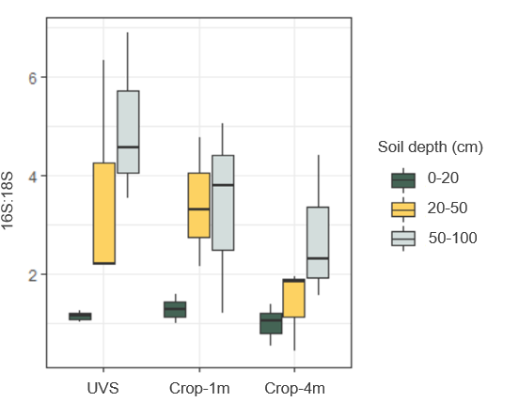
Supplementary Fig. 5 Soil 16S:18S ratio (n=3) according to depth (0-20, 20-50 and 50-100 cm) and location (UVS, Crop-1 m, Crop-4 m).

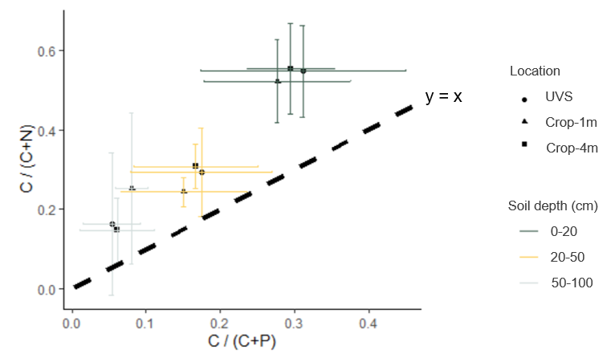
Supplementary Fig. 6 Ecoenzyme stoichiometry of the relative C to N acquisition versus C to P acquisition according to depth and location. Data are mean values, and error bars represent the standard deviations (n=3).

Supplementary Table 5 Results of the first ANCOVA: effects of some soil variables (explicative variable), location and their interaction on some root characteristics (response variable) to test H1. Data are p-values (n=9). Column ANOVA (lm1, lm2) answers the hypothesis: “the effect of soil on roots varies according to the location”. Column anova (lm2, lm3) answers the hypothesis: “soil explains a part of roots that is not explained by the location”.
Response variable (Root) | Explicative variable (Soil) | anova (lm1, lm2) | anova (lm2, lm3)
Biomass density | Bulk density | 2.38 × 10⁻³ | 1.21 × 10⁻⁵
Biomass density | Mineral N content | 1.87 × 10⁻² | 2.63 × 10⁻³
Biomass density | Stones | 0.45 | 0.09
Lignin content | Bulk density | 0.47 | 0.77
Lignin content | Mineral N content | 0.79 | 0.91
Lignin content | Stones | 0.07 | 0.09
Stele diameter | Bulk density | 0.98 | 6.53 × 10⁻⁷
Stele diameter | Mineral N content | 3.44 × 10⁻² | 9.39 × 10⁻³
Stele diameter | Stones | 0.38 | 2.84 × 10⁻²

Supplementary Table 6 Results of the second ANCOVA: effects of some root variables (explicative variable), soil depth and their interaction on some soil properties (response variable) to test H2. Data p-values (n=9). Column ANOVA (lm1, lm2) answers the hypothesis: “the effect of roots on soil varies according to the soil depth”. Column anova (lm2, lm3) answers the hypothesis: “roots explain a part of soil that is not explained by the soil depth”. When ANOVA (lm1, lm2) is significant (p-value < 0.05), ANOVA (lm2, lm3) should not be considered.
Response variable (Soil) | Explicative variable (Root) | anova (lm1, lm2) | anova (lm2, lm3)
Soil organic C stocks | Lignin:N | 0.15 | 0.09
Soil organic C stocks | C:N | 0.30 | 0.08
Soil organic C stocks | Ligno-cellulosic index | 0.64 | 0.42
Soil organic C stocks | Root C stocks | 2.83 × 10⁻² | 0.11
 | Lignin:N | 0.76 | 0.23
 | C:N | 0.61 | 0.30
MBC | Ligno-cellulosic index | 0.84 | 0.38
 | Root C stocks | 0.36 | 1.50 × 10⁻²
Specific N enzymatic activity | Lignin:N | 1.80 × 10⁻² | 8.02 × 10⁻⁴
Specific N enzymatic activity | C:N | 3.21 × 10⁻² | 5.51 × 10⁻³
Specific N enzymatic activity | Ligno-cellulosic index | 0.35 | 4.37 × 10⁻²
Specific N enzymatic activity | Root C stocks | 0.39 | 0.40
Specific C enzymatic activity | Lignin:N | 0.29 | 0.65
Specific C enzymatic activity | C:N | 0.53 | 0.06
Specific C enzymatic activity | Ligno-cellulosic index | 0.64 | 0.76
Specific C enzymatic activity | Root C stocks | 0.60 | 0.85

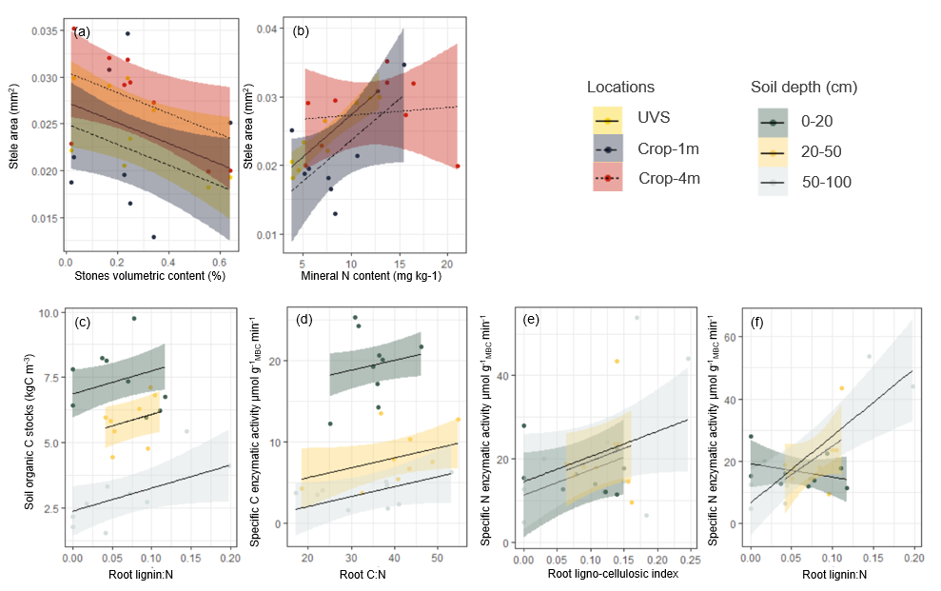
Supplementary Fig. 7 Correlations between some root and soil variables at different locations (UVS, Crop-1 m and Crop-4 m) to test H1 (a and b) and between some soil and root variables at different soil depths (0-20, 20-50 and 50-100 cm) to test H2 (c, d, e and f).

