3a. LG1
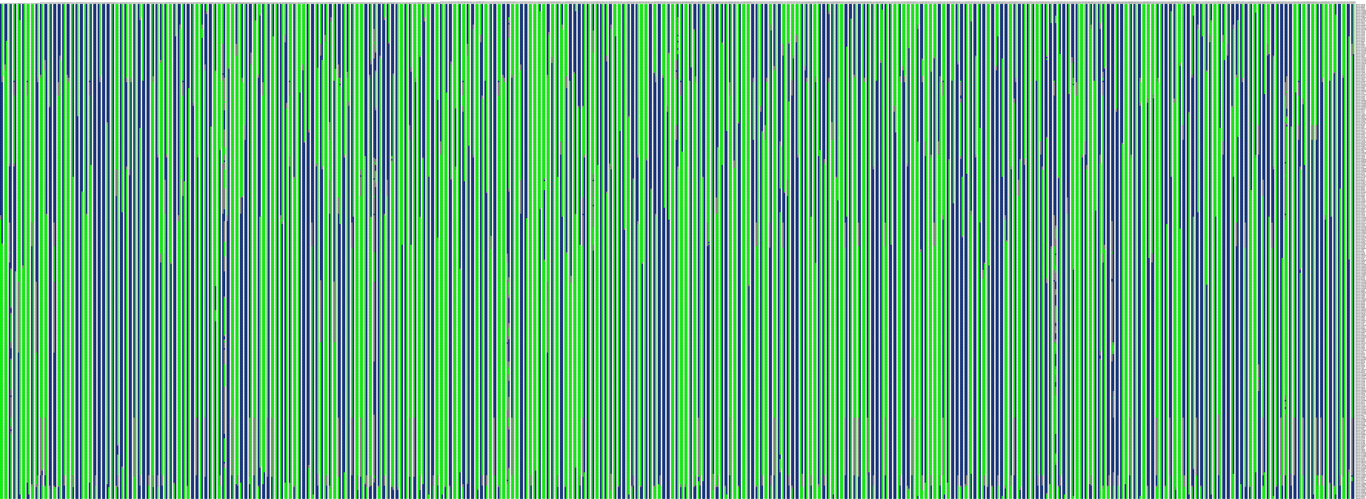

3b. LG2

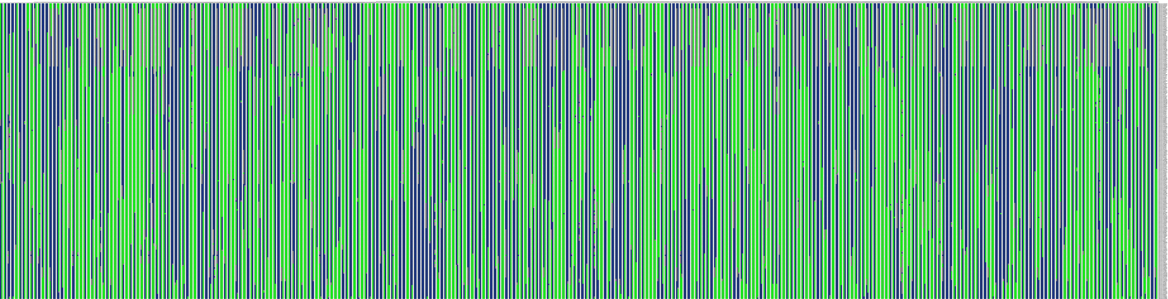

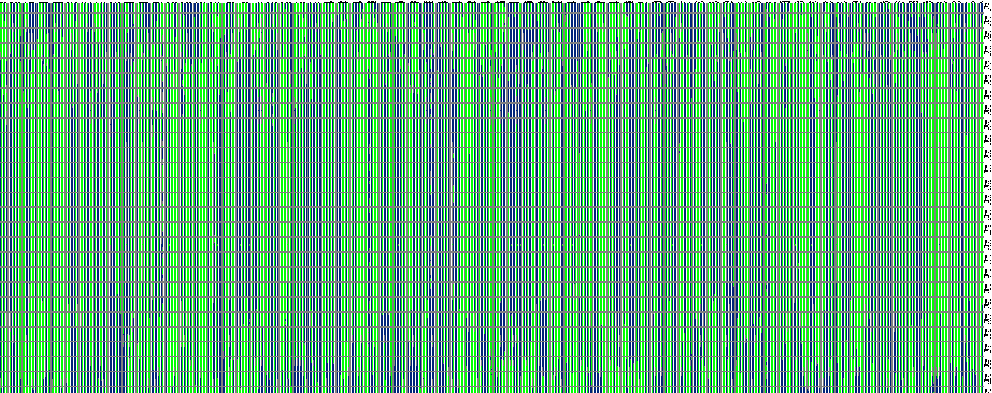
3c. LG3

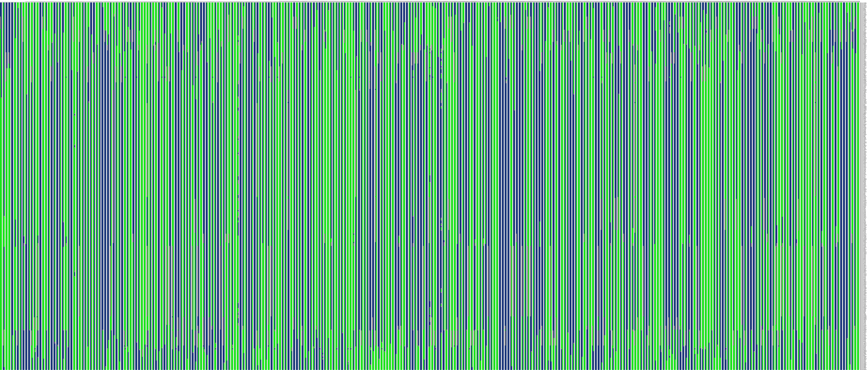
3d. LG4

3e. LG5
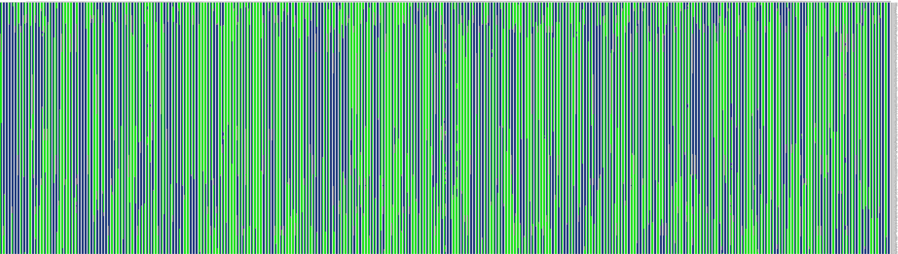

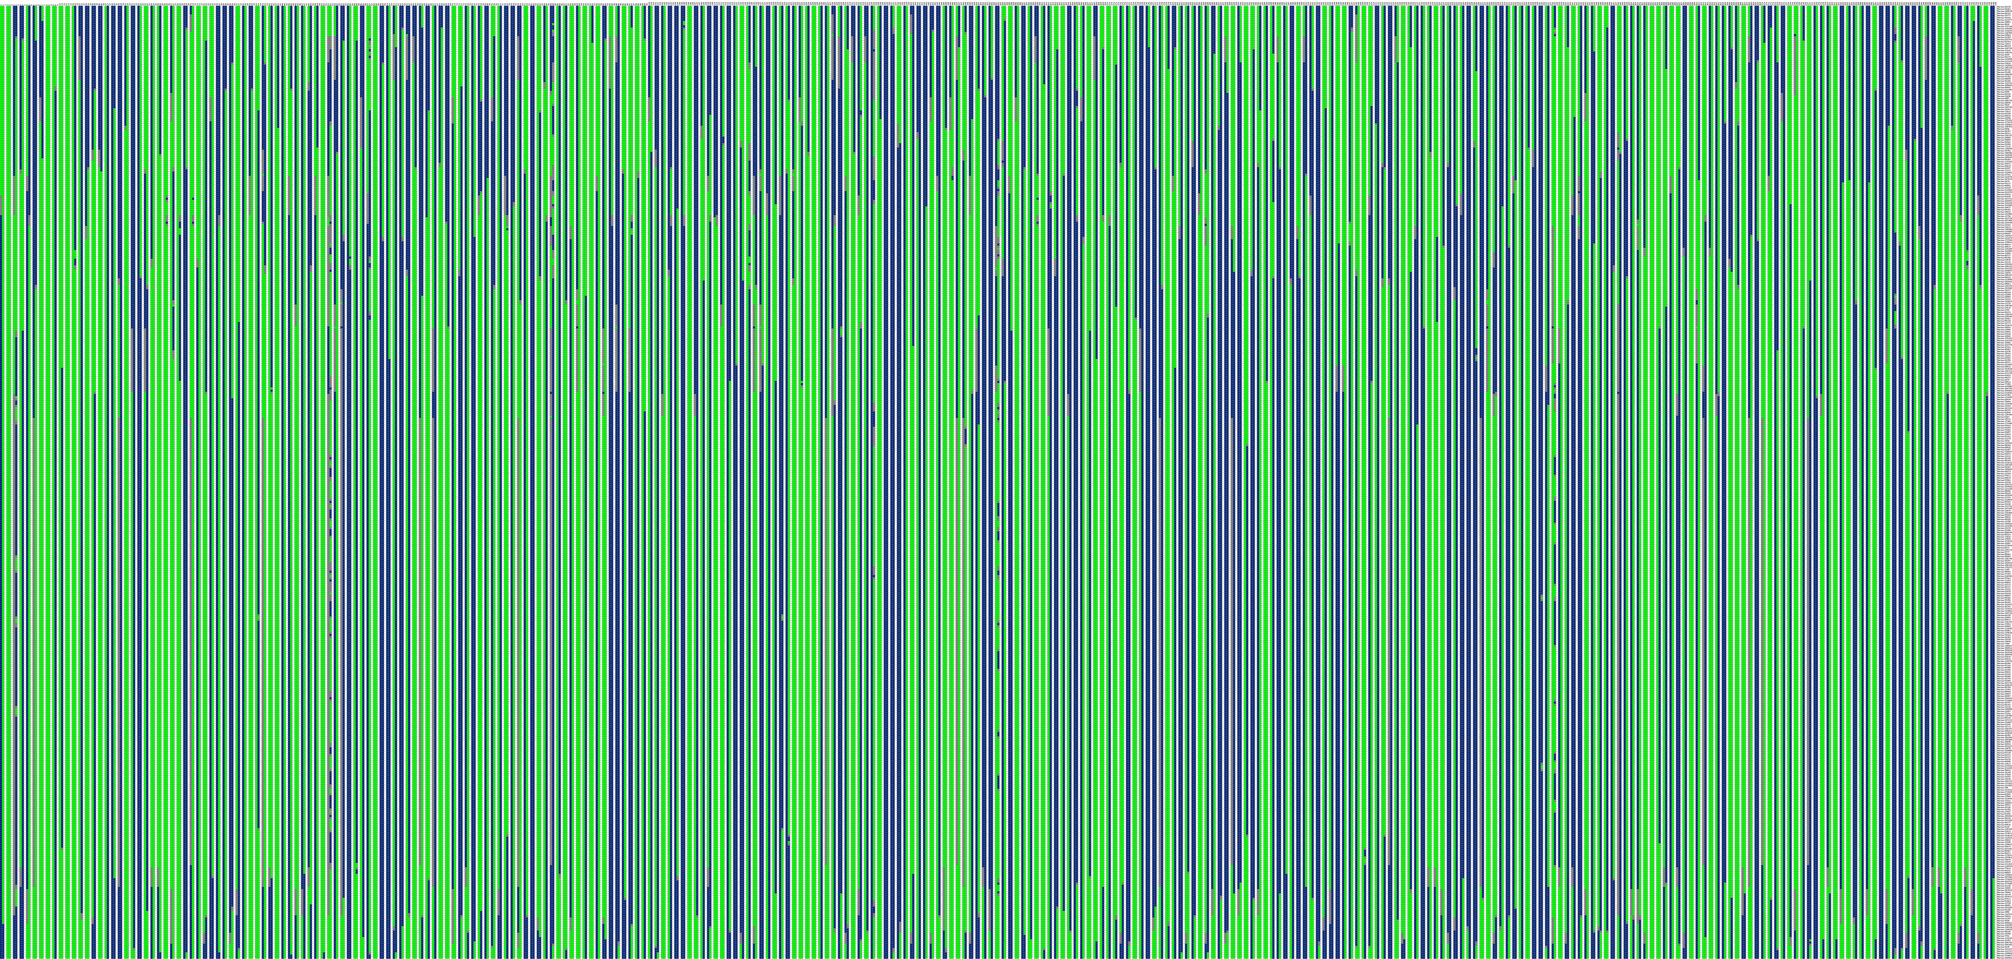
3f. LG6

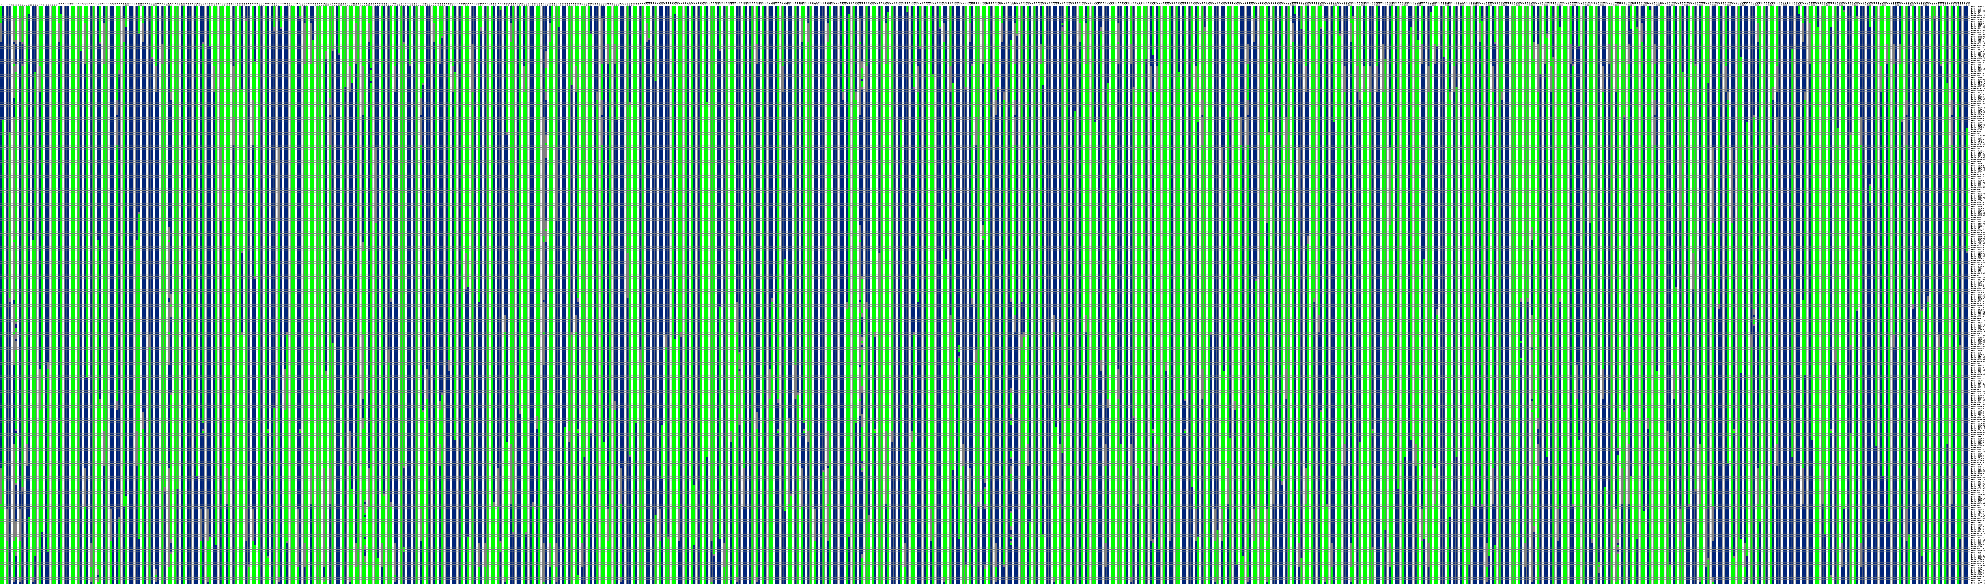
3g. LG7

3h. LG8

3i. LG9

3j. LG10

3k. LG11

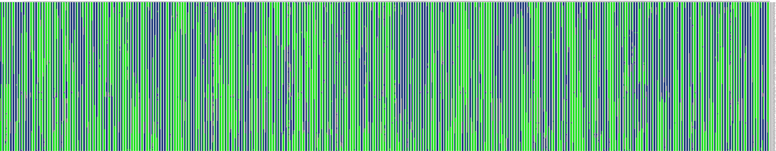
3l. LG12

Figure S3(a-l) Haplotype mapping of 305 F₁ individuals based on 12 linkage groups of integrated maps. In each map, horizontal line stands a marker and column shows a chromosome in a sample. The first column of the map shows a paternal chromosome and the second column as maternal chromosome, and individuals are separated by blank columns. Green color indicates first allele from the parent, blue as the second allele from the parent, white color shows not judged event, and grey indicates a missing event. The position where color changes in the same column display reorganization events.

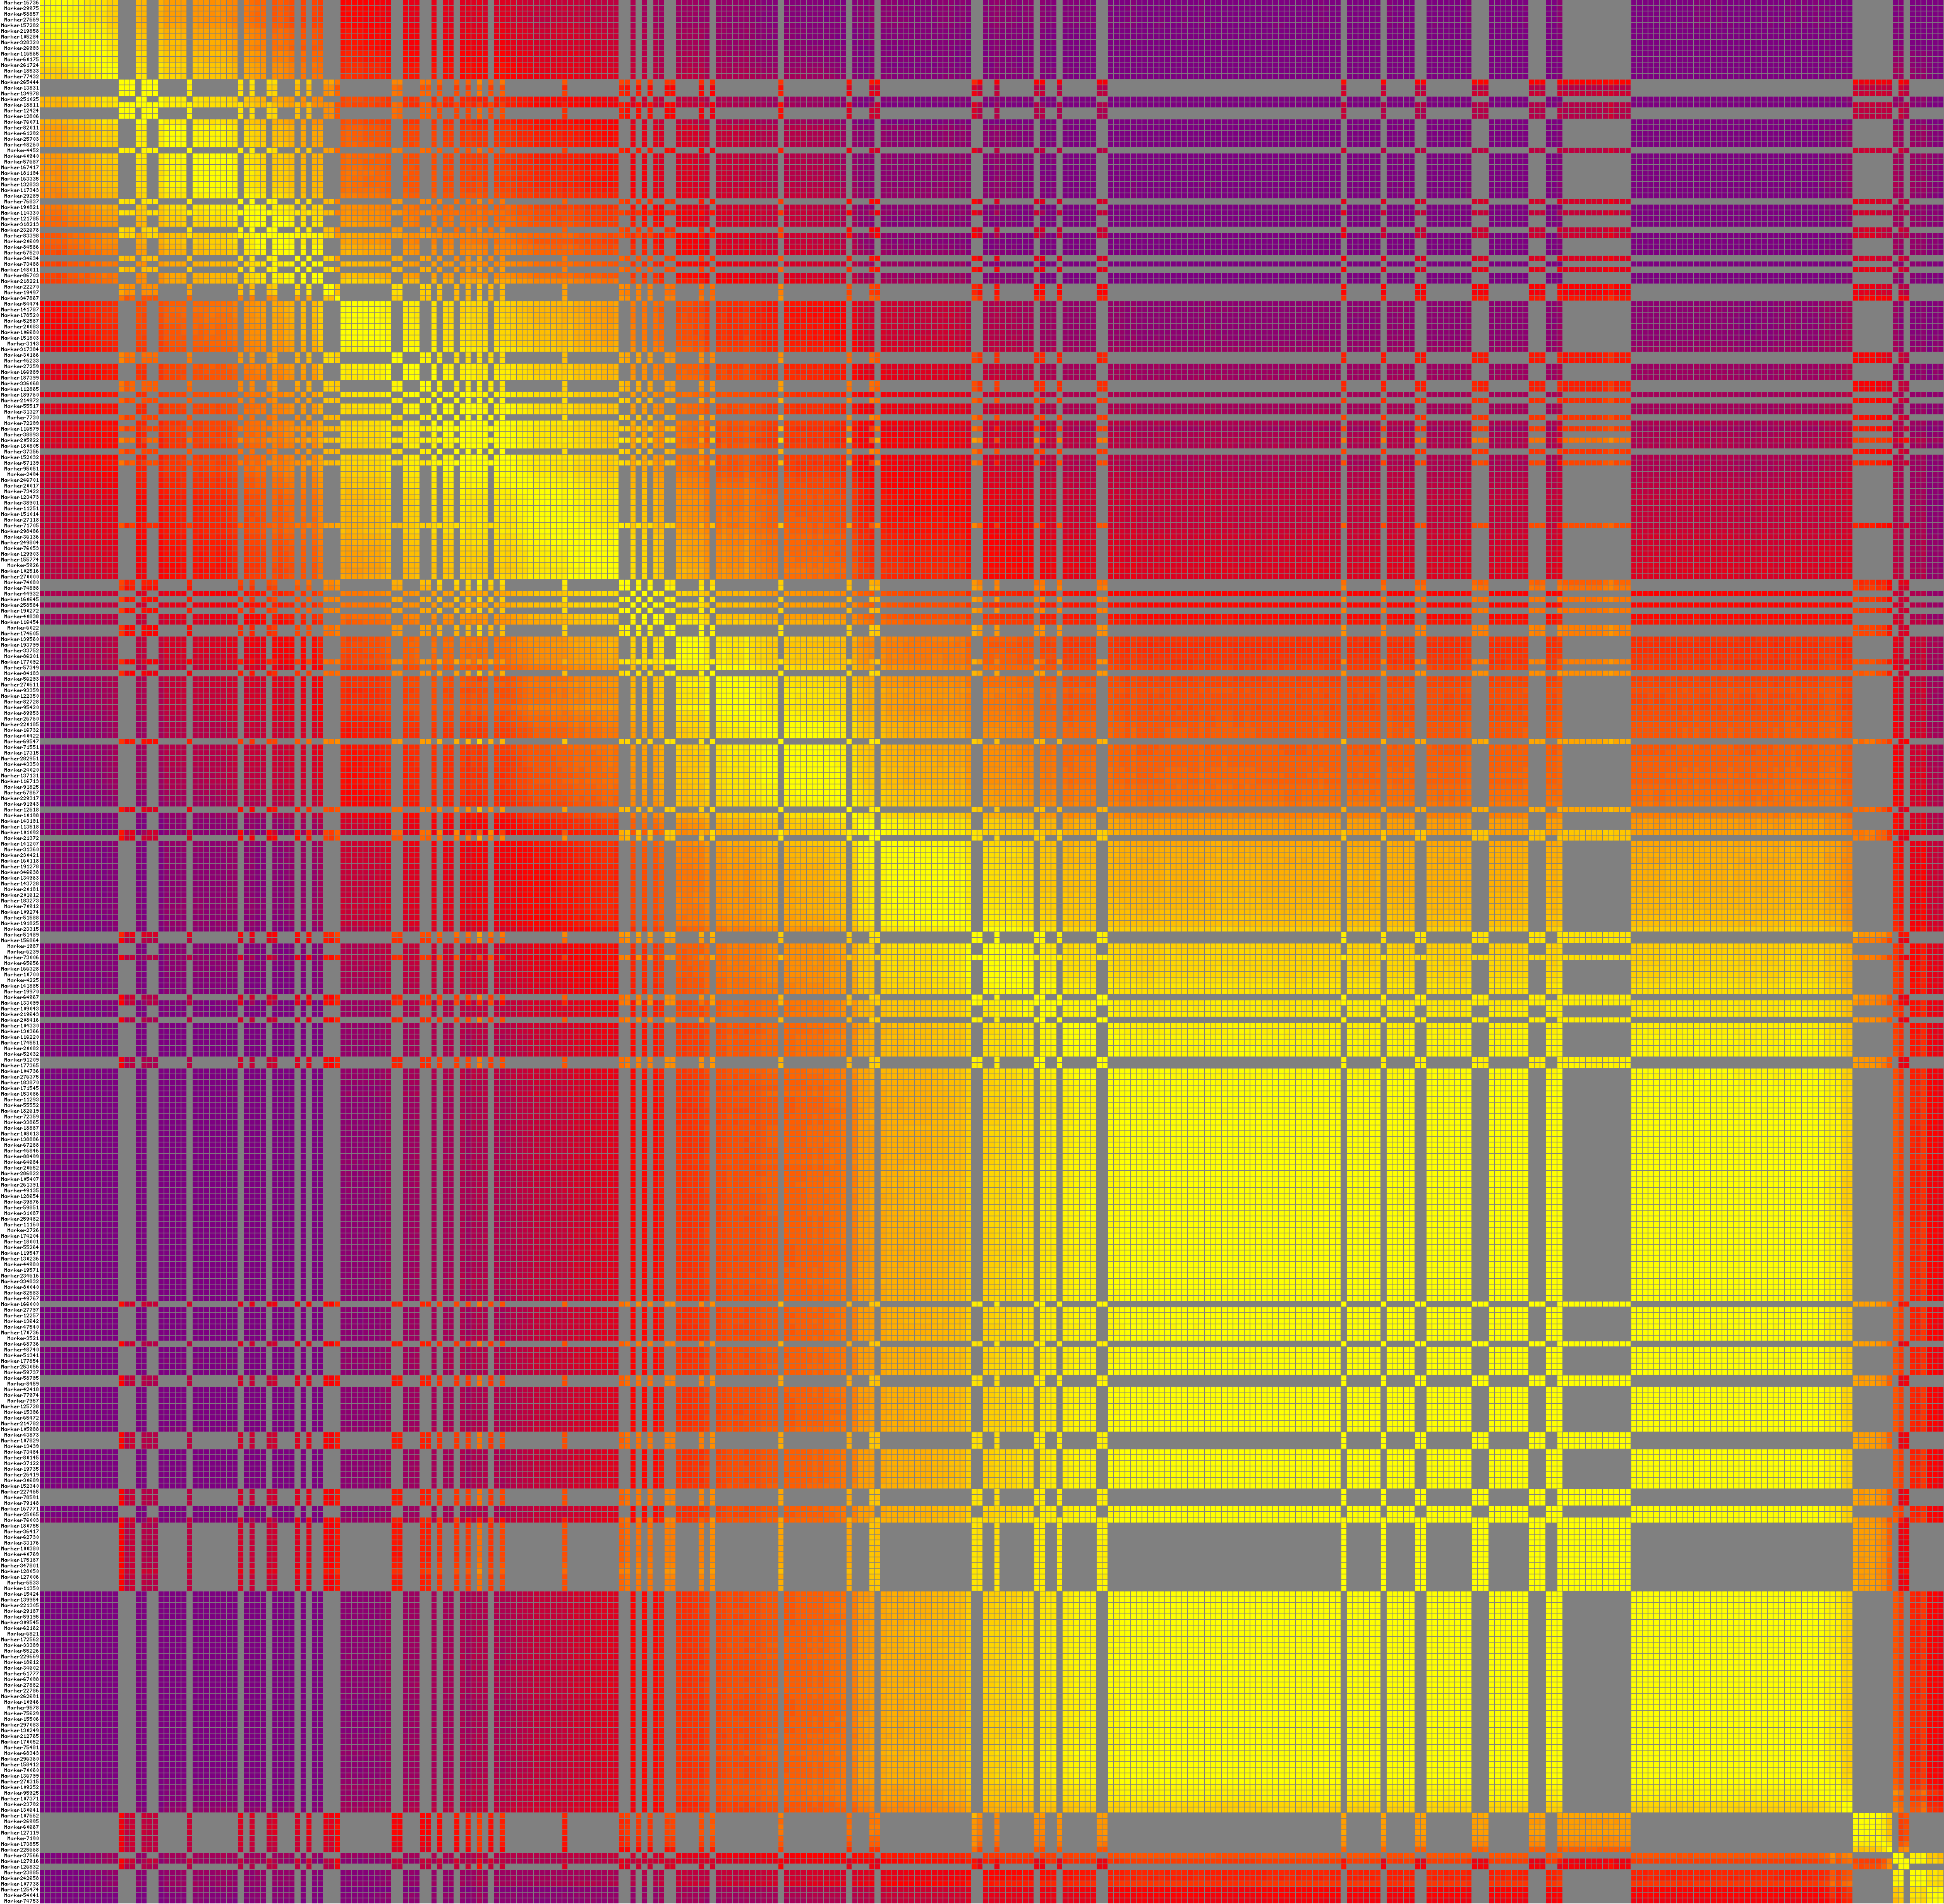
4a. LG1

4b. LG2

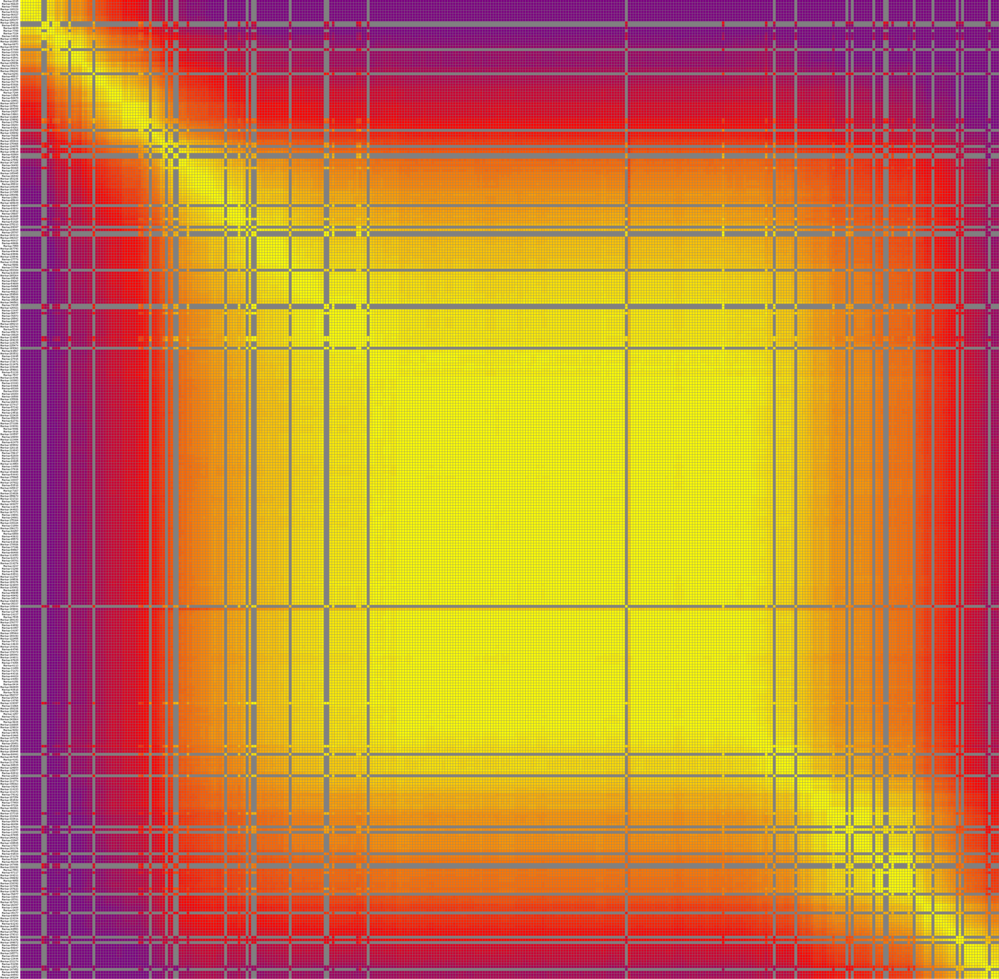
4c. LG3

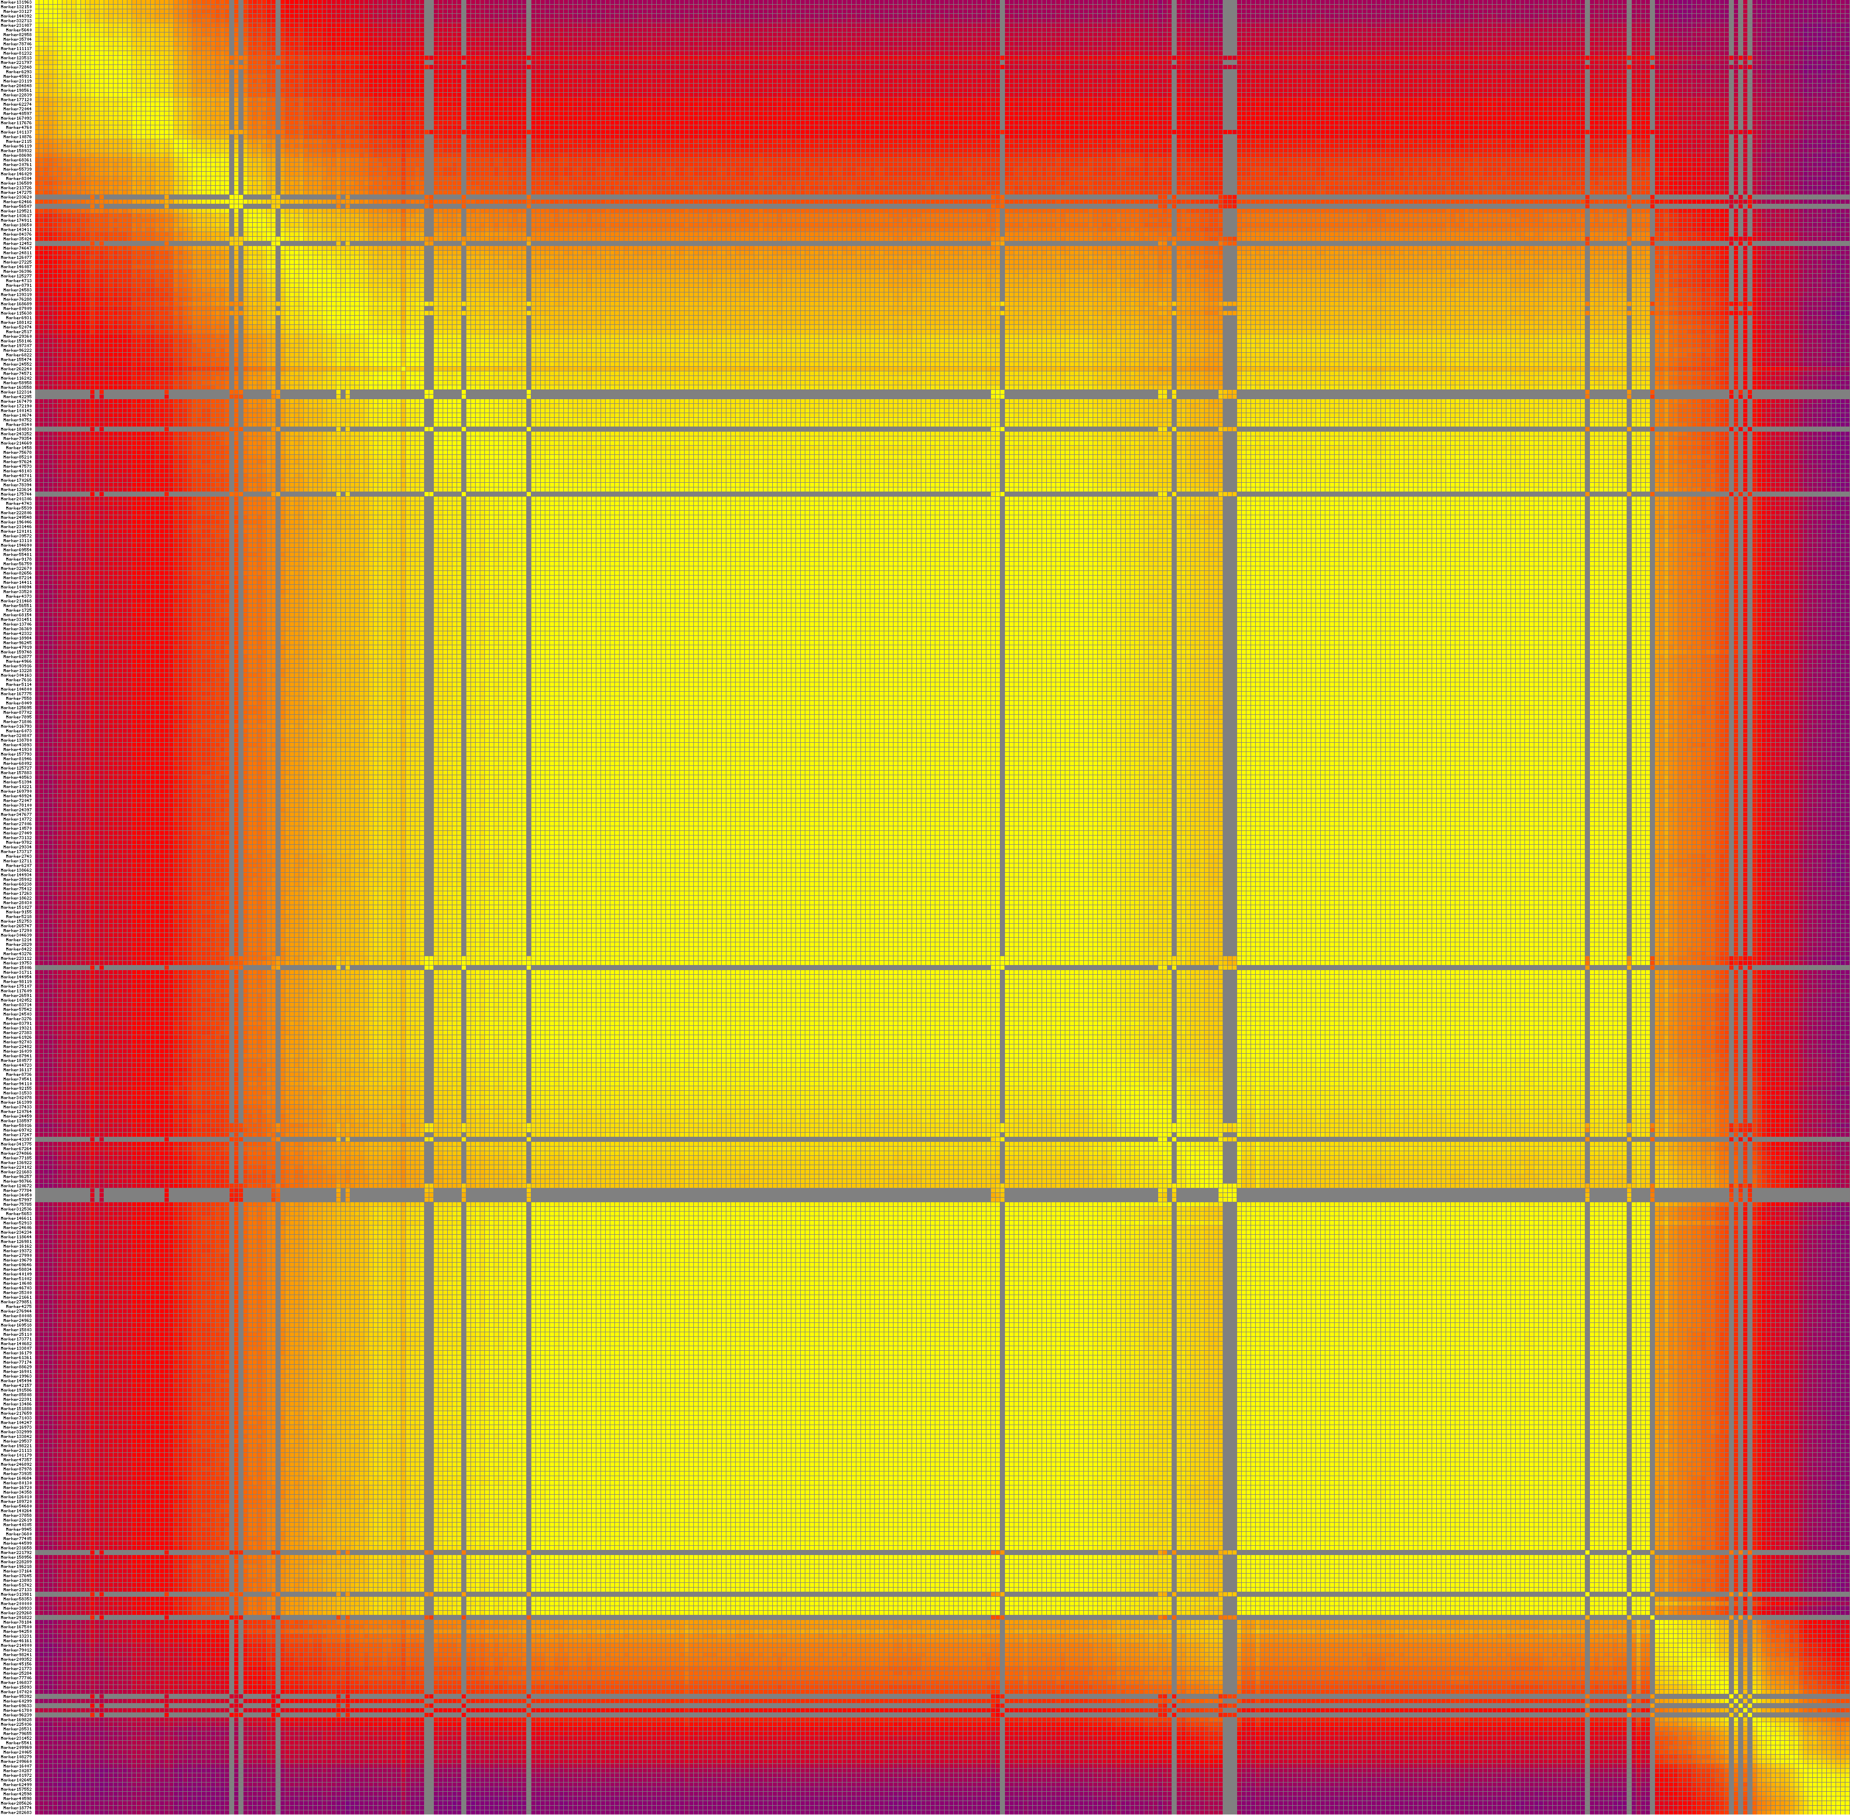
4d. LG4
4e. LG5
4f. LG6
4g. LG7

4h. LG8

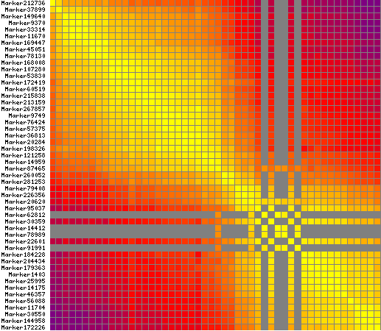

4i. LG9

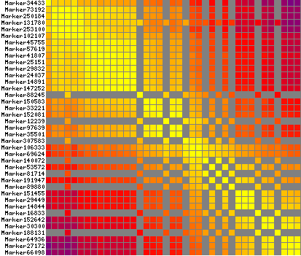

4j. LG10

4k. LG11

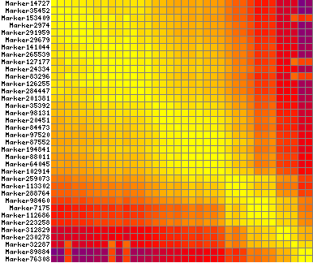

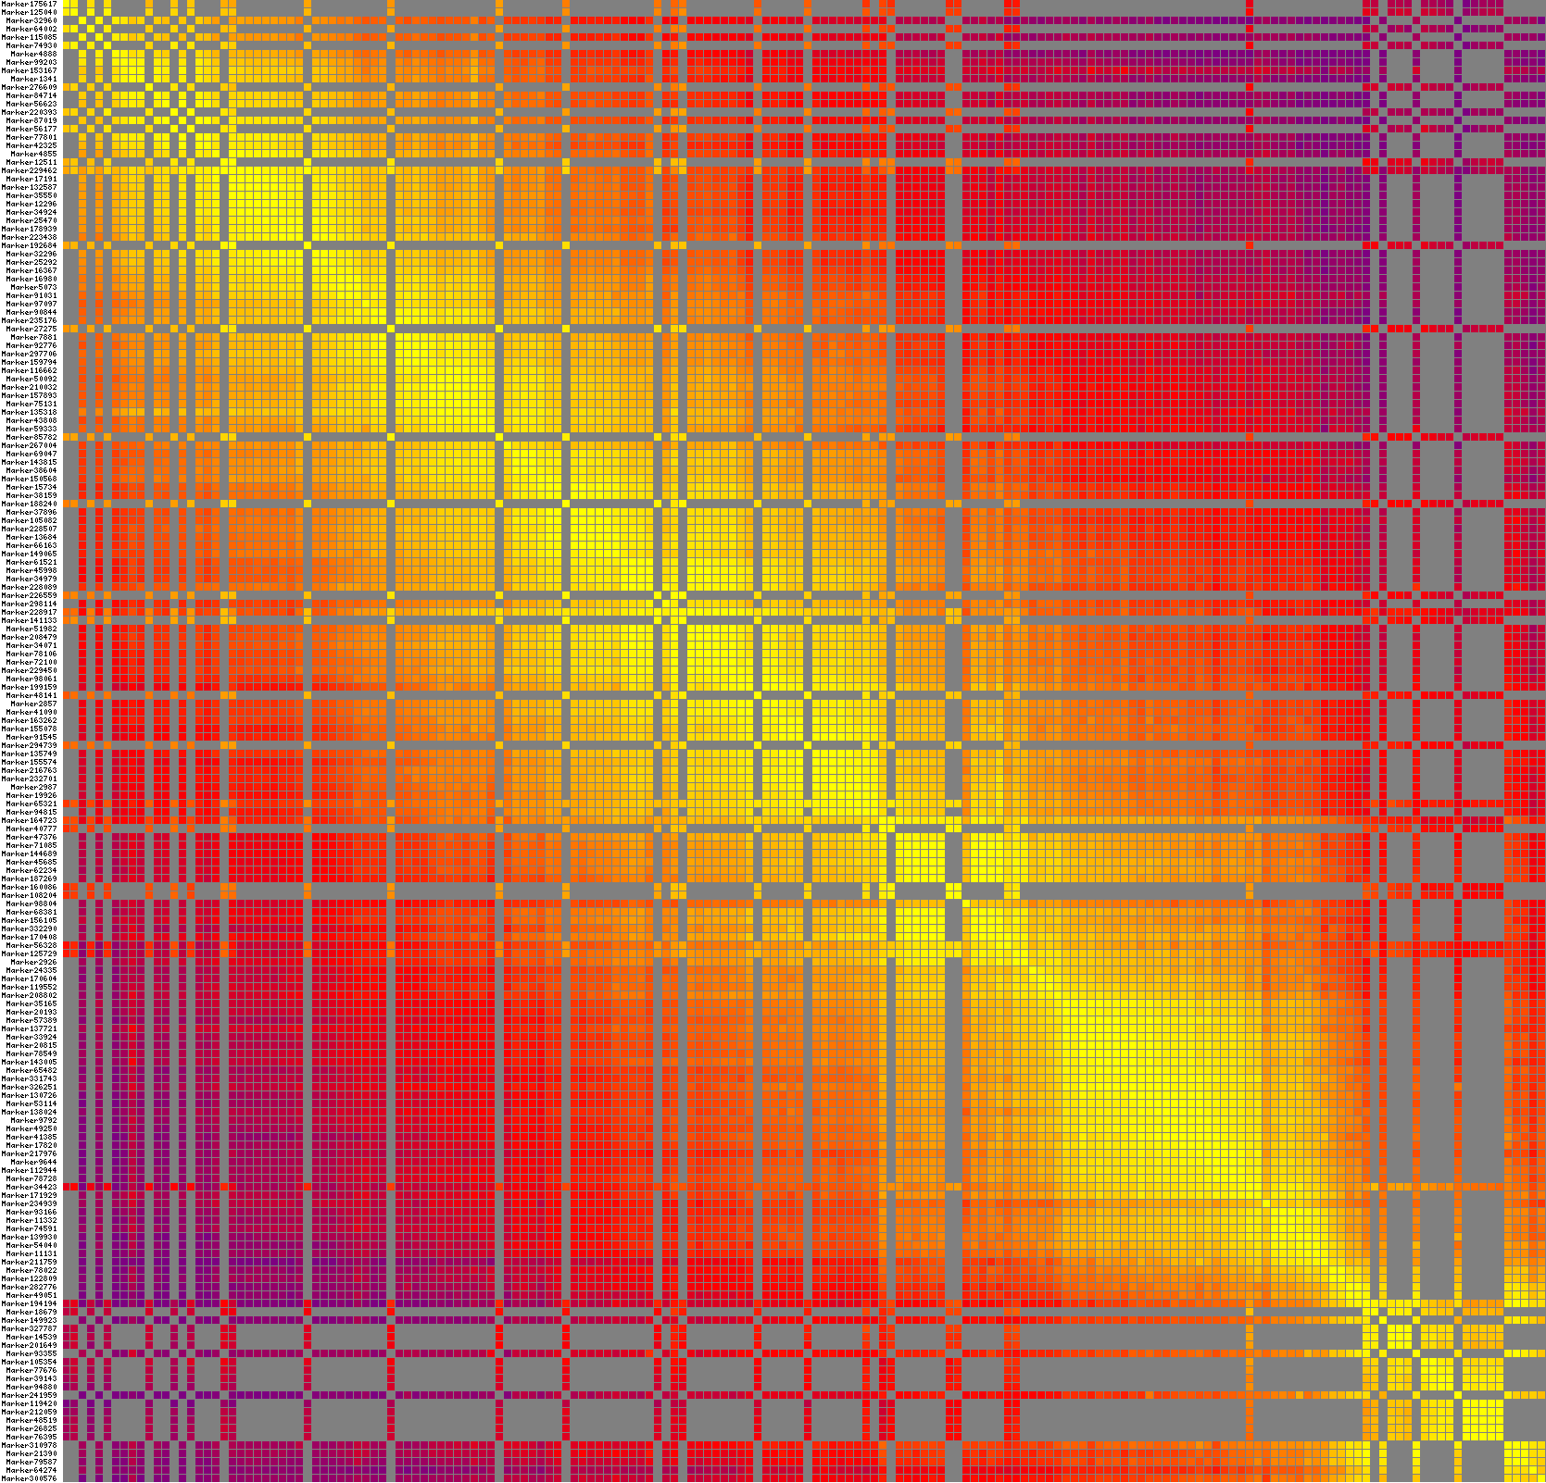
4l. LG12

Figure S4(a-l) Heatmaps of 305 F₁ individuals based on 12 linkage groups of integrated maps. Each row and column represent marker arranged in the orderliness of the map. Every small square show recombination rate between two markers. The color change trend from yellow to red to purple display reorganization rate from small to large. Yellow color indicates closer marker recombination rate, whereas closer the color from yellow to purple farther becomes the recombination rate.

