SUPPLEMENTARY MATERIAL

Supplementary Table 1. Additional quality criteria for magnetic resonance spectroscopy (MRS) acquisition.

 | Hippocampus |  | Thalamus |  | Striatum |  | Cortex
 | WT | Tg | WT | Tg | WT | Tg | WT | Tg
Voxel location (%) | 63.55±8.25 | 67.03±15.41 | 69.98±7.43 | 68.15±20.38 | 77.19±8.50 | 74.19±8.72 | 72.63±6.98 | 71.34±11.53
Brain temperature | 36.23±1.01 | 35.89±1.01 | 35.89±0.84 | 35.55±1.02 | 35.55±1.12 | 34.88±1.35* | 35.55±1.35 | 35.22±1.35*
Rectal temperature | 35.30±0.98 | 34.84±0.93 | 35.42±1.12 | 34.73±0.98 | 35.43±1.10 | 34.70±0.91* | 35.32±1.04 | 34.60±0.98*

Accuracy of the voxel location, estimated as the percentage of the MRS voxel covering the region of interest; and measured and estimated temperature during estimation were evaluated to ensure acquisition quality. Rectal measurement of temperature was performed during acquisition. Brain temperature was estimated based on chemical shift of the N-acetylaspartate (NAA) peak relative to water. Asterisks indicate significant differences between wildtype and transgenic animals.

Supplementary Table 2. Significant effects of age, group or age-group interaction in the metabolite concentration.

REGION | METAB. | Age |  | Group |  | Group x age interaction
 |  | p-value | Cohen’s f² | p-value | Cohen’s f² | p-value | Cohen’s f²
Cortex | Cr | 0.0069** | 0.6134*** | n.s. | - | 0.0408* | 0.6245***
Cortex | tCr | 0.0077** | 0.3910*** | n.s. | - | n.s. | -
Cortex | NAA | 0.0060** | 0.9723*** | 0.0325* | 0.4156*** | 0.0027** | 1.1117***
Cortex | tNAA | 0.0072** | 0.8372*** | 0.0370* | 0.3457** | 0.0049** | 0.9624***
Cortex | Glu | 0.0127* | 0.2977** | n.s. | - | n.s. | -
Cortex | Glx | 0.0267* | 0.2726** | n.s. | - | n.s. | -
Cortex | Tau | 1.09e-6*** | 2.4696*** | 0.0092** | 0.9263*** | 8.08e-5*** | 2.5571***
Cortex | tCho | n.s. | - | 0.0105* | 0.2466** | 0.0445* | 0.7643**
Thalamus | tCr | 0.0097** | 1.7123*** | n.s. | - | 0.0012** | 2.2174***
Thalamus | NAA | 0.0002*** | 2.0831*** | n.s. | - | 6.86e-6*** | 2.8519***
Thalamus | tNAA | 0.0119* | 1.0185*** | n.s. | - | 0.0036** | 1.4505***
Thalamus | Glu | 0.0028** | 1.0504*** | n.s. | - | 0.0138* | 1.1599***
Thalamus | Glx | 0.0356* | 0.6520*** | n.s. | - | n.s. | -
Thalamus | Ins+Gly | n.s. | - | n.s. | - | 0.0281* | 0.6752***
Thalamus | tCho | 0.0031** | 1.6175*** | n.s. | - | n.s. | -
Hippocampus | NAA | n.s. | - | n.s | - | 0.0211* | 0.5779***
Hippocampus | Ins | 0.0089** | 0.3165** | n.s. | - | n.s. | -
Hippocampus | Ins+Gly | 0.0116* | 0.2298** | n.s. | - | n.s. | -
Hippocampus | tCho | n.s. | - | 0.0449* | 0.2116** | n.s. | -
Striatum | Glu | n.s. | - | 0.0437* | 0.3845*** | n.s. | -
Striatum | Ins | 0.0149* | 0.8547*** | n.s. | - | n.s. | -
Striatum | Ins+Gly | 0.0395* | 1.2619*** | n.s. | - | 0.0178* | 0.7194***

Significant effects of age, group or age-group interaction in the metabolite concentration adjusted by linear mixed effects model (LME). p-value (* p<0.05; ** p<0.01; *** p<0.001) and Cohen’s f² effect size are reported. Asterisks represent small (*, f²>0.02), medium (**, f²>0.15) and large (***, f²>0.35) effect according to convention. Cr: creatine, tCr: total creatine; NAA: N-acetylaspartate; tNAA: NAA+N-acetylaspartylglutamate (NAAG) pool; Glu: glutamate; Glx: Glutamate and glutamine pool; Tau: taurine; tCho: choline compounds; Ins: myo-inositol; Ins + Gly: myo-inositol and glycine.

Supplementary table 3. Significant age effects in the metabolite concentration in wild-type and TgF344-AD animals.
 |  | CONTROL |  | TgF344-AD
REGION | METAB. | Age |  | Age
 |  | p-value | Cohen’s f² | p-value | Cohen’s f²
Cortex | Cr | n.s. | - | 0.0065** | 0.3326**
Cortex | NAA | n.s. | - | 0.0024** | 0.3973***
Cortex | tNAA | n.s. | - | 0.0038** | 0.3780***
Cortex | Tau | n.s. | - | 1.03e-5*** | 0.8274***
Thalamus | tCr | 0.0278* | 0.3443** | 0.0040** | 0.4784***
Thalamus | NAA | 0.0057** | 0.3035** | 0.0006*** | 0.7764***
Thalamus | tNAA | n.s. | - | 0.0050** | 0.6552***
Thalamus | Glu | n.s. | - | 0.0041** | 0.6062***
Thalamus | Ins+Gly | 0.0400* | 0.1877** | s.s. | n.s.
Hippocampus | NAA | 0.0171* | 0.2690** | n.s. | -
Striatum | Ins+Gly | 7.95e-8*** | 1.0284*** | 0.0272* | 0.2374**
Significant effects of age detected after fitting linear mixed effect model to each group (estimated only if age-group interaction was significant in the whole-cohort model). p-value (* p<0.05; ** p<0.01; *** p<0.001) and Cohen’s f² effect size are reported. Asterisks represent small (*, f²>0.02), medium (**, f²>0.15) and large (***, f²>0.35) according to convention. Cr: creatine, tCr: total creatine; NAA: N-acetylaspartate; tNAA: NAA+N-a1cetylaspartylglutamate (NAAG) pool; Glu: glutamate; Tau: taurine; Ins + Gly: myo-inositol and glycine.

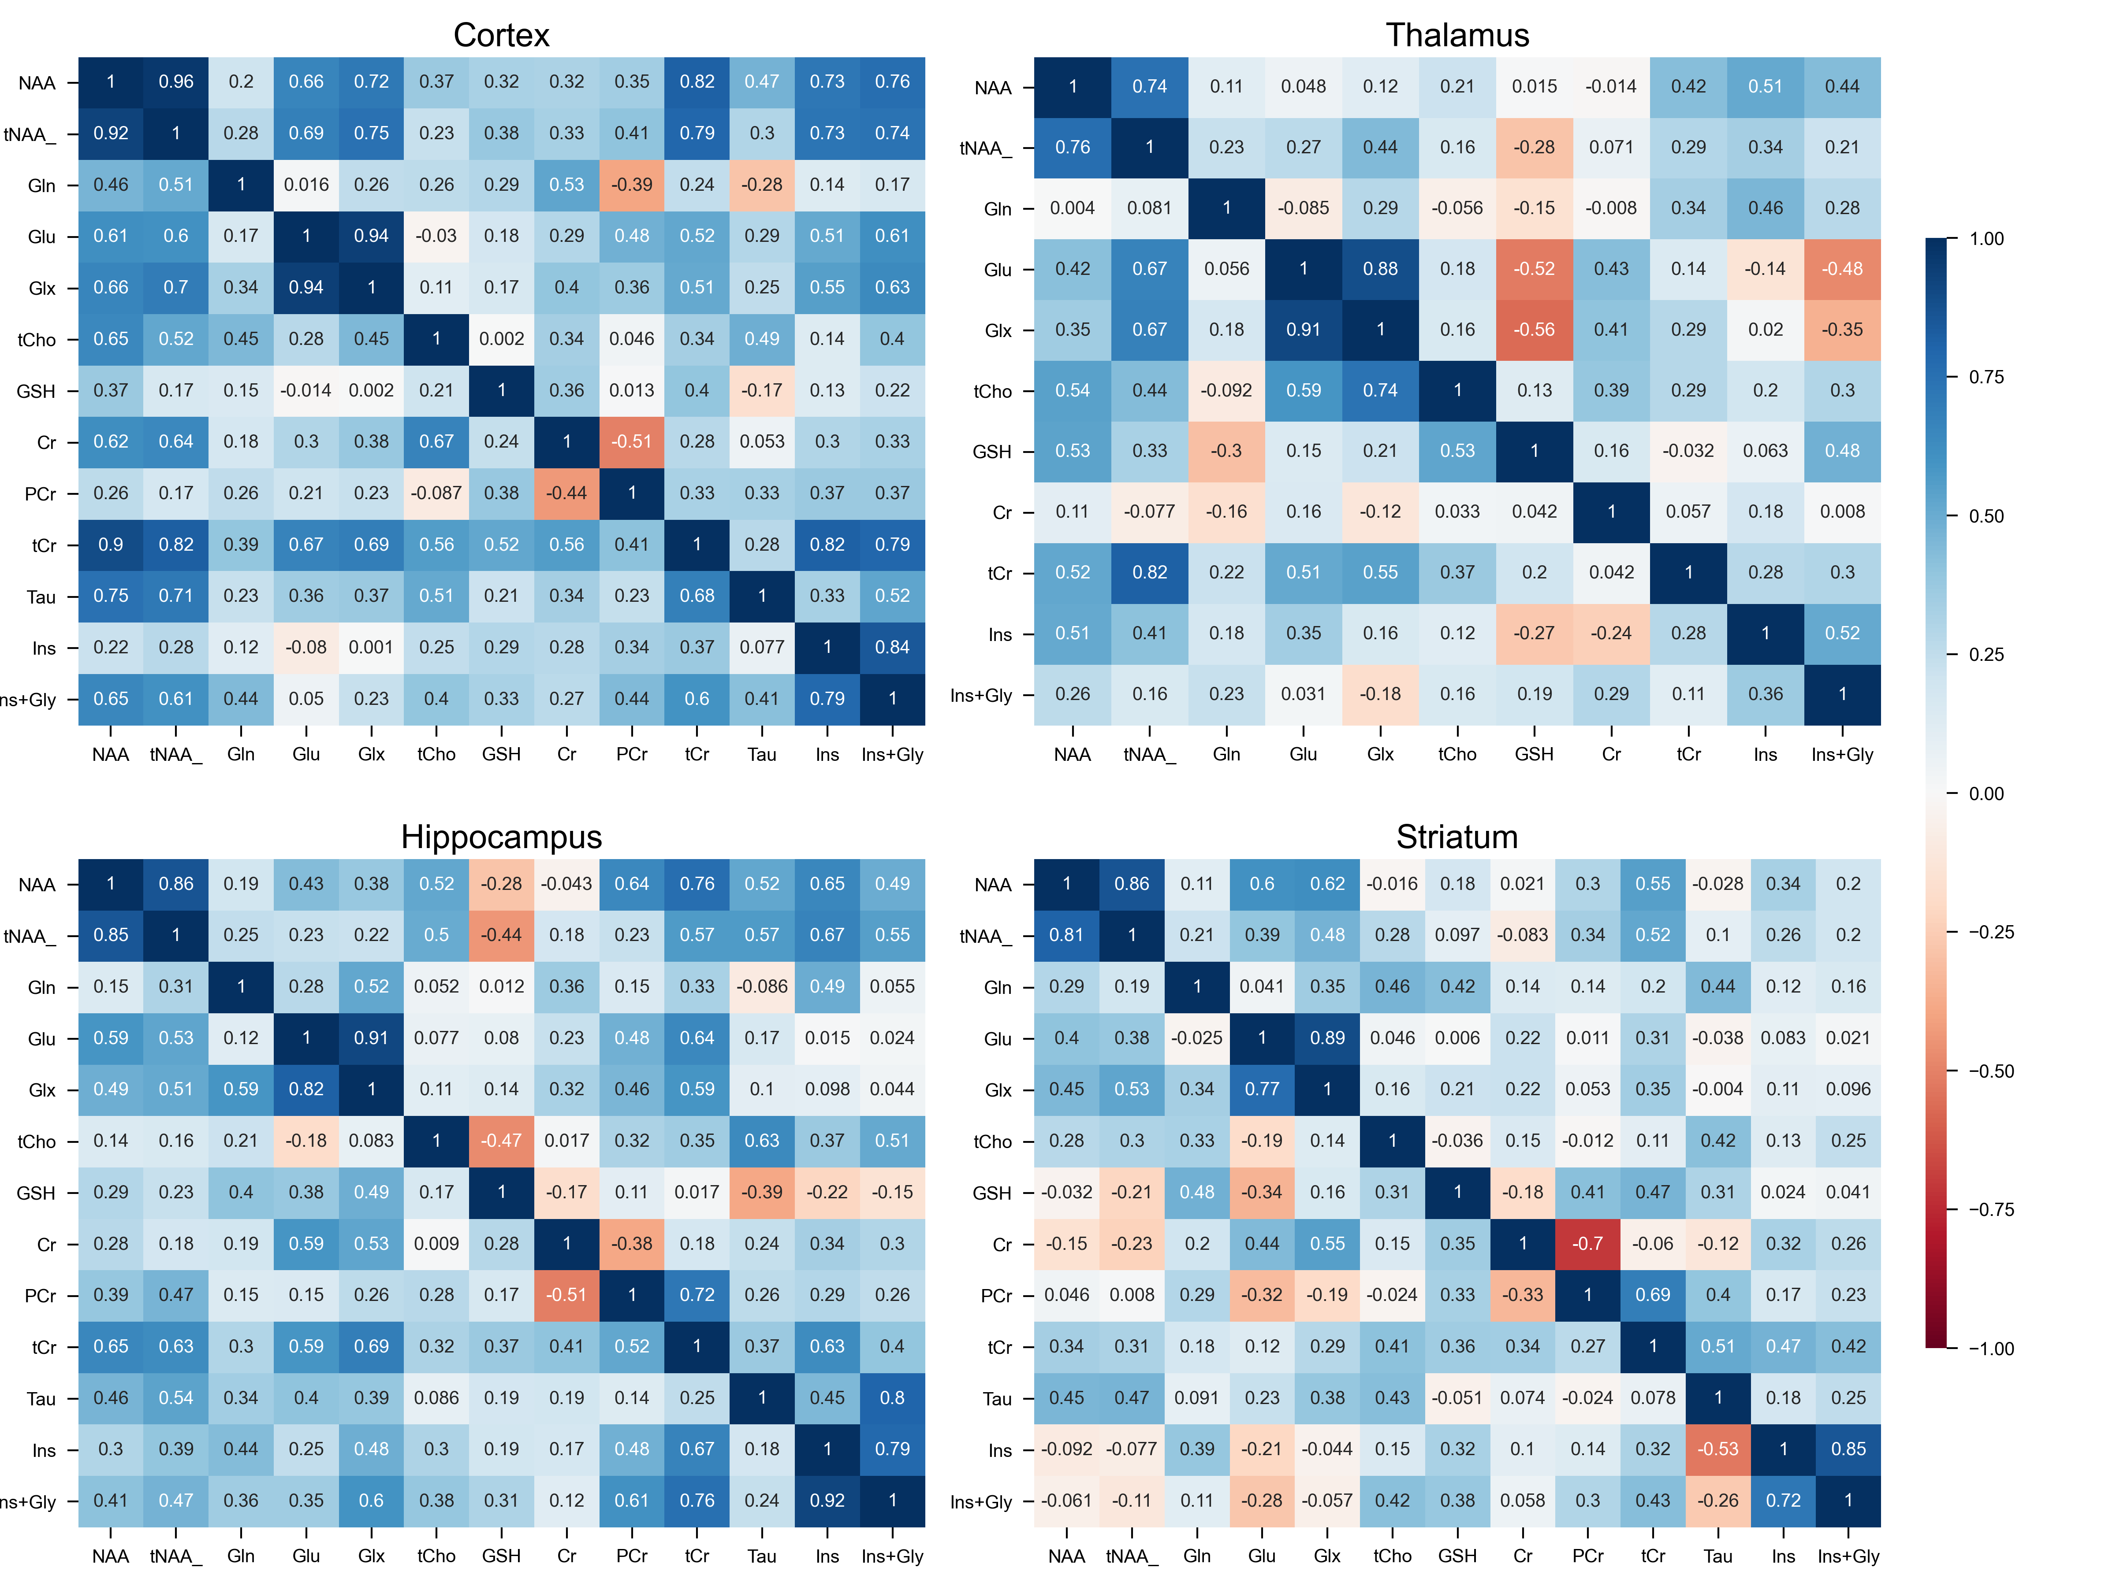

Supplementary Figure 1. Intra-regional correlation coefficients between metabolite concentration in each region. Upper triangle: correlation in wildtype animals; lower triangle: correlation in TgF344-AD. NAA: N-acetylaspartate; tNAA: NAA+N-acetylaspartylglutamate (NAAG) pool; Gln: glutamine; Glu: glutamate; Glx: Glu+Glx pool; GSH: glutathione; Cr: creatine; PCr: phosphocreatine; tCr: total creatine; Tau: taurine; Ins: myo-inositol; Ins + Gly: myo-inositol and glycine.

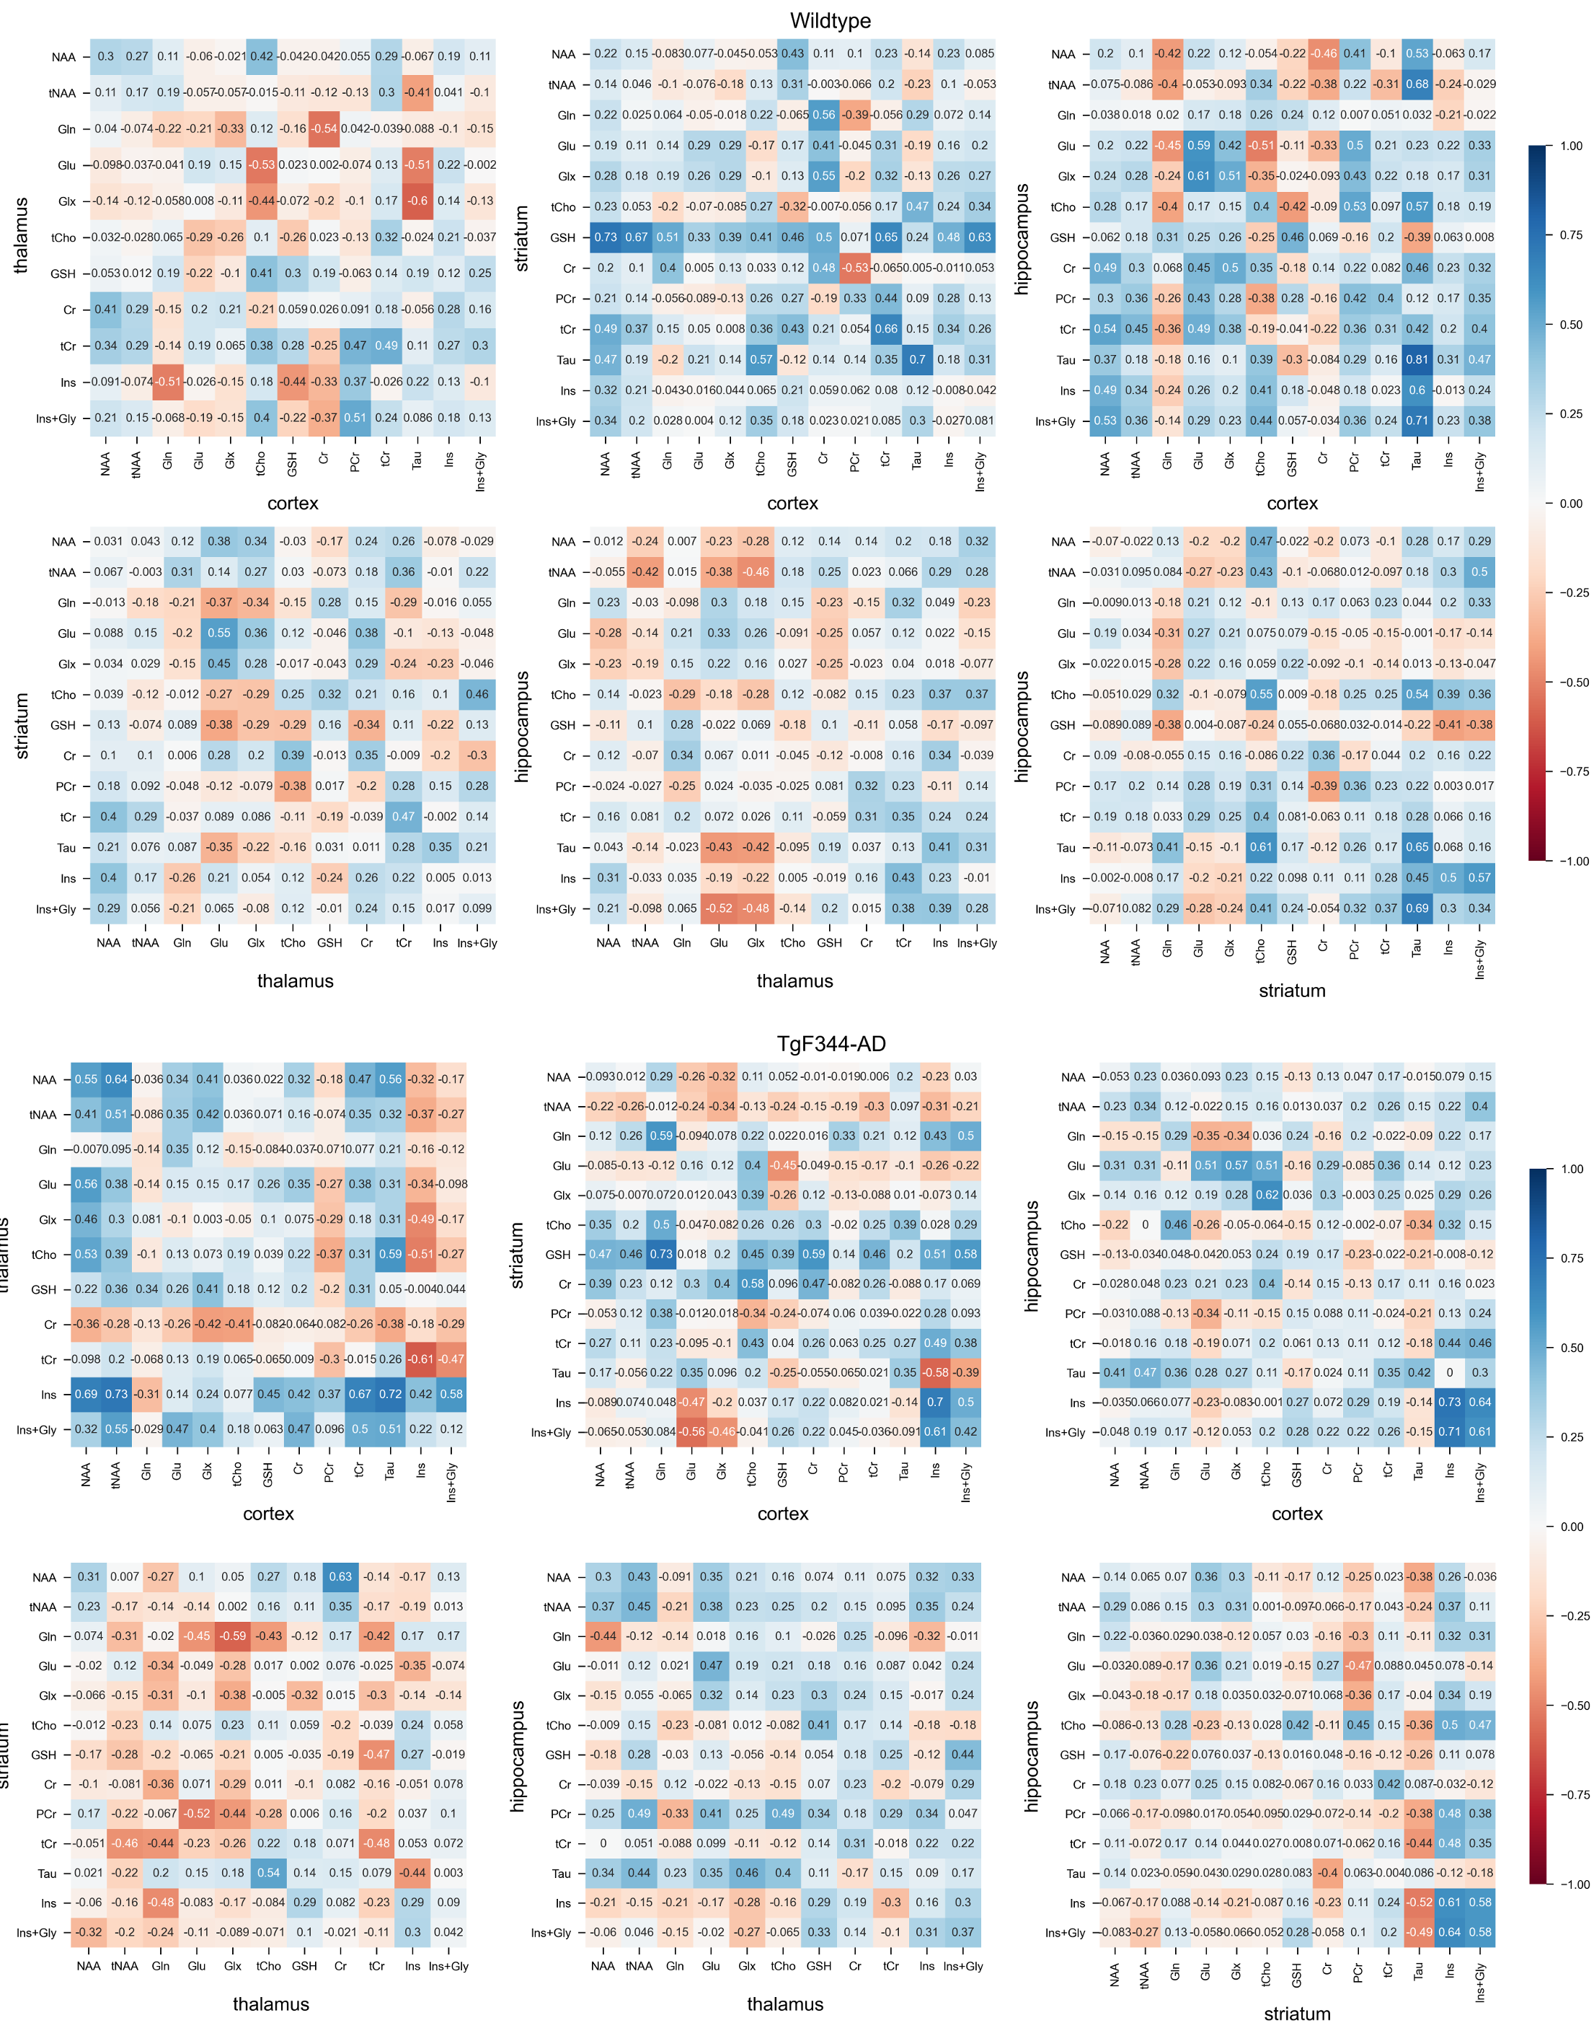
Supplementary Figure 2. Inter-regional correlation coefficients between metabolite concentration in each pair of regions in wildtype (superior rows) and TgF344-AD (inferior rows). NAA: N-Acetyl-Aspartate; tNAA: NAA+N-acetyl-aspartyl-glutamate (NAAG) pool; Gln: glutamine; Glu: glutamate; Glx: Glu+Glx pool; GSH: glutathione; Cr: creatine; PCr: phosphocreatine; tCr: total creatine; Tau: taurine; Ins: myoinositol; Ins + Gly: myoinositol and glycine.

