Supplementary Data
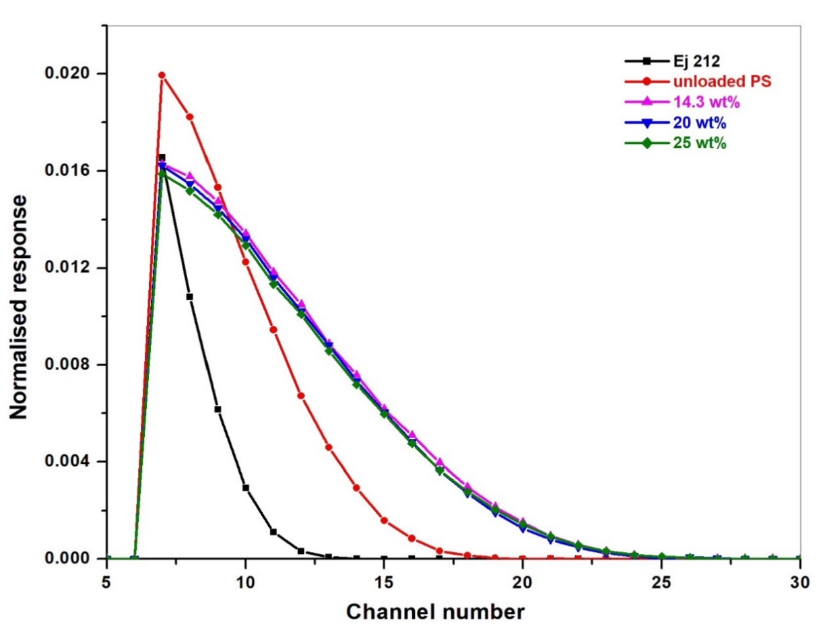
Fig. S1. PHS of ¹⁴C recorded for Ej 212 and PS loaded with different wt% of Gd(BO₂)₃:Tb.
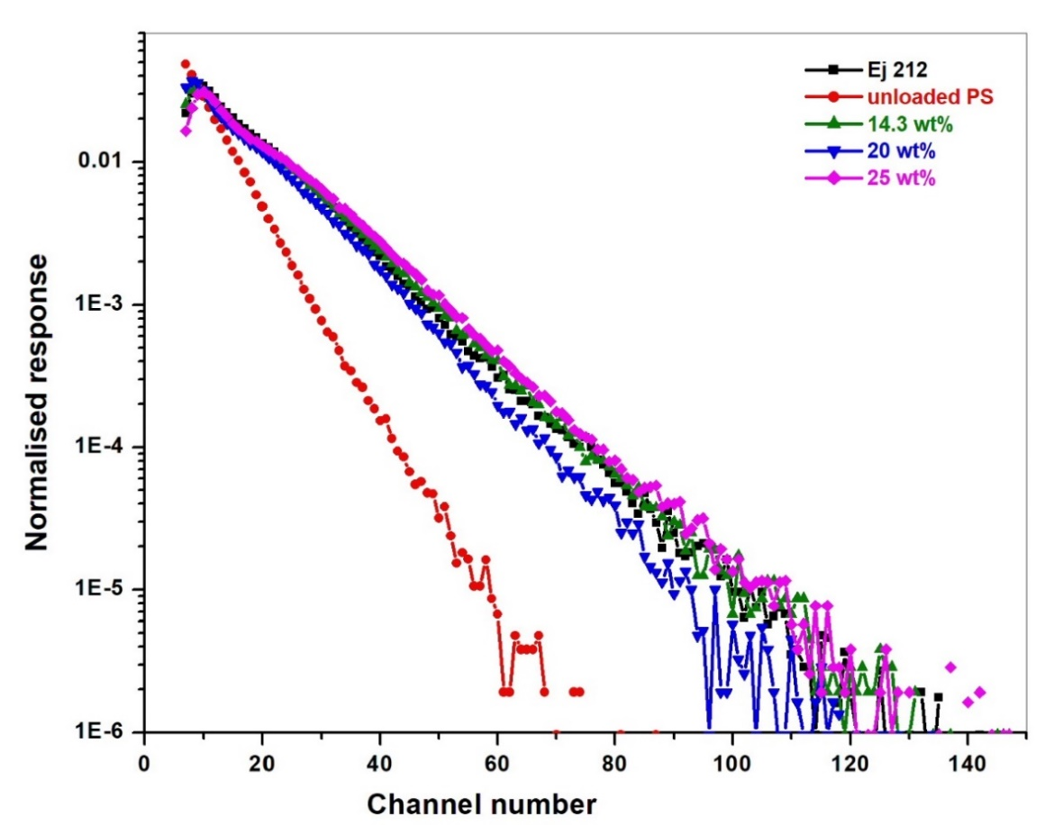
Fig. S2. PHS of ⁹⁰Sr-⁹⁰Y recorded for Ej 212 and PS loaded with different wt% of Gd(BO₂)₃:Tb
Ej 212 scintillator and all the composite scintillators showed similar spectra except unloaded scintillator. The unloaded scintillator exhibited lesser detection efficiency and end channel.
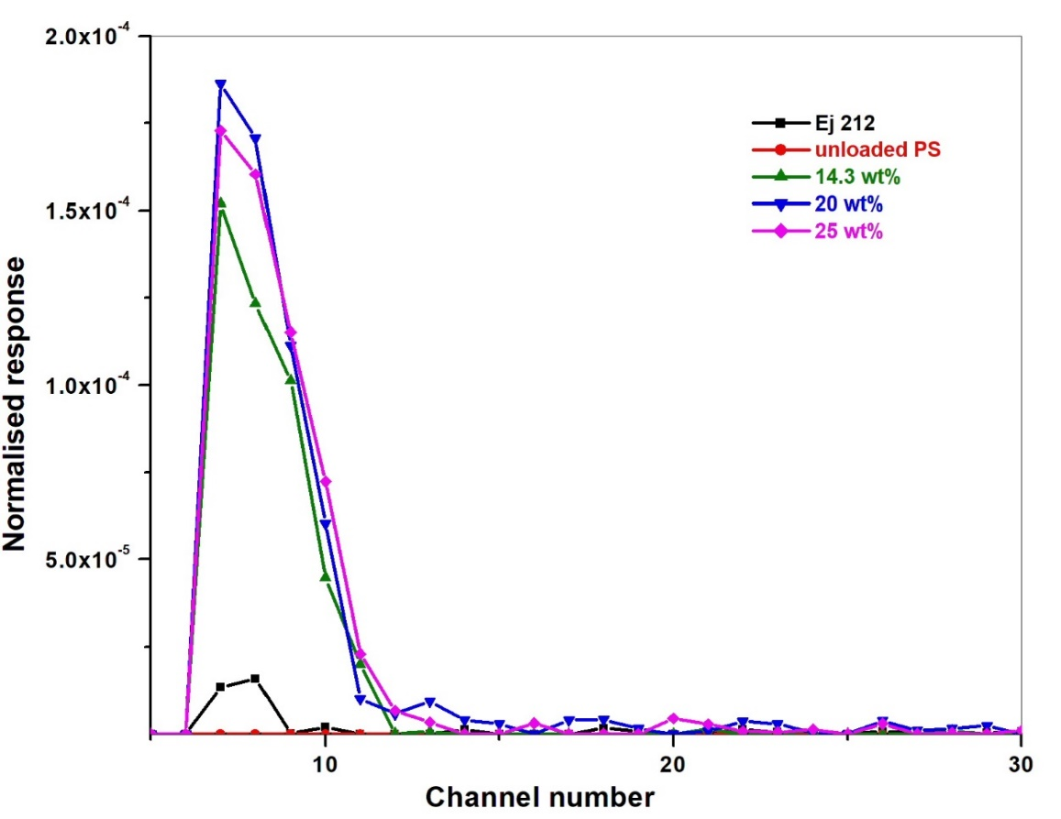
Fig. S3. PHS of ²⁴¹Am recorded for Ej 212 and PS loaded with different wt% of Gd(BO₂)₃:Tb
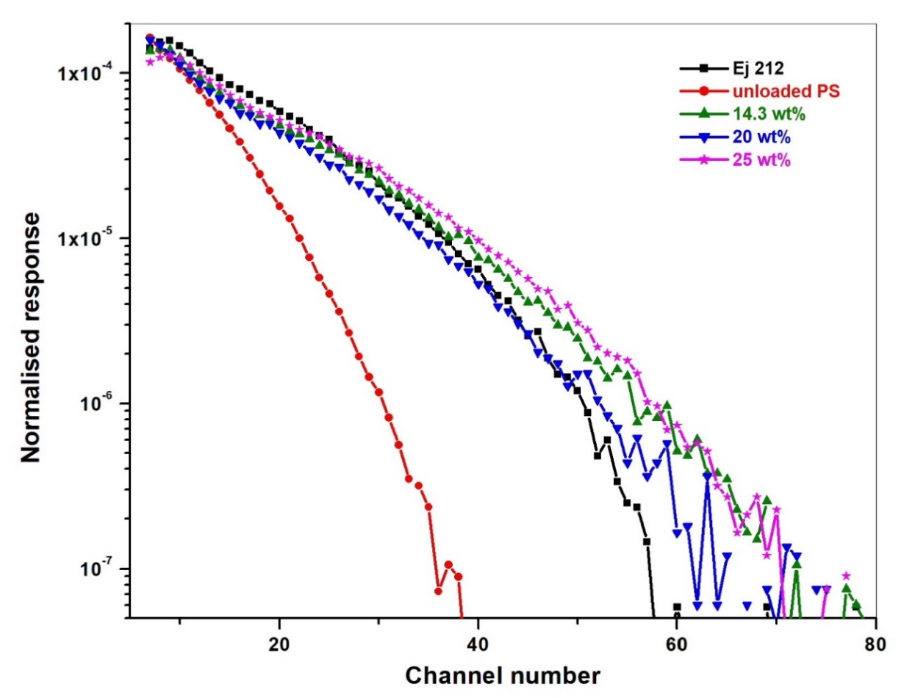
Fig. S4. PHS of ¹³⁷Cs recorded for Ej 212 and PS loaded with different wt% of Gd(BO₂)₃:Tb

