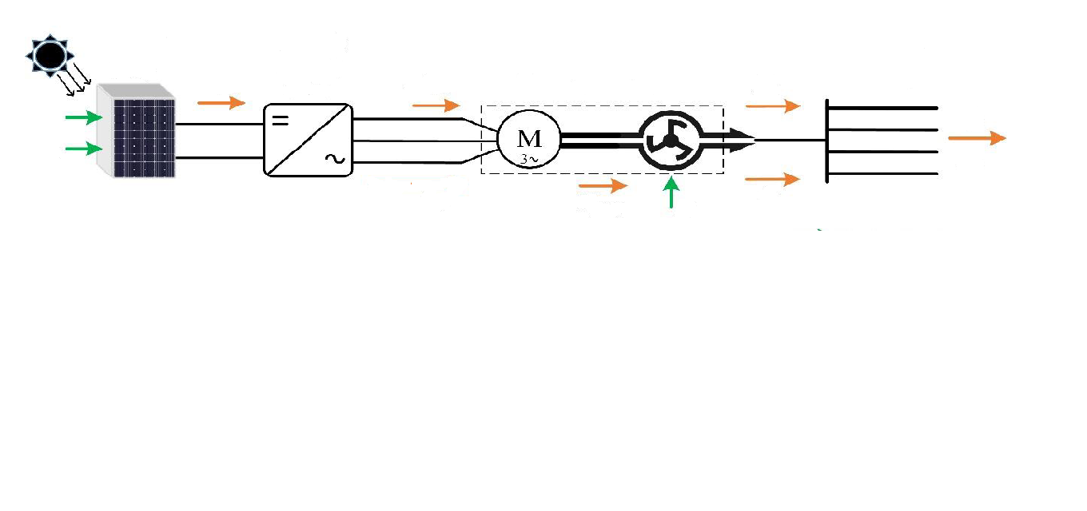
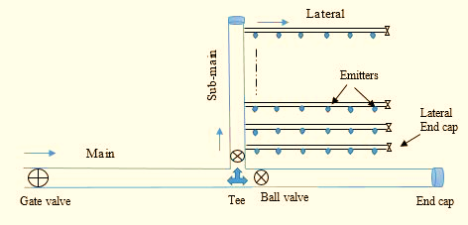
Crop Irrigation Schedule

Plan of operation
Solar PV system
Controller
Motor-pump
Sub-main manifold of
Drip irrigation system
Dynamic Simulation
System Evaluation
Power
Speed
Discharge
Head
Frequency
Water level
Graphical Abstract
Irradiation
Temperature

