Study Team | Mircher 2019 -> Thyroid hormone and folinic acid in young children with Down syndrome: The phase 3 ACTHYF trial
Study Design | single center, randomized, four-arm, double-blind, parallel-group, placebo-controlled phase 3 trial, performed in infants with DS  Period: April 2012 to December 2016
- Method of Randomization | Block randomization
- Stratification of Randomization | Randomization was stratified on the basis of age (<12 months vs. ≥12 months) and sex
- Strategy of allocation and concealment | Patients were assigned to treatment at JLI at the end of the inclusion visit by centralized randomization using a computer program, prepared by a statistician.
- Blinding  - Patients/Parents  - Clinicians  - Assessors  - Outcome Assessment | Yes Yes N/A N/A
- Objective Outcome | The primary endpoint was adjusted change from baseline in Griffiths Mental Development Scale global development quotient (GDQ) after 12 months
- Intention to treat analysis | Yes
- Examination of generalization | Yes
- Source of participants (setting/country) | Institut Jérôme Lejeune in Paris, France
- Number of participants with down syndrome  - Randomized | - A total of 175 patients were randomized between April 2012 and December 2016. Among them, 156 patients were included in the mITT population (41 placebo; 38 FA; 37 L-thyroxine; 40  FA+L-thyroxine; Fig. S1, Supplementary Appendix). Thirteen mITT patients prematurely discontinued the study and could not be assessed for the primary endpoint, resulting in the

- Initial Assessments  - Final Assessments  - Analyzed | primary analysis being performed in 143 patients (40 placebo patients, 30 FA, 35 L-thyroxine and 38 FA+L-thyroxine). Another five children did not cooperate during psychomotor assessment and were excluded from the per-protocol analysis (138 patients: 37 placebo patients, 30 FA, 34  L-thyroxine, and 37 FA+L-thyroxine).  - 156 patients  - mITT population: 143  - Not applicable
- Age | infants aged 6–18 months
- Diagnosis Confirmation | Patients had to be aged between 6 and 18 months at inclusion, with a karyotype demonstrating homogeneous free or Robertsonian translocation, complete trisomy 21, and without any serious cardiac conditions (i.e., unstable or with hemodynamic consequences) or neurological conditions.
- Gender | Males: 89  Females: 65
- Exclusion Criteria | Main exclusion criteria were gestational age <231 days, 5-minute Apgar score <7, congenital hypothyroidism, hypothyroidism (TSH > 7 mIU/L), hyperthyroidism, and leukemoid reaction at birth.
- Level of developmental functioning
- Type of antioxidant used | There are 4 intervention groups  - Folic Acid placebo and L-thyroxine placebo  - Folic Acid placebo and L-thyroxine  - Folic Acid and L-thyroxine placebo  - Folic Acid and L-thyroxine
- Mode of administration | Everything was orally administered
- Dose of antioxidant | Folinic acid (Folinoral®, Therabel) 1 mg/kg/day and L-thyroxine (Lévothyrox®, Merck) 3 µg/kg/day (or matched placebo) were administered orally for 12 months
- Duration | 1 year (12 months)
- Frequency per week | Daily

- Outcomes measured (developmental domain function) | - The primary efficacy endpoint was the adjusted change from baseline in global development quotient (GDQ) at 12 months, using the Griffiths Mental Development Scales (GMDS).  - Secondary endpoints included the change from baseline at 12 months for the Brunet–Lézine GDQ (a French psychomotor test for infants), as well as for height and head circumference.  - Exploratory endpoints included overall evolution of clinical global impression at 12 months from baseline in terms of no progress, slight progress, marked progress, or very marked progress.
- Statistical Analysis | Mean difference from baseline in GMDS GDQ
- Adverse Events | - five patients in the FA arm (11.6%) who discontinued treatment due to hypothyroidism  - two patients discontinued following unrelated events of acute myeloid leukemia and infantile spasms  - one patient in the L-thyroxine arm discontinued due to infantile spasms  - Sudden death was reported in a female patient treated in the combination arm at 18.5 months. She had normal T4 and TSH levels at her last evaluation and at death, and her death was considered not related to treatment by the IDMC
- Period to assessments | Three visits were scheduled (at baseline, 6 and 12 months after treatment initiation), plus telephone contact at least every 2 months, and follow-up assessments 2 and 4 months after last treatment intake. Psychologist performing baseline and 12-month evaluations, and baseline GMDS GDQ.
- Duration of follow-up | 1 year (12 months)
- Number lost on follow-up | 0
- Outcome scale used | Griffiths Mental Development Scales (GMDS) Brunet–Lézine Scale
- Assessors’ professional background | Neuropsychologists
- Conflict of interest | Jerome Lejeune Institute provided consulting fees to MP, AB, ES, JD, and AAK, and Effistat provided subcontracting fees to EB for statistical analysis. Writing assistance was provided by Sarah MacKenzie (funded by the Jerome Lejeune Foundation). The other authors declare no conflicts of interest.
- Incomplete outcome data | None identified
- Selective outcome reporting | None identified

- Other issues | None identified
- Outcomes reported | The present trial does not support the efficacy of either thyroid hormone or folinic acid as single agents or in combination, for improving psychomotor development in these patients → The effects on GDQ were not statistically significant
- Funding | Jerome-Lejeune Foundation  Fonds St. Michael

Study Team | Ellis, 2008, Supplementation with antioxidants and folinic acid for children with Down syndrome: a randomized controlled trial
Study Design | Randomised controlled trial with two by two factorial design Period: May 2002 to February 2004
- Method of Randomization | Random sequence generated by a Minim computer programme
- Stratification of Randomization | minimisation for sex and presence of congenital heart disease
- Strategy of allocation and concealment | Pharmacists, who retained the allocation lists, allocated participants according to a random sequence generated by a Minim computer programme with minimisation for sex and presence of congenital heart disease.
- Blinding  - Patients/Parents  - Clinicians  - Assessors  - Outcome Assessment | Yes N/A Yes N/A
- Objective Outcome | - One of four trained assessors measured the primary outcome, age adjusted general quotient on the Griffiths mental developmental scales (birth to 2 years, 1996 revised version), 18 months after enrolment.  - We assessed language development with a modified version of the MacArthur communicative development inventory, a five section postal questionnaire. As this was designed for the United States, we replaced the standard word list (section B) with one used for UK children24; we administered it to the parents at the 18 month home visit.
- Intention to treat analysis | Yes
- Examination of generalization | Yes
- Source of participants (setting/country) | Children living in the Midlands, Greater London, and the south west of England.

- Blinding  - Patients/Parents  - Clinicians  - Assessors  - Outcome Assessment | - 156  - 139
- Age | Under 7 months
- Diagnosis Confirmation | Not applicable
- Gender | Male: 89  Female: 67
- Exclusion Criteria | We excluded children with chromosome mosaicism or translocation, severe cardiac defects, or other serious long term illness and those from non-English speaking families.
- Level of developmental functioning | Not applicable
- Type of antioxidant used | 4 treatment groups  - Antioxidants → selenium 10 μg, zinc 5 mg, vitamin A 0.9 mg, vitamin E 100 mg, vitamin C 50 mg  - Folinic acid (0.1 mg)  - A combination of the same doses of antioxidants and folinic acid  - A placebo (mannitol, malodextrin, and a natural food colour)
- Mode of administration | Everything was orally administered
- Dose of antioxidant | - selenium 10 μg  - zinc 5 mg  - vitamin A 0.9 mg  - vitamin E 100 mg  - vitamin C 50 mg  - folinic acid (0.1 mg)  - The doses used in the study were 100% of the recommended daily allowance for vitamin E, zinc, and selenium and 200% of the recommended daily allowance for vitamin C and folinic acid  - the dosage was increased by 30% after the child’s first birthday

- Duration | 18 months
- Frequency per week | Daily
- Outcomes measured (developmental domain function) | - Age adjusted general quotient on the Griffiths mental developmental scales (birth to 2 years, 1996 revised version), 18 months after enrolment.  - The scales combine observations on how the child interacts with test equipment, together with developmental questions to parents. The number of “successes” the child achieves is converted to a developmental age equivalent. Scores are also produced on five subsections (locomotor, personal-social, hearing and language, coordination, and performance), and age adjusted subquotients are calculated. Parents used a diary to prospectively record the date their child achieved major motor milestones such as sitting without support and walking. Missing records were completed on the basis of parental recall at visits nine and 18 months after enrolment. We used Cox regression to estimate treatment differences in recorded age of attainment of milestones.  - We assessed language development with a modified version of the MacArthur communicative development inventory, a five section postal questionnaire. As this was designed for the United States, we replaced the standard word list (section B) with one used for UK children; we administered it to the parents at the 18 month home visit.  - We scored signed as well as spoken words and calculated the total number of gestures; phrases understood; and words said, signed and said, or signed. We adjusted the results for age.
- Statistical Analysis | Not applicable
- Adverse Events | More of the children taking antioxidants than taking folinic acid alone or placebo stopped taking supplements (15/74, 20% v 2/65, 3%; relative risk 6.5, 95% confidence interval 1.5 to 27). Only children taking antioxidants stopped supplements because of vomiting or distress (10/74 v 0/65; P=0.002).
- Period to assessments | One assessment 18 months after enrolment
- Duration of follow-up | 18 months after enrolment
- Number lost on follow-up | Lost to follow up (n=17) → Died (n=3), developed Leukemia (n=3), moved abroad (n=4), lost contact (n=7)
- Outcome scale used | Griffiths developmental quotient and an adapted MacArthur communicative development inventory

- Assessors’ professional background | Not applicable
- Conflict of interest | None identified
- Incomplete outcome data | None identified
- Selective outcome reporting | None identified
- Other issues | None identified
- Outcomes reported | Study found no evidence for clinically or statistically significant effects of antioxidants or folinic acid on any of the outcomes measured (GDQ).
- Funding | Down syndrome association Foundation Jerome-Lejeune Foundation

Study Team | Coleman, 1985, A double blind study of Vitamin B5, in Down syndrome infants. Part I clinical and biochemical results
Study Design | Double-blind experiment
- Method of Randomization | The parents of patients in this study did not represent an unselected population of DS parents, but rather those parents willing to have their children be part of a research project. All patients in the clinic were required to enroll in an infant stimulation or infant learning programme, in addition to the research protocol.
- Stratification of Randomization | N/A
- Strategy of allocation and concealment | N/A
- Blinding  - Patients/Parents  - Clinicians  - Assessors  - Outcome Assessment | - Yes  - N/A  - Yes
- Objective Outcome | This paper (Part 1) describes the results of the clinical portion of the evaluation; the following paper (Part  2) reports on the effects of B6 on the auditory evoked potentials of the infants enrolled in this study.
- Intention to treat analysis | Yes
- Examination of generalization | Yes
- Source of participants (setting/country) | Washington → Georgetown University
- Number of participants with down syndrome  - Randomized | In the DS clinic, the double blind 3-year trial of B or placebo was planned for 20 patients. During the first year of the protocol, two patients with congenital cardiac disease died, and one was able to be replaced before the protocol was closed. Thus, the double blind study ended up with 19 patients.  - 19  - 19

- Initial Assessments  - Final Assessments  - Analyzed | - 19  - 19
- Age | Under 8 weeks
- Diagnosis Confirmation | N/A
- Gender | There were six male infants and four female infants who received the vitamin; there were five male infants and four female infants on placebo.
- Exclusion Criteria | N/A
- Level of developmental functioning | N/A
- Type of antioxidant used | B6
- Mode of administration | Oral
- Dose of antioxidant | The double blind protocol consisted of the administration of pharmacological doses of B6 (25 mg/kg for the first 6 months of age and 35 mg/kg thereafter) or placebo to each infant once daily in the morning until they were 3 years of age.
- Duration | 3 years
- Frequency per week | once daily in the morning
- Outcomes measured (developmental domain function) | Psychological testing at 3 years of age  Height, weight, cranial circumference, and amount of tongue protrusion 5-HT and pyridoxal phosphate (PLP) determinations of blood
- Statistical Analysis | The Kurskall-Waliace one-way analysis of variance and the Chi square were used in this paper. Study also used mean difference
- Adverse Events | During the double blind study, one of the infants developed the infantile spasms syndrome

- Period to assessments | The patients were brought to the clinic in most cases eight times a year in the first year of life and four times a year in subsequent years. After the child's third birthday and the completion of the 3-year independent evaluations, the code was broken for parents and professionals.
- Duration of follow-up | The patients were brought to the clinic in most cases eight times a year in the first year of life and four times a year in subsequent years.
- Number lost on follow-up | None lost on follow-up
- Outcome scale used | An informal system of scoring the amount of tongue protrusion was developed during the study. Bayley Scales of Infant Development or the Stanford-Binet and the Vineland Social Maturity Scale.
- Assessors’ professional background | Physicians (Pediatricians)
- Conflict of interest | None identified
- Incomplete outcome data | None identified
- Selective outcome reporting | Yes
- Other issues | - A comparison of the height and weight of the children at birth and at 3 years of age was done. In order to correct for genetic factors, the height and weight of the parents was also examined. By chance, the mothers of the control group were 5 inches taller on the average and the difference in heights between the two sets of mothers was statistically significant!
- Outcomes reported | - In the case of the cranial circumferences, again there was no difference between treated and control patients.  - There was no significant difference between the height and weight of the treated and control patients.  - Psychological testing at 3 years of age indicated no difference between the two groups in any type of testing.  - An informal system of scoring the amount of tongue protrusion was developed during the study → no statistically significant differences were found
- Funding | - None

Study Team | Smith 1984, Use of mega doses of vitamins with Down syndrome
Study Design | The study used a two-group, matched-pair design carried out in three phases.
- Method of Randomization | In the baseline phase, each child was evaluated in two or three sessions with a battery of standard psychological tests, a physical examination, and blood tests. A group of 13 psychologists was randomly assigned to individual children to administer the tests. At the completion of all evaluations, summary data were sent to a co-investigator who assigned the children to either a vitamin-mineral or placebo group.
- Stratification of Randomization | N/A
- Strategy of allocation and concealment | Group assignment was done in 2 steps  - matched pairs were formed on the basis of five criteria  - group membership was randomly determined for each pair  The matching criteria were selected for two reasons: to create two comparable groups on the major variable to be evaluated (intelligence), and to minimize initial group differences on variables shown to be related to deviations in intelligence in the study population. The criteria were initial level of intelligence, chronologic age, sex, socioeconomic status of the family, and type of educational program of the child. Group assignment data were sent to the hospital pharmacy, where, by code, a 4-month supply of either the vitamin-mineral supplement or the placebo was distributed to each child.
- Blinding  - Patients/Parents  - Clinicians  - Assessors  - Outcome Assessment | - yes  - Yes  - Yes
- Objective Outcome | To evaluate the effects of mega doses of vitamins with minerals on the cognitive intelligence of children with Down syndrome

- Intention to treat analysis | Yes
- Examination of generalization | n/a
- Source of participants (setting/country) | USA → metropolitan area
- Age | 7-15 years
- Diagnosis Confirmation | Karyotyping
- Gender | n/a
- Exclusion Criteria | Minimal eligibility criteria for those included in the study group were diagnosis confirmed by karyotyping; no serious hearing, vision, or motor impairment; child residing at home and attending a school program; no major illness or untreated heart defects; and no over-the-counter vitamin or mineral preparations taken by the child during the course of the study.
- Level of developmental functioning | Unclear
- Type of antioxidant used | 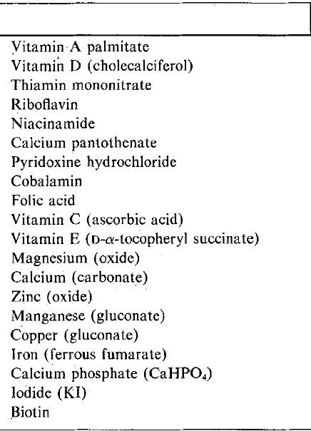
- Mode of administration | Oral administration

- Dose of antioxidant | 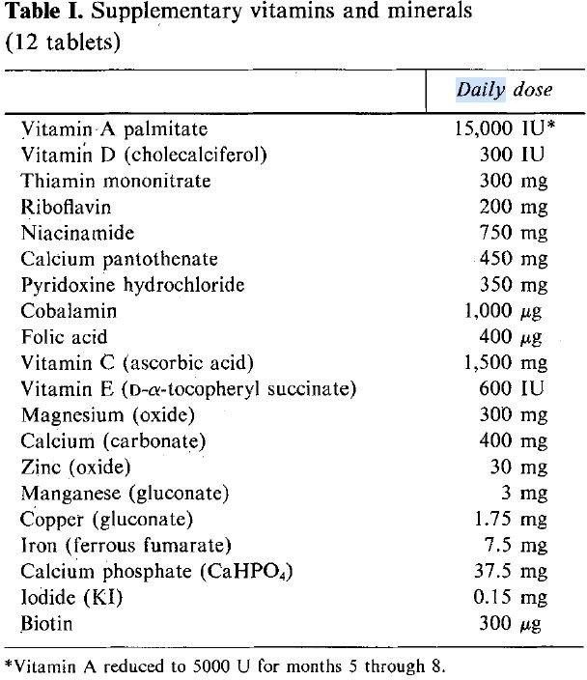
- Duration | 8 months
- Frequency per week | Throughout the two 4-month periods, each child took 12 pills or capsules per day in three equal doses
- Outcomes measured (developmental domain function) | Intellectual quotient, motor proficiency, receptive language, visuo-motor integration
- Statistical Analysis | Two (group) by three (time) repeated measures analysis of variance was used to compare  vitamin-mineral versus placebo groups on the standardized tests over time. Group matching variables were compared with Student t test and chi-square tests.
- Adverse Events | none
- Period to assessments | Baseline, 4 months and 8 months
- Duration of follow-up | 8 months
- Number lost on follow-up | No participants lost to follow-up
- Outcome scale used | Wechsler Intelligence Scale for Children Peabody Picture Vocabulary Test  Bruininks-Oseretsky Test of Motor Proficiency Developmental Test of Visual-Motor Integration

 | A medical history and physical examination were then done, height and weight were recorded, blood was drawn, and a urine sample was collected
- Assessors’ professional background | Psychologists
- Conflict of interest | None identified
- Incomplete outcome data | None identified
- Selective outcome reporting | None identified
- Other issues | None identified
- Outcomes reported | Our results provide no evidence that these nutritional supplements enhance any of the specific abilities that contribute to overall global intelligence.
- Funding | None mentioned

Study Team | Pueschel, 5-Hysdroxytryptophan and Pyridoxine: Their effects in young children with Down’s syndrome
Study Design | Randomized Controlled Trial (double-blind study)
- Method of Randomization | Paper doesn’t state the method of randomization only the fact that random assignment was done by our biostatistical consultant from the Harvard School of Public Health, Boston, and transmitted directly to the participating pharmacist so that the evaluation team was unaware of the random assignment
- Stratification of Randomization | n/a
- Strategy of allocation and concealment | n/a
- Blinding  - Patients/Parents  - Clinicians  - Assessors  - Outcome Assessment | - Yes  - n/a  - yes
- Objective Outcome | The primary objective of this study was to evaluate the effects of 5-hydroxytryptophan or pyridoxine hydrochloride administration on motor, social, intellectual, and language development in young children with Down's syndrome.
- Intention to treat analysis | no
- Examination of generalization | Unclear
- Source of participants (setting/country) | general hospitals located in the greater Boston area, other parts of Massachusetts, southern New Hampshire and Vermont, northern Connecticut, and Rhode Island.
- Number of participants with down syndrome  - Randomized  - Initial Assessments | four study groups were designed: placebo, pyridoxine, 5-hydroxytryptophan, and 5-hydroxytryptophan pyridoxine

- Final Assessments  - Analyzed | - 20 children in the placebo group, 23 in the pyridoxine group, 22 in the 5-hydroxytryptophan group, and 24 in the 5-hydroxytryptophan-pyridoxine group.  - Of the 114 children, 25 were excluded for various reasons → 13 died (12 of 13 had severe congenital heart disease), 10 withdrew from study, 2 were excluded (one had mosaic down’s syndrome and other had incomplete data at the time of study)  - 89 children  - 89 children analyzed
- Age | Newborns
- Diagnosis Confirmation | karyotyping
- Gender | Male: 50  Female: 39
- Exclusion Criteria | Children with severe congenital heart disease and with mosaic down syndrome were excluded from study.
- Level of developmental functioning | No baseline developmental functioning as criteria for children to partake in study
- Type of antioxidant used | - 5-hydroxytryptophan  - Pyridoxine
- Mode of administration | Oral administration
- Dose of antioxidant | The various compounds, placebo, pyridoxine, 5-hydroxytryptophan, and 5-hydroxytryptophan-pyridoxine, were provided in capsules indistinguishable from each other and were administered in divided doses of 1 to 2 mg/kg/day of 5-hydroxytryptophan and 5 to 10 mg/kg/ day of pyridoxine hydrochloride. The initial dosage was low (1 mg/kg/day of 5- hydroxytryptophan and 5 mg/kg/day of pyridoxine hydrochloride). If no side effects were observed, the dosage was gradually increased to its maximum (2 mg/kg/day of  5-hydroxytryptophan and 10 mg/kg/day of pyridoxine hydrochloride).
- Duration | 3 years
- Frequency per week | Daily

- Outcomes measured (developmental domain function) | Muscle Tone  Social competence (Vineland Social Maturity Scale)  Cognitive, Language (Receptive & Expressive), Motor (Gross & Fine), Social-Emotional and Adaptive → Bayley Scales of Infant Development  5-hydroxyindole in the blood of participants
- Statistical Analysis | Table 6 - Means, SD, and Interaction Effects of Vineland Social Maturity Scale Raw Scores Obtained at Six-Month Intervals
- Adverse Events | n/a
- Period to assessments | 3 monthly lab investigations  The parents' ability to comply and follow through with the furnished guidance was rated as yes or no by the participating nurse after lengthy interviews with the parents at six-month intervals.  Receptive Expressive Emergent Language Scale on 3rd birthday Vineland Social Maturity Scale every 6 months  Bayley Scales of Infant Development every 6 months
- Duration of follow-up | 3 years
- Number lost on follow-up | Didn’t mention anything
- Outcome scale used | Vineland Social Maturity Scale Bayley Scales of Infant Development  Receptive Expressive Emergent Language Scale  The muscle tone of the children in the study was evaluated independently by three examiners: pediatrician, neurologist, and physical therapist, each of whom followed his or her individual protocols. D
- Assessors’ professional background | Neurologist, Physiotherapist, Pediatrician
- Conflict of interest | None identified
- Incomplete outcome data | None identified
- Selective outcome reporting | None identified

- Other issues | - the random assignment of children to the study groups placed more children with moderate and severe congenital heart disease in the placebo group  - It is generally agreed that the conventional assessment of muscle tone is not an accurate science. Therefore, we attempted to objectively quantify the muscle tone of children with Down's syndrome by computerized electromyography however these efforts failed and examiners resorted to conventional assessments  - It seems that if there was any positive drug effect, it was overshadowed by the parental compliance variable
- Outcomes reported | Even if 5-hydroxytryptophan administered to children with Down's syndrome were transported adequately into the CNS, we still would lack information on how increased 5-hydroxyindole compounds in the CNS would affect the overall mental functioning of these children.
- Funding | None mentioned

Study Team | Lonsdale, 1986, Clinical Trials of Thiamine Tetrafurfuryl sulfide (TTFD) in Down syndrome
Study Design | Randomized Controlled Trial (double-blind study)
- Method of Randomization | Assignment to groups was made at random by a study coordinator, and the parents and clinical investigators were blind to the assignment.
- Stratification of Randomization | Age and sex matched
- Strategy of allocation and concealment | Study coordinator concealed assignment from parents and clinical investigators.
- Blinding  - Patients/Parents  - Clinicians  - Assessors  - Outcome Assessment | - Yes  - Yes
- Objective Outcome | Assessing the effect of TTFD on children Down Syndrome symptoms
- Intention to treat analysis | Yes
- Examination of generalization | Yes
- Source of participants (setting/country) | Couldn’t find in study

- Number of participants with down syndrome  - Randomized  - Initial Assessments  - Final Assessments  - Analyzed | 22 children → 11 children in placebo and 11 in treatment groups  - 22  - 22  - 22  - 22
- Age | 8 to 16 years of age
- Diagnosis Confirmation | n/a
- Gender | Male: 8  Female: 14
- Exclusion Criteria | n/a
- Level of developmental functioning | n/a
- Type of antioxidant used | Tetrahydrofurfuryl Disulfide (TTFD)
- Mode of administration | Oral administration → bright yellow enteric coated pills (both placebo and treatment intervention was identical in appearance)
- Dose of antioxidant | The dose of TTFD used was 50 mg in divided doses, given three times a day.
- Duration | 12 months (1 year)
- Frequency per week | Daily
- Outcomes measured (developmental domain function) | - Each subject received an initial IQ test, and a hair analysis. IQ test was repeated after 6 months and again after a second 6 months. Hair analysis was repeated at one year, but not at six months.  - A clinical photograph was made of the face in order to document any clear cut visible change that might occur.
- Statistical Analysis | IQ percentage increase

- Adverse Events | None identified
- Period to assessments | IQ test - baseline, 6 months and 12 months Hair analysis - baseline, 12 months  Clinical photograph - baseline
- Duration of follow-up | 12 months
- Number lost on follow-up | None of the participants were lost to follow-up
- Outcome scale used | - The Wechsler Intelligence Scale for Children — Revised (WISC-R) was used for those subjects below the age of 16 years throughout the study. The Wechsler Adult Intelligence Scale — Revised (WAIS-R) was used for those subjects who would be over 16 years at the end of the study  - Hair Analysis → Refer to Table 3 (The changes of heavy metal concentrations hair of 22 subjects were reported)  - Symptom Inventory Chart → Refer to Table 1
- Assessors’ professional background | Not identified
- Conflict of interest | None identified
- Incomplete outcome data | None identified
- Selective outcome reporting | None identified
- Other issues | None identified
- Outcomes reported | Wechsler Intelligence Scale for Children
- Funding | Association of Retarded Citizens, Ohio.

Study Team | Bidder, 1989, The effects of minerals and vitamins on children with Down syndrome
Study Design | Randomized, double-blind, placebo-controlled, cross-over, single-centre trial
- Method of Randomization | Nothing identified
- Stratification of Randomization | Nothing identified
- Strategy of allocation and concealment | Nothing identified
- Blinding  - Patients/Parents  - Clinicians  - Assessors  - Outcome Assessment | - Yes  - Yes  - Yes
- Objective Outcome | Effects of high doses of multivitamins and minerals on the developmental quotient and developmental age of children with DS
- Intention to treat analysis | No
- Examination of generalization | Nothing identified
- Source of participants (setting/country) | South-east Wales Down’s Association

- Number of participants with down syndrome  - Randomized  - Initial Assessments  - Final Assessments  - Analyzed | - 15 (Three families opted out at the beginning of the first trial: two children persistently refused to take the trial preparation in any form, and the third child had a very strong reaction to the active treatment, involving erythema, oedema and vomiting. A further child was withdrawn for similar reasons in the second part of the trial.)  - 15  - 13  - 13
- Age | 8 to 63 months
- Diagnosis Confirmation | Nothing identified
- Gender | Active Treatment First Group (M:F) → 3:8 Placebo First Group (M:F) → 6:7
- Exclusion Criteria | None identified
- Level of developmental functioning | Mean developmental quotient in active treatment first group → 62 (SD 15) Mean developmental age in active treatment first group → 24 (SD 10)  Mean developmental quotient in placebo first → 59 (SD 17) Mean developmental age in placebo first group → 19 (SD 6)

- Type of antioxidant used | 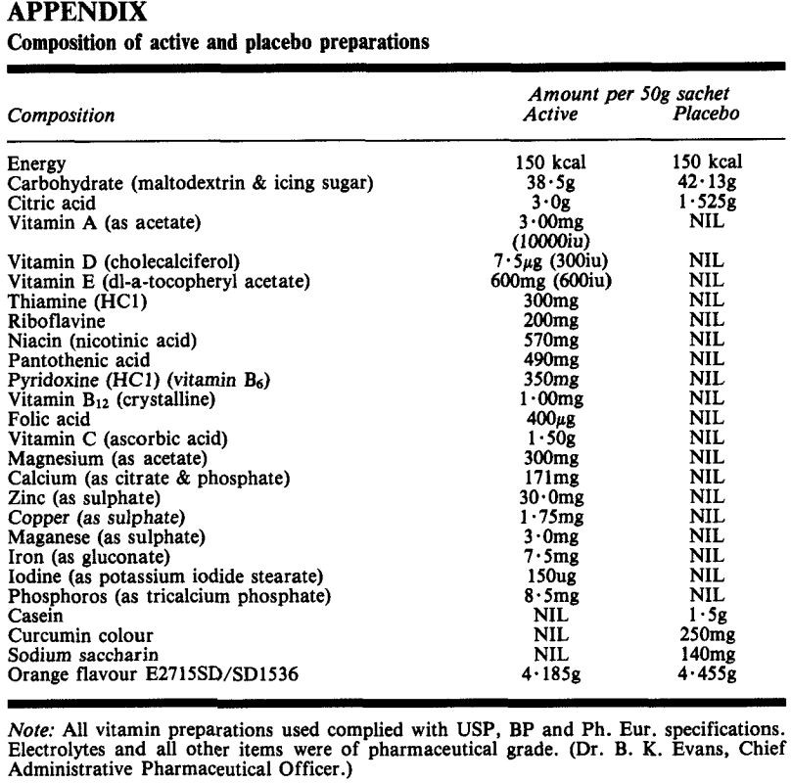
- Mode of administration | Oral administration (powder composition could be mixed it into puddings, ice lollies and drinks)
- Dose of antioxidant | The dosages of both were adjusted for the child’s weight as follows: S15kg, 30g; 16 to 20kg, 40g; >20kg, 50g.
- Duration | 3 months - first treatment period  This phase was followed by a 1 month washout period without supplements 3 months - second treatment period (reversed)
- Frequency per week | Daily
- Outcomes measured (developmental domain function) | Standard black-and-white photographs were taken of the children before each assessment. These were rated for general appearance, hair texture and blotchiness of skin by two raters (Child Development Advisors) who are experienced in working with children with Down syndrome.  Parents kept regular recordings of their child’s appearance, behaviour recorded on a bipolar scale of relevant adjectives, sleep routine and bowel motions, every day for one week once a month. The parents also kept an illness diary.  Urine analysis also carried out (blind).  Language, Eye and Hand Coordination and Performance subscales of the Griffiths Developmental scales
- Statistical Analysis | Mean

 | SD
- Adverse Events | Most parental reports of side-effects related to the active preparation, and included flushing, tightness of the skin and occasional vomiting. Furthermore, its poor palatability led to compliance problems.
- Period to assessments | The research team assessed the children at the beginning of the study, at the end of the first treatment period, after the wash-out phase, and finally at the end of the second treatment period.
- Duration of follow-up | 7 months
- Number lost on follow-up | None lost to follow-up
- Outcome scale used | The measurements taken on the four occasions included the Language, Eye and Hand Coordination and Performance subscales of the Griffiths Developmental scales (Griffiths 1954, 1970).
- Assessors’ professional background | Child Developmental Advisors
- Conflict of interest | None identified
- Incomplete outcome data | None identified
- Selective outcome reporting | None identified
- Other issues | None identified
- Outcomes reported | The estimated mean difference is - 3 -5 DQ points (t= -2.43, p<0-05), and the 95 percent confidence interval, -6.7 to -0.3, excludes any beneficial effect of active treatment.
- Funding | None mentioned

Study Team | Blehaut, 2010, Effect of Leucovorin (Folinic acid) on the Developmental Quotient of children with Down syndrome (Trisomy 21) and influence of Thyroid status
Study Design | We carried out a one-year, double-blind, single-centre, randomised, placebo-controlled trial
- Method of Randomization | Patients were assigned to a treatment by the random permuted block method (1:1 ratio).
- Stratification of Randomization | None identified
- Strategy of allocation and concealment | An independent contract research organisation (LC2, Lyon, France) performed this operation and the randomisation list was not made available until the data were frozen. Thus, all investigators were blind to treatment assignments.

- Blinding  - Patients/Parents  - Clinicians  - Assessors  - Outcome Assessment | - Yes  - Yes
- Objective Outcome | The primary endpoint (efficacy variable) was an increase in global developmental age (DA), calculated as the following ratio: months acquired/months of follow-up.
- Intention to treat analysis | Yes
- Examination of generalization | Nothing identified
- Source of participants (setting/country) | Institut Jerome Lejeune, Paris, France
- Number of participants with down syndrome  - Randomized  - Initial Assessments  - Final Assessments  - Analyzed | - 117 - 4 withdrew early without an assessment of treatment efficacy - no patient withdrew due to treatment effects  - 113  - 113  - 113 - Evaluation by the same psychometric examiner before and after treatment, as required by the protocol, was not possible for 26 of the 113 patients (23.0%). The other 87 patients were included in an additional per protocol analysis of efficacy
- Age | Children aged 3 to 30 months
- Diagnosis Confirmation | Karyotyping
- Gender | Male: 50  Female: 53
- Exclusion Criteria | The inclusion criteria were: children aged 3 to 30 months, with complete, homogeneous trisomy 21. Patients had to weigh more than 4 kg, and be able to undergo assessment with the revised Brunet-Lezine

 | psychometric scale (BLS). Patients with a history of leukaemia or any other condition that might interfere with evaluations of treatment efficacy, such as epilepsy or unstable hypothyroidism, were excluded.
- Level of developmental functioning | LV group (Developmental Quotient):   Placebo group (Developmental Quotient): 
- Type of antioxidant used | pentahydrated calcium salt of leucovorin
- Mode of administration | Oral administration (capsules)
- Dose of antioxidant | The drug was produced as 5 mg capsules, which had to be opened for administration—in a single intake—at breakfast. The active drug was administered as the pentahydrated calcium salt of leucovorin, to obtain a daily dose of 1.060.3 mg/kg.
- Duration | 12 months
- Frequency per week | Daily
- Outcomes measured (developmental domain function) | Global Developmental Age (DA)
- Statistical Analysis | In an exploratory way, a principal component analysis was carried out with SPAD software  Once the influential factors had been identified, several models of analysis of variance (ANOVA) were tested for treatment efficacy.

- Adverse Events | 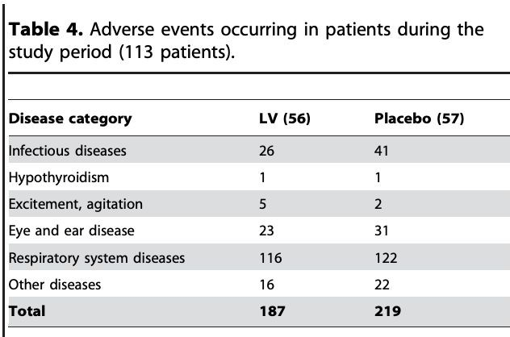
- Period to assessments | Baseline 6 months  12 months
- Duration of follow-up | 12 months
- Number lost on follow-up | None lost to follow-up
- Outcome scale used | The revised Brunet-Lezine scale was used to assess developmental age. This scale of psychomotor development in early childhood investigates four fields of childhood development: (i) ‘posture’, (ii)  ‘co-ordination’, (iii) ‘language’ and (iv) ‘sociability’, each with a corresponding subscore. The global DA score is derived from these four subscores. This scale has been validated for children of the general population with a developmental age of 2 to 30 months. It has been adapted for French populations and resembles the Bayley or Griffiths scales used in other countries.
- Assessors’ professional background | Physicians (4)  Psychologists (6)
- Conflict of interest | None identified
- Incomplete outcome data | None identified
- Selective outcome reporting | None identified

- Other issues | None identified
- Outcomes reported | The intention-to-treat analysis (113 patients) revealed no greater positive effect of LV than of placebo on change in global DA (52.1% of normal DA vs. 51.5%, respectively).  However, the per protocol multivariate analysis carried out on the 87 patients examined by the same person at the start and end of the trial showed that leucovorin probably enhanced DA. Children who received LV displayed a greater increase in DA (52.6%) than those treated with a placebo (42.8%, p = 0.046).  The cofactors most strongly linked to the first axis (and thus global DA) were leucovorin treatment, age at start of treatment, sex and concomitant thyroxin treatment
- Funding | Therabel-Lucien-Pharma Laboratories for providing leucovorin and the placebo.  Jerome Lejeune Foundation (Paris-France).

Study Team | Harrel, 1981, Can nutritional supplements help mentally retarded children? An exploratory study
Study Design | RCT
- Method of Randomization | Their initial intelligence test scores and other information were sent to William Shive (The University of Texas at Austin) who divided the subjects into two groups matched primarily on the basis of IQ.
- Stratification of Randomization | None identified
- Strategy of allocation and concealment | The group assignments were made known to Bronson Pharmaceuticals (La Canada, CA), the company that furnished the supplements and placebos. Sealed bottles of tablets were given to the parents each month; each bottle labeled only with the child's name and the dosage.
- Blinding  - Patients/Parents  - Clinicians  - Assessors  - Outcome Assessment | - Yes  - Yes  - Principal Investigator not blinded in second period of study
- Objective Outcome | Improvement in IQ  Measurements of height, weight, and urine tests for pH, specific gravity, protein, and blood cells Electroencephalograms
- Intention to treat analysis | Yes
- Examination of generalization | None identified
- Source of participants (setting/country) | children living in or near Norfolk, VA
- Number of participants with down syndrome | Originally there were 10 subjects in group 1 and 12 subjects in group 2. During the first 4 months, six subjects dropped out, mostly because of transfers of military families to new locations. Five of these were in group 1. There were 16 subjects that completed the

- Randomized  - Initial Assessments  - Final Assessments  - Analyzed | - 5  - 5  - 4  - 4
- Age | 5 to 10 years
- Diagnosis Confirmation | Nothing identified
- Gender | Male: 2  Female: 3
- Exclusion Criteria | None identified
- Level of developmental functioning | Group 1 Initial Mean IQ → 46.3 + 3.6  Group 2 Initial Mean IQ --. 48.5 + 5.2
- Type of antioxidant used | 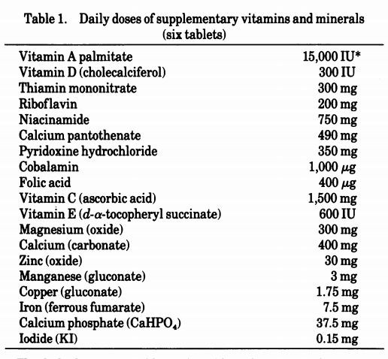
- Mode of administration | Oral administration

- Dose of antioxidant
- Duration | 8 months
- Frequency per week | six tablets to be swallowed each day, preferably two at each meal.
- Outcomes measured (developmental domain function) | Intellectual Quotient
- Statistical Analysis | Difference in IQ after 4th month and 8th month
- Adverse Events | None identified
- Period to assessments | Parents were asked to obtain two mental tests of their child during each of the three testing periods; one test was administered by the principal investigator (R. F. H.) and the other by the parents' choice among six local psychologists.
- Duration of follow-up | 8 months → The study consisted of two 4-month experimental periods. During the first period, one group of subjects (group I) received supplements and the other group (group II) received placebos. During the second period both groups received supplements. (We recruited the subjects with the understanding that all would eventually receive supplements.

- Number lost on follow-up | None lost to follow-up
- Outcome scale used | Stanford-Binet Intelligence Scale (everyone but 2 mute children) Wechsler Intelligence Scale  Cattell Infant Scale (2 mute children) Urinalysis  Electroencephalograms Visual Acuity.
- Assessors’ professional background | One test was administered by the principal investigator (R. F. H.) and the other by the parents' choice among six local psychologists. All seven psychologists were either licensed or certified; some were school psychologists and others were in private practice.
- Conflict of interest | None identified
- Incomplete outcome data | None identified
- Selective outcome reporting | None identified
- Other issues | “we hesitate to emphasize this analysis on the basis of our limited study”
- Outcomes reported | During the first 4-month period (double-blind) the 5 children who received supplements increased their average IQ by 5.0-9.6, depending on the investigator, whereas the 11 subjects given placebos showed negligible change. The difference between these two groups is statistically significant (P < 0.05).

Study Team | Weathers, 1982, Effects of nutritional supplementation on IQ and certain other variables
Study Design | RCT
- Method of Randomization | Not identified clearly
- Stratification of Randomization | Not identified clearly
- Strategy of allocation and concealment | Not identified clearly
- Blinding  - Patients/Parents  - Clinicians  - Assessors  - Outcome Assessment | - Yes  - Not sure  - Yes  - Not sure
- Objective Outcome | Asses the effects of vitamins and minerals on the intellectual, educational and language capabilities in children with DS
- Intention to treat analysis | Yes
- Examination of generalization | Not identified clearly
- Source of participants (setting/country) | Atlanta Down Syndrome Parents Association
- Number of participants with down syndrome  - Randomized  - Initial Assessments  - Final Assessments | - 47

- Analyzed | 47
- Age | 6 to 17 years
- Diagnosis Confirmation | Not identified
- Gender | Male: 31 (Treatment 16 and Control 15)  Female: 16 (Treatment: 8 and Control: 8)
- Exclusion Criteria | Inclusion Criteria: Children attending public school and living at home; all non-verbal children excluded from study
- Level of developmental functioning | Treatment group mean pretreatment IQ: 45.6 Control group mean pretreatment IQ: 45.4
- Type of antioxidant used | Formula used in Harrell et al study
- Mode of administration | Oral administration  12 tablets daily (4 tablets per meal)  Tablets were medium sized and prepared half in size by manufacturer therefore, double the number of tablets were administered  Parents asked to minimize use of sweets and snacks but no other considerable dietary changes
- Dose of antioxidant | Not clear
- Duration | 16 weeks
- Frequency per week | Daily
- Outcomes measured (developmental domain function) | Stanford-Binet Intelligence Scale: Differences not significant VMI: Differences not significant  Vision: 8 control and 10 experimental cases showed improvements Eye muscle balance: Improvement in 1 experimental case Stereopsis: Improvement in 1 experimental case  Behaviour changes: Differences not significant  Parents reported improvements in skin, hair, alertness and attention span

- Statistical Analysis | Responses to author constructed behaviour scales were given a number and the cumulative scores were compared using Hotelling T square technique  One way analysis of variance technique using SPSS conducted Group means and SDs on behaviour change scales  IQ, VMI, height, weight → pretest and post measures
- Adverse Events | 1 case of boils in adolescent boy of experimental group  1 child developed elevation of liver enzymes in experimental group
- Period to assessments | Stanford Binet and Beery VMI → all participants prior to intervention Behaviour changes assessed by weekly parental ratings  Weekly phone calls by student assistant to parent to discuss motor functions, response to environment, communication, activity level, physical signs, overall health  Height, weight, photograph, visual acuity and eye muscle balance assessed as well
- Duration of follow-up | 4 months
- Number lost on follow-up | None lost to follow-up
- Outcome scale used | Stanford Binet Intelligence Scale  Beery Buktenica visuomotor integration  Tests of visual acuity and eye muscle balance Height and weight  Photo
- Assessors’ professional background | Not mentioned
- Conflict of interest | None identified
- Incomplete outcome data | None identified
- Selective outcome reporting | None identified
- Other issues | None identified

- Outcomes reported | Stanford-Binet Intelligence Scale: Differences not significant VMI: Differences not significant  Vision: 8 control and 10 experimental cases showed improvements Eye muscle balance: Improvement in 1 experimental case Stereopsis: Improvement in 1 experimental case  Behaviour changes: Differences not significant  Parents reported improvements in skin, hair, alertness and attention span

Study Team | Bennet, 1983, Vitamin and mineral supplementation in DS
Study Design | RCT
- Method of Randomization | Unclear about the systematic method of randomization
- Stratification of Randomization | None identified
- Strategy of allocation and concealment | The person making these assignments had no other direct or indirect involvement in the study; thus, all investigators, parents, school teachers, and the children themselves were completely unaware of any participant’s group status throughout the entire duration of this investigation.
- Blinding  - Patients/Parents  - Clinicians  - Assessors  - Outcome Assessment | - Yes  - Not stated  - Yes  - Not stated
- Objective Outcome | Asses the effects of vitamins and minerals on the intellectual, educational and language capabilities in children with DS
- Intention to treat analysis | Yes
- Examination of generalization | No formal examination of generalization  Demographics of study: Children with DS → living with biological parents in middle income homes

- Source of participants (setting/country) | Study subjects were recruited from the Seattle, Washington metropolitan area by means of announcements in newsletters regularly circulated to parents of children with Down’s syndrome. Outpatient records of the University of Washington’s Child Development and Mental Retardation Center were also reviewed for potential participants.
- Number of participants with down syndrome  - Randomized  - Initial Assessments  - Final Assessments  - Analyzed | - 20  - 20
- Age | The study children ranged in age from 5 years, 9 months to 13 years 10 months with a median age of 1 1 years, 6 months
- Diagnosis Confirmation | Karyotyping
- Gender | Male: 10  Female: 10
- Exclusion Criteria | All participants were white, middle to upper-middle social class as determined by parental education and occupation. All 20 children had Down’s syndrome documented by karyotype; there were no cases of mosaicism. All were reared at home by their natural parents at the time of this investigation, and 19/20 had attended early developmental programs. starting between 1 month and 4 years of age.
- Level of developmental functioning | Mean pretreatment IQ of treatment group → 53.1 Mean pretreatment iQ of control group → 45.2
- Type of antioxidant used | Formula used in Harrell et al study
- Mode of administration | All children were required to swallow 12 medium-sized tablets daily in two or three divided doses, and parents were encouraged not to break or crush the tablets because a bitter odor and taste were associated with the vitamin/mineral supplements. All parents were asked to discontinue any additional vitamins or minerals that were being administered to their child.

- Dose of antioxidant | 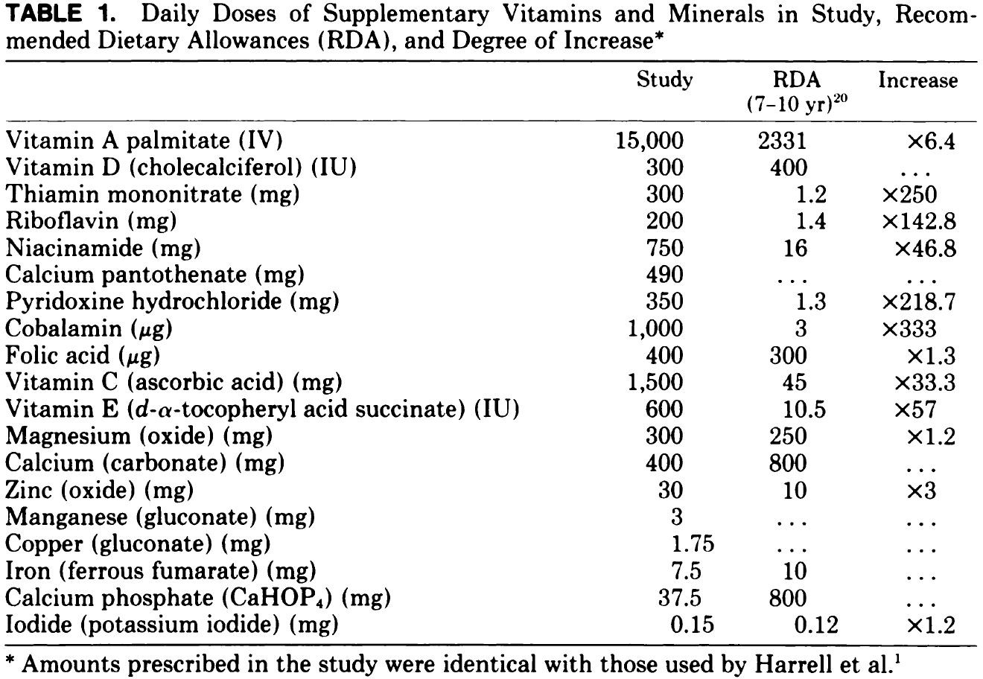
- Duration | 8 months
- Frequency per week | Daily
- Outcomes measured (developmental domain function) | - Oral vocabulary assessment: Children in treatment group showed slight improvement  - Arizona Articulation Proficiency: Children in treatment group showed slight improvement  - Detroit Tests of Learning Aptitude: Children in treatment group showed slight improvement (memory and definition subtests specifically)  - Illinois Test of Psycholinguistic Abilities: Children in placebo group showed slight improvement (receptive and expressive subtests)  - Peabody Picture Vocabulary Test (widely used receptive language measure):14/20 study children scored below the first percentile both at the outset and conclusion, and only two children (the youngest case-control pair, one child given vitamins/minerals and one child given placebo) increased their percentile rankings.  - Behavioural rating scale: A behavioral rating scale assessing such qualities as cooperation, attention, task persistence, and mood was administered at both the outset and conclusion of the study. Both groups demonstrated small average improvements on this scale, with 6/10 children in each group showing increased functional, adaptive behavior.  - Academic achievement assessment: The teachers’ subjective impressions revealed no group differences or substantial changes in school performance. Of the 20

- children, six (four given vitamins/minerals, two given placebo) were felt to have had an “above average” school year, ten (three given vitamins/minerals, seven given placebo) an “average” school year, and four (three given vitamins/minerals, one given placebo) had a “below average” year
- Stanford-Binet Intelligence Scale: Nine study children (three given vitamins/minerals, six given placebo) showed a slight increase in intelligence test performance (maximum IQ gain 9 points) at the end of the study; nine children (six given vitamins/minerals, three given placebo) showed a slight decrease in test performance (maximum IQ loss 7 points), and two children (one given vitamins/minerals, one given placebo) were unchanged. The modest IQ increases were clustered among the younger subjects, whereas IQ decreases were more prevalent in the older subjects.
- Statistical Analysis | Mean group difference
- Adverse Events | Possible negative side effects reported included (1) nocturnal enuresis in a child given treatment; this was managed successfully by administering all tablets in the morning; and (2) behavioral change (ie, more withdrawn, isolated, apathetic) in one control child who was experiencing home disruption due to the marriage of an older sibling; this was managed by discontinuing the study tablets at 6 months. No other potential complications were identified.
- Period to assessments | Not clear
- Duration of follow-up | The study was conducted during the 1981 to 1982 school year with a total study period of 8 months.
- Number lost on follow-up | None lost to follow-up

- Outcome scale used | 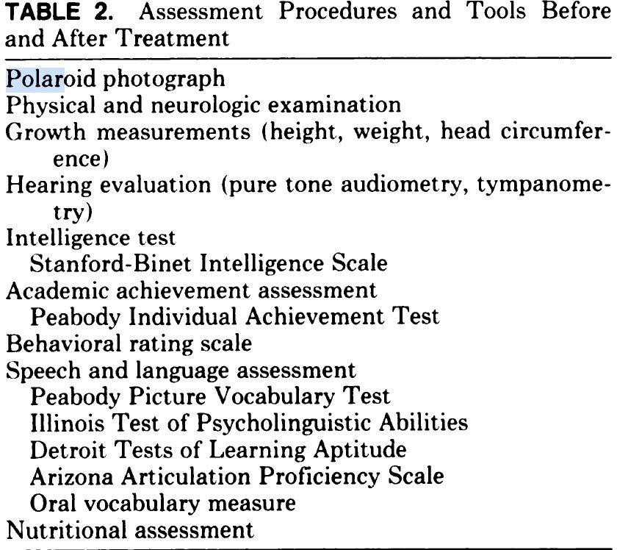
- Assessors’ professional background | Psychologist, Pediatrician (developmental), Communication Disorders Specialist, Nutritionist
- Conflict of interest | This work was supported, in part, by a grant from the Washington Association for Retarded Citizens (WARC) and by Maternal and Child Health Services, Bureau of Community Health Services, Health Services Administration, Department of Health and Human Services, Project No. 913.
- Incomplete outcome data | None identified
- Selective outcome reporting | None identified
- Other issues | None identified
- Outcomes reported | Refer to outcomes measured section

