Supplementary Information
Controllable mitochondrial aggregation and fusion by a programmable DNA binder

Longyi Zhu¹, Yiting Shen¹, Shengyuan Deng², Ying Wan³*, Jun Luo¹, Yan Su³, Mingxu You⁴, Chunhai Fan⁵ and Kewei Ren¹*

¹ School of Chemistry and Chemical Engineering, Nanjing University of Science and Technology, Nanjing 210094, China
² School of Environmental and Biological Engineering, Nanjing University of Science and Technology, Nanjing 210094, P.R. China
³ Intelligent Microsystem Technology and Engineering Center, School of Mechanical Engineering, Nanjing University of Science and Technology, Nanjing 210094, P.R. China
⁴ Department of Chemistry, University of Massachusetts, Amherst, MA 01003, USA
⁵ School of Chemistry and Chemical Engineering, Shanghai Jiao Tong University, Shanghai 200127, China
*e-mail: wanying@njust.edu.cn (Y.W.); kwren@njust.edu.cn (K.W.R.)

Table of Contents
1. Supplementary Table S3
2. Supplementary Figures S4-S9

Supplementary Table
Supplementary Table 1. DNA sequences used in this work. The binding sequences of primer1 and liner DNA1 are shown in bold. The binding sequences of primer2 and liner DNA2 are shown in bold and italic. The ATP aptamer sequences in SA1 (TAMRA-SA1) and BHQ-SA2 are shown in blue.
Primer1 | AATCTGGCTGCGCTTGAA
Ligation DNA1 | TGCTTTAGGAAATCTGGCTG
Linear DNA1 | P-TCCTAAAGCATGACCTTCCGTTTCCGTAGTTTCAAGCGCAGC  CAGATT
Linkage DNA | TCCTAAAGCATGACCTTCCGTTTCTTTTTTTTTTT-Azide
FAM-linkage DNA | TCCTAAAGCATGACCTTCCGTTTCTTTTTTTTTTT-FAM
Primer2 | TTTTGCGGAGGAAGGTTT
Ligation DNA2 | AGGAAGGTTTTTTTGCGGAG
Linear DNA2 | - AAACCTTCCTCCGCAAAAAAACCTTCCTCCGCAAAAAAACCTTCCTCCGCAAAA
SA1 | ACCTGGGGGAGTATTTTTTTTTTTTTTT-Azide
TAMRA-SA1 | TAMRA-ACCTGGGGGAGTATTTTTTTTTTTTTTT
CSA1 | GACGCGTGAGTAGTTTTTTTTTTTTTTT-Azide
TAMRA-CSA1 | TAMRA-GACGCGTGAGTAGTTTTTTTTTTTTTTT
BHQ-SA2 | TGCGGAGGAAGGT-BHQ2

Supplementary Figures
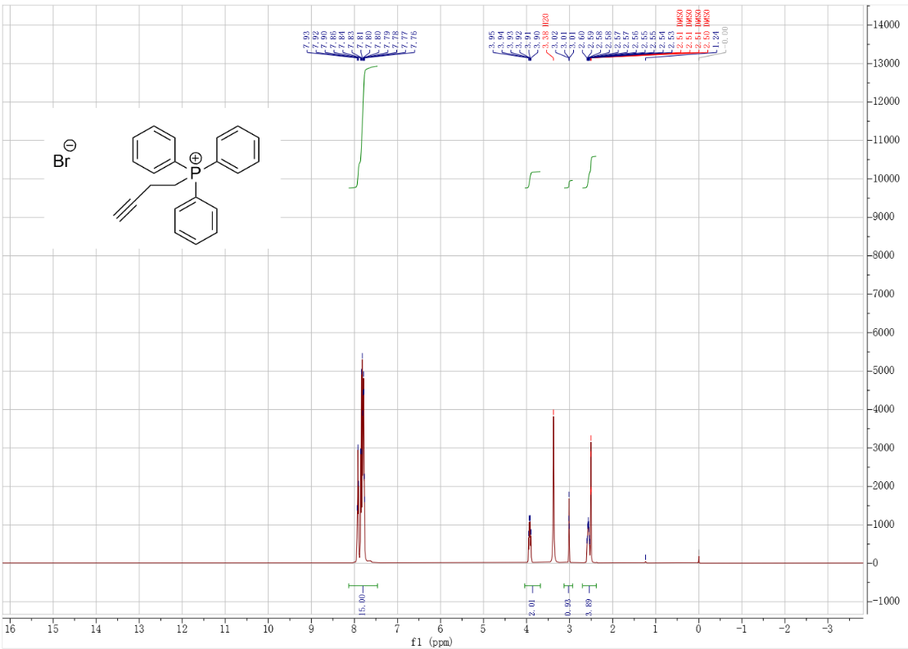
Supplementary Fig. 1 ¹H-NMR spectrum of alkynyl-TPP.

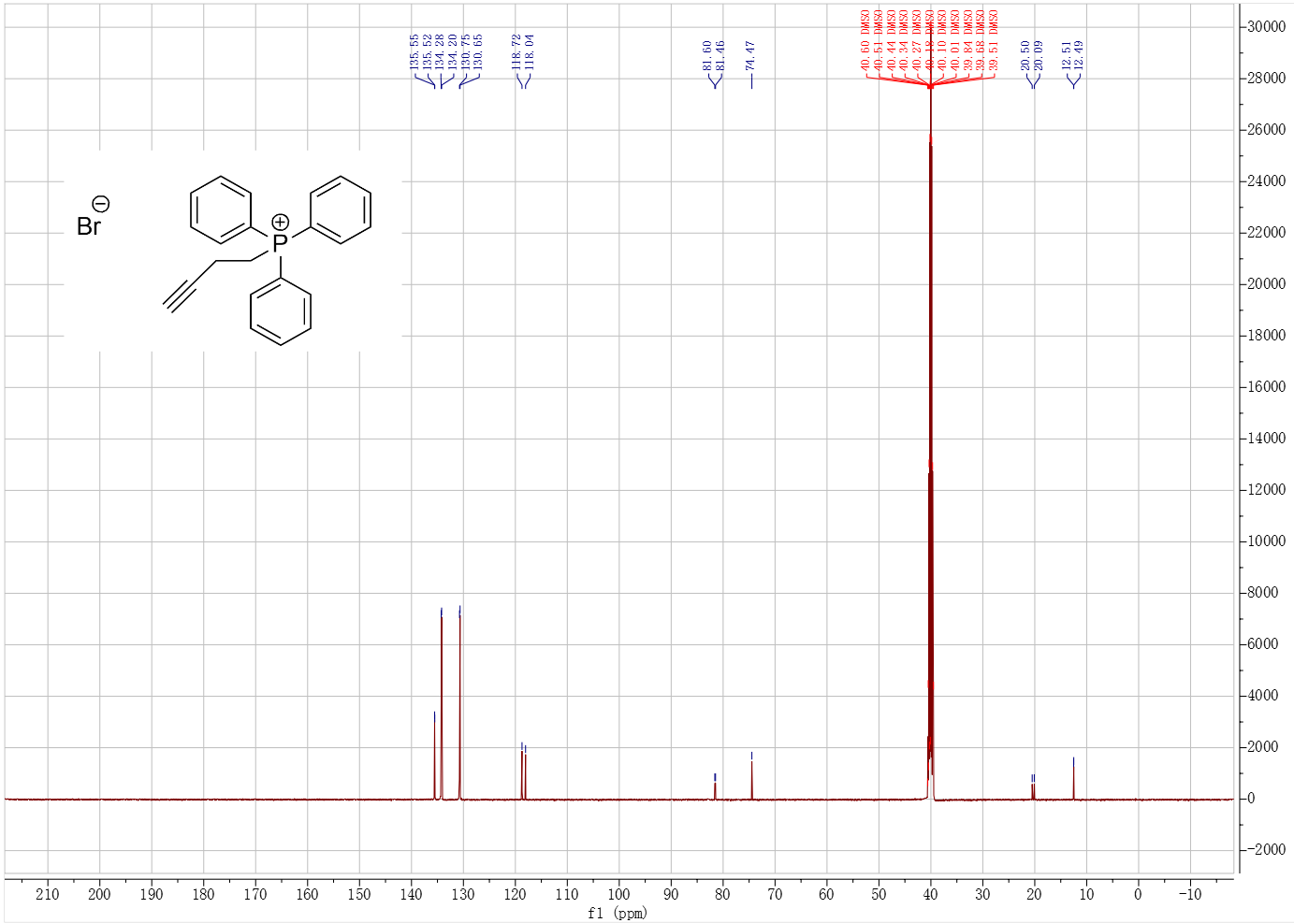
Supplementary Fig. 2 ¹³C-NMR spectrum of alkynyl-TPP.
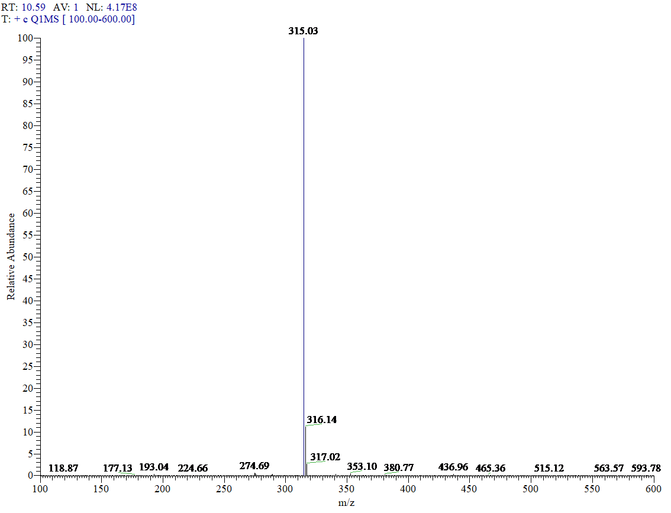
Supplementary Fig. 3 ESI-MS spectrum of alkynyl-TPP cation.

Supplementary Fig. 4 MALDI-TOF MS spectra of LDNA and TPP-LDNA.
Supplementary Fig. 5 Grafting ratio calculation of TPP-LDNA on the DNA chain. (a) Standard calibration curves for FAM-LDNA at λ_{ex} of 488 nm. The data error bars indicate means ± SD (n=3). (b) Fluorescence spectrum of 1.0 µM F-binder. The concentration of FAM-LDNA strands was calculated as 0.93 µM according to the linear equation.

Supplementary Fig. 6 Confocal fluorescence study of extracellular mitochondria (blank) after treated with 1.0 µM TPP-LDNA, C-Binder and DNA binder, respectively.
Supplementary Fig. 7 Cytotoxicity of DNA binders. Cell viabilities of (a) 4T1 and (b) SH-SY5Y cells in the absence (Control) and presence of different concentration of DNA binder.

Supplementary Fig. 8 Co-localization study of DNA binders in living cells. Co-staining of 4T1 cells with MitoTracker (red) and DAPI (blue) after incubation with 1.0 µM F-binder (green) for 24 h. Scale bar: 10 µm.
Supplementary Fig. 9 Schematics and characterization of self-assembled ATP-triggered DNA switches and R-DNA binder response. (a) Fluorescence intensities of split aptamer mixture (SA1/SA2) incubated with 1 mM ATP (1-ATP) and 4 mM ATP (4-ATP), and 4 mM CTP, GTP and UTP, as well as mixture of random SA1 sequence (CSA1) and SA2 incubated with 4.0 mM ATP, (b) TAMRA fluorescence signal from 2 μM TAMRA-SA1 and 2 μM R-DNA chain in response to 4.0 mM ATP. The data error bars indicate means ± SD (n = 3).

Supplementary Fig. 10 Confocal fluorescence study of extracellular mitochondria aggregation by ATP-triggered DNA binders. Extracellular mitochondria (blank) after incubation with 1.0 µM R-binder in the absence and presence of 2.0 mM ATP, as well as NR-Binder in the presence of 2.0 mM ATP. Scale bar, 10 µm.

Supplementary Fig. 11 Control study of mitochondria aggregation in living cells. Confocal fluorescence images of 4T1 cells with and without (Blank) 1.0 μM NR-binder, and 1.0 μM NR-binder and 10 μM oligomycin, respectively. The nucleus and mitochondria were staining with DAPI (blue) and mitochondria tracker red (red), respectively. Scale bars, 10 µm. The percentage of cells with elongated mitochondria in these experiments. For each construct, 100 cells were scored in biological triplicate.

