Supplementary information

Sustainable and color-indicated tannic acid@high amylose starch/polyvinyl alcohol (TA@HAS/PVA) fibers for adsorbing uranium from aqueous solutions
Qun Liuª, Xiaoyang Wang^{b}, Meiyan Bai^{b}, Jiayi Guo^{b}, Zhengjie Qian^{b}, Jihui Li^{b}, Zhifen Wang^{c}, Yucang Zhang^{a,∗}
ªCollege of Ocean Food and Biological Engineering, Jimei University, Xiamen 361021, Fujian, China
^{b}School of Chemical Engineering and Technology, Hainan University, Haikou 570228, China
^{c}School of Materials Science and Engineering, Hainan University, Haikou 570228, China

Pseudo-first-order model |  |  | Pseudo-second-order model
k_{I} (min⁻¹) | q_{e} (mg g⁻¹) | R² | k_{II} (g mg⁻¹ min⁻¹) | q_{e} (mg g⁻¹) | R²
0.0078 | 74.0518 | 0.8243 | 1.5587×10⁻⁴ | 81.0422 | 0.9299
Table S1. Fitted parameters and correlation coefficients (R²) from the two models for U(VI) adsorption (200 mg L⁻¹) onto the TA@HAS/PVA fibers.

Langmuir model |  |  | Freundlich model
q_{m} (mg g⁻¹) | K_{L}(L mg⁻¹) | R² | K_{F} (mg g⁻¹) | n | R²
504.2677 | 0.0105 | 0.9492 | 60.2126 | -0.3032 | 0.8133
Table S2. Langmuir and Freundlich isotherm parameters and correlation coefficients (R²) for U(VI) adsorption onto the TA@HAS/PVA fibers.

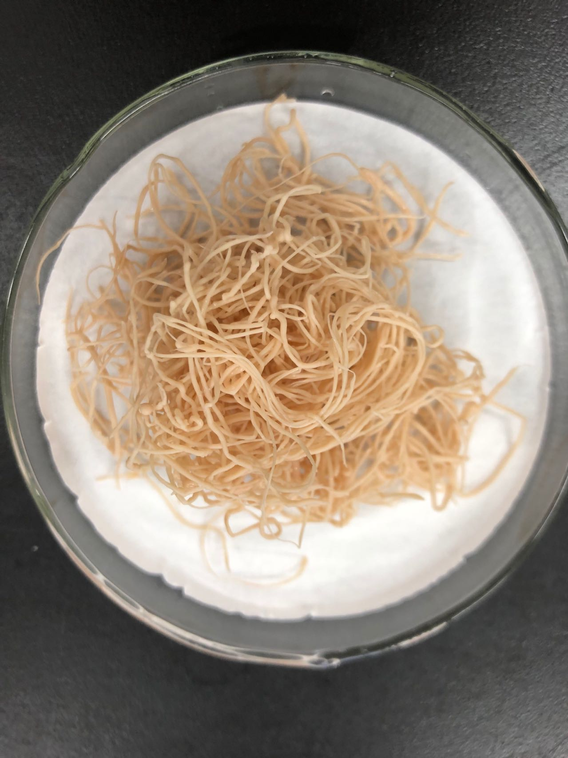
Figure S1. Morphology of TA@HAS/PVA fibers.
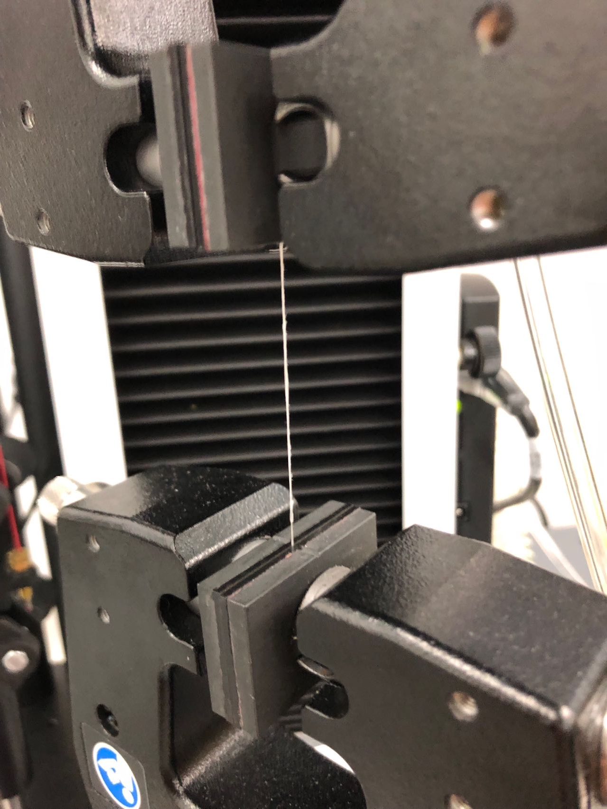
Figure S2. Stretch ability of TA@HAS/PVA fiber.

∗ Corresponding author. E-mail address: yczhang@jmu.edu.cn (Y. Zhang)

