Supplementary Figure
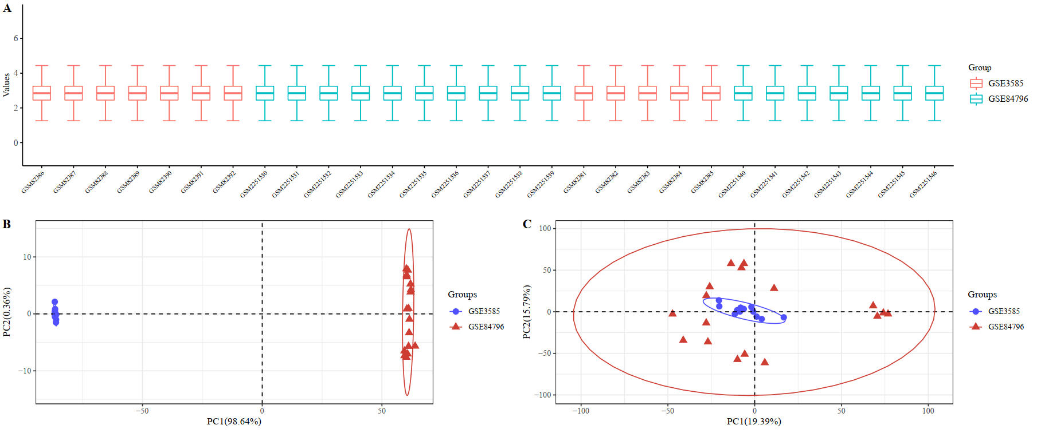
Supplementary Figure 1. Data procession for the DCM gene expression profiles of GSE3585 and GSE84796. (A) The result of data standardization for the two DCM gene expression profiles; (B-C) The PCA results between gene expression profiles before and after batch removal.

