Supplementary Information

Halide Perovskites Glues Activate Two-dimensional Covalent Organic Framework Crystallites for Selective Gas Sensing
Wen Ye^{[a]}, Liangdan Zhao^{[b]}, Hong-Zhen Lin^{[c]}, Lifeng Ding^{[b]}, Qiang Cao^{[d]}, Ze-Kun Chen^{[d]}, Jia Wang ^{[d]}, Qi-Meng Sun^{[d]}, Jing-Hui He ^{[d]} and Jian-Mei Lu*^{[a, d]}

W. Ye, L.-D. Zhao, Prof. H.-Z. Lin, Prof. L.-F. Ding, Q. Cao, Z.-K. Chen, J. Wang, Q.-M. Sun, Prof. J.-H. He, Prof. J.-M. Lu
[a] Wen Ye, Jian-Mei Lu
State Key Laboratory of Radiation Medicine and Protection, Soochow University, Suzhou, China
E-mail: lujm@suda.edu.cn
[b] Liangdan Zhao, Lifeng Ding
Department of Chemistry, Xi’an JiaoTong-Liverpool University, Suzhou, China
[c] Hong-Zhen Lin
Department i-LAB, Suzhou Institute of Nano-Tech and Nano-Bionics (SINANO), Chinese Academy of Sciences, Suzhou, China
[d] Qiang Cao, Ze-Kun Chen, Jia Wang, Qi-Meng Sun, Jing-Hui He and Jian-Mei Lu
College of Chemistry Chemical Engineering and Materials Science, Collaborative Innovation Center of Suzhou Nano Science and Technology, National United Engineering Laboratory of Functionalized Environmental Adsorption Materials, Soochow University, Suzhou, China

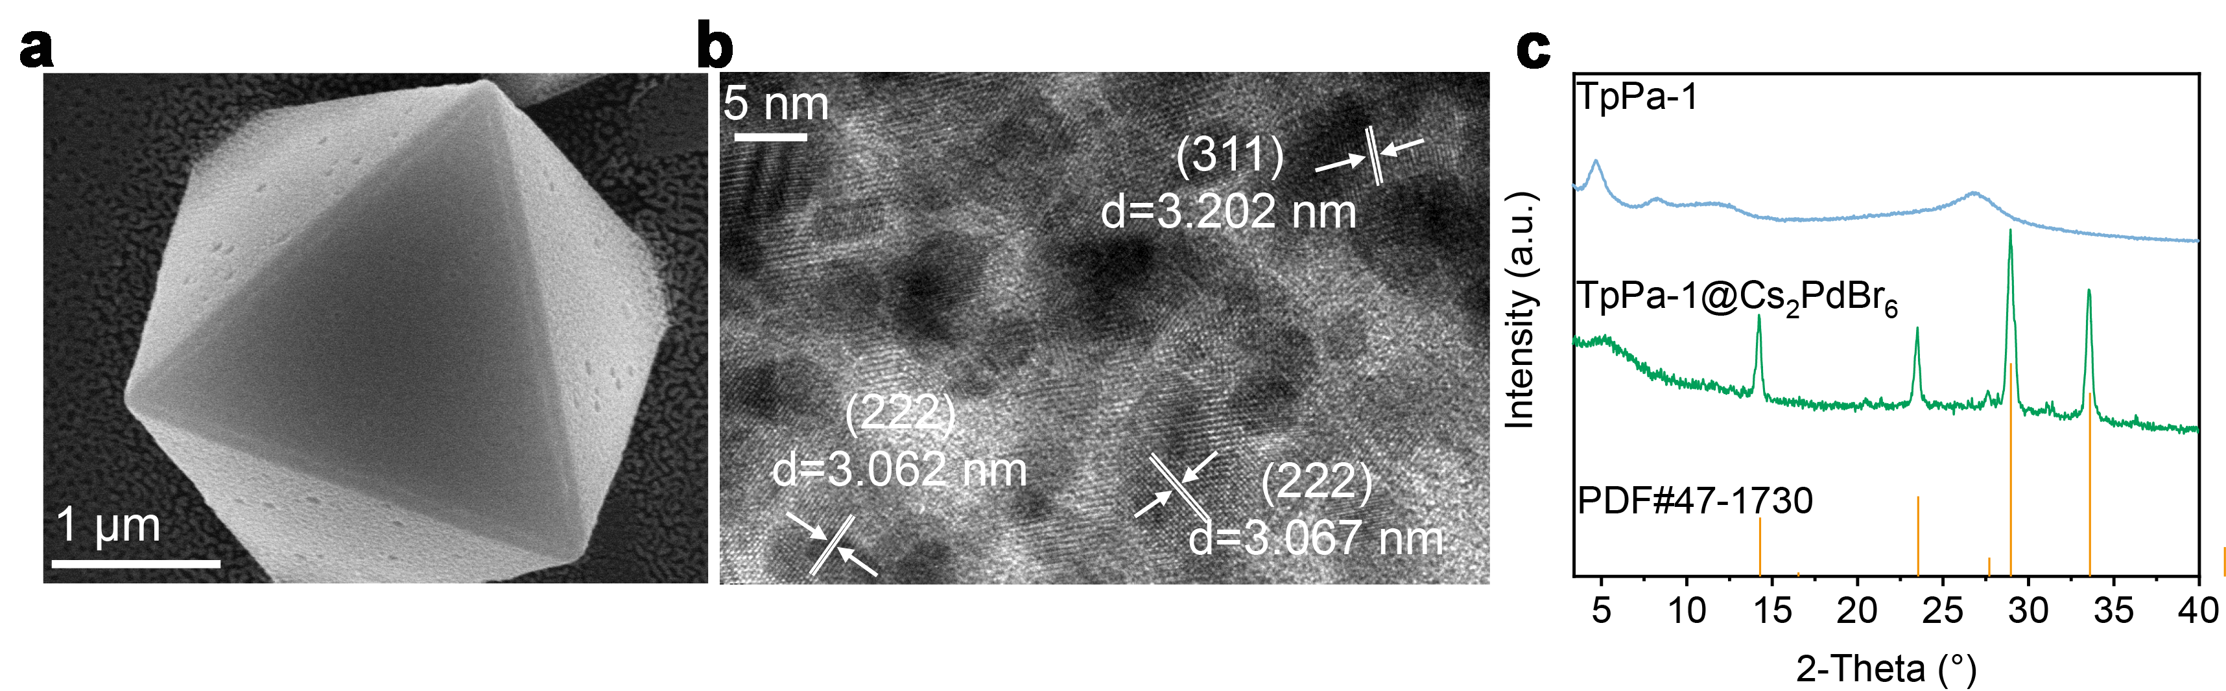 Supplementary Fig. 1: Characterization of the Cs₂PdBr₆ and TpPa-1/ Cs₂PdBr₆. a) FSEM image and b) HRTEM image of Cs₂PdBr₆ powders. c) PXRD pattern of TpPa-1 and TpPa-1/ Cs₂PdBr₆ powders.

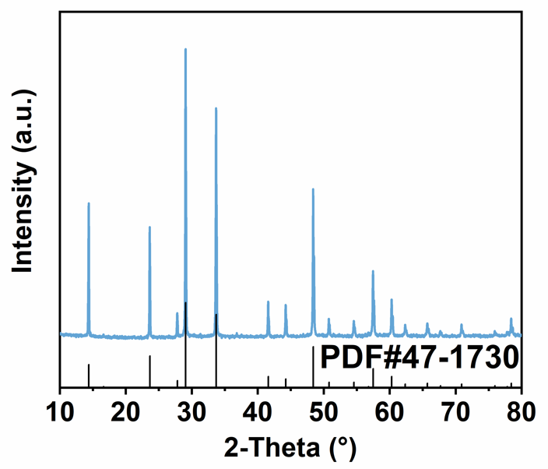
Supplementary Fig. 2: XRD pattern of Cs₂PdBr₆ powders.

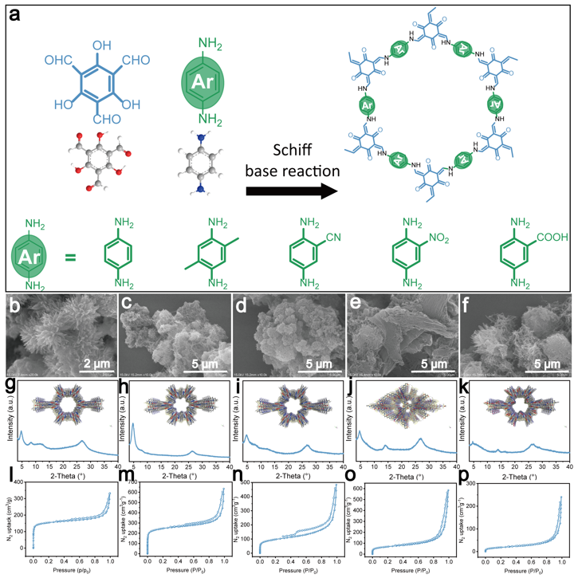

Supplementary Fig. 3: a) Synthesis of TpPa series COFs through the Schiff base reactions of 1,3,5-triformylphloroglucinol (Tp) and p-phenylenediamine (Pa-1) and its derivatives (Pa-2, Pa-CN, Pa-NO₂ and Pa-COOH). b−f) The FESEM images, g−k) PXRD patterns, l−p) N₂ sorption isotherms for TpPa-1, TpPa-2, TpPa-CN, TpPa-NO₂ and TpPa-COOH respectively.

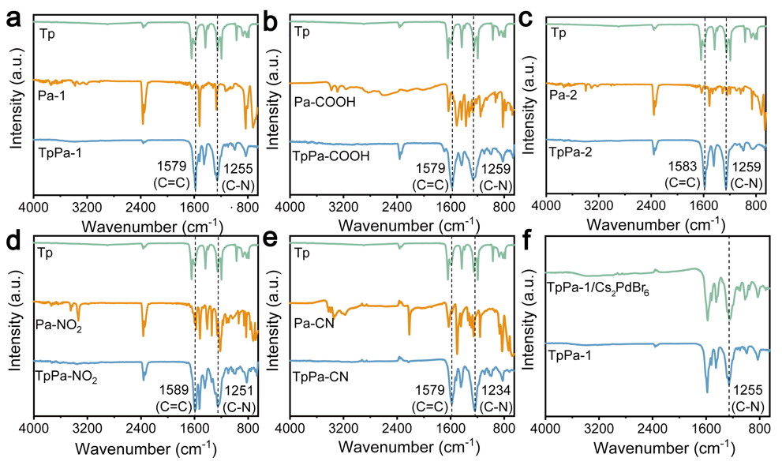
Supplementary Fig. 4: a-e) FTIR spectra of different COF and its raw materials. f) Comparison of FTIR spectra of TpPa-1 and TpPa-1/Cs₂PdBr₆.

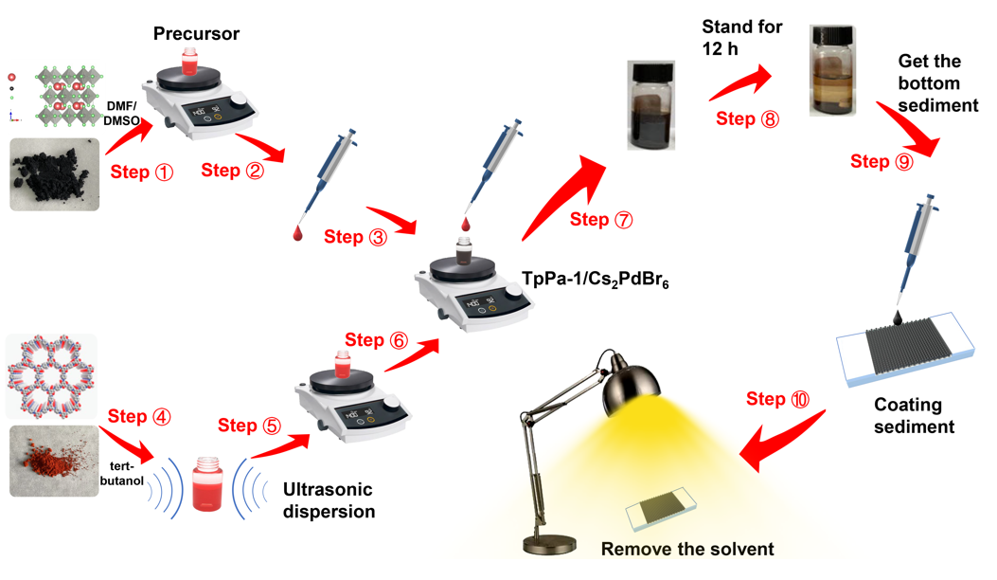 Supplementary Fig. 5: Schematic illustration of the preparation of sensor device.
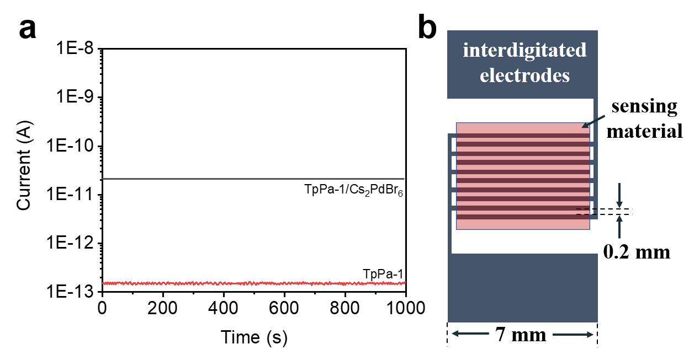
Supplementary Fig. 6: a) The change of current with time when the TpPa-1 and TpPa-1/Cs₂PdBr₆ sensor is exposed to N₂ (99.999%). A constant voltage of 5 V was applied across the interdigital electrodes. b) Specifications of interdigitated electrodes.

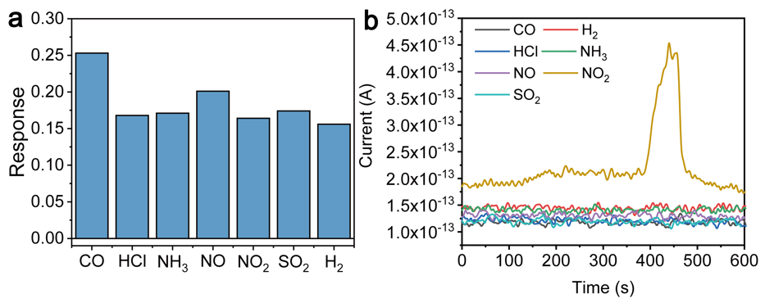
Supplementary Fig. 7: a) The response of the Cs₂PdBr₆ sensor to different gases (all at 2 ppm concentration). b) The change of current with time when the TpPa-1 sensor is exposed to different gases (all at 2 ppm concentration).

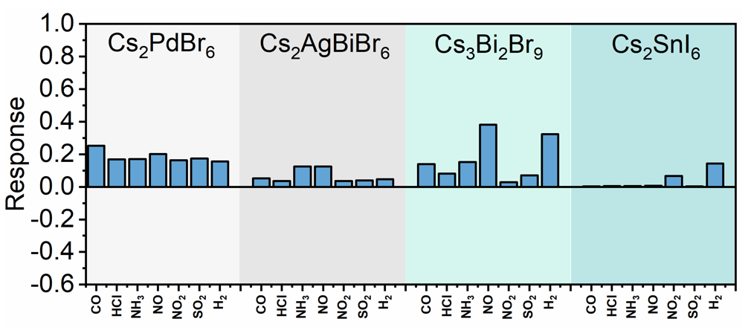

Supplementary Fig. 8: The response of different double perovskite sensors to different gases (all at 2 ppm concentration).

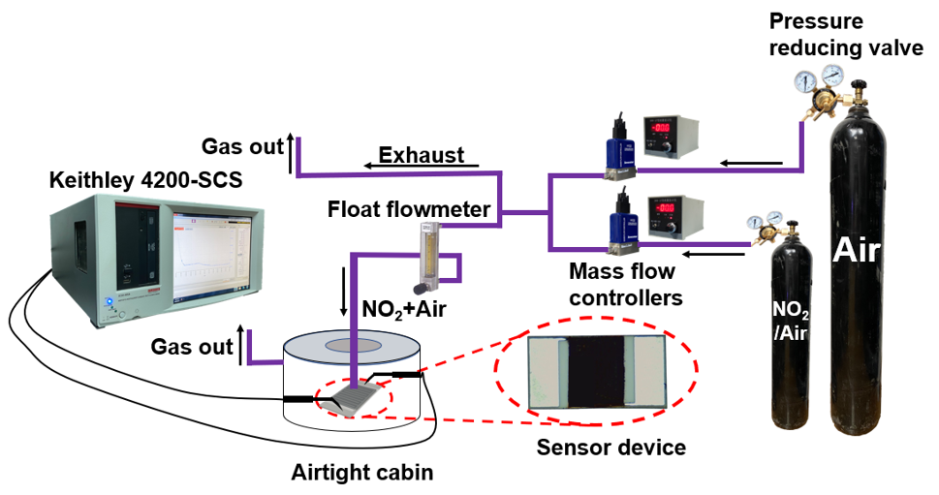 Supplementary Fig. 9: Gas sensor test system.

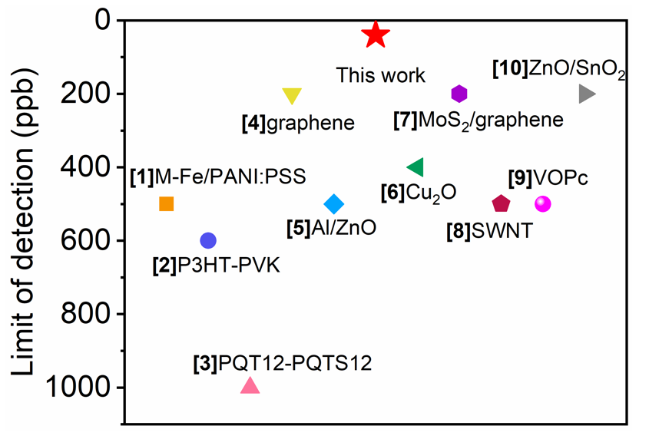

Supplementary Fig. 10: Ranking graph of different NO₂ chemiresistors.^{1, 2, 3, 4, 5, 6, 7, 8, 9, 10}

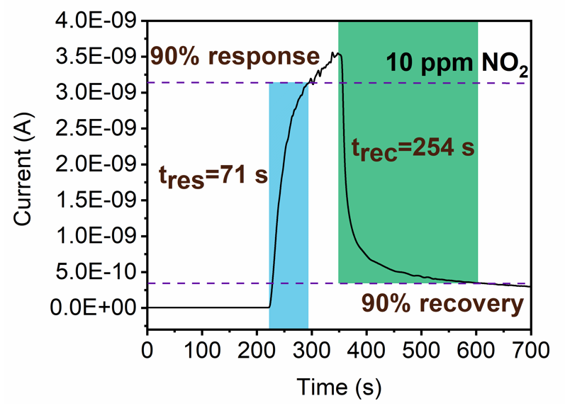
Supplementary Fig. 11: Response/recovery time at 10 ppm NO₂.

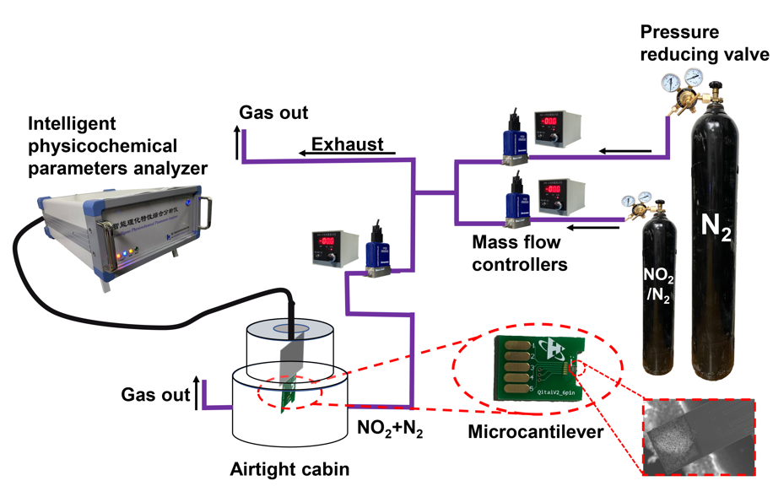 Supplementary Fig. 12: Resonant microcantilever test system.

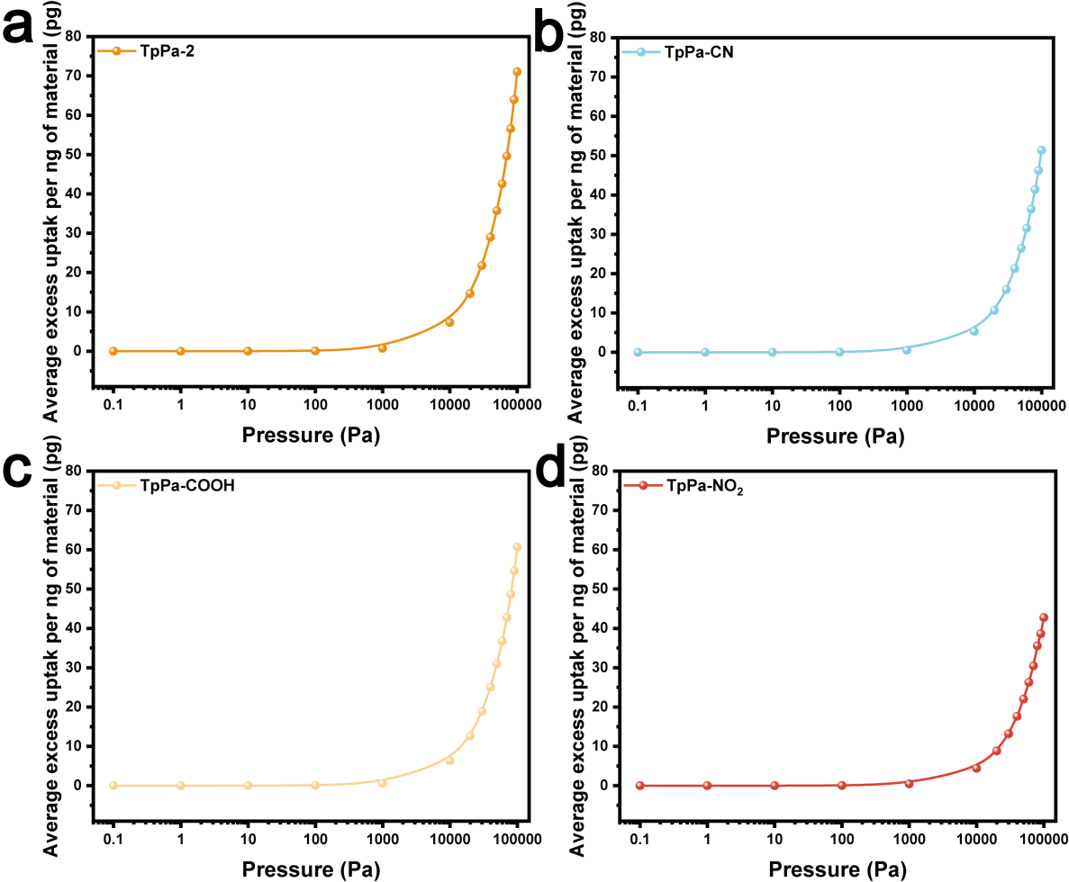
Supplementary Fig. 13: Grand canonical monte carlo (GCMC) simulation of average excess uptake of NO₂/N₂ mixture per ng of material.

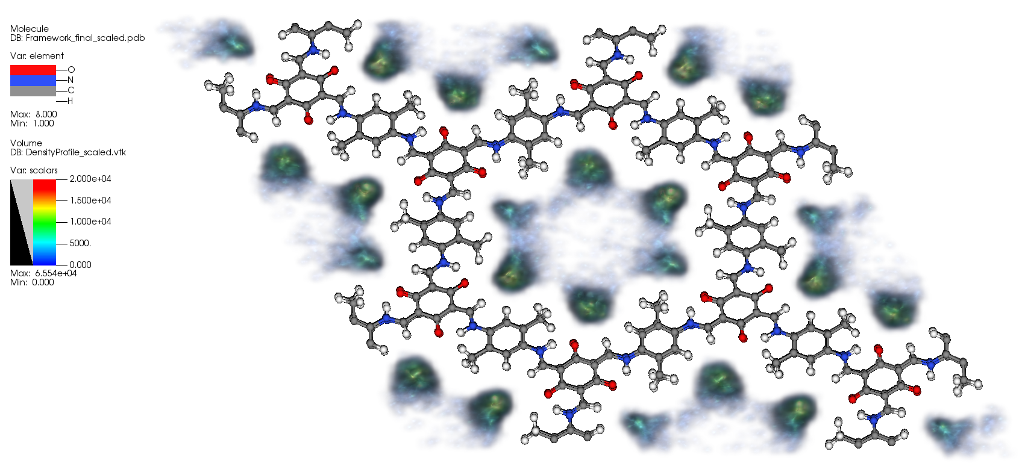 Supplementary Fig. 14: Grand canonical monte carlo (GCMC) simulation of NO₂ adsorption density plot on TpPa-2.

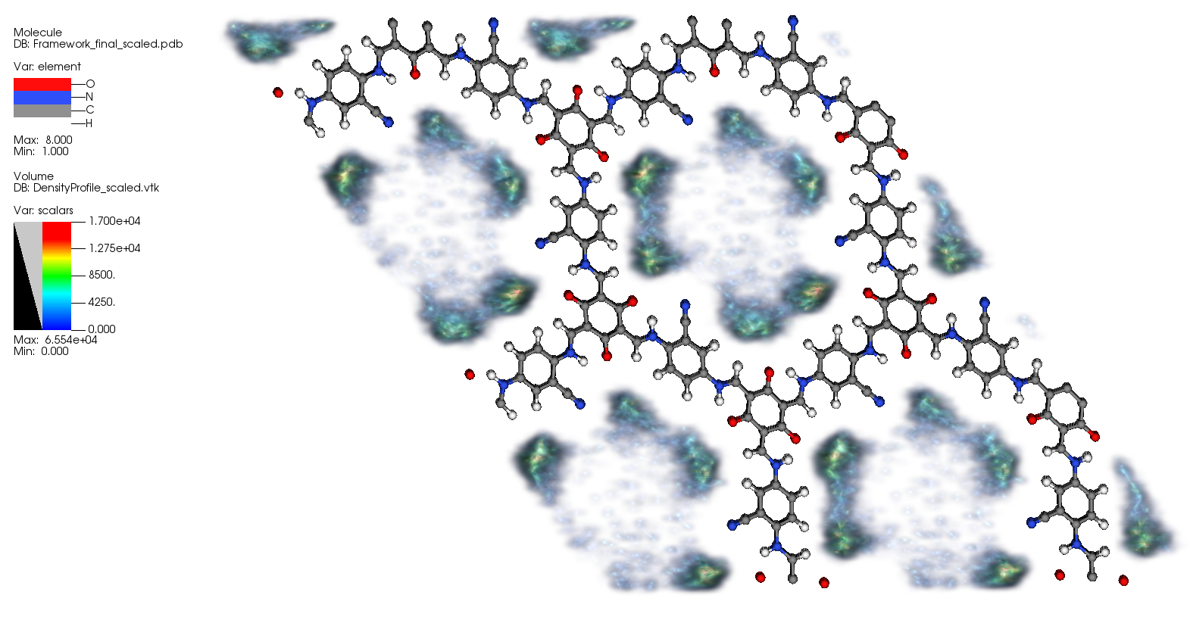 Supplementary Fig. 15: Grand canonical monte carlo (GCMC) simulation of NO₂ adsorption density plot on TpPa-CN.

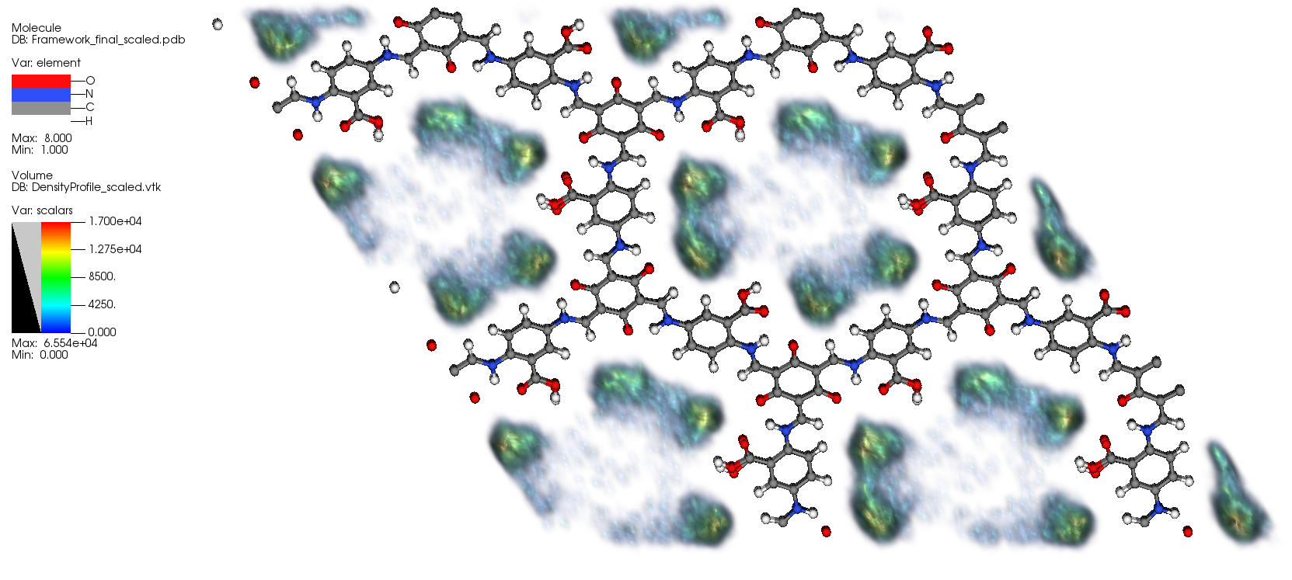 Supplementary Fig. 16: Grand canonical monte carlo (GCMC) simulation of NO₂ adsorption density plot on TpPa-COOH.

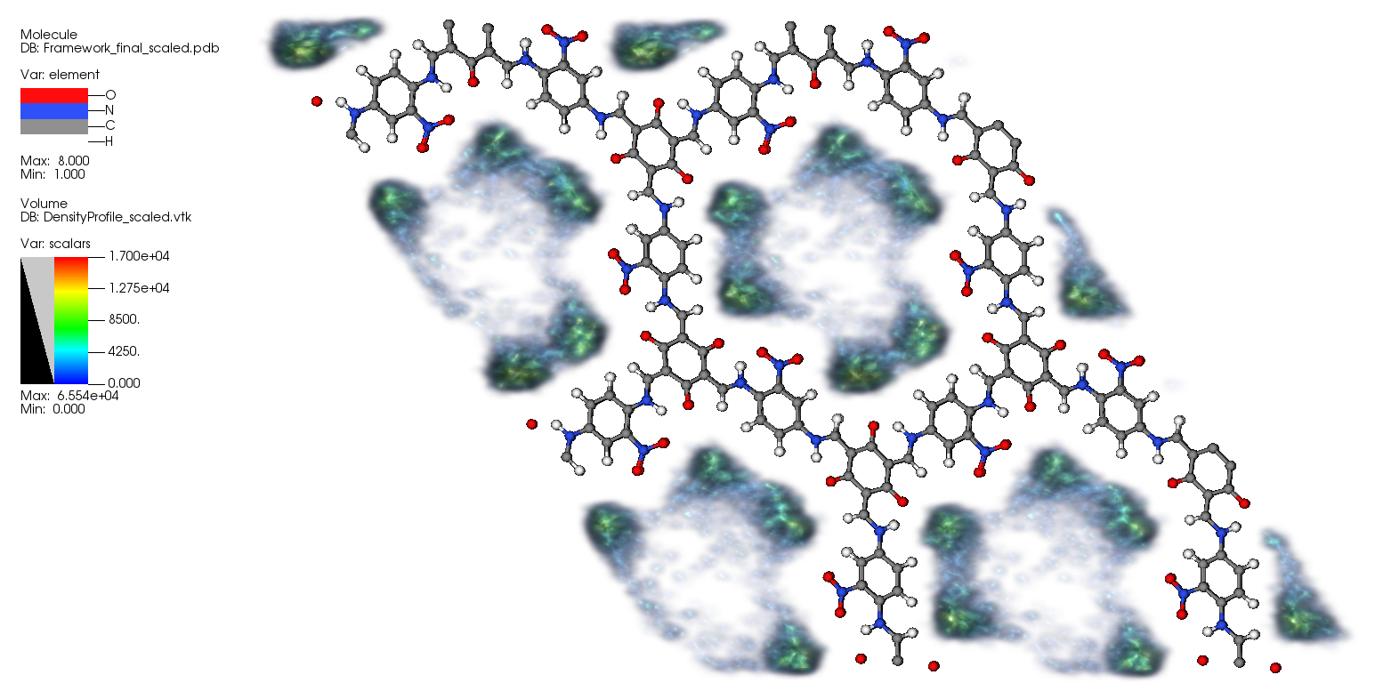 Supplementary Fig. 17: Grand canonical monte carlo (GCMC) simulation of NO₂ adsorption density plot on TpPa-NO₂.

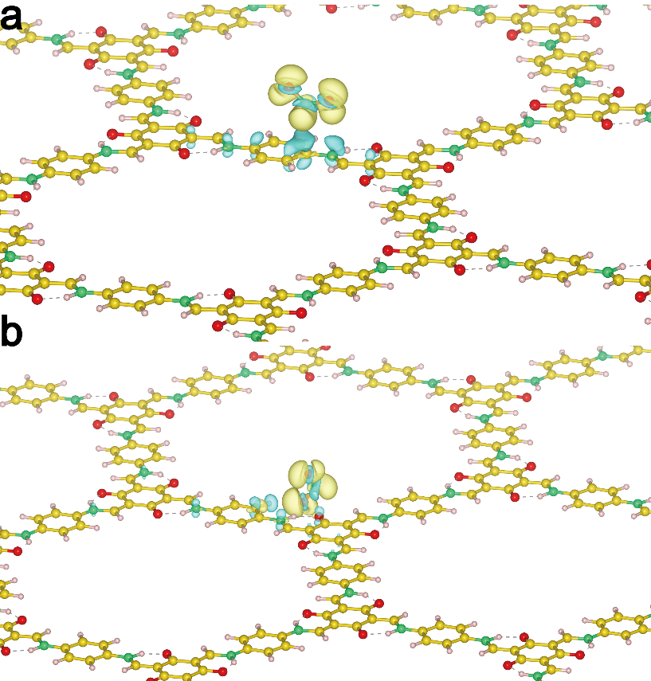
Supplementary Fig. 18: Differential charge density of NO₂. The charge transfer difference between NO₂ and TpPa-1 layers, where the yellow and cyan areas indicate the charge accumulation and depletion with iso-surfaces at 0.007 e/Å³. The yellow, pink, red and green balls refer to C, H, O and N atoms, respectively.

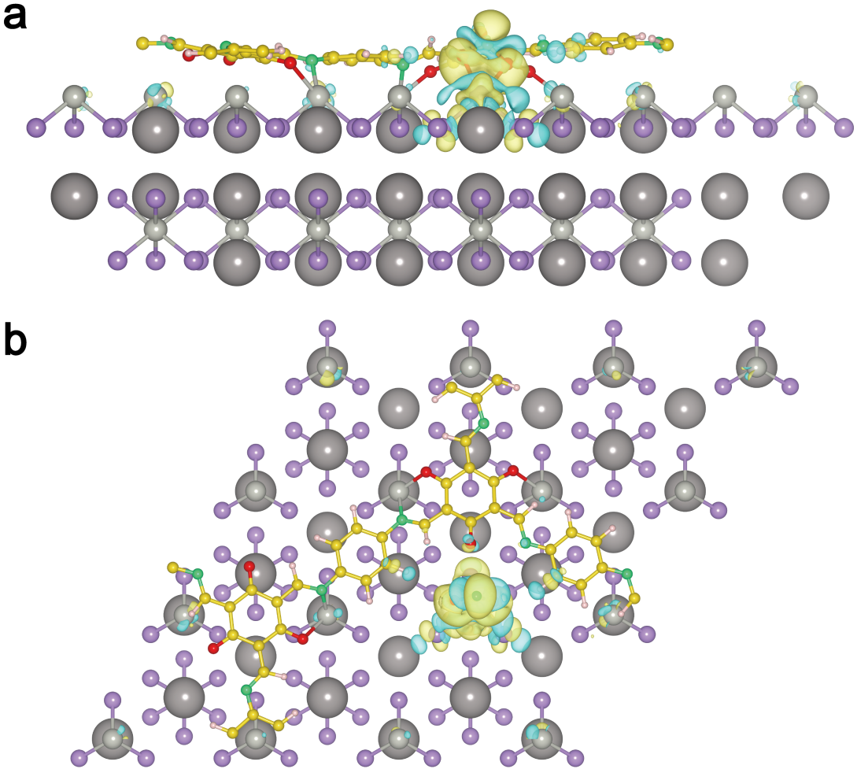
Supplementary Fig. 19: Differential charge density of NO₂. The side and vertical view of the charge transfer difference between NO₂ and TpPa-1/Cs₂PdBr₆ layers, where the yellow and cyan areas indicate the charge accumulation and depletion with iso-surfaces at 0.006 e/Å³. The yellow, pink, red, green, violet, brown and gray balls refer to C, H, O, N, Br, Pd and Cs atoms, respectively.

References

1. Kim SG, Jun J, Lee JS, Jang J. A highly sensitive wireless nitrogen dioxide gas sensor based on an organic conductive nanocomposite paste. J Mater Chem A 7, 8451-8459 (2019).

2. Han S, Yang Z, Li Z, Zhuang X, Akinwande D, Yu J. Improved room temperature NO2 sensing performance of organic field-effect transistor by directly blending a hole-transporting/electron-blocking polymer into the active layer. ACS Appl Mater Interfaces 10, 38280-38286 (2018).

3. Li H, Dailey J, Kale T, Besar K, Koehler K, Katz HE. Sensitive and selective NO2 sensing based on alkyl-and alkylthio-thiophene polymer conductance and conductance ratio changes from differential chemical doping. ACS Appl Mater Interfaces 9, 20501-20507 (2017).

4. Wu J, et al. Facile synthesis of 3D graphene flowers for ultrasensitive and highly reversible gas sensing. Adv Funct Mater 26, 7462-7469 (2016).

5. Sanger A, Kang SB, Jeong MH, Kim CU, Baik JM, Choi KJ. All-transparent NO2 gas sensors based on freestanding Al-doped ZnO nanofibers. ACS Appl Electron Mater 1, 1261-1268 (2019).

6. Deng S, et al. Reduced graphene oxide conjugated Cu2O nanowire mesocrystals for high-performance NO2 gas sensor. J Am Chem Soc 134, 4905-4917 (2012).

7. Hong HS, Phuong NH, Huong NT, Nam NH, Hue NT. Highly sensitive and low detection limit of resistive NO2 gas sensor based on a MoS2/graphene two-dimensional heterostructures. Appl Surf Sci 492, 449-454 (2019).

8. Kumar D, et al. Effect of single wall carbon nanotube networks on gas sensor response and detection limit. Sens Actuators, B 240, 1134-1140 (2017).

9. Jalil AR, et al. Fully integrated organic nanocrystal diode as high performance room temperature NO2 sensor. Adv Mater 28, 2971-2977 (2016).

10. Wang Z, Gao S, Fei T, Liu S, Zhang T. Construction of ZnO/SnO2 heterostructure on reduced graphene oxide for enhanced nitrogen dioxide sensitive performances at room temperature. ACS Sens 4, 2048-2057 (2019).

