Supplementary information

Glow Discharge Plasma Effects on Colored Nylon 6 with Azo Dye
Mohammad Reza Yari^{1,}*^{,+}, Mohammad Sadegh Zakerhamidi^{2,3,4}, and Hamid Ghomi^{1,}*^{,+},

¹Laser and Plasma Research Institute, Shahid Beheshti University, Tehran, Iran. ²Faculty of Physics, University of Tabriz, Tabriz, Iran. ³Research Institute for Applied Physics and Astronomy, University of Tabriz, Tabriz, Iran. ⁴Photonics Center of Excellence, University of Tabriz, Tabriz, Iran. Mohammad Reza Yari, E-mail: M_Yari@sbu.ac.ir, Hamid Ghomi, E-mail: h-gmdashty@sbu.ac.ir
⁺These authors contributed equally to this work

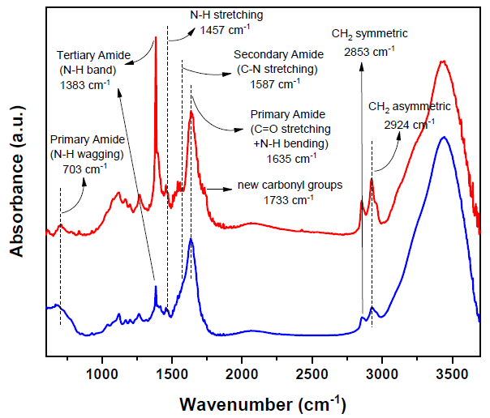

Figure S1. FT-IR spectra and peak information of DR1 dye-doped nylon 6 before and after plasma treatment for 300 s

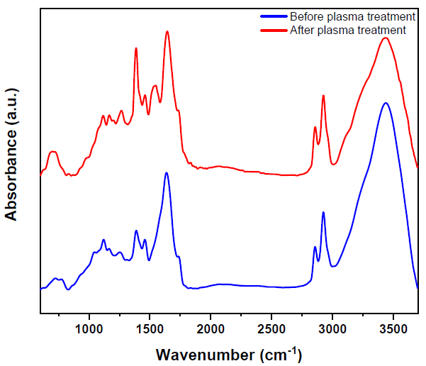
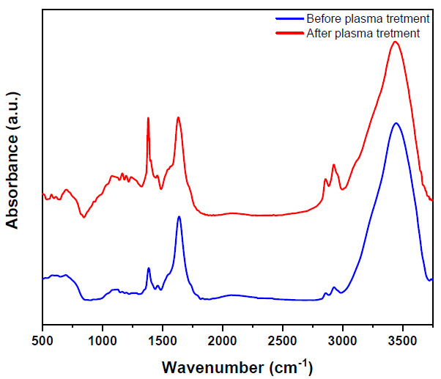

Figure S2. FT-IR spectra of (left) pure nylon 6 (right) DR1 dye-doped nylon 6 polymer before and after plasma treatment for 150 s

Figure S3. AFM images of (left) untreated nylon 6 surface (right) argon plasma treated nylon 6 surface for 150 seconds modification

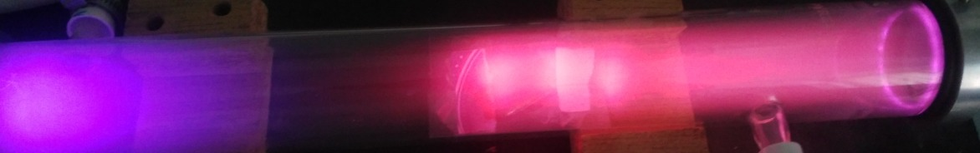

Figure S4. Image of argon DC glow discharge plasma

Figure S5. Schematic figure showing glow discharge plasma system

