Supplementary Information

Selective block of sensory neuronal T-type/Cav3.2 activity mitigates neuropathic pain behavior in a rat model of osteoarthritis pain
Brandon Itson-Zoske, Seung Min Shin, Hao Xu, Chensheng Qiu, Fan Fan, Quinn H. Hogan, and Hongwei Yu

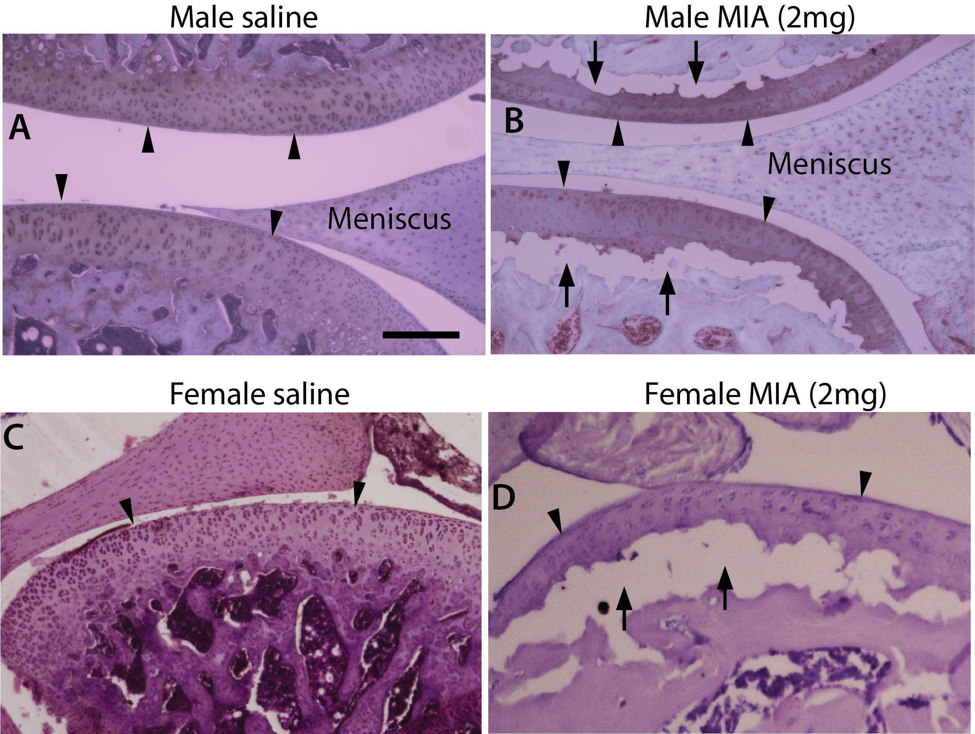

Figure S1. MIA OA knee histopathology. H&E stained sagittal section of saline-injected knees, showing full-depth normal cartilage and normal subchondral bone structure in male (A) and female (C). OA-like findings in the representative H&E-stained sagittal sections of knee 8 weeks after MIA (2mg) injection, showing articular cartilage loss (arrowheads), reduced chondrocyte numbers, subchondral bone collapse (arrows) in both male (B) and female (D). Scale bar: 500 µm for all.

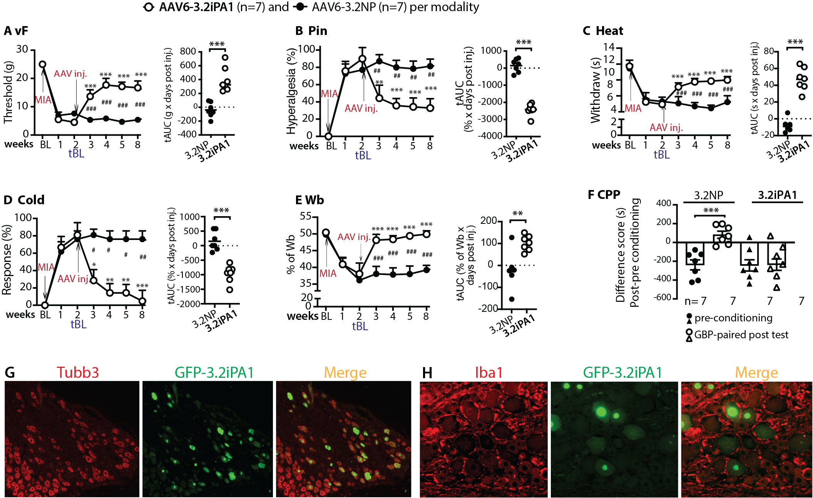

Figure S2. Analgesia of MIA-OA pain by DRG delivery of AAV6-3.2iPA1 (male rats). Analogous figures (A-F) to Figure 1 for treatment with AAV6-3.2iPA2 shows comparable effectiveness to MIA-OA pain likewise to AAV6-3.2iPA2. Representative IHC montage images show double immunostaing of Tubb3 (red) and GFP-3.2iPA1 (green) (G). GFP-3.2iPA1 signal (green) is not detected in GFAP-positive glial cells (H, red). Scale bar: 100μm for all images.

