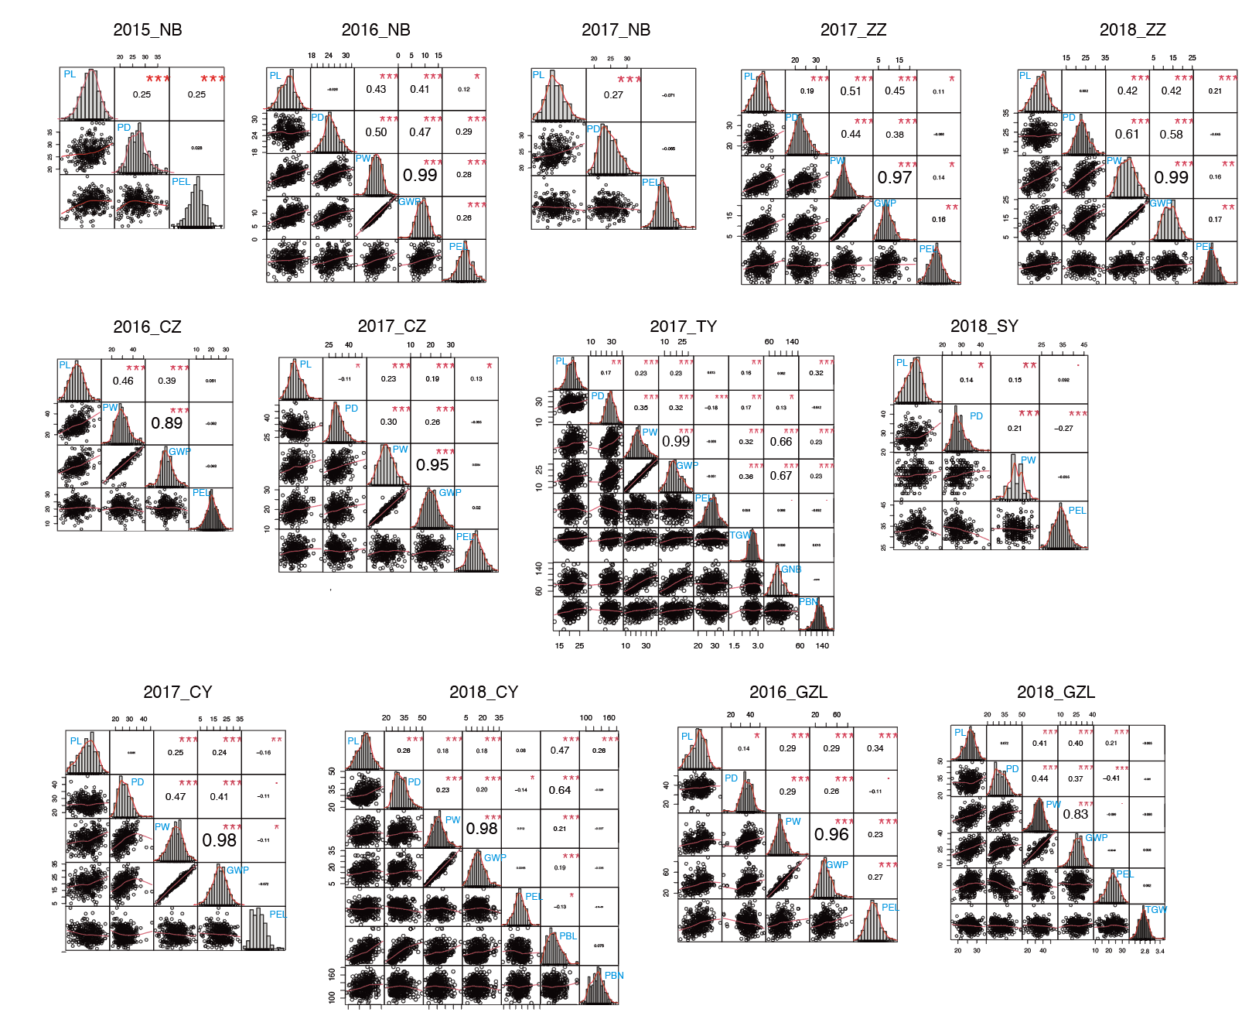
Figure S1. Phenotypic distribution and correlations of nine panicle architecture related parameters in 13 environments. The plots on the diagonal show the phenotypic distribution of each trail. The values above the diagonal are pairwise correlation coefﬁcients between traits, and the plots below the diagonal are scatter plots of compared traits.

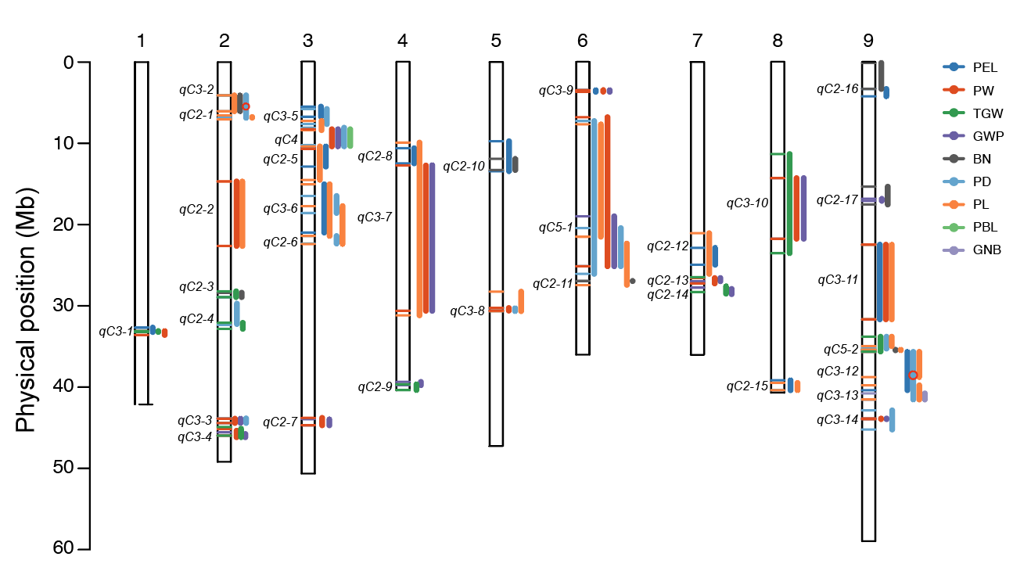
Figure S2 Co-locations of QTL for multiple traits. qC2-1~qC2-17 were double co-located QTL clusters, qC3-1~qC3-14 were triple co-located QTL cluster, qC4 was a quadruple co-located QTL cluster, qC5-1 and qC5-2 were quintuple co-located QTL clusters.

