Glucocorticoid Receptor Regulated KCNA5 Mediates Cell Proliferation in Human Fetal Membranes
Sarah J Cunningham¹²³, Alejandro Barrera¹³, Laavanya Sankaranarayanan¹²³, Terrence K Allen⁴, Timothy E Reddy¹²³*
1Department of Biostatistics and Bioinformatics, Duke University, Durham, NC, USA
2University Program in Genetics and Genomics, Duke University, Durham, NC, USA
3Center for Advanced Genomics Technologies, Duke University, Durham, NC, USA
4Department of Anesthesiology, Duke University Hospital, Durham, NC, USA
*Correspondence:
Corresponding Author
Tim.Reddy@Duke.edu

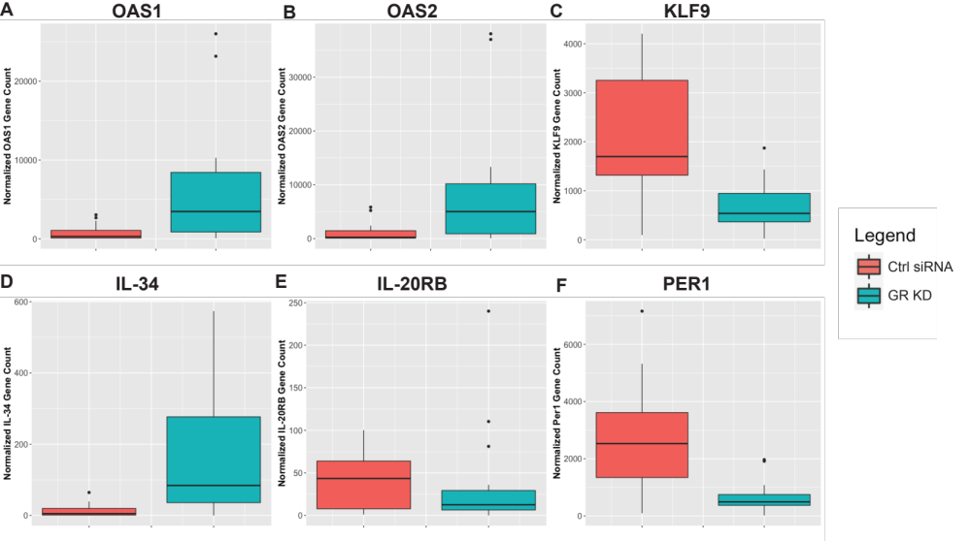
Supplementary Figure 1. Known glucocorticoid regulated genes. We found known glucocorticoid regulated genes OAS1 (A), OAS2 (B), KLF9 (C), IL-34 (D), IL-20RB (E), PER1 (F) to be differentially regulated by glucocorticoid receptor knockdown. Gene counts were first normalized by library size. The bar plots in red represent samples treated with a control siRNA and the ones in blue represent the glucocorticoid receptor knockdown.

Name | Sequence
Non-targeting | GTATTACTGATATTGGTGGGG
1 | ACACCCGCTGCCACGAGACCG
2 | AACCTTCAGCCGCCCCTCTCG
3 | TTGACGTCAGGGCCAAGCGAG
4 | GGCAGCGGGTGTCTCCCCGGG
5 | CGCCCCCTACTCACGCTCCGG
6 | CGCCCGCGGAGCGTGAGTAGG
7 | GCCCGCGGAGCGTGAGTAGGG
8 | GCGCCCGCGGAGCGTGAGTAG

Supplement 3. Guide RNAs tested. Sequence data for each guide RNA tested in dCas9-P300 CRISPR experiment.

