Supplementary Material
SILTATION PROCESS AND METALS SEDIMENT PROFILE IN A HYDROELECTRIC POWER PLANT RESERVOIR LOCATED IN THE BRAZILIAN MOST INDUSTRIALIZED REGION, PARAÍBA DO SUL RIVER BASIN, SOUTHEASTERN BRAZIL

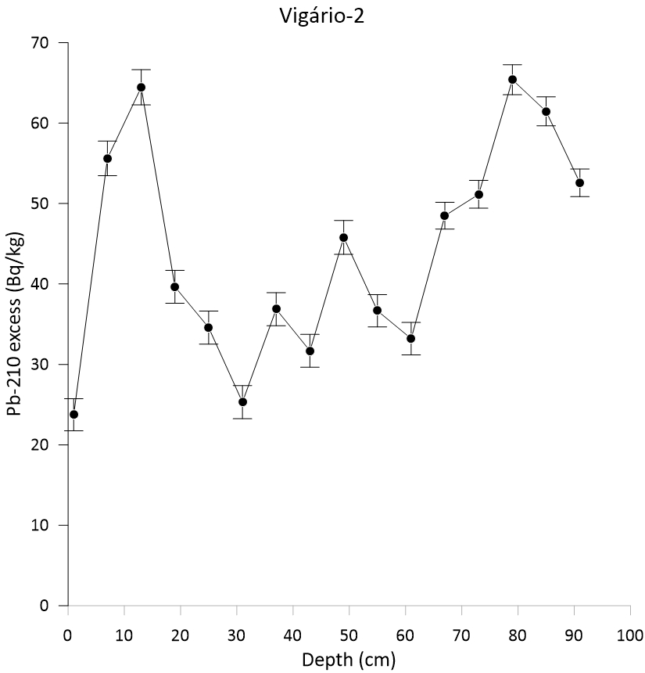
(a)
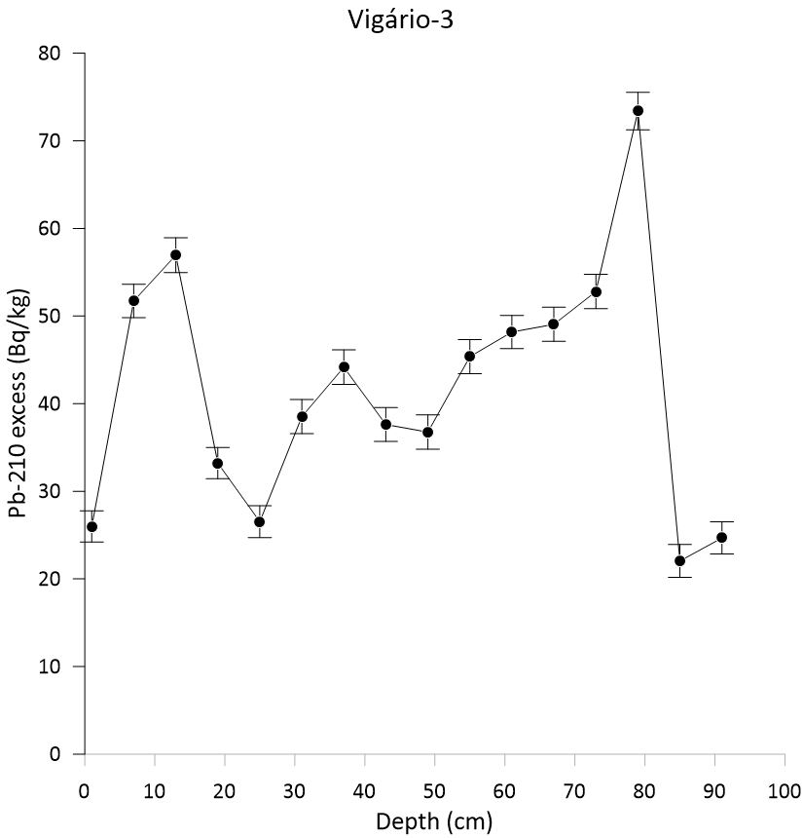
(b)
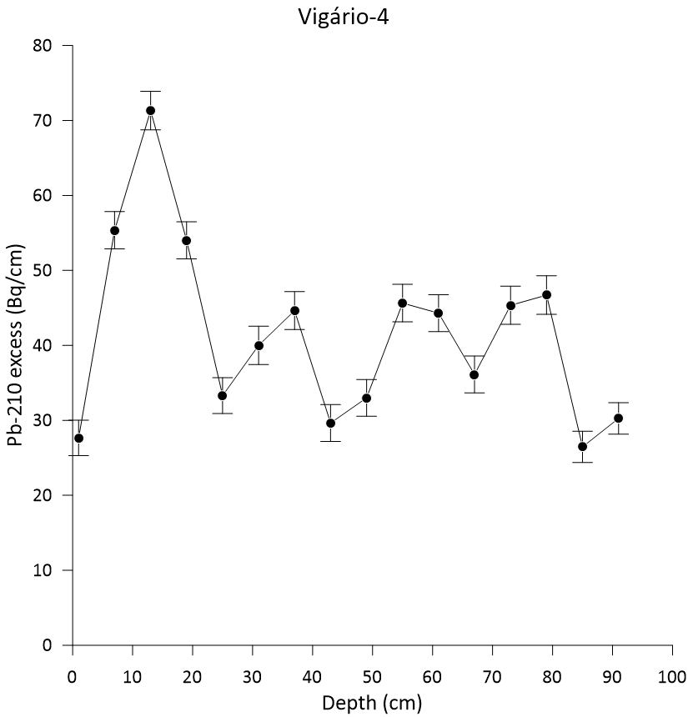
(c)
Fig. S1: Excess ²¹⁰Pb profile with the sediment layer depth for the sediment core (a) 2, (b) 3 and (c) 4

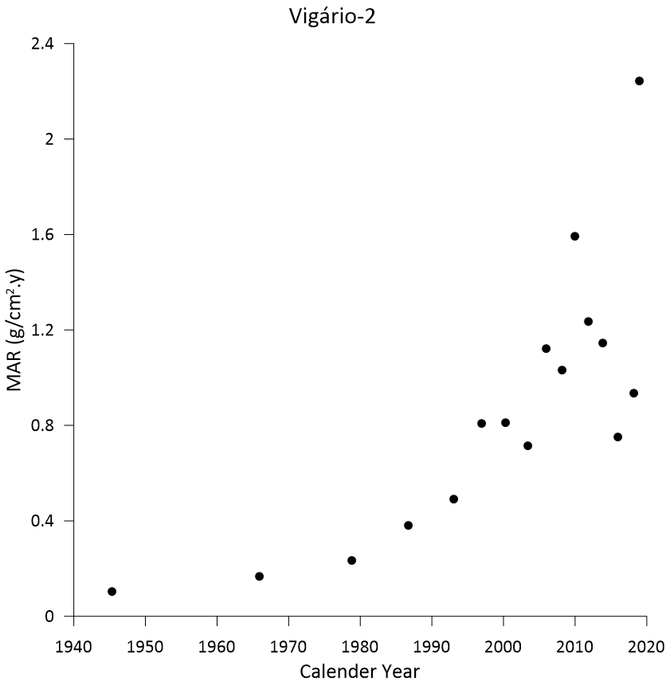
(a)
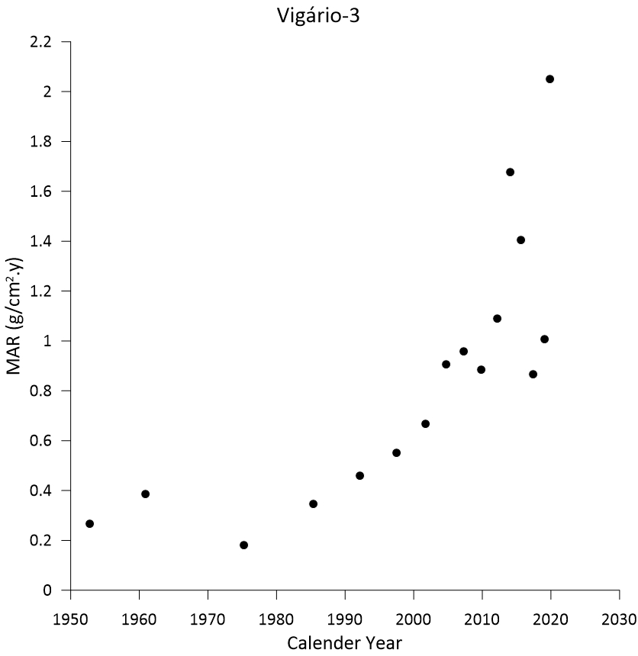
(b)
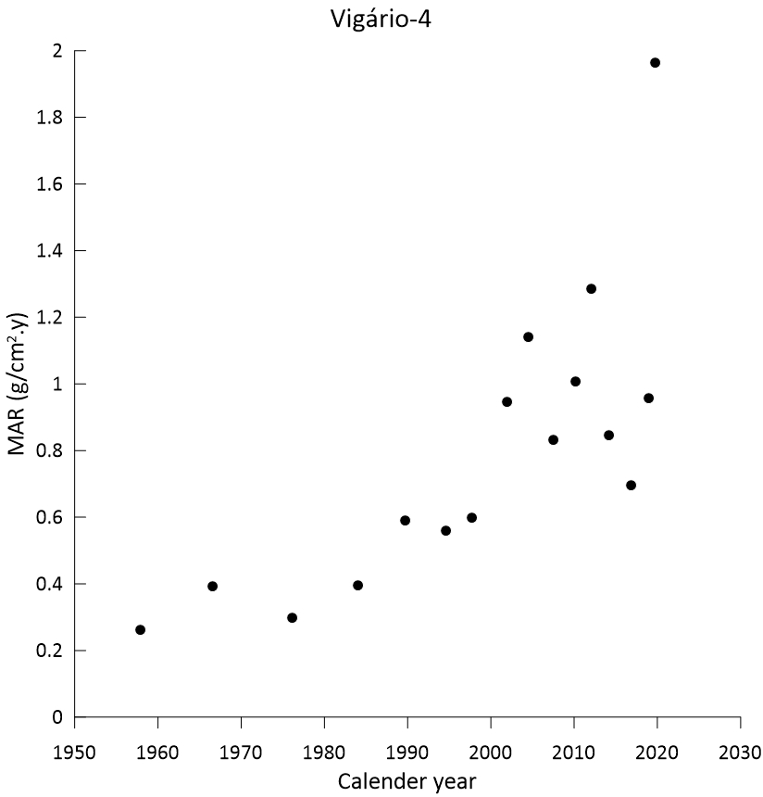
(c)
Fig. S2: MAR variation with the time observed in sediment cores (a) 2, (b) 3 and (c) 4

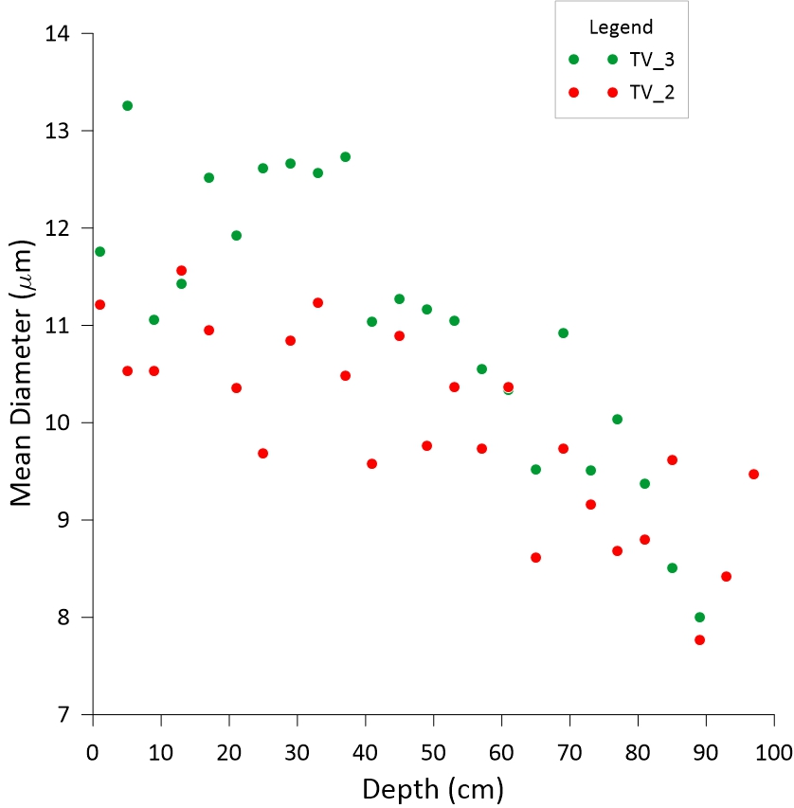
Fig. S3: Mean sediment particles diameter dependency with the sample layer depth

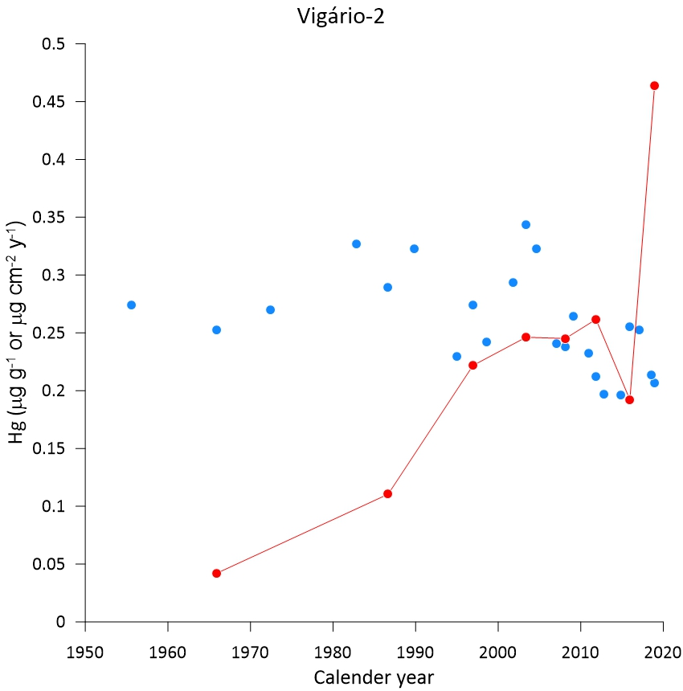
(a)
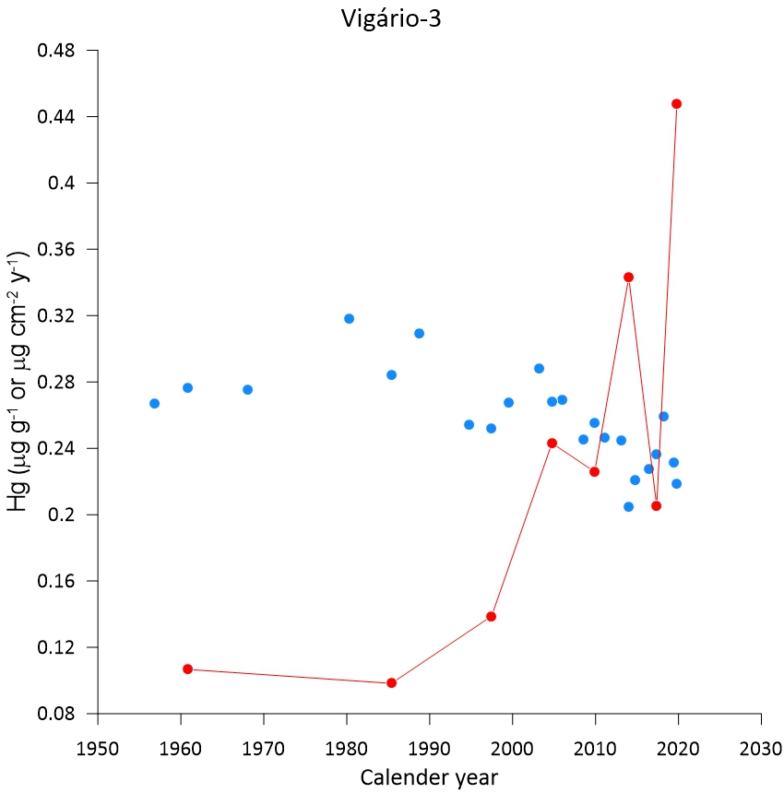
(b)
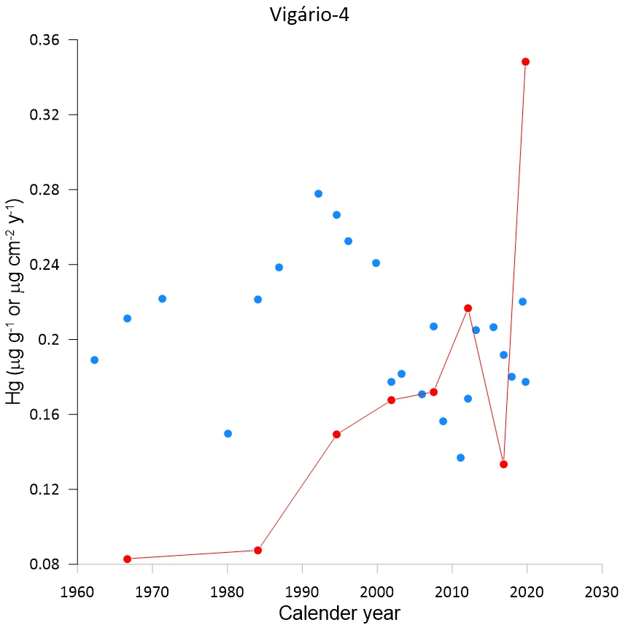
(c)
Fig. S4: Hg concentration and flux variation with the time observed in sediment cores (a) 2, (b) 3 and (c) 4

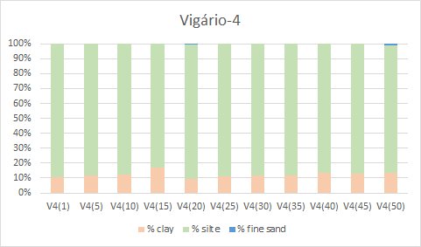
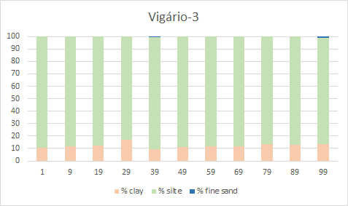
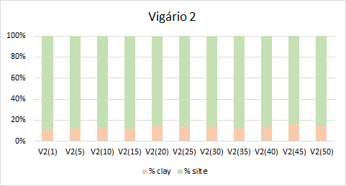
Fig. S5: Granulometry according to the depth of the sediment cores Vigário-4, Vigário-3 and Vigário-2

Table S-1: Obtained ²²⁶Ra concentration according to the sediment depth and sediment core (values in Bq kg⁻¹)
Sediment core | ²²⁶Ra
Vigário-2 | 35.6±1.3 (n=7), until 67 cm sediment layer depth | 28.33±0.51 (n=3), bellow 67 cm
Vigario-3 | 36.64±0.93 (n=10), entire core
Vigário-4 | 34.8±1.80 (n=8), until 79 cm sediment layer depth | 40.2±1.2 (n=2), bellow 79 cm

Table S-2: Obtained ²¹⁰Pb concentration according to the sediment depth for the Vigario-2 sediment core (values in Bq kg⁻¹)
Depth | ²¹⁰Pb | Uncertainty
1 | 59.3 | 1.5
7 | 91.2 | 1.7
13 | 100.1 | 1.8
19 | 75.2 | 1.6
25 | 70.2 | 1.6
31 | 60.9 | 1.6
37 | 72.5 | 1.6
43 | 67.3 | 1.6
49 | 81.4 | 1.7
55 | 72.3 | 1.5
61 | 68.8 | 1.5
67 | 76.8 | 1.6
73 | 79.5 | 1.6
79 | 93.7 | 1.8
85 | 89.8 | 1.7
91 | 80.9 | 1.6
97 | 101.3 | 1.8

Table S-3: Obtained ²¹⁰Pb concentration according to the sediment depth for the Vigario-3 sediment core (values in Bq kg⁻¹)
Depth | ²¹⁰Pb | Uncertainty
1 | 62.6 | 1.5
7 | 88.4 | 1.7
13 | 93.6 | 1.8
19 | 69.9 | 1.5
25 | 63.2 | 1.6
31 | 75.2 | 1.7
37 | 80.8 | 1.7
43 | 74.3 | 1.7
49 | 73.4 | 1.7
55 | 82.0 | 1.7
61 | 84.8 | 1.7
67 | 85.7 | 1.7
73 | 89.4 | 1.7
79 | 110.0 | 1.9
85 | 58.7 | 1.6
91 | 61.3 | 1.6
97 | 57.1 | 1.5

Table S-4: Obtained ²¹⁰Pb concentration according to the sediment depth for the Vigario-4 sediment core (values in Bq kg⁻¹)
Depth | ²¹⁰Pb | Uncertainty
1 | 62.5 | 1.5
7 | 90.2 | 1.7
13 | 106.1 | 1.8
19 | 88.8 | 1.7
25 | 68.1 | 1.6
31 | 74.8 | 1.8
37 | 79.4 | 1.8
43 | 64.4 | 1.7
49 | 67.8 | 1.7
55 | 80.4 | 1.8
61 | 79.1 | 1.7
67 | 70.9 | 1.7
73 | 80.1 | 1.8
79 | 81.5 | 1.8
85 | 66.7 | 1.7
91 | 70.5 | 1.7

