Supplementary Information

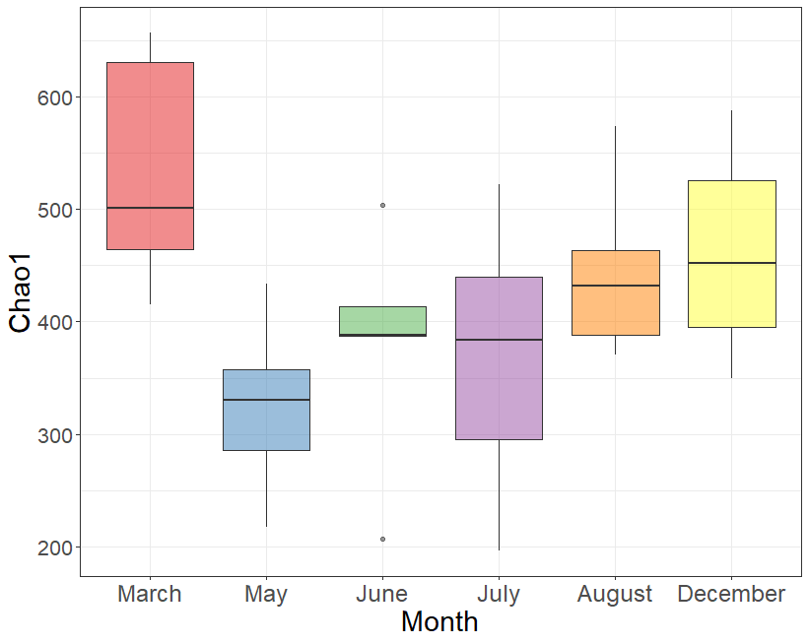
Figure S1. Box plots representing alpha diversity (Chao1 index) for bacterial communities of bacterioplankton from two Crassostrea gigas farms in Ireland. Site locations can be seen in Figure 1.

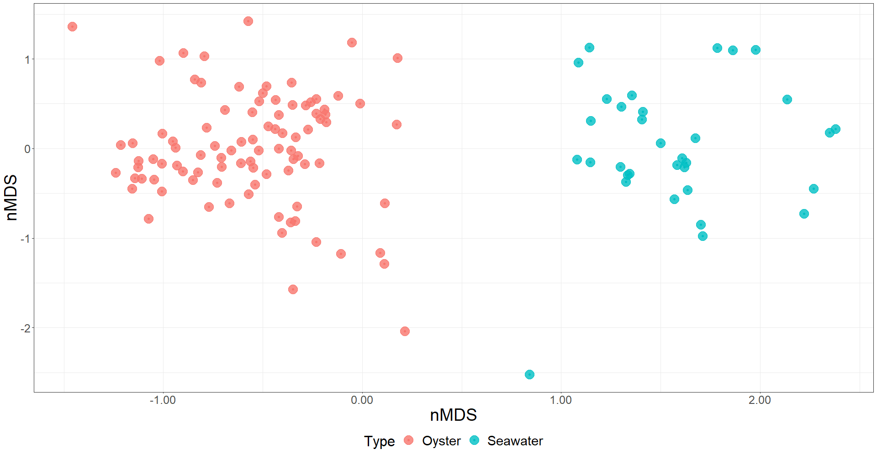
Figure S2. nMDS plots depicting Bray-Curtis dissimilarity between bacterial communities associated with the Pacific oyster, Crassostrea gigas and bacterioplankton. Sampling locations can be seen in Figure 1.

Figure S3. Relative abundance of bacterial classes associated with the Pacific oyster, Crassostrea gigas and bacterioplankton (seawater) from two oyster farms (Cromane and Bannow Bay) in Ireland. Samples were taken over the course of one year (March – December 2018). Locations of oyster farms can be seen in Figure 1.

Figure S4. Relative abundance of bacterial orders associated with the Pacific oyster, Crassostrea gigas and bacterioplankton (seawater) from two oyster farms (Cromane and Bannow Bay) in Ireland. Samples were taken over the course of one year (March – December 2018). Locations of oyster farms can be seen in Figure 1.

Table S1. Results of multivariate community structure (PERMANOVA) between Sites and Sampling months in the Pacific oyster Crassostrea gigas. Analysis is based on Bray-Curtis dissimilarity and was performed on data agglomerated back to the taxonomic ranks of class, order and family.
 |  | Phylum |  | Class |  | Order |  | Family
 | df | Pseudo-F | p | Pseudo-F | p | Pseudo-F | p | Pseudo-F | p
Site | 1 | 15.6 | <0.001 | 15.6 | <0.001 | 16.2 | <0.001 | 15.0 | <0.001
Month | 5 | 19.4 | <0.001 | 17.9 | <0.001 | 16.2 | <0.001 | 15.8 | <0.001
Site*Month | 5 | 17.7 | <0.001 | 14.3 | <0.001 | 11.9 | <0.001 | 11.8 | <0.001

Table S2. SIMPER analysis on significant pairwise comparisons identified by PERMANOVA analysis. Presented taxa represent those that contributed to 50% of observed dissimilarity between comparisons. Letter represents lowest resolved taxonomic rank C = Class, F = Family, G = Genus
Contrast | average | sd | ratio | ava | avb | cumsum | p | best_hit
December vs June
 | 0.15 | 0.09 | 1.73 | 0.05 | 0.34 | 0.23 | 0.01 | ASV2:g__Mycoplasma
 | 0.07 | 0.04 | 1.52 | 0.26 | 0.17 | 0.34 | 0.37 | ASV1:f__Spirochaetaceae
 | 0.04 | 0.04 | 0.98 | 0.00 | 0.07 | 0.39 | 0.91 | ASV5:f__Mycoplasmataceae
 | 0.03 | 0.05 | 0.56 | 0.06 | 0.01 | 0.44 | 0.04 | ASV27:g__Psychrobacter
 | 0.01 | 0.02 | 0.61 | 0.03 | 0.02 | 0.46 | 0.04 | ASV67:f__Rhodobacteraceae
 | 0.01 | 0.01 | 1.33 | 0.01 | 0.02 | 0.48 | 0.76 | ASV8:g__Synechococcus CC9902
 | 0.01 | 0.01 | 0.75 | 0.01 | 0.02 | 0.50 | 0.16 | ASV26:g__Polynucleobacter
December vs July
 | 0.18 | 0.09 | 1.99 | 0.05 | 0.39 | 0.24 | 0.01 | ASV2:g__Mycoplasma
 | 0.10 | 0.06 | 1.69 | 0.26 | 0.08 | 0.38 | 0.01 | ASV1:f__Spirochaetaceae
 | 0.04 | 0.04 | 0.95 | 0.00 | 0.08 | 0.43 | 0.01 | ASV20:g__Roseibacillus
 | 0.03 | 0.06 | 0.53 | 0.06 | 0.00 | 0.47 | 0.03 | ASV27:g__Psychrobacter
December vs August
 | 0.13 | 0.07 | 2.01 | 0.05 | 0.30 | 0.19 | 0.02 | ASV2:g__Mycoplasma
 | 0.08 | 0.05 | 1.71 | 0.26 | 0.11 | 0.30 | 0.01 | ASV1:f__Spirochaetaceae
 | 0.03 | 0.04 | 0.77 | 0.00 | 0.06 | 0.35 | 1.00 | ASV5:f__Mycoplasmataceae
 | 0.03 | 0.05 | 0.54 | 0.06 | 0.01 | 0.39 | 0.05 | ASV27:g__Psychrobacter
 | 0.02 | 0.04 | 0.38 | 0.00 | 0.03 | 0.41 | 0.01 | ASV47:g__Stenotrophomonas
 | 0.01 | 0.02 | 0.84 | 0.00 | 0.03 | 0.43 | 0.01 | ASV74:g__Persicirhabdus
 | 0.01 | 0.02 | 0.62 | 0.03 | 0.01 | 0.45 | 0.01 | ASV67:f__Rhodobacteraceae
 | 0.01 | 0.02 | 0.70 | 0.01 | 0.02 | 0.47 | 0.01 | ASV66:g__Vibrio
 | 0.01 | 0.02 | 0.76 | 0.00 | 0.03 | 0.49 | 0.07 | ASV24:lekithochrous
December vs March

 | 0.07 | 0.05 | 1.39 | 0.26 | 0.24 | 0.13 | 0.28 | ASV1:f__Spirochaetaceae
 | 0.03 | 0.04 | 0.98 | 0.00 | 0.07 | 0.20 | 0.91 | ASV5:f__Mycoplasmataceae
 | 0.03 | 0.05 | 0.69 | 0.06 | 0.03 | 0.27 | 0.01 | ASV27:g__Psychrobacter
 | 0.03 | 0.02 | 1.06 | 0.05 | 0.07 | 0.32 | 1.00 | ASV2:g__Mycoplasma
 | 0.01 | 0.02 | 0.61 | 0.03 | 0.01 | 0.34 | 0.01 | ASV67:f__Rhodobacteraceae
 | 0.01 | 0.01 | 0.72 | 0.02 | 0.00 | 0.36 | 0.01 | ASV56:g__Halomonas
 | 0.01 | 0.02 | 0.31 | 0.01 | 0.00 | 0.37 | 0.42 | ASV66:g__Vibrio
 | 0.01 | 0.01 | 1.08 | 0.01 | 0.01 | 0.38 | 0.83 | ASV26:g__Polynucleobacter
 | 0.01 | 0.02 | 0.32 | 0.00 | 0.01 | 0.39 | 0.28 | ASV63:g__Polaribacter
 | 0.01 | 0.00 | 1.25 | 0.01 | 0.02 | 0.40 | 1.00 | ASV8:g__Synechococcus CC9902
 | 0.01 | 0.01 | 0.39 | 0.00 | 0.01 | 0.41 | 0.22 | ASV72:g__Wolbachia
 | 0.01 | 0.00 | 1.26 | 0.01 | 0.01 | 0.42 | 0.02 | ASV201:algae
 | 0.00 | 0.00 | 1.21 | 0.02 | 0.02 | 0.43 | 0.98 | ASV73:g__Blastopirellula
 | 0.00 | 0.01 | 0.35 | 0.00 | 0.01 | 0.44 | 0.19 | ASV111:g__Streptococcus
 | 0.00 | 0.00 | 1.35 | 0.01 | 0.01 | 0.45 | 0.01 | ASV328:f__Gemmataceae
 | 0.00 | 0.01 | 0.64 | 0.01 | 0.00 | 0.46 | 0.02 | ASV128:g__Neptunomonas
 | 0.00 | 0.00 | 1.24 | 0.02 | 0.01 | 0.47 | 0.42 | ASV37:f__Desulfocapsaceae
 | 0.00 | 0.00 | 1.32 | 0.02 | 0.02 | 0.47 | 0.97 | ASV123:f__Pirellulaceae
 | 0.00 | 0.00 | 1.39 | 0.01 | 0.01 | 0.48 | 0.84 | ASV244:f__DEV007
 | 0.00 | 0.00 | 1.31 | 0.02 | 0.01 | 0.48 | 0.81 | ASV22:g__Rubripirellula
 | 0.00 | 0.01 | 0.57 | 0.00 | 0.01 | 0.49 | 0.09 | ASV380:f__Flavobacteriaceae
 | 0.00 | 0.00 | 1.36 | 0.01 | 0.01 | 0.50 | 0.08 | ASV1663:g__Legionella
December vs May
 | 0.11 | 0.12 | 0.92 | 0.00 | 0.21 | 0.16 | 0.01 | ASV7:g__Pseudomonas
 | 0.08 | 0.08 | 0.97 | 0.00 | 0.16 | 0.28 | 0.01 | ASV5:f__Mycoplasmataceae
 | 0.07 | 0.05 | 1.50 | 0.26 | 0.19 | 0.39 | 0.21 | ASV1:f__Spirochaetaceae
 | 0.05 | 0.04 | 1.18 | 0.05 | 0.11 | 0.46 | 1.00 | ASV2:g__Mycoplasma
June vs July
 | 0.10 | 0.07 | 1.42 | 0.34 | 0.39 | 0.20 | 0.50 | ASV2:g__Mycoplasma
 | 0.06 | 0.04 | 1.61 | 0.17 | 0.08 | 0.32 | 0.77 | ASV1:f__Spirochaetaceae
 | 0.04 | 0.04 | 0.96 | 0.01 | 0.08 | 0.39 | 0.01 | ASV20:g__Roseibacillus
 | 0.04 | 0.04 | 0.99 | 0.07 | 0.02 | 0.47 | 0.86 | ASV5:f__Mycoplasmataceae
June vs August
 | 0.09 | 0.06 | 1.46 | 0.34 | 0.30 | 0.18 | 0.96 | ASV2:g__Mycoplasma
 | 0.04 | 0.03 | 1.56 | 0.17 | 0.11 | 0.26 | 1.00 | ASV1:f__Spirochaetaceae
 | 0.04 | 0.04 | 1.14 | 0.07 | 0.06 | 0.34 | 0.73 | ASV5:f__Mycoplasmataceae
 | 0.02 | 0.04 | 0.38 | 0.00 | 0.03 | 0.37 | 0.02 | ASV47:g__Stenotrophomonas
 | 0.01 | 0.01 | 0.94 | 0.01 | 0.03 | 0.40 | 0.01 | ASV74:g__Persicirhabdus
 | 0.01 | 0.02 | 0.78 | 0.00 | 0.03 | 0.43 | 0.04 | ASV24:lekithochrous
 | 0.01 | 0.03 | 0.38 | 0.00 | 0.02 | 0.45 | 0.06 | ASV19:g__Endozoicomonas
 | 0.01 | 0.01 | 1.81 | 0.02 | 0.01 | 0.47 | 0.69 | ASV8:g__Synechococcus CC9902
 | 0.01 | 0.01 | 0.92 | 0.01 | 0.02 | 0.49 | 0.01 | ASV44:f__Helicobacteraceae
June vs March
 | 0.14 | 0.09 | 1.60 | 0.34 | 0.07 | 0.23 | 0.01 | ASV2:g__Mycoplasma
 | 0.06 | 0.04 | 1.49 | 0.17 | 0.24 | 0.34 | 0.52 | ASV1:f__Spirochaetaceae
 | 0.04 | 0.03 | 1.19 | 0.07 | 0.07 | 0.41 | 0.83 | ASV5:f__Mycoplasmataceae
 | 0.02 | 0.01 | 1.08 | 0.01 | 0.03 | 0.43 | 0.68 | ASV27:g__Psychrobacter
 | 0.01 | 0.02 | 0.73 | 0.02 | 0.01 | 0.45 | 0.09 | ASV26:g__Polynucleobacter
 | 0.01 | 0.01 | 1.66 | 0.02 | 0.02 | 0.47 | 0.70 | ASV8:g__Synechococcus CC9902
 | 0.01 | 0.00 | 1.60 | 0.01 | 0.02 | 0.48 | 0.05 | ASV73:g__Blastopirellula
 | 0.01 | 0.02 | 0.39 | 0.01 | 0.01 | 0.49 | 0.12 | ASV63:g__Polaribacter
June vs May
 | 0.12 | 0.08 | 1.50 | 0.34 | 0.11 | 0.21 | 0.04 | ASV2:g__Mycoplasma
 | 0.11 | 0.12 | 0.92 | 0.00 | 0.21 | 0.39 | 0.01 | ASV7:g__Pseudomonas
July vs August
 | 0.10 | 0.07 | 1.38 | 0.39 | 0.30 | 0.18 | 0.69 | ASV2:g__Mycoplasma
 | 0.04 | 0.03 | 1.53 | 0.08 | 0.11 | 0.25 | 1.00 | ASV1:f__Spirochaetaceae
 | 0.04 | 0.04 | 0.99 | 0.08 | 0.01 | 0.33 | 0.01 | ASV20:g__Roseibacillus
 | 0.03 | 0.04 | 0.82 | 0.02 | 0.06 | 0.39 | 0.86 | ASV5:f__Mycoplasmataceae
 | 0.03 | 0.04 | 0.76 | 0.06 | 0.01 | 0.44 | 0.01 | ASV8:g__Synechococcus CC9902
 | 0.02 | 0.02 | 0.88 | 0.02 | 0.03 | 0.47 | 0.01 | ASV24:lekithochrous
July vs March
 | 0.17 | 0.08 | 2.00 | 0.39 | 0.07 | 0.24 | 0.01 | ASV2:g__Mycoplasma
 | 0.09 | 0.06 | 1.61 | 0.08 | 0.24 | 0.37 | 0.01 | ASV1:f__Spirochaetaceae
 | 0.04 | 0.04 | 0.96 | 0.08 | 0.00 | 0.42 | 0.01 | ASV20:g__Roseibacillus
 | 0.04 | 0.04 | 1.00 | 0.02 | 0.07 | 0.47 | 0.87 | ASV5:f__Mycoplasmataceae
July vs May
 | 0.16 | 0.08 | 1.96 | 0.39 | 0.11 | 0.22 | 0.01 | ASV2:g__Mycoplasma
 | 0.11 | 0.11 | 0.93 | 0.01 | 0.21 | 0.37 | 0.01 | ASV7:g__Pseudomonas
 | 0.08 | 0.08 | 1.00 | 0.02 | 0.16 | 0.48 | 0.01 | ASV5:f__Mycoplasmataceae
August vs March
 | 0.12 | 0.06 | 1.94 | 0.30 | 0.07 | 0.18 | 0.03 | ASV2:g__Mycoplasma
 | 0.08 | 0.05 | 1.56 | 0.11 | 0.24 | 0.30 | 0.02 | ASV1:f__Spirochaetaceae
 | 0.04 | 0.04 | 1.14 | 0.06 | 0.07 | 0.36 | 0.80 | ASV5:f__Mycoplasmataceae
 | 0.02 | 0.04 | 0.38 | 0.03 | 0.00 | 0.39 | 0.01 | ASV47:g__Stenotrophomonas
 | 0.01 | 0.01 | 1.07 | 0.01 | 0.03 | 0.41 | 0.65 | ASV27:g__Psychrobacter
 | 0.01 | 0.02 | 0.84 | 0.03 | 0.00 | 0.43 | 0.01 | ASV74:g__Persicirhabdus
 | 0.01 | 0.02 | 0.76 | 0.03 | 0.00 | 0.45 | 0.04 | ASV24:lekithochrous
 | 0.01 | 0.03 | 0.39 | 0.02 | 0.00 | 0.47 | 0.02 | ASV19:g__Endozoicomonas
 | 0.01 | 0.01 | 0.79 | 0.02 | 0.00 | 0.48 | 0.01 | ASV44:f__Helicobacteraceae
 | 0.01 | 0.01 | 1.10 | 0.02 | 0.00 | 0.49 | 0.27 | ASV66:g__Vibrio
August vs May
 | 0.11 | 0.06 | 1.72 | 0.30 | 0.11 | 0.16 | 0.34 | ASV2:g__Mycoplasma
 | 0.11 | 0.12 | 0.91 | 0.00 | 0.21 | 0.32 | 0.01 | ASV7:g__Pseudomonas
 | 0.08 | 0.07 | 1.15 | 0.06 | 0.16 | 0.44 | 0.01 | ASV5:f__Mycoplasmataceae
March vs May
 | 0.11 | 0.12 | 0.92 | 0.00 | 0.21 | 0.17 | 0.01 | ASV7:g__Pseudomonas
 | 0.08 | 0.06 | 1.22 | 0.07 | 0.16 | 0.30 | 0.01 | ASV5:f__Mycoplasmataceae
 | 0.07 | 0.05 | 1.45 | 0.24 | 0.19 | 0.41 | 0.29 | ASV1:f__Spirochaetaceae
 | 0.05 | 0.04 | 1.29 | 0.07 | 0.11 | 0.48 | 1.00 | ASV2:g__Mycoplasma
Bannow vs Cromane
 | 0.11 | 0.08 | 1.38 | 0.25 | 0.18 | 0.17 | 0.01 | ASV2:g__Mycoplasma
 | 0.06 | 0.05 | 1.37 | 0.17 | 0.18 | 0.27 | 0.77 | ASV1:f__Spirochaetaceae
 | 0.05 | 0.05 | 0.86 | 0.05 | 0.07 | 0.35 | 0.73 | ASV5:f__Mycoplasmataceae
 | 0.04 | 0.08 | 0.45 | 0.07 | 0.00 | 0.41 | 0.02 | ASV7:g__Pseudomonas
 | 0.02 | 0.03 | 0.57 | 0.04 | 0.01 | 0.44 | 0.01 | ASV27:g__Psychrobacter
 | 0.02 | 0.02 | 0.65 | 0.01 | 0.04 | 0.47 | 0.01 | ASV8:g__Synechococcus CC9902
 | 0.01 | 0.03 | 0.49 | 0.00 | 0.03 | 0.49 | 0.04 | ASV20:g__Roseibacillus

